Minutes v1.0
WGCV-49 Day #2
Wednesday, 30 June 2021

Welcome [Slides]
Presenter: A. Kuze
Main points:
- Summarised day 1, which focused on reviewing the activities of the LPV, IVOS, and TMSG subgroups. There has been good progress overall. It is clear that intercomparison exercises are now a very popular approach.
- Recalled the SI-traceable Space-based Climate Observing System (SITSCOS) report and proposed branding this with the WGCV / CEOS logos.
- The proposed joint WGISS-WGCV meeting in March 2022, will be an ideal opportunity to discuss the terminology and common online dictionary topic further.
Atmospheric Composition (ACSG) Subgroup Report [Slides]
Presenter: J-C. Lambert
Main points:
- ACSG and AC-VC-18 meetings: Brussels, March 2022, if possible. ACSG is contributing to AC-VC topics on aerosols, trace gases, GHG, and ozone. Further collaboration with AC-VC on topics like aerosols is being considered.
- Various airborne and field campaigns are underway for: UV-Vis and IR spectrometers; Mapping, enhanced horizontal resolution; Inter/intra pixel experiments and (super)sites; Geostationary peculiarities vs. LEO; Surface BRDF, orography, clouds.
- Maintaining and tailoring various networks for GHG measurements for satellite validation: NDACC IRWG, TCCON, COCCON. Various discussions and activities are ongoing. The three networks are used operationally for: CAMS, Sentinel-5P MPC and EUMETSAT AC SAF trace gases validation.
- Fiducial Reference Measurements (FRM): Various measurement and development programmes ongoing (see slides).
- Tropospheric Ozone Dataset Validation and Harmonization (VC-20-02): CEOS (AC-VC / WGCV) response to IGAC TOAR-II needs. Coordinated with TOAR-II Satellite Ozone WG and HEGIFTOM WG. Status as at AC-VC-17 (June 2021): Data harmonisation and validation protocols for satellite tropospheric ozone; Gap analysis for cross-constellation validation; Initial validation results; Feedback to ground-based data providers. Results to be reported at AC-VC-18 (14-18 March 2022, Brussels) and anticipating contributions to TOAR-II publications from 2022.
- Copernicus Cal/Val Solution (CCVS) – Atmosphere: EC H2020 project to elaborate a holistic Cal/Val solution for the Copernicus Sentinel missions, overcoming current limitations (i.e., lack of cross-Sentinel synergies; insufficient handling of interoperability requirements within the Copernicus programme; excessive dependency on data obtained from external entities without any long-term operational commitments to the Copernicus programme; global lack of reference data compliant with internationally endorsed good practice methods for operational Cal/Val, both from permanently maintained sites and campaign-based acquisitions). Reviewed current activities and stakeholders (see slides). CCVS addresses GHG Roadmap CV-2 and CV-5, and is also relevant to CV-6. CCVS documentation highlighted as a possible contribution towards a generic validation protocol for atmospheric (L2) data products (see slides for details).
- Level-1 / Reflectance / Surface: Emerging interest in validation of Level-1 FCDRs (calibration validation), in validation of LER/DLER/GLER/GELER retrievals and climatologies, in use of PICS, in directional properties of surface, in validation of pixel geolocation from UV-Vis to SWIR and TIR. Suggested that WGCV might want to investigate opportunities for a future WGCV activity cataloguing existing methods and data and exploring new possibilities.
- Development of validation protocols for aerosols and clouds: proposal for a new Task by the EarthCARE validation team (see slides)
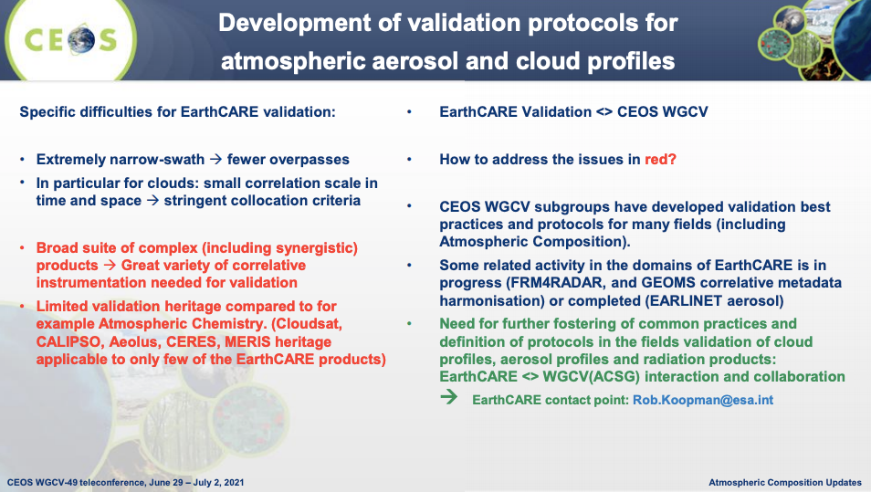
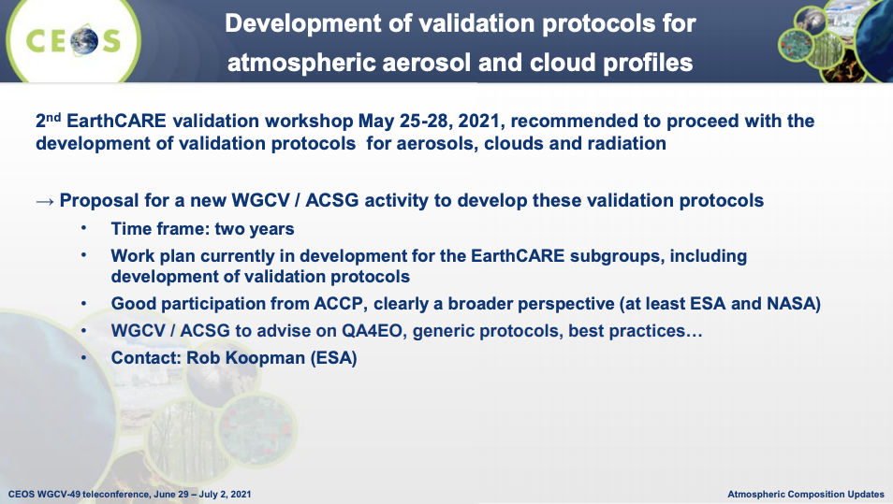

Discussion
- Akihiko Kuze asked about GEMS and TEMPO and what ideas exist regarding intercomparisons for these instruments. Jean-Christopher noted that as they do not cover the same geographic area, the idea is to use LEOs as travelling references. Sentinel-5P is the first candidate. In the AC-VC/ACSG GEO-AQConstellation Geophysical Validation Needs document Sentinel-5P, Gaofen-5, and the JPSS series are identified as traveling standards. There will also be a close cooperation on validation campaigns – deploying consistent validation equipment across regions to ensure consistency.
WGCV-49-01 | Jean-Christopher to maintain a watch on surface related validation activities emerging in the atmospheric composition world (PICS, (D)(G(E))LER, etc.) over the coming months, collect material and contact points, and investigate (by WGCV-50) opportunities for a concrete action or activity.  Background/context: The emerging topic on surface related validation (PICS, (D)(G(E))LER, etc.) is still too dispersed in scope and not mature enough technically to elaborate a concrete action. | WGCV-50
WGCV-49-02 | WGCV Chair and Vice Chair to consider the addition of a CEOS Work Plan 2022-2024 Task regarding "Development of Validation Protocols for Atmospheric Aerosol and Cloud Profiles".  Background/context: There is a clear desire by the EarthCARE team to have the "development of validation protocols for atmospheric aerosol and cloud profiles" endorsed officially by WGCV. | In time for the CEOS Work Plan 2022-2024 revision (Q1 2022)
Microwave Sensors (MSSG) Subgroup Report [Slides]
Presenter: X. Dong
Main points:
- Reported progresses on CEOS Work Plan action CV-20-05: Standards and Metrics for Scatterometers and Wind Retrievals. Target completion in Q4 2021.
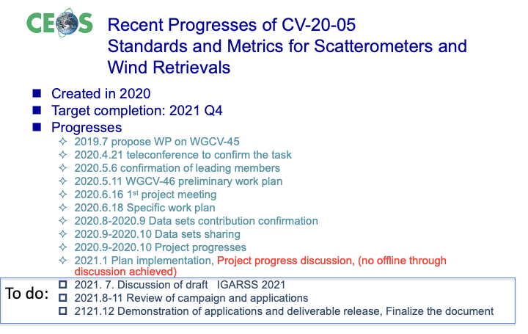
- In-depth updates were provided for each of the tasks outlined above. See slides for details.
- Next steps for this project include a discussion during IGARSS 2021, further confirmation of more data availability, and an investigation into the use of the recently launched HY-2C/D satellites (with inclined orbits) for cross-calibration.
- It was proposed that this task be given a half-year extension (wrap-up by June 2022). This is necessary due to the lack of meeting opportunities over the last year and a half.
ACIX / CMIX [Slides]
Presenter: P. Goryl
Main points:
- CMIX main conclusions:
  - All five validation datasets have different strengths and weaknesses, meaning results vary depending on the validation dataset used.
  - Subjectivity of detecting/photo-interpreting clouds, especially thin clouds, in the validation datasets should be minimised, e.g., by using a network of sky images.
  - No clear superiority of any methodology (spectral tests vs. AI, mono vs. multitemporal).
  - Buffer and its size have a strong influence on the validation results. A larger buffer leads to better results.
  - Thin semi-transparent clouds and cloud boundaries are an issue for mostly all algorithms. Defining a transparent cloud or boundary of a cloud is an open question.
  - The validation datasets and methods do not allow for the detection of systematic errors.
- ACIX-II Land main conclusions:
  - Simulation reference using 6S and AERONET may be biased due to differences between processors and references (adjacency correction, RTM, etc.).
  - No clear superiority – similar results for most processors in the SR comparison with RadCalNet measurements.
  - Uncertainty needs to be assigned to ground measurements when involved in the analysis.
  - Some geographical areas were missing (Africa, South America, Australia) and many sites close to big cities and deserts.
  - More in situ SR measurements are needed.
- ACIX-II Aqua main conclusions:
  - AC processors’ performance differed for Community Validation Database (CVD) and AERONET-OC matchups, likely reflecting inherent variability in aquatic and atmospheric properties between the two datasets.
  - The largest uncertainties were associated with the blue bands (25 to 60%) for the best-performing processors considering both CVD and AERONET-OC assessments.
  - Uncertainty propagation to the downstream products was assessed using satellite matchups from the CVD along with in situ of chlorophyll-a (Chla) and Total Suspended Solids (TSS) 20–30% uncertainties in 𝝆𝒘 (490 ≤ λ ≤ 743 nm) yielded 25–70% uncertainties in derived Chla and TSS products for the top-performing AC processors.
- ACIX-III and CMIX-II Proposal:
  - International collaborative initiative to inter-compare a set of atmospheric correction (AC) and cloud masking (CM) processors for Hyperspectral (PRISMA) and multispectral (Sentinel-2 & Landsat-8) imagery. The objective is to point out strengths and weaknesses, as well as commonalities and differences.
  - ACIX and CMIX are open and free exercises and every developer team with an atmospheric correction and/or cloud masking processor is welcome to participate.
  - Potential Participants – Multispectral Data: Processors applicable to Sentinel-2 and Landsat-8 data that participated in the previous exercises (namely national space agencies, R&D companies, universities, research institutes, etc.) and any newly developed processor or interested developer team is welcome to participate.
  - Potential Participants – Hyperspectral Data:
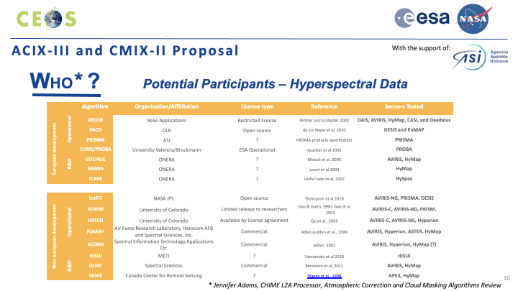
  - The exercises will have the same general process as past intercomparison exercises, as shown in the figure below. Additional details for each step are available in the slides. The first workshop is anticipated in the northern Autumn of 2021.
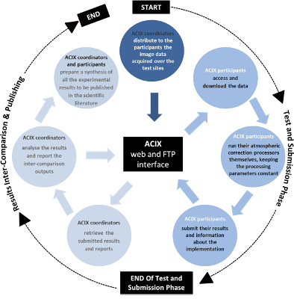
Discussion
- Noting the remark that geographical areas including Australia were missing from the ACIX-II Land activity, Cindy Ong asked what validation is required for Australia for ACIX? She noted that the Pinnacles site is a desert and the historical data can be made available. More work will be done there leading up to the installation of additional instrumentation. More ground measurement work will be undertaken with PRISMA & DESIS data on routine capture as well. Philippe acknowledged the opportunities for collaboration with the Australian team and he is aware of their capabilities and interest in hyperspectral. The ACIX team will follow up with Cindy in time.
VH-RODA 2021 [Slides]
Presenter: P. Goryl
Main points:
- The Very High-resolution Radar & Optical Data Assessment (VH-RODA) 2021 workshop was held online, 20–23 April 2021. Topics covered included ARD, FRM, quality maturity matrix and quality control best practices, as well as AI for cal/val and AI for QC and data processing.
- The workshop provided an open forum (including new space, commercial and institutional participants) on the status and future developments related to Cal/Val activities of space borne very high-resolution SAR and optical sensors and data products. There was a focus on commercial entities in Cal/Val activities, synergies between optical and SAR communities, and the presentation of standards and best practices for data quality.
- Information and presentations can be found on the VH-RODA ESA official website: https://earth.esa.int/eogateway/events/vh-roda-workshop-2021
- The continued growth of EO satellites and sensors underscores the need for standardised inputs for sensor fusion and expanded interoperability at all processing levels. This growth should also stimulate the creation of a wide multi-sensor community.
- The discussion on the definition of ARD is still open. Institutional and commercial points of view are complementary, and the need to define a working group to bring the different actors together is evident and advisable.
- The heterogeneity of EO sensors requires the sustainment of numerous different sites for calibration activities. Increased coordination among institutions/agencies to make Cal/Val data more available by the community was a key theme. A joint effort (commercial and space agencies) on a collection of sites for geometric cal/val was suggested.
- The availability of larger and more distributed GCPs is becoming fundamental. The accessibility and availability of DBs shall be improved in the frame of CEOS and made available on the CEOS Cal/Val portal. There was interaction with USGS during the meeting regarding sharing DBs for VHR GCPs.
- In situ and other reference data deserves increased focus from data providers and should be considered a core part of any 'free and open' data policy.
- Quality control of EO data needs coordination: a systematic approach defining and implementing QA standards requires the effort of all in order to keep pace with development.
  - Quality information of each pixel is necessary for interoperability (uncertainty per-pixel is important for medium resolution and data assimilation).
  - Institutions have to work in order to provide common references and to permit sensor intercomparison at different scales.
  - Uncertainty associated with measurements and derived quantities should be always included. QA4EO can support commercial entities in improving the provision of uncertainty information through standardisation.
  - The Maturity Matrix has been recognized as an important instrument for the quality evaluation of data and processes.
  - With the growth of VHR missions, an intercomparison exercise involving commercial companies should be considered.
- Artificial Intelligence and Machine Learning methods and tools are becoming fundamental instruments in data processing chains, and are very promising in terms of performance and support to decision making. Some suggestions resulting from the VH-RODA discussions on these topics:
  - Large training datasets are key and should be made readily available.
  - Motivating a large number of people and providing a benchmark is the way agencies can help the community progress this topic.
  - Stimulate interaction between EO and AI communities.
  - Stimulate initiatives to push forward the re-analysis of past datasets with AI methods.
  - Objective for the agencies/institutions: provide reference/ground truth data.
Discussion
- Peter Strobl noted the suggestion regarding compiling a collection of sites for geometric cal/val. This could be an interesting subject (following the main work of DEMIX) for the TMSG to start investigating. It is a good fit for WGCV overall. It was noted that Sentinel-2 is releasing its GRI as a library of path points (GCPs) and there is similar available from USGS/Landsat and Planet. Overall there is a feeling that there is a willingness to converge on a library/repository of GCPs at different scales, resolutions, etc. Such a collection could be instrumental when combined with DEMs for a reference framework that would make sure the problem of co-registration is being solved. These comments are also applicable for CCVS, which should eventually have a chapter on geometry too. Peter has suggested this to the CCVS JRC lead already and WGCV should remain engaged.
- Akihiko Kuze noted the 160 attendees figure and asked about the split of agency and commercial participants. The split was around 50-50, with around 50% of the commercial numbers representing ‘New Space’ companies.
Synthetic Aperture Radar (SAR) Subgroup Report [Slides]
Presenter: B. Chapman
Main points:
- SAR subgroup website fully ported to the cal/val portal. Substantial improvement to time management. Appreciate ESA’s efforts on this.
- The subgroup met Oct. 6-8, hosted by CSA (virtual). The meeting consisted of three sessions: SAR cal/val targets, CARD4L, and operating mission updates.
- Draft outline of “Requirements for SAR Calibration Targets” document: This will require a lot of work to complete. The group is discussing splitting the document into smaller components. The overview was shared (see slides).
- Next workshop is planned for November. On the agenda is: a discussion of SARCALNET; “Requirements for SAR Calibration Targets” document; updates from operating missions; and, upcoming mission updates.
- SAR Calibration Inventory and Joint-use Assessment: Existing SAR target database. Contains position of reflectors from various agencies. Additional information would make this database more useful. The Database contains Radarsat swaths over natural targets.
- SARCALNET: Currently most missions design their own external targets and typically use a combination of natural and artificial sources. Like RadCalNet there is a desire to have an established network of calibration sites that facilitate collaboration between sensors by using the same references. Would publish calibration results to facilitate their joint-use along with the target database for joint-use and cross-calibration. Various types of image calibration with different dependencies.
- Natural Targets:
  - Typically large, uniform SAR backscatter areas, spanning the image swath (now often >150km). Uniformity of an area may be frequency dependent, so this can be challenging.
  - Time history of data should be hosted on the CEOS WGCV SAR webpage, and in addition, methods and source data for calculating time series results should be provided.
  - Incidence angle, Asc-Desc, overlap regions, and seasonal changes present further complications and this information needs to be provided with results.
  - Plan for natural targets: document on webpage; select a group representing different agencies to define areas, monitor results from different sensors, and hold monthly calls; discuss at the next meeting.
- Artificial Passive Targets:
  - Point targets of known brightness for assessing image radiometric calibration, geolocation, resolution and more. These are frequency band dependent (size and material) and are typically deployed during mission commissioning and not necessarily maintained thereafter. Information about these sites should be shared and characterised for broader use, and maintained.
  - Characteristics change over time, including background information, and these changes need to be measured and reported periodically.
  - If reflectors were aligned North and South, rather than being flight path dependent, the sites could be used more broadly and by both left- and right-looking missions. While they will appear slightly less bright, they will be much more broadly usable.
  - Next steps: set standards for measurements and guidelines for size and materials; write strategies for collaboration (covering for example: N/S orientation, sufficient and stable RCS for multiple wavelengths, up-to-date inventories).
- Artificial Active Targets:
  - Band-specific, re-transmits received signal, can be polarimetric, requires power on for satellite overpass.
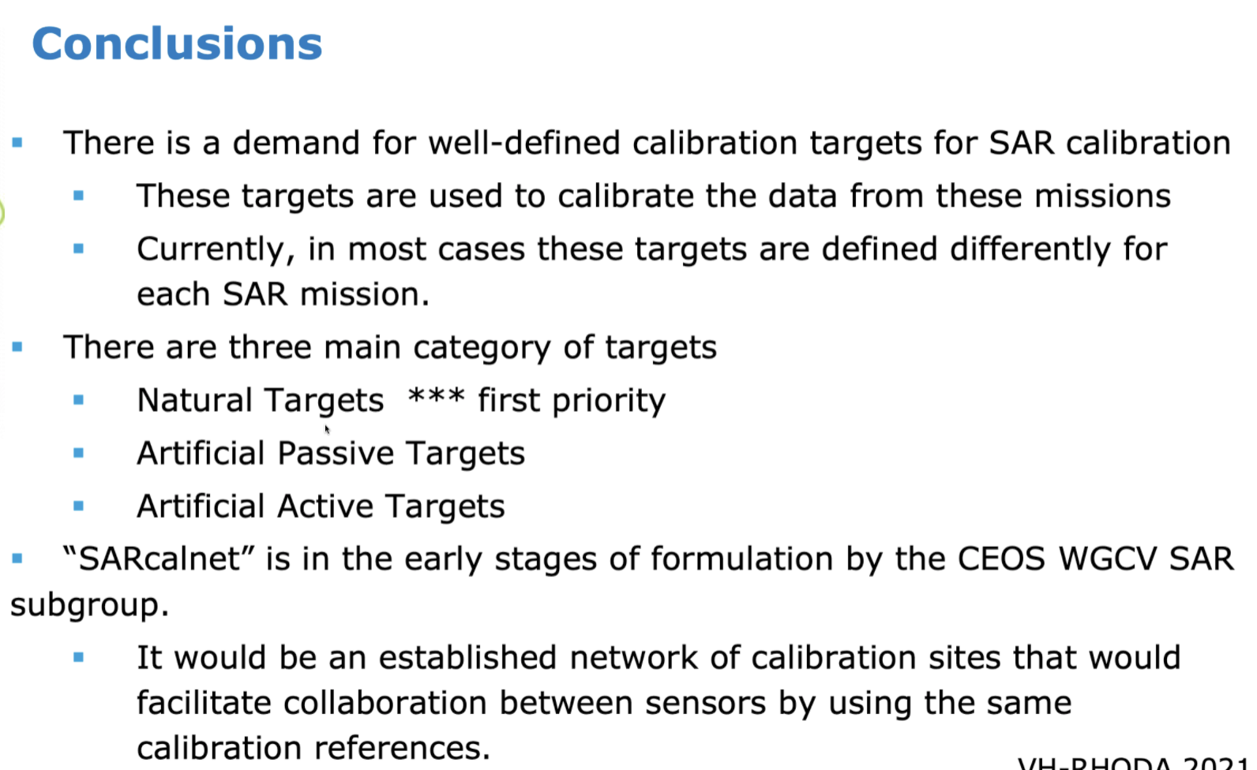
Next Meeting, Adjourn
Main points:
- Kuze-san encouraged additional contributions to the new cal/val portal – particularly from the subgroups. He thanked ESA for their effort setting up these pages.
- Kuze-san thanked everyone for joining and closed Day 2 of the WGCV-49 meeting.

