Minutes v1.0
WGCV-49 Day #3
Thursday, 1 July 2021

Welcome [Slides]
Presenter: A. Kuze
Main points:
- Presented day 2 actions.
CEOS Analysis-Ready Data for Land (CARD4L) [Slides]
Presenter: M. Thankappan
Main points:
- Reviewed current CARD4L assessment and peer review process and the peer review principles of: independence, expertise based, timeliness and efficiency.
- Presented current CARD4L review status and associated panels. There is a need to broaden the peer review panel pool to increase diversity in the panels.
- It has been suggested that we revisit and streamline the WGCV CARD4L review process to improve timeliness and efficiency and to ensure that the workload is manageable and that data providers receive feedback in a reasonable period of time. Currently this is a 12-week process at a minimum (around 20 weeks in practice).
  - Turnaround times for CARD4L reviews are not optimal/sustainable and are not compatible with data providers’ product development cycles.
  - Incomplete submissions for peer-review leads to wasted effort (when non-compliance is known beforehand).
  - CARD4L Review Panel Member Pool: Need more members / specialist panels. A WGCV review member pool is in place, but with low redundancy for domain coverage.
- Medhavy presented some recommendations for endorsement by WGCV to take back to LSI-VC:
  - No partial submissions for Threshold (or Target). Gating of submissions at the LSI-VC end to ensure completeness and avoid delays. Provide examples of complete self-assessments. Rationale: Outcome of review is known beforehand through the self-assessment, i.e., non-compliant – a review would be wasted effort.
  - ‘Lightweight’ review for “Threshold-only” self-assessments submitted for evaluation. No need for a full review panel – instead have LSI-VC and WGCV POCs review through one-on-one sessions with data providers (expected turnaround of 4 weeks). Rationale: Fewer requirements to fulfil at ‘Threshold’, e.g., 34 - 43% of items have no requirement (16/37 for Surface Reflectance, 10/29 for Surface Temperature).
  - Evaluation by a WGCV Review Panel only for fully completed self-assessments at Target level. Increase the Panel member pool for redundancy and domain coverage, establish panels in advance (expected turnaround 8 weeks). Rationale: Higher level of requirement at Target justifies review, with better availability / use of panel members’ time.
  - Remove requirement for a vote by WGCV membership. Instead share the outcome of the peer-review process via email with the WGCV membership for transparency (saves 4 weeks). Rationale: Saves 4 weeks; can allocate additional time for expert panel review for Target.
- Medhavy also noted CEOS ARD Beyond Land and the emerging CEOS ARD Governance Framework and asked whether WGCV would want to (or be able to) conduct peer reviews for other domains (e.g., aquatic, atmospheric, ocean colour, etc.).
Discussion
- Greg Stensaas supported the idea of only having a formal peer review at the Target level. Nigel Fox agreed and suggested going forward with the change.
- Greg suggested there is no reason that Threshold assessments cannot be continually updated with new percentages of completeness and documented by the provider.
- The need to maintain the Target feedback loop was noted. We shouldn't discourage people from looking at the Target requirements and providing feedback.
- There was support for not allowing partial submissions for Threshold or Target.
- Kurt Thome supported the recommendations and the need to speed up the review process for evaluations that are clearly passes / rejections. WGCV will need to work closely with LSI-VC to streamline this.
- Regarding WGCV’s role in a broader CEOS ARD concept (beyond land) and whether WGCV will want to (or be able) conduct peer reviews for other domains (e.g., aquatic, atmospheric, ocean colour etc.):
  - There is some concern that we are still finding our feet with the land review process and our approach to interacting with LSI-VC and the data providers. Some would be keen to see this operating smoothly for a period of time before expanding the effort. It was noted that the expansion beyond land will be a longer term goal and will take some time to ramp up.
  - Greg suggested that if WGCV is doing assessments for LSI-VC it should not deny others the same.
  - It is important that WGCV be involved early in the definition of PFS for other domains.
- Peter Strobl asked whether the open questions around versioning of PFS and assessments in response to incremental updates have been resolved. He asked how a data provider brings their assessments up to date in an efficient manner. Medhavy noted that versioning is being recorded, but there is still a need to fix the very manual process of updating assessments to match new versions of the PFS. There are numerous issues around versioning to be addressed, including: communicating changes to users, tracking changes and past versions, communications with data providers on what updates mean and how they impact the previous assessment, etc. This requires a longer form discussion both within LSI-VC and as part of the broader CEOS ARD Governance Framework.
- All of the recommendations presented by Medhavy were agreed and supported.
WGCV-49-03 | Medhavy to summarise the proposed changes to the CARD4L peer review process agreed at WGCV-49 in an email for review by WGCV before sending to the LSI-VC Leads. | ASAP
WGCV and GSICS Coordination [Slides]
Presenter: P. Goryl
Main points:
- GSICS Annual Meeting 2021 was held from March 29 to April 2. Meeting details are provided in the slides. Overall it was noted that there is a lot of complementarity and opportunities for WGCV and GSICS collaboration. As can be seen in the below activities and recommendations, there are a number of opportunities for WGCV and GSICS synergies:
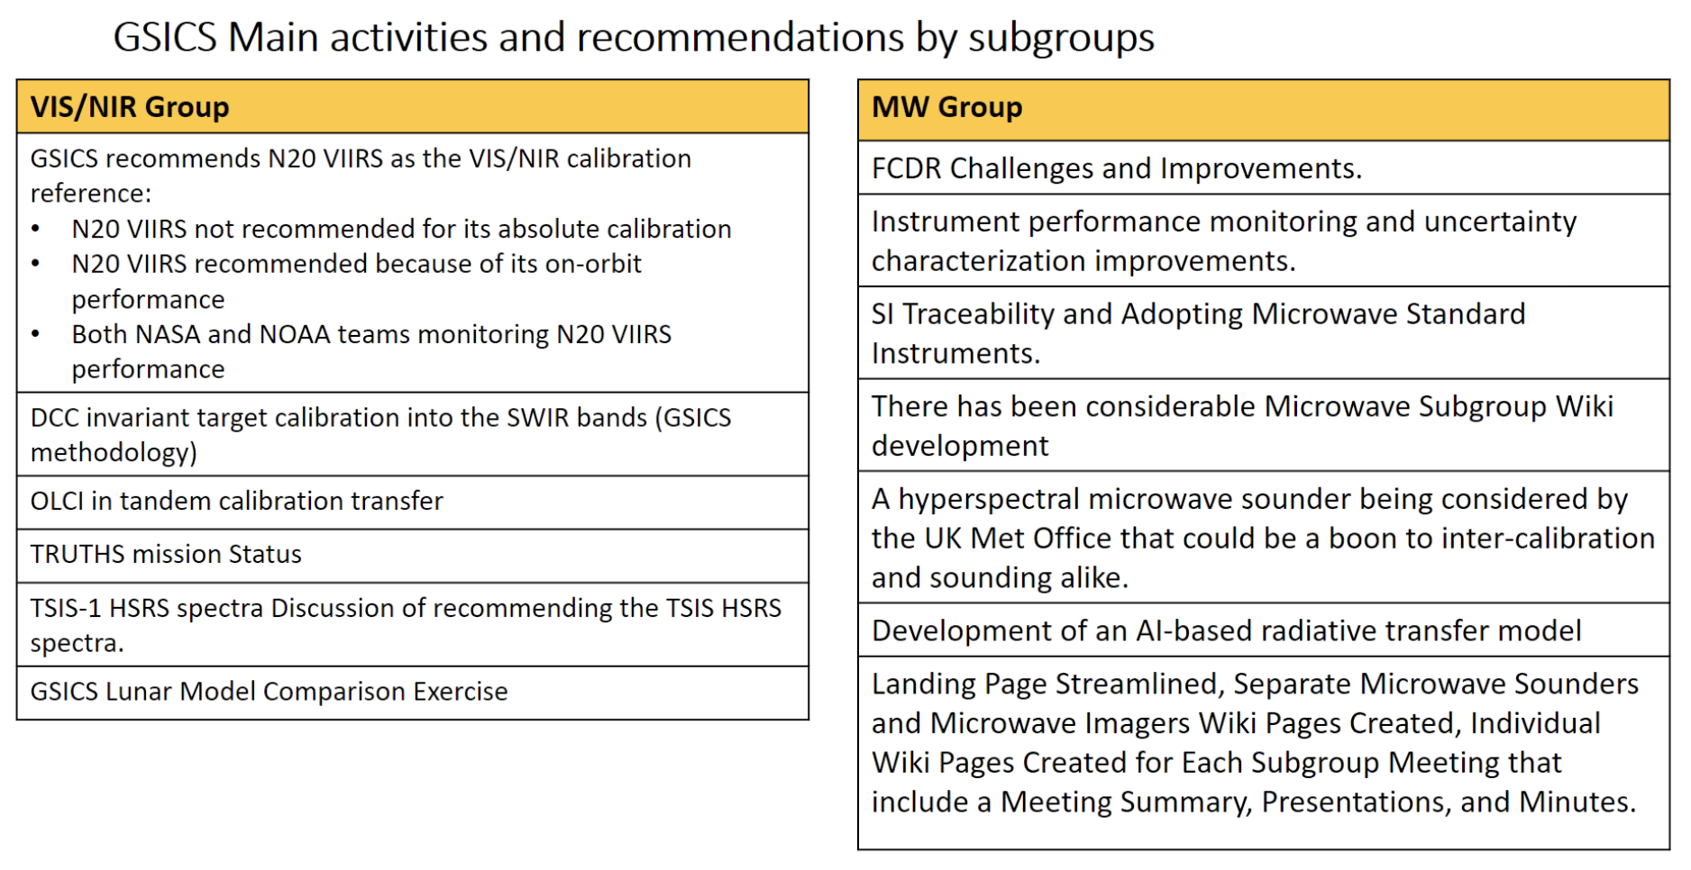
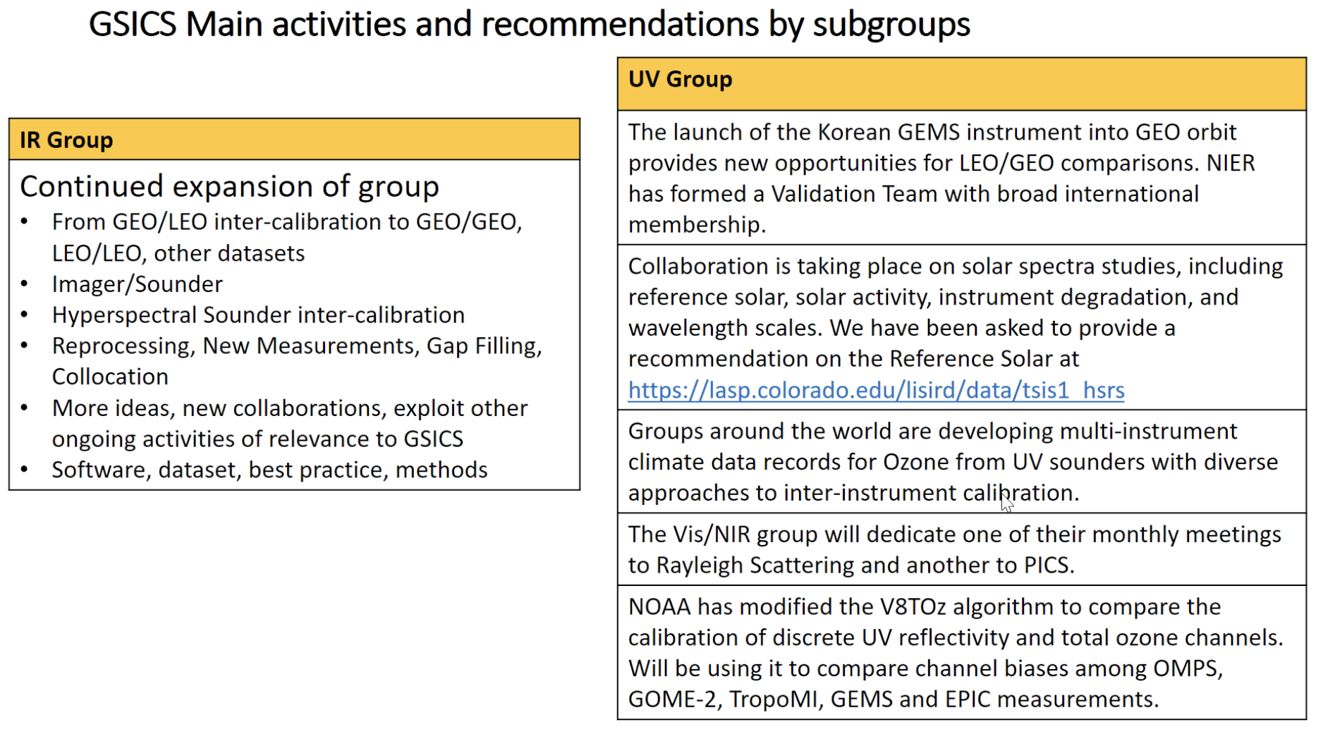
- Two key items for consideration by WGCV during this meeting are:
  - Potential CEOS-GSICS collaboration on a Rayleigh intercomparison exercise.
  - Potential CEOS WGCV recommendation of the TSIS HSRS solar spectra, which the GSICS community has already endorsed.
Discussion
Rayleigh Intercomparison Exercise
- Patrice noted that some work was done in this direction around 10 years ago, including the establishment of a subgroup, which held a couple of meetings. He added that the most important difference between the methods is due to water colour and the model used for that. It is not so much the method, but the database/parameters for water colour which is the most important point to discuss. The atmospheric model is important, but secondary.
- Bertrand partly agreed with Patrice, noting that we need to keep in mind that we try to calibrate many spectral bands and the approach depends on which part of the spectrum is the focus. At the red end of the spectrum atmospheric components have a greater contribution. The decision depends on the application.
- Nigel Fox has asked the IVOS team for expressions of interest in such an activity, but no positive responses have been received to date. It doesn't seem to be a high priority for IVOS members at the moment.
- Kurt Thome noted that his NASA and NOAA colleagues are already quite active on the GSICS side, and it is not clear that WGCV also needs to be involved. Greg added that USGS also participates in GSICS and he has the same feeling as Kurt.
Solar Reference Spectrum [Slides]
- Odele Coddington of the Laboratory for Atmospheric & Space Physics (LASP), University of Colorado, presented on the TSIS-1 HSRS high-accuracy (0.3-1.3%), high-resolution (0.01 nm or better), solar reference spectrum. The proposal is for CEOS to recommend it as the new CEOS solar irradiance reference spectrum, following the lead of GSICS.
- The motivation is to address issues in the SWIR bands of the existing spectra, which exhibits discrepancies of around 8-10% in this range. This is a substantial error for Earth science applications, in particular for Greenhouse Gas measurements.
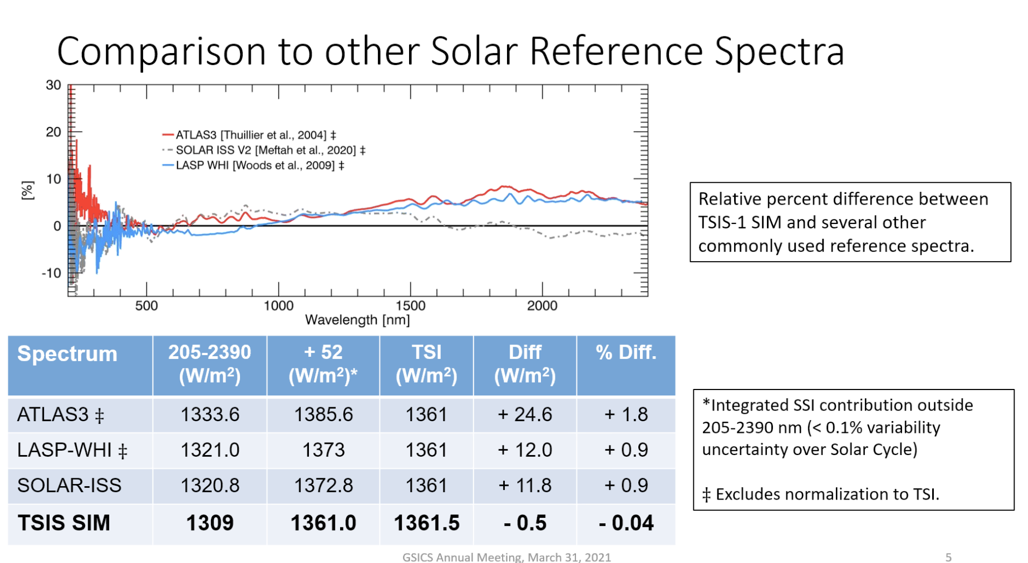
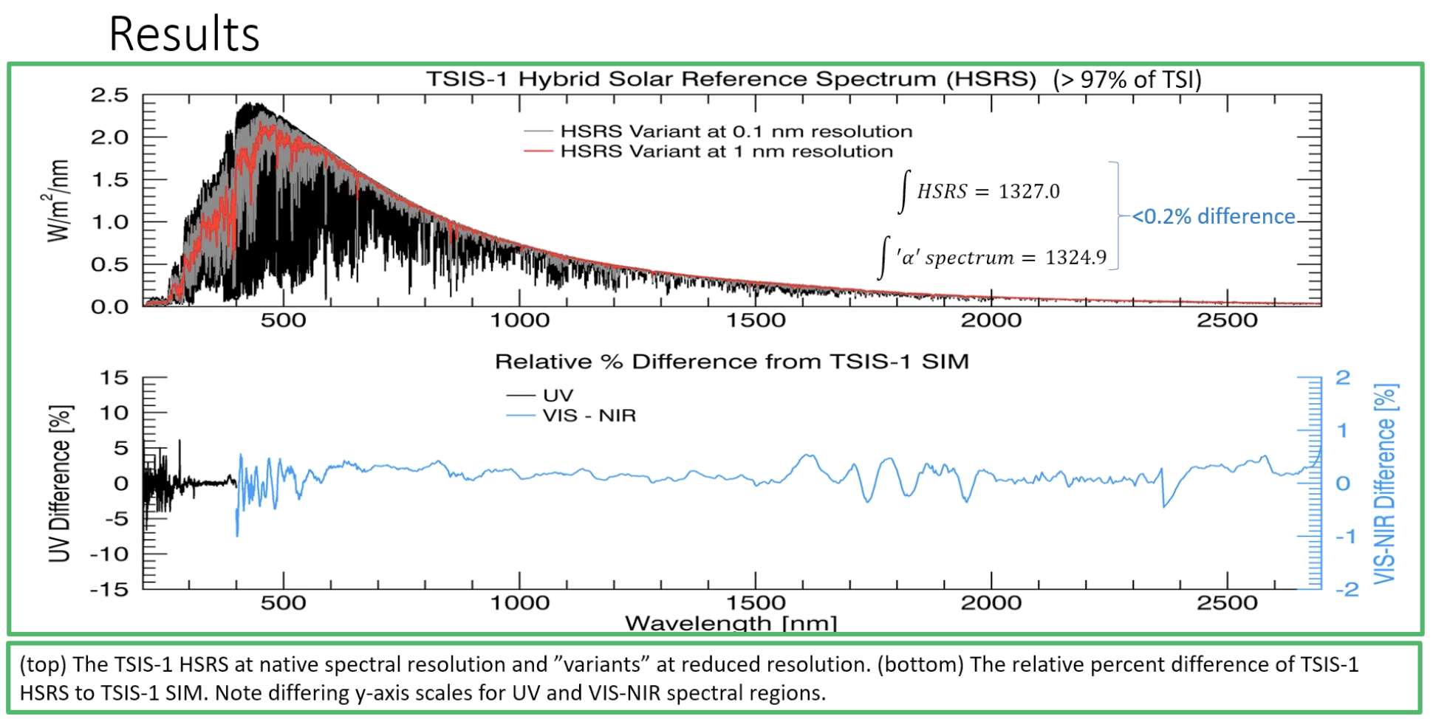
Discussion
- Nigel Fox recommended adoption of this spectrum based on evidence shown here and in the publications referenced in the slides. IVOS has given a consensus view that they are happy to adopt it, but a decision remains for WGCV. Nigel recalled that the spectrum has already been endorsed by GSICS and clarity should be provided to CEOS sooner rather than later.
- Akihiko Kuze noted that in the Greenhouse Gas field, AC-VC, JAXA’s GOSAT team, NASA’s OCO team, and ESA’s Sentinel-5P team are assessing the TSIS-1 HSRS spectrum. Vicarious calibration activities are currently underway, after which they can make recommendations. At this stage it looks like these groups would all endorse the proposal for CEOS to adopt the spectrum.
- Changyong Cao asked whether comparisons have been done with MODTRAN. Odele noted that many different comparisons have been undertaken. It was noted that the TSIS-1 HSRS is being extended to the full spectrum. Changyong said a comparison chart of the TSIS-1 HSRS and other curves would be very helpful and provide a clear understanding to support a recommendation.
WGCV-49-04 | Odele to provide comparisons of the TSIS-1 HSRS vs other solar references to support the potential WGCV recommendation of the TSIS-1 HSRS solar spectra. | ASAP to support a WGCV revisit of the recommendation on a dedicated call.
WGCV-49-05 | WGCV Chair and Vice Chair to schedule a follow up teleconference on the potential WGCV recommendation of the TSIS-1 HSRS solar spectra. | 2022

Copernicus Calibration Validation Solution (CCVS) [Slides]
Presenter: J-C. Lambert
Main points:
- Scope of the Copernicus Calibration Validation Solution (CCVS) project: To define a holistic solution for all Copernicus Sentinel missions (either operational or planned) to overcome current limitations of Calibration and Validation (Cal/Val) activities.
- There are five component work packages:
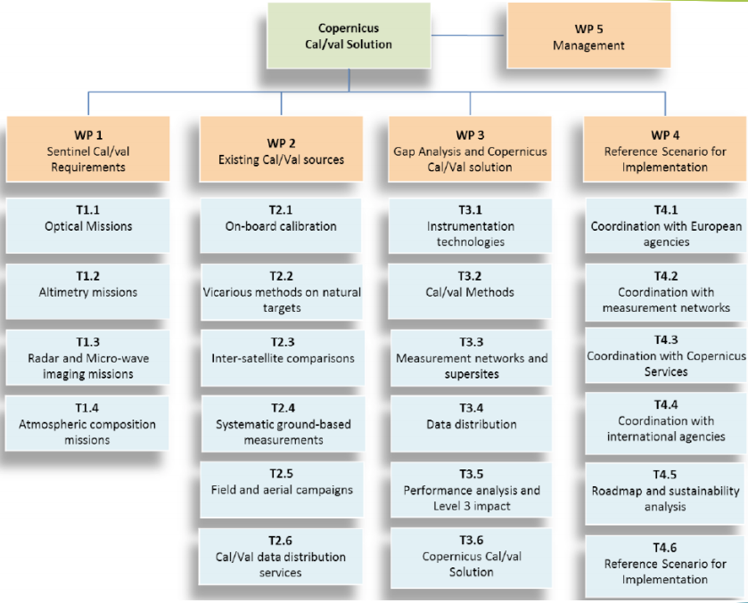
- Sentinel Cal/Val Requirements (WP1): Establish calibration and validation needs for all Sentinel L1 and L2 data products.
- Existing Cal/Val Sources (WP2): Identify currently available Calibration and Validation sources; Establish constraints and limitations affecting these sources (technical and operational); Identify perspectives on methods and emerging technologies.
- Gap Analysis & CCVS (WP3): Identify gaps in the current Cal/Val of Sentinel missions; Identify synergies and cross-Sentinel harmonisation needs; Define a network of core operational sites for the Sentinel missions; Define an operational organization and procedures for the cal/val activities of the Sentinel missions (data curation and distribution); Analyse expected impact on uncertainty of Sentinel products and downstream products (including Level-3).
- Reference Scenario for Implementation (WP4): Define a way forward for the implementation of the Copernicus Cal/Val solution; Establish roles and responsibilities among Copernicus stakeholders; Analyse sustainability and identify funding gaps; Define implementation schedule.
- Deliverables are available at: https://ccvs.eu/
- CCVS Workshop: 13-15 October 2021 (online, 14:00-18:00 CET). Registration and abstract submission will open soon on https://ccvs.eu
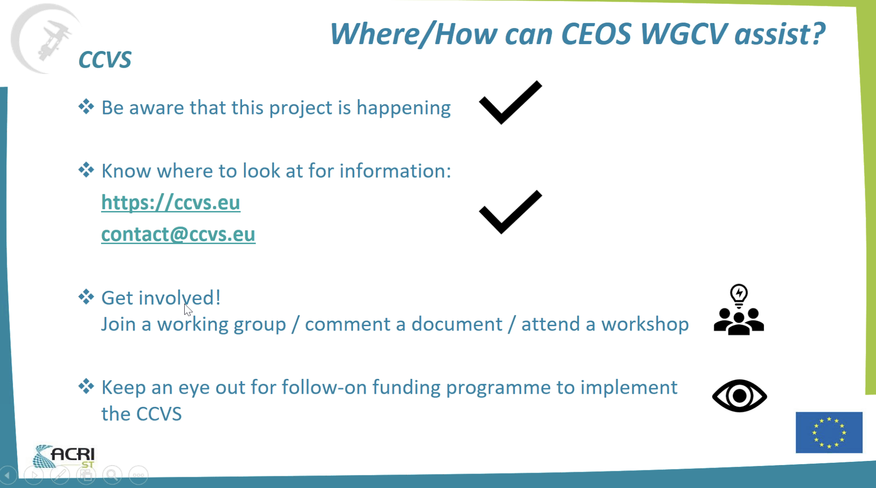
Discussion
- Akihiko Kuze suggested that linking CCVS to the CEOS cal-val portal would be a good idea.
Next Meeting, Adjourn
Main points:
- Kuze-san thanked everyone for joining and closed Day 3 of the WGCV-49 meeting.

