Minutes v1.0
WGCV-49 Day #4
Friday, 2 July 2021

Welcome [Slides]
Presenter: A. Kuze
Main points:
- Presented day 3 actions.
WGCV Support to the CEOS Strategy for the Global Stocktake of the UNFCCC Paris Agreement [Slides]
Presenter: D. Crisp
Main points:
- The first UNFCCC Paris Agreement Global Stocktake will take place in 2023. Nations are compiling bottom-up inventories by compiling statistics on, e.g., the consumption of fossil fuels, agriculture, industry, waste. This is just one approach, and the bottom-up calculation can miss emissions due to the difficulty of some sectors, e.g., agriculture.
- Another approach is top-down inventories from atmospheric observations. Measurements are assimilated into a model that includes transport by the wind (atmospheric inversion model) to derive the location and times of Greenhouse Gas (GHG) sources. Top-down approaches are well suited to detecting emissions hotspots and rapid changes to the natural biosphere.
- These two approaches should be seen as complementary.
- There are growing capabilities in ground-based and space-based atmospheric Greenhouse Gas measurements. The space element includes GOSAT-1/2, OCO-2/3, and TROPOMI/Sentinel-5P.
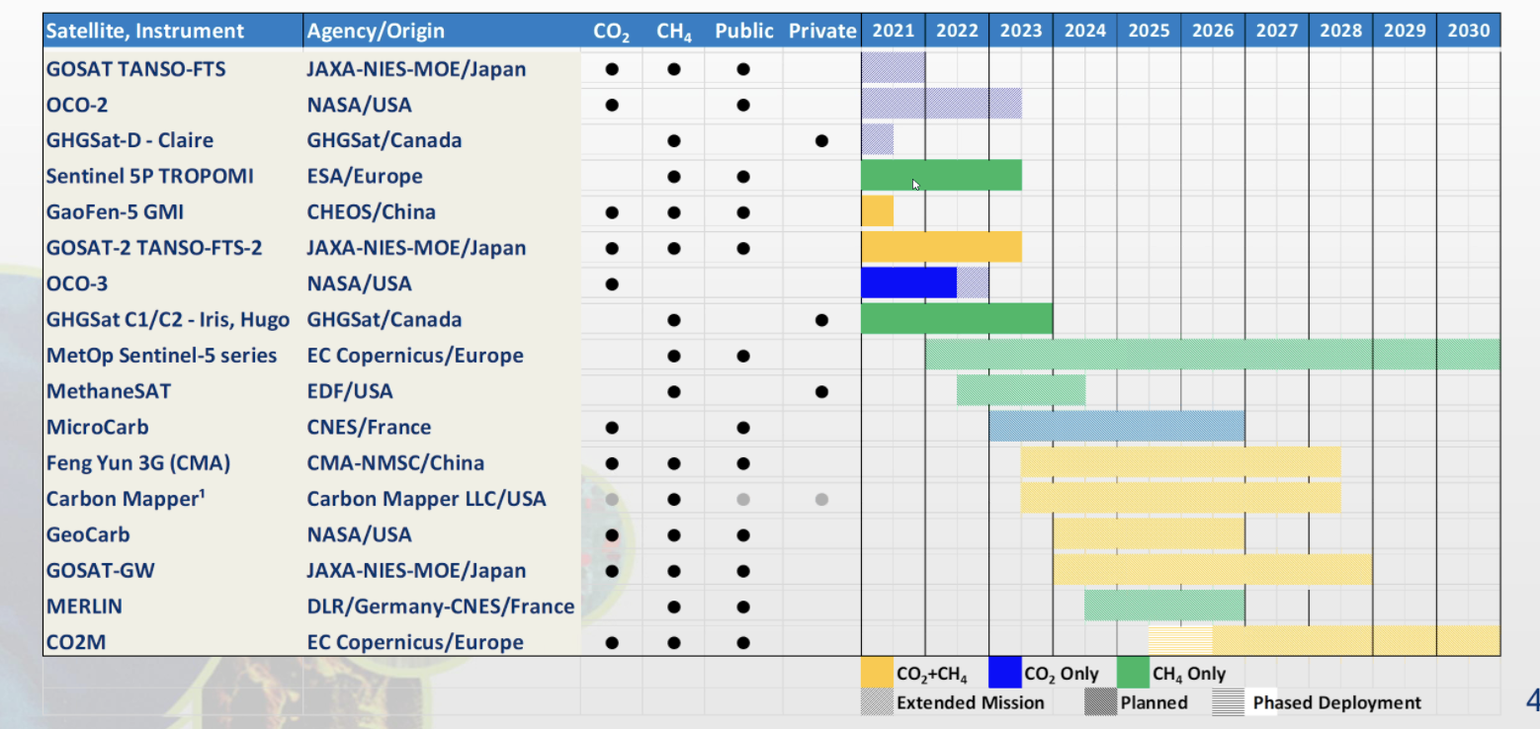
- CEOS is undertaking to pilot global top-down inventory products for CO₂, CH₄, and local source inventory products at urban to national-scale (from a synthesis of GOSAT, OCO and TROPOMI).
- Demonstration products are planned for localized hot spots including large urban areas, power plants and oil fields. Existing space-based capabilities lack the resolution to do this everywhere, but this type of monitoring should be possible in future.
- The primary objective of this pilot inventory activity is to provide a product that starts a conversation with the national inventory agencies, the UNFCCC, and other relevant players (e.g., IG3IS, GCOS, IPCC) to establish the utility and best practices for the use of top-down atmospheric inventories in future Global Stocktakes.
- Interoperability is crucial for measurements and derived products. WGCV is playing a role in harmonizing measurements from different satellites as well as harmonizing retrieval model results.
- Very high accuracy solar reference spectra (i.e., TSIS SIM HSRS) are critical for interpreting these measurements. Moon observations are used to trend long-term changes in the throughput of the optical system for relative radiometric calibration.
- Railroad Valley, NV, USA is the primary vicarious calibration site used to cross-calibrate the current fleet of GHG sensors.
- XCO₂ (column-average of carbon dioxide in the atmosphere) precision and accuracy are validated through comparisons with TCCON and other standards.
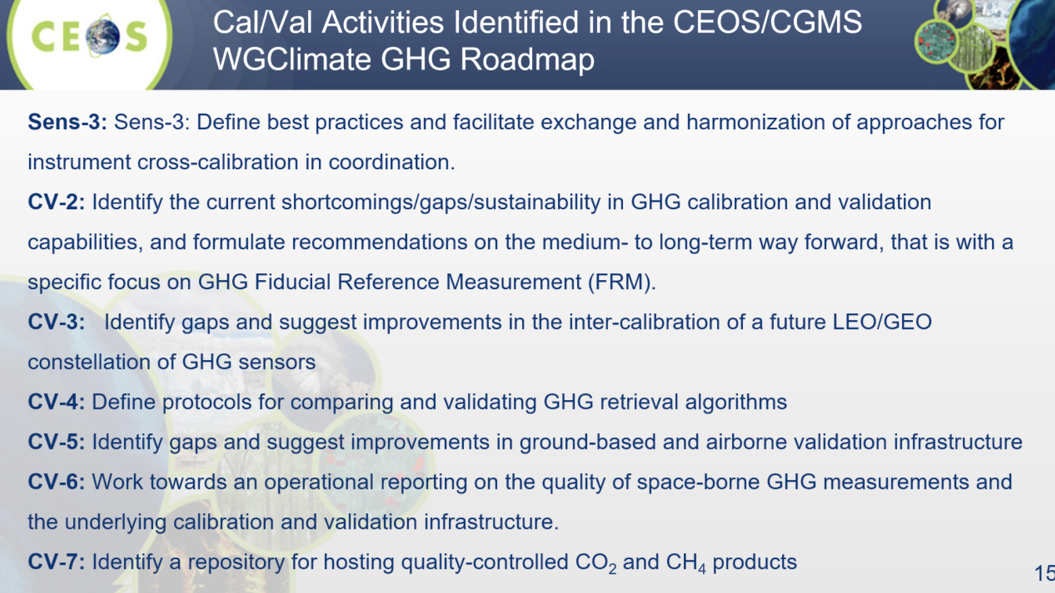
Greenhouse Gas Reference Standards for Interoperability. Intercomparison Between Greenhouse Gas Sensors, Vicarious Calibration, and the Portal [Slides]
Presenter: A. Kuze
Main points:
- Presented an update on the field work undertaken to perform intercomparisons between GOSAT-1/2, OCO-2/3, and TROPOMI. Each mission was able to acquire data around the same time of day over the Railroad Valley site.
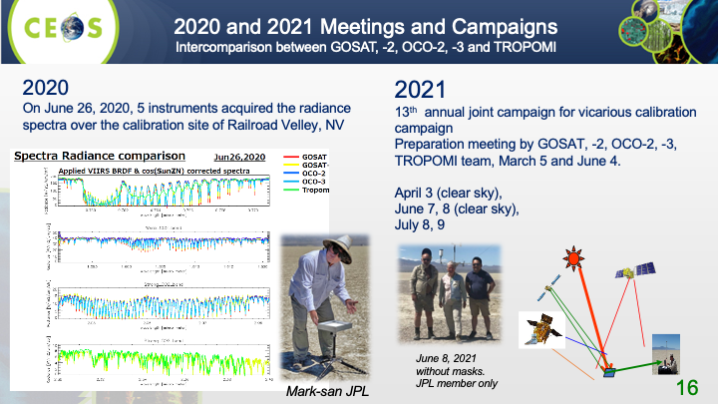
- GHG VICAL Portal: The website (test here; user: gosat / pass: vicalrrv) describes vicarious calibration techniques and provides a long time record of calibration and validation information used to determine the radiometric spectral level and the sensor degradation of high spectral resolution GHG sensors (such as GOSAT, OCO-2, TROPOMI, OCO-3, and GOSAT-2). The focus is radiometric calibration in Railroad Valley, NV, USA.
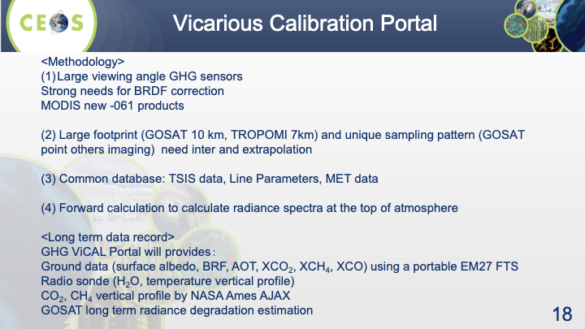
- The OCO-2 and GOSAT teams are both using the TSIS HSRS solar spectrum. GOSAT shows a larger radiance degradation factor (RDF) (less degraded) when TSIS is applied (0.93 to approximately 1.00). Use of the TSIS spectrum provides best-estimates of radiance in Level 1 products. There is no direct impact on surface albedo and XCO₂ and XCH₄ retrievals. Over the next few months RRV 2020 and 2021 campaign data will be analysed using TSIS to check consistency between GHG missions and pre- and post-launch calibrations.
- BRDF Correction for GHG Sensors with Large Viewing Angles: Existing MODIS BRDF products have large uncertainty in cases of bright surface due to aerosol multiple scattering such as over the Sahara desert. However, AOT over RRV is low. There is a new MODS MCD43A1-061, which is similar to the UMass special product. University of Massachusetts Boston provides a special product for RRV for 2020 and 2021 (April). The JAXA-EORC GOSAT forward model (vector) uses the UMASS BRD Special product. BRDF correction for 2.3 μm without MODIS bands (needs uncertainty estimation). Using MCD43A1-061 other than RRV2020 and 2021.
Discussion
- Ruediger Lang (EUMETSAT) asked whether JAXA is already using the TSIS spectrum in the NIR and SWIR bands as a reference, or is work still required for it to become a reference? Kuze-san noted that GOSAT uses a TSIS database for absolute radiometric calibration. Surface measured albedo from RRV is used with the TSIS database to calculate TOA spectral radiance. This is then compared with pre- and post-launch radiance degradation factors (RDF). David noted that the absolute radiometric accuracy for TSIS is about 2-3% at the moment.
- Jean-Christopher Lambert (BIRA-IASB) noted that several of the issues presented are common to AQ, AER and O₃ observations. He asked whether in the future there could be an extension of RRV activities to non-GHG observations (as a multi-application cal/val supersite) and VICAL in other spectral domains. Kuze-san noted that at shorter wavelengths Rayleigh scattering becomes a greater concern. RRV is a good candidate for such a multi-application cal/val supersite, but this scattering would need to be carefully measured for other applications. The long-term record on the website will cover bands from 380 nm to 2.5 μm.
Inventory of Space Data Product Formats Used by CEOS Agencies (FDA-18-05) [Slides]
Presenter: K. Thome
Main points:
- FDA-18-05: Develop an inventory of current product formats used in CEOS agencies and identify recommendations to facilitate interoperability.
- Discussed approaches during WGCV-48 to make progress and close FDA-18-05 by using overlaps with WGISS activities. Action WGCV-48-04 was assigned to Akihiko Kuze to explore the possibility of transferring action FDA-18-05 to WGISS with the WGISS Vice Chair, Makoto Natsuisaka (JAXA) and WGISS Chair, Rob Woodcock (CSIRO).
- Kuze-san has contacted the WGISS Chair and Vice Chair and asked for help closing this CEOS Work Plan action. He noted the overlap with WGISS tasks including those related to compiling inventories of existing FDAs, software, and tools. It would be efficient to formally roll this task in with the existing FDA work under WGISS.
- Still working to understand how WGCV could complement WGISS activities. We will take advantage of the WGCV-50 meeting that is planned to be joint with WGISS to discuss this further.
Discussion
- Manik Bali (NOAA) suggested that in addition to engaging with WGISS we could also benefit from a discussion with the WIGOS Data Quality Monitoring System (WDQMS).
ISO Standard on EO Products [Slides]
Presenter: J-C. Lambert
Main points:
- WGCV review of ISO/TC 211 WD 19159 (2010-2011): reviewed terminology and suggested a focus on calibration and validation, not on data and derived products; added to pre- and post-launch practices; commented on consistency of various factors discussed.
- ISO WD 19124-1: geographic information, calibration and validation of remote sensing data and derived products. New working draft on fundamentals covers terminology, pre-launch calibration, post-launch calibration, validation, and specific parts of the ISO 19124 series of standards.
- WGCV comments were provided in Spring 2021 on terminology; advocacy for an open, holistic glossary; specific technical comments; and questions regarding the universality of the recommendations, validation hierarchy, and the validation maturity matrix. The comments were circulated to the WGCV mailing list.
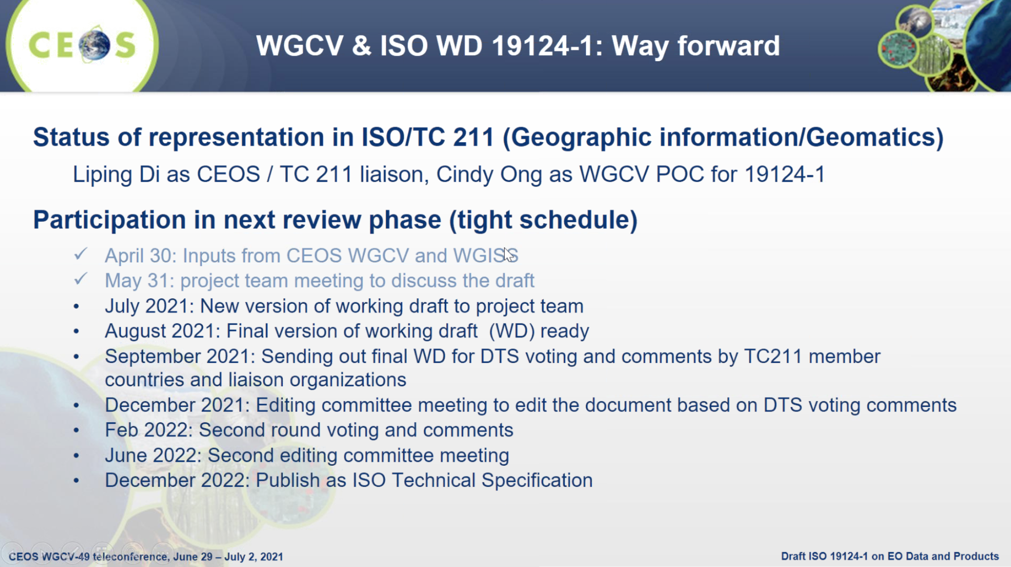
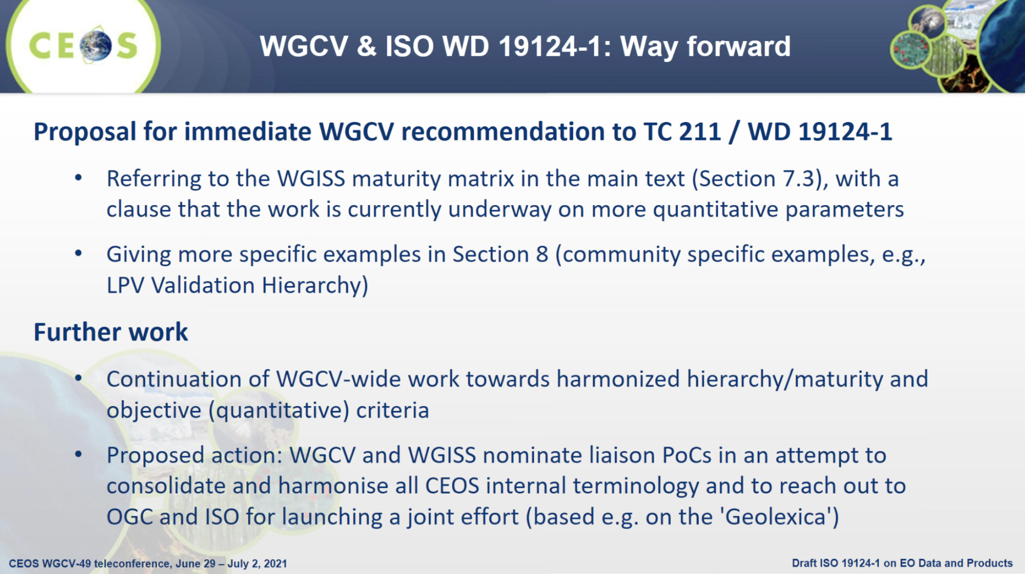
- Philippe will follow up with Jean-Christopher offline regarding the maturity matrix for ESA Third Party Missions.
- Larry Flynn noted that NOAA’s practice is to identify the corners of the field of view as a polygon so that data requests for certain regions can be addressed. He asked if this is covered in the standards/recommendations raised here. Jean-Christopher is not sure this is covered in detail in this document – it is perhaps covered in the annexes and 19159. Larry also noted that NetCDF is used for NOAA archives. Jean-Christopher doesn’t think ISO will recommend specific data formats in this standard as it is focused on cal/val practices. Cindy Ong (CSIRO) confirmed that the current document is very general and does not go into the details raised by Larry.
- Greg Stensaas (USGS) is happy to see CEOS involved in this ISO standard. He thanked Jean-Christopher and Cindy for pushing this along. It is critical that WGCV and WGISS provide international representation to ensure this standard has the right terminology and documentation. There are a lot of other efforts happening that get into details on file, format, registry, etc. Some of those standards could be good references, but this is more of a general cal/val standard.
- Cindy confirmed that the latest copy of the standard was sent to everyone before the meeting in May. All comments provided since then have been incorporated. Wolfgang is reviewing every comment. A second round of WGCV review is planned now. Cindy noted this round will be a short turnaround for comments.
WGCV-49-06 | Peter Strobl to work with IVOS and WGISS to advance the idea of a CEOS common online dictionary, with a view to eventually reaching out to launch a broader community effort (e.g., based on the ‘Geolexica’).  Background/context:  It was agreed that the best way forward regarding a common online dictionary would be for CEOS to progress the task internally, before then sharing with the broader community for inputs.  It was also suggested that WGISS would be the best lead for such a task (with WGCV contributing to cal-val topics) and for WGISS to suggest the most appropriate way forward for a broader community effort (perhaps through OGC, ISO, WMO, etc.).  IVOS (led by Emma Wooliams) has been working on a compilation of WGCV vocabulary (available on the cal-val portal).  WGISS is also working on a glossary of terms and Peter Strobl has been nominated to the activity for WGCV. Peter is working with Katrin in WGISS. | ASAP
WGCV-49-07 | Cindy to share the latest copy of the ISO 19124-1 document for comments.  Background/context: Document was first shared in May. Final feedback will be needed in July to meet the submission deadline. | ASAP
AOB
Main points:
WGCV-49-08 | WGCV members to consider nominations for the WGCV Vice Chair (October 2022 to October 2024).  Background/context: Nominations need to be formalised in time for discussion at WGCV-50. In the past a geographic rotation has been attempted, meaning the next candidate would ideally be from the Americas region. However, this is not a strict requirement. | WGCV-50
- The WGCV mailing list restriction on one person per agency has been relaxed. All requests for additions to the mailing list should be sent to Matt.
- WGCV-50 is planned for early 2022 in Tokyo, Japan. It is proposed as a joint meeting with WGISS from March 21-24, depending on the SIT schedule and the COVID-19 situation. A hybrid meeting will be planned if necessary to allow remote participation. Marie-Claire Greening (CEOS Executive Officer) noted that SIT-37 is tentatively scheduled for March 28 to April 2. WGISS members are available between March 21-24 if the joint meeting is a hybrid one.

