Minutes V1.0
WGCV-50 Day #2
Wednesday, 23 March 2022

Attendees:
AEM: Adrian Guzman
AOE-CAS: Lingling Ma
BIRA-IASB: Jean Christopher Lambert
CEO: Marie-Claire Greening
CSIRO: Cindy Ong
EC-JRC: Peter Strobl
ESA: Philippe Goryl
EUMETSAT: Stefanie Linow
GA: Medhavy Thankappan
GISTDA: Prayot Puangjaktha
ISRO: Arundhati Misra
JAXA: Akihiko Kuze
Labsphere: Christopher Durell
MYSA: Adhwa Amir Tan, Wayne Ng, Jessica Wong
NASA: Kurt Thome, Robert Rosenberg
NOAA: Changyong Cao, Taeyoung (Jason) Choi, Larry Flynn
NRSCC: Xiaolong Dong
Symbios: Matt Steventon, Riza Singh
UKSA: Nigel Fox
University of Colorado: Odele Coddington
USDA: Michael Cosh
USGS: Cody Anderson
Yaokai Lui
Yonhhuang Zhao

Welcome [Slides]
Presenter: A. Kuze
Main points:
- Welcomed everyone to the meeting and summarised the Day 1 discussion.
- Noted that two agencies are interested in the WGCV Vice Chair position. The final vote for the Vice Chair will be done by WGCV members in October 2022 at WGCV-51 and final approval will be at the CEOS Plenary in December in Biarritz, France.
- Reviewed the Day 1 action items.
Team Photo
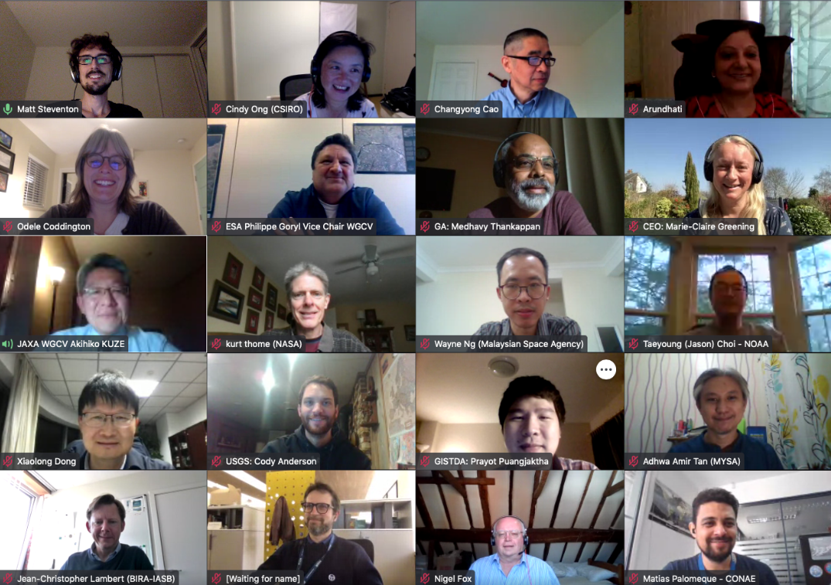
Microwave Sensors (MSSG) Subgroup Report [Slides]
Presenter: X. Dong
- Xialong Dong (NRSCC) noted microwave sensor subgroups include active and passive sensors operating in the microwave spectral range, except SAR. It also includes micro radiometers, radar scatterometers, radar altimeters, GNSS-RO and reflectometry.
- The Microwave Sensors Subgroup mission is to foster high quality calibration and validation of microwave sensors for remote sensing purposes. These include both active and passive types.
- CV-20-05 (Standards and Metrics for Scatterometers and Wind Retrievals)
  - A task group was created in 2020 with the target completion date as Q4 2021 but has been extended to Q2 due to the COVID-19 pandemic.
  - The main objective of MSSG with this task is to develop standards and guidelines for the requirements, procedures, and assessment of spaceborne radar scatterometer measurement calibration, wind retrieval approaches, wind data validation and assessments for the OSVW-VC. These guidelines will be used to assure the consistency and quality of data needed for scientific research and applications.
  - The scope of the task is to develop cross-calibration of L1 and L2 data; validate scatterometer wind data; and develop quality indices of L1 and L2 data.
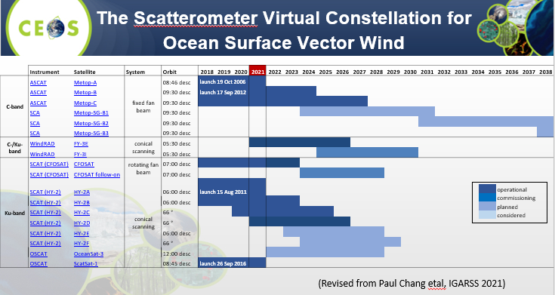
  - Subtask 1: Development and validation of algorithms and methods for calibration of Sigma 0 using different references or metrics;
  - Subtask 2: Standardisation and best practices of retrieval approaches of ocean surface winds (L2b data) by radar scatterometer data and guidelines to users. The leading agencies are KNMI, NSOAS, ISRO, ICM and NOAA;
  - Subtask 3: Development of guidelines and standards of validation of ocean surface winds (L2b data) by radar scatterometer data.
- Two invited sessions at IGARSS 2021 were held on the 15th and 16th of July, 2021. Discussions focused on improving coordination, consolidation, and development of the collective OSVW capability; achieving a more active engagement by nations operating or preparing satellite ocean surface vector winds sensors with the international wind vector community; maintaining a strong and mutually supportive relationship with the International Ocean Vector Winds Science Team (IOVWST); providing an interface to CEOS for the IOVWST; developing recommendations on the driving requirements to create, validate, and sustain the development of an international ensemble of Essential Climate Variable (ECV) measurements; providing advice on and advocating the international community for the importance of OSVW measurements; developing and consolidating training on the use of scatterometer wind measurements for different applications, as well as outreach to the general public to demonstrate the societal benefit of these data.
- Various progress has been made in the three above noted subtasks. More details can be viewed in the linked slides.

Atmospheric Composition (ACSG) Subgroup Report [Slides]
Presenter: J-C. Lambert
Main points:
- Provided an overview of the atmospheric composition missions of the ACSG. There are a variety of AC missions across spectral ranges.
- Nadir IR satellites, GOSAT, and TROPOMI noted the recent emergence of private-sector missions on GHG. These raise questions about how the landscape is changing and how to coordinate CEOS and private missions in this space.
- AC subgroup Chair Bojan Bojkov stepped down in 2021 and a new Chair needs to be elected. Jean-Christopher Lambert is the interim Chair for the time being.
- AC-VC and WGCV ACSG collaboration has increased over recent years with participation in several white papers. Some evolution in the past years focused on the work on tropospheric ozone (CV-20-01).
- Working to strengthen the linkage of space agencies with ground-based monitoring networks as their prime source of validation measurements.
- Regarding ACSG membership, there is a discussion about restructuring of ACSG leadership underway to 3 co-leads and ad hoc expert topic leads for increased flexibility.
- AC-VC-18 was held virtually for five days, March 14-18. The sessions focused on greenhouse gases, air quality (aerosols and trace gases), tropospheric ozone and science serving society. All the sessions involved discussions on Cal/Val activities, Cal/Val needs, coordination of constellation-wide validation, interleaved activities of AC-VC/WGCV activities and new validation needs beyond L2.
- Highlighted that there are ongoing studies to establish the validation plan and further develop the ground-based validation networks for CO2 missions.
- For GHG measurement networks, the three main networks identified are NDACC, TCCON and COCCON networks. In situ Vertical profile data is key to good calibration of both satellite and ground-based measurements.
- Several agencies like ESA, EUMETSAT, IASB-BIRA, NASA, SAO are contributing to the CEOS AC-VC/WGCV 2021-2023 work plan on the CEOS Air Quality Constellation. The work plan includes VC-20-02: air quality constellation validation coordination, VC-20-03: air quality constellation validation coordination plans, and VC-20-04: Air quality constellation validation coordination: announcements of opportunity.
- Tropospheric Ozone Assessment Report (TOAR) is a scientific effort initiated by IGAC. The TOAR-II Satellite Ozone WG was set up during the TOAR-II workshop with the goals to reconcile satellite, ground and aircraft-based data, global chemistry, and transport models as transfer standards, and provide a common methodology for validation of trends. CEOS had responded to the IGAC TOAR-II needs with the new activity VC-20-01:Tropospheric ozone dataset validation and harmonisation. ACSG members have participated in several TOAR-II meetings and shared the first VC-20-01 report which included the harmonisation and validation results at AC-VC-18.
- CV-22-01: Development of validation protocols for atmospheric aerosol and cloud profiles. This activity was initiated by EarthCARE which is a joint ESA-JAXA mission. The 2nd EarthCARE validation workshop recommended the WGCV/ACSG proceed with the development of validation protocols for aerosols, clouds and radiation which is the rationale behind the CV-22-01 activity.
- Several documents on Copernicus Cal/Val Solution (CCVS) related to the atmosphere are available on the website: https://ccvs.eu/. These include Cal/Val Requirements for the Atmospheric Composition Sentinels and related missions, a gap analysis for Cal/Val measurement networks, for Cal/Val methods, for vicarious calibration, and for Cal/Val data distribution services. The next phase is now to identify recommendations for a holistic solution to Copernicus Cal/Val.
- The steering committee of the Network for the Detection of Atmospheric Composition Change (NDACC) expressed its interest in easily accessing the general satellite validation resources, satellite overpass predictors, overpass data files, Cal/Val database, validation protocols and toolkits and satellite validation services. The action item for NDACC Satellite WG was to populate the NDACC satellite WG webpage with the list of satellite related resources. There is potential to cooperate between the NDACC Satellite WG and WGCV to further develop the Cal/Val portal for atmospheric composition purposes.
- More details on the status updates can be viewed from the linked slides.
Discussion
- WGCV-49-01:Maintain a watch on surface related validation activities emerging in the atmospheric composition world (PICS,(D)(G(E))LER, etc.) over the coming months, collect material and contact points, and investigate opportunities for a concrete action or activity. This action was closed. This watching brief will remain ongoing anyway.
- Jean-Christopher noted some election process is needed for ACSG Chair nomination to ensure legitimacy and perhaps an update on ACSG membership to better match the AC-VC membership. Cal/Val is always a part of the mission itself, it is not practical to stay with the small group of agency delegates. Should consider moving to something mimicking more to the AC-VC to ensure the needs are responded to.
- For the nomination of the ACSG chair, the minimum requirement is the endorsement by WGCV; like AC-VC, a short list of member agencies delegates have the voting rights that ensure the legitimacy of the chair.
- Philippe Goryl (ESA) noted the nomination of the ACSG Chair should be organised by WGCV and the organisation of ACSG subgroups is up to the members of the ACSG subgroups themselves.
- Cindy Ong (CSIRO) noted the LPV subgroup has a defined process for nominations and voting of leads every 2-3 years. Membership is open to everyone and not restricted to CEOS Agency representatives. Cindy clarified that the subgroups vote on the chair nominations and WGCV is responsible for endorsing their decision.
- Marie-Claire Greening (CEO) shared an extract from the WGCV Terms of Reference via chat: “a sub-group is dedicated to a specific and focussed area of interest in order to discuss the topics on a broad scientific and technical basis. It is a discussion forum which allows action on selected topics of interest. The sub-groups are usually dedicated to sensor-oriented or thematic data product-oriented topics. The sub-group will be led by a chair and vice-chair (or co-chairs) whose specific roles are determined by each Sub-group, but both (or all) will be relied on by the CEOS WGCV Chairs to provide insight into the Sub-group’s activities. The method of nomination and selection of the chairs is at the discretion of the Sub-group membership. The length of term for the Chairs is not to exceed 5 years. The implementation of term limits and succession of Chairs is at the discretion of the Sub-group membership. A sub-group is open to CEOS members and scientific/technical experts, as well. Mission and objectives are part of the CEOS WGCV work plan. The mission and objectives and the concrete breakdown of activities are given in the CEOS WGCV work plan.”
- Philippe noted that Jean-Christopher rightly mentioned in his presentation that there is a need to coordinate with GSICS on level 1 calibration validation and the use of PICS. Philippe suggested ACSG Subgroup coordinate with IVOS. Nigel Fox (UKSA) agreed and noted references to PICS and IVOS. There is certainly a lot of work, history and knowledge in the group on how to utilise and remove seasonality from PICS based L1 monitoring.
- Jean-Christopher asked whether the Cal/Val maturity matrix in development would be embedded into WGISS or as a standalone process. Several important matrices are user-oriented and project-oriented which are not aligned to WGISS. In contrast, WGCV needs to expand a MM addressing the full validation process and not just the product validation results.
- Philippe noted the WGISS maturity matrix is more generic than the Cal/Val maturity matrix and has an element linked to data quality. It has been agreed with WGISS that this column on data quality should be further expanded and adapt Cal/Val maturity matrix as an extension.
- Jean-Christopher suggested continuing this discussion of the DMSMM validation entry in context to WGISS and in parallel developing the needed Cal/Val maturity matrix in the framework of CEOS WGCV. Philippe noted the discussion about the maturity matrix fits well with the discussion from Day 1 that Stephen had presented “Towards a better assessment of Earth Observation data”. The next meeting is the perfect time for this discussion.
WGCV-50-ACT-04 | Philippe/Nigel to exchange information on the Cal/Val Maturity Matrix (MM) and prepare, together with WGCV, a coordinated approach to present to WGISS-54 in October 2022.  As part of the initial dialogue there will be an interaction with CCVS to check on their priority concerns in terms of gaps in the EDAP approach.  Context: Need for a MM enabling end-to-end evaluation of the Cal/Val process. | ASAP

WGCV-50-ACT-05 | Jean-Christopher to connect with Paolo regarding the addition of a specific resource section on the CEOS Cal/Val Portal for surface-related validation activities for atmospheric missions, and to explore support for / synergies with NDACC resources. | ASAP

WGCV-50-ACT-06 | Paolo and Philippe to discuss a coordinated scheduled/periodic approach to WGCV Cal/Val Portal updates. | ASAP

ACIX / CMIX Discussion [Slides]
Presenter: P. Goryl
CMIX
Main points:
- A research paper on CMIX has been published in Remote Sensing of Environment. The paper can be accessed here. The action on CMIX can be closed.
- One main conclusion extracted from the aforementioned paper is that the validation dataset is the key element for effective cloud masking. The five validation datasets (VD) that were prepared, have different strengths and weaknesses and the results vary depending on the validation dataset.
- There is subjectivity in detecting the clouds, especially thin clouds, this should be minimised in the validation dataset.
- There is no clear superiority of any methodology or approaches such as AI vs Spectral tests, mono vs. multitemporal to name a few. The validation dataset does not allow the detection of systematic errors.
- There are issues for mostly all algorithms related to Thin semi-transparent clouds and cloud boundaries.
- Noted the CMIX exercise will be continued to CMIX-II for improving the validation approach.
ACIX-II
Main points:
- Philippe noted the Atmospheric Correction Intercomparison Excercise (ACIX-II) over land report is in progress and will be published soon.
- The main conclusion of ACIX-II land is that AOD retrievals are working mostly in moderate agreement with AERONET reference values. There is a strong correlation with the AERONET data and some variation in the results amongst the processors however overall results are improving from VNIR to SWIR.
- We can see that the users are using the data from the Cal/Val portal extensively.
- ACIX-II will be continued to ACIX-III. This exercise will probably be extended for land atmospheric correction and aquatic atmospheric collection.
- There will be a first workshop (possibly a hybrid meeting) at ESA ESRIN in Frascati, Italy, on 20-21 June. Participation is open to everyone. Information and registration link: https://earth.esa.int/eogateway/events/1st-workshop-of-acix-iii-land-aqua-and-cmix-ii
- PRISMA ad-hoc acquisitions over a selected set of land and aquatic sites will be provided by ASI for atmospheric correction and cloud masking intercomparison exercises.
- Thanked the teams from the land sites, aquatic sites and intercomparison task coordinators for their efforts.
Discussion
- Peter Strobl (EC-JRC) noted that the previous WGCV/ACSG presentation mentioned cloud retrieval approaches used in the retrieval of L2 atmospheric data products and suggested it might be useful references for CMIX. For CMIX, science-based definitions for clouds, are there any connections already?
- Jean-Christopher Lambert (BIRA-IASB) noted it is important to consider the three-dimensional nature of clouds in their characterisation. He is unsure if atmospheric sensors and CMIX are working toward the same definition of a cloud, and if finding a common definition across domains of what a cloud is can make sense. For atmospheric retrievals, the nature of the cloud (and aerosols) is less important than the effect on the spectrum.
- Philippe Goryl (ESA) will try to coordinate with the ACSG and CMIX group via email to discuss and investigate if the definition of cloud is important for the CMIX exercise.
- Peter noted that with cloud masking it is necessary to somehow differentiate/categorise clouds on a spectrum from total transparency (and therefore not useful for any land observation) to something that might still be of some use at least in some spectral ranges. It is not about a yes or no in cloud detection, but a useful categorisation of transmittance so that we can inform users. This is very important in the context of ARD so that we can provide users with some confidence on which part of the data they can use without any concerns and where they have to be careful because the land observation might be impacted by atmospheric effects. Peter noted some more links to the atmospheric community could be helpful in the cloud discussion.
RadCalNet [Slides]
Presenter: K. Thome
Main points:
- Summarised RadCalNet architecture.
- The team works mostly with NPL to develop SI-traceability and error budgets and make sure that it goes through a peer-reviewed process. The uncertainty budget includes the instrumentation effects, data sources, spatial homogeneity of site, radiative transfer code, sampling and processing assumptions that derive uncertainty of the products.
- Monte Carlo scheme is used to derive the uncertainty of products. More information can be viewed from this link
- There has been a good increase in the number of RadCalNet users over time. There was a drop in mid-2021 due to some policy changes. There is a broad range of users across the globe.
- For 2022, the radiative transfer code has been changed to MODTRAN 6.0.2r2.
- Hope to have the entire reprocessed dataset out in late April 2022.
- RadCalNet Guidance Evidencing Site Interoperability: Comparisons and Peer Review paper can be weird from the https://www.radcalnet.org portal. Need to be a registered user to have access to this site.
- Three possible sites that are being assessed for RadCalNet processing include Pinnacles in Australia from CSIRO, Dunhuang in China from CMA and Glomud in China from AIR and CAS.
- More details on the status updates can be viewed from the linked slides.
Discussion
- Changyong Cao (NOAA) noted NOAA has been using two different sites for testing by using the low-resolution instruments and are looking to extend the area by using some colder region or validation sites that include the Railroad Valley area for logical sensors. Appreciated the work of the RadCalNet team.
- Kurt Thome (NASA) thanked Changyong and noted that he will pass this message to the RadCalNet team. There are groups that are looking to officially expand the size of their sites to work with moderate resolution systems. At the Railroad Valley site, the uncertainties exist for a 1 km*1 km area which at times is not perfect for some of the larger resolution sensors and would appreciate any help that NOAA could offer to increase the spatial resolutions.
Greenhouse Gas Cal/Val Update [Slides]
Presenter: A. Kuze
Main points:
- COP-26 was held in Glasgow, Scotland in November 2021. CEOS released the GST portal in support. It covers GHG fluxes as well as AFOLU.
- Noted VCAL portal for GHG sensors has been officially released. This portal site provides a methodology of vicarious calibration for various size footprints and off-nadir data. It has a 13- year annual joint campaign data for Cal/Val, various datasets for analysis and analytical results from various types of spectrometers such as GOSAT FTS, OCO and S5P TROPOMI.
- ESA, NASA and JAXA are collaborating on the Earth Observation (EO) dashboard. The dashboard provides measure values from multiple instruments, tells stories to the public and has different indicators. This dashboard is planned to be released in March 2022.
- The dashboard shows a high-level validation using multiple sensors with collaboration from multiple agencies.
Day 2 Close
Kuze-san thanked everyone for joining and closed Day 2 of the WGCV-50 meeting.

