Minutes V1.0
WGCV-50 Day #4
Friday, 25 March 2022

List of Attendees
AEM: Adrian Guzman
BIRA-IASB: Jean-Christopher Lambert
CEO: Marie-Claire Greening
CMA: Peng Zhang
CNES: Patrice Henry
CONAE: Matias Palomeque
CSIRO: Cindy Ong
EC-JRC: Peter Strobl
ESA: Philippe Goryl, Paolo Castracane
GA: Medhavy Thankappan
GISTDA: Prayot Puangjaktha
JAXA: Akihiko Kuze
Labsphere: Brandon Russell
MYSA: Adhwa Amir Tan, Wayne Ng
NASA: Kurt Thome
NOAA: Changyong Cao, Taeyoung (Jason) Choi, Larry Flynn
Symbios: Matt Steventon, Riza Singh
UKSA: Nigel Fox
USGS: Greg Stensaas, Cody Anderson
Ning Wang
Lingling Ma

Welcome [Slides]
Presenter: A. Kuze
Main points:
- Kuze-san (JAXA, WGCV Chair) welcomed everyone to the last day of the WGCV-50 meeting and reviewed the Day 3 action items.
- Announced that Fabrizio Nio from ESA has been elected as the Vice Chair of the LPV subgroup.
A Network Of Sites For Land Surface Temperature (LST) Measurements Based On Thermal IR Sensors [Slides]
Presenter: P. Henry
- Noted that one of the priorities of CNES as CEOS Chair 2022 is support to Cal/Val initiatives. The following calibration and validation activities will be explored:
  - A new cooperation for a CEOS protocol to support the cross-calibration of thermal infrared measurements from future CEOS Agency missions, in particular those missions identified as key for Surface Biology and Geology (SBG), including Trishna, Copernicus LSTM, CSIRO Aquawatch, etc. Ideally, this would include the establishment of a network of sites for Land Surface Temperature (LST) measurements based on thermal IR sensors.
  - Development of multi-thematic Cal/Val sites based on capacity pooling as much as possible, in order to develop international synergies between CEOS Agencies and support the sustainability of future use cases.
- CNES is working on the thermal infrared mission TRISHNA with ISRO and is looking to support Cal/Val for this mission as well as the many other CEOS Agency missions on the horizon. This is a good opportunity for CEOS Agencies to work together on this common topic.
- Provided a brief overview of the TRISHNA mission which will be launched in 2025 with a lifetime of 5 years. This mission will focus on ecosystem stress, water use and coastal and inland waters. It will have global coverage and will provide free and open data for scientific use.
- There are several TIR operational missions namely ECOSTRESS, ASTER, LANDSAT-8 and 9, MODIS, VIIRS, SLSTR and SEVIRI. Higher-resolution TIR future missions include TRISHNA, LSTM and SBG. Have to prepare to use more demanding LST accuracy requirements having higher resolution data. Vicarious calibration for the validation of on-board calibration systems is important.
- A network of instrumented sites for TIR radiometric calibration is required:
  - To collect surface temperature and emissivity, and atmospheric data necessary for the simulation of observations by TIR optical sensors and thus verify their radiometric calibration;
  - To increase the number of matchups between in-situ measurements and space sensor observations and reduce the overall uncertainties, and reduce the efforts of individual agencies;
  - To ensure traceability of the space sensor radiometry to the “Système International” (SI);
  - To support the establishment of the Global Earth Observation System of Systems by providing measurements to verify the radiometric consistency between EO space sensors;
- The WGCV/LPV subgroup identified existing networks and their limitations in the Land Surface Temperature Product Validation Best Practice Protocol (Jan. 2018).
- There are various limitations of the existing ground-based measurements:
  - Spatial representativeness of the in situ reference measurements
  - No information about directional effects
  - Lack of emissivity measurements
  - Data access
  - All sites require data harmonisation in terms of format and type of product delivered
  - No TOA radiances are provided for most of the sites
  - No data quality assurance (error budget traceable to SI)
  - Need to improve in situ instrument calibration quality and traceability
  - Need development of a denser ground-based reference network
- Propose to set up a joint network between IVOS and LPV subgroups and have a dedicated working group including site owners. Initial discussions have been held between CNES and ESA regarding this, and CNES would like to have a broader discussion with all relevant CEOS Agencies.
- CNES's first site dedicated to TIR Cal/Val is being built. CNES could serve as the first beta tester to join the network and see if the procedure is operational and efficient.
Discussion
- Kuze-san (JAXA, WGCV Chair) asked if CNES is planning intercomparisons with the IASI instruments. Patrice noted that the focus is high-resolution instruments. IASI can be used as a reference for global calibration of the instrument, but here we are trying to focus on high resolution at a pixel level.
- Changyong Cao (NOAA) noted that the former IR validations are mostly done over the oceans and not much has been done over the land. The challenge is to have uniformity in identifying targets as the emissivity will vary greatly. This is a very good and interesting initiative. Patrice noted that most work is being done in calibration, it is possible to use data both inland and over the water surface. Changyong noted the challenges are increased over land compared to oceans.
- Philippe Goryl (ESA) noted that ESA fully supports this initiative and it fits the WGCV mandate perfectly. Philippe noted the FRM4STS project is also very relevant for LST http://www.frm4sts.org/project-documents/.
GSICS Feedback [Slides]
Presenter: P. Goryl
Main points:
- Noted the GSICS annual meeting was held virtually on 10 March 2022. The presentations and minutes can be found here and MoM with actions and recommendations.
- Noted the annual meeting had sessions on UVN spectrometer, mini conference, agency report plenary, IR and GDWG, VIS/NIR and MW and cross-cutting plenary.
- Shared the summary of links to GSICS tools noting that the bash script to download GSICS data is available at http://gsics.atmos.umd.edu/bin/view/Development/DownloadGSICSProducts. There are a series of notebooks to read, view and process GSICS data and deliverables from the browser in a collaborative ecosystem.
- DCC products notebook reads DCC products and plots and lists them. GSICS product catalog can be accessed through https://www.star.nesdis.noaa.gov/smcd/GCC/ProductCatalog.php. GSICS Product Status registration link is here.
Discussion
- Larry Flynn (NOAA) noted via chat: Recommended meetings for GSICS UV/VIS/NIR Spectrometer Subgroup: R.GUV.20220310.2: Hold a monthly meeting on Solar measurements and comparisons. R.GUV.20220310.3: Hold a joint monthly meeting with IR subgroup on OCO-n, GOSAT, CO2M, etc. R.GUV.20220310.4: Hold a joint monthly meeting with the VIS/NIR subgroup on methods for calibration and comparison of reflective channels. R.GUV.20220310.5: Hold monthly meetings with CEOS (WGCV and AC-VC) on calibration requirements and approaches for UV/VIS Spectrometer measurements for trace gas and aerosol retrievals. A lot of things going on. Will have the usual cross coordination going on.
Review Progress on Other WGCV CEOS Work Plan Activities [Slides]
Presenter: A. Kuze, P. Goryl
Main points:
- WGCV will ensure that the results of the Cal/Val work are readily available and will take place through a significant update to the CEOS Cal/Val portal, the GHG vicarious calibration portal, and the WGCV website within the CEOS interface. Calibration and validation data are available from these websites.
- The WGCV will continue to strengthen its cooperation with GSICS on the topic of sensor calibration following the joint effort on a recommendation for a GSICS/CEOS solar spectrum with various spectral resolution and solar cycle that ensures interoperability.
- The status of WGCV’s CEOS Work Plan deliverables was confirmed:
- CV-14-03: Workshop on state of the art for pre-flight calibration techniques 2021 Q4 WGCV
  - This workshop has been postponed many times due to COVID.
- Paolo Castracane (ESA) shared the link for the CMIX paper via chat.
WGCV-50-ACT-09 | WGCV Chair to follow up on the status of CV-14-03 (Workshop on state of the art for pre-flight calibration techniques) with Nigel and Albrecht. Also, to check whether the paper done by NIST on pre-flight calibration techniques is looked at and potentially updated as part of this effort. | ASAP
- CV-16-02: Report on the application of approaches for cloud masking 2021 Q4 WGCV.
  - The report can be viewed at https://calvalportal.ceos.org/cmix. A peer reviewed publication has been published. This action has been closed.
- CV-17-01: L1 top-of-atmosphere interoperability 2021 Q4 WGCV.
  - Philippe noted this action should be postponed. Nigel and the WGCV group will need to interact and clarify the concrete output for this action. The end of 2022 is proposed as the new due date.
WGCV-50-ACT-10 | WGCV Chair to confirm a new due date for CV-17-01 with Nigel. | ASAP

- CV-20-01: Surface Reflectance measurements Intercomparison exercise for vegetation (SRIX 4Veg).
  - This action is ongoing and is progressing well.
- CV-20-02: Biomass Retrieval Intercomparison eXercise (BRIX-2) WGCV.
  - This action is ongoing and delayed due to COVID. The first workshop was held on 29-30 April 2021. The report will be submitted in May 2022 and the second and final workshop will be held in July 2022.
- CV-20-03: DEMIX
  - Peter Strobl (ECJRC) noted this is progressing well. Two publications have been released, and the third publication is in preparation. He hopes that this deliverable will be completed by the end of Q2, 2022.
- CV-20-04: SAR Calibration inventory and joint use assessment SAR subgroup.
  - This action could be closed and a new action opened for SARCALNET.
WGCV-50-ACT-11 | WGCV Chair to coordinate the closing of CEOS Work Plan Deliverable CV-20-04 and creation of a new task on SARCALNET. | ASAP
- CV-20-05: Standards and metrics for scatterometers and wind retrievals.
WGCV-50-ACT-12 | WGCV Chair to confirm the status of CV-20-05 (Standards and metrics for scatterometers and wind retrievals) with Xiaolong. | ASAP
- Philippe noted that the new deliverable on validation protocols for atmospheric aerosols and cloud profiles was presented by Jean-Christopher on day 2. Jean-Christopher noted that this action item is progressing.
- The second new deliverable is CEOS Terms and Definitions Wiki (Q4 2024). Philippe noted it is progressing well in coordination with WGISS. Peter noted that this action should remain open. A new connection to WGClimate is being explored at their request, which is positive.
Discussion
- Paolo Castracane (ESA) shared the link for the SRIX4VEG workshop via chat.
ISO Standards [Slides]
Presenter: C. Ong
Main points:
- It is important to note that this “Draft ISO 19124-1 Technical Specification on Calibration & Validation of Remote Sensing Data and Derived Products – Part 1: Fundamentals” is a technical specification and not a standard, as it is not fully developed as a standard yet. It may develop as a technical standard at a later stage.
- Part 1 contains Terms and Definitions; Calibration of remote sensing data; Pre-launch calibration; Post-launch calibration; Calibration Reference Sources; Calibration Methods; Validation of Derived Products; Parts of the ISO 19124 series of standards; Imaging instruments; Infrared instruments; Ultraviolet, visible, and near-Infrared instruments; Microwave instruments; Non-imaging instruments
- Since WGCV-49, there have been many review phases for this document. Most of the comments received from WGCV have been considered and adopted in the draft technical standard document.
- The draft document ISO TS 19124-1 has been submitted to the ISO TC 211 Secretariat. There will be a 3 month voting period that will allow ISO TC 211 member countries and liaison organisations to provide their comments.
- There will be an editing committee meeting to go through the comments in June 2022.
- WGCV has been able to impact the document at a broad level.
- The validation inputs from LPV, ACSG, and TMSG have been largely incorporated into the document.
- The WGISS maturity matrix has been referenced, with a clause that the work is currently underway on more quantitative parameters.
- In context to terminology, it is challenging when terms have historical foundations i.e. if the terms are established in other standards, references or documentation, then it is hard to have those terms. Peter Strobl has opened up the dialogue for an open holistic glossary.
- If CEOS work on the terms and definitions concretely and this work is established within 3 years then CEOS will have a good rationale to have the terms adopted.
Discussion
- Greg Stensaas (USGS) asked how the WGISS Maturity Matrix (MM) compares to the EDAP MM. Philippe Goryl (ESA) noted that the WGISS MM is broader, with the EDAP MM focusing on the Cal/Val aspects.
- Greg asked if WGCV is now a member of ISO or are we still going through WGISS. Cindy noted there is no advantage to getting status as a member of ISO. It is easier to go through WGISS than being an actual member of ISO. People have the opportunity to provide feedback via the member organisation. Greg agrees, noting that each agency at a country level is also connected.
- Peter Strobl (EC-JRC) noted that it would be helpful if WGCV members that have access to a national representative could raise concerns regarding the consistency of geospatial terminology.
WGCV-50-ACT-13 | WGCV members with connection to national representatives to ISO 19124-1 to pass on feedback on the deficiencies related to terminology and request that this be submitted through the formal review processes. | ASAP
- Paolo Castracane (ESA) via chat: “Latest updates on WGISS MM (including Quality Aspects) on 23rd March 2022 – Iolanda Maggio talk: https://ceos.org/meetings/wgiss-53/”

CLARREO Update [Slides]
Presenter: K. Thome
Main points:
- Kurt provided a brief history of the CLARREO Pathfinder mission.
- The mission objective of the CLARREO Pathfinder mission is to demonstrate the ability to achieve climate-critical high accuracy measurements of earth reflectance and to inter-calibrate with CERES broadband and VIIRS multi-spectral.
- This mission has a LASP-led payload and reflected solar spectrometer covering the 350 - 2300 nm spectral range with a nominal one-year mission plus one-year science data analysis.
- The launch of the mission is estimated in late 2023.
- The science objective of CLARREO Pathfinder is to have high-accuracy, SI-traceable reflectance measurements and inter-calibration capabilities.
- The NASA GSFC partnership CLARREO Pathfinder independent calibration effort supports the demonstration that the HySICS rationing radiometer approach provides CLARREO-level accuracy. It provides independent calibration traceability relying on the traditional pathway using a laboratory and detector based absolute radiometric calibration.
- It also provides an independent test of CPF's calibrated product with minimal cost and schedule impact on the project.
- The schedule of the CLARREO Pathfinder mission is shown below:
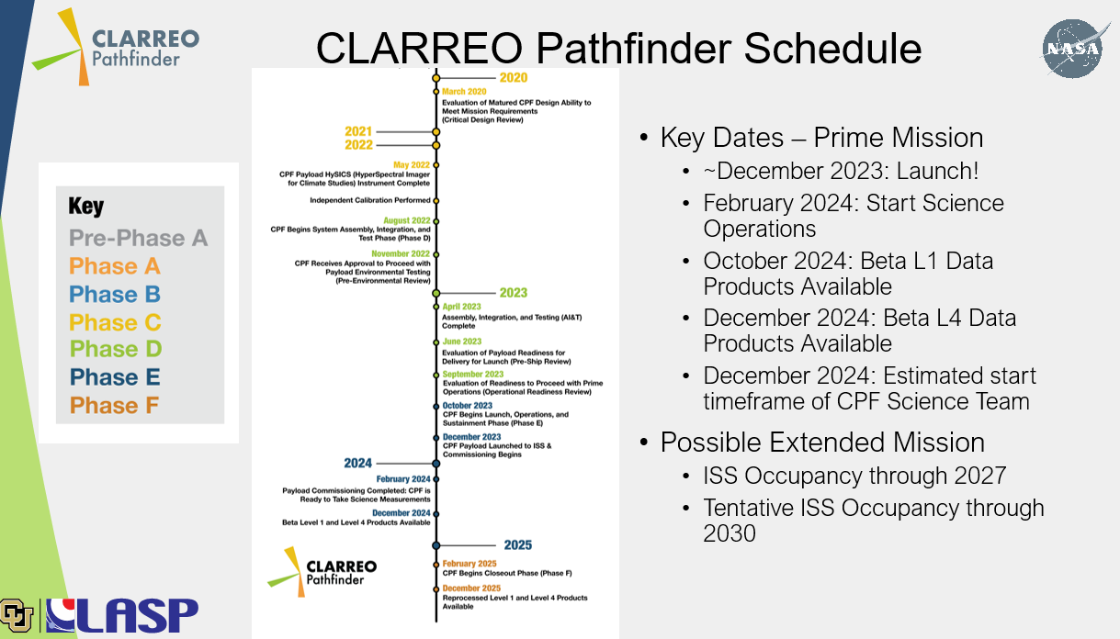
Discussion
- Kurt noted that NOAA-20 is the current target for inter-calibration but it would be great to do intercalibration with Suomi-NPP as well. Also hoping that MODIS will continue long enough to allow inter-calibration activities.

Chinese SITSAT Update
Presenter: P. Zhang
- Peng reported on the progress of the Chinese Space-based Radiometric Benchmark project.
- Noted that the vision for WMO integrated global observing system in 2040 is to harmonise the radiometric measurement from all kinds of platforms in operation. There are many important documents that emphasise the SI-Traceable Space-based climate observing system and radiometric benchmark system.
- The project on space-based radiometric benchmark includes realising the importance of reference type missions for improving climate science and harmonising global satellite observation.
- The road map of the Chinese space-based benchmark project can be seen below:
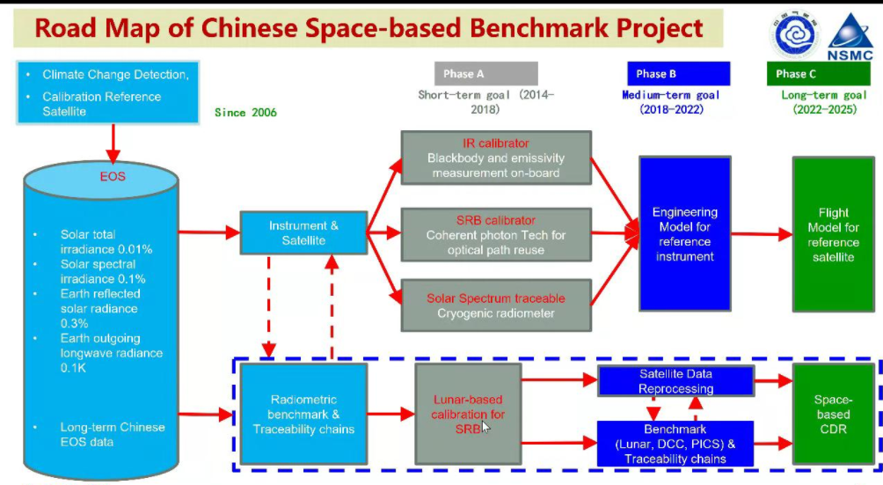

- Various institutes are working to prototype the model for benchmarking instruments.
- For the prototype, the Infrared Spectrometer (IRS) and Earth-Moon Imaging Spectrometer (EMIS) system scheme and performance analysis have been completed.
- Intercalibration with reference sensors recommended by CEOS WGCV is very important. For example, pseudo-invariant sites (PICs), quasi-synchronous intercalibration mode by Orbital manager, SNO, lunar observations for intercalibration and vicarious reference targets.
- In summary, Chinese Space-based Radiometric Benchmark (CSRB) projects have been going well. The engineering model of the reference instrument (IRS, EMIS, TSI and SITQ) will be completed this year. The Libra mission has not been approved yet. It is under consideration whether to have Infrared Spectrometer (IRS) mounted on the FY-5 mission. The key technologies of EMIS, TSI and SITQ will be considered for use in the development of FY-5 (2028 timeframe).
Discussion
- Greg Stensaas (USGS) noted the mounting of IRS on FY-5 and asked if the development is taking place in 2028 or whether that is the launching timeframe. Peng noted that it is possible there will be a demonstration mission with IRS before 2028 and following that IRS would also be considered to fly on FY-5 in 2028. Demo vs. FY-5 is different.

WGCV-51 Meeting (Tokyo) [Slides]
Presenter: A.Kuzel
- Kuze-san announced that the WGCV-51 meeting will be a joint meeting with WGISS, in-person in Tokyo, on October 4-6, 2022. A pre-meeting will be held on October 3, 2022, to run through logistics.
- The meeting focus will be to build collaboration between WGCV and WGISS.
Day 4 Close
Presenter: A.Kuze
Main points:
- Matt Steventon reviewed the action items from Day 4.
- Kuze-san thanked everyone for joining and closed the WGCV-50 meeting.

