Minutes
WGCV-51 Day #1
Tuesday, 4 October 2022

Participants
AEM Adrian Guzman*
BIRA-IASB Jean-Christopher Lambert
CEO Marie-Claire Greening*
CNES Patrice Henry
CONAE Angel Matias Palomeque*
CSIRO Cindy Ong, Ian Lau*
DLR Albrecht von Bargen*
ESA Philippe Goryl, Paolo Castracane, Fabrizio Niro*
EC-JRC Peter Strobl
FrontierSI Claire Fisk
GISTDA Sitthisak Moukomla, Prayot Puangjaktha
GA Medhavy Thankappan
JAXA Akihiko Kuze, Hiroshi Murakami, Riko Oki, Stephen Ward*, Toshiyuki Tanaka*,
Yukio Haruyama*
NASA JPL Bruce Chapman*
MYSA Jessica Wong*, Wayne Ng Su Wai*
NASA Xiaoxiong (Jack) Xiong, Eric Vermote
NOAA Lawrence Flynn*, Taeyoung Jason Choi*, Manik Bali*
NPL/UKSA Nigel Fox
NRSCC Xiaolong Dong*
USDA Michael Cosh*
USGS Cody Anderson
WGCV Sec Matt Steventon*, Riza Singh
* Virtual Participants

Welcome and Chair Report [Slides]
Presenter: A. Kuze, P. Goryl, R. Oki
Main points:
- Kuze-san (WGCV Chair, JAXA) welcomed everyone to the meeting. He expressed his happiness to have the first in-person meeting in three years. He welcomed opening statements from Riko Oki, Director of Earth Observation Research Centre (EORC).
- Riko Oki welcomed everyone to the meeting. Heard that WGCV and WGISS have the longest history in CEOS. She was very proud to welcome everyone to Tokyo.
- She explained the organisation structure of JAXA. Takeshi Hirayabashi is the Senior Chief Officer of Earth Observation missions. There are two centres under him - Earth Observation Research Center (EORC) and Satellite Operations Data Production and Distribution (SAOC). EORC is focused on Cal/Val activities whereas SAOC is focused on the satellite operations and interface of user applications.
- GCOM, EarthCARE, GOSAT, ALOS, and GPM programs fall under the EORC.
- JAXA EORC is contributing to various CEOS activities, including CEOS-ARD, the CEOS Chair priority on thermal IR Cal/Val, the UNFCCC Global Stocktake, and Cal/Val for New Space.
- ALOS-2/PALSAR-2 SAR ARD is under development. GCOM SGLI is contributing to thermal IR Cal/Val.
- In support of the GST, the GHG vicarious portal is being provided by EORC and will be covered by Kuze-san later.
- Several satellite projects are currently being operated under Takeshi Hirabayashi’s leadership.
- CEOS is working to make Earth observation (EO) data, a common asset of humankind more widely available. EORC under the concept of quality first Cal/Val is the higher priority task making the activities undertaken by WGCV very important.
- Tour de table introduction was conducted for the in-person participants followed by the remote participants.
SIT TW 2022 Cal/Val Highlights [Slides]
Presenter: M. Steventon
Main points:
- Provided brief updates related to WGCV from the SIT-TW 2022.
- Highlighted a Joint Draft of ESA-NASA Earth Observation Mission Quality Framework Guidelines for Optical and Synthetic Aperture Radar (SAR).
- WGCV and Cal/Val, in general, were recognised as the value addition from CEOS to ‘New Space’.
- There were few discussions on strategy for CEOS Engagement with Standards Organisations.
- Recommended CEOS agencies to consider resourcing people with CEOS-ARD heritage to join the OGC ARD Standards Working Group. Please let Matt know if anyone from WGCV is interested in joining the OGC ARD SWG.
WGCV-51-ACT-01 | All to consider participation in the OGC ARD SWG. | CLOSED
- It was suggested that WGCV keep watching briefs on AFOLU Roadmap development, GCOS IP and satellite supplement development and engage where appropriate.
- On IMEO-MARS Validation Concepts, there is a potential role for WGCV in inter-comparisons of “operational” MARS algorithms, concurrent acquisitions, controlled methane release experiments, and general validation coordination.
- Please let Matt know if WGCV would like to provide inputs to the draft white paper “ Monitoring Surface PM2.5: An International Constellation Approach to Enhancing the Role of Satellite Observations” by 15 October 2022.
- More details can be viewed from the linked slides.
Discussion
Philippe Goryl (WGCV Vice-Chair, ESA) thanked Matt for the presentation. Noted that SIT-TW was a productive meeting. WGCV is a part of the CEOS as a community. People and the team rely on WGCV for some core activities in various projects like AFOLU, and Atmospheric Subgroup Virtual Constellation (ASVC). Reference datasets for Cal/Val and intercomparison are the core pillars of WGCV. He emphasised the importance of better coordination and communication within the WGCV to respond to the new tasks.
Philippe asked whether WGCV had any mechanism to respond to the New Space. Matt Steventon (WGCV Secretariat) noted both the New Space and Biodiversity task teams would be taken in terms of reference to the Plenary.
Cindy Ong (CSIRO) suggested WGCV should see how some of the activities are already aligned and try reaching out to the team if it is formed to see how WGCV can support.
Kuze-san (WGCV Chair, JAXA) noted New Space is a good initiative but doesn't have good calibration and validation facilities. JAXA has been involved in Methane and GHG projects. JAXA is happy to support the New Space.
WGCV-51-ACT-02 | WGCV Chair / Vice Chair / Secretariat to flag WGCV interest in nominating a representative to the eventual Task Teams on ‘New Space’ and Biodiversity (Ecosystem Extent). | 2022 CEOS Plenary
Action Review
Presenter: M. Steventon
Main points:
- Reviewed WGCV-50 actions. Details of the actions can be viewed here.
- Noted that WGCV-50-ACT-01, WGCV-50-ACT-02, WGCV-50-ACT-03, WGCV-50-ACT-04, WGCV-50-ACT-07, WGCV-50-ACT-12 and WGCV-50-ACT-13 have been completed.
- WGCV-50-ACT-05 - Jean-Christopher to connect with Paolo regarding the addition of a specific resource section on the CEOS Cal/Val Portal for surface-related validation activities for atmospheric missions, and to explore support for / synergies with NDACC resources. The action is in progress. Paolo has received the documents from Jean-Christopher and is reviewing them.
- WGCV-50-ACT-06 - Paolo and Philippe to discuss a coordinated scheduled/periodic approach to WGCV Cal/Val Portal updates. The action is in progress.
- WGCV-50-ACT-08 - Philippe, Paolo and Xiaolong to discuss increased MSSG representation on the WGCV Cal/Val portal. The action is in progress. Paolo has received the document and is reviewing it.
- WGCV-50-ACT-09 - WGCV Chair to follow up on the status of CV-14-03 (Workshop on state of the art for pre-flight calibration techniques) with Nigel and Albrecht. Also, to check whether the paper done by NIST on pre-flight calibration techniques is looked at and potentially updated as part of this effort. In progress. CV-14-03 due date has been extended to Q4 2023. Nigel noted the process needs to be reformulated and the announcement needs to be done by the end of this year. Albrecht and Nigel will discuss further on this. CV-14-03 due date has been extended to Q4 2023.
- WGCV-50-ACT-10 - WGCV Chair to confirm a new due date for CV-17-01 with Nigel. The action is completed, but the task is in progress.
- WGCV-50-ACT-11 - WGCV Chair to coordinate the closing of CEOS Work Plan Deliverable CV-20-04 and creation of a new task on SARCALNET. CV-20-04 has been closed. Kuze-san noted that SARCalNet has started. The end of the year will be a good time to add new tasks.
WGCV Vice-Chair 2023-2024 Results [Slides]
- Two nominations were received from USGS and CONAE. There is a long heritage of USGS with WGCV. Following numerous discussions, it was agreed that USGS could go first, followed by CONAE, to allow time for Matias Palomaque (CONAE) to get exposure to all WGCV activities.
- WGCV Leads recommended Cody Anderson (USGS) as the candidate for the Vice-Chair for the term 2023-2024.
- The criteria for the voting was that the members would have to attend at least two out of three WGCV meetings. The Sub Group Lead and the member representing the agency got to vote twice.
- 19 out of 22 eligible voters voted for Cody Anderson (USGS) as the Vice-Chair for 2023-2024.
Discussion
- Kuze-san suggested adjusting the terms of reference to ease voting rights.
Decision 01 | It was agreed that voting rights for future WGCV Chair selections will be assigned if a person/agency has attended two out of the last three WGCV Plenary meetings, with at least one of those being in person attendance. It was clarified that each vote is per agency, not person, so the vote can be earned by and delegated to another agency representative.

WGCV-51-ACT-03 | WGCV Chair, Vice Chair and Secretariat to prepare an update of the WGCV Terms of Reference that clarifies the eligibility criteria for voting for WGCV Vice Chair nominations, consistent with the agreement detailed in Decision 01 above. | Documents for Plenary Endorsement Due Nov. 15
- Peter Strobl (EC-JRC) noted that if there is no obligation, no restrictions to travel then the member should attend at least one in-person meeting.
- Kuze-san Chair term is ending in December 2022, and the Chair position will be transferred to Philippe Goryl (ESA).
- The WGCV Secretariat has undertaken a big effort to clarify the mailing list, voting rights, and communications. Old WGCV list will be rebranded to a new WGCV-community list. And the WGCV list (wgcv@lists.ceos.org) will be clarified to only include official POCs and their secondary contacts (if defined).
- The Cal/Val should be used as the general communication tool and need to be cautious about what information we are sharing with the mailing list.
Decision 02 | Cody Anderson (USGS) was confirmed as the nomination for WGCV Vice Chair for 2023-2024 and the subsequent Chair term of 2025-2026. The nomination will be presented to the 2022 CEOS Plenary for endorsement by CEOS Principals.
- Atmospheric Composition Subgroup Chair (ACSG), Bojan Bojkov stepped down in 2021 and a new Chair needs to be elected. Jean-Christopher Lambert is the interim Chair for ACSG.
- Jean-Christopher Lambert (BIRA-IASB) noted that a voting poll was conducted for the new Chair and 50 percent of the ACSG members responded, all in his favour.
Decision 03 | The Atmospheric Composition Subgroup (ACSG) nominated Jean-Christopher Lambert as the new ACSG Chair and this was agreed by the WGCV Plenary.

WGCV-51-ACT-04 | WGCV Secretariat to ensure the leadership of the Atmospheric Composition Subgroup (ACSG) is updated on the CEOS website, WGCV membership and voting list, mailing lists, etc. | COMPLETED
WGCV-51-ACT-05 | WGCV Secretariat to consider the modes of communicating different types of WGCV information, and to consider approaches for maintaining a database of official communications. | WGCV-52
WGCV Vice-Chair 2023-2024 Presentation [Slides]
Presenter: C. Anderson
Main points:
- Provided a brief introduction about himself. He graduated from South Dakota State University in 2010 with a degree in Electrical Engineering and Mathematics.
- Started his career in the commercial field from RapidEye in Berlin, Germany as a Calibration Engineer.
- Worked at Stinger Ghaddarian Technologies (SGT), U.S. Geological Survey (USGS) Earth Resources Observation and Science (EROS) Centre, the company that handles the working and archives of LANDSAT satellites.
- Has been working as a Project Manager for USGS in the EROS Cal/Val Centre of Excellence (ECCOE) since 2018.
- ECCOE high-level priorities include ensuring the data quality of LANDSAT. Collection 3 of Landsat archive will be going around after five years.
- Lead the Joint Agency Commercial Imagery Evaluation (JACIE). More information on JACIE Cal/Val activities can be viewed at: https://www.usgs.gov/calval/jacie
- Online compendium: https://calval.cr.usgs.gov/apps/compendium
- System characterisation reports: https://www.usgs.gov/calval/system-characterization
- Other priorities include Validation of National Elevation and Bathymetric Dataset Accuracy
- Have technical assistance agreements with Planet and Maxar.
- JACIE has engagements with Very High-resolution Radar & Optical Data Assessment (VH-RODA), and Analysis Ready Data (ARD) Workshop Coordination.
- Potential WGCV areas of focus include analysis ready data interoperability, reference Calibration and Validation Networks, and Commercial Engagement.
- Detailed information can be viewed from the linked slides.
Discussion
- Peter Strobl (EC-JRC) suggested it would be good for USGS to get involved as CEOS representatives. Cody Anderson (USGS) noted USGS will consider getting involved in the OGC initiatives.

TSIS Solar Irradiance Spectrum version 2.0 update [Slides]
Presenter: A. Kuze
Main points:
- Noted the TSIS Solar Irradiance Spectrum version 2.0 was recommended at the WGCV-50
- The direct TSIS-1 observations continue in good form, producing high-quality daily SSI and TSI.
- A paper on version 2 of the TSIS-1 HSRS (the hybrid, composite, spectrum), plus extension in wavelength from .115 to 200 micron using independent observations and theory has been submitted.
- This latter work has a change in the UV between 202 and 210 nm. It also updates solar lines in the JPL/SPTS database, primarily impacting around 1.3 microns.
- With the extension to the "full spectrum", a reference spectrum that integrates to TSI, within uncertainties have been provided. For climate studies that require a solar spectrum that integrates to TSI, a <0.1% adjustment (for all wavelengths) to identically match TSIS-1 TIM observations for that period is recommended.
- TSIS Version 2 is an incremental update. A reprocessing changes the radiometric baseline between 202 and 210 nm. Updates the JPL SPTS high spectral resolution aligns to the latest version which can be accessed from the below link: https://mark4sun.jpl.nasa.gov/toon/solar/solar_spectrum.html
- New GOSAT irradiance has been set for the TSIS community. More details can be viewed from the linked slides.
Land Product Validation (LPV) Subgroup Report [Slides]
Presenter: F. Niro, M.Cosh [Virtual]
Main points:
- Four focus areas include Fire/Burn Area, Phenology, Vegetation Index and Land Cover.
- SALVAL tool has been uploaded to the Cal/Val portal.
- CV-20-01 has been completed.
- SRIX4Veg represents a joint effort to ensure consensus on Surface Reflectance (SR) validation protocols using drones. It has been endorsed by CEOS and conducted in the framework of the ESA FRM4Veg project.
- Contributing towards defining global community-agreed guidelines, protocols and procedures for UAV-based SR product validation.
- The SRIX4Veg exercise campaign was held in July 2022. There were seven teams from the EU, Canada, and the US.
- The processing of UAV data is ongoing and comparison over integrated spectral bands matching S2 will be undertaken after gathering the results.
- Inter-comparison results will be published in a peer-reviewed journal (Q2 2023).
- Best practices protocol for UAV-based SR product validation will be prepared and agreed upon with the first version expected to be completed in Q2 2023 for endorsement by CEOS.
- Second Biomass Retrieval Inter-comparison experiment (BRIX-2) is the intercomparison of biomass algorithms based on a test dataset and comparison with ground truth (representative of BIOMASS, NISAR and GEDI mission data) with the use of the ESA-NASA joint-MAAP.
Michael Cosh provided an update on Surface radiation.
- QA4SM online validation tool has been launched. A Python validation toolbox is available. Biophysical CEOS DIRECT 2.1 database has been updated with new sites from Asia and FRM4VEG.
- Currently looking at what the Supersites are and how they interact with the Cal/Val communities.
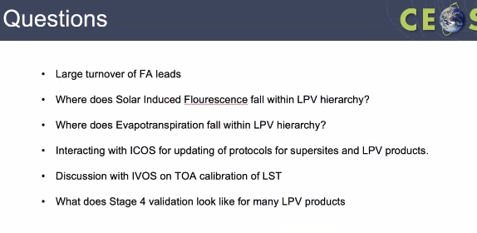
- Proposed in-person LPV Plenary at ESRIN, LPVE in June 2023.
- More details can be viewed from the linked slides.
Discussion
- Philippe Goryl (WGCV Vice-Chair, ESA) noted that ESA is planning to organise the next WGCV at ESRIN in June 2023. LPV meeting is being planned a week after WGCV-52. This is to be confirmed. It is disappointing to see BRIX-2 participation dropping, especially when the work is progressing. The biomass protocol document that was endorsed recently is a good document and should have been a motivating factor. He asked if a lack of interest or technical issues is the reason for the drop-off.
- Fabrizio Niro (ESA) noted there is no technical issue but it is more of a lack of engagement, and involvement, due to other commitments.
WGCV-51-ACT-06 | Fabrizio Niro to seek clarification from the BRIX-2 leadership team as to whether there is anything the WGCV Chair/Vice Chair/Subgroup leads can do to try to revitalise participation in the BRIX-2 activity. | COMPLETED
- Kuze-san (WGCV Chair, JAXA) asked about the plans for SIF/ET and if there would be any validation in LPV.
- Michael Cosh (USDA) noted LPV is not considering a new focus area on SIF/ET. GeoCarb funded by NASA will have a SIF product. LPV should know the current products and the needs of the community and where it fits within the LPV hierarchy.
- Philippe noted that it is difficult to validate geometry. ESA is launching FLEX in two years time and validation is a big issue. Have started to think about FRM4FLEX / Fluorescence. This will be an activity for the coming year.
- Jean-Christopher Lambert (BIRA-IASB) noted the CO2M mission being launched in a couple of years, which will contribute to a SIF data product as well. Establishing a SIF validation working group and collaborating on best practices would be good.
Synthetic Aperture Radar (SAR) Subgroup Report [Slides]
Presenter: B. Chapman [Virtual]
Main points:
- Attended the second international SAR coordination workshop in ESRIN and noted he presented on the development of SARCalNet.
- SAR instruments require external calibration targets to calibrate imagery and long-term monitoring of images.
- There is a strong desire by the CEOS and SAR community to have an established network of calibration sites that would facilitate collaboration between sensors by using the same calibration references.
- SARCalNet is an initiative of the SAR subgroup to coordinate SAR multisensor Cal/Val. It will provide predefined information on the calibration targets
- The SAR subgroup hosts a target database. Thanked Paolo Castracane for managing the database through the Cal/Val portal.
- The information is lacking in several ways. For Natural targets the data are not currently curated, the regions are broadly specified and sensor frame coordinates so not broadly applicable to all SAR. There is no comprehensive list of natural targets.
- For Artificial targets, the data are user-submitted and not curated. The information can be out of date with varying degrees of measurement capacity.
- Working on making SARCalNet a reality by establishing requirements for inclusion in SARCalNet, curating the content and preparing an annual summary report on SARCalNet.
- Currently meeting at regular intervals to prepare the guiding requirements documents:
  - Requirements and guidelines for Artificial and Natural calibration targets
  - Guidelines for image calibration analysis
  - A handbook that describes how SARCalNet operates
  - Requirements for the web portal that will host SARCalNet
- Meeting in Montreal in two weeks to review the current status of the above-listed documents.
- Recommends that space agencies manage the international SAR calibration arrays and their maintenance, coordinate regular multi-sensor and multi-agency calibration campaigns over the same natural and artificial target sites and free sharing of data and results from calibration sites through a single, reliable and long-term data archive.
- More details can be viewed from the linked slides.
Discussion
- Matt Steventon (WGCV Secretariat) asked how advanced is the web platform for SARCalNet as it is one of the possible candidates for CEOS Earth Analytics Interoperability Lab.
- Bruce Chapman (NASA JPL) noted the web platform contains a lot of information. However, some features don't fit in the web platform such as the archival of datasets and reporting of the results. He was not sure if having a website will help in the long-term archiving of the datasets and ensuring they are easily searched by API. SAR Subgroup is considering having an API and setting up a GitHub to store the analysis software that people are willing to share.
- Michael Cosh (USDA) asked about the long-term support from space agencies and how SAR would interact with commercial satellites in the support of the Cal/Val network if the data is free and open. Bruce noted NASA is interested in pursuing this. He anticipates that if NASA starts funding then other agencies might follow. Planning to draft a letter to NASA explaining the recommendations of the SAR Subgroup.
- Philippe Goryl (ESA) believes in this strategy. New Space will also be participating in VH-RODA in November 2022. It would be a good place to have interaction between SAR and the New Space. Bruce noted there will be a presentation on the SARCalNet topic at VH-RODA. Many commercial agencies have not been involved in setting up calibration sensors but are interested in SAR Subgroup's work. They often share their calibration results in presentation forms and not by providing data, would like to continue working with them and would like the commercial sectors to participate in SARCalNet by sharing their data.
- Bruce highlighted that one of the recommendations from the SAR Coordination workshop held the previous week was in support of SARCalNet.
Microwave Sensors Subgroup (MSSG) Report [Slides]
Presenter: X. Dong [Virtual]
Main points:
- MSSG Subgroup is currently focusing on standards and metrics for scatterometers and wind retrievals and development of calibration and validation of remote sensing imagery sensors and specification data for space-borne passive microwave radiometers.
- CV-20-05 task on standards and metrics for scatterometers and wind retrievals is in progress and is expected to be completed this year.
- The wind scatterometer constellation includes MetOp-B and MetOp-C, HY-2B, HY-2C, HY-2D, CFOSAT/SCAT and FY-3E.
- The main task includes the development and calibration of algorithms and methods for calibration of Sigma 0 using different references or metrics, standardisation and best practices of retrieval approaches of ocean surface winds (L2b data) by scatterometer data and guidelines to users, development of guidelines/standards of validation of ocean surface winds (L2b data) by radar scatterometer data, identifying and organising collocation data.
- A guideline document on Scatterometers and Wind Retrieval Practice Is being prepared. The final version of the draft of the specification has been submitted for publication and is expected to be published this month.
- The data type includes long-term L2 wind products, a month of L1 NRCS data products and Buoy data.
- Further steps include a final review of the document, and more materials are being prepared as deliverables for Cal/ Val portal. Cal/Val for GNSS-R, a newly developed instrument for ocean and land surface environment, is being prepared.
- More information can be viewed from the linked slides.
Discussion
- Kuze-san (WGCV Chair, JAXA) asked if the MSSG subgroup was planning to release MSSG information from the WGCV Cal/Val portal site or through its own website.
- Xiaolong Dong (NRSCC) noted this is being discussed with Paolo Castracane. MSSG would like the information published through the WGCV Cal/Val portal.
CEO Report [Slides]
Presenter: M-C. Greening [Virtual]
Main points:
- Apologised for not being able to join in person due to her busy schedule.
- Recalled the CEOS mission, objectives, long term and short-term priorities. The role of WGCV continues to be a vital component of the work being done under CEOS.
- Recalled the three priorities of the 2022 CNES CEOS Chair and noted that the third priority is specifically more important for WGCV which is to support CEOS Cal/Val initiatives to increase CEOS Agency Cal/Val Collaboration with respect to cross-calibration of thermal infrared measurements and in advancing the idea of joint multi-thematic Cal/Val sites to develop CEOS agency synergies and support future applications.
- Noted the CEOS Chair will report on all priority areas at the CEOS Plenary this year. The progress has been very good in all the priority areas.
- Noted WGCV mission and objectives reflect the vision of CEOS and align with the CEOS priorities
- The four key governing documents vital to CEOS leadership are CEOS Terms of Reference, Strategic Guidance document, CEOS Governance and Processes and CEOS Work Plan.
- The CEOS Work plan is a three-year plan updated by all CEOS entities.
- WGCV is working on eight deliverables one of which is overdue and the other seven remain open and on track. Of eight open deliverables, four are due for the end of this year, three will be due next year, and one will be due beyond 2024. Two deliverables will be left in the mid of next year assuming everything else remains on track.
- Suggested WGCV to start thinking about how WGCV can best define both short and long-term activities beyond next year as most activities are nearing completion.
- It would be good to come at the next version of the work plan update next year with a visionary list of deliverables from WGCV for the 2023-2025 cycle of work planning.
- Thanked WGCV Chair, Vice-Chair and Secretariat for continuous commitment.
- More details can be viewed from the linked slides.
Discussion
- Kuze-san (WGCV Chair, JAXA) asked Marie-Claire to briefly provide an update on the CEOS contribution plan for GEO and COP-27 as this will also be related to WGCV.
- Marie-Claire (CEO) noted that the GEO Symposium is being held in Accra, at the end of October 2022. There will be a CEOS booth which will be run by SEO as a promotion and outreach effort. CEOS is also a participating GEO organisation and will attend GEO Plenary and Executive Committee meetings. CEOS is heavily involved in GEO and will provide a statement to GEO.
- CEOS does not have much active participation in COP-27. WGClimate will provide a statement to SBSTA that will be publicised at COP.
- Philippe Goryl (WGCv Vice Chair, ESA) appreciated Marie-Claire for her continuous contribution to CEOS. Noted that the BRIX-2 CV-20-02 action is delayed. Marie-Claire asked WGCV to think about forward planning to fit into the new deliverables.
- Kuze-san provided updates to Marie-Claire that Cody Anderson has been nominated as WGCV Vice Chair for the 2023-2024 term. He also flagged intent to update WGCV Terms of Reference to refine voting rights.
- WGCV Chairs will work with the CEO to prepare updated WGCV terms of reference in time for endorsement at CEOS Plenary 2022.
ACIX / CMIX Discussion [Slides]
Presenter: E. Vermotte, P. Goryl
Main points:
ACIX
- Provided background on Atmospheric Correction and Cloud Masking intercomparison activities.
- Generic approach for AC for multiple sensors was defined. Landsat 8/OLI and Sentinel 2/MSI Surface reflectance is largely based on MODIS C6 (LaSRC) and relies on radiative transfer modelling with high accuracy (1%). Serves as the reference dataset and then compares different AC methods to this reference product.
- ACIX-I got people in the room to talk about results. While designing ACIX-II the lesson learned from ACIX-I was the need to have subgroups for land and aquatic. Also, the criticality of Cloud Masking was realised.
- Objective of ACIX-II is to point out the strengths, weaknesses, commonalities and differences between the different approaches.
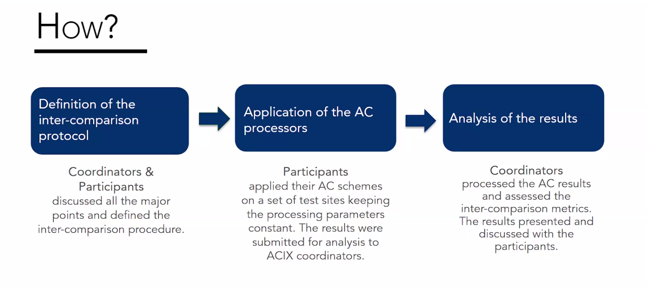
- Have 12 teams, 120 study sites based on AERONET stations, 3500 image scenes and seven months to submit results.
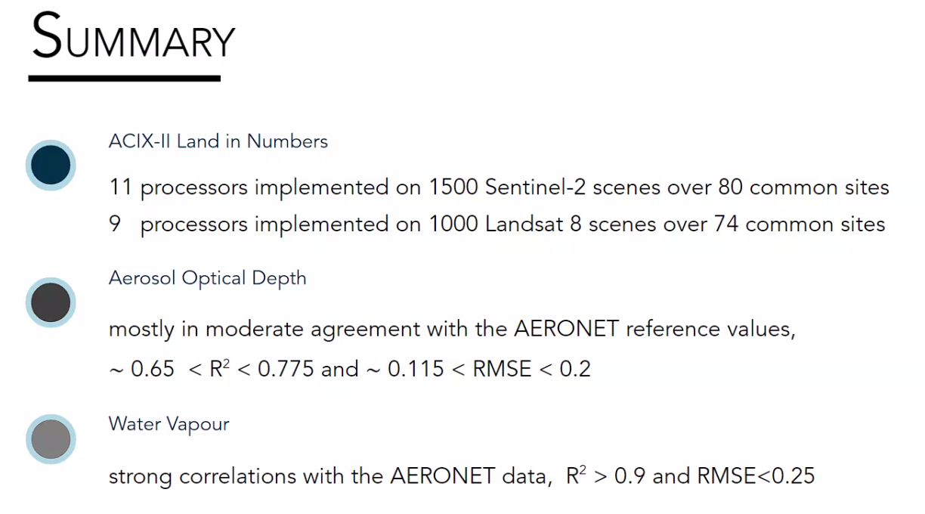
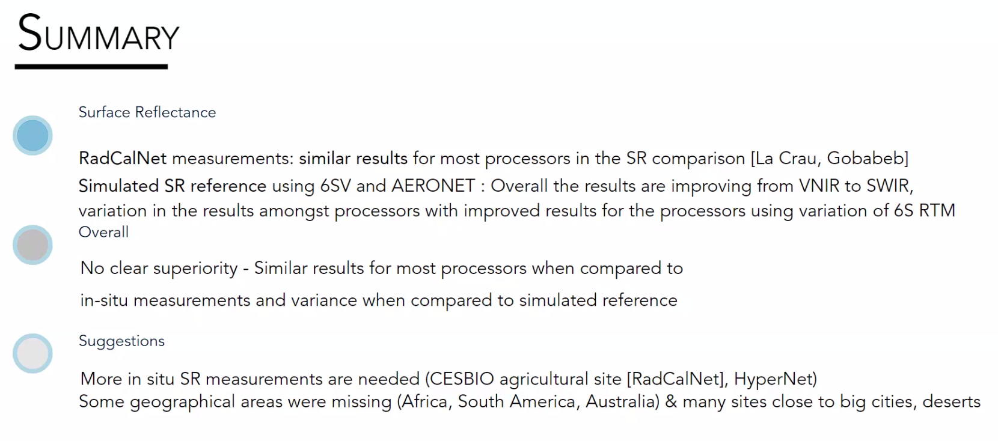
- Now looking at time series analysis for further insights. Shows the importance of cloud masking.
- Detailed information can be viewed from the linked slides.
CMIX
- Comparing various cloud masking approaches to a number of reference datasets.
- Thin clouds have a noticeable impact on the difference between the different cloud masking approaches. The performance also depends strongly on the reference data used.
- CMIX-I lessons learned and recommendations for CMIX-II:
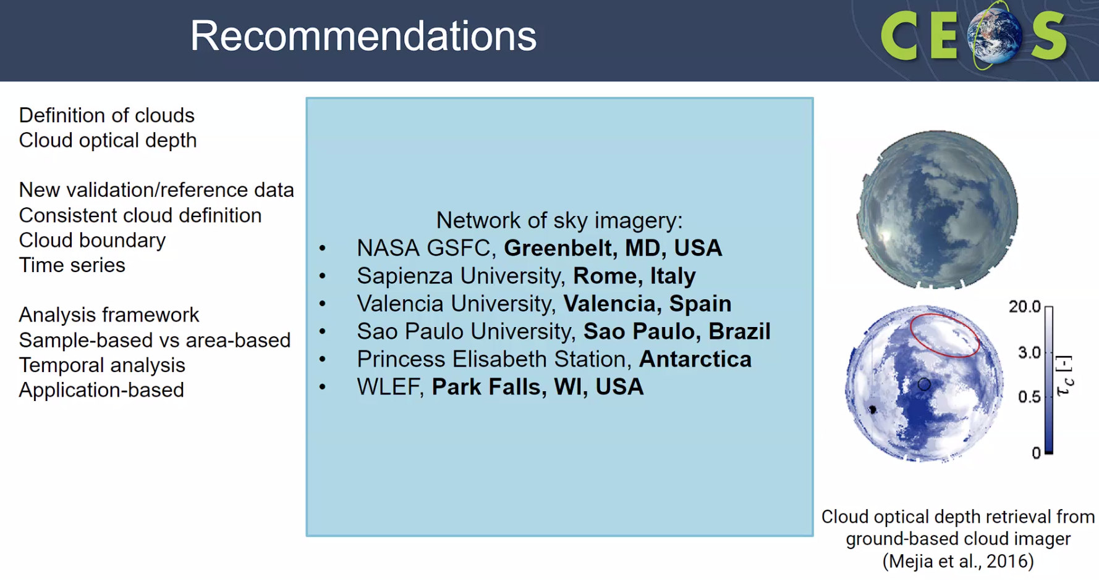
- SkyCam system for cloud mask reference, cheap approach. Implemented at NASA/GSFC.
- Way forward includes ACIX-III and CMIX-II. Considering the inclusion of hyperspectral.
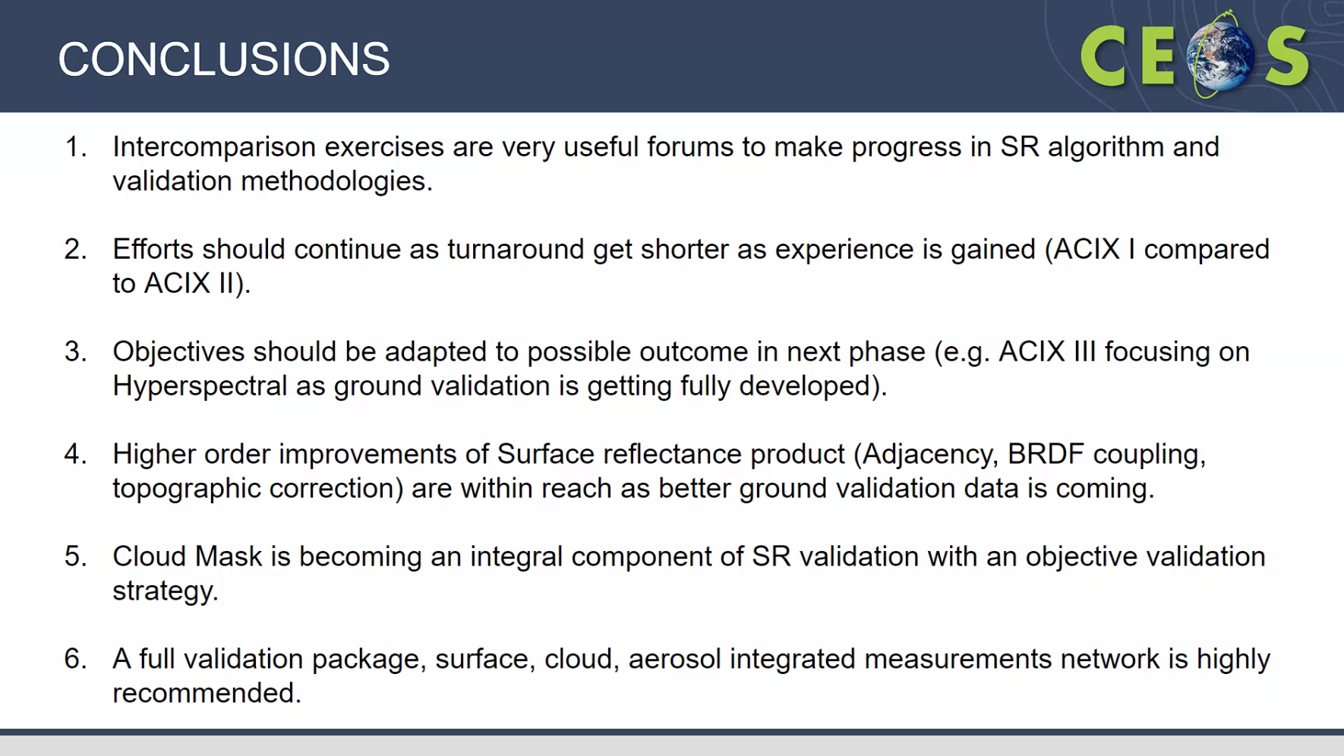
Discussion
- Patrice Henry (CNES) asked about the publication on ACIX and CMIX. Patrice is convinced of the interest in this exercise and asked if any other people are interested in this and ways to interest people outside WGCV.
- Eric Vermote (NASA) noted a publication on ACIX-1, ACIX-II and CMIX-I. These are all separate publications.
- Eric noted if everybody agrees on the final accuracy of the product which he thinks would be interesting for the users then that would be good. Nobody has agreed on this yet. Need to come to an agreement first. Have a foundation for the product but no accuracy.
- Peter Strobl (EC-JRC) suggested calling it ‘Uncertainty’ rather than ‘Accuracy’ as there are no available references. Eric corrected that it is uncertainty and not accuracy.
- Cindy Ong (CSIRO) asked about the lack of validation in-situ validation data. Eric clarified that there is too much validation on arid regions but not enough on agriculture.
- Cindy noted there are many test sites in Australia where some have systematic measurements installed for SR and if those kinds of sites could be beneficial in ACIX III. Eric noted it could be helpful for ACIX 4 as version 3 is focused on Hyperspectral.
- There was a discussion on the inconsistency of terminology in general. Peter will present this tomorrow as an effort to clarify and standardise terminology across CEOS.
- Reference network for cloud masking - suggest following this topic in WGCV.
- CAMSIS will not be used for ACIX-III. Focus for ACIX-III will be hyperspectral.
- There were some discussions on references, uncertainty and accuracy measurements.
- If the references are not better than what is being compared, the comparison should still be consistent with the measurement. It is about consistency. For uncertainty to be a reference, it should be lower than what is being measured.
CEOS Earth Analytics Interoperability Lab (EAIL) [Slides]
Presenter: M. Steventon for B.Killough [Virtual]
Main points:
- Presented on behalf of Brian Killough and Jonathan Hodge.
- The Earth Analytics Interoperability Laboratory (EAIL) has been operating for the last two years. It is maintained by SEO for CEOS.
- Significant data updates have occurred over the last six months including increased coverage and new products.
- There are a range of potential data sources, services and applications which could be added to EAIL if there is interest.
- New capabilities could include significant enhancements in Machine Learning and GPU capabilities.
- It could be a good platform for WGCV and might have some applications that WGCV is currently working on like interoperability.
- EAIL is built using the Open Data Cube software and CSIRO’s Earth Analytics, Science and Innovation platform.
- Numerous other data sources either under development or in operation in related projects could benefit EAIL, including MODIS (numerous products), Sentinel 5P and GEDI.
- New and potential analytics capabilities include GPU processing with AWS GPU nodes, additional scientific programming options with R, and new machine learning capabilities.
- More details can be viewed from the linked slides.
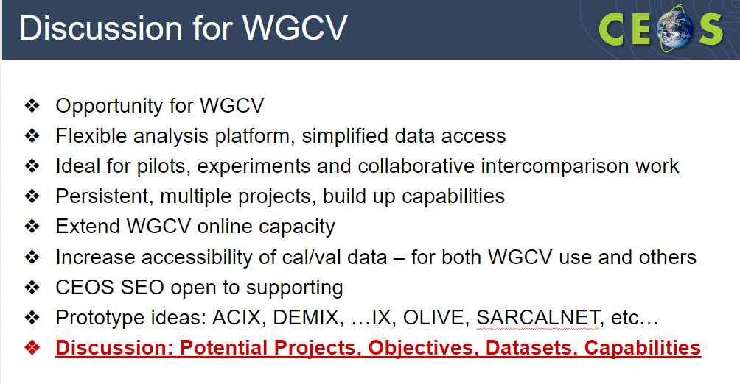
Discussion
- Philippe Goryl (ESA) noted that EAIL would be a useful platform for all intercomparison exercises. He suggested adding ACIX, DEMIX data to this platform. It is complementary to the Cal/Val portal.
WGCV-51-ACT-07 | WGCV Secretariat to organise a teleconference between the WGCV, EAIL, and CEOS SEO teams to discuss EAIL opportunities for WGCV (potential projects, objectives, datasets, capabilities/tools) and connections with the WGCV Cal/Val Portal. Long term sustainability of EAIL should be a point of discussion. | December 2022
WGCV-51-ACT-08 | WGCV team to consider CEOS EAIL opportunities for WGCV (e.g., potential projects, objectives, datasets, capabilities, tools) and bring these ideas to the teleconference referenced in WGCV-51-ACT-07. | Before call referenced in WGCV-51-ACT-07
- Peter Strobl (EC-JRC) noted DEMIX investigated the use of EAIL but instead went with a system funded by ESA. WGCV team can investigate the transfer of tools if useful and EAIL provide long-term continuity.
- Patrice Henry (CNES) asked about the capacity to host the data on this platform. If we want to make the data available to everyone then there should be easy accessibility. It is difficult to make something generic as each project has its own platform for its needs.
- Peter stressed ensuring a sustainable platform. It should have sustainable funding otherwise it would prevent other people from embarking on it.
RadCalNet [Slides]
Presenter: N. Fox on behalf of M. Bouvet and RadCalNet team
Main points:
- RadCalNet portal has various features.
- Current sites are Railroad Valley, Gobabeb, LaCrau, one sandy and one man made site in China.
- Had the first RADCALNET users meeting in June 2021 with about 100 online participants. Had discussions with national space agencies, satellite owners and operators and new space.
- Have established a formal process for accepting new sites into the RadCalNet group. The acceptance process of new sites goes through the acceptance panel.
- The new sites are being proposed and developed. Emphasised that the criteria for RadCalNet is to demonstrate what can be done and deliver data in an operational way for an amount of time each year.
- Have five new sites joining the network and have a growing and enthusiastic user base.
- More details can be viewed from the linked slides.
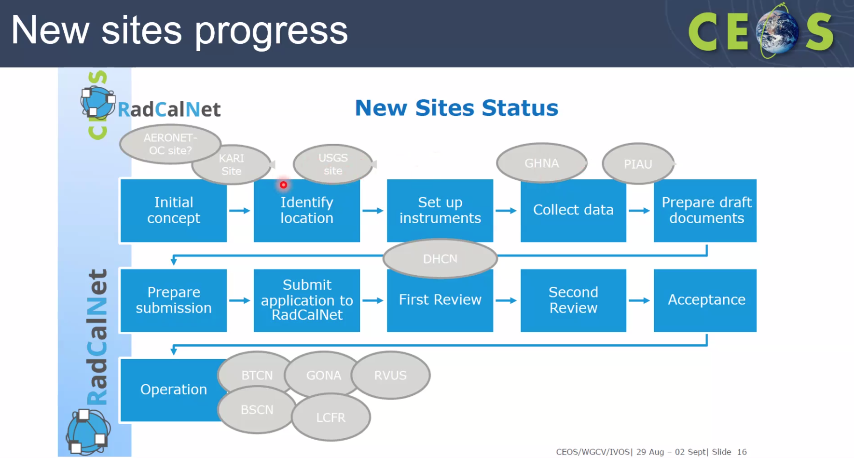
Discussion
- New sites are the Dunwhyane site in China, the Pinnacle site in Australia. The sites at the early stage do not have a name. It will be set up as it progresses to a later stage.
- Jack Xiong (NASA) asked if all the data including the previous data were reprocessed in 2022. Nigel noted there was a complete reprocessing of archived as well as new data.
- Kuze-san (WGCV Chair, JAXA) asked what percentage of the new space people are interested in RadCalNet.Nigel noted most of the new space operators will be utilising the Cal/Val in the optical domain.
- Philippe Goryl (ESA) asked if India has proposed a site for RadCalNet. Nigel noted India has not contacted formally showing their interest.
Atmospheric Composition Subgroup (ACSG) Report [Slides]
Presenter: J-C. Lambert
Main points:
- New ACSG Chair J-C Lambert candidature has been endorsed by the ACSG team.
- Proposed himself as ACSG Chair to WGCV.
- Review of membership by agency is in progress. Next ACSG meeting has been proposed for 2023.
- The proposed topics of interest are noted below:
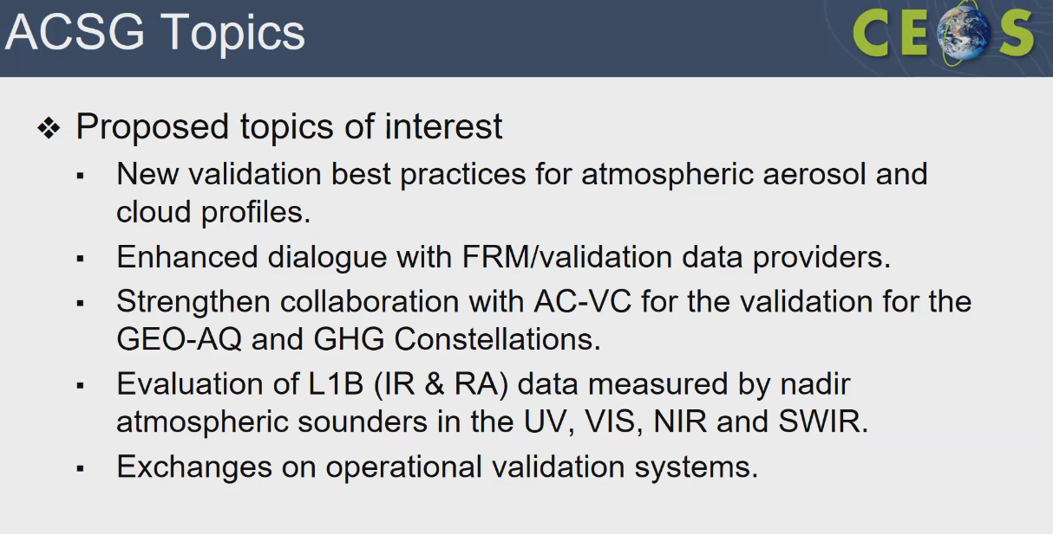
- The NDACC satellite website is updated annually. It consists of a list of all relevant atmospheric composition satellite missions and downloadable mission charts. New features such as validation resources, validation services, validation reference measurements, overpass predictors and data access have been added to the Resources page.
- ACSG triggered a NDACC Steering Committee brainstorming about self-assessment of FRM maturity for every NDACC Instrument Working Group of the network.
- WGCV-50-ACT-05 - Exchanges with Cal/Val Portal are in progress and is likely to become a recurrent activity.
- Status of GHG networks for satellite validation was updated, with highlights on new profiling capabilities, traveling standard NIR instrument, progress towards central processing, and AirCORE profile developments for new species.
- CMRS-22-04 - Review of GCOS Implementation Plan 2022 - Several ACSG members contributed to the public review in May 2022 and participated in the WMO RRR activity.
- Need for a central database or ground base validation of the data. Prefer mirroring of the network data archive.
- Cal/Val in AC-VC-18 meeting was held virtually in March where Cal/Val presentations were embedded in the thematic sessions. There were also seed questions on Cal/Val in discussion time slots.
- VC-20-02 is due on 2024 Q4, VC-20-03 due on 2022 Q4 and VC-20-04 is due on Q4 2023.
- TOAR-II set up a Satellite Ozone Working Group to address the issues from TOAR-I, reconcile satellite, ground- and air-based data, use global chemistry transport models as a transfer standard and provide a common methodology for the assessment of trends.
- VC-20-01 progress was reported at AC-VC-18, with presentation of tropospheric ozone data harmonization and validation results. Activities continue in support of TOAR-II, as planned.
- CV-22-01 on validation protocols for aerosol and cloud profiles is in progress. There are validation challenges unique to aerosol and cloud profiling and to precipitation. Have many different definitions and perceptions leading to difficulty in intercomparison. Tools will be developed for LIDARS and imagers. Several brainstorming meetings have taken place to form the working group for the CV-22-01 task. Collaboration of ESA, NASA AOS SOWG and JAXA.
- ACSG would like to participate actively in validation protocols for aerosol and cloud profiles. JAXA has confirmed interest in participating.
- Several brainstorming meetings have taken place to form the working group for the CV-22-01 task.
- More details can be viewed from the linked slides.
Discussion
- FRM includes tailoring to the satellite and the data product. Uncertainties, and traceability with respect to a specific type of satellite.
- Reference measurements could be in-situ measurements or have other criteria with respect to the specific type of satellite.
- Albrecht von Bargen (WGClimate) via chat noted FRM4DOAS is not mission-specific. It is instrument and measurement-type specific.
- FRM is required both to validate prognostic uncertainties and to determine diagnostic uncertainties.
- There will be a scientific publication and tools for FRM cloud validation.
Infrared and Visible Optical Sensors (IVOS) Subgroup Report [Slides]
Presenter: N. Fox
Main points:
- The Terms of Reference of IVOS were reiterated.
- Need to find new Leads and Co-leads for Geospatial image quality tasks as both the Chair and Vice-chair have resigned.
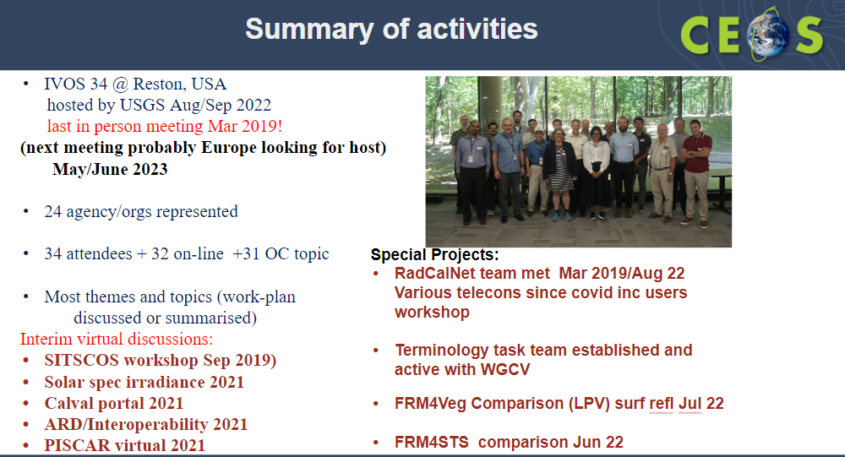
- Cal/Val methods are critical for L1 interoperability.
- All the presentations and minutes from the IVOS 34 meeting will be available on the Cal/Val portal.
- Had a comprehensive presentation from CNES. Full methodologies are being developed.
- CV-17-01 - Eatablishming means to achieve L1 radiometric interoperability. The action is completed but the work on the action is not yet completed. IVOS will create a template on a Cal/Val portal initially in a private forum. Methods must be documented and be subject to peer-review. The data and information will be reviewed by the IVOS team before it becomes publicly accessible.
- Had presentations on CLARREO Pathfinder. Talked about how the aspects of pre-flight calibration will be validated.
- Planning a virtual meeting on PICS before the end of 2022.
- For Solar Spectral irradiance, when someone chooses a spectrum, they need to be clear on which spectrum they are using.
- More details can be viewed from the linked slides.
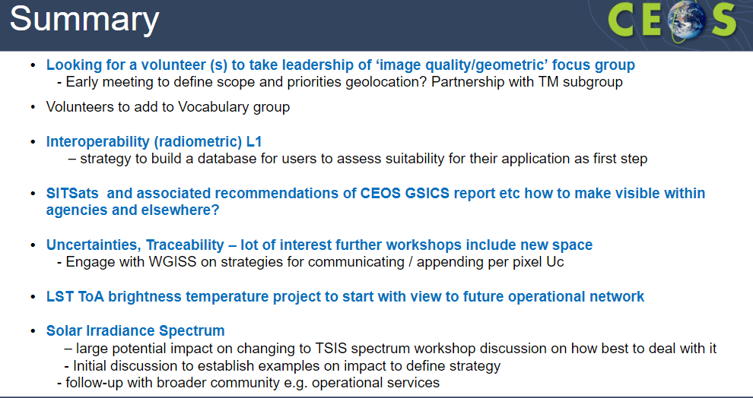

WGCV-51-ACT-09 | Nigel Fox and Paolo Castracane to update the wording on the Cal/Val Portal regarding solar irradiance spectrum references. | WGCV-52

WGCV-51-ACT-10 | Nigel Fox and Paolo Castracane to investigate the creation of a private IVOS section of the Cal/Val Portal that would allow for peer review by IVOS members of proposed radiometric calibration methodologies and associated documentation/uncertainties before publishing to a wider audience. | WGCV-52

Discussion
- TSIS spectrum is relatively new and IVOS wants to encourage the MODTRAN team to put TSIS in their software package. Need to have users asking for it to be added. Have not yet asked the MODTRAN team, but IVOS has an action to encourage MODTRAN to add as a reference spectrum.
- Peter Strobl (EC-JRC) asked if there is a need for an intercomparison exercise on the different spectra.
- Nigel (UKSA) noted Odele has reviewed the origin, basis, and in some cases very loose observational basis for spectra. In CEOS, have taken the view that the TSIS spectrum is an observational measurement at TOA with uncertainties lower than the others (where they exist) and it is therefore the most robust spectrum to this date. In some cases the other spectra are perceived to be ‘wrong’ – don't need to be doing additional comparisons, until there is another observational spectra with comparative uncertainties there will be no need for a comparison.
- Patrice Henry CNES) noted the value has to be put into the product. It is very important to have the reference, traceability and computed value.
- Kuze-san (WGCV Chair, JAXA) believes that applying TSIS data is much more consistent and is the better reference at this moment in time.
- Current guidance is only that the spectra used must be referenced to inform the user.
- Jack Xiong (NASA) asked about the status of the pre-launch calibration workshop. Nigel noted that IVOS plans to organise the meeting in the Autumn/Fall of next year. Will reinstate the Working Group so that it starts to happen. Albrecht von Bargen (WGClimate) will contact Nigel after November 2022 to focus on this action.
Terrain Mapping Subgroup (TMSG) Report [Slides]
Presenter: P. Strobl
Main points:
- Have some updates in DEMIX. Have 20 active people meeting bi-weekly.
- Subgroup 2 has the most intense activity to develop the method and results that should come out.
- Intercomparison is useful for non-expert users to have tools to help them decide on which of the several choices they have are more recommendable.
- We need a configurable, reusable and expandable test environment to fulfill the criteria.
- Provided an overview of the DEMIX wine contest framework. If you think of a candidate product that goes beyond the elevation model and if you have different options for products and want to identify which one to use for a specific purpose then you should identify and define some criteria to evaluate the products.
- In the elevation model we think about coverage. Something that can be done without much reference. The evaluation table is the numerical output of the evaluation. Then there is an opinion table that states if the numerical value is better or worse. Will have to define tolerances from which point onward will be considered different. This will have iterations.
- The paper is being put together for the DEMIX wine contest. Have identified 134 DEMIX tiles on three different continents with reference data.
- Next steps include finalisation of SG2 paper, consolidation of VTWeb platform for reference DEM access, wrap up DEMIX, and organise TMSG in-person Plenary. Ideas for future activities include
  - reloaded fully cloud-hosted DEMIX with more criteria and reference tiles
  - intercomparison of GCP libraries
  - spatial matching and comparison of global GCPs and DEMs
- More details can be viewed from the linked slides.

WGClimate Presentation [Slides]
Presenter: A. Bargen [Virtual]
Main points:
- WGClimate main goal is to improve the systematic availability of climate data records through the coordinated implementation and further development of the architecture for climate monitoring from space.
- The architecture for climate monitoring from space started twelve years ago. Have sensing and climate record creation in the climate data records.
- Climate data records in action is the use case of Earth Observation Aiding Decision Making.
- WGClimate is addressing the observational needs of UNFCCC. WGCV is also a member of the GHG Task team. The GHG Task team has representatives from CEOS, CGMS and GSICS.
- Much information can be found at http://climatemonitoring.info.
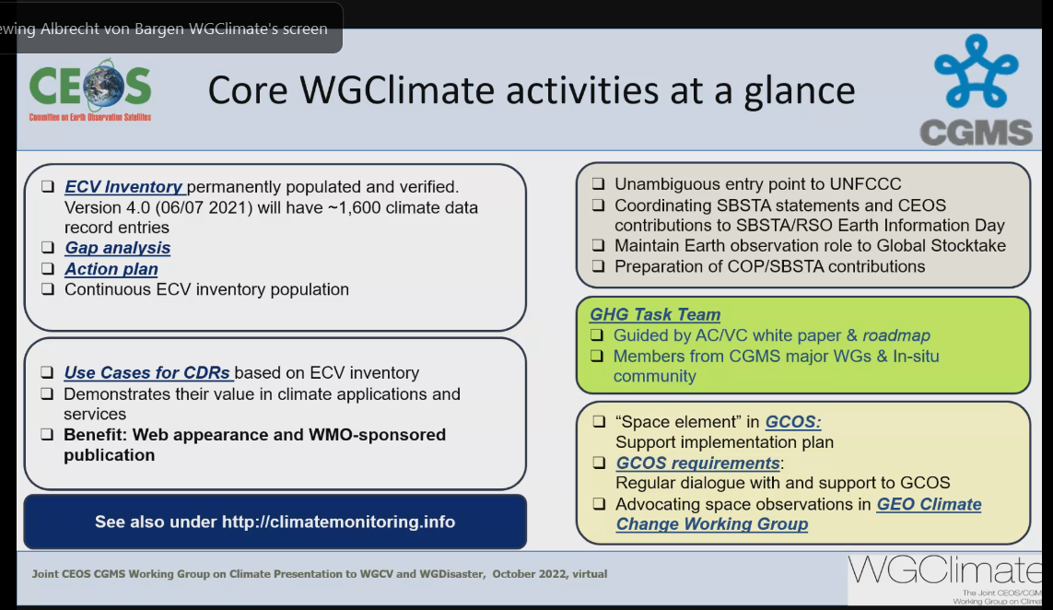
- Albrecht von Bargen (DLR) is the current Chair of WGClimate until the end of 2022. Jeff Privette (NOAA) is the incoming Chair and Wenying Su is the nominated incoming Vice -Chair.
- More details can be viewed from the linked slides.
Day 1 Close
Kuze-san (WGCV Chair, JAXA) thanked everyone for joining and closed Day 1 of the WGCV-51 meeting.

