Minutes
WGCV-51 Day #2
Wednesday, 5 October 2022

Participants
AEM Adrian Guzman*
BIRA-IASB Jean-Christopher Lambert
CNES Patrice Henry
CONAE Angel Matias Palomeque*
CSIRO Cindy Ong, Ian Lau*
ESA Philippe Goryl, Paolo Castracane
EC-JRC Peter Strobl
FrontierSI Claire Fisk*
GISTDA Sitthisak Moukomla, Prayot Puangjaktha
GA Medhavy Thankappan
JAXA Akihiko Kuze, Hiroshi Murakami, Yukio Haruyama*, Kazuhisa Tanada,
Takeo Tadono*, Stephen Ward*
MYSA Jessica Wong*, Wayne Ng Su Wai*
NASA Xiaoxiong (Jack) Xiong, Eric Vermote
NOAA Taeyoung Jason Choi*, Manik Bali*, Changyong Cao*
NPL/UKSA Nigel Fox
NRSCC Xiaolong Dong*
USDA Michael Cosh*
USGS Cody Anderson
WGCV Sec Matt Steventon*, Riza Singh
* Virtual Participants

Welcome
Presenter: A. Kuze, P. Goryl
Main points:
- Kuze-san reviewed the decisions and actions from Day 1.
Discussion
On WGCV-51-ACT-08, Peter Strobl (EC-JRC) suggested that it might be helpful to have the status of EAIL and plans for a sustainable platform. Matt Steventon (WGCV Secretariat) updated the action accordingly.
For WGCV-51-ACT-01, please email Matt If anyone from WGCV is interested in joining the OGC ARD SWG.
Cody Anderson (USGS) asked about WGCV-51-ACT-02 being two different actions. Matt noted it is two different actions, but Matt will email the SIT Chair Team about New Space and Biodiversity, so the actions were embedded together.
Update on the Australian Effort to Establish an EO Data Quality Facility [Slides]
Presenter: S. Ward (Virtual), M. Thankappan
- Australia has announced its first National Satellite Program for Earth Observation, the SCR series of Cal/Val satellites
- SCR will support improved characterisation and calibration of other satellites making them fit for more users.
- The concept is about improving confidence and trust, increasing commercial opportunities and making the data accessible simultaneously.
- EO AIM will provide access to legacy public Cal/Val ground sites and an automated open source toolkit to participating data providers to allow them to undertake routine checks on fundamental data quality measures.
- Integrated checks are required by CEOS partners such as JACIE, and EDAP so that the company sees advancing engagements.
- It is an exploratory concept, budget application in progress, not yet funded. It is part of a broader plan for Australia.
- The concept overview can be viewed from the screenshot below:
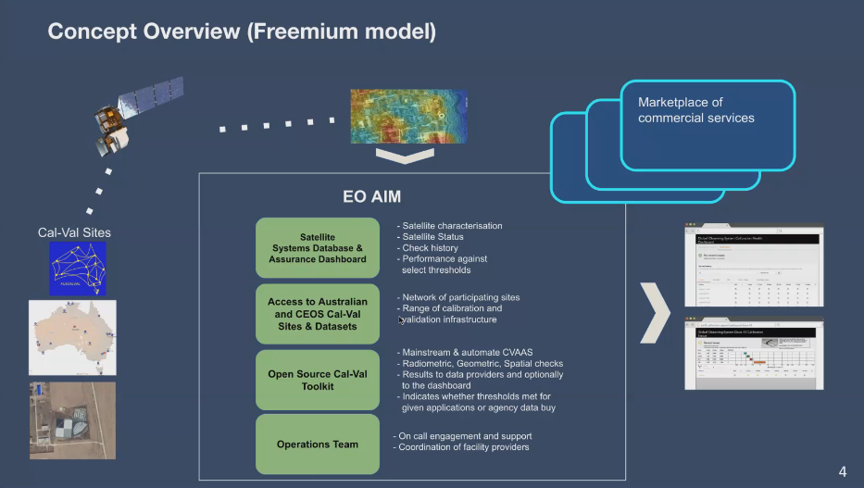
- Want to make the best use of investment for agencies like ESA that maintain the CEOS database. The internal team at Symbios updates the database annually and is looking to add as much information as we can and integrate these into the system.
- It is one of the initiatives for the New Space future CEOS activity. Some strengths include data standardisation, interoperability, and data mixing. Big agencies are going for broader architecture and pixel mixing. New Space was one of the priority topics put forward at SIT. Cal/Val is one of the key tools for CEOS in supporting the application data.
- The Australian team wants to work with the SIT Chair Team and WGCV to inline the directions. Want CEOS agencies to come together, and identify modules that can be integrated. Put the works ideally under the CEOS badge.
- Many questions related to the feasibility, integrity, and functionality of EO AIM have been previously discussed with the WGCV team.
- Medhavy Thankappan (GA) reiterated that this project is at the exploratory stage. GA is gathering evidence that will be consolidated as reference cases for receiving Government funding. It is built on what is already available (tools, certification schemes, software, etc.).
- Would like to have support from WGCV and get benefits from the advice and expertise.
- More information can be viewed from the linked slides.
Discussion
- Philippe Goryl (ESA) suggested conducting assessments and exploring the tools and software that would be used for SCR. See how to integrate workshops from JACIE and VH-Roda into the system. Many things proposed are based on the tools, so it would be helpful to check for the open source tools and software. It would be good to break down components and analyse what they offer.
- Medhavy Thankappan (GA) noted Phillipe’s comments would be considered going forward. Will need to split the components into different levels and be sure what each system will do.
- Would like to see industry investments used in a way that can benefit the whole community. Provide data quality and sustainable means of carrying the data quality agenda forward.
CEOS-ARD Update [Slides]
Presenter: M. Thankappan
Main points:
- Three objectives of the presentation were to review the tenure of review panels, identify an additional Point of Contact, resolve a single point of contact/failure, and find members to constitute a SAR review panel.
- CEOS ARD OG has been formed. The Terms of Reference document was endorsed at SIT-37. The group was identified as a core component of the CEOS-ARD Governance Framework.
- Provide strong coordination across CEOS and ensure that the CEOS agenda across ARD is conducted in a unified way.
- WGCV role for CARD4L reviews includes the below:
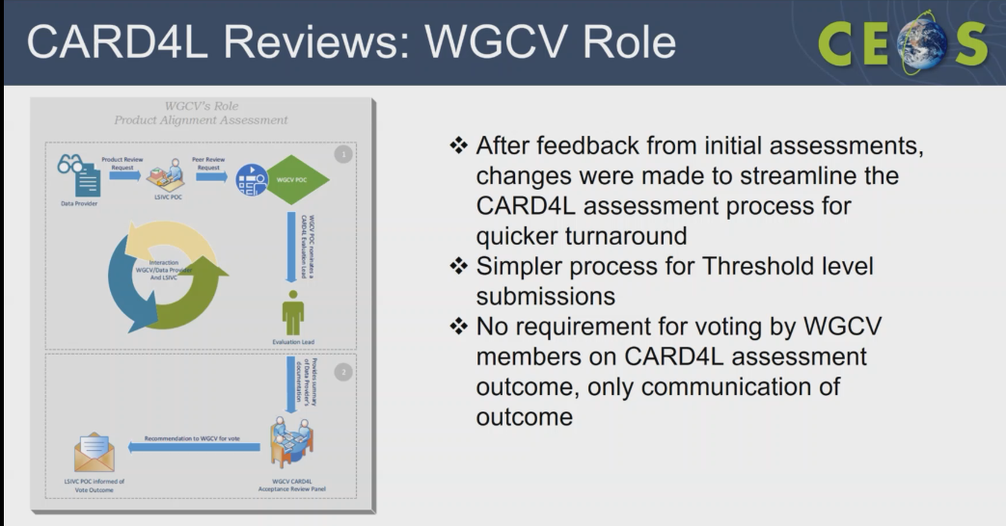
- Need to review the CARD4L review panel. The tenure of the review panel is for two years and it has not been reviewed for four years. Need to consider the tenure of the members including the PoC for better continuity.
- EnMAP from DLR and Landsat Collection -2 from USGS have been endorsed as compliant at the threshold level. Some recently endorsed CEOS-ARD includes Landsat collection 2 Surface Reflectance and Surface Temperature, Sentinel-1 RTC Normalised Radar Backscatter and Sentinel-2 Level-2A Surface Reflectance.
- CARD4L assessments in progress includes PROBA-V Collection 2 Surface Reflectance, Sentinel-2 Level-2A (E84) Surface Reflectance, ALOS-2 PALSAR-2 Global Mosaics (RTC), ALOS-2 PALSAR-2 ScanSAR NRB. Many products are under development.
- Steady stream of CARD4L submissions is coming through and it is important to have additional PoC for redundancy and backup.
- Recruitment for assistance with CARD4L evaluations is in progress at GA.
- Seeking back-up for WGCV PoC, new CARD4L Review Panel for SAR.
- More details on the status updates can be viewed from the linked slides.
Discussion
- Nigel Fox (UKSA) noted the review panel would not have anything to review for some time and there is no need to step down or rotate the review panel.
- Medhavy Thankappan (GA) agreed with Nigel and noted a need to have an additional PoC for supporting CARD4L evaluations. Medhavy flagged that there will be another person from GA to help with the assessments.
- Medhavy will put forward a proposal for a peer review panel and SAR PoC for assessments with the SAR subgroup. The review panel is a stringent process and would certainly benefit if there is an additional PoC.
- Eric Vermote (NASA) asked about Target Specifications for CARD4L Assessments.
- Medhavy noted for Landsat Collection 2 product, out of 100% requirements, 81% have been met. Initially, before the changes to the rules were made, the submissions were made for both the threshold and the target. The review panel did an assessment for both. The not assessed for Target Specification is after the change of rule and the percentages provided for Target Specification are from before the change of rules.
- Peter Strobl (EC-JRC) noted that with the standards and OGC coming forward, we will see differences in the situation in a very short time. In standards, there will be compliance parts that anyone can assess by following the instructions. The company can do compliance analysis for standards on behalf of the set of rules provided by ISO guidelines. He suggested starting to think about how we are going to position ourselves in future as WGCV, how we position ourselves concerning the standards, and what we want to have in setting the threshold for the standards.
- Eric noted for MODIS we went for stage validation so maybe segregating into stages might work. Cody Anderson (USGS) noted that USGS plans to achieve the target level in three to four years.
- Peter asked whether we want the OGC standards aligned with CEOS ARD. Philippe noted it could be a question for LSI-VC. We are talking about the process and it may be beyond this group.
- Cindy Ong (CSIRO) noted CSIRO could potentially help to carry out SAR assessment.
Decision 04 | It was agreed that there is no immediate need to make changes to existing CEOS-ARD review panel membership, given that no assessments have been submitted at the Target level, and none are expected to be forthcoming in the near-term. Medhavy will however seek to define a SAR peer review panel in coordination with the WGCV SAR Subgroup.
Decision 05 | In addition to Medhavy and the new recruit at Geoscience Australia (engaged to support Medhavy with CEOS-ARD peer reviews) it was agreed that having additional CEOS-ARD POCs from WGCV is desirable for redundancy and agility. Having a representative from the WGCV SAR Subgroup for SAR assessments would be desirable.

WGCV-51-ACT-11 | Philippe Goryl, Cody Anderson, Medhavy Thankappan and the WGCV Secretariat to schedule a discussion around identifying additional WGCV POCs for CEOS-ARD peer reviews. | December 2022
Role of WGCV to provide guidance similar to CEOS-ARD for conducting self-assessment of Fiducial Reference Measurements [Slides]
Presenter: P. Goryl
Main points:
- The understanding of the uncertainties has a long-term impact for most EO products and in particular for downstream and climate applications.
- The Calibration and Validation programme is composed of different complementary activities that need to be combined together to produce fully documented and consolidated performances.
- FRM is important for Cal/Val activities as it gives a reference properly characterised and traceable to standards and/or community best practices on which the Cal/Val results can be anchored.
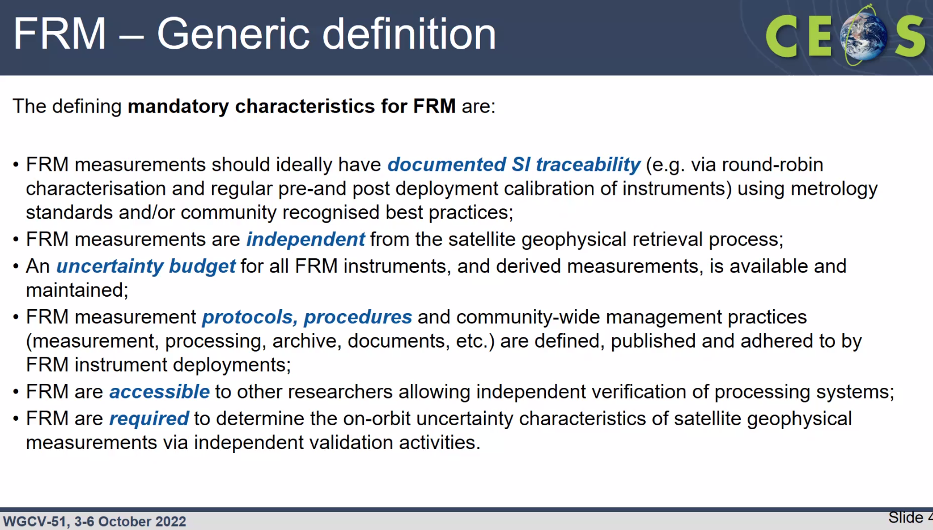
- Distinction between FRM and in situ measurements was clarified. FRM are well-characterised measurements for the Cal/Val of satellite or specific measurements, while in situ can be more general.
- Some historical examples of FRM such as FRM4STS, endorsed by CEOS, were shown.
- There is a growing interest in the FRM concept. The terminology is starting to get accepted widely. The quality and knowledge of the measurements are also improving.
- The question from various forums, including the CCVS project, is “How do I know if my measurement is FRM compliant? Who is certifying and what is the role of CEOS?”
- Proposed CEOS WGCV could play a role in certifying and accepting the measurements as FRM.
- CEOS WGCV is a natural place for coordinating. The approach could be self-assessment, review from the CEOS WGCV board and publishing in the Cal/Val portal.
- There should be some flexibility and it could be based on Maturity Matrix with level and not binary.
- Opened the floor for further discussion to move forward with the FRM concept.
- More details can be viewed from the linked slides.
Discussion
- Cody Anderson (USGS) asked would each potential FRM measurements need to be evaluated or instead the process. Philippe Goryl (WGCV Vice-Chair, ESA) thinks each instrument needs to be evaluated for FRM measurements. For example Hypernet should be evaluated to know if it is FRM or not.
- Cody asked about how a single bad measurement could affect the FRM of an entire series of measurements.
- Nigel Fox (UKSA) noted there should be a criteria, a process for evidencing consistency. There should be a process that evidences that there is consistency. There may need to be a level of differences between mature and immature systems.
- FRM measurement has similarities with RadCalNet than the CEOS ARD but it is more rigorous. FRM has SI traceability uncertainty which is what ARD or CARD4L target would seek to be.
- Peter Strobl (EC-JRC) noted it is a metrological issue, an engineering subject. He assumes ISO has a standard in place for this.
- Nigel noted the standard is ISO 17045, but it is laboratory measurement focused due to difficulty in the field. It requires a much more vigorous process than what is expected for FRM measurement. Here we are not suggesting that the Earth observation system is mature enough commercially to want to go down that ISO route of very high rigour. This is much more an intermediate process, trying to do something rigorous but that is not requiring ISO level authority.
- Peter suggested starting from ISO standard and tailor to needs. Would then have the complete compliance framework that always comes with ISO standard.
- Nigel noted we could start to run into problems by having a formal quality system to underpin the activities. Many organisations like universities, etc. may not be at the level to do these measurements. Need to avoid having all of the baggage to make it realistic by providing a subset, i.e. the critical threads of the ISO process. Documented SI traceability, independent measurements, available uncertainty budget, protocols, procedures, accessible information are the mandatory characteristics for FRM.
- There were some discussions on FRM uncertainty characteristics.
- Maturity Matrix is not prescriptive on the uncertainty budget approach and it needs to be documented. It is up to the user to determine whether what is presented is fit for their purpose. Same needs to apply to any FRM approach, need to use the same approach as ARD andt document what has been done.
- FRM are required to determine the on-orbit uncertainty characteristics of satellite geophysical measurements via independent validation activities.
- Jean-Christopher Lambert (BIRA-IASB) suggested there needs to be a clear distinction between what FRM and representative measurement are as it will differ between operators.
- Peter Strobl (EC-JRC) thinks the distinction is relatively clear given the terminology. FRM is not a measurement on the ground, but an end value at a sensor derived from the independent means like ground measurement, with uncertainties, traceability, etc.
- Cody noted if we are going to evaluate something, it should be for a grouping of these. However, it is unmanageable to do this for all, since it is different for each sensor.
- We need to decide whether we are assessing FRM processes or the at-sensor-specific FRM measurements for a specific satellite/measurement.
- Peter asked is specific instrument part of FRM. Nigel noted it has to be suitable for the particular class of instrument that is being used for.
- Philippe noted MOBI is FRM as the assessment is done following the methodology.
- RadCalNet is an example where the measurement is ‘delivered’ at top of the atmosphere.
- There is no value to produce FRM for one sensor. By definition there is no sensor independent FRM.
- There were further discussions on FRM definitions and it was decided that the discussion will be carried forward to the WGCV-52 meeting.
Decision 06 | It was agreed in principle that WGCV should consider the development of an assessment framework for FRMs.

WGCV-51-ACT-12 | Philippe and Nigel to present to WGCV-52 their findings in relation to Fiducial Reference Measurement (FRM) assessments, definitions, and the potential role for WGCV, so that a way forward for a possible FRM assessment framework in WGCV can be discussed. | WGCV-52

Cal/Val for Hyperspectral Sensors [Slides]
Presenter: P. Goryl
Main points:
- The domain for Hyperspectral Sensors is growing rapidly. Some of the hyperspectral missions are EO-1 (NASA) HYPERION, PROBA-1 (ESA), PRISMA (Italy), EnMAP (Germany), HISUI (Japan), HyspIRI (United States), Jilin -1 Hyperspectral Satellite (China), CHIME (ESA), SBG (NASA) and PACE (NASA).
- Hyperspectral is also growing faster within the New Space.
- Recalled the request from Ben Poulter asking the guidance for hyperspectral Cal/Val reference site instrumentation.
- Have some sites equipped with PANTHYR and HYPSTAR instruments. There are twelve water sites and twelve land sites and more coming in 2023.
- The objective is to validate all VIS/NIR spectral bands (400-1700nm @3nm FWHM) for all satellite missions measuring water or land surface reflectance.
- ESA and NASA have had bilateral discussions on SBG and CHIME.
- More details on the status updates can be viewed from the linked slides.
Discussion
- Philippe Goryl (ESA) asked what we should do as a group on Hyperspectral.
- Cindy Ong (CSIRO) noted the different initiatives that WGCV has done. Eg. In the CHIME Hypersense Campaign, conducted in 2004, the measurements were from guidelines that WGCV wrote for the protocol for validation of surface reflectance. WGCV has the package that Ben Poulter is asking for. In the EnMAP commissioning phase, the package or work plan, the guideline is the same guideline. The network used for validation for Level 1 is the RadCalNet network. Have listed some of the key sites which are water sites and land sites. We can prepare a document that points to the different guidelines that we have written. An imaging spectroscopy person looks for the full spectrum. For EnMAP, PRISMA, CHIME and SDG, we are consistent in that we don't have the short-wave technology fully covered. A lot of instruments go up to 2300 which is not sufficient. Not sure if this should get into the WGCV initiative.
- Cindy noted responding to Ben’s question could simply be a matter of compiling all of the activities that are already done. We have the guideline document and we need to direct Ben to the relevant documents that are already available.
- Peter Strobl (EC-JRC) stressed on the consistency of terminology, spectral radiometry/imaging spectrometry or hyperspectral.
- Nigel Fox (UKSA) noted if we start using another term and we use that terminology, you will get the people who are using those sensors. We need to use the terms commonly used in the community to ensure consistency. It does not cause any issue to use the term Hyperspectral. Most of the terminology that we are using is consistent. The calibration methodologies are very similar. We are talking about 4-5% uncertainties.
- Medhavy Thankappan (GA) noted hyperspectral is relevant in the context of SCR.
- It was agreed that hyperspectral and imaging spectroscopy are synonymous and can be used interchangeably from a calibration point of view.
WGCV-51-ACT-13 | Prepare a dedicated statement/area on hyperspectral/imaging spectroscopy/spectral radiometry for the WGCV Cal/Val Portal as a means for linking and or pointing to information, guidelines, networks, tools, etc. on this topic. | WGCV-52
WGCV-51-ACT-14 | Cindy and Philippe to coordinate a response to Ben Poulter (NASA) regarding his question on hyperspectral/imaging spectroscopy/spectral radiometry cal/val reference site instrumentation:  “...the need for guidance for hyperspectral cal/val reference site instrumentation. If CEOS could provide a document that described instrumentation for land, coastal, open ocean, types of instrumentation that would be relevant across missions (EnMAP, DESIS, PRISMA, SBG, CHIME, HISUI, etc) this would be really useful for having a global coordinated network.” | December 2022

