Minutes
WGCV-51 Day #3
Thursday, 6 October 2022

Participants
AEM Adrian Guzman*
BIRA-IASB Jean-Christopher Lambert
CMA Peng Zhang, Lin Sun
CNES Patrice Henry
CONAE Angel Matias Palomeque*
CSA Cassandra Bolduc*, Marcus Dejmek*
CSIRO Cindy Ong, Ian Lau*
ESA Philippe Goryl, Paolo Castracane
EC-JRC Peter Strobl
GISTDA Sitthisak Moukomla, Prayot Puangjaktha
GA Medhavy Thankappan
ISRO Santhishree Basavaraju*, K.N. Babu*
JAXA Akihiko Kuze, Hiroshi Murakami, Yukio Haruyama*, Kazuhisa Tanada
MYSA Wayne Ng Su Wai*
NASA Xiaoxiong (Jack) Xiong, Eric Vermote
NOAA Taeyoung Jason Choi*, Manik Bali*, Changyong Cao*
NPL/UKSA Nigel Fox
NRSCC Xiaolong Dong*
USDA Michael Cosh*
USGS Cody Anderson
WGCV Sec Matt Steventon*, Riza Singh
* Virtual Participants

Welcome
Presenter: A. Kuze, P. Goryl
Main points:
- Kuze-san welcomed everyone for joining the last day of the meeting and reviewed the decisions and actions from Day 2.
- There were no further comments or changes to the Day 2 action items.
- Matt reviewed the action items from the WGCV-WGISS joint session.
- WGCV-WGISS-ACT-01: Matt to confirm for Andy the specifics of the connection between the MIM and the ECV Inventory. This action is complete.
- Matt noted on the CEOS-ARD topic, he requested WGCV and WGISS to consider support for CEOS Plenary actions on Interoperability Framework, OGC ARD SWG and CEOS Strategy for Engagement with Standards Organisations.
- WGCV-WGISS-ACT-02: WGISS to send the latest version of the Maturity Matrix to WGCV for review and fine-tuning in order to prepare the final version of the White paper that could be presented as a deliverable to CEOS next year.
- For CEOS Interoperability Framework, Matt requested WGCV and WGISS to consider support for CEOS Plenary actions on the Interoperability framework.
- Requested WGCV and WGISS members to consider participation in the effort to define a Common Online Dictionary for CEOS.
Discussion
- Philippe Goryl (WGCV Vice Chair, ESA) suggested checking if Maturity Matrix (MM) could be linked to MIM. Matt noted the suggestion.
WGCV-51-ACT-15 | Matt to raise with the CEOS MIM Database team the idea of including (in future) Maturity Matrix information alongside the dataset records. | December 2022
- Philippe noted he was expecting advice from WGISS to progress on the uncertainty pixel. A dedicated working meeting between WGCV-WGISS would be good.
- Patrice Henry (CNES) noted uncertainty per pixel was discussed at IVOS meeting. The uncertainty estimate was, we have a model to compute uncertainty instead of having dedicated storage in the product. We can just do the estimation.
- Nigel Fox (UKSA) noted he is hoping for a mechanism, a starting point to host an initial workshop with IVOS. Looking for a representative from WGISS to join that and have feedback, and see if they can help with potential suggestions. This would be a starting point.
- There were some discussions around the uncertainty topic. It was agreed that uncertainty is a complex topic, and WGCV should explain the current issues and challenges to WGISS.
WGCV-51-ACT-16 | Nigel to share the IVOS presentation on per-pixel uncertainty and the Cal/Val Maturity Matrix. | October 2022
WGCV-51-ACT-17 | Nigel/Cody to consider the best way to proceed with engaging WGISS in the discussion around per-pixel uncertainty and reporting – whether this be an invitation of a few key WGISS people to an already planned workshop or another dedicated meeting. | October 2022

Update on GSICS and WMO Collaboration with CEOS [Slides]
Presenter: P. Castracane
- Shared GSICS Wiki link and upcoming meetings.
- Some of the GSICS actions are important to the WGCV groups. There are some actions directly related to the CEOS Cal/Val portal, and collaboration with GSICS on Cal/Val is in progress.
- There are some GSICS tools, such as RAPID, linked on the Cal/Val Portal. Have started a collaboration with GSICS to host notebooks via Google Colab for demos/exercises in the Cal/Val portal.
- The GSICS Quarterly Newsletters are regularly updated in the Cal/Val portal to increase outreach.
- WGCV and GSICS share methods and protocols for vicarious calibration. GSICS is more focused on Level 1. Both WGCV and GCIS look for references. GSICS look for references on which data they can intercalibrate more operationally.
- The next steps include implementing and finalising the actions already in progress, increasing CEOS/GSICS interactions, and activities on Twitter account @CEOS_WGCV.
- Please let Philippe or Paolo know if you need the contact point for GSICS.
Discussion
- Medhavy Thankappan (GA) asked if anyone from WGCV subgroups regularly attends the GSICS meetings. Philippe Goryl (ESA) noted he attends the Plenary meeting. Paolo Castracane (ESA) noted he attends the regular group data meeting and monthly telecons. There are opportunities for WGCV subgroups to present during the joint sessions with GSICS.
- Philippe Goryl (WGCV Vice Chair, ESA) noted that WGCV has proposed some level 2 activities to GSICS. Cody Anderson (USGS) noted that USGS has also attended some GSICS meetings.
- Kuze-san (WGCV Chair, JAXA) recalled that GSICS invited WGCV to present at the Plenary last year.
- GSICS focuses on weather and climate-related Cal/Cal space-based observation. There is no separate task group in GSICS for GCOS. GCOS and WMO are related, under the same umbrella. There is no subgroup dedicated to climate actions. The Secretary of the GSICS board is the link to GCOS.
- Manik Bali (NOAA) represents GSICS. He noted he would look at the climate action and see if there is anything they can respond to. He noted GSICS has benefitted by interacting with WGCV and hopes to continue to carry the interaction.
Review Progress on Other WGCV CEOS Work Plan Activities [Slides]
Presenter: A. Kuze, P. Goryl
Main points:
- Work Plan I: Coordinate and contribute to the development of suitable methodologies for the onground characterisation of satellite-based EO sensors, the on-orbit calibration of EO missions, and the validation of satellite-based Level 1 and Level 2 products. This is progressing well.
- Work Plan II: Continue cooperation with GEO, Global Space-based Inter-calibration System (GSICS), and WMO and ground-based networks in the provision of high quality EO data products. This is in a good state.
- Provided an update on the CEOS Deliverables. Please let the Chair or Vice-Chair know if any of the deliverables have been completed.
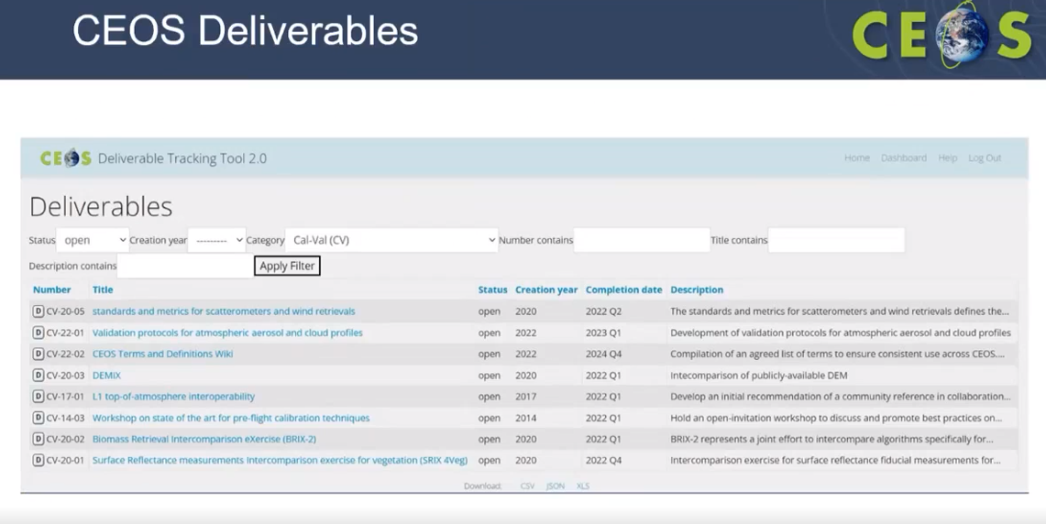
- For CV-20-03, Peter Strobl (EC-JRC) noted that he had discussed this with Marie-Claire to update the deadline to the end of December 2022.
- For CV-17-01, Nigel Fox (UKSA) noted that this had been reported to Marie-Claire, and the due date has been pushed back. IVOS needs to create a template of the results of different methodologies to complete the task.
- CV-14-03 and CV-20-02 due date has been postponed.
- CV-20-01 could be considered complete. The due date is the end of December 2022.
- Kuze-san will update the due date for the deliverables and report in the plenary.

SCR Update [Slides]
Presenter: M. Thankappan
Main points:
- Provided background on the space-based calibration mission
- There are many tradeoffs of increasing mass and complexities.
- Limited opportunities for cross-calibration coverage.
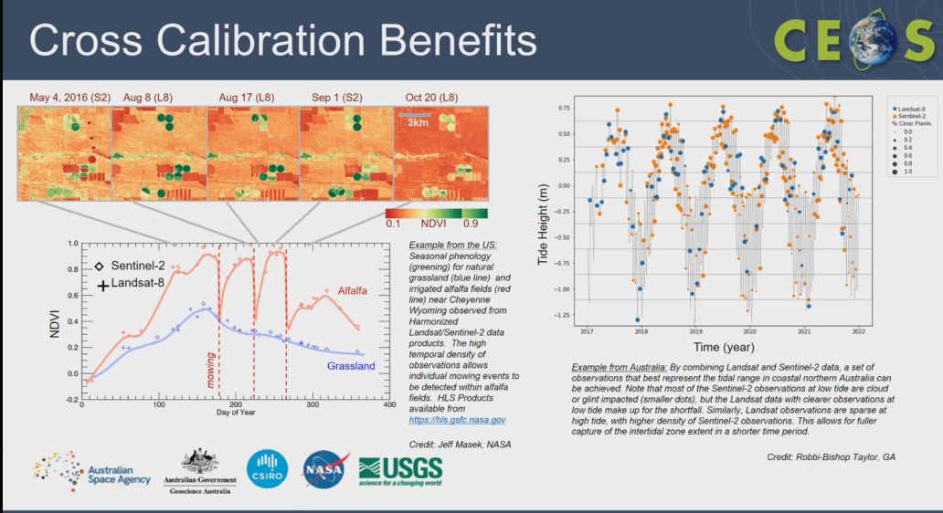
- Details of SCR background information are provided in the given slides.
- The rationale behind SCR is sustainable access to the datasets and not relying on the single sensor system.
- There is a huge potential to combine the multi-sensor data and cross-calibration that will help in achieving the multi-sensing data together.
- SCR is a series of four satellites designed to collect hyperspectral data. SCR 1 and 2 are block A. SCR 3 and 4 will be block B with a full capability system at the class C level.
- Australia is currently entirely dependent on foreign satellites for land imaging data. Moreover, most users in Australia are entirely dependent on data from a single satellite or satellite series – making them vulnerable to technical failures or sudden policy changes by foreign governments or companies.
- The SCR mission will help address one of the biggest challenges of successfully integrating satellite data from multiple sources, for interoperable use.
- SCR is different from SITSATs. SITSATs have a bottoms-up design approach for high-accuracy climate monitoring applications with SI traceable radiometric uncertainty below 1%. In contrast, SCR has a choice of COTS design meeting requirements for calibration transfer from a reference sensor (e.g. Landsat), which will perform similar functions, but lack the accuracy or traceability of SITSATs.
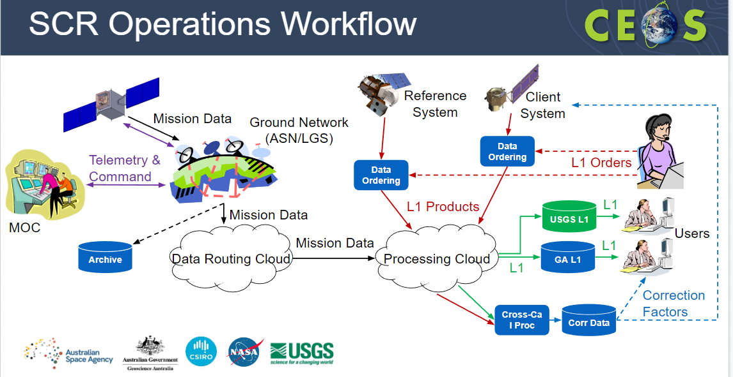
Discussion
- Onboard calibration solution is yet to be decided for SCR.
- Patrice Henry (CNES) asked about the SNL method and the viewing angle difference limits.
- Medhavy Thankappan (GA) noted the client system would be as close to nadir as possible. Not all client systems might be nadir at the time of SCR overpass. There would be some tolerances. Details are being worked out. Only nominal specifications are presented in the presentation slides.
- Nigel Fox (UKSA) noted the satellite scales with the swath and the uncertainties. For TRUTHS highest accuracy and lowest uncertainty have been arranged with a limit of 1 to 2 degrees for best performance. Other angles work, but with increased uncertainty. He noted the ‘golden’ overpasses that give ideal performance.
- Peter Strobl (EC-JRC) asked if SCR will record data constantly or if it will be a scheduled process.
- Medhavy noted SCR is a small satellite, so a scheduled process is being planned for recording data. Medhavy also noted that GA is initially working with the client partners system for the acquisitions process and that the data will be free and open.
- Santhishree Basavaraju (ISRO) asked will SCR data have a systematic collection near NADIR. Suppose there is a client system for calibration, will the client system also be oriented for the simultaneous pass by the SCR?
- Medhavy noted SCR data collection would not be systematic, rather it will have a schedule for data acquisition. He also noted that SCR would organise simultaneous takes for both systems based on the orbit dynamics.

Chinese SITSAT Update [Slides]
Presenter: P. Zhang
Main points:
- Updates on the Chinese Space-Based Radiometric Benchmark project.
- The project will focus on the high accuracy, stability and lifetime of the satellite to meet the climate requirements.
- Recalled the vision for WMO Integrated Global Observing System in 2024.
- The main goal is to harmonise the radiometric measurement from all operation platforms.
- There are various documents to support the SI-Traceable Space-based Climate Observing System
- Chinese Space Based Radiometric Benchmark (CSRB) project was initiated after realising the importance of reference-type missions for improving climate science and harmonising global satellite observations.
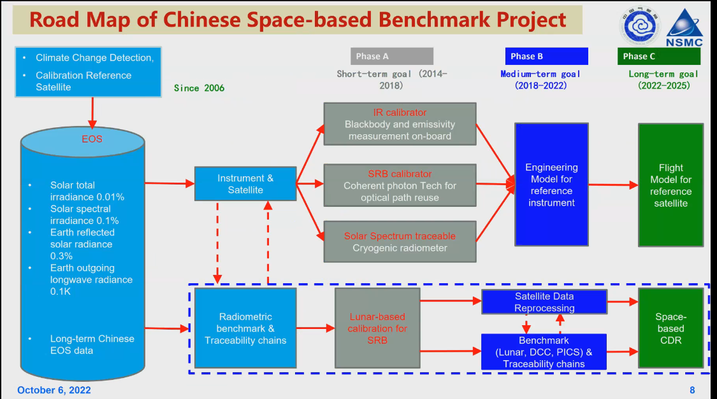
- The CSRB project is progressing well. The engineering model of the reference instrument (IRS, EMIS, TSI and SITQ) will be completed this year. The 3rd phase of CSRB will be funded by MOST from 2023.
- The LIBRA mission has not been approved yet. However, the demonstration mission with IRS is considered an opportunity mission by CNSA.
- IRS will be considered to mount on FY-5. The key technology of the EMIS, TSI and SITQ will be considered to be used in the development of FY-5 in 2028.
- Each satellite agency should consider samples and store the match-up data in the standard way by the recommended inter-calibration method as the satellite calibration metadata.
- More details can be viewed from the linked slides.

Discussion
- Matt Steventon (WGCV Sec) asked if the point ”Each satellite agency to consider sample and store the match-up data in the standard way by the recommended inter-calibration method as the satellite calibration metadata” is a suggestion or an action that WGCV should be taking.
- Peng Zhang (CMA) noted that it is a suggestion for agencies to consider.
- Kuze-san (WGCV Chair, JAXA) asked if there is a specific website for the CSRB data access.
- Peng noted CMA has a partnership with GSICS, and data can be accessed through the GSICS website. Peng will send the link to the reference.
TRUTHS [Slides]
Presenter: N. Fox
Main points:
- TRUTHS is an ESA earth watch mission currently being funded by the UK, Swiss, Romania and the Czech Republic. There may be other contributors to it following the next contribution grant in November 2022.
- TRUTHS is an operational climate mission which aims to benchmark the state of Earth, particularly by monitoring and measuring the incoming and outgoing radiation
- Provides SI Traceable measurements of the solar system
- A meteorology lab in orbit, does pre flight calibration at the highest level through the spacecraft. Mimicking the calibration on the ground.
- Establish a benchmark of ToA and BoA surface reflectance to help enable climate action supporting net zero, climate action and mitigation, adaptation and sustainability, climate sensitivity and response.
- An agile methodology, will have a continuous observation of the Earth throughout the day.
- TRUTHS 90°pole to pole orbit, observing through the diurnal cycle, allows many opportunities to overpass the orbit of sun-synchronous sensors.
- Underpins the operational ECV retrievals for climate monitoring, data set harmonisation, data-gap risk mitigation and model improvement.
- Sun as a source, Cryogenic Solar Absolute Radiometer (CSAR) compares the heating of optical power to electric power.
- Completing phase B1 to provide a mature concept.
- TRUTHS is planned to be launched on 2029/30 and will help initiate a sustainable long-term international climate & calibration observatory
- More details can be viewed from the linked slides.

Discussion
- Cindy Ong (CSIRO) asked to confirm the SWIR bandwidth wavelength for TRUTHS.
- Nigel Fox (UKSA) noted that the SWIR bandwidth would achieve <8nm (expecting 6nm). Some applications may choose to make bandwidth larger to achieve better SNR. The native resolution that will be downloaded is 6 nm.
- Cindy asked if a similar type of analysis done for OLCI-type sensors is planned for SWIR.
- Nigel noted the analysis has been done. For most of the other IR missions, the bandwidth is usually quite large, around 20-30 nm and similarly, other than hyperspectral missions typically have 10 nm resolution, the criteria we have for that will be closely matched. The hyperspectral missions at 10nm are typically aiming for around 5% uncertainty - TRUTHS aiming to be <5% but will be limited by the resolution.
- Medhavy Thankappan (GA) asked if it would be worthwhile to have a dedicated task team for SITSATs given discussions around SITSATs are of big interest.
- Nigel Fox (UKSA) noted he sees a value in having such a task group. TRUTHS was originally conceived in the frame of CEOS though initial discussions were conceived in IVOS. CLARREO has always been foreseen as a CEOS mission. He thinks there is value in a strategy to look at how SITSATS can work together, and how we can help motivate the community to build more SITSATs (also in MW, TIR) to build a VC. There would at least be CEOS-GSICS coordination. Building on what exists for CLARREO-TRUTHS, having a forum for international coordination. Need to know if agencies are interested in that. The community should work together to look at how to exploit all SITSATs and ensure coordination so they can be a system rather than independent entities.
- There were some discussions around having a dedicated VC for SITSATs.
- It was agreed that the information would be presented at plenary, consult with impacted agencies ahead of time, and ensure resources are there and the desire for those actively engaged to join such a group. The next step would be to develop a further concept for SIT-38 in March 2023.
WGCV-51-ACT-18 | WGCV Chair and Vice Chair to work with Nigel, Medhavy, Peng and others as interested to:  - Consult with agencies operating/planning SITSat missions regarding the idea to establish a CEOS team (exact form/governance TBD) that will work together on matters related to SITSats (e.g., collaborative activities, future developments, mission coordination, new technologies and bands, forum for international coordination, exploitation of data, ensure a system approach rather than independent missions; along the lines of a Virtual Constellation).  - Prepare an input for CEOS Plenary (for information) presenting the concept and seek feedback from CEOS leadership on the best way forward organisationally. | CEOS Plenary 2022
CNES CEOS Chair 2022 Cal/Val Priorities [Slides]
Presenter: P. Henry
Main points:
- Third priority of CEOS Chair 2022 is to push the definition of a network of sites for Land Surface Temperature (LST) measurements based on Thermal IR sensors.
- There are several existing TIR operational missions like ECOSTRESS, ASTER, LANDSAT-8 and 9.
- There will be more high-resolution missions in near future like TRISHNA, LSTM and SBG.
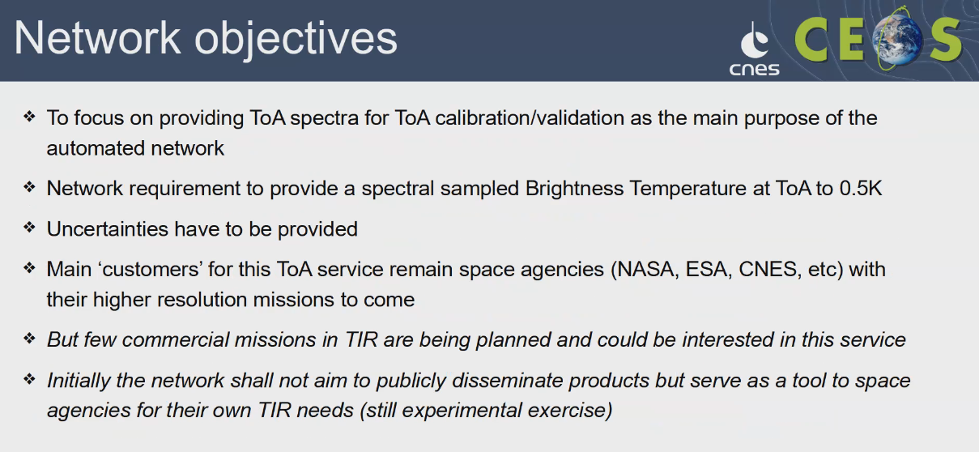
- The Working Group including WGCV/IVOS and LPV members meeting was held on 14 September 2022.
- The first task was to complete the inventory of the existing sites and methods. Focus on a few high-quality sites rather than a larger number of sites that may lack parts of the required characterisation. Also, focus on the way forward to establish budget uncertainties at the ground and ToA levels.
- It will be nice to have someone from the Australian team joining this WG.
- More details can be viewed from the linked slides.
Discussion
- Patrice Henry (CNES) suggested it would be good to report on the establishment of the LPV-IVOS working team at the CEOS Plenary.
- Philippe Goryl (WGCV Vice Chair, ESA) noted that this progress was reported to Selma Cherchali and agreed that it could also be shared at the Plenary.
- The idea is to have FRM in TIR Cal/Val sites in the sense that the Working Group will support the missions like Copernicus.
- Medhavy Thankappan (GA) noted as there are two WGCV subgroups involved so it would be WGCV level terms of reporting.
- It was agreed to report to the Plenary that WGCV has defined a WGCV task team/group to take this action forward - established composed of LPV and IVOS representatives.
- Cindy Ong (CSIRO) the perception was that the WGCV subgroups work in isolation to demonstrate the subgroups and cooperation and collaboration is important. The IVOS and LPV would be a collaboration effort.
- Nigel Fox (UKSA) noted the future objective of TIR Cal/Val sites would be to have an operational network analogous to brightness temperature at top of the atmosphere.
WGCV-51-ACT-19 | WGCV Chair to report to CEOS Plenary on the establishment of a joint LPV-IVOS working team under WGCV that is taking forward the exploration of a network of TIR cal/val sites that will provide TOA spectral brightness temperature, noting that this is in response to the CNES 2022 CEOS Chair priority and is being undertaken to support high-resolution TIR missions that are forthcoming from a number of CEOS Agencies. | CEOS Plenary 2022
CEOS Cal/Val Portal Update [Slides]
Presenter: P. Castracane
- As of 26 September 2022, there are 1069 registered users of which 155 are CEOS WGCV SAR Subgroup members and 21 are terms and definitions editing members.
- Maintenance and support of Cal/Val Portal is a two-year funded project and will begin in 2023.
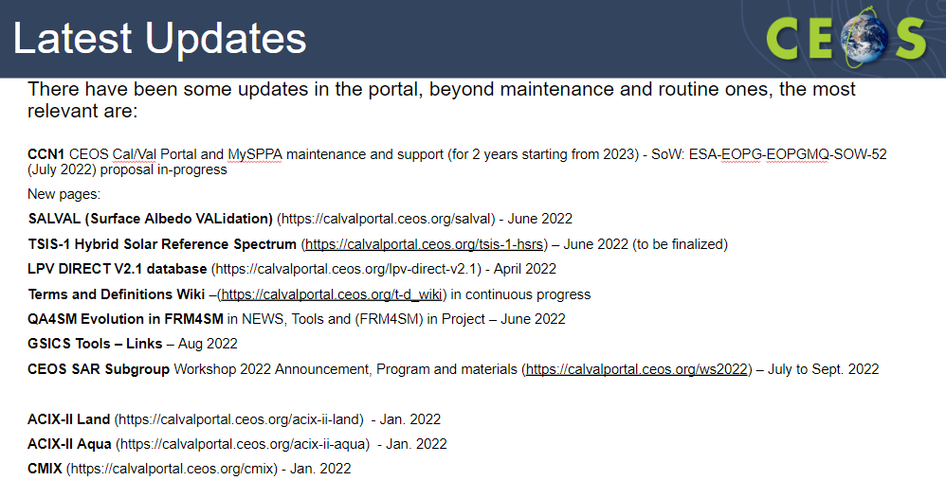
- For more information on the latest updates please check the linked slides.
- Next steps involve implementing the actions (WG-50-ACT-08, WGCV-50-ACT-05 and ESA IDEAS/QA4EO Cal/Val data and activities) currently in progress. Finalisation of CCN1
- Latest updates and news shall be emailed to the WGCV community every two months interval. Periodic newsletters will be released every nine months after each WGCV plenary.
- Plan to increase outreach activities on the Twitter account: @CEOS_WGCV.
Discussion
- Philippe Goryl (WGCV Vice Chair, ESA) noted that a connection with SEO / Libby had been made. Will seek to coordinate and promote increased CEOS WGCV Twitter content. Now have CEOS, CEOS-ARD and CEOS-WGCV Twitter which should be consistently coordinated.
- Philippe reiterated that Paolo would send requests for inputs to the planned Cal/Val newsletter via email. Please keep an eye out for that and contribute where possible. This will be done nine months after each WGCV Plenary.
- Peter Strobl (EC-JRC) suggested having more cross-links between the ceos.org and the Cal/Val portal.
- Matt Steventon (WGCV Secretariat) noted the recent revamp of the CEOS ‘Our Work’ page which has a link for the Cal/Val portal. Matt agreed more could be done to increase cross-links.
WGCV-51-ACT-20 | Matt and Paolo to increase the number of links between the main ceos.org website and the Cal/Val Portal. | WGCV-52
Space Agency Reports
CSA [Slides]
Presenter: M.Dejmek [Virtual]
- Provided updates on SCISAT and OSIRIS on Odin Cal/Val activities, PEARL and Eureka site instrument activities.
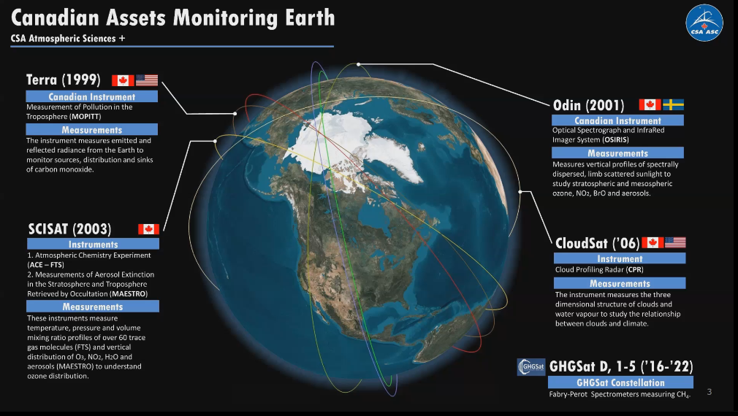
- PEARL is an important location for the validation of Arctic satellite measurements and has contributed to the validation of data from 15 national/international instruments.
- PEARL instruments are affiliated with multiple international networks involved in satellite validation, including NDACC, TCCON, AERONET, Pandonia and MPLNet.
- New missions being planned include HAWC on AOS, AOM and CASS.
- PEARL will not be available to support Arctic validation of current and new missions unless new funding is found soon. Stable and predictable support is essential for maintaining expertise and operations.
- More information can be viewed from the linked slides.
Discussion
- Philippe Goryl (WGCV Vice Cahir, ESA) recommended Marcus Dejmek (CSA) to contact Paolo or himself if CSA would like to communicate some of the results in the Cal/Val portal.
- Marcus Dejmek (CSA) noted the presentation that he presented today was mostly concentrated on Greenhouse gases. CSA has missions related to SAR and will plan on having updates for SAR Cal/Val work for the next WGCV meeting.
NOAA [Slides]
Presenter: J. Choi presented on behalf of Changyoung Cao.
- Reported on Polar Orbiting Satellites (Soumi NPP VIIRS, NOAA-20) and Geostationary Satellites.
- Soumi NPP VIIRS had anomalies from 26 July to 18 August 2022. It has been fully recovered after the anomaly with negligible impacts.
- NOAA-20 (J1) VIIRS showed a stable radiometric performance in the RSB based on SD and SDSM calibrations, lunar F-factors and DCC observations.
- JPSS-2 VIIRS will be launched on 1 November 2022.
- Working on developing a time series for a global 20 plus site validation system. More details can be viewed from this link: https://ncc.nesdis.noaa.gov/Globe/index.php
- Have 10 global regional sites for Global/Regional Validation Site (GReVS). Global-regional validation sites for polar orbiting satellites with near real-time display, analysis, and monitoring to support satellite missions. More details can be viewed from this link: https://ncc.nesdis.noaa.gov/Regional
- GOES-16/17 ABI are currently operational.
- GOES-18 was launched on 1 March 2022. GOES-18 ABI Level 1B radiance data achieved provisional maturity on 28 July 2022 and became publicly accessible.
- GOES-18 will replace OES-17 as the GOES-West at 137W in early 2023.
- More details can be viewed from the linked slides.
EU project CCVS [Slides]
Presenter: J-C Lambert (BIRA-IASB)
- Reported the progress made on the EU H2020 Copernicus Cal/Val Solution (CCVS) project.
- The objective of CCVS is to define a holistic solution for all Copernicus Sentinel missions to overcome the current limitations of Cal/Val activities.
- It is a consortium project led by ACRI with fourteen different partners involved.
- All deliverables and series of reports are publicly available on CCVS website.
- Some CCVS WGCV highlights are shown in below screenshots and more details can be viewed from the linked slides.
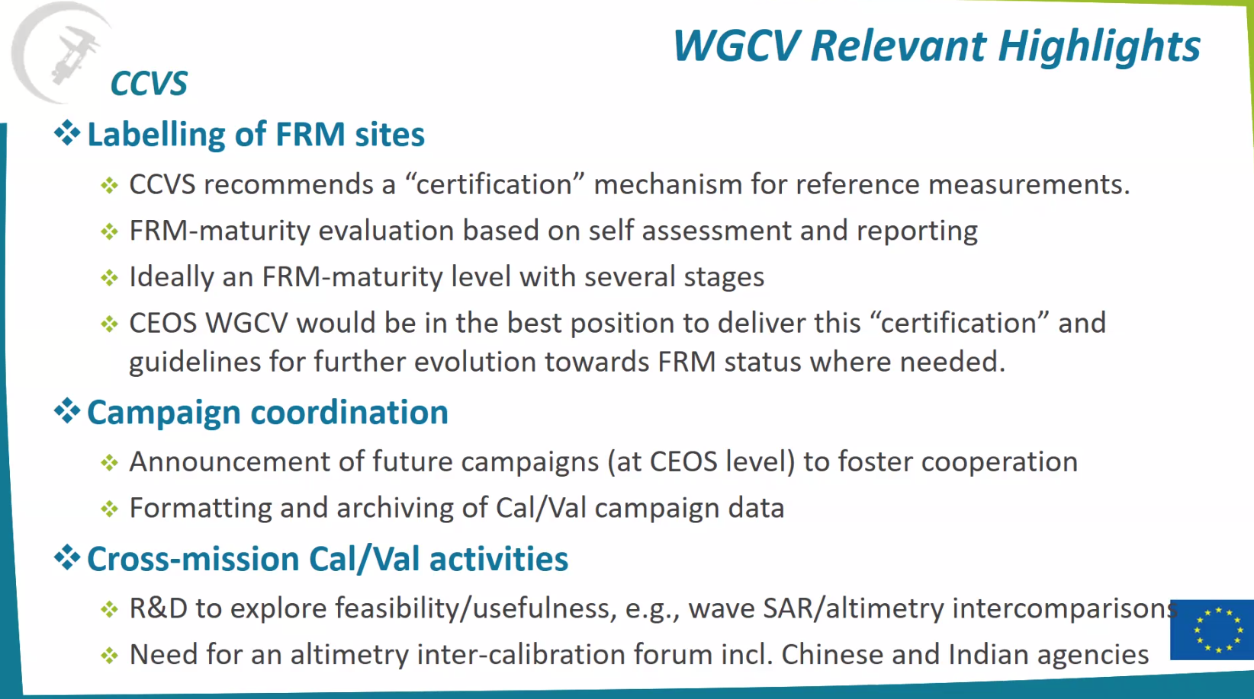
GISTDA [Slides]
Presenter: S. Moukomla
- THEOS-1 (THAICHOTE) is still operational.
- THEOS-2 is a 50 cm resolution satellite currently being built by AIRBUS.
- Twenty engineers from GISTDA were sent to get trained from the University of Surrey for THEOS-2A. The satellite was transferred to Thailand in the SNV facility.
- GISTDA has been participating in Cal/Val activities.
- GISTDA is the incoming CEOS chair for term 2023-2024.
- THEOS-1 pointing accuracy method is based on the comparison of the programmed area at MPC level through acquisition plan export with the real acquired area that comes with the inventoried segments at the image terminal level. The pointing accuracy of THEOS-1 has been stable in the last two years.
- Have six different locations, Barcelona, Beijing, Canberra, Los Angeles, Port Said, and Santiago for testing the geolocation accuracy. The result of location accuracy for THEOS-1 is still stable.
- Test site location for THEOS-1 can be viewed through this link.
- Results for vicarious calibration conducted in Thailand were unstable with a high error rate. Hence, GISTDA seeks opportunities to do calibration outside Thailand.
- GISTDA joined the APSCO Radiometric Calibration of Satellites Sensors project from 2017 to 2019 to perform the radiometric calibration.
- Asked WGCV to invite GISTDA if any agency plans to perform any calibration projects in the future.
- GISTDA is happy to assist with anything related to Cal/Val activities.
WGCV-51-ACT-21 | Paolo to work with the GISTDA team to include THEOS-1 calibration site data on the Cal/Val Portal. | WGCV-52
CSIRO [Slides]
Presenter: C. Ong
- Noted new developments with a coarse spatial resolution site; Work at Pinnacles with the new imaging spectroscopy satellites; and new national Cal/Val facility.
- Designed a custom trailer to minimise land disturbance and ease transportation of the mast. Did not make a traditional platform to minimise land disturbances.
- Started deployment on 21 March 2022. Have replaced the initial robot with the new one.
- Had issues of cable entanglement but ceased after 1 May 2022.
- EnMap overpass was conducted on 20 August 2022.
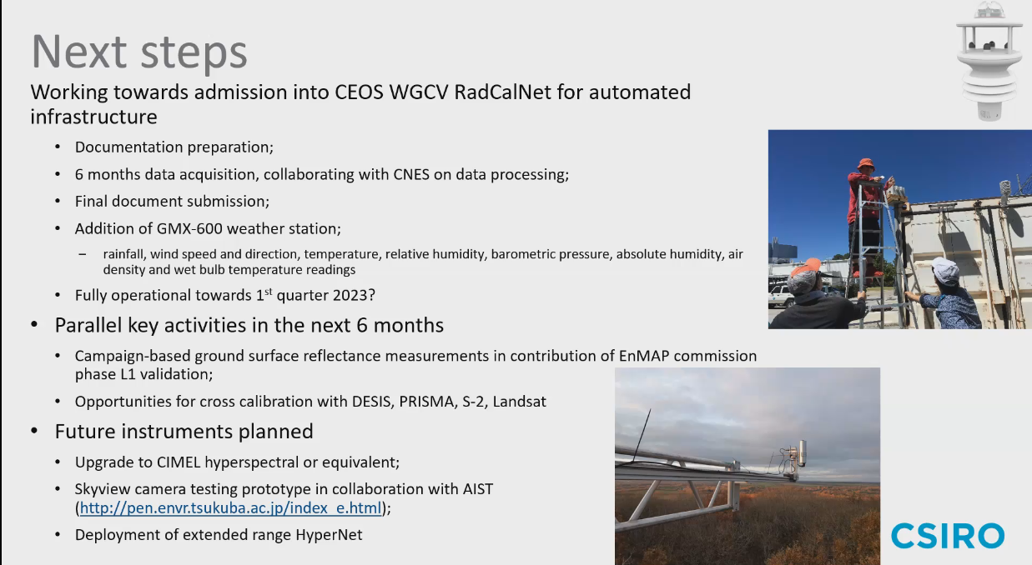
- Had a workshop on the validation of surface reflectance across vegetation on 22 August 2022. Need to develop an Australian community approach for collecting data and validating the surface reflectance products over vegetated areas.
- Proposing to extend the SRIX4Veg initiative by bringing SRIX4Veg to Australia with more considerations such as complex heterogeneous cover types, inclusions of profilers, assessments of complexities and associated uncertainties, a permanent automated system on towers, possible extension beyond VNIR.
Discussion
- Philippe Goryl (WGCV Vice Chair, ESA) asked if the Pinnacle site be a SARCalNet site. Cindy Ong (CSIRO) noted no ground infrastructure to support SAR instruments at Pinnacles. NovaSAR is the satellite, and the idea is to collect the data from the site to validate the data.
USGS [Slides]
Presenter: C. Anderson
- Reported on the calibration of the recently launched Landsat-9 and JACIE.
- Landsat-9 was launched on 21 September 2021, and the first data was released on 10 February 2022. Data can be accessed through https://earthexplorer.usgs.gov/ . Reprocessing of first-year data will be conducted in December 2022.
- Landsat-9 carries operational Land Imager (OLI) and Thermal Infrared Sensor (TIRS). It has significant improvement over LANDSAT-8. There have been no issues with Landsat-9 on-orbit performance.
- Landsat-9 is being raised to its nominal orbit height.
- On JACIE, USGS is trying to collaborate with VH-RODA for some collaboration activities.
- Trying to get the EROS RadCalNet Site at USGS EROS, South Dakota, USA up and online.
- More details can be viewed from the linked slides.

Discussion
- Philippe Goryl (WGCV Vice Chair, ESA) asked if the radiometric calibration parameter of Landsat 9 on-orbit performance is also in the ARD specification. Cody Anderson (USGS) noted it is the specification for the actual instrument and not the ARD specification. It is the specification before applying terrain correction. It becomes ARD compliant after adding terrain correction and orthorectification.
- Eric Vermote (NASA) asked what the resolution of the tier band for geometric calibration of Landsat-9 is. Cody Anderson (USGS) noted it is the cross-registration between OLI and TIRS correlation. 30 m between OLI and TIRS instruments.
- Eric asked if there is only one instrument for RadCalNet. Cody noted there are three viewing radiometers of 100m by 100m.
NASA [Slides]
Presenter: X. Xiong
- Reported on Visible Infrared Imaging Radiometer Suite (VIIRS) Instrument Calibration status.
- JPSS-1 was launched on 18 November 2017, JPSS-2 is scheduled to launch on 1 November 2022, PSR of JPSS-3 was completed on 22 June 2022, and JPSS-4 testing is planned for 2023.
- Both S-NPP and N-20 VIIRS continue to perform well; changes in spectral band responses are accurately tracked via onboard calibrators (OBC) as well as lunar observations; data quality is continuously maintained through timely updates of calibration look-up tables.
- J2 and J3 VIIRS pre-launch test program was successfully completed; high-quality data was collected and analysed to support sensor performance assessment; Overall performance exceeds requirements with a few non-compliances; all non-compliances have been reviewed with impacts investigated and mitigation plans prepared and tested for on-orbit processing.
- Lessons from S-NPP/J1/J2/J3 VIIRS to be applied for J4 VIIRS; JPSS-4 VIIRS sensor TVAC testing to start in 2023.
- Ongoing preparation for J2 launch; VIIRS algorithm changes and LUTs development have been made to support its SDR processing.
- More details can be viewed from the linked slides.
Discussion
- Nigel Fox (UKSA) asked about scattering. Jack Xiong (NASA) noted scattering in one of the SNP, and overpolishing caused more polarization leading to scattering. These were taken as lessons learned for the future.
- Eric Vermote (NASA) how is the spectral response after launch measured?
- Jack Xiong (NASA) noted it is not measured but is categorised. It is not a measurement but an observation.
BELSPO [Slides]
Presenter: J-C Lambert
- Level 2 validation plan for Atmospheric Limb Tracker for the Investigation of the Upcoming Stratosphere (ALTIUS) is in the development phase.
- The existing validation facility for Sentinel-5P TROPOMI is the pathfinder for the operational validation of ALTIUS.
- New ATM-MPC Sentinel-5P validation activities include PICS-based evaluation of TROPOMI L1B_RA, validation of AER_LH with EARLINET lidars, and PGN-based validation of SO2, HCHO and O3. Validation of full mission reprocessing is progressing.
- ESA FRM4DOAS has funded Central Data Processing System for UV-Vis MAX-DOAS instruments.
- BIRA-IASB coordinates the CREGARS center of the EU research infrastructure ACTRIS for harmonization, central processing and archiving of trace gases FRM datasets.
- HYPERNETS are automated measurements for validation of water and land surface reflectance at all VIS/NIR spectral bands (400-1700 nm, @3nm FWHM)
- In the context of the ESA SPAR@MEP study, Rayference has worked on the radiometric harmonisation of Vegetation-1, Vegetation-2 and PROBA-V data.
- PROBA-V calibration appears consistent and robust while some adjustments are needed for the two Vegetation instruments.
- Rayference is assessing the impact of measuring bottom-of-atmosphere HDRF that can constitute the intended FRM database to estimate top-of-canopy BRF within the CCVS framework. This study uses the Eradiate radiative transfer model to simulate in-situ (UAV) and top-of-canopy measurements on a 3D vegetated cover.
- Working on the validation of LCI L1 radiometry with OSCAR Rayleigh, OSCAR Sun glint and Lunar Lime Model.
- More details can be viewed from the linked slides.
Discussion
- Kuze-san (WGCV Chair, JAXA) asked where the validation data can be accessed.
- J-C Lambert (BIRA-IASB) noted that the validation results are available through https://mpc-vdaf.tropomi.eu/ facility.
- Cindy Ong (CSIRO) asked are the reference data available in the Cal/Val portal. She proposed to develop guidance material similar to the Cal/Val portal.
WGCV-51-ACT-22 | Philippe Goryl, Jean-Christopher Lambert and Paolo Castracane to discuss additional atmospheric composition reference data for the Cal/Val Portal. | WGCV-52
JAXA [Slides1 ] [Slides2]
Presenter: A. Kuze
- Provided an overview of JAXA’s EO satellites and sensors.
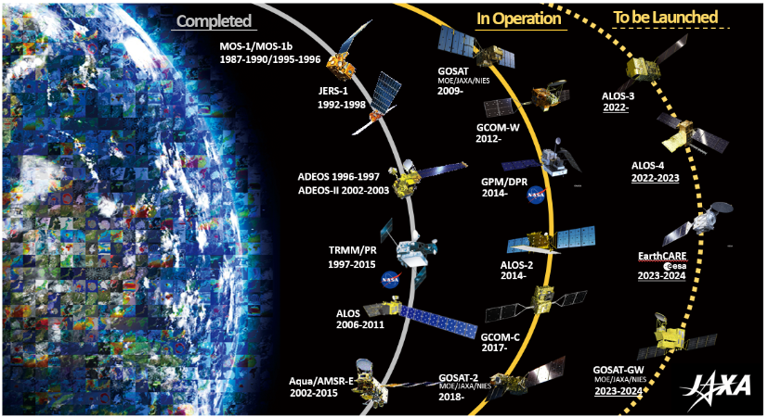
- ALOS-3 is a wide swath high-resolution optical imager satellite.
- Both ALOS-3 and ALOS-4 are ready to be launched. Once the H3 launch vehicle is ready both satellites will be launched.
Presenter: Kazuhisa Tanada (Responsible for algorithm development and validation works)
- GCOM-C was launched in December 2017.
- GCOM-C data are validated with the help of sky radiometers, sky-camera and other satellite products such as MODIS.
- GCOM-C atmospheric products are validated with various in-situ data, and it continues to maintain the in-situ instrument data to validate the satellite products.
- More details can be viewed from the linked slides.
ISRO [Slides]
Presenter: S. Basavaraju, K.N. Babu
- INSAT 3D/3DR, ResourceSat-2, and CartoSat-2 are the current satellites on board. Also, EOS-04 and EOS-06 are C-Band SAR sensors that have been successfully launched and are in the operational phase.
- Two new river sand basin sites have been identified, for measuring coarse resolution. It is being covered with the support of Landsat-8. The sites are not automated, and the calibration exercises are conducted manually.
- Landsat-9 vicarious calibration experiment was conducted at Mandarna site.
- SARCalNet expansion was conducted using C-Band sentinel data. The results were promising.
- INSAT-3D/3DR vicarious calibration was conducted in the desert site. VIS and SWIR channels were monitored regularly, and the results were shared.
- Oceansat-3 will have both land and global area coverage mode. It will have a marching orbit to obtain glint-free data after eight days.
- More details can be viewed from the linked slides.

Greenhouse Gas Cal/Val Update [Slides]
Presenter: A. Kuze
Main points:
- Organised a joint RRV 2022 campaign in June 2022. Had coincident measurements for five instruments: GOSAT, GOSAT-2, OCO-2 (partially cloud), OCO-3, and TROPOMI (every day).
- GHG Vicarious Calibration Portal linked from the WGCV Cal/Val Portal is established as a means to bring some standardisation, commonality, and provide all of the datasets in a single location. Provides datasets used for analysis as well as results from GOSAT FTS, OCO, S5P TROPOMI. Also a 14-year annual joint campaign data for Cal/Val, surface albedo, radiosonde data, CO2 and CH4 total column data, etc.
- Have a joint GHG Vicarious Calibration Campaign site. This is the first site to measure vicarious calibrations for larger footprints. >2 km as compared to the MODIS instrument. Tried using IFOV corrections to extend the footprint.
- Have started the reanalysis using the single forward calibration transfer modules in five different instruments.
- Common campaign data and radiative transfer code using five instruments namely GOSAT(RRV2009-), OCO-2 (RRV2015-), TROPOMI (RRV2018-), GOSAT-2 (RRV2019-), OCO-3 (RRV2019-)
- Each instrument is looking in the same direction but with a different footprint and geometry. So the instruments were intercompared with NADIR spectral levels
- There are current challenges with using the HITRAN database. The OCO team has prepared a GHG specific database for more appropriate values limited to OCO-2 spectral and CO2 bands. This will be expanded for wider use.
- Polarisation is another issue. If polarisation information is known then we can retrieve aerosols and thin clouds. Consider 3 polarisations: High spectral resolution spectrometers,
- Currently checking if two different geometries are producing the same vicarious calibration result or not.
- GHG Vicarious portal datasets and the 2022 summer methane campaigns are both key sources available to IMEO, noting SIT's priority for CEOS-IMEO collaboration.
Review of WGCV Presentation for the 2022 CEOS Plenary
Presenter: A. Kuze
Main points:
- Kuze-san and Phillipe will work together to prepare the final presentation before the plenary.
- WGCV will propose Cody Anderson as WGCV Vice Chair 2023-2024.
- Propose to change the WGCV Terms of Reference for the Vice-Chair voting process.
- Agree J-C Lambert as the new ACSG Chair.
- WGCV will support New Space.
- WGCV will collaborate with IMEO through emails. Kuze-san will be the PoC from WGCV if WGCV agrees.
- CEOS CAL-VAL portal update.
- Report the result of Maturity Matrix and update on the joint meeting with WGISS.
- Initiate the idea of establishing the SITSAT team. Kuze-san will propose the plan at the next SIT-TW.
Discussion
- Cindy Ong (CSIRO) suggested focusing on three key items for the Plenary presentation. The items could be linked to CEOS SIT priorities, CEOS Chair priorities and so on.
- Peter Strobl (EC-JRC) noted LSI-VC will ask CEOS for support on Interoperability Framework so it does not have to be reported in the WGCV slides. Matt Steventon (WGCV Sec) suggested WGCV could intervene during LSI-VC presentation on interoperability. Matt will keep an eye on interoperability.
- There should be an opportunity to see WGISS presentation to harmonise the presentation before the plenary.
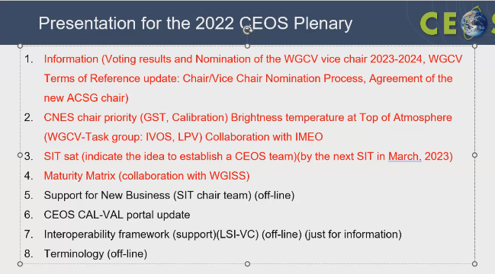

WGCV-52 Meeting Preparation
Presenter: P. Goryl
Main points:
- Proposed 5-9 June 2023 for WGCV-52 meeting.
- The week after WGCV-52 will be the LPV Workshop Plenary. It would be a good opportunity for people to join. This is to be confirmed.
- Planning to have some focused teleconferences before the next WGCV plenary to review the open actions: e.g. SITSAT, EAIL, WGISS Maturity Matrix telecon.
Decision 07 | WGCV-52 will be held 5-9 June 2023 at ESA ESRIN.

Day 3 Action Review, Close
Kuze-san (WGCVChair, JAXA) reviewed day 3 action items. He thanked everyone for joining and closed Day 3 of the WGCV-51 meeting. He noted that this was the first and last in-person meeting on JAXA’s Chair term and acknowledged everyone who joined in-person despite the strict Covid rules to enter Japan.

