Minutes
WGCV-WGISS Joint Meeting
Wednesday, 5 October 2022
Participants
AEM Adrian Guzman*
BIRA-IASB Jean-Christopher Lambert
CNES Patrice Henry, Richard Moreno
CONAE Angel Matias Palomeque*
CSIRO Cindy Ong, Ian Lau*
DLR Katrin Molch*
ESA Philippe Goryl, Paolo Castracane, Damiano Guerrucci*, Iolanda, Mirko Albani,
Damiano Guerrucci*, Filippo Marchesi*
EC-JRC Peter Strobl
GISTDA Sitthisak Moukomla, Prayot Puangjaktha, Pakorn Apaphant,
Panu Srestasathiern, Nuttavipa Thanthawewut
GA Medhavy Thankappan
ISRO Nitant Dube, Santhi Sree Basavaraju, KN Babu
JAXA Akihiko Kuze, Hiroshi Murakami, Yukio Haruyama*, Kazuhisa Tanada,
Takeo Tadono*, Makoto Natsuisaka, Ikehata Yousuke
MYSA Jessica Wong*, Adhwa Amir Tan*
NASA Xiaoxiong (Jack) Xiong, Eric Vermote, Minnie Wong, Diane Davies, Michelle Piepgrass,
Andrew Mitchell, Doug Newman
NOAA Taeyoung Jason Choi*, Ken Casey*
NPL/UKSA Nigel Fox
NRSCC Xiaolong Dong*
RESTEC Michihiro Koide
STFC UKRI Esther Conway
USGS Cody Anderson, Tom Sohre
WGCV Sec Matt Steventon*, Riza Singh
AIR-CAS Xuesong Li *
Spacebel Yves Coene*
Solenix Bryan Keary
Velarie Dixon, Michael Morahan, Dawn Lowe, Julie Warner, Paolo Sacremento
* Virtual Participants

Opening Remarks
Kuze-san (JAXA, WGCV Chair) welcomed everyone to the first WGISS-WGCV Joint Symposium.
WGCV Overview [Slides]
Presenter: A. Kuze
Main points:
- Shared updates on the recent topics at WGCV, noting that WGCV will nominate Cody Anderon (USGS) as Vice Chair for 2023-2024. WGCV is happy to support New Space, and WGCV will collaborate with the International Methane Emissions Observatory (IMEO).
- Recalled CNES CEOS Chair Priorities 2022 and noted WGCV’s objectives align with all the priorities, mainly with the third priority, i.e. supporting Cal/Val initiatives. WGCV supports the cross-calibration of thermal infrared measurements.
- OCO-2, OCO-3, GOSAT, and GOSAT-2 have important calibration and validation work which supports the UNFCCC Global Stocktake.
- WGCV has six subgroups: Atmospheric Composition (ACSG), Infrared Visible Optical Sensors (IVOS), Land Product Validation (LPV), Microwave Sensors (MSSG), Synthetic Aperture Radar (SAR) and Terrain Mapping (TMSG).
WGISS Overview [Slides]
Presenter: M. Natsuisaka
Main points:
- Working Group on Information Systems and Services (WGISS) promotes collaboration in developing systems and services that manage and supply Earth observation data as a working group of CEOS.
- Recent topics include data integrity, authenticity on the cloud, data quality assessment and indicators and DMSMM Maturity Matrix-Best Practice, WGISS Connected data assets
- Best practices documents are STAC, Service Discovery, Data Quality Assessment and Indicators and DMSMM Maturity Matrix.
- EAIL has been initiated, and many WG and VC have shown interest in EAIL. The continuity of EAIL is an issue as Robert Woodcock has resigned from the group.
- Best practices for Jupyter notebooks initiative will be issued soon.
- White paper for machine learning initiatives is being prepared.
- WGISS has cooperation with various CEOS entities.
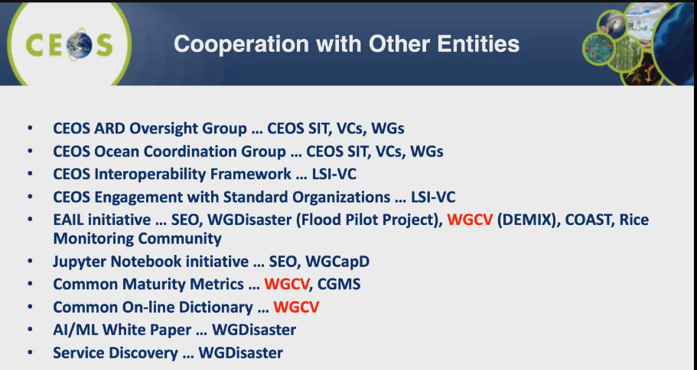
ESA EO Portal, CEOS Cal/Val Portal, CEOS MIM Database: Status, Synergies and Improvements [Slides1]
Presenter: M. Steventon, P. Castracane
Main points:
- Matt Steventon provided an overview of the CEOS Missions, Instruments Measurements (MIM) database presentation on MIM database noting that there is an annual survey for updating the MIM database. New developments include quarterly reports, datasets, sensor response curves, gap analysis tools, etc.
- Information on open search integration, ESA TPM, CEOS-ARD, Featured Datasets, and Commercial Cloud has also been added to MIM.
- CEOS Quarterly reports are published on https://ceos.org/mim-reports-archive/
- EoPortal is maintained by ESA. It provides a trusted, accurate and up-to-date gateway to knowledge and resources related to Earth observation missions.
- Future plans for EoPortal include continuing refinement of the current integration of CEOs Database integration in the EO Portal, considering ways for additional richness such as measurements, GCOS, SDGs, Disasters content from CEOS Database, future development of the content team built off of evolution project.
- Opened the floor for further discussion on the below topics:
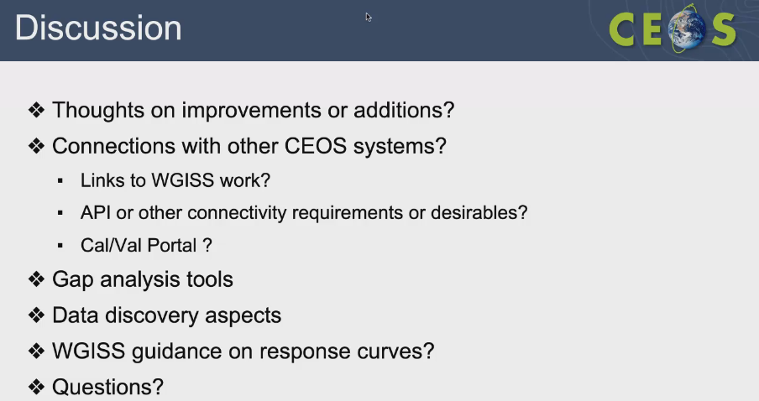
Discussion
- Andrew Mitchell (WGISS, NASA) asked what datasets are available in the AWS registry.
- Matt noted there are Sentinel-2, LANDSAT-2, LANDSAT-8 record collections in the AWS.
- Andrew Mitchell (WGISS, NASA) asked if there is any link between the MIM and ECV inventory and if the link is manual or automated. Matt noted ECV inventory is integrated into the MIM database and there should be links to the ECV inventory.
WGCV-WGISS-ACT-01 | Matt to check with George on the specifics of MIM ECV inventory. | COMPLETE
CEOS Cal/Val Portal [Slides2]
Paolo presented on CEOS Cal/Val portal.
Main points:
- CEOS Cal/Val portal is the main forum for the exchange of information related to CEOS WGCV.
- Cal/Val is the centralised space for the WGCV subgroups. There are two websites for IVOS and SAR subgroups.
- LPV has an independent website, and Cal/Val portal has a link to the LPV website.
- Presented the Cal/Val portal screenshots for various subgroups.
- There is a specific WG for compiling the terms and definitions wiki. This is a work in progress.
- There is a page dedicated to the Cal/Val site that shows the general network or endorsed network from CEOS.
Discussion
- Velarie Dixon (WGISS) asked how the Cal/Val portal provides access to data.
- Paolo Castracane (ESA) noted WGCV has access to EVDC, NTF information, and older data access. One must register on the Cal/Val portal to access the data. There are different access rights provided for different roles.
Status of ARD Activities [Slides]
Presenter: M. Steventon presented on behalf of F.Gascon
Main points:
- CEOS-ARD aims to facilitate data usage by reducing the data processing burden on users. It is a key step within the ‘interoperability spectrum’.
- CEOS-ARD compliance assessment increases confidence and expands the reach and uptake of datasets.
- ALOS-2 PALSAR-2 Normalised Radar Backscatter ARD from JAXA is under peer review.
- CEOS-ARD concepts are the first step and gridding, cloud optimisation, discoverability (STAC), consistent terminology, radiometric and geometric references and traceability are also needed. There is a critical role for WGCV and WGISS in the CEOS Interoperability Framework.
- An action from the SIT-TW 2022-03, CEOS Agencies to consider resourcing people with CEOS-ARD heritage to join the OGC ARD Standards Working Group. Matt has emailed for participation and feedback on the charter for this action. Please let Matt know if anyone is interested in contributing.
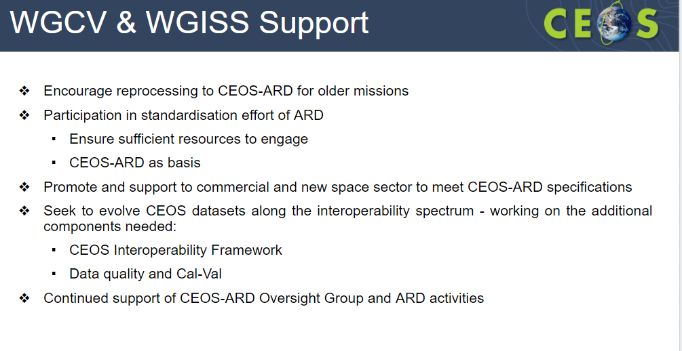

Data Quality Assessment and Indicators, and DMSMM Maturity Matrix [Slides1] [Slides 2][Slides 3]
Presenter: I. Maggio, P. Goryl, P. Castracane
Philippe Goryl (ESA) reported:
- Provided a brief overview on QA4EO Principle. Data and derived products shall be associated with the GEO vision for a Global Earth Observation System of Systems (GEOSS) with a fully traceable indicator of their quality.
- The quality indicators can be expressed in different layers of information. WGISS and WGCV need to collaborate on the data quality indicators aspects.
- A lot of work has been done beginning last year to derive pixel-level uncertainties.
- Have developed Cal/Val Maturity Matrix (MM) in collaboration between ESA and NASA to assess the quality of commercial missions and New Space in particular. The EarthNet program also compares the results which is a kind of harmonisation.
- Have developed guidelines to help people understand the maturity matrix.
- More details are provided in the linked slides and the video.
Iolanda Maggio (Rhea Group, ESA) reported:
- DMSMM is a way to measure processes for the stewardship of the data.
- MM has embedded parts for planning and execution with policy, and hence it has been named DMSMM.
- The CEOS WGISS DMSMM generation process was shared.
- Original MM has only one column related to Data Quality. This was reviewed by the experts, including WGCV, and WGISS teams and came up with different components.
- The white paper with the description of each component can be found here.
- Five areas of DMSMM are discoverability, accessibility, usability, preservation and curation. It has 12 components and all 12 components cannot be covered or managed individually.
- More details can be viewed from the linked slides.
Paolo Castracane (ESA) presented on Quality Assessment Framework.
- Objective of EDAP is to perform quality assessments on various Earth observation missions.
- Cal/Val Maturity Matrix is dedicated to the validation and verification of activity.
- The Maturity Matrix tool is currently under development.
- Full framework of the AVHRR L1B Dataset Maturity Matrix was shared. More details can be viewed from the linked slides.
Discussion
- Tom Sohre (USGS) noted that WGISS is planning to release a white paper to explain how to use the Maturity Matrix (MM). This is a work in progress. He asked Paolo if the Maturity Matrix tool is only focusing on WGCV MM or if it would be covering other commons.
- Paolo Castracane (ESA) noted files could be configured when XML is available. It is a dynamic site. We can also get feedback from users. This is a good way to process to have more flexibility.
- When the tool is available it will facilitate the work. The configuration is a more critical part. It requires an expert to do this. Will try to make this tool as easy as possible.
- Tom Sohre (USGS) noted the objective of the MM. We have several examples of heritage missions, and many datasets and some were not accessible. He asked to what extent we should be using the datasets, what do users want from the dataset and how much money needs to be invested. This method is easy to use. You make an assessment to see where you are then try to understand from the user communities what they want and what can be offered. We start defining the objective, and at the end, we assess what is done and make the analysis. We are using the matrix and will be a helpful support to the WGISS as well as WGCV.
- Iolanda Maggio (Rhea Group, ESA) noted an evolution of the Maturity Matrix tool can be presented at the next WGISS meeting.
- Tom Sohre (USGS) noted when producing downstream products, the primary datasets should have DOIs. In theory, initial information should not be collected. There are a lot of DOIs implemented in place.
- With the recent inclusion of datasets in the MIM DB, perhaps the Maturity Matrix information could also be featured in future.
- J-C Lambert (BIRA-IASB) noted that the latest update of the WGISS DMSMM distributed today is limited to only two aspects of the data validation (MMP6: 'Validation Method' and 'Validation Results Compliance'), while previous version 1.3 judged also the maturity of 'Reference Data Representativeness' and of 'Reference Data Quality', which are essential aspects as well and should probably be restored in the DMSMM. He noted also that the logical sequence is to perform (prognostic) Data Uncertainty characterization (currently MMP7), then (diagnostic) Data Quality Control when the EO data are being produced (currently MMP8), and finally (diagnostic) Data Validation of the QC'ed data (currently MMP6); therefore, columns should better be reordered accordingly (MMP7, MMP8, MMP6). He asked about the mechanism for providing feedback on the WGISS Maturity Matrix.
- Tom Sohre (USGS) noted a consolidated version of MM is available and shall be shared with WGCV for review.
- Ken Casey (NOAA) noted at NOAA when similar DMSMMs were applied at scale to about four hundred datasets, it was very expensive and consumed much time and energy. He asked who is expected to assess datasets using these Cal/Val and DMSMM maturity matrices and at what point in their data lifecycles.
- Tom Sohre (USGS) noted this depends on the situation. ESA has started to do the analysis for heritage missions. It can be done at different steps of the data lifecycle.
- Philippe Goryl (ESA) noted that the Cal/Val and WGISS MM have different objectives. Cal/Val MM was developed to access commercial data, smallsat or new space missions, whereas WGISS MM serves a different perspective. Combining it into a single MM so that it would be jointly used by the space agencies would be helpful. There are few things to adapt and converge.
- Pakorn Apaphant (GISTDA) suggested thinking about how the MMs could be linked and that it could be taken forward to the CEOS Plenary.
WGCV-WGISS-ACT-02 | WGISS to send the latest version of the Maturity Matrix to WGCV for review and fine-tuning in order to have the final version of the White paper that could be presented as the deliverable to CEOS next year. | ASAP
CEOS Interoperability Framework Initiative [Slides]
Presenter: P. Strobl
Main points:
- Interoperability is the ability of two or more systems or components to exchange information and to use the information that has been exchanged.
- Complex problems are best resolved by breaking them down into simpler and related sub-parts through separation of concerns.
- Interoperability requires a framework that captures all aspects of the problem.
- Some examples of interoperability from the European Open Science Cloud were provided.
- Interoperability requires commonalities, i.e. a certain structure or organisation.
- If we want to increase interoperability, we need to embark more on standards.
- Old interoperability was looked at in linear steps. The idea is to give a richer processing level matrix.
- Currently, there are fewer people to discuss interoperability concepts.
- More details can be viewed from the linked slides.
Discussion
- Cindy Ong (CSIRO) noted that the interoperability frameworks and standards are difficult to break into as different standards talk in different languages. They are not very interoperable. She asked how we can have a breakthrough in this area.
- Peter Strobl (EC-JRC) noted that the ARD Standards OGC and IEEE will go ahead and develop the standards whether we are with them or not. We should also be involved as it is crucial for us. We need to be well aligned with the standards to ensure the data produced are compatible with the standards. This is being discussed at WGCV regarding how we have a role at ARD standards. We should be more present as CEOS at this discussion.
- Ken Casey (NOAA) via chat, asked to elaborate on the idea of moving toward point clouds. “Over the last few years, I have been thinking that if we ever really want to get to a point where disparate datasets can be used together, we need to free ourselves from standard data packaging approaches and move to point clouds.”
- Peter noted one of the key questions in data cube in business is how we get to pay for the data cubes. One solution in the IF data environment includes standardising the group by having a global grid system. OGC has been active in discrete global grid systems for the past ten years. The other way is by staying with point clouds and going to original measurements in the point cloud and having some spatial discretisation.
- Patrice Henry (CNES) noted that the grid is not so important for some sensors. Sometimes it is better to use data as they are instead of trying to make something which is similar. Information is lost in some cases. For many applications, it is best to take data as they are. For example, in meteorology, users use data as they are.
- Ken Casey (NOAA) via chat, commented, “I agree with that statement - it is better to use the data as they are. Gridding/binning/etc results in a loss of information. But the idea of processing data as a series of gridded snapshots in time is so ingrained in the way people think about the problem.”
- Cody Anderson (USGS) LANDSAT as the focal point has many different pieces. When data is analysis ready, it is easy for people to access. Level 0 and 1 data makes it more difficult for people to access. He asked Peter to explain this process.
- Peter noted when we talk about level 0 and level 1, the sensor level data may not be aligned. No one may have much interest in it. It starts with calibrated data at the centre. It is geolocated and not orthorectified.
CEOS Common Online Dictionary: Progress with Joint Activity between WGISS and WGCV [Slides]
Presenter: P. Strobl, K. Molch
Main points:
- There is a need to harmonise the concepts across domains and build consistent ontologies and taxonomies for CEOS Common Online Dictionary.
- A committee has been set up to consolidate the ten different dictionaries.
- There is a lot of terminology in the vocabulary.
- This is a challenging ambition. The work will probably take decades. Looking into base terms.
- The main purpose of ISO-Geolexica terms is to have observation functionality.
- The difference between objective and conceptual reality is based on what you observe. Eg. Ownership will be an attribute but not property. There are many non-observable items but they are important in terms of the entity.
- Organise your observation world with terms that are parallel in both worlds. Eg. Land use has elements on both sides.
- Examples of high-impact terms include ISO definitions for ‘remote sensing’ and ‘in-situ’. It does not seem to be related in any sense.
- WGCV and WGISS members should consider participation in the effort to define a common online dictionary for CEOS.
- More details can be viewed from the linked slides.
Discussion
- Cindy Ong (CSIRO) noted entities at the CEOS level, are coming for terminology, asking for the opportunity to review the definitions. From the CEOS experience, it is correct to fix the definitions of terminology within the organisation. We could fix it within WGCV and get it transferred to ISO.
- Peter Strobl (EC-JRC) is looking for feedback on whether the Common Online Dictionary is a useful activity that should be continued, with WGCV and WGISS involvement. And also seeking nominations to be involved.
- Kuze-san (WGCV Chair, JAXA) asked to explain more about Open Geospatial Consortium (OGC). Peter noted that it is a commercial organisation with consistencies similar to CEOS with other agencies and organisations. It has members from big organisations like NASA, NOAA, CSIRO, and JAXA and is a mix of government and private agencies. It is working to develop open standards in geospatial sectors. It is a broad family of WG that publishes its standards for free.
- Cody Anderson (USGS) asked what you foresee as a victory in the common online dictionary effort, what would be a win and what is the desired solution.
- We cannot take steps on the interoperability framework without a consistent baseline of terminology. It is crucial to put the terms in a way to make people easier to read. Need some appealing functionality. It will only grow over time.
- It would be helpful if we could have a bit of conversion in concepts. Bring data and methods from different fields together. There should be harmonisation of data to make it consistent.
- ISO definition of observation in Peter’s personal opinion, is inappropriate and should be changed.
Summary on Joint Interaction; Additional Opportunities; Joint Recommendations to CEOS and GEO; Action Items
Presenter: A. Kuze
Main points:
- Cal/Val portal site is progressing well.
- Maturity Matrix is a good concept. WGISS will send the MM materials for WGCV for review.
- There was a discussion on interoperability. Noted that people have different opinions on interoperability. It still needs some more detailed discussion.
- The Common Online Dictionary should also have more discussion.
Greetings from the Senior Chief Officer of Earth Observation Missions, JAXA CEOS Principal
Presenter: T. Hirabayashi
Main points:
- Appreciated participants who have been able to join the meeting.
- Thanked everyone for active discussion at the meeting.
- Weak point of satellite EO is it is limited to spatial-temporal coverage.
- CEOS, GEO, and UN tackle such issues. JAXA also aims to resolve such issues through International participation and mainly through CEOS activities.
- Satellite data are archived in the cloud.
- The WGISS-WGCV Joint meeting had discussions on the CEOS interoperability framework and CEOS engagement with the Standards organisation. He believes that all the effort from the participants will help in the interoperability of the satellite data. It is a necessary component for a successful outcome.

Group Photo
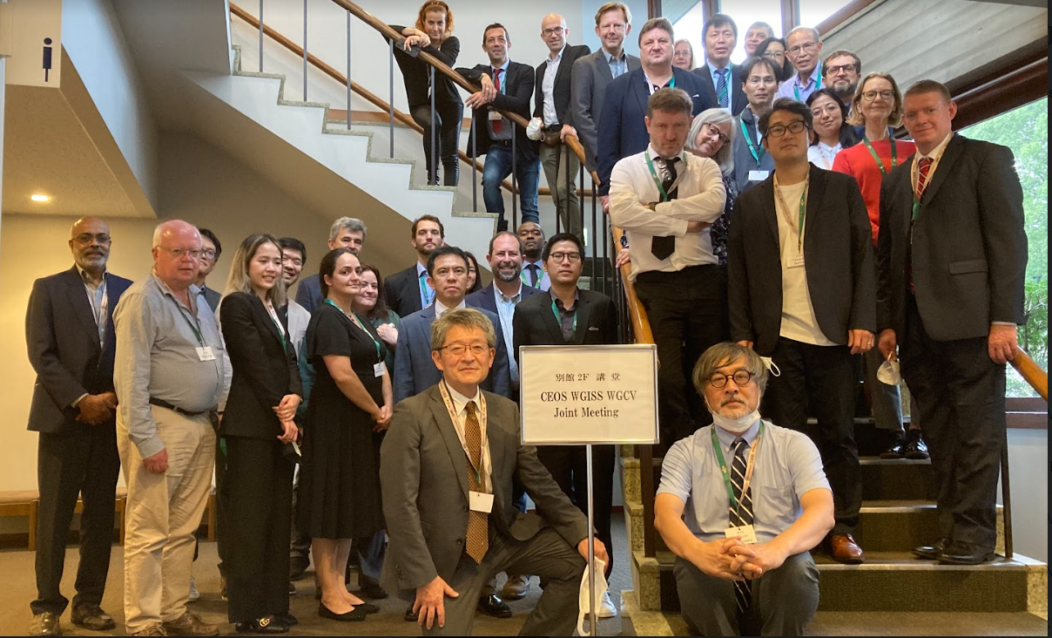
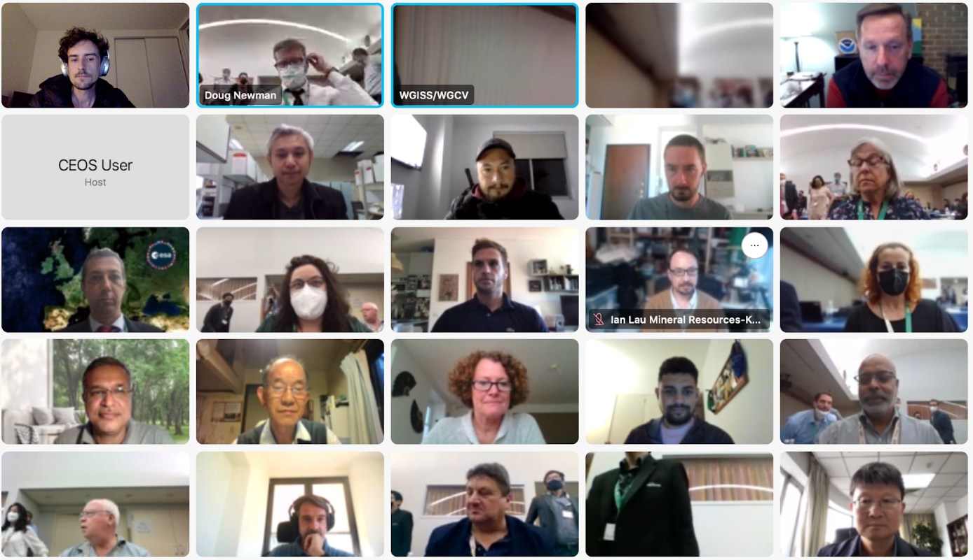

Close
Kuze-san (WGCV Chair, JAXA) and Makoto-san (WGISS Chair, JAXA) thanked everyone for attending the Joint meeting.

