Minutes
WGCV-52 Day #1
Monday, 5 June 2023

Participants (* Virtual Participants)
ASI Antonio Montuori*
AIRCAS Lingling Ma, Ning Wang
BIRA-IASB Jean-Christopher Lambert
CAST He Hongyan, Wenwen Qi
CEO Marie-Claire Greening*
CONAE Angel Matias Palomeque*
CSIRO Cindy Ong, Matt Garthwaite
ESA Philippe Goryl, Paolo Castracane, Bjoern Frommknech, Valentine Boccia, Ferran
Gascon, Henri Laur, Clement Albinet, Angelika, Jonas Von Bismarck*, Stefano
Casadio*, Robert Koopman*
EC Peter Strobl
GISTDA Prayot Puangjaktha, Passapak Sarathin
GA Medhavy Thankappan
GSICS Manik Bali*
JAXA Akihiko Kuze, Kazuhisa Tanada
KARI Kyoung-Wook Jin
MYSA Wayne Ng Su Wai*
NASA Xiaoxiong (Jack) Xiong, Eric Vermote, Kurt Thome*
NOAA Taeyoung Jason Choi, Lawrence Flynn*
NPL/UKSA Nigel Fox
NRSCC Xiaolong Dong
NSMC-CMA Ling Sun
USDA Michael Cosh
USGS Cody Anderson
WGCV Sec Matt Steventon, Riza Singh

Welcome and Chair Report
Presenter: Philippe Goryl (WGCV Chair, ESA)
Main points:
- Philippe Goryl (WGCV Chair, ESA) welcomed everyone to the meeting.
- An overview of the five days of the meeting and logistics information for in person participants was provided.
- The objectives and agenda items of the meeting were reviewed.
- Tour de table introduction was conducted for the in-person participants followed by the remote participants.
ESA Presentation [Slides]
Presenter: Henri Laur (Head of Mission Management and Data Quality, ESA)
Main points:
- Welcomed everyone to Italy.
- ESA does a lot of work on EO data quality.
- ESA is an institution with 22 member states with 2500 staff and 2500 contractors.
- The headquarters is in Paris. EO is located in ESTEC. ESA in ESRIN is focused on data management.
- The objective of the ESA EO strategy is to help society to develop and provide observations to better understand the complexity of the planet and monitor its health.
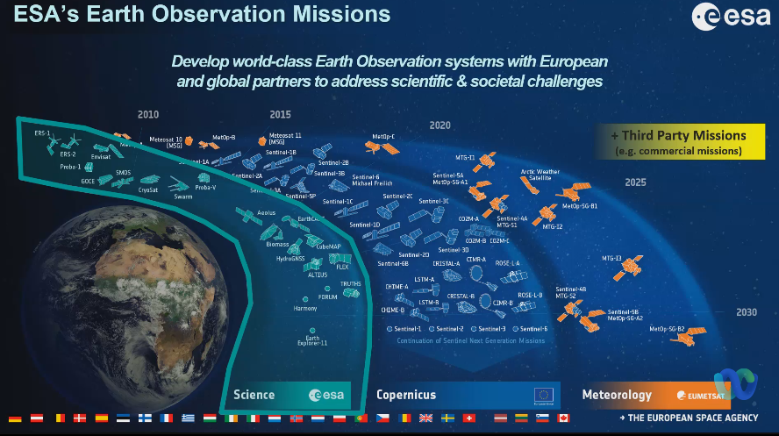
- ESA EO (data) customer role: ESA enables user access to EO data generated by commercial companies within two programmes: ESA and Copernicus
- ESA deals a lot with New Space data through Copernicus Contributing Missions (CCM) like ICEYE, COSMO-Skymed.
- The main challenges for the EO mission at ESA are innovation and big data.
- ESA's objective is to facilitate access to the best quality data.
- ESA relies on different institutions like research institutions. 85% of the project is going to outside companies. Have excellent companies dealing with the data. More details can be viewed from the linked slides.
ESA Presentation on EarthCARE Cal/Val [Slides]
Presenter: Bjoern Frommknecht (Mission Manager for EarthCARE)
Main points:
- EarthCARE is one of the Earth Explorer missions and is planned to be launched in 2024. Earth Cloud, Aerosol and Radiation Explorer linking Clouds, Aerosol and Radiation. The expected lifetime is three plus one year.
- This mission is in collaboration with JAXA. JAXA will provide the cloud profile.
- Clouds provide information on Earth's radiative balance and Aerosol forms the clouds.
- The EarthCARE mission incorporates both active sensors for detecting clouds and aerosols, as well as passive sensors capable of measuring the returning radiation.
- The radiometer has a coverage area of 10 km. The instruments featured in this mission include the Cloud Profiling Radar (CPR) developed by JAXA, the Atmospheric LiDAR (ATLID), the Multi-Spectral Imager (MSI), and the Broad Band Radiometer (BBR). All of these instruments have been manufactured. The Lidar operates at a wavelength of 355 nm, while the MSI consists of 7 bands, with 4 bands in the visible and infrared spectrum.
- Quality Assurance of the mission will be completed by Q2 2023. More details can be viewed from the linked slides.
Best Practice Protocol for Validation of Aerosol and Cloud Profiles
Presenter: Robert Koopman (ESA)
- Each agency coordinates the validation of its own products. JAXA (CPR) and ESA the rest.
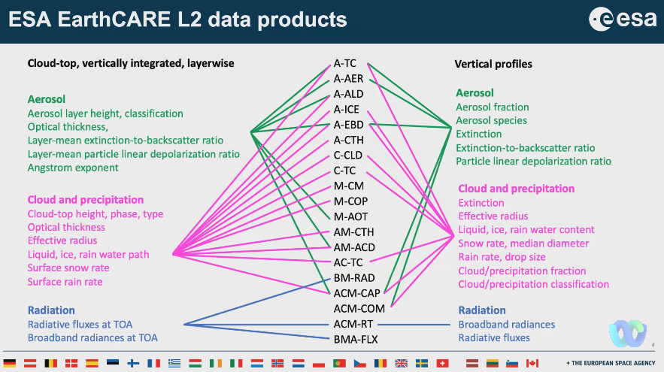
- Have a joint workshop with JAXA and ESA for ECVT on 13-17 November 2023. Several ECVT webinars on algorithms, data access and delivery, and tools are planned.
- Pre-launch validation campaigns started in 1998 from the CLARE campaign.
- ATMO-ACCESS Pilot EU is an organised response of distributed European atmospheric stations, and research facilities to coordinate and develop a pilot project to better serve the cal/val community. A detailed implementation plan has been prepared during the codesign phase.
- To build up statistical validation on the ground, we have to do synergistic validation in parallel.
- Scope of best practices, limited scope for aerosol and cloud profiles.
- The second ESA EarthCARE Cal/Val workshop was held online during 24-28 May 2021 to converge on common best practices protocols for the validation of aerosol, cloud and precipitation profiles.
- Open source tools will implement best practices.
Discussion
- Kyoung-Wook Jin (KARI) asked about the method to separate clouds and aerosols.
- Robert Koopman (ESA) noted LIDAR and CPR are two active complementary sensors that will be useful for this purpose.
- Cody Anderson (WGCV Vice Chair, USGS) asked about the functioning of different GSD sensors work and inquired about resampling and downsampling of products to a joint common grid.
- Robert noted it would depend on the algorithm of what is done beyond the joint common grid.
- The common grid for the measurement project is a GEOdetic grid, specifically the X-JSG (Joint Standard Grid). The radar instrument serves as the centre of the grid, and lidar data is interpolated at that location using several shots.
- Peter Strobl (EC-JRC) asked about the choice of a GEOdetic grid and expressed interest in understanding the reasons behind this decision.
- Robert via chat: Coming back to Joint Standard Grid, it is built up as follows: Along track the grid points correspond to the CPR measurements (NB every 7 points there is a slightly larger spacing). Across track, the grid spacing is fixed at 1km (so not using the MSI across track spacing). The altitude grid corresponds to ATLID (100m steps up to 20 km altitude, above that the steps become ~500m). Altitudes, Latitudes and Longitudes are geodetic (WGS84).
- Robert mentioned the possibility to have collaboration with the US, with the platform being considered as the infrastructure for this collaboration. A multi-mission initiative is being planned, and it is hoped that EarthCare will be shared within this framework.
WGCV-52-ACT-01 | EarthCARE team to share details of the X-JSG (Joint Standard Grid) and the details of how different algorithms approach downsampling of the various instruments to a common grid.  There will be a webinar on June 6 on this topic. | June 9

CEOS Work Plan Review [Slides]
Presenter: Marie-Claire Greening (CEOS Chief Executive Officer)
Main points:
- Noted ESA is supporting her for the CEO role in 2023.
- Marie-Claire reviewed the CEOS mission and detailed the CEOS Chair's priorities for 2023, including support to the UNFCCC Paris Agreement and exploration of CEOS and its engagement with New Space.
- There is a dedicated New Space Task team for 2023. Philippe is representing WGCV.
- CEOS has various governing documents, including the three-year CEOS Work Plan which is updated annually. WGCV provides substantial input via the Data Quality section.
- There are currently 13 active deliverables under WGCV and all are on track.
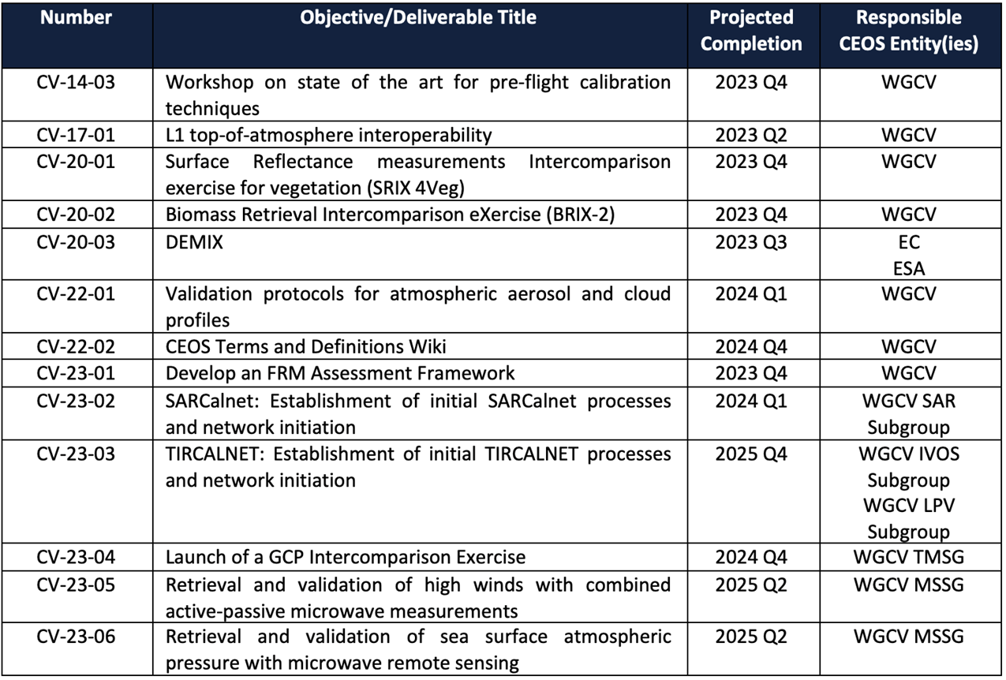
Discussion
- Manik Bali (GSICS) via chat asked if there is a process to declare an entity as a WGCV deliverable.
- Marie-Claire Greening (CEOS Executive Officer) via chat responded: To define a specific WGCV deliverable, one needs to discuss and agree on the details within the Working Group in the first instance. WGCV deliverables can be identified throughout the year, but the main push is at the beginning of each year when we update the CEOS Work Plan. Once you have it defined, Marie-Claire can help with the process and will then also insert it into the Work Planning.
Action Review
Presenter: Riza Singh (WGCV Secretariat)
Main points:
- There were 22 actions recorded at WGCV-51. Out of which 12 items have been completed.
- There are 5 open action items which will be discussed during their respective agenda items. Updates on the remaining 5 are noted below:
- WGCV-51-ACT-09: Nigel Fox and Paolo Castracane to update the wording on the Cal/Val Portal regarding solar irradiance spectrum references.
  - Nigel Fox (UKSA) has provided details. Still in progress but very close to closing the action
- WGCV-51-ACT-10: Nigel Fox and Paolo Castracane to investigate the creation of a private IVOS section of the Cal/Val Portal that would allow for peer review by IVOS members of proposed radiometric calibration methodologies and associated documentation/uncertainties before publishing to a wider audience.
  - Restricted access in IVOS part of cal/val portal. Technically easy for Paolo to do, propose to proceed and then see how the IVOS community uses this. There is a similar for the SAR subgroup already. Action on Nigel and IVOS to create the structure that needs to be added into that space. Discussion on test sites. The context is that commercial providers asked for IVOS endorsement of their approach. Maybe a broader discussion on this is required. As agreed at IVOS and subsequently agreed at WGCV-51, what we are doing is not necessarily endorsing but instead making transparent the results information that is then reviewed by WGCV for users to make their own decision. Endorsement is the wrong word, rather than making the result visible so people can make their judgement. Providing information in a format and vehicle to allow people to make a judgement. Will be further discussed in the New Space topic.
  - Cal/Val portal will be presented on the last day. Open issues will be reviewed on Friday. Irradiance, in particular, discussion between Nigel and Paolo. Also, Kevin Ruddick was asking about solar irradiances. Need a broader discussion about how we present solar irradiance data.
  - Need to make the agreed protocols etc. more prominent and accessible on the portal.
- WGCV-51 ACT-17: Nigel/Cody to consider the best way to proceed with engaging WGISS in the discussion around per-pixel uncertainty and reporting – whether this be an invitation of a few key WGISS people to an already planned workshop or another dedicated meeting.
  - Nigel Fox and Cody Anderson will discuss this further during the week of WGCV-52. Philippe Goryl (WGCV Chair, ESA) suggested it would be good to have a dedicated topic around this activity at the WGCV/WGISS joint meeting at the end of 2024, WGCV-54. This will provide sufficient time to investigate between now and then and come up with some ideas. It was suggested to leave the action open.
- WGCV-51-ACT-21: Paolo to work with the GISTDA team to include THEOS-1 calibration site data on the Cal/Val Portal.
  - Paolo Castracane (ESA) had interaction with the GISTDA team. Paolo will link the two portals once the final input is received.
- WGCV-51-ACT-22: Philippe Goryl, Jean-Christopher Lambert and Paolo Castracane to discuss additional atmospheric composition guidance for the Cal/Val Portal.
  - Philippe Goryl (WGCV Chair, ESA) proposed adopting a similar approach to the one used for the hyperspectral action. It was agreed to review the approach for the hyperspectral guidance document and assess its usefulness for the current situation. Consider using hyperspectral as an example to guide the approach. As part of this action item, ensure regular exchange of information on the website and cal/val portal. TCCON, COCCON, and Pandora should be emphasised during the exchange. Highlight the discussion on AC validation as a significant outcome of the WGCV-52 meeting.
- CV-14-03: Workshop on state of the art for pre-flight calibration techniques.
  - There has been significant interest in the workshop, perhaps now more than ever. Given the intention has been announced and promoted broadly, it is recommended to make progress. Nigel Fox, Jack Xiong, Patrice Henry, Medhavy Thankappan, Albrecht von Bargen, and representatives from GSICS have resumed discussion about the workshop. One issue raised was the differing views regarding the perimeter of the workshop. Philippe suggested keeping the scope broad but focusing on optical sensors. The next step is to determine a suitable date and location for the workshop.
  - Philippe had proposed two dates, but there has been no response from the organising committee yet. It is important to have at least one year for planning the workshop. The duration of the workshop should be 2.5 to 3 days.
  - Proposed ESA as an alternative venue for the workshop.
- Manik Bali and Larry Flynn could facilitate the interface with GSICS, further strengthening collaboration.
- Medhavy Thankappan (GA) emphasised the importance of confirming the scope, as it would provide a clear direction for progress.
- Nigel Fox (UKSA) shared his views on the scope, reiterated that it should encompass all passive sensors in the solar reflective and thermal infrared domains, including spectral, hyperspectral, and spectroscopic sensors. However, Nigel mentioned that active sensors like Lidar may not need to be included unless there is a specific reason to do so. Nigel also mentioned the existence of an overview document developed in 2018/19, which could serve as a useful reference.
- Jack Xiong (NASA) expressed that September 2024 would be a most likely time for the workshop and agreed to the topics that Nigel proposed.
- Nigel emphasised the need to cover hyperspectral and spectroscopic domains as a key to cover CO2 related missions as part of the process.
Discussion
- Peter Strobl (EC-JRC) sought clarification on whether the "reflective source of the sun" referred to an illuminative source. Nigel Fox clarified that it pertained to solar reflective and emissive bands. The underlying principles were the same and the aim was to cover both domains passively.
- The originating source from the sun was important in the spectral domain but not crucial for understanding how the sensor works. Peter raised an issue with using TOA reflectance as a unit in S-2. Nigel noted that pre-flight calibration and characterisation shared similar principles regardless of the domains.
- Cody Anderson (WGCV Vice Chair, USGS) added that although the principles were similar, the methods and tests differed.
- Nigel Fox (UKSA) proposed establishing a boundary for thermal infrared (TIR) and solar reflective domains, acknowledging that test setups may differ, but the characterisation and usage approaches were not significantly different. He emphasised the importance of organising a comprehensive workshop covering both solar reflective and thermal emissivity rather than postponing the latter. Nigel highlighted the benefits of initiating discussions, breakout sessions, and follow-ups, given the substantial overlap in expertise and participants. Limiting the workshop could unnecessarily exclude valuable contributors.
- Jack Xiong (NASA) and Jason Choi (NOAA) will find out PoC from NOAA. Mitch has left.
Decision 01 | It was agreed that the Pre-Flight Calibration Workshop will be organised for September 2024. It will be a three-day meeting. The scope will be all passive sensors in the solar reflective and emissive thermal infrared domains. Not active sensors. Will include hyperspectral and spectroscopic.

WGCV-52-ACT-02 | Philippe Goryl to follow up with Albrecht Von Bargen of DLR regarding continued interest in hosting the pre-flight calibration workshop in Germany and to agree possible locations if so.  Notes: ESRIN can serve as the backup. | In Progress  Awaiting response from Albrecht
WGCV-53-ACT-03 | Philippe Goryl to check with Patrice Henry regarding a new CNES point of contact for the Pre-Flight Calibration Workshop. | June 19
WGCV-52-ACT-04 | Nigel Fox to share the existing outline of the program of the Pre-Flight Calibration Workshop (from 2018/19). | COMPLETE
WGCV-52-ACT-05 | Philippe Goryl to email the Pre-Flight Calibration Workshop organising committee regarding connection on the GSICS side. | COMPLETE  Email Sent. Paolo will follow up with Manik

SI-Traceable Satellite (SITSat) Discussion [Slides]
Presenter: Nigel Fox
Main points:
- The drafting of SITSat Terms of Reference (ToR) process was agreed to set up the Joint CEOS WGCV and GSICS SITSat coordination group following various activities and discussions at WGCV-51.
- Context of SITSat is a sensor characteristic on a satellite.
- The definition of SITSat has been circulated with colleagues at NASA working on a Pathfinder mission and they are satisfied with the provided definition.
- A SITSat is a satellite-based sensor which can provide and verifiably- evidence, in a fully open and transparent manner, all significant contributions to the uncertainty of its measurements, traceable to the international system of units, SI, at the location and time from where they are made. In addition, this uncertainty must be at a level that is considered by the community to be of ‘Fiducial reference’ quality, i.e. that for a defined spectral domain/application it can be considered ‘state-of-the-art’ and able to unequivocally serve as a reference for similar measurements from other sensors. Typically, a SITSat might be expected to have a measurement uncertainty of <0.5 compared to that of its peers.
- If we don't include the measurement uncertainty parameter then everything can be called as SITSat. Need to ensure that the methods used to compare with other sensors is also documented.
- Motivation for having SITSats:
  - Desire for ‘high quality’ ‘Reference/Fiducial’ data from which change can be unequivocally detected in relatively short time-scales and mitigate ‘data gaps’ (particularly for climate)
  - ‘system of systems’ Integrated EO data, interoperable/harmonised knowledge of/removal of biases
  - New space are reliant on having some post-launch calibration anchor – no on-board Cal
  - There are existing CEOS/GSICS initiatives to establish international references/methods & SI-Traceability
- Motivation for creating task group:
  - Recognition, visibility of the new class of sensor to senior levels in space agencies & beyond
  - In a similar manner to CEOS-VCs – coordinate, where appropriate, to facilitate commonality of purpose (shared vision)
  - Establish an agreed minimal set of definitions and principles (including operational) to distinguish SITSats and their utilisation
  - Seek to build a common user/customer base transcending individual missions
- Initial Questions:
  - Any limitations in initial scope? i.e. include all sensor domains from the outset
  - Is the definition reasonable/understandable/encompassing and sufficiently differentiating?
  - Are ToR acceptable?
- More details can be viewed from the linked slides and draft SITSat Terms of Reference document.
Discussion
- Medhavy Thankappan (GA) suggested using solar reflective as a pilot to expedite progress, referring to examples like RADCALNET and TIRCALNET. Starting with solar reflective would provide focus without limiting the scope.
- Peter Strobl (EC-JRC) suggested focusing on the Fiducial Reference Measurements (FRM) and making significant advancements in defining technologies that produce such measurements.
- It was noted that FRM Assessment Framework will be covered in a later session. When we come up with a definition for FRM, it will subsequently require a sub definition of what a SITSat is. SITSat is a special case of an FRM.
- The discussion touched upon solar reflective and thermal emissive domains. Nigel expressed no concerns with limiting the scope at the first instance.
- Peter clarified that while limiting the scope of implementation was acceptable, we should have definitions that carry further.
- The group should allow the participation of bodies as observers from different domains. These observers would report regularly through WGCV to ensure that domain-specific definitions were not unnecessarily included. Efforts should be concentrated on implementing detailed strategies for the solar reflective domain.
- It was clarified that the group would not be working on detailed specifications of microwave sensors initially.
- The participation of observers in the group was welcomed, but the focus would be on detailed strategies for the solar reflective domain.
- Cindy Ong (CSIRO) asked if we are thinking of setting up a task group to start with. Logistically, task groups have to be time limited.
- Philippe Goryl (WGCV Chair, ESA) noted the original idea was to keep the SITSat task group within the WGCV group. WGCV is free to propose to VC but since Cal/Val is the key thing it was proposed to be under WGCV.
- Cindy suggested starting tasks in the regions that we know best and then processing with sub tasks similar to those in VCs, having a sub team.
- Peter suggested the focus should be on developing a generic framework initially, ensuring clear definitions, and then selecting appropriate CEOS branches during implementation.
- Philippe noted that the group would start with existing technologies, rather limiting the scope to SI-Traceable ones. The initial focus would be on three satellites, CLARREO-PF, TRUTHS, and LIBRA and routes to utilise the dissemination of their capabilities using existing infrastructure and methods as well as intermediate satellites such as SCR and the group would work in two directions, with emphasis on these ‘primary’ satellites. The formation of a VC could be proposed at a later stage.
- It was suggested to reach out to SAR experts and inquire about the possibility of SI-Traceable SAR measurements.
- Xiaolong Dong (NRSCC) noted that small satellites, and climate change applications, are placing similar demand on microwave sensors. It is difficult to develop the SI for microwave sensors as it relies on brightness temperature rather than direct radiance measurements. Xiaolong suggested that applying standards of radiance could prove beneficial for microwave sensors.
- Nigel is reluctant to allow the use of the label SITSat unless it fulfils all of the criteria we are looking to achieve. It doesn’t mean that in the near term we have to have a SITSat in each domain. The definition of a SITSat should not be weakened to allow other domains to have a SITSat and should be maintained without loosening requirements. The definition has SI-traceable but it means it should also have an uncertainty that is significantly better than the norm for that sensor domain.
- Cody suggested perhaps saying half the uncertainty would be better instead of <0.5. The question of whether the transfer or use of the reference needs to be explicitly mentioned was raised.
- Nigel noted that this aspect only applies to the use of the reference for observations. However, it was noted that the note should include a statement indicating that if the satellite is used as a reference, the method for comparing with other sensors and its associated uncertainty to the SI should be thoroughly documented and supported by evidence. He expressed concern about overcomplicating the definition of SITSat by including spectrals and non generic domains.
- There were discussions regarding the need to define FRM in the context of SITSat. It was acknowledged that the concept of SITSat existed before the concept of FRM. However, it was also recognised that demonstrating the linkage between the two, without dwelling too much on the interface, would be helpful for people's understanding.
- SITSat would be considered an FRM, but FRM would encompass a broader range of scenarios. It is important to avoid confusion by implying that SITSats are part of the same domain as other FRMs. Careful consideration was needed in describing this relationship to prevent the indiscriminate use of FRM terminology for other sensors in satellite space.
- There were some discussions on the FRM Assessment Framework, highlighting the need to define different classes within it. It is important to maintain a strong linkage between FRM and SITSat and ensure that this linkage is not weakened.
- Philippe mentioned that the SITSat Terms of Reference had been widely circulated and the decision to endorse it could be finalised on day 5 of WGCV-52, allowing for further review and discussion.
- Philippe noted the next step would be to share the Terms of Reference with GSICS.
- Philippe proposed the formation of a team for the SITSat initiative. Potential team members from various agencies were suggested, including Munir, Manik, or Larry from GSICS, Thorsten from ESA, Nigel from UKSA, Yolanda and Kurt from NASA, Peng Zhang from CMA, Lingling Ma from CSA, and Medhavy Thankappan from GA.
- Manik Bali (GSICS) expressed willingness to support the SITSat initiative, mentioning that GSICS has been actively working on quality assurance for EO and is eager to contribute to SITSat.
- Philippe stated his intention to have a representation from the SITSat group present at the upcoming GSICS plenary. It was emphasised to include this as a point on the GISCS plenary agenda.
- Matt Steventon (WGCV Secretariat) proposed the idea of elevating SITSat to a higher level within CEOS. He suggested that progress towards forming a VC could be made within 2-3 years.
- Nigel agreed with the suggestion and mentioned that considering the scope of other VCs, it would be logical to eventually establish SITSat as a VC. However, he also expressed willingness to have it initially placed within the WGCV. Nigel emphasised the importance of ensuring the ambition and visibility of SITSat, making it clear that it is a WGCV activity, at the CEOS plenary.
- Philippe highlighted that SITSat is a significant input for the New Space domain, and he has included the details of SITSat in the New Space working document.
- Nigel emphasised the importance of using the SITSat acronym correctly. He clarified that "SITS" should be written in uppercase, while "at" should be in lowercase.
WGCV-52-ACT-06 | Nigel Fox to update the SITSat definition to replace ‘0.5’ with ‘one half the uncertainty’ of its peers. | COMPLETE
WGCV-52-ACT-07 | Send SITSat Task Team Terms of Reference to GSICS contacts ahead of endorsement planned for June 9. | COMPLETE
WGCV-52-ACT-08 | Nigel Fox and Philippe Goryl to confirm initial names for the SITSat Task Team from GSICS, ESA, UKSA, NASA, China, GA. | In Progress
WGCV-52-ACT-09 | Manik Bali, Nigel Fox, Philippe Goryl, Paolo Castracane, Larry Flynn to organise a presentation at next GSICS in March 2024 on SITSat Task Team. | GSICS March 2024

Day 1 Close
Philippe Goryl (WGCV Chair, ESA) thanked everyone for joining and closed Day 1 of the WGCV-52 meeting.

