Minutes
WGCV-52 Day #2
Tuesday, 6 June 2023

Participants (* Virtual Participants)
ASI Antonio Montuori
AIRCAS Lingling Ma, Ning Wang
BIRA-IASB Jean-Christopher Lambert
CAST He Hongyan, Wenwen Qi
CEO Marie-Claire Greening*
CONAE Angel Matias Palomeque*
CSIRO Cindy Ong, Matt Garthwaite
ESA Philippe Goryl, Paolo Castracane, Fabrizio Niro, Marc Bouvet, Valentina Boccia, Ben
Veihelmann*, Stefano Casadio, Ben Veihelmann, Clement Albinet, Muriel Pinheiro
EC-JRC Peter Strobl
EUMETSAT Reudiger Lang*
GISTDA Prayot Puangjaktha, Passapak Sarathin
GA Medhavy Thankappan
JAXA Akihiko Kuze, Kazuhisa Tanada
KARI Kyoung-Wook Jin
NASA Xiaoxiong (Jack) Xiong, Eric Vermote
NOAA Taeyoung Jason Choi, Manik Bali*
NPL/UKSA Nigel Fox
NRSCC Xiaolong Dong
NSMC-CMA Ling Sun
USDA Michael Cosh*
USGS Cody Anderson
WGCV Sec Matt Steventon, Riza Singh

Welcome and Review of Day 1 Actions
Presenter: Philippe Goryl (WGCV Chair, ESA)
Main points:
- Philippe Goryl (WGCV Chair, ESA) welcomed everyone to Day 2 of the WGCV-52 meeting.
- Matt reviewed the decision and action items from Day 1.
Atmospheric Composition Subgroup (ACSG) Report [Slides 1 and 2]
Presenter: Jean-Christopher Lambert, Ben Veihelmann
Main points:
- Restructuring of the ACSG group is in good progress. The list of members will be shared in October 2023.
- The newly launched LEO Nadir UV-NIS missions include NOAA-21 with CrIS instrument. MicroCarb, Merlin IPDA Lidar, MethaneSat, CarbonMapper, Sentinel-5 UVNS and IASI-NG, CO2M are in the pipeline.
- GEO Nadir mission TEMPO was launched recently and has been performing well. The validation plan is currently being deployed.
- The 12th International Atmospheric Limb Workshop was held in Brussels in May 2023 where techniques, algorithms, products for occlusion, limb scattering and planetary assimilation were discussed.
- There are new validation challenges for the new limb missions that are currently being developed. The challenges include mesosphere, aerosols and clouds, water vapour, waves, 3D/tomography, and constellations.
- Vicarious Cal/Val campaigns, DCC, PICS, SNO, Rayleigh Scattering, GEO/LEO intercomparisons ongoing for L1B verification and validation. ACSG should be at least an observer of ongoing initiatives and identify gaps if any.
- An extensive network has been deployed for GEMS validation.
- Working on updating the network strategy for NDACC.
- A statement of guidance is being prepared for network evolution considering the satellite validation needs of WMO GCOS review of the requirement for the climate system.
- FRM Maturity Assessment (FRM-MAP) procedure for assessing the level of maturity of NDACC is being developed. It will be a self assessment procedure.
- Maturity of Validation Method (ValMet-Map) is a maturity assessment process developed for AC validation methods Round-robin generic chain (Keppens et al., AMT 2015), QA4ECV Automated Validation Server DPM v2 (Compernolle et al., 2016), Validation across EO domains (Loew et al., Rev. Geophys. 2017). This method has been applied to all Sentinel data products. Details of the assessment are published on the CCVS website.
- Development of FRM and Validation Method Maturity Assessment Procedures undertaken by NDACC in response to recommendations from H2020 Copernicus Cal/Val Solution (2020-2022)
- Draft FRM-MAP and ValMet-MAP have been tested on several cases.
- Fair convergence with the draft WGCV FRM Assessment Framework Roadmap (version for review received on May 25, 2023) is encouraging, although applicability to atmospheric composition products is not always obvious and key specificities have not been considered.
- NDACC Satellite WG and Instrument WGs are happy to cooperate with WGCV on further developments, convergence, feedback, test cases, etc.
CV-22-01: To establish validation protocols for atmospheric aerosol and cloud profiles
  - PoC: Rob Koopman, ESA/ESTEC
  - Agencies: ESA, NASA, JAXA and EUMETSAT, group expanding with 83 contributors at present
  - Status: see wider picture and details in EarthCARE Cal/Val presentation by Rob Koopman ( June 5, Item 1.3)
  - Deliverable: 7 chapters to be submitted to AMT, and an overview paper to BAMS; first draft by July 2023, final version in 2024/Q1
VC-20-01: Tropospheric ozone dataset validation and harmonization
  - Coordinator: D. Loyola, DLR
  - Contributors: BIRA-IASB, DLR, ESA, FMI, JPL, KNMI, LISA, NASA, NOAA, RAL, ULB, U.Busan…
  - Close cooperation with TOAR-II Satellite Ozone WG and HEGIFTOM WG
  - Schedule and status: Kick-off at AC-VC-16 (2020/06), harmonization and validation protocol AC-VC-17 (2021/06). Several TOAR-II SOWG and HEGIFTOM meetings in 2021 and 2022. VC-20-01 report at AC-VC-18 (March 2022/03): first harmonization and validation results. Methods and validation results discussed at TOAR-II Workshop (2023/03, Cologne),
  - Ongoing: more datasets, large scale validation, scoping of TOAR-II publications (2023+)
  - A complete report on VC-20-01 will be presented at AC-VC-19.
- More details can be viewed from the linked slides.
Ben Veihelmann (ESA) presented on behalf of AC-VC
- AC-VC looks at the use of satellite data atmospheric composition and synergy cases.
VC-20-02: Cal/Val coordination plans (-03) Announcements of Opportunities (AO)(-04)
  - Joint effort with WGCV for writing the AO white paper.
  - GEMS AO issued in 2018: Cal/Val activities with international participation, comparisons with Sentinel-5P, and testing of Sentinel-4 L2 algorithms.
  - Sentinel-4/-5 AO preparation has started, Call to be issued end of 2023.
  - Growing Pandora Asian Network complements coverage of Pandora Global Network for the operational acquisition of reference data for validation.
  - TEMPO was launched on 7 April 2023, joint NASA/NOAA summer 2023 science field campaigns will contribute to validation.
  - Contributions welcome on VC-20-05: Monitoring Surface PM2.5 white paper which was endorsed at plenary 2022. A number of recommendations are relevant to the cal/val team. Specifically, recommendations 4, 6, 14 and 15.
  - AC-VC-19 and ACSG joint meeting will be held in Brussels, Belgium on October 24-27, 2023.
  - More details can be viewed from the linked slides.
Discussion
- It was noted that a dedicated session on FRM will be held on WGCV-52 Day 5. ACSG's effort on their FRM-MAP will be fundamental input. Philippe expressed his curiosity to see if the efforts align.
- There was an email exchange with Mark Dowell, highlighting TCCON, COCCON to be mentioned as one of the tasks in the CEOS WGCV Workplan. It was essential to report on the Atmospheric domain, particularly focusing on EnMAP. Adding it to the CEOS WGCV work plan is necessary.
- WGCV and GSICS need to stimulate joint coordination across ACSG and GSICS, considering the overlap in various topics.
- For AC-VC, inputs from WGCV for a draft white paper on monitoring PM2.5 were deemed significant for this activity.
- Ben Veihelmann (ESA) noted the need to follow up on recommendations with a roadmap and encouraged collaboration with WGCV. There was a concrete request for collaboration, and Jean-Christopher (BIRA-IASB) would coordinate with AC-VC.
- Traditionally, ACSG's focus has been on trace gases, not PM. Starting from scratch and expanding the team to include PM is necessary. PM retrieval is a substantial challenge and it is not expected to have any significant progress to report at WGCV-53, for instance.
- Collaboration with GSICS is necessary to avoid duplication of activities. A list of activities involving both low Earth orbit (LEO) and geostationary (GEO) sensors had been developed. There is no need for a new activity in this domain, but need to maintain the observer status. Level 2 activities are not a mandate of GSICS, so no overlap is expected in that area.
- A joint meeting between ACSG and AC-VC is planned for October. Kevin Ruddick's opportunity to discuss Hypernets was noted.
- Regarding the FRM Assessment Framework, it is important to consider the concept of fitness for purpose. Nigel Fox mentioned preliminary discussions, suggesting the addition of examples and specificities to the criteria to aid the assessment process. Using the same framework and adding specific examples into columns was deemed feasible.
- It was important to keep in mind significant issues and ensure that fitness for purpose remained a priority. It was also necessary to have a plan and be attentive from the beginning, considering the potential adoption and growth of FRM.
ACIX, CMIX and Cloud Camera Network [Slides]
Presenter: Eric Vermote
Main points:
- ACIX is a joint effort between ESA and NASA aimed at organising the inter-comparison of atmospheric correction processors for Landsat 8 and Sentinel 2. A common and harmonised inter-comparison procedure was agreed upon and followed by all the participants. The first workshop on ACIX I was held in June 2016 and ACIX II was initiated in 2018.
- Results of ACIX I are available on the WGCV Cal/Val portal.
- There are components ACIX II land, ACIX water also called ACIX II aqua.
- ACIX II consists of two components: ACIX II land and ACIX II water, also known as ACIX II aqua.
- ACIX II had more sites compared to ACIX I and included comparisons with ground-based measurements.
- ACIX II outcomes for land revealed good accuracy in aerosol retrieval (0.1-0.2) and a range of optical fitness (1-0.5).
- CMIX utilised reference datasets that were also used for ACIX.
- Reliable and high-quality reference datasets for cloud masking are essential to reduce result variability. Performance varied based on the reference data used. Average overall accuracy for Sentinel-2 ranged from 80% to 89%, while for Landsat 8, it ranged from 80% to 98%. Performance improved when thin or semi-transparent clouds were not considered.
- Future activities include providing a quantitative definition for clouds using Landsat 8 and Sentinel-2 imagery, generating new reference datasets, and expanding the analysis framework to include multi-temporal analysis and application-driven validation. These intercomparison studies aim to improve algorithms and work towards standardising cloud masking. CEOS is encouraged to continue CMIX activities due to the importance of cloud masking in optical imagery.
- Skycam, a ground-based sky camera network, is used for cloud characterisation and validation. Having sky pictures is crucial for confirming the absence of clouds, as bright spots are often falsely identified as clouds. Skycam is lightweight, inexpensive, waterproof, fully characterised, and calibrated. Ideally, two cameras per location are recommended. Skycam units are available for free, and contributors can access raw data and contribute to the data access portal.
- CMIX outcomes call for a quantitative definition of clouds, the generation of new reference datasets, and application-driven validation.
- The ongoing effort of Skycam continues to address the challenge of distinguishing clouds from other bright targets, such as roofs.
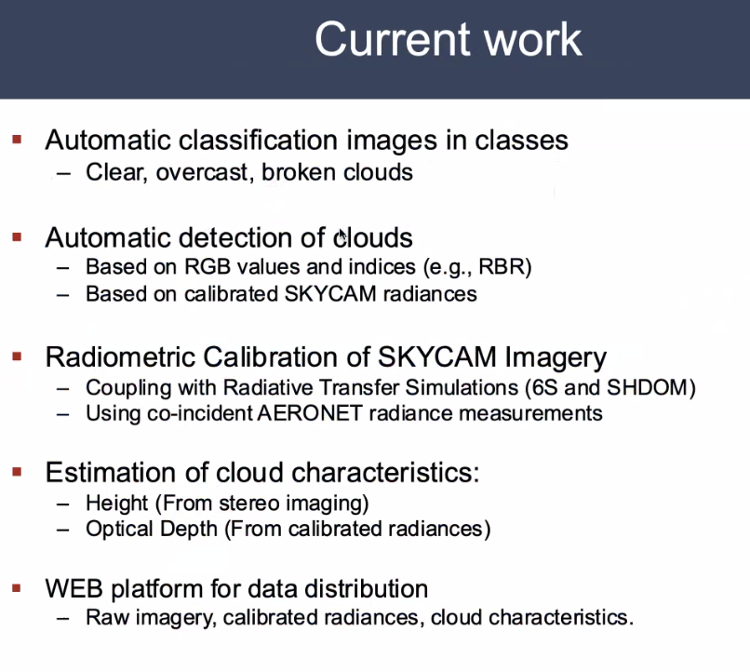

- More details can be viewed from the linked slides.
Discussion
- Philippe Goryl (WGCV Chair, ESA) commended the team working on ACIX for their excellent work. He considered ACIX as a great exercise that serves as a model for various other exercises.
- In GSICS and WGCV, there was a past action to bring back an intercomparison of Rayleigh scattering approaches. Philippe still believed that it holds significant importance and should not be taken for granted. He welcomed the opportunity to revisit the Rayleigh scattering intercomparison as a future topic.
- ACIX is evolving towards hyperspectral, PRISMA and EnMap. Philippe highlighted its increasing importance as a tool for selecting algorithms.
- Skycam was acknowledged as filling an important gap by providing a reference dataset for cloud validation. Philippe mentioned that ESA would try to install a camera at locations together with HYPERNET and RADCALNET sites.
- Cody Anderson (WGCV Vice Chair, USGS) asked about stating accuracies and uncertainties and trying to get some commonalities in reporting.
- Eric Vermote (NASA) noted the need to have uncertainty from the beginning at every level.
- Michael Cosh (USDA) asked about the maintenance of the Skycam.
- Eric noted that somebody needs to visit the site for cleanup.
- Eric provided information on the cloud masking algorithm used in Skycam, mentioning a simple whiteness test and spectral dependence. Further details would be shared in the following week, including optical tests to map cloud impact.
- Peter Strobl (EC-JRC)asked if the viewing angle was towards the horizon.
- Eirc noted that the initial attempt had some imperfections with polygonal mapping of cloud and altitude considerations. The criteria for cloud masking were based on the results.
- Kazuhisa Tanada (JAXA) asked about the installation of Skycam in the infrared region for cloud classification. Eric noted it won’t be installed in the infrared region.
- Marc Bouvet (ESA) provided feedback on past work during the Envisat time and emphasised the need for research to explore sensitivities to parameters and their impacts on atmospheric composition. Eric added that polarization is also important.
- Nigel Fox (UKSA) mentioned previous reluctance from CNES regarding retrieval algorithms but suggested revisiting the topic.
WGCV-52-ACT-10 | Philippe Goryl and Marie-Claire Greening to ensure TCCON and COCCON references are included in the description of certain ACSG CEOS Work Plan tasks.  Notes: Reference past discussions initiated by Mark Dowell, which weren’t addressed in time for the CEOS Work Plan 2023-2025. | In time for CEOS Work Plan 2024-2026
WGCV-52-ACT-11 | Jean-Christopher Lambert and Ben Veihelmann to connect with Shobha Kondragunta, leader for aerosol in AC-VC, and see how WGCV can help in response to need for implementation roadmap.  Notes: CEOS Principals have directed AC-VC to define an implementation roadmap building on the ‘Monitoring Surface PM2.5’ white paper recommendations. The recommendations of relevance for cal/val are 4, 6, 14, 15, and 16. | Include topic on joint AC-VC-19 / ACSG meeting agenda

Terrain Mapping Subgroup (TMSG) Report [Slides]
Presenter: Peter Strobl
Main points:
- TMSG in person plenary will be held on 12 and 13 July 2023.
- DEMIX started in early 2019 to establish a coordinated approach for Digital Elevation Model (DEM) validations and comparisons.
- DEMIX outcomes: Over 130 meetings conducted to date with a conference paper and video available. More than two peer-reviewed publications, a new DEMIX tiling system and a processing platform are currently under development.
- TMSG Subgroup 1 has completed the revision of Digital Elevation Models: Terminology and Definitions and published the peer reviewed paper. The group has retired. Subgroup 2 has been looking into metrics, algorithms and software. Identified three major parameters (elevation, slope, roughness) for comparing DEMs using different metrics (RMSE, MAE, etc.) , highlighting the differences and advantages/disadvantages.
- Each criterion can be associated with specific applications to ensure user-friendly understanding, even for non-experts. Ranking tools were developed to assist users in choosing the criteria. The role of tolerances (i.e. the significance of differences) was emphasised.
- Wine contest framework:
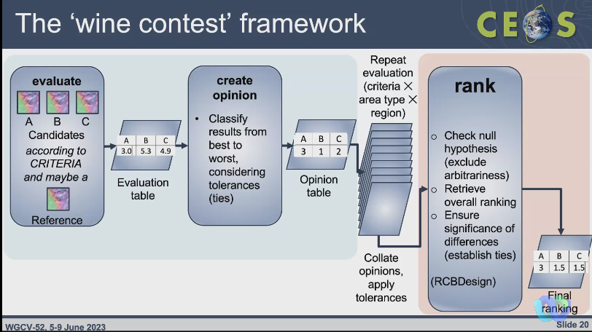
- Wine contest advantages include accommodating any number of DEMs, test sites, and criteria, accepting both objective and subjective criteria, allowing ties, having a statistical basis, providing a confidence level for the final ranking, and allowing stratification based on specific requirements.
- 1” resolution DEMIX candidates include SRTM, NASADEM, ASTER-GDEM v3, ALOS AW3D30, Copernicus DEM and FABDEM. 133 DEMIX tiles (10*10) were placed on three different continents with reference data. It was emphasised not to compare the candidates directly but to rely on the reference data for evaluation.
- More than 50,000 individual ‘opinions’ were collected. There is a dedicated python notebook for users to interact and copy the contents.
- Subgroup 2 implemented the ‘wine contest’ framework, undertook comprehensive intercomparison, and submitted a peer reviewed paper summarising their findings. The ranking indicated that COPDEM performed the best, ALOS was close but distinctively behind, and ASTER consistently ranked last.
- The investigation of platform options for DEMIX was underway, with EAIL and VTWeb (developed by ESA) being considered.
- The peer-reviewed paper needs to be finalised, and it was noted that the name "wine contest" might need to be dropped if it attracts critical comments from the community.
- TMSG is looking for a Co-Chair. Nominations are welcome.
- Lessons learned from DEMIX included the importance of clarifying terminology and concepts, recognising the indispensability of CEOS partners, and addressing challenges related to grid conventions, metadata, and vertical datums.
- There was an interest in exploring how the "wine contest" framework could be utilized beyond the scope of DEM comparisons.
Discussion
- Philippe Goryl (WGCV Chair, ESA) anticipates that the achievement of the wine contest will be better. Discussions regarding GCP were planned for the week, and ideas on GCPIX and GDMIX were considered relevant. Agencies were requested to propose a Co-Chair for the initiative, with Philippe as the contact person.
- Muriel Pinheiro (ESA) via chat acknowledged the value of the DEM terminology paper. She noted she has experienced some confusion regarding what the quality parameters attached to DEMs mean, e.g, we have seen the concept of relative accuracy/absolute accuracy being used in different ways by different DEM providers. She asked if the TMSG team works in the standardisation of the quality indicators as well. Muriel also mentioned confusion regarding the meaning of typical quality indicators for Lidar data.
- Peter Strobl (EC-JRC) noted the metrics for comparisons were being developed while writing the terminology paper, so some go beyond. The new paper describes the process of testing candidates against reference data but cannot compare candidates directly as this would require to resample (and therefore disadvantage) some of them. Algorithms for computing the metrics have been harmonised and can only provide recommendations but cannot enforce compliance. All major DEM providers, including USGS, NASA, JAXA, AIRBUS, and ESA, were involved in the process.
- References for New Space, GCPs, and DEMs were requested. The availability of DEM and GCP data from commercial providers for sharing was discussed. However, it was noted that access to very high-resolution (VHR) DEM and optical data might be limited due to commercial considerations.
- New Space, GCPs, and DEMs are a couple of the requests for references. Were any of the providers of DEMs and GCPs open to further sharing? Question of policy and money. VHR is still a key commercial sector, so most providers will not allow it. Will start to transcend the 1 arc second limitation currently in future, but this is already sufficient for many applications.
- The issue of uncertainties, reliability, and local control of DEMs obtained from commercial providers was raised. The need for coordination and finding solutions to ensure traceability and control of DEM data was highlighted.
- The topic of coordinating with commercial providers to establish common references for DEMs and GCPs was discussed. CEOS agencies are encouraged to agree on a set of DEMs and GCPs and engage in discussions with commercial providers to establish coarser resolution (i.e. 5-10m) GCPs that could support the use of higher resolution data.
WGCV-52-ACT-12 | WGCV Chair to distribute a call for nominations for a new TMSG Co-Chair. | COMPLETE
Microwave Sensors Subgroup (MSSG) Report [Slides]
Presenter: Xiaolong Dong
Main points:
- MSSG covers Earth observation sensors operated in the microwave spectrum, except SAR. It includes coverage of Microwave Radiometers (MWR), Radar Scatterometers (SCAT), Radar Altimeters (ALT), and GNSS-Radio Occultation/Reflectrometry (GNSS-RO/GNSS-R). MSSG team is currently focusing on Radar Scatterometers (Active Microwave) and Microwave Radiometers (Passive Microwave).
- Completed tasks include Radar Scatterometers (Active Microwave), CV-20-05: Standards and Metrics for Scatterometers and Wind Retrievals.
  - ISO-TS has been initiated in TC-211 plenary in May 2023 to address this task.
  - Microwave Radiometers (Passive Microwave), ISO/TS 19159-4:2022: This ISO Technical Specification, published in November 2022, pertains to the calibration and validation of remote sensing imagery sensors and data specifically for space-borne passive microwave radiometers. It is part of the ISO TC-211 19159-series, which deals with geographic information.
- Ongoing tasks include:
  - CV-23-05: Retrieval and validation with high winds with combined active-passive microwave measurements (2025 Q2)
    - Prof. Wenming Lin from Nanjing University of Information Science and Technology (NUIST) has been leading this task.
    - The main development issue for CV-23-05 revolves around error analysis, specifically employing triple collocation, for multi-mission winds and reference data. The goal is to improve the accuracy of wind measurements by enhancing radiation and/or scattering models. Joint statistical and spatial analysis involving SFMR (Stepped Frequency Microwave Radiometer), SAR (Synthetic Aperture Radar), SCAT (Scatterometer), and RAD (Radiometer) data is expected to provide additional value. Spatial analysis, focusing on parameters like RMW (Radius of Maximum Wind) and wind radii, is deemed necessary to further validate the winds obtained from satellites.
    - Seeking user feedback to ensure that the resulting improvements align with user needs and requirements.
    - Further details on the progress can be viewed from the linked slides
  - CV-23-06: Retrieval and validation of sea surface atmospheric pressure with microwave remote sensing (2025 Q2)
    - Dr. Zijin ZHANGfrom National Space Science Center, CAS has been leading this task

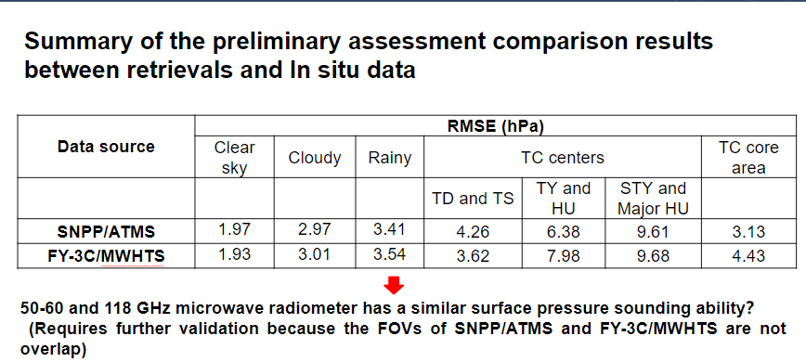
- Ocean surface atmospheric pressure data with high spatiotemporal resolution can be retrieved from satellite passive microwave observations for both low and high wind conditions. In situ comparison demonstrates that the retrieval accuracy is better than 2.0 hPa for clear-sky, 3.0 hPa for cloudy, and 3.5 hPa for rainy, 6.0 hPa for TD and TS centres, 8.0 hPa for TY and HU centres, and 10.0 hPa for STY and Major HU centres, respectively; a joint retrieval algorithm is proposed to retrieve surface pressure over oceans using the observations of FY-3D/MWTS-II and FY-3D/ MWHTS together, which shows better retrieval accuracy;
- Further optimisation of the retrieval model and algorithm are still needed;
- Validation methodology and data sets need to be developed. More details can be viewed from the linked slides.
- Other work in preparation includes promoting the ISO TS on calibration and retrievals of sea surface wind by radar scatterometry, which is the further deliverable of task CV-20-05. Cal/Val for the GNSS-R task is also underway.
Discussion
- Philippe Goryl (WGCV Chair, ESA) noted the contribution made by MSSG to ISO. Philippe suggested having a round table discussion to request Xiaolong's input and contributions before the SIT TW. Philippe acknowledged the importance of leveraging Xiaolong's expertise and experiences to enhance their engagement with ISO.
WGCV-52-ACT-13 | WGCV Chair to send a call for inputs regarding the status of WGCV engagement with standards organisations, for presentation to the CEOS Plenary as a stocktake, following up past discussions at SIT/Plenary. | September 30

- Xiaolong Dong (NRSCC) asked how WGCV can propose the initiative for the standards through CEOS.
- Cindy Ong (CSIRO) noted CEOS is not a member of ISO and suggested that Xiaolong could contribute to CEOS by contacting standards organisations in China and proposing the initiative through different routes, such as IEEE or OGC. Additionally, Cindy recommended approaching the lead on ISO to explore if the MSSG could provide contributions.
- Peter Strobl (EC-JRC) added a national patronage and support from five other countries are needed. Perhaps identifying individuals in CEOS who are involved with ISO and establishing communication channels to facilitate the process would be a good idea. It would be helpful to have such contacts.
- MSSG is collaborating with GSICS on various tasks. It was suggested that it would be beneficial to identify, and collaborate with Paolo and Manik on the area of common interest for GSICS and WGCV.
- Philippe asked how MSSG forms and selects the task team members.
- Xiaolong noted that the task team is based on the previous collaborations. He is hoping to have more people from the community to participate.
- Commercial satellites are using the data for GNSS-R, not just for ocean surface wind but also includes data for soil moisture. A lot of research has been conducted for calibration and validation. This could be explored as a potential contribution to commercial sectors.
- Michael Cosh (USDA) via chat noted that he will discuss GNSS for Soil Moisture in LPV. There could be some areas of common interest to identify.
- Kyoung-Wook Jin (KARI) asked why MSSG is primarily focused on Sea Surface Temperature (SST) and Ocean Surface Winds and atmospheric pressure.
- Xiaolong noted these areas have been prioritised due to lack of significant progress in the past, but there is a considerable interest from the community in advancing these domains. Extreme wind, high wind conditions, remain a challenge, especially for sea surface and atmosphere interactions. Xiaolong also mentioned that there is currently no available product for measuring Ocean surface atmospheric pressure, highlighting the need for further development in this area.
WGCV-52-ACT-14 | MSSG Chair to share a call for participation in the task teams. | July
WGCV-52-ACT-15 | WGCV Chair to follow up with MSSG and LPV Chair regarding potential input to the CEOS New Space Task Team regarding GNSS-R cal/val. +commercial | July

BRIX-2 [Slides]
Presenter: Clement Albinet
Main points:
- BRIX-2 is a joint effort between ESA and NASA to intercompare algorithms specifically for biomass mapping using current and future spaceborne missions.
- These objectives shall be achieved by making available standardised test cases (based on airborne campaign and spaceborne simulated data), inviting the scientific community to develop and apply retrieval algorithms based on this test case, and finally comparing and evaluating the performance of submitted results.
- For the purpose of an objective algorithm evaluation, the exercise will be based on the ESA-NASA joint Mission Algorithm and Analysis Platform (MAAP).
Objectives of BRIX-2:
- Provide an objective, standardised comparison and assessment of biomass retrieval algorithms developed for the Biomass, NISAR and GEDI missions, and fusion of these mission datasets.
- Establish a forum to involve scientists in the development of retrievals that have so far not been part of the biomass community.
- The adoption of vetted validation standards and methods to compare biomass estimates to reference datasets (e.g. field plots or airborne lidar biomass maps).
- Collect inputs from the biomass user and scientific community on data formats and characteristics towards the generation of Analysis Ready Data.
Current Challenges:
- Current challenges include using the available P-band SAR, L-band SAR and LIDAR data in the retrieval optimally, global applicability of algorithm although retrieval will be tested on a limited geographic area, identifying ways to use datasets, including time-series, from future BIOMASS, NISAR and GEDI missions and identifying ways for consistent global retrieval in agreement with each mission requirements.
- The inter-comparison exercise for BRIX-2 experienced a lack of participation, with no results being submitted. Despite extending the submission deadline multiple times, no submissions were received. The original submission deadline was set for December 2021, but even with the extensions, participation remained absent.
- It was decided to close to BRIX-2 with only two teams that provided preliminary results. The decision to support only these teams was made to provide the following deliverables:
  - Biomass maps of estimates over the four defined sites in the exercise.
  - The algorithm (software) necessary for MAAP users to regenerate the results.
  - Documentation of the algorithm, detailing its specifications and usage.
  - A brief experience report on the exercise set-up, including limitations of the algorithm, suitability of data, and insights gained from the exercise.
- There is also an idea proposed for BRIX-3, which would involve working with real satellite data and obtaining financial support from core teams, specifically from ESA and NASA.
- More details can be viewed from the linked slides, BRIX-1 webpage and BRIX-2 webpage.
Discussion
- It was noted that BRIX activity was in the overall context of biomass validation. Where there was a lot of enthusiasm at the beginning. BRIX-I was very positive, thought BRIX-2 would be equally good, but only two teams provided input. Need to close BRIX-2 if open in the CEOS Work Plan.
- The reasons behind the limited participation were discussed. Clement Albinet (ESA) suggested that the teams might have been working on a best-effort basis, with some teams potentially lacking necessary support. Having supported teams could serve as a core group that catalyses the activities of others who are working with best efforts.
- Peter Strobl (EC-JRC) emphasised the need for caution regarding funding. He noted that introducing funding could set a negative example for other groups and go against the desired direction and activities of the organisation.
- Michael Cosh (USDA) noted that attrition or drop off is common in cal/val projects. When funding is limited and not attached to the collection of data but to the analysis of data it can be discouraging and lead to unfortunate interpretations of data. This issue is not unique to the BRIX activity but is seen across various disciplines.
SRIX4Veg [Slides]
Presenter: Valentina Boccia
Main points:
- FRM4Veg is an ESA-funded activity aimed at defining and applying the FRM concept to the vegetation biophysical variables acquired by European satellites, i.e. surface reflectance (SR), fraction of absorbed PAR (fAPAR), and canopy chlorophyll content (CCC).
- Surface Reflectance Inter-comparison eXercise for Vegetation using UAVs (SRIX4Veg) concept was developed in the context of the FRM4Veg activity.
- Significant interest in UAV hyperspectral instruments. Protocols yet to be developed.
- The goal is to assess the variability associated with different teams conducting the same SR validation work with drones and moving towards a community-agreed Protocol to reduce this variability, following the FRM principles.
- Two experiments were conducted during the first SRIX4Veg campaign:
  - EXPERIMENT 1: Each team was given a data collection plan based on an initial, draft protocol based on a typical Sentinel-2 overpass.
  - EXPERIMENT 2: Each team collected data according to their own plans but was given the same information about a satellite overpass.
- Second SRIX4Veg workshop will be held in ESA/ESRIN on 24-24 November 2023. The goal is to discuss the outcomes of SRIX4Veg field campaigns and receive feedback on the draft Protocols and Procedures for SR validation using UAVs.
- Proposed future steps include updating the version of the Protocols and Procedures for SR validation using UAVs which will be shared with CEOS WGCV LPV and IVOS for review and contribution in Q1 2024.
- CEOS WGCV LPV and IVOS review process (2-3 months).
- Inclusion of feedback and updated version of Protocols & Procedures to be submitted to CEOS WGCV for potential endorsement in Q3 2024.
- Plan to cooperate with SRIX4Veg II in Australia by sharing the latest version of the Protocols & Procedures document available at that time, so as to be used by SRIX4Veg-II participants. A detailed plan to be discussed.
- Cooperation with SRIX4Veg-II in order to prepare updated Protocols & Procedures, based on the outcomes of both SRIX4Veg-I and -II.
SRIX4Veg-II
Presenter: Cindy Ong
Main points:
- Australia has an active community deploying UAS for Earth observation including the development of complementary methods, protocols and apps, e.g. TERN Drone Protocols for Data Collection, RB and Multispectral Imagery Processing, Lidar Processing;
- There is a recognised need to develop a community approach/guideline for the collection of data from UAS for the validation of satellite-derived surface reflectance products across vegetated areas;
- Good synergies to extend effort and be involved in co-development with international partners;
- The aim is to harness the Australian community;Development of EO community project (as an EOA cal/val WG initiative) and showcase Australian EO capabilities & infrastructure (sites, facilities, labs)
- TERN site, also selected as LPV supersite, Calperum across 9000 km2 ~270 km E of Adelaide, close to Renmark;
- The selected site is heterogenous, Mallee semi-arid ecosystem, fringing the River Murray floodplains on Calperum Station, South Australia;
- Comprises undulating mallee woodlands and riverine vegetation alongside the river;
- The campaign has been postponed to weeks of 4th or 11th March 2024;
- Currently there are seven local teams, 1-2 international teams, noting that this is close to the limit, 52 flights for seven teams for SRIX4Veg-I. Developing a proposition for financial support.
- More details can be viewed from the linked slides.
Discussion
- Cody Anderson (WGCV Vice Chair, USGS) asked Valentina about seeking CEOS approval of UAS usage of the protocols. USGS will review the protocols after SRIX4Veg-2. Every country will have a different set of restrictions that should be considered. Want it to be broadly applicable to many countries.
- CSIRO will be getting early access to protocols for SRIX4Veg-II, to support the preparation for the Australian campaign.
- The SRIX3Veg-I team had first shared protocols and procedures with partners, cooperating agencies, USGS, CSIRO, and ASI, before conducting the field campaign, and used an iterative process to do the first review with cooperating agencies. The next step is to involve the broader CEOS level to make the protocol internationally relevant. LPV and IVOS were suggested as appropriate bodies to review and provide recommendations to WGCV before broader circulation.
- Nigel Fox (UKSA) noted the aim of producing a CEOS-endorsed protocol is to provide guidance rather than imposing requirements on anyone. It is a guidance document to help the agencies but not an obligation.
- Cindy agreed with Nigel and noted an example of a protocol developed for the validation of surface reflectance. CEOS endorsed it but afterwards, a few agencies took it and modified it for their specific requirements.
- Also good as a continually improving document through use and iteration. That would be a good progress for protocols like this.
- Nigel noted the need to be careful about an evolving document and version control. If it is evolving, you need to have good version control on the cal/val portal to make clear what people are using and manage that process.
- Medhavy Thankappan (GA) noted on Cody’s point, that when it comes to protocols, different countries have specific nuances and requirements and are perhaps obvious. In Australia, drones need to be registered if they exceed a certain threshold.
- Peter Strobl (EC-JRC) asked if the idea is to have a protocol for getting FRM for the current class of operating sensors. If so, he suggested that the protocol should include guidelines on how to determine the uncertainties associated with the exercises performed.
- Valentina Boccia (ESA) noted that uncertainties are a key aspect of FRM and are measured. Surface Reflectance is measured using hyperspectral sensors mounted on drones. However, guidelines on how to retrieve uncertainties need to be provided.
- Peter also asked about the limitations of uncertainties and if there is a specified range within which the values should fall for FRM to be valid.
- Nigel noted that the specification of uncertainties within a range is not necessary until an application is assigned, such as FRM4X. The provider should provide uncertainties that are suitably low for a specific application. It is then up to the user to define the application and assess whether the provided uncertainties are appropriate.
- For example, if a new space sensor measures SR with a 10% uncertainty and a provider offers FRM with a 10% uncertainty, it is applicable for users who require a 10% uncertainty. If the provider offers FRM with a 5% uncertainty, it is applicable for both 5% and 10% uncertainty users. The key characteristics of FRM are transparency and the methods used.
Greenhouse Gas Cal/Val Campaign and Network Updates and Future Requirements [Slides]
Presenter: Akihiko Kuze, Ben Veihelmann, Jean-Christopher Lambert, Reudiger Lang (Virtual)
Cal/Val for multiple GHG sensor and Railroad Valley Campaign [Slides]
Presenter: Akihiko Kuze
- Attended one meeting for GHG Calval. It was OCO-TROPOMI-GOSAT Calibration Team Meeting #7, April 12. GSICS members also participated.
- Kuze-san will be attending the International Coordination Workshop on Detection of Anthropogenic Methane Emissions from High-Resolution Satellites on 7 – 8 June 2023 – Harvard University, the UNEP International Methane Emissions Observatory (IMEO), in collaboration CEOS and with support from the Global Methane Hub.
  - Objective of this meeting is to produce a vision guiding the development of a system of systems that can rapidly deliver critically needed high-resolution methane emissions datasets and understanding of methane emissions and trends to diverse end users.
- Joint CGMS plenary was held from June 26-28 and GSICS EP meeting was held from June 29-30 in Tokyo. It was hosted by JMA and JAXA.
- WGCV contributions to the CEOS GHG Task team include
  - Intercomparison between GHG sensors.
    - Radiance spectra (Level 1)
    - Retrieved parameters such as XCH4, XCO2, Psurf, SIF (Level 2)
    - Estimated emissions
- Three important calibration topics include:
  - Need Radiometric (Degradation correction) accuracy to differentiate between surface and atmospheric Scatterometry
  - Spectroscopic
  - Polarization (Spectrometers, Earth’s surface, Atmospheric scattering)
- CAL-VAL field and airplane campaigns and open CAL-VAL database
  - Vicarious calibration portal
  - CEOS CAL-VAL portal (link to TCCON, COCCON, Contrail etc.)
Recommendation:
  - Database (solar irradiance of TSIS-HSRS, molecular line parameters, lunar surface model etc.)
  - Algorithms
- The GHG team is interested in joining pre-flight calibration workshop. More details can be viewed from the linked slides.
TCCON / COCCON / PGN / NDACC [slides]
Presenter: J-C. Lambert, B. Veihelmann
- Joint infrared working group making exchanges between NDACC, TCCON, COCCON.
- Reviewed some documents. In Strategy Towards an Architecture for climate monitoring from Space document that was published in 2013, GHG cal/val networks are mentioned only in a footnote in the strategy towards an architecture for climate monitoring from space; In 2014 document, TCCON is mentioned in the CEOS Carbon strategy. GHG Roadmap and White Paper identify TCCON.
- Operational validation for S5P tropomi relies on NDACC FTIR, TCCON FTIR, COCCON FTIR. All FTIR, Decreasing resolution from NDACC->TCCON->COCCON.
- Jean-Christopher reviewed the specifics of the different types of instrumentation and their unique characteristics. Data was collected from 17 stations.
- NDACC FTIR automated validation channel in ATM-MPC Automated Validation Server More information available at: https://mpc-vdaf-server.tropomi.eu
- Validation protocols based on published experience with HALOE, MOPITT, SCIAMACHY, MIPAS, ACE-FTS, IASI, GOSAT.
- TCCON FTIR manual validation channel in ATM-MPC, ESA contract for operations support will be placed in 2023.
- COCCON FTIR automation is in progress, with 6 stations working with automatic data collection and validation. There is a manual validation channel in ATM-MPC (ESA contract 2023-2027)
- NDACC can read profile retrievals while TCCON and COCCON could read profile scaling retrievals.
- NDACC portfolio targets O3, CH4, N2O, (CO2, HCHO, SF6, CFC, HCFC, H2O, HDO not official), CO, HNO3, HCl, HF, HCN, C2H6, ClONO2, (C2H2, PAN, OCS, CH3OH, NH3, HCOOH, NO2 not official). TCCON portfolio targets CO2, CH4, N2O, H2O, HDO, CO, HF. COCCON portfolio targets CO2, CH4, and CO. All these three networks are used for satellite validation. There are recent harmonisation efforts made.
- Recent developments include retrieval of CH4 vertical profile information from TCCON NIR spectra with 2.4 DOFs, Retrieval of CH4 and N2O total columns from low-resolution (0.2 cm-1) Bruker Vertex70 in the mid-infrared region, development of travelling standard instrument to improve network consistency, development of autonomous mobile set-up for field deployment of low-resolution spectrometers.
- Future challenges and requirements include:
  - Improve operational performance: Minimise instrument outages and align measurement frequency with satellite validation needs.
  - Develop sustainable funding scenarios: Ground-based networks lack structural funding, posing long-term operation and reference data availability concerns.
  - Enhance network responsivity: Reprocessing time-series data is time-consuming, but central processing facilities can improve data delivery, update databases, and implement software and prior profile data improvements.
- More details can be viewed from the linked slides.
Discussion
- Philippe Goryl (WGCV Chair, ESA) asked whether there are ideas about the sustainment of the three networks: NDACC, TCCON, COCCON. He emphasised the need to find a mechanism to support the GHG networks for Cal/Val activities.
- It was noted that on FRM levelling, FRM should be somehow limited. When it is applied to a network it is challenging due to the size and cost involved. However, it was suggested that data to support FRM measurements and ensure the long-term operation of the full network is crucial. FRM was seen as a tool that could promote and support the sustainability of these networks and their Cal/Val activities.
Update on CO2M Cal/Val planning [Slides]
Presenter: Reudiger Lang (Virtual)
- CO2M is an ESA and EUMETSAT joint mission. ESA and EUMETSAT are developing a platform for ground stations and EUMETSAT will deploy the CO2M mission data processing system platform.
- Reviewed L1 cal/val and continuous product monitoring approach.
- CO2M validation based on a four-pillar approach. PANDONIA, COCCON, TCCON / NDACC-FTIR, Microcarb:
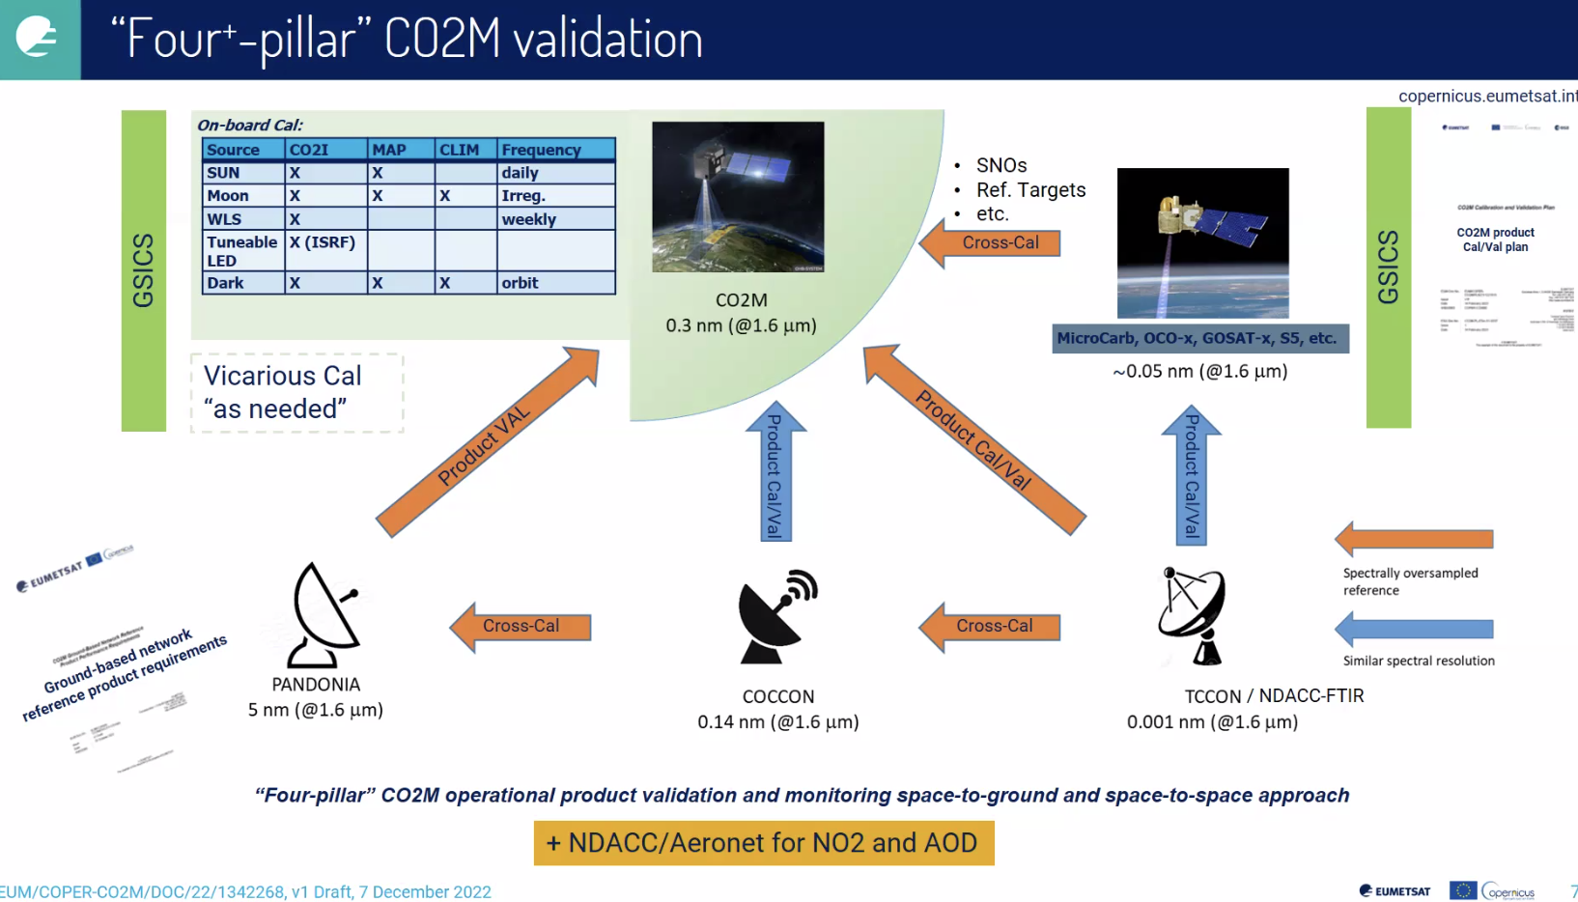
- Reviewed base targets for CO2M products.
- All information and statistics have been consolidated in the CO2M project map server database. Large database of stations provides background information via map server. Putting all criteria on the map, overpass statistics, baseline analysis tool that shows how many stations are providing the criteria needed at all times. Not many are currently providing
- Together with the Cal/Val study and with the support of CNES, planning to organise a workshop at the forthcoming IWGGMS-19 meeting on 4-6 July 2023 in Paris. Workshop title: "Ground-based network design workshop for validation of CO2M/MicroCarb and related missions. A draft web-page exists for participants to register under: https://events.spacepole.be/event/167/ Location: CNES headquarters, Paris, Time: 7 July 2023, 10:00 - 16:00 CEST
- More details can be viewed from the linked slides.
Discussion
- Philippe Goryl (WGCV Chair, ESA) noted there is significant interest and synergy between teams including Angelika from ESA.
- Reudiger Lang (EUMETSAT) noted that the EUMETSAT team is working with Angelika, efforts are being made to set up a ground-based facility and establish support contracts, with a focus on providing scientific support. He agreed that there is a lot of synergy between ESA and EUMETSAT.
- There are also opportunities for synergies for different networks within ACSG. It is important to get CEOS engagement and also see how each national agency can create an impact. It was suggested that this activity is raised to ensure visibility at SIT or Plenary.
- Jean-Christopher (BIRA-IASB) noted the importance of maintaining sustained contact between space agencies and personnel working at the sites of NDACC, TCCON, and COCCON. The active participation of delegates from ESA, NASA, and EUMETSAT in WG meetings helps to encourage and motivate people, validate the systems, and ensure the scientific aspects of these networks.
WGCV-52-ACT-16 | WGCV Chair team to consider an approach to raise to CEOS leadership level the need for support to the GHG networks: NDACC/FTIR, TCCON, and COCCON networks. | SIT Technical Workshop 2023
Space Agency Report
JAXA [Slides]
Presenter: Akihiko Kuze and Kazuhisa Tanada
Main points:
- The launch of ALOS-3 experienced a failure and the status of ALOS-4 remains uncertain.
- EarthCARE is a joint ESA JAXA mission scheduled to be launched in 2024.
- Tanada-san is working for JAXA programs focused on climate, particularly in recent work on evapotranspiration. Understanding the aerosol-cloud-precipitation system is crucial for Earth system prediction and supporting policy-making efforts.
- The US Decadal Survey in 2017 designated "Aerosol" and "Clouds, Convection, and Precipitation" (A-CCP) as important observables. In response, NASA initiated the "AOS" (Atmosphere Observing System) project, an international effort to observe A-CCP using a constellation of instruments.
- The AOS constellation consists of two projects: AOS-I, which operates in an inclined orbit and AOS-P, which operates polar orbit.
- JAXA’s GPM and EarthCARE community has agreed to join the AOS project with PMM (Precipitation Measurement Mission) / KuDPR (Ku-band Doppler Precipitation Radar) as AOS-I following new/advanced functions improved from GPM/DPR.
- Summary of current and future instruments:
  - GOSAT, GCOM-W, GPM Core/DPR, ALOS-2, GCOM-C, GOSAT-2: Operating
  - ALOS-3 (advanced Optical): The H3 new rocket failed.
  - ALOS-4 (advanced SAR, successor of ALOS-2)
  - EarthCARE/CPR (joint mission with ESA): to be launched
  - GOSAT-GW (successor of GOSAT-2 & GCOM-W): Planned to be launched in JFY2024
- More details can be viewed from the linked slides.
Discussion
- ALOS-3 failure was unfortunate. JAXA has done exceptional work on ALOS DEM. Looking forward to the next missions.
USGS [Slides]
Presenter: Cody Anderson
Main points:
- Landsat 9 reprocessing:
  - L9 Collection 2 OLI and TIRS from the first year of ops ~Nov 2021, reprocessing started March 2023. Updates to calibration change identified by USGS/NSA cal/val team.
  - Geodetic accuracy updates. L1GTs only. Only affects geodetic scenes. Of interest in a couple of areas across the globe.
  - Corrected SWIR2 band.
  - Revisited underfly data. Reevaluated data, and made slight adjustments to calibration of certain bands. On the thermal side, also made an adjustment. Not a linear correction for thermal.
- Making finishing touches on Landsat 9 Pre-launch, Commissioning, and Early On-Orbit Imaging Performance. Details are available here.
- L8 radiometric performance, issuing quarterly reports, OLI and TIRS behaving well.
- Landsat Collection 3 potential improvements include:
  - In the process of defining the scope for collection 3, USGS is looking at potential enhancements and data improvements.
  - Schedule sliding to the right, looking now at the 2028 timeframe.
  - Engaging with the community regarding data changes. Welcome all feedback.
  - Landsat Next is envisioned to fit seamlessly into Collection 3 in the 2030 and 2031 timeframe.
- Landsat 7 is still operating. LST shifting but still taking data. Landsat 8, 9, and 7 are performing nominally. Landsat 9 cross-calibration with Landsat 8 are within sub percent.
- USGS Collection 3 scope definition is underway.
- More details can be viewed from the linked slides.
Discussion
- It was noted that per-pixel uncertainty in the geometry domain is planned for Collection 3. It is the first time this has been done among missions.
- Peter Strobl (EC-JRC) suspects this is covered in Collection 2 for Sentinel-2. Think it is on the roadmap too.
Day 2 Close
Philippe Goryl (WGCV Chair, ESA) thanked everyone for joining and closed Day 2 of the WGCV-52 meeting.

