Minutes
WGCV-52 Day #3
Wednesday, 7 June 2023

Participants (* Virtual Participants)
ASI Antonio Montuori, Valerio Grimani, Cristina Lidó de la Muela (Thales Space for ASI)
AIRCAS Lingling Ma, Ning Wang
BIRA-IASB Jean-Christopher Lambert
CAST He Hongyan, Wenwen Qi
CEO Marie-Claire Greening*
CONAE Angel Matias Palomeque*
CSIRO Cindy Ong, Matt Garthwaite
ESA Philippe Goryl, Paolo Castracane, Fabrizio Niro, Marc Bouvet, Sabrina Pinori (Serco
for ESA), Stefano Casadio, Antonio Ciccolella, Angelika Dehn, Marin Tudoroiu*,
Antonio Valentino* (RHEA for ESA), Leonardo De Laurentiis*
EC-JRC Peter Strobl
GISTDA Prayot Puangjaktha, Passapak Sarathin
GA Medhavy Thankappan
JAXA Kazuhisa Tanada
KARI Kyoung-Wook Jin
NASA-JPL Bruce Chapman*
MYSA Wayne Ng Su Wai*
NASA Xiaoxiong (Jack) Xiong, Eric Vermote, Kurtis Thome*
NOAA Taeyoung Jason Choi, Manik Bali*
NPL/UKSA Nigel Fox
NRSCC Xiaolong Dong
RBINS Kevin Ruddick*
SEO Dave Borges*
USDA Michael Cosh*
USGS Cody Anderson
WGCV Sec Matt Steventon, Riza Singh
WGISS Makoto Natsuisaka*, Tom Sohre*

Welcome and Review of Day 2 Actions
Presenter: Philippe Goryl (WGCV Chair, ESA)
Main points:
- Philippe Goryl (WGCV Chair, ESA) welcomed everyone to Day 3 of the WGCV-52 meeting.
- Matt reviewed the action and decision items from Day 2.
WGCV Contributions to the CEOS New Space Task Team
Presenter: Antonio Ciccolella, Philippe Goryl, Cody Anderson
Main points:
- Antonio Ciccolella recalled that the New Space Task Team was formed last year and after some internal discussions, it was decided to produce a white paper for SIT-39. The task team is currently working on consolidating the white paper which includes sections on introduction and objectives, the reciprocal benefits between CEOS and New Space, defining the scope of New Space relevance to CEOS, outlining the process, distinguishing between new and old space, and highlighting the ecosystem that New Space is fostering, particularly in terms of increased accessibility for public services.
- The involvement of both upstream and downstream stakeholders is integral to this effort, and the WGCV is being consulted for recommendations.
- The interfaces between agencies and private industry vary depending on the specific circumstances and characteristics of each country.
- Provided a brief overview of the chapters of the New Space white paper (draft document link)
Presenter: Philippe Goryl [Slides]
- Philippe presented the potential WGCV contributions to the 'New Space' community and reviewed the inputs that have been provided as input to the NSTT White Paper.
- There are four main categories of contribution: References, Methods and Protocols, Tools, and Expertise.
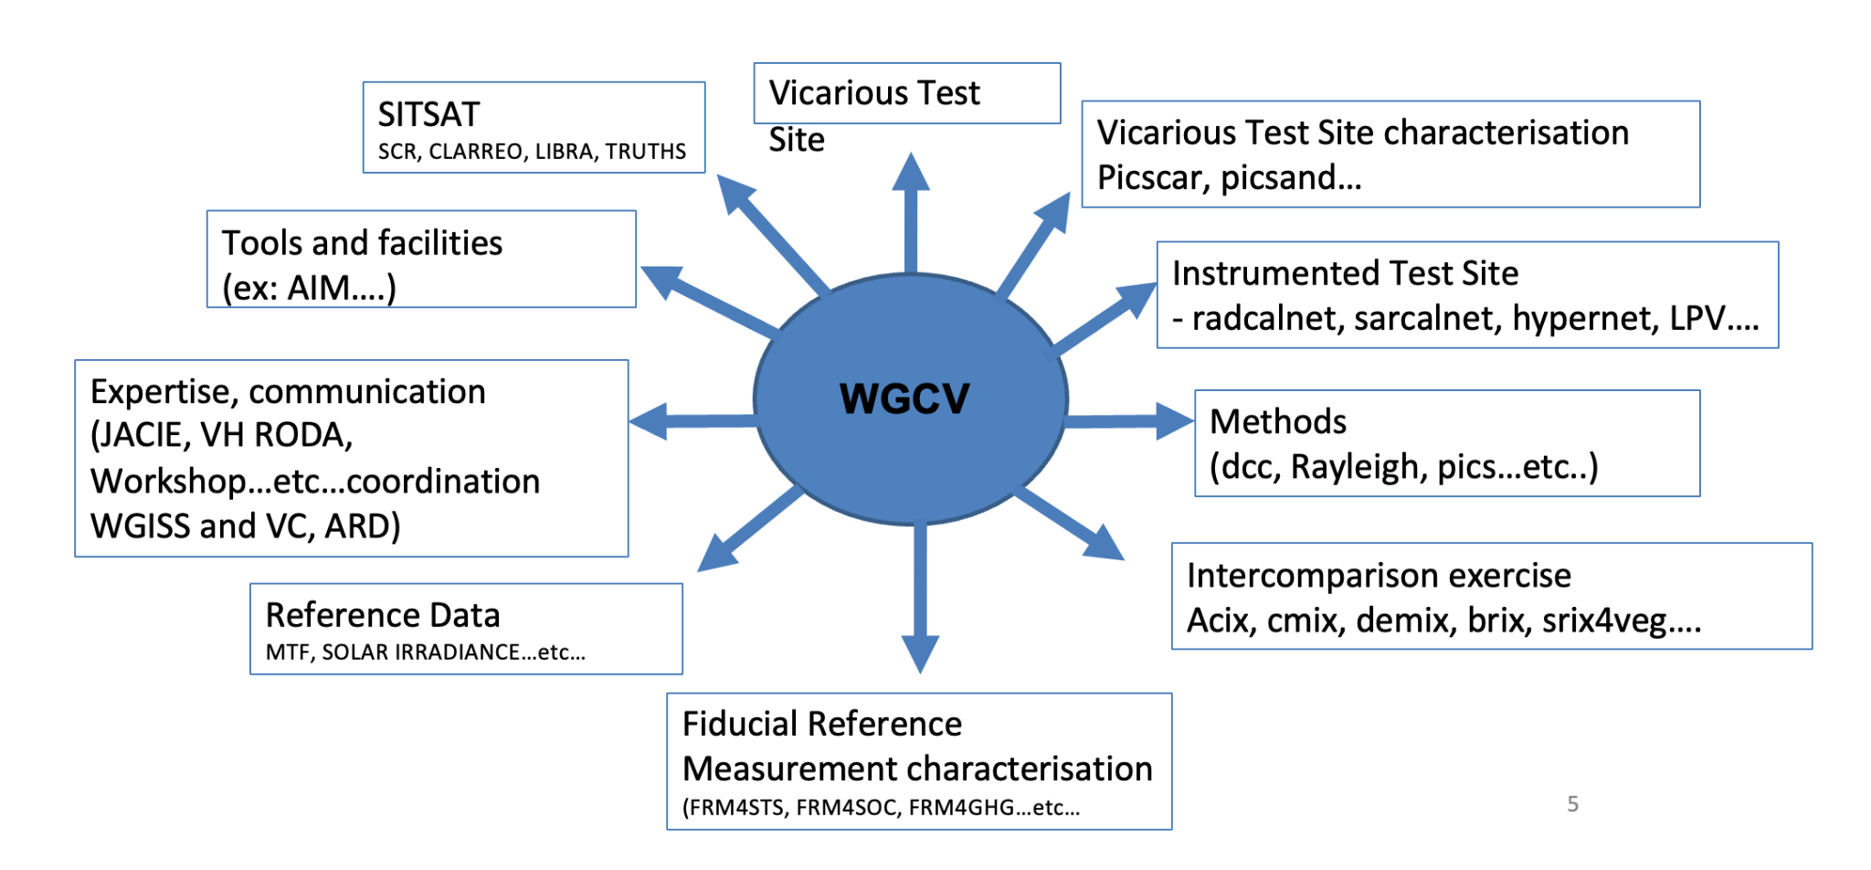
- Recalled that WGCV is involved with the New Space through JACIE and VHRODA workshops.
- Starting collaboration between NASA and ESA in the framework of the New Space mission, GSCA and EDAP. Have tried to coordinate and access New Space data in a harmonised way. Have developed the MM concept for cal/val and also facilitate the discussion between NASA and ESA and also facilitate communication with the data provider.
- The EDAP tool has been integrated into the WGISS MM and is one of the contributions of CEOS to New Space. More details can be viewed from the linked slides.
JACIE and VHRODA [Slides]
Presenter: Cody Anderson
- Provided a brief overview of JACIE members and meetings.
- Some takeaways from the last JACIE workshops, continuing to be a cal/val workshop focusing on data quality.
- New space, interoperability, and commercial companies are utilising free open data and analysing the data. Not good at communicating among themselves but doing a lot of good work with open data and their own data. It was the first face to face workshop since covid.
- Actions recorded from the last JACIE meetings where WGCV can contribute:
  - Common Recommendations from JACIE and ESA’s Very High-resolution Radar and Optical Data Assessment (VH-RODA)
    - Database of high-resolution Ground Control Points (GCPs) and Digital Elevation Models (DEMs)
    - Common Cal/Val Evaluation Sites
    - Common data pool for commercial imagery over evaluation sites
    - Encourage/Require reporting of commercial pre-launch characterisation data (i.e. Relative Spectral Responses, Thermal Stability, etc.)
- Coordination between JACIE and ESA agencies includes:
  - Continue JACIE and VH-RODA(ESA) workshop coordination
  - Coordinate assessment methodology and division of assessments
  - Coordinate with ESA on Cal/Val Park/In-Situ Network requirements
- More details can be viewed from the linked slides.
Discussion
- New space is impacting our Earth observation world and we need to be aware and look for opportunities for mutual benefit. Hyperspectral is an emerging priority, thermal infrared is also growing rapidly, also the atmospheric domain. Seeing some good results, but can't take everything at face value. CEOS has a key role in helping with ca/val and the quality of data that is out there for the community. But there will also be mutual benefits, a vast increase in data out there for society. NSTT is trying to clarify a way to fit with this new paradigm.
- Antonio Ciccolella noted the importance of assessing data provided by constellations as a whole, rather than just focusing on individual satellites. The WGCV was suggested as a potential body to undertake such assessments, considering not only the quality of the images but also the complementary datasets, ancillary data, and derived products.
- Quality of constellations is a specific topic in VH RODA and JACIE. It is inherently difficult, even for instances like Sentinel-2A/B.
- Characteristics of New space, are quick launch and improvement, evolution of the Planet constellation was noted. There are different paradigms for time series.
- Rapid development and rapid improvement but they don't look at the archives like the government funded agencies do.
- Cody Anderson recalled that there was a question raised at the JACIE meeting about how open are some of the commercial companies regarding opening up the archives for reprocessing, science, etc. Typically the big money is provided by the intelligence agencies, for Near Real Time data, and they are not so interested in older data. Going back to the archive is not a big priority in terms of investment for commercial data providers.
- The company, Spire, was noted as providing reports to ECMWF, NOAA, GNSS, and other agencies. Initially, Spire faced some challenges, but it has now demonstrated its capability to provide reliable reports for these agencies.
- Jean-Christopher (BIRA-IASB) mentioned that within the framework of the atmospheric mission composition cluster, two pilot commercial companies are involved in measuring methane and working towards developing protocols. The kickoff will be in July 2023. It was emphasised that participating in the VH RODA workshops is a mandatory aspect of this activity, and there have been significant developments in the atmospheric domain.
Discussion on Shared Data Quality Metrics and NSTT Report Input
- Philippe Goryl (WGCV Chair, ESA) noted that the shared data quality metrics topic is included in the New Space Task Team White Paper and there is a need to decide on WGCV’s contribution to this section.
- The discussion revolved around providing additional guidance or parameters for data quality assessment in the New Space context. It was suggested that the minimum requirement is to replicate the Maturity Matrix (MM) in the chapter, focusing on guidelines for accessing the matrix.
- Nigel Fox (UKSA) noted that if more guidance is required, the MM should be adapted rather than creating a new assessment framework. The MM aims to provide an assessment of quality based on documentation and its evaluation.
- More verbose: “Matrix to share the Maturity of the Quality”
- Philippe reviewed the SIT-38 presentation on the Cal/Val Maturity Matrix (MM) concept and value to the NSTT work. The original presentation from Sam Hunt can be accessed through this video link.
- Peter Strobl (EC-JRC) asked about the assessment level that goes from basic to ideal, is that about having the level documented?
- Nigel noted it's about assessing what the persons say they are doing, not making a judgement as to whether it's 10% or 5%. It is based on documentation and assessing the documentation to see how well it is evidenced by data providers.
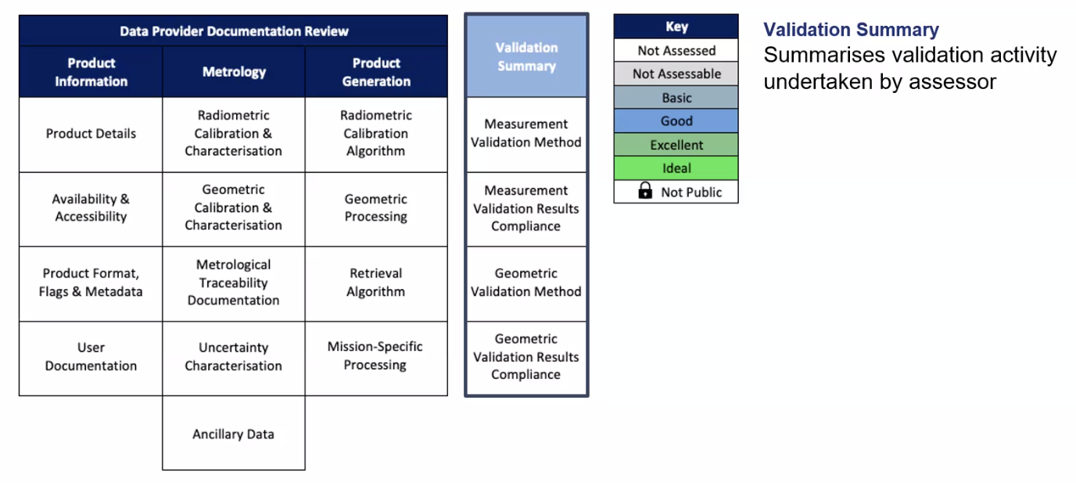
- Peter Strobl (EC-JRC) raised the potential overlap between the CEOS-ARD Specifications and the MM.
- The WGISS Maturity Matrix, which focuses on data management, was mentioned as a counterpart to the Cal/Val MM. Both matrices provide a comprehensive overview when used together. The Cal/Val MM is adapted to data providers and accessors to communicate high level results in terms of Cal/Val quality, while the users of the WGISS MM are agencies and mission managers to monitor their missions.
- MM is a comprehensive standard for mission quality defined by ESA and NASA. and is currently being used for Quality Assurance evaluation in ESA/NASA commercial missions. The assessment process has opened a "communication channel" between agencies and New Space companies.
- Philippe noted there is a significant similarity, in ARD assessment MM. The work done in MM has also been reused to develop the FRM Assessment Framework, which will be valuable for ARD.
- Medhavy Thankappan (GA) noted a subtle difference between ARD and the Cal/Val MM. The MM goes a step further to assess the quality of the data, while ARD functions more like a checklist.
- Peter emphasised the need to align the ARD Specifications and MM, considering three different axes: documentation quality, absolute parameter quality, and relative fitness for purpose which are completely independent of each other. It is important to ensure consistency across these axes.
- Cody Andreson (WGCV Vice-Chair, USGS) addressed the fitness for purpose discussion and noted that commercial providers might be hesitant to provide such information.
- Nigel mentioned having conversations with commercial providers at IVOS, indicating their growing interest in pursuing this direction.
WGCV-52-ACT-17 | WGCV Chair to contact the team with a call to consider if there is anything else to report in addition to the Maturity Matrix for the section of the ‘shared data quality metrics’ for the New Space Task Team White Paper. | July 30

New Space Match Up Database Action from VHRODA
- This is one of the action items for WGCV that came from VHRODA.
- The idea is to create a match up database by acquiring a series of data over specific sites and making it available through an open system for sharing and comparison. Acquisition of data over sites like RadCalNet, Hypernet, and Libya 4 was suggested to ensure an adequate number of sites. Calibration and intercalibration coefficients would be extracted from the acquired data and made accessible through a publicly accessible database. Implementing such a system is complex and requires an exploration of implementation methods.
- Commercial companies are generally open to providing data but may be reluctant to approve publications or statements on their data. However, if data quality assessments are built into contracts, they are obligated to comply.
- Nigel supported the initiative, seeing it as the conclusion of the interoperability action. He believes it can lead to quick convergence in data quality.
- The framework should consider incorporating a "blind test" for independent evaluation of other sites.
- Nigel noted that CEOS may not be efficient in responding quickly, suggesting a need for timely action even if it is not perfect to demonstrate CEOS's commitment. Decision-making points should be prepared and presented at the IVOS workshop in September 2023.
- Cindy Ong (CSIRO) highlighted the goodwill of new space providers to contribute data. Encouraging their contribution can be facilitated by offering the RadCalNet data in exchange.
- Dependency lies in the goodwill of new space providers, and a flexible approach is necessary. The offer of free calibration characterisation of their sensors acts as a carrot, while procurement decisions and data purchases serve as the stick.
- Philippe mentioned that the deadline to respond to this action is set for the upcoming VHRODA workshop in November 2023.
- Peter emphasised the importance of involving the new space industry right from the beginning. He mentioned the positive experience with the TMSG and how including industry representatives proved to be beneficial.
- The geometric registration framework has the potential to attract industry interest. The success of the MTF activity involved industry collaboration and highlighted their valuable contribution. The discussion of GCPs within that context also generated clear industry interest.
WGCV-52-ACT-18 | IVOS Chair to include the ‘New Space’ match-up database topic on the agenda for the next IVOS Subgroup meeting. | Next IVOS meeting
WGCV-52-ACT-19 | WGCV Chair to prepare a presentation for VH-RODA on the ‘New Space’ match-up database. Presentation + concrete, real examples of what it will look like. | September
WGCV-52-ACT-20 | Cody Anderson to make a start and connect with IVOS Chair - consolidate a list of approx. 5-10 locations for a radiometry match-up database. | July
WGCV-52-ACT-21 | WGCV Secretariat to send a poll for an end-October teleconference on the possibility of a GCP match-up database in addition to the existing radiometry focused match-up database proposal. The call will take stock of: potential participation, summarise work done to date, consider a survey of what exists with respect to GCP data sources and availability for geometry aspect of match up database. Consider Ling ling connection. | July
WGCV-52-ACT-22 | TMSG Chair to include GCP match-up database topic on the agenda for the TMSG plenary meeting. | COMPLETED
WGCV-52-ACT-23 | Paolo Castracane to provide the list of people from the MTF activity that had interest in exploring something along the lines of a GCP match-up database. Send to Peter. | COMPLETED

HYPERNETS Update [Slides]
Presenter: Kevin Ruddick
Main points:
- HYPERNETS draws inspiration from AERONET, and RadCalNet and aims to establish connections with FLUXNEt and BSRN in the future.
- It is a joint initiative by ESA, BELSPO, and the EU.
- HYPERNETS focuses on validating the correction between Top of Atmosphere (TOA) and Bottom of Atmosphere (BOA) measurements. Automated measurements are conducted to validate water and land surface reflectance across various VIS/NIR spectral bands (380-1700 nm).
- There is a recognised user community needs to expand measurements to the Short-Wave Infrared (SWIR) range (2300-2500 nm).
- The HYPERNET system is built on the HYPSTAR instrument and collects measurements every 30 minutes during daylight hours for a year before recalibration is required.

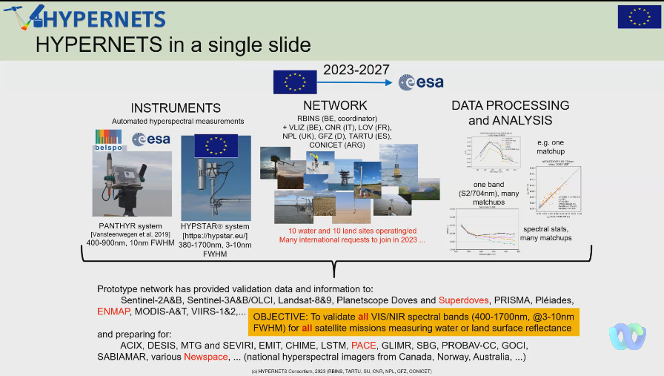
- Ongoing reviews of water and land sites are being conducted, and the number of sites will increase in the coming months.
- Validation results comparing Planetscope/Doves with HYPERNETS/PANTYR data from 2019-2020 showed good interoperability with 52 satellites and 88 matchups. The Red+Green bands were found usable for turbidity, but not the NIR band.
- Data from HYPSTAR will be released by June 2023, with reprocessing expected by December 2023. Reprocessing of PANTHYR data is currently in progress, and PANGAEA data is slated for release in June 2023. More details can be viewed from the linked slides.
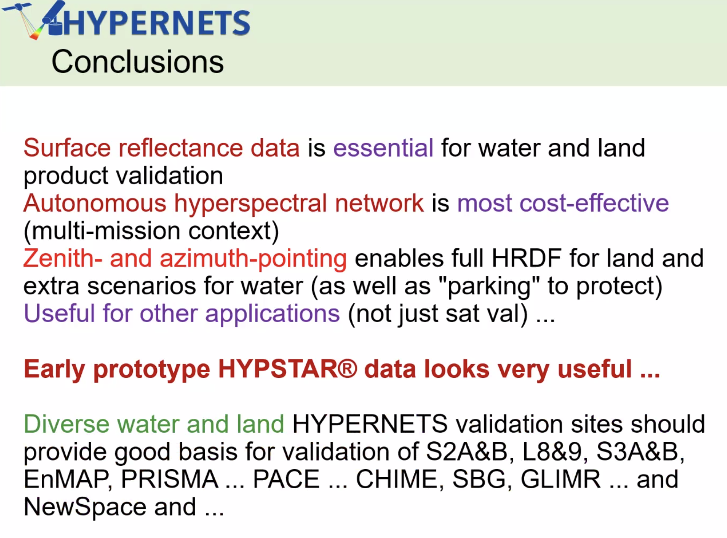
Discussion
- Eric Vermote (NASA) asked about the data Kevin presented for Planetscopes with 52 different satellites, specifically asking if the results only involved Doves or the new Super Doves.
- Kevin Ruddick (RBINS) clarified that the results were from Doves, as mentioned in the 2020 paper, specifically over water.
- Eric expressed that he found different results, noting partial agreement depending on the satellite used.
- Eric asked about accounting for spatial non-homogeneity, and how the small footprint of the sensor is taken into account.
- Kevin noted that the aim for each site is to have a quantification of the uncertainty in spatial variability as a function of length scale. He explained that the variability varies between sites and the information is derived from the highest resolution satellite data, where the variables can be quantified for different length scales.
- Eric noted that he will present CAMSIS, camera system, and spatial imager at high altitude, at the LPV meeting, and noted it would be beneficial to combine HYPERNET with CAMSIS.
- Kevin liked the idea. However, Kevin mentioned that when dealing with large amounts of data and measuring multiple angles over the year, there could be a possibility to separate out the angular variability from spatial variability. He further explained that some patches are darker like the forest sites, and variations that occur during the day due to changing shadowing. If there is a long dataset with both spatial and angular extent, it would be interesting to colocate it with the spatial imagery.
- Kevin noted there are three sources of variability: spatial variability, variability related to scattering angle and variability influenced by the sun’s azimuth angle.
- Cindy Ong (CSIRO) asked about the timeline for extending HYPERNET to the SWIR region. Kevin noted that it is at least two years away due to the challenges involved in developing spectrometers beyond 1700nm. The quality of currently available spectrometers in that range is also uncertain, although there is a clear demand for SWIR measurements.
- Peter Strobl (EC-JRC) asked about the link between HYPERNET and FRM. He specifically inquired about the documentation of procedures, metadata, uncertainties, and the standards being followed to ensure interoperability.
- Kevin noted that HYPERNET is compliant with the INSPIRE directive in its entirety. Regarding FRM, it is embedded within the FRM4Veg activity through the National Physical Laboratory (NPL) and is part of the FRM4SOC consortium. The measurement uncertainties are already included in the HYPERNET processor. The processor outputs land surface reflectance along with uncertainties and contributing factor information. However, he noted that more work needs to be done to ensure full compliance with FRM and to address any additional uncertainties required.
- The incorporation of a skycam at HYPERNET sites was suggested for further exploration.
- RadCalNet and HYPERNETS provide a great combined tool for cal/val. Top-down and bottom-up. Information on HYPERNETS is also included in the hyperspectral cal/val reference document and will be made available on the cal/val portal.
CEOS Interoperability Framework [Slides 1 and Slides 2]
Presenter: Tom Sohre (Virtual), Peter Strobl
CEOS Interoperability Framework [Slides]
Presenter: Tom Sohre
Main points:
- The CEOS Interoperability Framework initiative was initiated as WGISS action during the 2022 CEOS Plenary with the goal to consider Data and Service interoperability. The CEOS Interoperability team was formed under the leadership of the current WGISS Chair, Makoto Natsuisaka from JAXA. The first CEOS Interoperability team meeting took place on 15 February 2023 to discuss vision, teams, topics, memberships and the annual process.
- Shared the current status update of the works done by the CEOS Interoperability team.
- Briefly reviewed the seven interoperability factors: semantic, syntactic, data architecture, data accessibility, data quality, data preservation and data policy.
- Data Quality and the semantic factor would be most relevant for WGCV to contribute. The rest of the factors have been assigned to other CEOS Working groups as the groups that seem most relevant to that topic. However, the intent is to have a joint collaborative effort. There is an action on appointing factor Champions within the framework.
- Seeking Factor Champions from WGCV for Data quality topic.
- Have an action to present the Interoperability Roadmap at CEOS SIT-TW in October 2023.
- More details can be viewed from the linked slides.
Discussion
- Philippe Goryl (WGCV Chair, ESA) noted the Factors are well organised and Cody proposed leading the Data Quality Factor. The quality factor was seen as having some similarity to the New Space aspect of interoperability, providing references, cal/val, and consolidating and organising existing elements.
- Concerns were expressed about the Semantic Factor falling under WGCV coordination, as it is broader and requires significant resources and time. Peter would be a natural choice for this domain, but we run into the usual issue of resources and time. Maybe we should take what we have such as a common online dictionary published in cal/val portal and say this is the contribution to this Semantic Factor.
- Nigel Fox (UKSA) expressed confusion about the words presented on the slides for the Semantic Factor, which seemed different from the terminology piece.
- There was a discussion about the need for commonality and rewording the term “computer systems” in the semantic factor descriptions.
- The Interoperability Framework topic is important but has not been prioritised much. The need to involve external experts and other groups was emphasised, and the idea of organising a workshop was suggested.
- Resource limitations and the lack of individuals stepping up to lead the factors were acknowledged as challenges.
- Philippe noted given the tight due date, perhaps merging the Semantic and Syntactic Factors, and considering a work package dedicated to the common online dictionary as a starting could streamline efforts.
- Matt Steventon (WGCV Secretariat) suggested providing a response to the CEOS leadership regarding the lack of resources and experts, and Tom could prepare a recommendation.
- It was suggested that within each category and activity, responsibility for semantics should be absorbed, ensuring consistency.
- Peter strobl (EC-JRC) clarified that the Interoperability Framework is not a working program but a way to see different aspects of work to ensure compatibility and interoperability.
- Peter presented the current ambiguity in terminology and noted the need to resolve it if the terms are being used technically for ensuring interoperability such as the term ‘in-situ’:
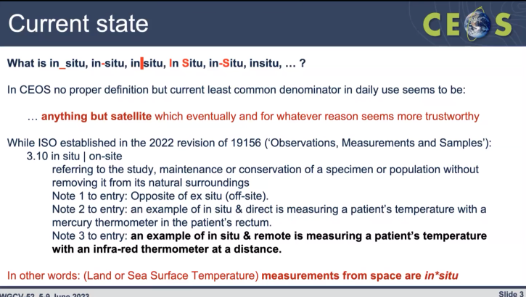
- The importance of having a common terminology was highlighted and developing a glossary that identifies critical definitions relevant to CEOS was recommended.
- It was suggested that every Factor Champion would finish their respective chapter with a glossary, which would be consolidated into a single document, ensuring coordination and international recognition.
- The idea of coordination among the Factor Champions to gather terms and publish them somewhere visible was proposed.
- The importance of visual representation and not removing the semantics block entirely was discussed.
Decision 02 | Cody Anderson was identified as the Factor champion for the ‘Data Quality’ Factor of the CEOS Interoperability Framework.
Decision 03 | Will suggest that the Semantics Factor of the Interoperability Framework be distributed vertically / cross-cutting and that there be no Factor champion for it, (and that the factor description with mention of ‘computer’ be re-worded) rather each of the other Factors will maintain their own glossary, with consistency to be coordinated by those Factor champions and via the forum of the Interoperability Framework team.  It will be a distributed function of the other champion leads to define consistent glossaries of only the most critical terms.  Peter: Prefer to have consistency and all factors orthogonal. We still need to work on a common understanding of what an IF is and how it is applied.

WGCV-52-ACT-24 | WGCV Chair to confirm the position of the WGCV with regard to the Interoperability Framework (Decision 02 & 03). That is, that Cody Anderson will be identified as the ‘Data Quality’ champion and that we suggest the semantics factor be cross-cutting, without a champion of its own, but instead be a distributed function of the other champion leads to define consistent glossaries of only the most critical terms. | July

Synthetic Aperture Radar (SAR) Subgroup Report [Slides]
Presenter: Bruce Chapman
Main points:
- SAR Subgroup meeting held the first in person meeting since the Covid-19 pandemic at CSA, Canada in 2022, with approximately 40 participants in attendance. During the meeting, there was a special session to discuss the Sentinel-1 ARD workshop. Several sessions focused on calibration targets of ongoing and future missions, the role of the SAR Subgroup in supporting CEOS ARD initiatives, and SARCalNet.
- The ARD workshop was focused on the development of Radiometric Terrain Correction (RTC) products from Sentinel-1 data by ESA, NASA and DLR. Discussions were held to explore the differences in RTC products being investigated by the three agencies.
- The SAR Subgroup also discussed the presence of different PFS within the CEOS ARD group for SAR data and the ongoing efforts to harmonise these specifications.
- The time for the new SAR Subgroup Chair to take over was announced, and the group is ready for the new Chair nominations. However, there had not been a meeting to discuss this matter at the time.
- The next SAR Subgroup meeting is scheduled to take place at DLR on October 16-18, 2023.
SARCalNet
- A group of 20 volunteers have been working on defining the SARCalNet requirements document. Documents are available on the ESA SharePoint. The list of documents includes SARCalNet Handbook, SARCalNet website requirements, SARCalNet submission template, requirements for artificial targets, natural targets and imager calibration analysis.
- The SARCalNet Handbook provides general information on the SARCalNet initiative. While the document is mature, it still requires careful review before publication to ensure its accuracy and completeness.
- The submission template requires careful review and coordination before publishing it to the website.
- The artificial targets requirement document is under development and is expected to be completed before Fall 2023 meeting
- National targets are used to help with evaluating the radiometric characteristics of the data. All SAR missions use national targets for calibration.
- The image calibration analysis document describes analyses for both natural and artificial targets and allows comparison between sensors. It is currently undergoing a thorough review and is expected to be finalised before the Fall 2023 meeting.
- The SAR Subgroup plans to publish all these documents on the SAR Subgroup website, making them accessible to the wider community.
- More details can be viewed from the linked slides.
Discussion
- Marie-Claire Greening (CEOS Executive Officer) via chat noted that for SAR subgroup chair nominations, reach out to the subgroup membership in the first instance. If no one comes forward and you need help, let the WGCV chair know and we can look to raise it at the Principal level, but first try your community in the hope that someone raises their hand.
- The subgroup chair is totally up to the subgroup to decide. Bruce Chapman (NASA-JPL) will discuss this within the SAR Subgroup soon. He has someone in mind for the Subgroup Chair.
- Bruce noted he will continue to lead the SARCalNet activity.
- Nigel Fox (UKSA) noted that the actual formal documents at the Top level were approved and endorsed by WGCV.
- RadCalNet was elevated to WGCV level for visibility and gave it a higher status for it to be WGCV badged.
- SARCalNet is a major activity. Philippe will ensure that it is highlighted at the major CEOS meetings.
- Bruce supported the idea of WGCV reviewing and endorsing the SARCalNet documents.
Decision 04 | SARCalNet documents will, in time, be presented to WGCV for review and eventual endorsement such that the activity can be badged as a top-level WGCV activity (like RadCalNet) and benefit from the visibility that such an endorsement brings.

- Antonio Montuori (ASI) asked about the sharing of analysis results conducted by different groups on the SARCalNet targets. He questioned whether it would be beneficial to analyse and evaluate contributions from various sites, considering that different sites may have different analyses compared to the actual analysis conducted by Thales Space Agency.
- Bruce Chapman (NASA-JPL) acknowledged the significance of this topic for SARCalNet. He emphasised that SARCalNet aims not only to host the target sites but also to facilitate the sharing of imagery and analysis results on the SARCalNet platform. The goal is to provide accessibility to the imagery and analyses, making them available to interested individuals through the SARCalNet website. This approach would enable collaboration and comparisons among different groups and their respective analyses.

CEOS-ARD [Slides]
Presenter: Matt Steventon, Medhavy Thankappan
Main points:
- The OGC ARD Standards Working Group was approved on 3 May 2023.
- ISO has designated the ARD series of standards to be ISO 19176.
- Recalled recent updates on the ARD23 meeting. Engaged experts with STAC specifications to see how it supports CEOS ARD discoverability and accessibility. Have some actions to push this.
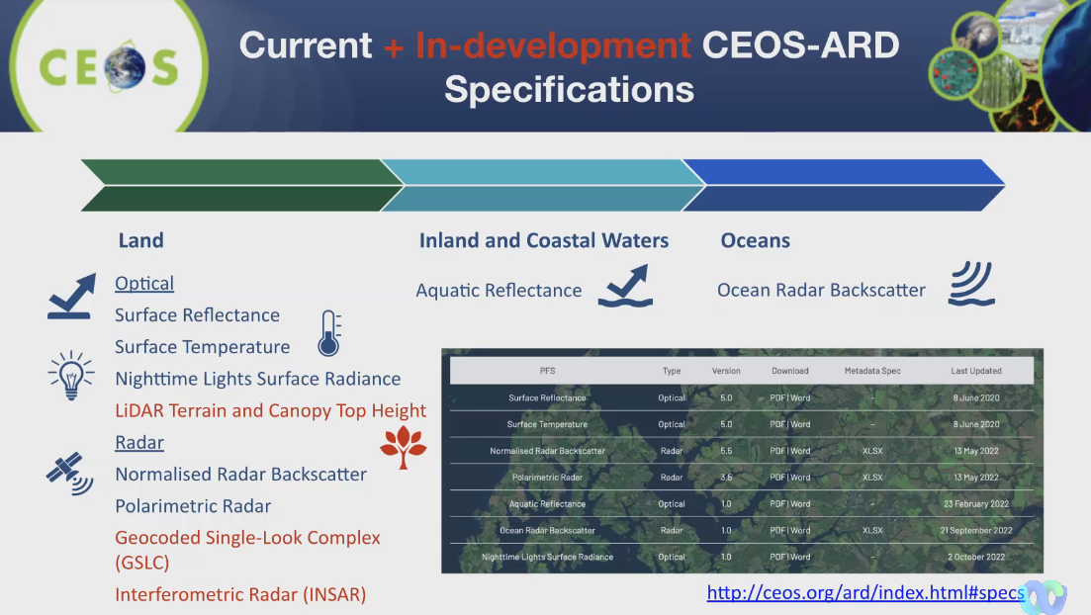
- The collection of CEOS ARD datasets is growing substantially.
- Some open questions on CEOS-ARD OG are related to versioning, CEOS-ARD inheritance for derived datasets.
- Medhavy shared a proposal for CEOS Interoperability Framework Pathfinder: Surface Reflectance Equivalency/consistency for information and awareness. This document is a work in progress taking the next step to move closer to interoperability. It is a one-page summary compiled from the workshop presentation and available here.
- Taking a step further toward moving Surface Reflectance to a more harmonised product.
- Clement Albinet from ESA has offered to serve as an alternate PoC for CEOS-ARD evaluations.
- Medhavy acknowledged that some terminologies used in the document are ambiguous and require updating and that the document is primarily shared for awareness purposes only.
- More details can be viewed from the linked slides.
Discussion
- Nigel Fox (UKSA) emphasised the need to establish the basics before delving into more complex aspects.
- Medhavy Thankappan (GA) noted the shared document is primarily for awareness purposes as it may evolve through other entities.
- Peter Strobl (EC-JRC) noted that there is a demand from the users already to use the data and we should speed up to make it available to the users. He sees convergence in the discussion around sensor-agnostic ARD.
- Nigel suggested that if the framework does not involve measuring anything related to uncertainty, it is better not to mention it at all.
- Cody Anderson (WGCV Vice Chair, USGS) noted his experience at JACIE, where some commercial providers mentioned that they were already incorporating uncertainty. Consistency is more important, he realised some inconsistency on how BRDF increases the uncertainty of a direction of reflectance.
- Peter supported Cody's point and emphasised the need to carefully consider data processing. He explained that due to the absence of a single processing method, uncertainty always increases in linear processing downstream.
- Eric agreed with Cody and insisted on the importance of clear terminology, “directional surface reflectance” should not be vague.
- Medhavy noted that the document was presented at the ARD 23 workshop and as this also fits in with the discussion on the CEOS Interoperability Framework, he thought it was a good idea to alert WGCV.
Decision 05 | Clement Albinet of ESA was confirmed as the alternate WGCV PoC for CEOS-ARD self-assessment peer reviews.

WGCV-52-ACT-25 | Medhavy Thankappan to coordinate an update of the 1-pager on Surface Reflectance Equivalency/Consistency to reflect feedback and circulate to the WGCV team for information. | July

Hyperspectral Cal/Val Resources [Slides]
Presenter: Paolo Castracane, Cindy Ong
Main points:
- Recalled the email received from Ben Poulter. A guidance document has been drafted following the request from Ben and has been shared with WGCV for review and feedback.
- Paolo presented a set of slides based on the structure of the document.
- Detailed information is available for review here.
- Philippe noted that this document will be published in the Cal/Val portal and would remain the living document open for comments. It was suggested to keep the WGCV-51-ACT-14 action open, publish the document, and send it via email to Ben.
Discussion
- Kurtis Thome (NASA) supported the output and thanked Paolo, Cindy, Riza and the team.
- Cindy Ong (CSIRO) noted Kurt has a good idea of what Ben wants, we tried to consolidate most of the things that we are doing and could be relevant.
- Kurt acknowledged that the team had gone beyond the initial request and appreciated the balanced contribution from WGCV
- The group discussed the possibility of applying the model to the Atmospheric domain and whether there is a need for such an extension. Jean-Christopher Lambert (BIRA-IASB) agreed to discuss this within the ACSG and explore the inclusion of such a document on the NDACC satellite webpage. He expressed interest in the idea, and action was assigned to Jean-Christopher Lambert to discuss and provide an update during the next WGCV monthly meeting.
WGCV-52-ACT-26 | WGCV to consider any additional feedback on the hyperspectral cal/val resources page that has been published on the cal/val portal.  In parallel send to Ben Poulter to complete outstanding action: WGCV-51-ACT-14. | September 1
WGCV-52-ACT-27 | ACSG Chair to share the example of the hyperspectral cal/val resources page with the ACSG team and discuss with them whether there is appetite for something similar for the atmospheric domain. | Include topic on ACSG meeting agenda

Decision 06 | Agreed to publish the hyperspectral cal/val resources summary document on the WGCV cal/val portal.

CEOS Earth Analytics Interoperability Lab (EAIL) [Slides]
Presenter: Dave Borges (Virtual)
Main points:
- Provided a brief status update on EAIL. Shared a snapshot of the EAIL white paper from 2020.
- There was a need for a communal sandbox, a technical platform.
- EAIL is a data analytics platform based on AWS Cloud and ODC. Include Jupyter lab, Jupyter hub, and customised ARD pipelines. 60 registered users across CEOS.
- Jonathan Hodge from CSIRO is the lead of the EAIL architect.
- A strategy session with Jonathan Hodge has recently been held in NASA with days dedicated to discussing EAIL.
- EAIL currently supports COAST, WG Flood Pilot, and DE Americas pilot projects. Additionally, there are ongoing discussions with the CEOS Ecosystem Extent Task team, indicating significant interest in utilising EAIL as the primary platform.
- EAIL is built using the Open Data Cube and leverages heavily on the CSIRO EASI hub.
- Current data available are Landsat, Sentinel 1, 2, and 3 with workflows ready to process.
- Stressed that we strive to create a baseline environment for CEOS entities.
- Open for suggestions and feedback from a data perspective.
- MODIS, Sentinel 5P, GEDI, seasons and annual geomedics data are under development.
- Web visualisation tools will be integrated into the next phase of EAIL. EAIL has powerful ML capabilities.
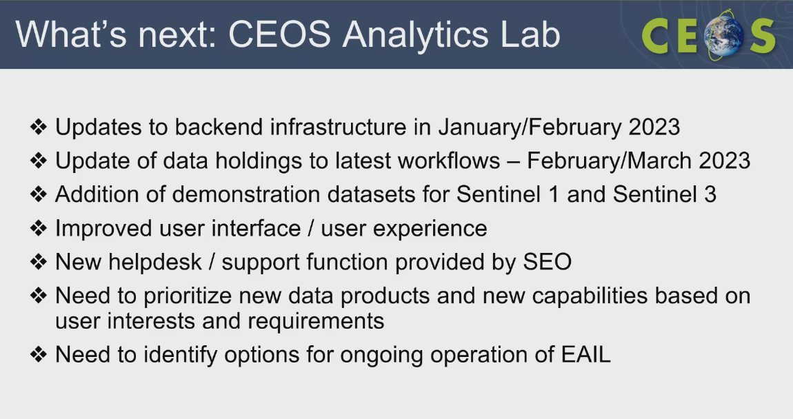
- Being renamed to “CEOS Analytics Lab” - a new and improved version should be open for business by SIT TW 2023.
- More details can be viewed from the linked slides.
Discussion
- Philippe has been discussing with Jamie and it appears that the OLIVE tool doesn’t seem to be a suitable candidate to be hosted on CEOS Analytics Lab. There might be other ideas specially for LPV. There will be some possibility to use CEOS Analytics Lab in the framework of intercomparison exercises, such as DEMIX.
- Peter Strobl (EC-JRC) noted this on the to-do list of TMSG subgroup 3. The subgroup developed the DEM comparison notebooks, in collaboration with ESA and VTweb, are now complete. Now it is ready, it is something that could be easily transferred to the CEOS Analytics Lab. These notebooks could be easily transferred to the CEOS Analytics Lab, providing users with the opportunity to generate their own comparisons against other input datasets. A decision regarding this transfer could be made after the workshop in mid-July.
- ACIX III is taking a different direction. It goes into the hyperspectral domain. Team of ACIX III and CMIX III teams will be using another platform.
WGCV-52-ACT-28 | WGCV Secretariat to organise a teleconference to discuss potential WGCV applications of the CEOS Analytics Lab. Secretariat to make a call for ideas from subgroup chairs ahead of the teleconference. Will follow up the latest on DEMIX also. | In September, Before SIT TW 2023

Space Agency Reports
CSIRO [Slides]
Presenter: Cindy Ong
Main points:
- AeroSPAN, a project led by CSIRO, focuses on sun photometry to study aerosols over a land area of 7.8 million km2 in Australia. The project operates a network of 10 sun photometer sites located in different regions of the country, including New South Wales, Northern Territory, Queensland, Victoria, and Western Australia.
- Good news that one of the Pinnacle sites got accepted in the AERONET network.
- During the observations conducted by AeroSPAN, the volcanic plume from the Hunga-Tonga volcano was observed by most of their sites. The observations captured changes in intensity and variations in the plume's characteristics across different wavelengths. These observations were compared with the Aerosol Optical Depth (AOD) trends obtained from AERONET, providing valuable insights into the behavior and properties of the volcanic plume.
- UAV-LIDAR LiDAR acquisitions have good comparisons between the terrestrial and UAV LiDAR so the measurements can be scaled out.
- Dark water Inland Observatory Network (DION) provides QA observation for Global Cal/Val community to increase Fidelity of Satellite derived water quality products. This initiative is currently in phase 1, deploying instrument for Googong Dam
- Pinnacles site has made progress: one year of continuous data collection, CIMEL approved for AeroNet, promising results, contribution to EnMAP, ongoing monitoring and cross-calibration exercises.
- More details can be viewed from the linked slides.
Discussion
- Marc Bouvet (ESA) noted ESA can assist with Sentinel-2 comparison using NPL tools. Data at the surface reflectance level needs to be provided to have them processed to TOA out of RadCalNet, and then a comparison with Sentinel-2 data could be done.
- A QC tool allows direct quality check on raw values coming from CIMEL instruments. Marc will show Cindy how the tool works and also discuss how to get the data from Beatrice later after this meeting.
- Kyoung-Wook Jin (KARI) asked about the motivation to build a cal/val in Australia.
- Cindy Ong (CSIRO) noted Australia is one of the most prolific users of satellite data, having been using it for 40+ years, and this is our contribution back to the community. We need the data ourselves.
- Peter Strobl (EC-JRC) asked about the existence of a documented strategy for identifying Landsat Cal/Val sites and whether it focuses on radiometry.
- Cindy noted that there is a strategy based on parameters from Kurt Thome's team and is currently being updated through ongoing work. The workflow includes multiple layers that are assessed, and the identified target is evaluated at the end. Previous work focused on bare targets, but it was discovered that many identified areas are actually a mixture of bare soil and plant cover. In the future, additional steps will be added to incorporate hyperspectral components and address any miscalibration issues.
- Marc Bouvet noted when ESA was searching for the RadCalNet site in 2015, a decision tree was developed and documented. It is available on the Cal/Val portal.
NASA[Slides]
Presenter: Xiong Xiong
Main points:
- NOAA-21 VIIRS was launched six months back with three calibration manoeuvres namely yaw, pitch and roll manoeuvres.
- Plankton, Aerosol, Cloud, ocean Ecosystem (PACE) mission is planned to be launched in 2024.
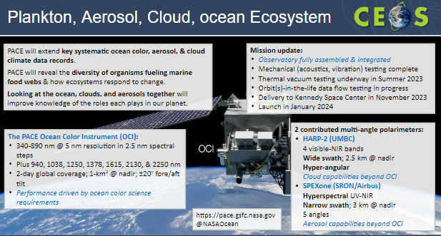
- Tentative launch date for the NASA SBG mission is September 2028 for TIR and June 2029 for VSWIR.
- More details can be viewed from the linked slides.
AIR-CAS [Slides]
Presenter: Lingling Ma
Main points:
- AIR was established by incorporating three former CAS institutes - AOE, RADI and IECAS.
- Reviewed the status of the Baotou Cal/Val site. It is a national cal/val site by NRSCC for RadCalNet.
- The project “Cross-calibration of high-resolution optical satellite with SI-traceable instruments over RadCalNet sites” was supported by ESA-MOST cooperative Dragon 5 with the objective to build the benchmark transfer chain from well-calibrated satellites (future SI-traceable sensor) to RadCalNet TOA reflectance, so as to decrease the uncertainty of TOA reflectance product.
- The validation site network for national civil space infrastructure has been established. Need integration and hope to carry out some international collaboration. Seeking contribution from WGCV.
- New technology explorations include Optical radiometric calibration based on PICS in Northwest China, Infrared sensor radiometric calibration with reanalysis time-series data, and Cross-calibration of HR optical satellite over RadCalNet sites.
- More details can be viewed from the linked slides.
Discussion
- A couple of potential follow ups include:
  - Nigel, Peter, and AIRCAS should see whether there are opportunities in the frame of the GCP match-up database project.
  - Dragon Cross-calibration, Nigel, SITSat task team, this work could be further covered there.

ASI [Slides]
Presenter: Antonio Montuori, Cristina Lidó de la Muela
Main points:
- Presented on COSMO-SkyMed Second Generation (CSG): characterisation for calibrators out of Italy. The third satellite is in the deorbiting phase starting in May 2022.
- The acquisition of the Italian calibrators is becoming more difficult due to the high number of requests from end users and institutional organisations; however the monitoring and the calibration tasks must be done
- A characterisation campaign was conducted to identify alternatives, over six months (from October 2022 to March 2023) Analysis conducted for Australia, Rosamond and Mendoza. Looked at radiometry, geolocation.
- Cristina presented the methodology of the study. IRF parameters have been considered for COSMO SG 1 and 2.
- Conclusion:
  - The outcomes of the study “COSMO-SkyMed Second Generation (CSG): characterisation for calibrators out of Italy” have shown the possibility to select some stable targets both in radiometry and geolocation out of Italian borders.
  - A radiometric characterisation has been needed in any case due to the unknown information about the size, pointing and maintenance status of targets.
  - All these targets will be included in the monthly monitoring campaign of COSMO SG together with the Italian ones.
  - Our suggestion would be to share, as much as possible, both calibration site information (depending on national security rules/policies) and results of monitoring campaigns, also over other mission calibration sites to provide feedback on their behaviour.
- More details on the characterisation campaign can be viewed from the linked slides.
Discussion
- Philippe Goryl (WGCV Chair, ESA) noted that the ASI presentation fits very well with the SARCalNet initiative. Liaise a communication with Bruce Chapman (NASA) and members of SAR Subgroup for the benefit of both. Antonio noted he received an email from Bruce. Antonio will interact with Paolo and Bruce to cooperate further on the SARCalNet via email.
- Antonio Montuori (ASI) mentioned that the targets for the study were selected from international libraries.
- Cristina Lidó de la Muela (Thales Space for ASI) noted that there is missing information for collaborators in Mongolia and Argentina. In Mongolia, location information is missing, and in Argentina, more accurate coordinates are needed. Angelika collected the available information by looking at images from different websites.
- Matt Garthwaite (CSIRO) offered to discuss with ASI to ensure ASI have the most up-to-date information on the Australian corner reflectors Sentinel site after the meeting concludes.
Day 3 Close
Philippe Goryl (WGCV Chair, ESA) thanked everyone for joining and closed Day 3 of the WGCV-52 meeting.

