Minutes
WGCV-52 Day #5
Friday, 9 June 2023

Participants (* Virtual Participants)
ASI Antonio Montuori*
AIRCAS Lingling Ma, Ning Wang
BIRA-IASB Jean-Christopher Lambert
CAST He Hongyan, Wenwen Qi
CEO Marie-Claire Greening*
CONAE Angel Matias Palomeque*
CSIRO Matt Garthwaite
ESA Philippe Goryl, Paolo Castracane, Fabrizio Niro, Steffen Dransfeld, Marin Tudoroiu,
Leonardo De Laurentiis, Lidia Saavedra De Miguel
GISTDA Prayot Puangjaktha, Passapak Sarathin
GA Medhavy Thankappan
JAXA Kazuhisa Tanada
MYSA Wayne Ng Su Wai*, Jessica
NASA Xiaoxiong (Jack) Xiong, Eric Vermote, Kurt Thome*
NOAA Taeyoung Jason Choi, Manik Bali*, Lawrence Flynn*, Cheng-Zi Zou*
NPL/UKSA Nigel Fox
NRSCC Jian Xu
NSMC-CMA Ling Sun
USDA Michael Cosh*
USGS Cody Anderson
WGCV Sec Matt Steventon, Riza Singh

Welcome and Review of Day 4 Actions
Presenter: Philippe Goryl (WGCV Chair, ESA)
Main points:
- Philippe Goryl (WGCV Chair, ESA) welcomed everyone to Day 5 of the WGCV-52 meeting.
- Matt reviewed the action and decision items from Day 4.
Infrared and Visible Optical Sensors (IVOS) Subgroup Report [Slides]
Presenter: Nigel Fox
Main points:
- Reiterated the Terms of Reference of the IVOS Subgroup, primarily the cal/val of all IVOS member sensors including level 1. Commercial new space domains are already covered.
- Noted the work plan is structured into themes namely Land Surface reflectance, Ocean colour, Surface Temperature and Geospatial image quality, each led by champions
- IVOS is contributing to the ongoing vocabulary terminology effort. Some discussions around the previously defined words on interoperability and continuity. Interoperability in particular some feedback that perhaps having flexibility is good. The CEOS Interoperability Framework is a good way to identify the components while retaining flexibility.
- Reviewed some cal/val methods in IVOS for cal/val. Lots of techniques and networks, Hypernets, FLARE, PICS, RADCALNET, lunar disc irradiance, vicarious cal sites, etc. Database of capabilities and performances. Highlighted the commitment and longevity of CNES cal/val infrastructure.
- CV-17-01: Establish means to achieve L1 radiometric interoperability - A community reference:
  - A template on the Cal/Val portal will be created to record achievable uncertainties for different methods. The IVOS team will populate the template.
  - Methods must be documented and be subject to peer review (IVOS team)
  - Evidence of results to specific sensors ideally to include Sensors such as S2, L8/9, S3, and VIIRS.
  - Any and all methods will be includable.
  - The next step will be to see how to combine results in the most effective manner.
- Extension to CV-17-01 discussed:
  - Establishing a database to collate and compare imagery/radiometry over set of CEOS sites to define a reference;
  - Collating and comparing imagery/radiometry over a set of CEOS sites to define a reference;
  - Selecting a subset of sites to constitute a reference (references) (in the absence of a SITSat assigned values may be from a 'reference sensor');
  - Providing guidance on the use of imagery over sites to provide representative values for comparison (allowing automation);
  - Encouraging observations from sensor operators - particularly 'New Space' over sites and providing ToA radiances or reflectances to the database;
  - Enabling assessment of provided radiometry;
  - Publishing results enable 'harmonisation coefficients' to be determined. The sensor owner may or may not apply them
- There were discussions at IVOS around different cal/val efforts at NASA and NPL on TRUTHS. Reviewed SITSCOS. Some discussion around how to better communicate to space agency leadership about needs and requirements and communicating activity - we elevate to CEOS leadership but there is a feeling it is not necessarily the right target.
- Looked at the advantages of using a result from a compendium of PICS rather than single PICS. Possible virtual meeting on PICS before IVOS 35.
- The presentation from Landsat 8, per-pixel uncertainty assessment following WGCV-51 has been made available. This led to the need and idea that we are getting all of the uncertainty information which is greatly increasing the volume of data - this needs further discussion on how to manage the uncertainty.
- Presented a result of Miami 5 in UK intercomparison of sea Surface Temperature measurements compared to SI traceability standards, direct comparison to a peer in Bournemouth site.
- Agreed on CEOS solar irradiance reference spectrum. TSIS-1 spectrum. There is a need to re-add cover notes to the reference spectrum page on the cal/val portal. (ref: slide 24). Need to provide the criteria, ask people to clarify what they are using, and also encourage the use of the CEOS spectrum.
- GSICS workshop on the next lunar calibration will take place on 4-8 December 2023. It is a joint initiative of GSICS and IVOS.
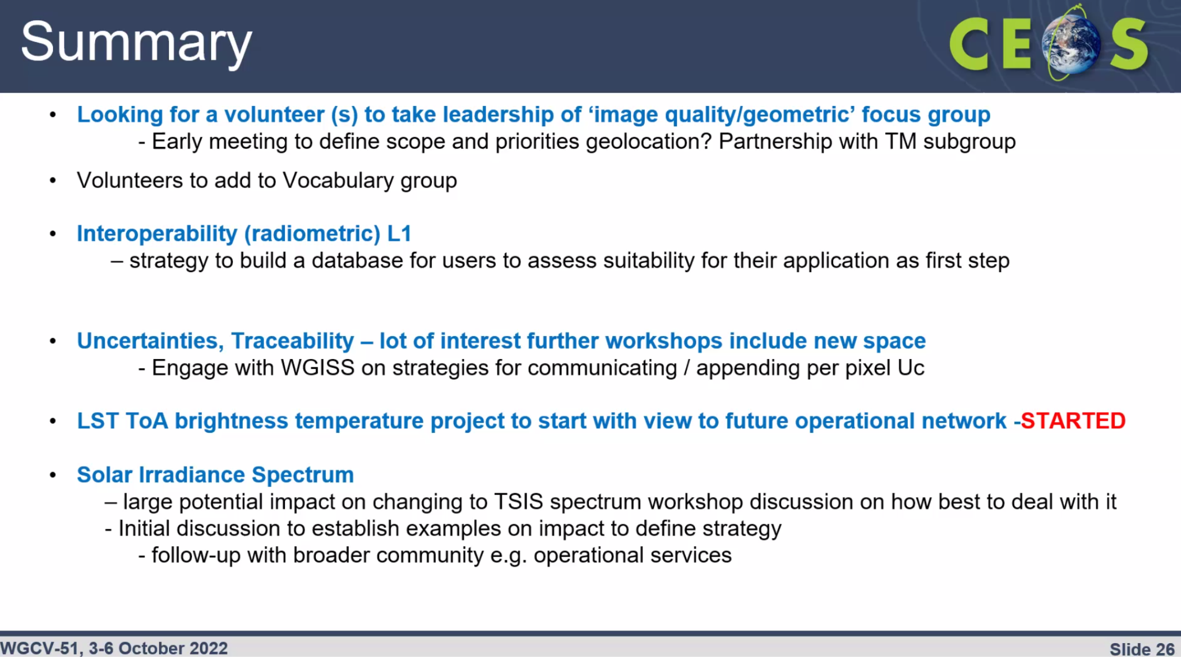
- Most of the backgrounds and details of the meetings are available on the IVOS pages in the cal/val portal
- More details can be viewed from the linked slides.
Discussion
- Philippe Goryl (WGCV Chair, ESA) noted that it will be essential to find a volunteer to replace Denise, mainly for GCP. The model for MTF was good and we should follow that, it will be a contribution to New Space as well. Nigel Fox (UKSA) is hoping to have a volunteer from GSICS.
- It was suggested to keep WGCV informed on the Workshop on Irradiance Spectrum. Kevin Alonso and Steffan Dransfeld from ESA would be interested to join the workshop. It is difficult to find solar irradiance through various missions. We should encourage people to publish the solar irradiance they are using and make it accessible. Coordination is essential despite the difficulty.
- Regarding FLARE, there is a small work package with a team from Canada and a small activity under QA4EO program on TIR. The team is specifically looking at the linearity with a control at the spectrum and using dark and bright targets, for some prototype activities.
- There will be a workshop soon, sometime in winter. This is to be followed up.
- CEOS to endorse the inter-calibration result. How are you planning to formulate this? We have been discussing this for many years. GSICS has been doing this. It's not a competition but other people will do it if we don’t make a start.
- Nigel Fox (UKSA) noted that the word choice is conceptually controversial but it is in reference to the match up database. The idea is to provide information, and coefficients to people, saying this is what your results are compared to a CEOS defined reference. It needs to be explored.
- Medhavy Thankappan (GA) asked about establishing some examples on the topic of solar irradiance spectrum and the impacts.
- Nigel Fox noted that the current CEOS recommended specification is TSIS and there is clearly a change that makes a difference in terms of the level 1 radiances you get from PRISMA, as an example what we were looking at is what difference it makes on other sensors so that it gives a portfolio to see the scale of the impact.
- To understand this impact better, IVOS is planning to create a portfolio of examples to visualise the scale of the difference. This becomes even more crucial when looking at real products and Surface Reflectance, as their impact will be more important for users. To address these issues, a virtual workshop is planned to be organised, where experts will share examples of the impact of the specification change. The workshop's goal is to identify and address the challenges transparently without causing concern among participants. Communication strategies will be developed to effectively share the findings.
- Medhavy and Nigel will keep in touch to discuss further about solar spectral irradiance.
- To increase the visibility of the SITSat and SITSCOS report, Philippe is trying at the CEOS level, and it was also reported in an internal ESA report.
- The SITSCOS paper was published, but not formally peer reviewed itself. It is a conference report. There is a DOI that allows it to be considered as a CEOS GSICS report. There are papers and references that are peer reviewed. The summaries of various activities and missions have been peer reviewed.
- Nigel asked how we get the recommendation on the support for the networks, it is the key thing to get in a mode to get the agency responses. Maybe have a newsletter in the cal/val portal that highlights the various activities, bring it up at CEOS to increase visibility.
- Philippe likes the way that LPV communicate their outputs and protocols. Could follow that approach for IVOS and for the SITSCOS, distribute some printed papers.
- Cody noted that VH-RODA and JACIE are great forums for sharing needs for references, etc. commercial companies have leverage that government agencies don’t, at least in the US they can lobby the government for things that are needed, e.g., references. It could be a good approach to keep in mind for elevating needs and requirements.
- ESA has a program on heritage mission AVHRR, MERIS to identify uncertainties that are well characterised.
- It was suggested that Nigel would want to review the Hyperspectral Guidance Document. Check it offline and provide feedback.
WGCV-52-ACT-35 | Paolo Castracane to update the cal/val portal section on the CEOS Reference Solar Irradiance Spectrum to re-add cover note / disclaimer (ref: slide 24, IVOS presentation). | July
WGCV-52-ACT-36 | WGCV Secretariat and Chair to review the SITSat section in the New Space Task Team white paper and ensure that the SITSCOS paper is referenced. | COMPLETE
WGCV-52-ACT-37 | WGCV Secretariat and Paolo Castracane to explore opportunities to better communicate IVOS (and all subgroup) outputs, starting with the SITSCOS report. Perhaps elevate this through CEOS Cal/Val portal newsletter and CEOS social media channels. | July

CEOS WGCV CalVal Portal Updates [Slides]
Presenter: Paolo Castracane
Main points:
- Reviewed and provided updates on the action from WGCV-51.
- WGCV-51-ACT-09: Nigel Fox and Paolo Castracane to update the wording on the Cal/Val Portal regarding solar irradiance spectrum references.
  - Input from Nigel will be updated in the Cal/Val portal by the end of June.
- WGCV-51-ACT-10: Nigel Fox and Paolo Castracane to investigate the creation of a private IVOS section of the Cal/Val Portal that would allow for peer review by IVOS members of proposed radiometric calibration methodologies and associated documentation/uncertainties before publishing to a wider audience.
  - It is up to IVOS to decide. Nigel to inform Paolo. It can be done easily and quickly.
- WGCV-51-ACT-21: Paolo to work with the GISTDA team to include THEOS-1 calibration site data on the Cal/Val Portal.
  - GISTDA’s calibration web portal is under construction. The link will be added once it is fully ready.
- WGCV-51-ACT-22: Philippe Goryl, Jean-Christopher Lambert and Paolo Castracane to discuss additional atmospheric composition guidance for the Cal/Val Portal.
  - It will depend on the decision of Jean-Christopher Lambert and Philippe Goryl.
  - Jean-Christopher Lambert noted there is an action item to test the appetite from ACSG. Will know how to progress by next month.
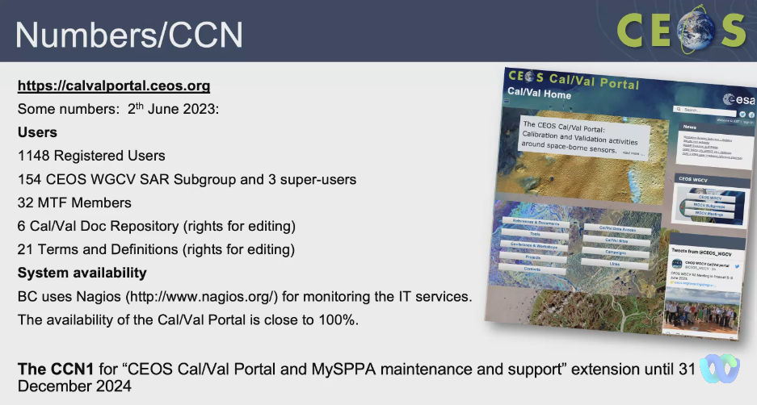
- Cal/Val portal software has been updated, new security patches have been applied and the overall performance of the website has been enhanced.
- For ACSG, inputs have been received from Jean-Christopher Lambert and have been implemented. Paolo is working on linking it to the dedicated website.
- There is a website for MSSG, inputs are received from Xiaolong Dong. The plan is to add more information from the dedicated subgroup.
- The SAR subgroup website has information on workshop announcements, it is a dedicated repository for SAR Subgroup activities.
- The LPV website has been updated with LPV Direct 2.1 database.
- Planning to have a dedicated website for TMSG.
- The Hyperspectral Cal/Val Resources guidance document will be published on the portal soon. It will have a dedicated webpage. FRM Assessment Framework will also be published in the portal.
- For outreach activities, a newsletter will be published this month.
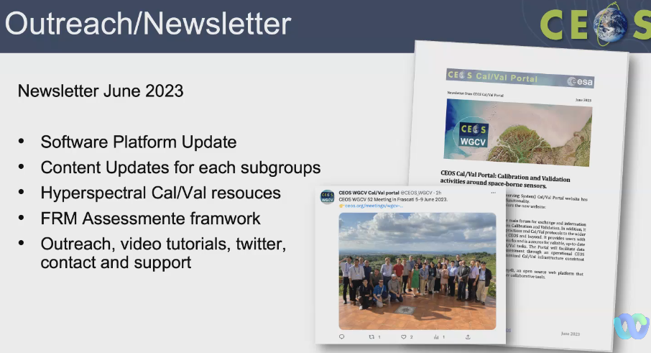
- CEOS Cal/Val portal overview video has been created and shared.
- More details can be viewed from the linked slides.
Discussion
- Philippe Goryl (WGCV Chair, ESA) acknowledged the continuous improvement of the CEOS Cal/Val portal and expressed appreciation to all subgroup chairs for their valuable inputs.
- There is a suggestion to consider adding a link to the CEOS Analytics Lab (EAIL) platform, with the SALVAL tool serving as a potential example.
- The team is in the process of planning the first newsletter and seeks feedback from the subgroup leader. The newsletter should be easily shareable and will be emailed to all high-level contacts within CEOS, WGs, WGISS, and VCs. Subgroup leads are requested to share the newsletter within their teams to promote broader dissemination and collaboration.
WGCV-52-ACT-38 | Paolo Castracane to work with WGCV Secretariat to ensure broad distribution of WGCV newsletter content - cross-posting to all CEOS mailing lists, CEOS Newsletter, CEOS social media, etc. Also consider printed formats, etc. | July

GSICS and WMO Collaboration Update [Slides]
Presenter: Paolo Castracane, Cheng-Zi Zou, Lawrence Flynn
Main points:
- Global Space-based Inter-Calibration System (GSICS) is an international collaboration group initiated by WMO with the aim to ensure consistent accuracy among space based observation worldwide for climate monitoring space based applications.
- GSICS delivers calibration corrections needed for accurately integrating data from multiple observing systems into products, applications and services. More details can be viewed on the GSICS website.
- GSICS includes 15 members worldwide and CEOS WGCV is a member of GSICS as an observer.
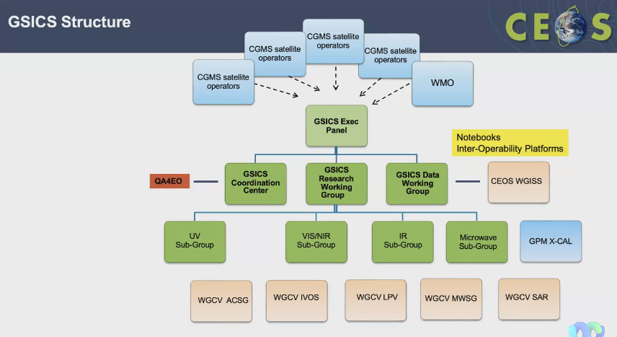
- The last GSICS annual meeting was held at College Park, MD, USA on 27 February - 3 March 2023. The recorded actions from the meeting are available at: http://gsics.atmos.umd.edu/bin/view/Development/Gsicsannualmeeting2023
- The main discussion points highlighted from the meeting were the importance of traceability, harmonisation and terminology. There was a recommendation to move from the use of single reference instruments to a consensus blend of reference instruments.
- Philippe Goryl and Paolo presented some CEOS topics at the GSICS meeting including SITSats common interest, FRM assessment framework, New Space and plans for pre-flight calibration and characterisation workshop. Paolo presented the QA websites that were developed for GSICS.
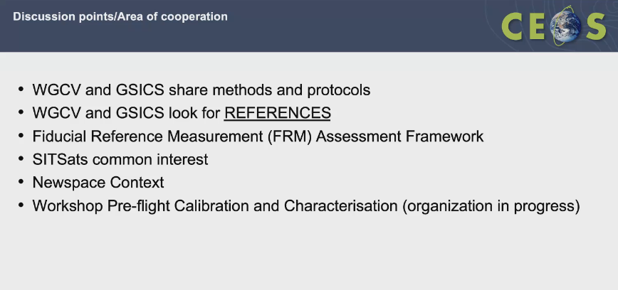
- CEOS and GSICS Data Working Group is a dedicated platform for building algorithms and data. Paolo works closely with Manik Bali from GSICS on this activity.
- Various recommendations and inputs have been received from GSICS subgroup Chairs from the Vis/NIR subgroup, and IR Subgroup, the details of which can be found on the linked slides.
GSICS Microwave Sounder Observations [Slides]
Presenter: Cheng-Xi Zou
- A summary of Microwave sounder observations was provided. POES, Aqua, and MetOp-A are in a stable orbit.
- Reference measurements are categorised into Climate and weather requirements.
- More details can be viewed from the linked slides.
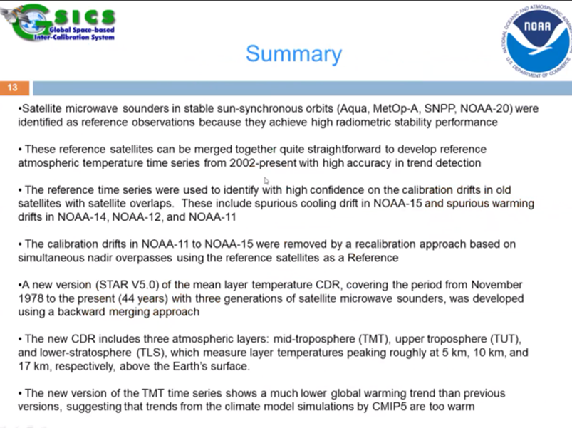

Summary of UV/Vis/NIR Spectrometer Subgroup
Presenter: Lawrence Flynn
- Provided a summary of an update on UV/Vis/NIR Spectrometer Subgroup
- UVN-S Subgroup members are making use of a range of GSICS methods including the following:
  - Deep convective cloud methods
  - Ray tracing and Simultaneous Nadir Overpass with/without Double Differencing
  - Radiative Transfer modelling and Rayleigh scattering methods
  - Comparisons to TSIS-2 HSRS reference and OMI time series for solar irradiance
  - Use of PICS and other ground sites (e.g., desert sites, open ocean, ice fields)
- The OCO/GOSAT/TropoMI Calibration Team has productive quarterly meetings. They have invited GSICS and CO2M to those meetings. OCO, TropoMI & CO2M teams gave four NIR-spectrometer related talks at the annual meeting.
- There is good communication across the community. There is significant overlap with the Vis/NIR group and we will continue to hold topical meetings with participation by both subgroups.
- The recently launched Geostationary instruments, GEMS and TEMPO, provide a new area for satellite inter-comparisons. The EPIC instrument at Lagrange 1 has under-flights by all LEO and GEO instruments.
Discussion
- Manik Bali (NOAA) appreciated Paolo Castracane’s presentation on CEOS and GSICS collaboration and the GSICS team is open to taking further actions to strengthen this collaboration. The Data Working Group is working on a tool for interoperability, and interoperability was a topic of discussion during the meeting. He also noted that Nigel raised important points about SITSat, and there is a plan to discuss and advance this matter.
- Lawrence Flynn (NOAA) GSICS noted that the GSICS Executive panel will meet at the end of June 2023. and expressed support for CEOS activities in the GSICS Quarterly Newsletter. For example, they have a list of people, the UVN Spectrometer Subgroup, to whom they can publicise the ACSG meeting.
- Paolo would like to continue to have such interactions and provide information from the various channels to increase outreach.
- Manik Bali serves as the editor of the GSICS newsletter and Lawrence is the GSICS Coordination Centre Director. They welcome any relevant articles such as describing the goal of WGCV, etc.
- The importance of the FCDR concept is fundamental, highlighting the importance of uncertainty. Intercalibration is also a key point for GSICS and both GSICS and WGCV share a common major goal of establishing long-term series of well-calibrated and intercalibrated data.
- Philippe will try to join the GSICS Executive panel meeting remotely and will iterate with Paolo and Manik to include some updates on WGCV in his ESA presentation. He stressed the need to review and fine-tune the objectives of the Pre-Flight workshop, targeting 2024 for the workshop.
- Lawrence (NOAA) Flynn shared that NOAA and NASA have a joint centre for satellite data assimilation, Community Radiative Transfer Model (CRTM) which is freely available worldwide. Heard about difficulties getting MODTRAN6. CRTM could be a help in getting MODTRAN6 data. More details can be viewed at: https://www.jcsda.org/crtm
WGCV-52-ACT-39 | WGCV Secretariat and Paolo Castracane to consider inputs for the upcoming GSICS newsletter. Send a call for inputs from WGCV and subgroup chairs. | June
WGCV-52-ACT-40 | WGCV Chair to consider the inclusion of a radiative transfer model session at WGCV-53, with GSICS and perhaps looking at intercomparisons. | WGCV-53

Plans for WGCV-53 Meeting
- Philippe Goryl proposed to organise the WGCV-53 meeting in Argentina. He had discussed this with Laura Frulla from CONAE during the SIT meeting and Laura supported the idea.
- Two possible dates for the meeting were proposed: 26 February 26 -1 March 1 or 4-8 March 2024.
- Matias also showed optimism about hosting the WGCV meeting in Cordoba, Argentina but is yet to receive final confirmation from Laura, who is currently occupied with another workshop. Matias will inform Philippe, Matt, and Riza once he receives confirmation.
- J-C Lambert prefers the dates of 4-8 March 2024 for the meeting in Cordoba, Argentina. Confirmation of these dates is being pursued.
- GSICS will be held in EUMETSAT the week after 4-8 March the proposed dates, followed by JACIE.
- SIT-39 is scheduled for 9-11 April 2024 in Tokyo, Japan.
- Plans for WGCV-54 are being made for Sioux Falls, USA. A joint WGCV-WGISS meeting is also being considered.
- Philippe shared that Xiaolong Dong from NRSCC also offered to host the next WGCV meeting in China, which could be kept as a backup option if WGCV-53 is not possible in Argentina. Alternatively, it could be considered for WGCV-55, WGCV-56, or WGCV-57, providing a range of options for future meetings and ensuring continuity.
WGCV-52-ACT-41 | Matias Palomeque to confirm to Philippe Goryl, Matt Steventon, and Riza Singh the holding WGCV-53 in Argentina, Cordoba, for preferably 4-8 March. Backup the week before. | In Progress  Confirming with Laura Frulla from CONAE for the date 4-8 March 2024

AOB
Endorsement of the SITSat Terms of Reference:
The WGCV Secretariat sent the SITSat Task Team Terms of Reference to the GSICS team on 5 June 2023. There were no further comments or suggested edits.
Decision 07 | SITSat Task Team Terms of Reference were endorsed.

Follow Up on Pre-flight Calibration Workshop Details
Philippe noted that Lawrence Flynn has emailed that it will be further discussed at the GSICS Executive meeting. Jack Xiong (NASA) suggested trying to allocate a 5-10 minute slot for discussing Pre Flight Calibration Workshop at the Executive meeting.
Day 5 Actions and Decisions Review
Matt Steventon (WGCV Secretariat) reviewed the actions and decisions for Day 5.
Day 5 Close
Philippe Goryl (WGCV Chair, ESA) thanked everyone for joining and closed Day 5 of the WGCV-52 meeting. He appreciated the positive and productive dialogues that took place among representatives from different agencies. Philippe highlighted the significant interactions on various activities during the meeting. He thanked everyone for their valuable contributions to the discussions and commended the good quality of the reports presented. Philippe also acknowledged the concrete feedback provided and the actions that were proposed during the meeting.

