Minutes
WGCV-53 Day #1
Tuesday, 5 March 2024

Participants (* Virtual Participants)
ASI Antonio Montuori*
BIRA-IASB Jean-Christopher Lambert
CEO Steven Ramage*
CONAE Ana Medico, Angel Matias Palomeque, Laura Frulla, Marc Thibeault
CSIRO Cindy Ong*, Ian Lau*, Matt Garthwaite
Servicio Aerofotogramétrico Carolina Barrientos*
DLR Albrecht von Bargen*
ESA Dirk Geudtner, Paolo Castracane, Philippe Goryl
EC-JRC Peter Strobl*
GA Medhavy Thankappan
ISRO Santhisree
JAXA Akihiko Kuze
MYSA Wayne Ng*
NASA Xiaoxiong (Jack) Xiong*, Eric Vermote, Kurt Thome*, Dave Borges
(SEO)
NOAA Taeyoung Jason Choi*, Manik Bali*, Larry Flynn*
NPL/UKSA Nigel Fox
USDA Michael Cosh*
USGS Cody Anderson, Tom Stone*
WGCV Sec Matt Steventon, Riza Singh*

Welcome and Chair’s Report
Presenter: Philippe Goryl (WGCV Chair, ESA)
Main points:
- Philippe Goryl (WGCV Chair, ESA) welcomed everyone to Day 1 of the WGCV-53 meeting.
- The objectives of the meeting were reviewed.
- Tour de table introduction was conducted for the in-person participants followed by the remote participants.
- Two unique topics for discussion at WGCV-53 will be exploring ways in which WGCV can contribute to the biodiversity priority of the Ecosystem Extent Task Team and CEOS Chair, as well as the GCOS Implementation Plan/WGClimate initiatives.
CONAE Welcome Presentation [Slides]
Presenter: Laura Frulla (CONAE)
Main points:
- The Argentine National Space Plan is a 10-year strategic plan. The main objective of the plan is to utilise space to serve Earth, with a focus on improving decision-making efficiency in both the public and private sectors. The plan also aims to promote the development of national industry in both upstream and downstream sectors, as well as to encourage national development and foster international cooperation.
- CONAE's main activities include receiving stations operation, satellite monitoring and commanding, conducting integration and test activities in dedicated laboratories, receiving and storing data, processing data and generating Earth observation products, distributing data, providing education, capacity building, and user training through the Gulich Institute, developing satellite missions, and facilitating access to space.
- Promotion of Utilisation and Mission Applications and Science (PUMAS) is a joint initiative between CONAE and ESA that organises collaborative activities between the two agencies in the field of Earth observation mainly for Copernicus and SAOCOM mission data access.
- The SABIA-Mar mission is currently under development, with a tentative launch scheduled for Q4 2024/Q1 2025. Its primary objective is to measure ocean colour, with a focus on both global scenarios dedicated to open ocean, and regional/coastal scenarios, dedicated to coastal waters. The idea is to support the primary productivity of the sea, marine ecosystems and habitats, fishing resources, and water quality. It holds potential contributions in measuring radiance in land areas, vegetation, land use, inland waters, and flooded areas.
- SAOCOM 1A and SAOCOM 1B are operational. CONAE intends to launch SAOCOM 2A in 2029 with the main objective of providing continuity of SAR data and generating new and improved products.
- SAOCOM products cover L1A: Single Look Complex-SLC, slant range, L1B: Detected Image-DI, ground range, L1C: Ground Ellipsoid Corrected-GEC, based on ellipsoid, L1D: Ground Terrain Corrected-GTC. The NRB products have been processed to ‘ARD’ but they have not yet gone through the formal CEOS-ARD process.
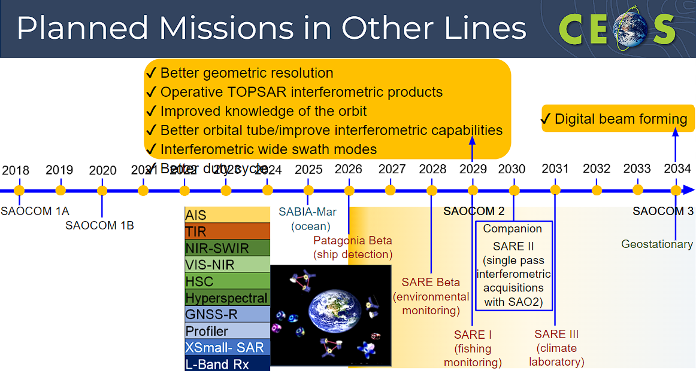
- CONAE is working on various higher-level products, such as soil moisture for agriculture and hydrology, radar products for interferometry, and NRB ship tracking, etc.
- SAOCOM strategy is built around a baseline observation, a foreground mission based on user requests, and a background mission. The SAOCOM catalogue is freely available at: https://www.argentina.gob.ar/ciencia/conae/saocom-1-acquisition-plans-downloads-0. Data can be accessed via various agreements/project processes, leading to the granting of the appropriate license. Also, a ‘one-click’ system with various data products is made available to both commercial and non-commercial users. Access varies for Argentine and international users. This includes acquisition requests as well as archive and reprocessing access.
- More details can be found in the slides.
Discussion
- Philippe Goryl (WGCV Chair, ESA) recalled Kuze-san’s initiation of discussion with CONAE to join WGCV a couple of years ago. CONAE's contribution to CEOS and WGCV is appreciated.
- Looking forward to the launch of the SABIA-Mar mission. With the launch of the PACE mission in 2024, there is increasing activity in this domain.
- Dirk Geudtner (ESA) noted from the SAR Subgroup perspective, that SAOCOM is a very successful mission. Many L-Band missions are coming along such as NISAR, ROSE-L, etc. There are interesting opportunities for cross-calibration. Aspects from Dirk’s presentation will be useful for CONAE, covering cal/val aspects for a variety of applications.
Action Review [Doc] [Slides]
Presenter: Matt Steventon (WGCV Secretariat)
Main points:
- An overview of the decisions recorded at WGCV-52 was provided.
- A total of 41 actions were recorded at WGCV-52 out of which 35 have been closed and 6 remain open.
- WGCV-52-ACT-09: Manik Bali and Nigel Fox, Philippe Goryl, Paolo Castracane, Larry Flynn, to organise a presentation at next GSICS in March 2024 on SITSat Task Team.
  - Scheduled for a presentation on the Friday of the GSICS meeting. The action can be marked as closed.
- WGCV-52-ACT-14: MSSG Chair to share a call for participation in the task teams.
  - The action will be clarified during the MSSG report to WGCV-53.
- WGCV-52-ACT-25: Medhavy Thankappan to coordinate an update of the 1-pager on Surface Reflectance Equivalency/Consistency to reflect feedback and circulate to the WGCV team for information.
  - The action can be closed in the next few days with the presentation to WGCV-53. Medhavy will circulate an updated paper for discussion.
- It was noted that updates on the remaining three open WGCV-52 actions will be covered in the respective WGCV-53 agenda items.
- The full actions and decision record is available here for reference.
CEOS Executive Officer’s Report [Slides]
Presenter: Steven Ramage (CEOS Executive Officer)
Main points:
- This is Steven’s first presentation as a CEOS Executive Officer to a WGCV meeting. Steven joined CEOS as CEOS Executive Officer on 2 January 2024. He spent seven years at GEO prior to that. He used to join Copernicus's in-situ activity through the European Environment Agency and was also involved in GEO's in-situ strategy development.
- The role of the CEO is to develop the CEOS Work Plan, discuss CEOS contributions to the GEO Work Programme, advise CEOS leadership on continued/increased internal and external cooperation and track progress on the CEOS Work Plan Objectives and Deliverables.
- He is also helping CEOS Biodiversity activity and is involved with GEOBON.
- Currently working with emerging economies and engaging them in CEOS. This is a personal priority for Steven during his term as CEOS Executive Officer. A lot of involvement is through WGCapD. He is also working with WGDisasters in connection with Early Warning for All (EW4ALL).
- Steven reviewed the WGCV’s CEOS Work Plan deliverables. The CEO team is trying to look at the work plan with a more integrated perspective to identify the complementarity of the Work Plan. Steven noted that some WGCV deliverables are due in Q1 2024 and offered support if required.
- Steven shared the list of meetings that the CEO will be attending in 2024. If any outreach is needed, Steven is happy to do that on behalf of WGCV. He offered support for promoting the Pre-flight Calibration Workshop if that would be helpful.
- Steven can be reached at: executive_officer@lists.ceos.org. Please copy steven_ramage@outlook.com.
Discussion
- The CEOS Executive Officer’s experience in GEO and GEOBON will be useful for the biodiversity initiative, and WGCV is currently exploring how it can support the CEOS biodiversity task. It is a complex space, so the CEO's help in navigating it will be very useful.
WGCV Vice Chair Nomination
Presenter: Medhavy Thankappan (GA)
Main points:
- Medhavy was hoping to confirm a nomination but will have to wait for internal approval before he can make any further announcement.
- If this is forthcoming, Medhavy will arrange to present at a WGCV telecon ahead of WGCV-54.
Discussion
- Albrecht von Bargen (DLR) supported Medhavy’s potential nomination. He noted he was in a similar situation with funding uncertainty.
- Philippe Goryl (WGCV Chair, ESA) noted that he has not received expressions of interest from other agencies so far. He emphasised the need for flexibility in the nomination approach and supported Medhavy’s nomination should it be confirmed, citing his qualifications and extensive involvement in several WGCV activities.
- The presentation of the WGCV chair nomination will take place at one of the WGCV teleconferences as soon as feasible, with the nomination presentation as a headline agenda item.
Decision 01 | It was agreed that the tentative nomination from Medhavy Thankappan of Geoscience Australia for the position of next WGCV Vice Chair (and subsequently WGCV Chair), will be deferred until formal organisational approval is granted. A formal confirmation of the nomination and presentation at a WGCV team teleconference, subject to agency approval from Geoscience Australia, is to follow as soon as possible. WGCV endorsement of the nomination will take place at the WGCV-54 meeting in Sioux Falls. The formal voting process, outlined in the WGCV Terms of Reference, will be dropped if there is only one nomination.
SI-Traceable Satellite (SITSat) Task Team Report [Slides]
Presenter: Nigel Fox
Main points:
- The SITSat Task Team operates as a joint effort between CEOS and GSICS. WGCV-52 agreed on joint co-leads for this activity. Nigel Fox and Yolanda Shea serve as the two co-leads. They are responsible for the two headline SITSats being implemented in the near term.
- The desire is to establish high-quality fiducial reference data for climate monitoring and as a reference for other satellites, thereby linking observations to a high quality reference. The task team is looking to build a system of systems from the various SITSat missions.
- SITSats can provide an anchor for the new space community which often lacks onboard calibration sources.
- The concept builds on the philosophy of the GSICS calibration system in space.
- There was a perceived need to create a task team in order to coordinate the upcoming missions, in a Virtual Constellation construct.
- The task team will focus on coordinating efforts, sharing data, and establishing shared principles to ensure compatibility and continuity of calibration coefficients between missions. It aims to create a mechanism for long-term continuity and trust, emphasising the importance of learning from past experiences and ensuring the collective value of SITSats exceeds the sum of their individual contributions.
- While the definition of SITSat in the Terms of Reference has evolved slightly following discussions at WGCV-52, the changes are minor and do not deviate significantly from the original concept.
- The Task Team objectives from the draft Terms of Reference were reviewed. Nigel noted the need to identify the minimal requirements to define what constitutes a SITSat - this is the first objective for the team.
- Membership of the group must be from a space agency or nominated by a space agency. When Nigel presented the Terms of Reference to the IVOS subgroup, there was significant interest from New Space and other entities. It became apparent that it was necessary to limit the membership of the group to prevent it from becoming diluted.
- Need to establish a vision/roadmap of what a SITSat enabled observing system looks like; confirm a systems based approach to data sharing and continuity.
- Communication strategy is one of the most important near-term outputs and deliverables. This involves raising awareness to senior levels at agencies, ensuring the vision of an observing system is clear and future proof, and harmonising and coordinating communication messages.
- A SITSat Task Team workshop was held a month ago to initiate the development of the communications strategy. One of the immediate tasks is to create a dedicated SITSat cal/val portal page. Paolo Castracane has produced a draft framework for the page and now we need content.
- Looking to use WGCV-53 to brainstorm and solicit views and inputs from the participants on the desired content and features for the web page.
- Nigel reviewed the current content already suggested:
  - Define SITSats and why they are important for the global climate observing system
  - How to evidence a SITSat – Traceability & Uncertainty
  - How they can transfer calibrations – Link to full cal val architecture – expected performance improvement
  - Purpose of the SITSat Task Team
  - SITSat task team members and how to contact the group
  - Overview of SITSats in development/planned and expected operational timeframes
  - Future: Past and upcoming group activities (meetings, etc)
  - Future: Relevant documentation (to be created by SITSat group)
- Nigel talked about where we should be seeking to promote the concept of SITSats at meetings, and conferences such as AGU, EGU, EUMETSAT meetings, AMS, GSICS, SITSat member organisations and space agencies. Please let Nigel or Yolanda know if there are any suggestions for potential venues or meetings for SITSat group members to educate the community.
- The SITSat Task Team is planning approx. three virtual half-day meetings a year and one in-person meeting tied to the next WGCV meeting in Sioux Falls. Other in-person meetings could be organised alongside events.
- A recommendation from the last SITSat Task Team meeting is for the WGCV Chair to compose a letter to NASA, emphasising the significance of SITSats to the community, with the aim of encouraging the possibility of an early launch of CLARREO Pathfinder (CPF) to the International Space Station (ISS). The letter should communicate that if conditions allow, an early launch for CPF's mission would be preferable, given its importance.
Discussion
- Dirk Geudtner (ESA) asked whether there are plans to develop a tool for coordination of acquisitions across different SITSats to enable a system of systems approach.
- Nigel noted one of the potential features for the SITSat portal could be to have some illustration and guidance of satellite orbital paths and therefore their ability to overlap and compare with other satellites.
- It was suggested that the CEOS Visualization Environment (COVE) tool could be used for this. Paolo Castracane (ESA) agreed that it is a good idea to have the orbit predictor API linked on the portal. Dave Borges (NASA, SEO) agreed that CEOS COVE could be a valuable tool.
- Nigel suggested the need for a simpler interface for COVE for this purpose, but agreed that COVE would be a good connection to make. Additionally, it was suggested to include PIC sites, in situ sites, and other relevant information.
- Larry Flynn (NOAA) noted via chat: The fifth bullet “ Overview of SITSats in development/planned & expected operational timeframes” can link to OSCAR. It would also be good to provide the documents on recommended format and content for SITSat products. We could consider having a repository for instrument information like spectral response functions.
- Nigel Fox (UKSA) agreed with suggestions related to making SITSat characteristics more open to the community. For SITSats to function, they would need to have access to the response functions of other sensors. The SITSat page on the cal/val portal could be utilised to encourage this.
- Philippe Goryl (WGCV Chair, ESA) noted the GSICS overpass tool could also be relevant. He also suggested that a MAAP-like system could be beneficial and suggested the cal/val portal could serve as the front end.
- Philippe Goryl (WGCV Chair, ESA) referenced a paper by Bruce Wielicki, highlighting the substantial economic impact of improved data and calibration accuracy, suggesting the need for a similar updated study to support the SITSat initiative. This would be a good reference for the cal/val portal SITSat page. See below:
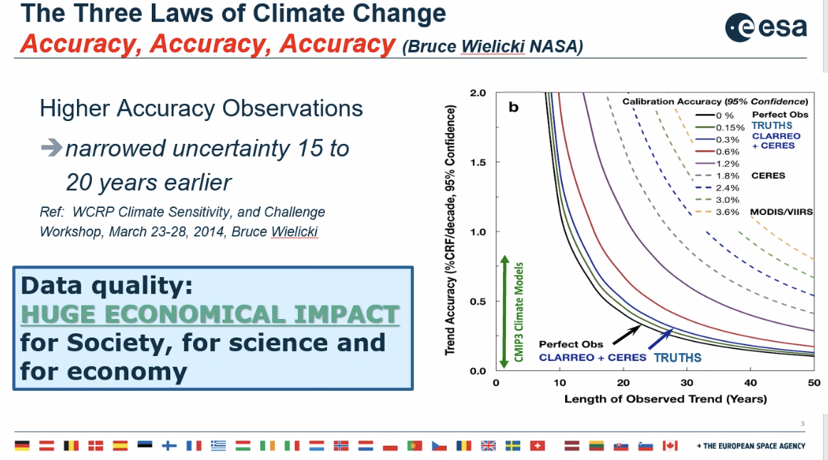
- Michael Cosh (USDA) noted ongoing assessments related to soil moisture, and cost-value estimates.
- It would be beneficial to clarify the importance of SITSats for climate, intercalibration, etc. on the cal/val portal.
- Manik Bali (NOAA) proposed via chat the idea of creating a link to collect user wish lists for SITSats, including desired variables and metadata. Nigel Fox (UKSA) supported the concept but suggested first identifying a user base. This question could be included on the cal/val portal page.
- Jean-Christopher Lambert (BIRA-IASB) suggested two potential references for the SITSat cal/val portal page: (i) improving the accuracy of XCO2 and XCH4, e.g., to be able to resolve natural CO2 fluxes varying by about 0.2 ppm/100 km and ocean fluxes varying by less than 0.1 ppm/100 km while the current XCO2 accuracy remains 0.8 ppm (John Worden), and (ii) reach the aerosols/PM2.5 accuracy needed to monitor environmental policies (Shobha Kondragunta). He referred to the cal/val session discussions held during the AC-VC-19/ACSG Joint Meeting 2023.
- Larry Flynn (NOAA) noted via chat: It would be nice to have a standard slide deck that gave an introduction to the SITSat. Something any member could use to explain the role to their agency or colleagues. I think you are close to having that. Nigel agreed. A generalised poster would be helpful too.
- Cody Anderson (WGCV Vice-Chair, USGS) noted via chat: SITSat – describing what a SITSat isn’t may be as important as what it is. A SITSat will not give every mission 0.3% uncertainty. Individual missions still need their own uncertainty estimate before calibrating to a SITSat. But is there a benefit to calibrating to a SITSat: to shift a mission’s response, but that alone won’t transfer an uncertainty. The cross-cal process and inputs required for that process need to be clear. Processes for how to generate those inputs.
- Kurt Thome (NASA) via chat: Keep in mind that Clarreo Pathfinder will intercalibrate a VIIRS instrument as well as CERES and TRUTHS can then do a cross-compare to those sensors or their connected follow-ons.

WGCV-53-ACT-01 | In support of the SITSat Task Team’s communication strategy, WGCV members are asked to help gather examples/case studies regarding ‘real world’ impacts of the reduction in uncertainties that are facilitated by SITSats.  We seek to show the unique value of these types of missions and highlight differences between usual calibration practices and those provided by SITSats. Examples should be accompanied by clear, transparent metrics (financial, improved decision-making, etc.).  Notes:  - The paper from Bruce Wielicki of NASA was cited as a good example.  - LPV Chair noted ongoing assessments related to soil moisture, cost-value estimates that might be applicable.  - ACSG Chair noted two potential examples: (i) improving the accuracy of XCO2 and XCH4, e.g., to be able to resolve natural CO2 fluxes varying by about 0.2 ppm/100 km and ocean fluxes varying by less than 0.1 ppm/100 km while the current XCO2 accuracy remains 0.8 ppm (John Worden), and (ii) reach the aerosols/PM2.5 accuracy needed to monitor environmental policies (Shobha Kondragunta). Ref.: discussions in AC-VC-19/ACSG Joint Meeting 2023. | June 2024
WGCV-53-ACT-02 | CEOS SEO to explore with the SITSat Task Team the application of the CEOS Visualization Environment (COVE) tool for visualisation of SITSat orbits and acquisition plans. | June 2024
WGCV-53-ACT-03 | WGCV Chair to coordinate the drafting of a letter to send to NASA leadership regarding the importance of SITSats and the CLARREO Pathfinder mission, and encouraging an early as possible launch of the CLARREO Pathfinder mission.  Note: Yolanda Shea can provide the name of the ideal addressee at NASA. | June 2024

Atmospheric Composition Subgroup (ACSG) Report [Slides]
Presenter: Jean-Christopher Lambert (BIRA-IASB)
Main points:
- Update covers:
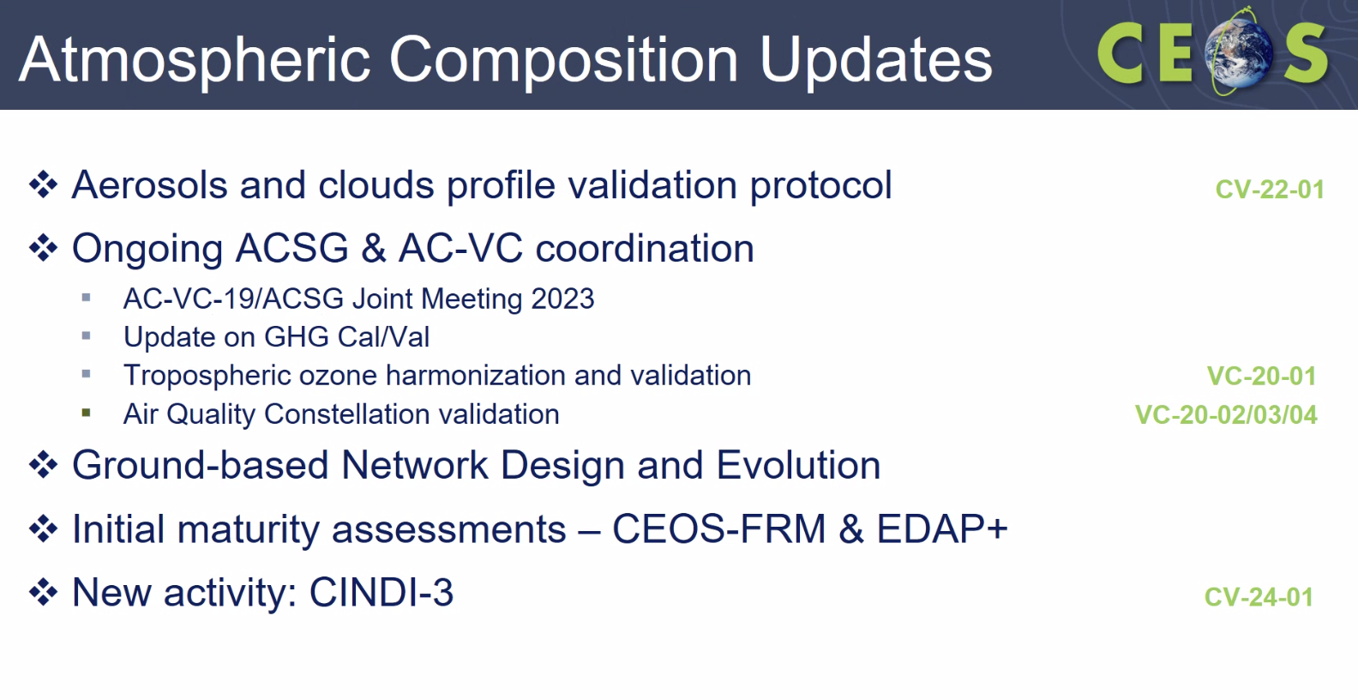
- ACSG is working on increasing linkages between the NDACC satellite Working Group website and the CEOS WGCV cal/val portal.
- Noted the updates on the cloud/aerosol profile validation protocol for the Earth Cloud, Aerosol and Radiation Explorer (EarthCARE) mission. The EarthCARE validation team held a validation rehearsal with true data streams and involvement from all stakeholders. The team tested the entire validation workflow and reviewed the Cloud/Aerosol Profile Validation Protocol. Please refer to the slides for more information on the key results and outcomes.
- Cloud/Aerosol Profile Validation Protocol is a broad community effort, including several space agencies. The CEOS-ready version is on track for April 2024. It will be presented for WGCV review and endorsement, before being presented to the 2024 CEOS Plenary for awareness.
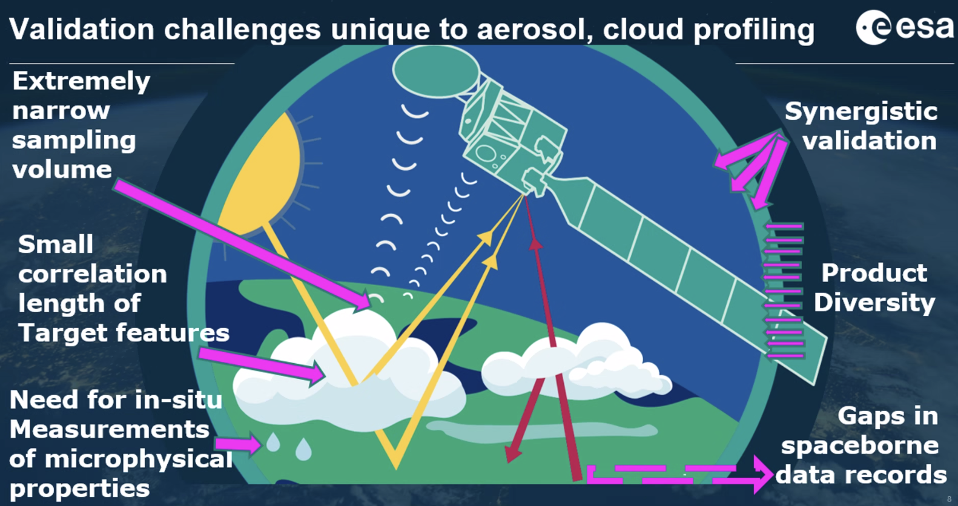
- A joint AC-VC-19 and ACSG meeting was held in 2023. There were cal/val related discussions in every session. Recommendations are included in detail in the slides. FRM was acknowledged, with some specific recommendations around optimising the location of measurements and handling differences in spatio-temporal scales and smoothing; improving FRM maturity, harmonising measurement procedures, and implementing central processing.
- Noted that Annex C of the CEOS Greenhouse Gas Roadmap was updated to reflect inputs from ACSG on GHG validation networks (NDACC, TCCON, COCCON).
- There are several activities on GHG cal/val underway with contributions being made to the GHG Task Team, IMEO Working Groups and others.
- The joint AC-VC-ACSG meeting held in 2023 also discussed the Air Quality PM 2.5 Constellation Whitepaper "Monitoring Surface PM2.5" (VC-20-05), which was endorsed at the CEOS Plenary in 2022. The paper includes various cal/val-related recommendations. Actions to supplement these recommendations are under preparation.
- For air quality, cal/val activities are being conducted for missions such as GEMS and TEMPO. Sentinel-4 L2 prototype testing is underway. The TEMPO mission, launched on April 7, 2023, is being validated in accordance with its Mission Validation Plan in place, with joint NASA/NOAA science field campaigns contributing.
- A joint ESA-EUMETSAT Sentinel-4/5 Announcement of Opportunity call will be issued in spring 2024, aiming for cross-validation with other satellites. Collaboration on ground-based networks, Pandora Asian Network complements Pandonia Global Network and CINDI-3 MAX-DOAS community campaigns are also planned.
- Cal/val network design and evolution updates:
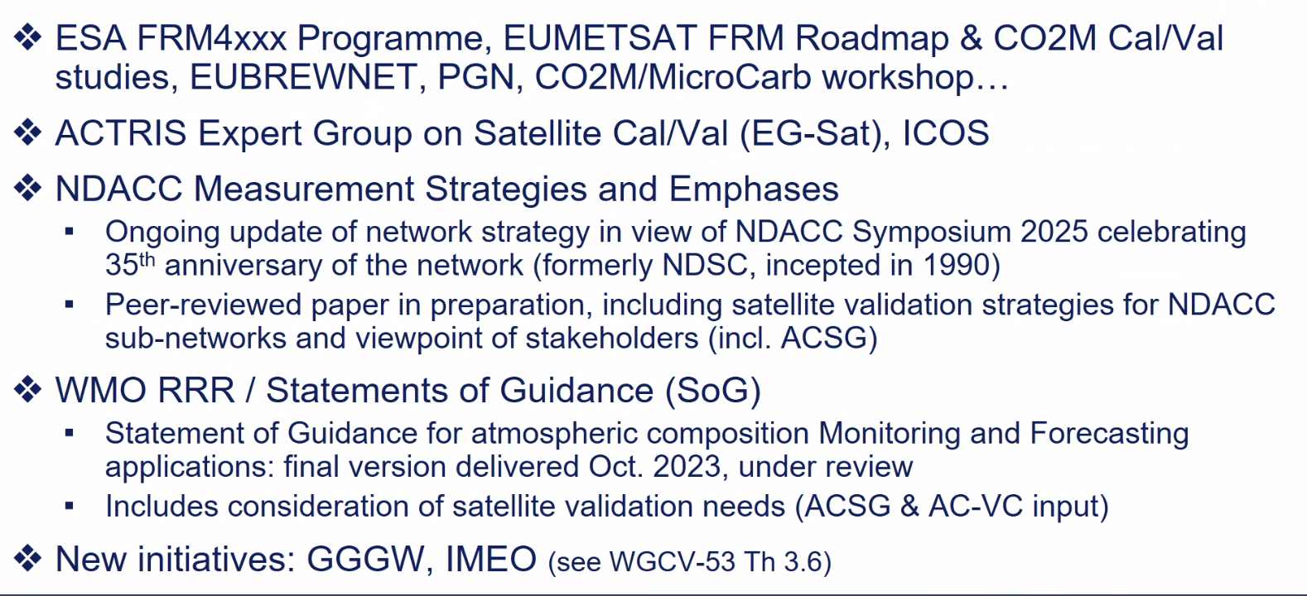
- ACSG is currently working with the IMEO cal/val Working Group on a technical note.
- Noted VC-20-01, CEOS response to tropospheric ozone needs: Papers are in preparation for the TOAR-II response. Summary papers will be published later in 2024/2025. There will be several satellite based papers and one constellation based assessment paper.
- There is a fair convergence between the FRM Assessment Framework and the NDACC FRM-MAP. Noted updates on FRM test cases, FRM4DOAS and PGN (Pandora Global Network). Showed how each of these networks aligns with different parameters of the framework. Feedback on the CEOS FRM Assessment Framework from these two pilot cases is detailed in the slides:
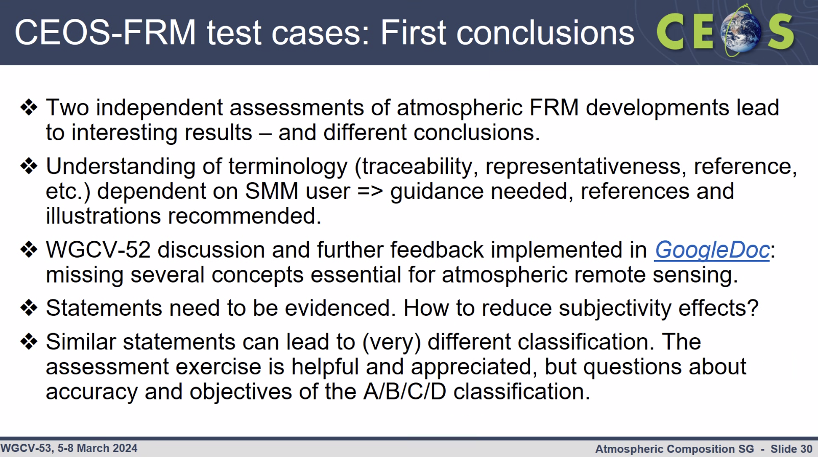
- Various other cases in progress:
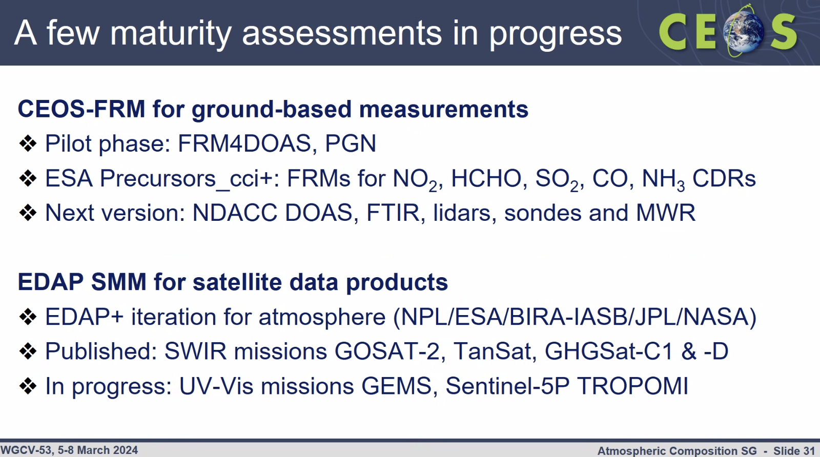
- Noted CINDI-3 campaign. Welcomed participation in the campaign. Please refer to the slides and website for details.
Discussion
- Paolo Castracane (ESA) noted that FRM results for FRM4DOAS and PGN had similar outcomes from other maturity matrix trials. While some subjectivity is unavoidable, further efforts are needed to remove ambiguities in the questions/parameters. Sometimes the classifications are related to specific categories and may not take into account all the necessary complexities. The assessments presented for PGN and FRM4DOAS are at different stages of development and operation.
- Philippe Goryl (WGCV Chair, ESA) suggested that the cloud-aerosol validation protocol document should be consolidated within ACSG and the author group and then sent to WGCV for approval, endorsement and discussion. Once endorsed, it can be presented and communicated to CEOS SEC and Plenary for information. Philippe and Jean-Christopher will coordinate the necessary promotion, etc.
- Philippe Goryl (WGCV Chair, ESA) commended ACSG for its engagement with AC-VC, GHG Task Team, IMEO and other groups.
- Philippe suggested the need for a mechanism to link all the GHG activities to key stakeholders, mapping out how their contributions align, overlap, and where they contribute. Jean-Christopher Lambert (BIRA-IASB) suggested that this is covered in the GHG Roadmap. Something that we can try to extract, see where the gaps remain in requirements / responses to recommendations, climate, biodiversity, whatever. Those recommendations could be linked to the IP/Terms of Reference of the Virtual Constellations, note linkages to external requirements, etc.
- Nigel Fox (UKSA) noticed that there is a cal/val working group under ACTRIS and questioned its necessity, suggesting that it could potentially be incorporated into the WGCV ACSG.
- ACTRIS is a legal entity and has a mandate to respond to specific requests. ACTRIS's scope is more specific and focused on their users such as ESA and EUMETSAT.
- Philippe Goryl (WGCV Chair, ESA) raised concerns about improving trust in atmospheric data from New Space and whether WGCV could play a compliance or checking role in this space. While there is ongoing work in IMEO Working Groups, such as John Worden’s and Angelika’s initiatives in Europe, Philippe felt that WGCV's contribution to the process and method is not yet fully developed. ACSG is involved in FCDR work, primarily focused on Level 1 data.
ACIX-III, CMIX-II and Cloud Camera Network [Slides]
Presenter: Eric Vermote (NASA)
Main points:
- Provided an update on Land Surface Reflectance and its validation. It is important to have good Surface Reflectance for climate analysis.
- Highlighted the significance of calibration in handling historical data effectively.
- Addressed challenges in geolocation and underscored the importance of quality compliance, demonstrating the enhancement of AVHRR vicarious calibration through indirect methods utilising past data and AERONET.
- Sentinel 2/MSI and Landsat8/OLI are valuable resources for better validating Surface Reflectance.
- ACIX-II upscaled the comparison of ACIX-I, to include a large number of sites. After ACIX-II, ACIX-III was initiated with a focus on the hyperspectral data.
- SkyCam project was launched to address cloud validation issues in ACIX-I and ACIX-II. SkyCam takes a picture of the sky and compares it to the satellite data. SkyCam is a small instrument with an RGB camera, that can observe clouds every minute and can estimate cloud base and project it on the satellite image.
- There are about ten SkyCam stations in operation and are growing at an accelerated pace. Presented various characteristics of the SkyCam and showed how SkyCam is used routinely in Sentinel-3 OLCI quality and validation reports.
- CAMSIS is a ground validation camera which has been installed at two sites, near Park Falls, Wisconsin and at the El Palmer supersite.
- Presented El Palmar supersite and first CAMSIS results. Please refer to the slides for detailed information.
- Conclusions:
  - The surface reflectance (SR) algorithm is mature and the pathway toward validation and automated QA is clearly identified.
  - The algorithm is generic and tied to documented validated radiative transfer code so the accuracy is traceable enabling error budget.
  - MODIS VIRA Rectands, sent somanson len sensors.
  - We are proposing a complete package for Surface reflectance validation at high spatial resolution (Landsat, S2, AERONET, CAMSIS, SKYCAM)
- Described ACIX-III Land Atmospheric Correction Inter-comparison eXercise which will also include hyperspectral data from PRISMA and EnMAP.
Discussion
- It was noted that the ACIX model is very good and moving towards hyperspectral is interesting and should provide valuable insights.
- CMIX is more difficult. Lessons learned from past exercises indicate that what was missing was a robust validation process, which is where the cloud cameras come in. Philippe Goryl (WGCV Chair, ESA) is supportive of that and looks forward to seeing the outcomes of CMIX-II.
- Philippe Goryl (WGCV Chair, ESA) is very supportive of the SkyCam cameras. The ESA team has identified some issues and will ensure their findings are communicated back to the NASA team.
- Recently, there has been development of a new CIMEL fish eye camera and it is expected that the team will reach out to WGCV members soon. It would be interesting to conduct an intercomparison exercise, perhaps at DOME-C. Philippe Goryl (WGCV Chair, ESA) supports the idea of having several camera networks so they can be compared and evaluated.
Terrain Mapping Subgroup (TMSG) Report [Slides]
Presenter: Peter Strobl (EC/JRC)
Main points:
- The TMSG group remains stable in terms of membership and activity.
- DEMIX is mostly concluded after an intense series of meetings and telecons. A workshop on DEMIX was held at the TMSG plenary in Romania in 2023, alongside the the conference of the international society of geomorphometry. TMSG also participated in the VH-RODA meeting in 2023.
- The DEMIX tiling system, developed during the process, has potential applications in other situations where global tessellation is needed.
- Outlined the DEMIX wine contest as a generic benchmarking and ranking method that could be utilised in many other products comparisons.
- Emphasising the importance of reference data. It would be helpful if agencies could make more of these references available. This could be adopted as a priority in GCPIX.
- There were 24 test areas and 236 DEMIX test tiles, covering a wide range of landforms and land cover types. Various criteria were used, and pixel by pixel comparisons were conducted, resulting in 55,000 individual tests done on the DEMs.
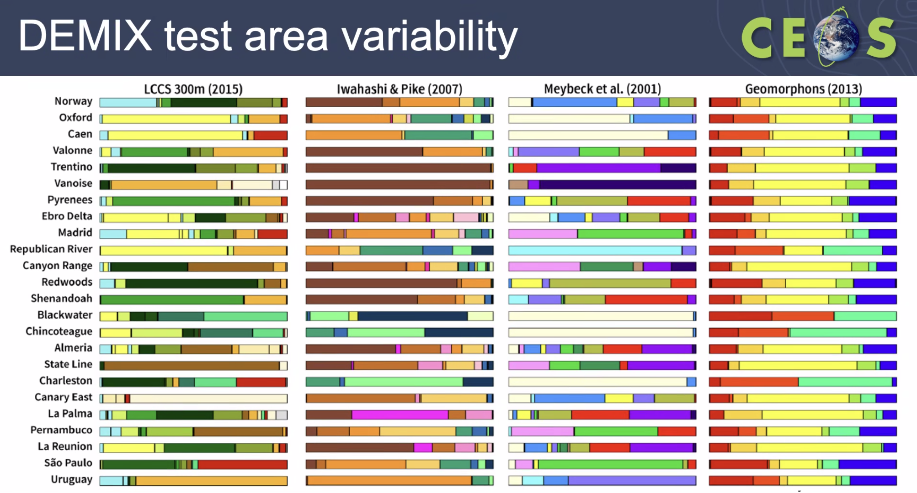
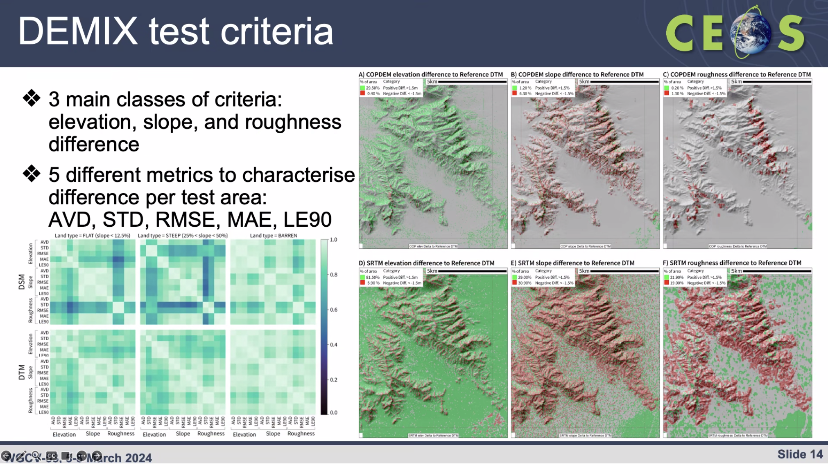
- DEMIX results:
  - Overall best DSM: COPDEM.
  - Best DTM (except for steep terrain): FABDEM.
  - ALOS AW3D30: Sometimes second place; might be better in steep terrain than FABDEM.

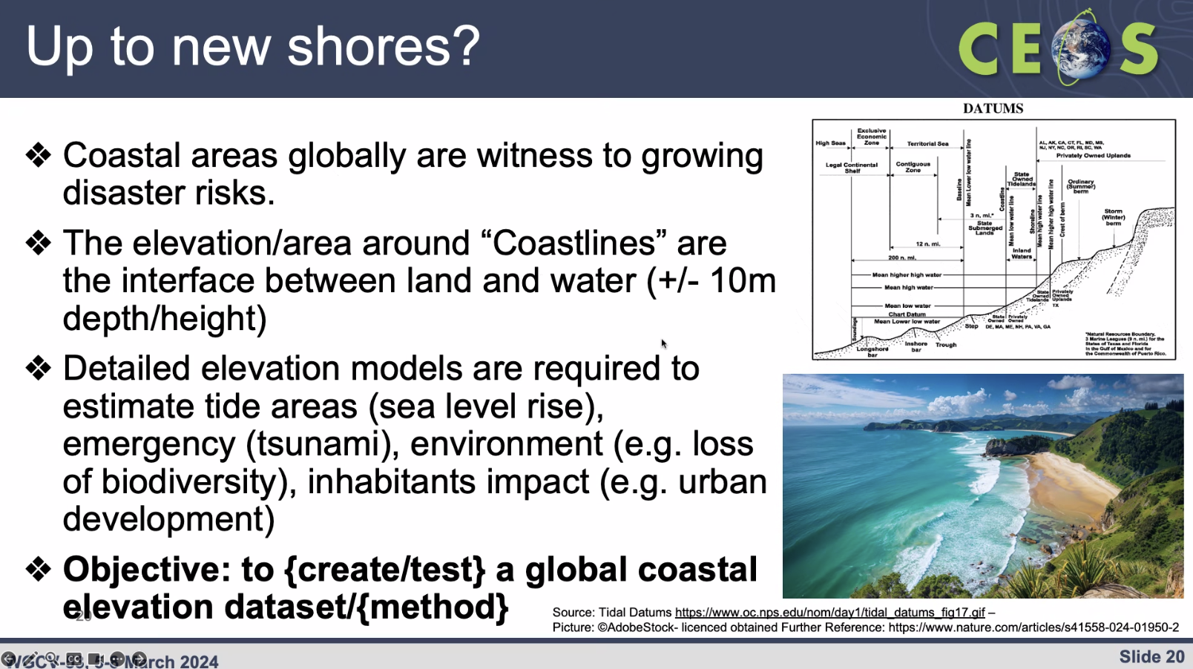
GCPIX
- CEOS is now proposing the development of a harmonised global CEOS Ground Control Points (GCP) database and its extension to also cover VHR Optical Data [2.5-10 m GSD, and potentially <2.5m GSD].
- CEOS agencies are pooling activities and resources towards a unified and harmonised CEOS GCP Database for HR and VHR Optical Data.
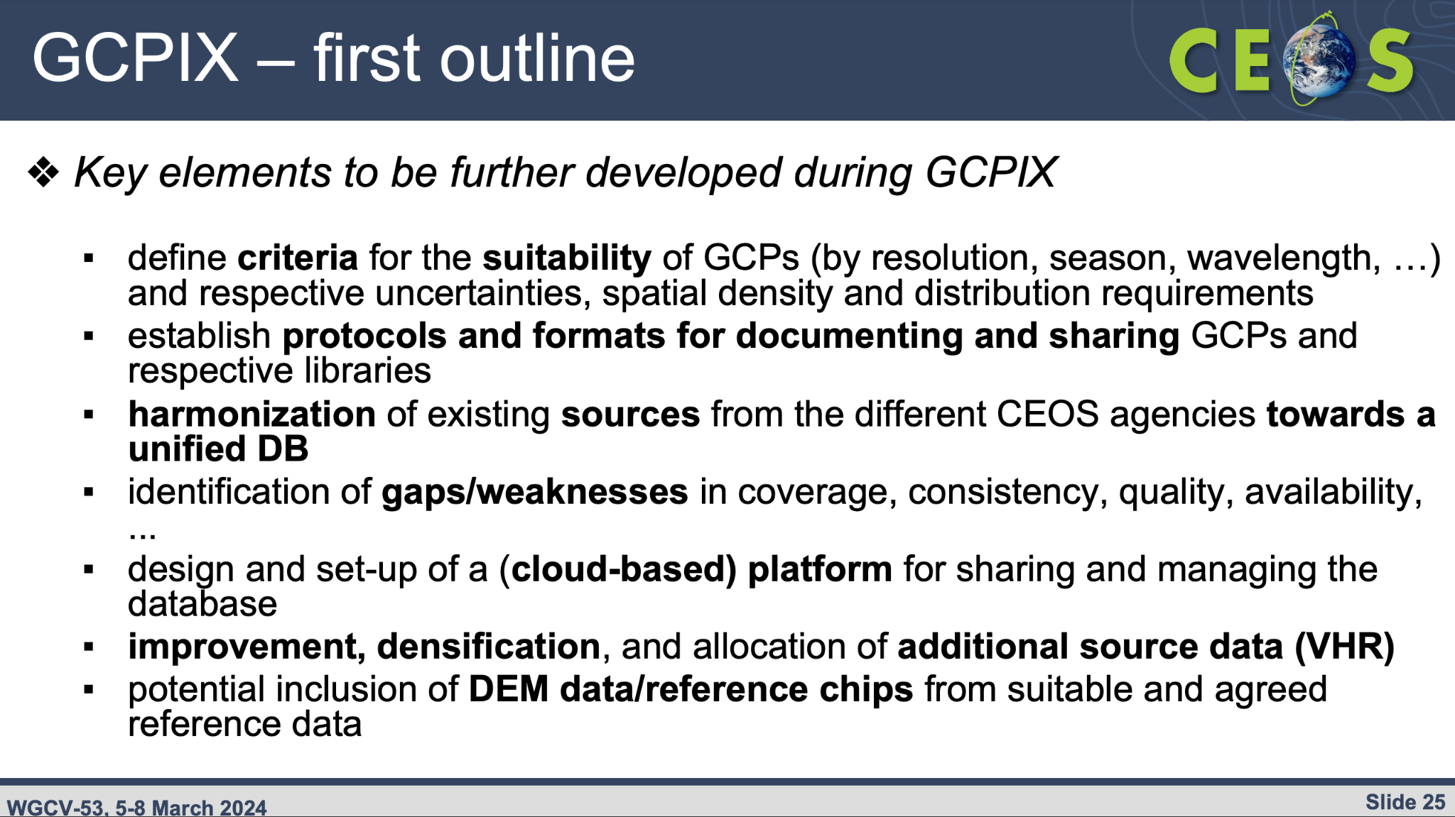
CEOS Common Terminology
- Paper was written and submitted for publication: “Lost in translation: The need for common vocabularies and an interoperable thesaurus in Earth sciences” P.A. Strobl, E.R. Woolliams and K. Molch (JRC, NPL, DLR). This completes the CEOS WGCV action CV-22-02.
Discussion
- TanDEM-X data is not as open as the others. FABDEM also has some commercial restriction clauses. CopDEM is free and open.
- Peter highlighted the comparison made in DEMIX against both surface and terrain versions of reference data, primarily derived from lidar data. DEMs derived from radar measurements represent an abstraction between the top of the canopy and the surface, varying with wavelength. All DEMs are estimations and abstractions of the surface rather than exact representations. There cannot be a 1:1 expression of the surface, it is inherently scale/resolution dependent.
- Regarding update frequency, there are certain areas in which it makes a big difference in quality metrics. The conclusion is if you want them to match, at least in vegetated areas you should get an update of the DEM every five years at least.
- GEDI and space based lidars are valuable for validation and to estimate differences in DEM in certain areas over the decades. This will be a topic for TMSG consideration in future. The objective of GCPiX is to create a dense library to allow users to do an orthorectification. The emphasis is on providing points in a sufficient quantity and with ease of access to facilitate the user’s orthorectification goals. Validating that is a different story and that is not the main target of this library.
- For orthorectification, it is mandatory to have DSM, and it is ideal to have both DSM and DTM. There is much interesting information between the two and the difference provides insights about the state of land cover.
- Philippe Goryl (WGCV Chair, ESA) highlighted a request from the VH-RODA workshop about developing a validation database for very high-resolution datasets, as a contribution to New Space in particular. Various inputs have been received from agencies, now looking to TMSG to consolidate the input.
- Progress on GCPIX will be reported at JACIE and VH-RODA meetings and it would be good to have progress by then. TMSG needs to start by addressing the terminology problem. For example, ‘very high resolution’ does not mean the same to everyone.
- 10m resolution and an accuracy of 0.5 m pixel are achievable for now. Additional resources are needed to go higher resolution. A dense net of reference points is also critical.
WGCV-53-ACT-04 | TMSG Chair, Dirk Geudtner, and WGCV Chair to coordinate an input for the 2024 CEOS Plenary regarding the importance of CEOS Agencies funding missions like TanDEM-X for the provision of Digital Elevation Models (DEMs). Recommendations from this group in view of TanDEM-X mission will eventually cease operations, in view of securing future DEM updates and also DEMs for bare surface in particular (another frequency band in addition to X) | WGCV-54
WGCV-53-ACT-05 | WGCV Chair and TMSG Chair to raise the idea of creating / testing a global coastal elevation dataset / method with the leads of the CEOS Coastal Observations Applications Services and Tools (COAST) Ad Hoc Team (likely soon to be Virtual Constellation) and also assess interest from other CEOS members (e.g., GA / Digital Earth Australia/Africa Coastlines is highly applicable).  Notes: If there is sufficient interest, consider forming a small working group to further explore and develop this proposal. | June 2024
WGCV-53-ACT-06 | WGCV Chair to send another call for nominations for the role of TMSG Co-chair, which remains open. | April 2024
WGCV Contributions to the CEOS New Space Task Team [Slides1] [Slides2]
Presenters: Philippe Goryl, Cody Anderson
- The CEOS New Space Task Team (NSTT) was established by CEOS to develop a white paper outlining what CEOS can do for New Space and vice versa. The white paper is available at: https://ceos.org/document_management/Meetings/Plenary/37/Supporting%20Documents/New%20Space%20White%20Paper%20v1.0.docx.pdf
- WGCV was a significant contributor to the NSTT white paper, identifying many potential areas of contribution.
- The emergence of New Space presents an opportunity for public space agencies to benefit from increased Earth observation data. However, ensuring the quality of this data is crucial, highlighting the mutual interest in developing approaches for assessment.
- Philippe reviewed the recommendations from the white paper that are relevant to WGCV.
- Philippe emphasised the importance of viewing New Space as complementary rather than competitive with public space agencies.
- CEOS-ARD plays a key role in enabling interoperability and the use of multiple datasets, facilitating synergistic data utilisation.
- Although sharing information is beneficial, discussions quickly encounter challenges related to confidentiality and intellectual property. Striking a balance between identifying data quality issues and offering assistance is essential.
- JACIE and VH-RODA are valuable platforms to continue the dialogue with New Space. Philippe plans to allocate more agenda time in the next VH-RODA meeting.
- The match-up database (radiometric) and GCP database are two concrete actions for WGCV, but they were not included in the final set of NSTT white paper recommendations.
CEOS Analytics Lab
Presenter: Dave Borges (SEO, NASA)
- Dave reported that SEO is demonstrating the integration of New Space data into CEOS Analytics Lab (CAL) and evaluating its interoperability with common CEOS datasets. This involves trialling various optical and SAR datasets, including both freely available data from NASA CSDA, and freely open commercial data. The datasets are being consolidated within the CAL to conduct interoperability studies and trial self-assessments against CEOS-ARD PFS.
- The technical approach and objectives of the Interoperability project include:
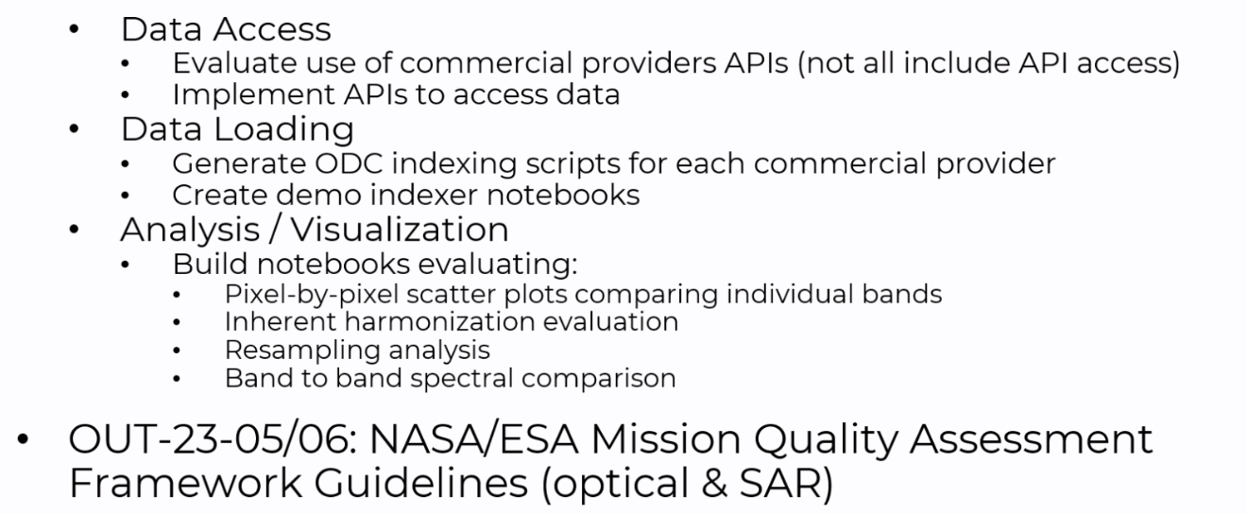
- Dave welcomes input from WGCV on the interoperability project.
Discussion
- Santhisree (ISRO) asked about the Planet data. Dave Borges (SEO, NASA) clarified that it is Planetscope data. Dave will share the details with Santhisree. Additionally, Santhisree offered Resourcesat-2 and RISAT-1A data for the interoperability study, which Dave welcomed as a valuable contribution.
WGCV-53-ACT-07 | Dave Borges (CEOS SEO) and Santhi Sree (ISRO) explore the inclusion of ResourceSat-2 and RISAT-1A data in the CEOS Analytics Lab (CAL), with particular reference to the interoperability study. Dave will also share the details of the Planet data available in the CEOS Analytics Lab. | May 2024
Supersite Suggestion
- Philippe Goryl (WGCV Chair, ESA) suggested establishing a distributed ‘supersite’ for image quality, which would consolidate various sites across WGCV. Sites in Australia, Europe, China, US, and India, were noted. Some of which support modulation transfer function (MTF) analyses.
- Philippe noted past discussions in IVOS on MTF. He suggested considering the formation of a new task team or similar initiative focused on image quality to coordinate efforts among agencies and sites. Nigel Fox (UKSA) agreed with the idea but noted the need for a new champion or champions to lead and drive the initiative forward.
Product ‘Certification’ Process
- This is a complex topic that requires careful consideration.
- The first question to be addressed is what exactly needs to be certified. There are three levels of certification to consider:
  - Company level: e.g., ISO type certification, audit company, make sure they follow the right protocol/procedure to get data of good quality, check company following best practices;
  - Dataset level: synthesis of the data quality. check preflight calibration, characterisation, traceability, etc.;
  - Application level: fitness for purposes of a dataset (e.g., including aspects like temporal revisit, etc.)
- The role that CEOS could play in the process is something that this group could discuss. One option is to formalise and generalise processes established by agencies like NASA (CSDA) and ESA (EDAP).
- Nigel Fox (UKSA) noted it is essential to consider how we express our intentions. Instead of framing the process as assessing (policing) the performance of data quality, we should aim to facilitate companies' ability to demonstrate their compliance with established standards. This approach may help foster constructive dialogue and cooperation with industry.
- Nigel noted that at VH-RODA there were multiple cases of companies stating that they do not prioritise cal/val because their customers do not ask for it. Educating the end user and creating this demand is a potential role for CEOS and may spur the prioritisation of cal/val.
- The NSTT white paper does not address the inclusion of specific requirements in agencies’ procurement mandates. Notably, major data procurement agencies affiliated with CEOS are not prominently mentioned in the paper.
- Cody Anderson (WGCV Vice Chair, USGS) noted that still, the major data buyers are intelligence agencies like NGA and NRO. There is a difference between the needs of these buyers (e.g., near real time) to that of the scientific/civil user communities.
- Cody encouraged WGCV participation in JACIE and VH-RODA to strengthen dialogues with New Space. He noted past action items from JACIE around common data cal/val sites, common data pools, and GCPs:
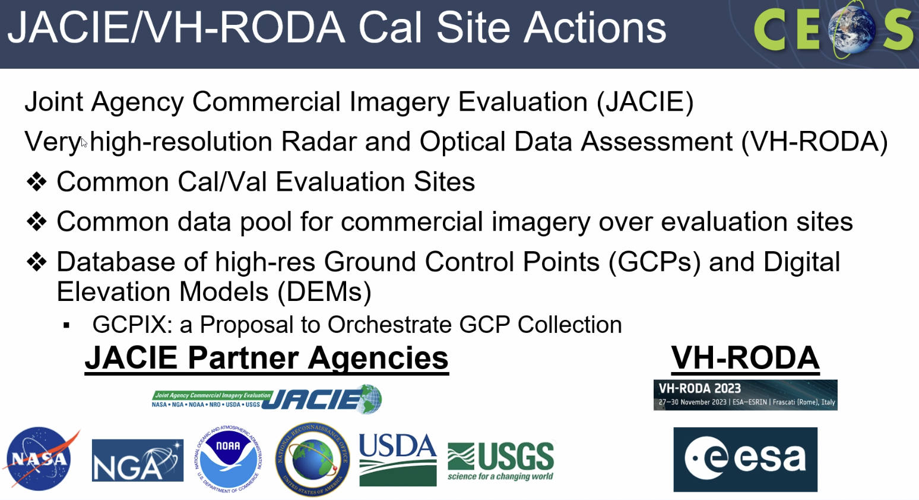

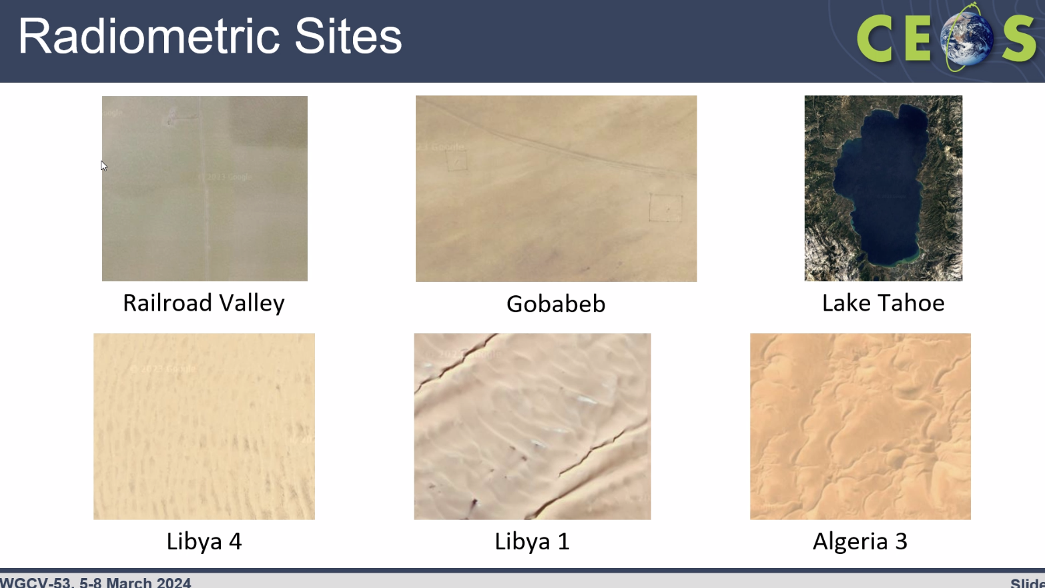
- A suggestion would be for both CEOS agencies and New Space to image over these joint sites and freely share data, work together on comparisons, etc.
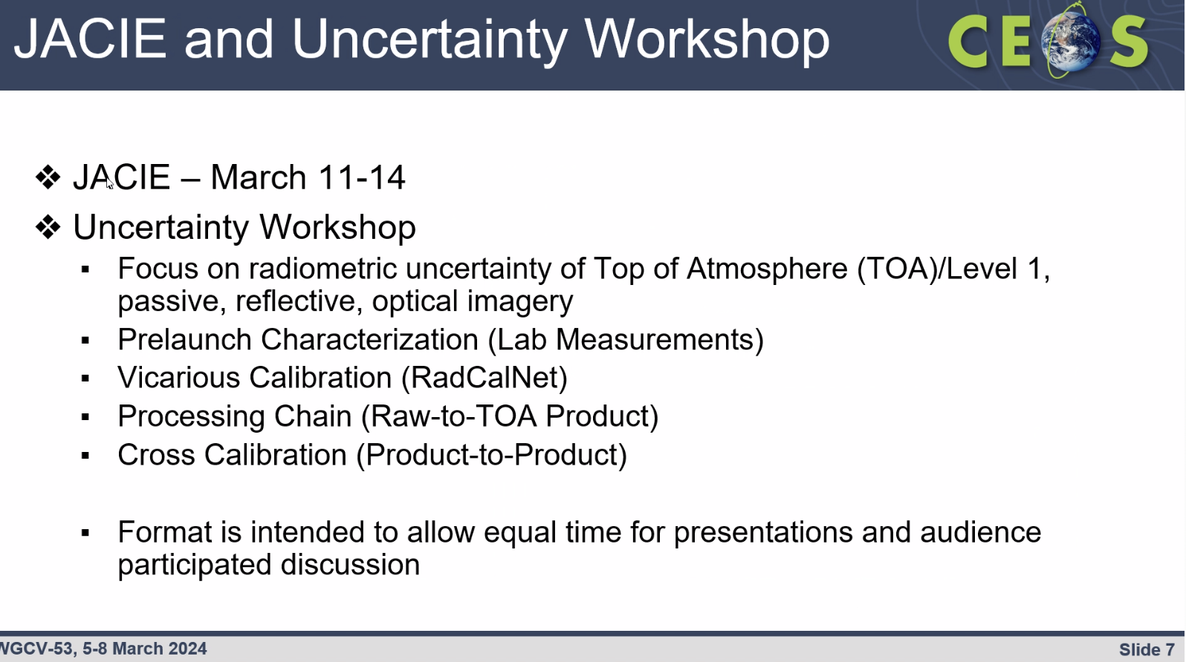
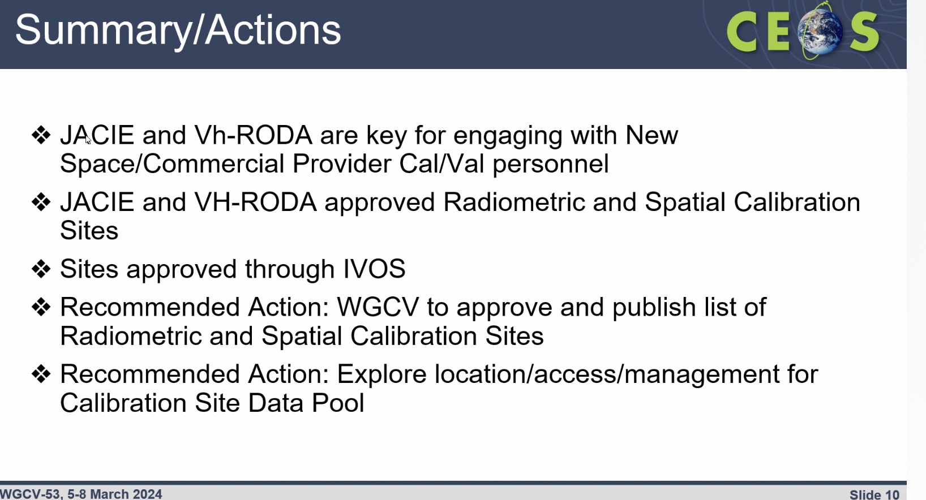
- Users and customers will play an important role in demanding data quality from New Space operators. CEOS can provide support. Making reference data and calibration/validation sites widely available is essential.
- Compliance / certification should be framed instead as a way that demonstrates the quality and suitability of data, rather than being seen as a means of policing.
- Larry Flynn (NOAA) noted that GSICS is also offering their methods and identified satellite reference instruments for use by New Space for calibration and monitoring.
- Buyers/customers need to be educated on asking questions and referencing CEOS methods and references – this is the way to create a demand for cal/val of products.
UK Match-up Data Cube [PPT]
Presenter: Nigel Fox
- Proposal at VH-RODA 2022 (via Ignacio Zuleta) to develop a community matchup comparison system to publish biases of missions with respect to references.
- Introduced UK ‘Match-up Data Cube’ proposal:
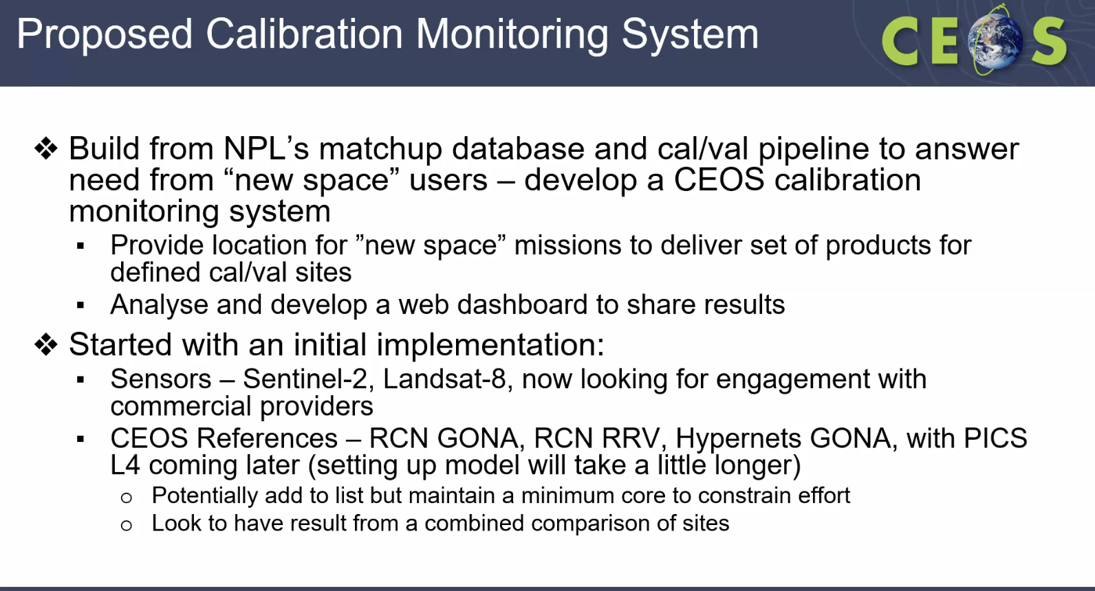
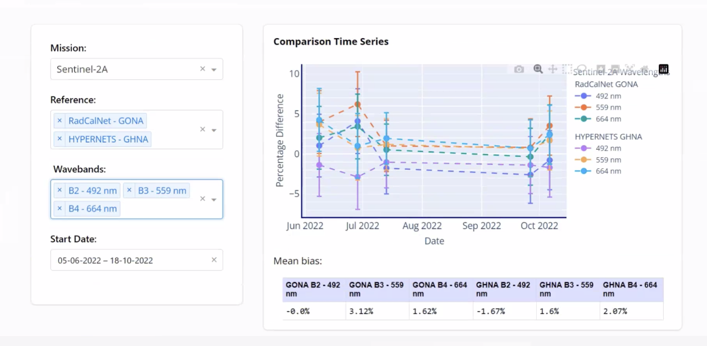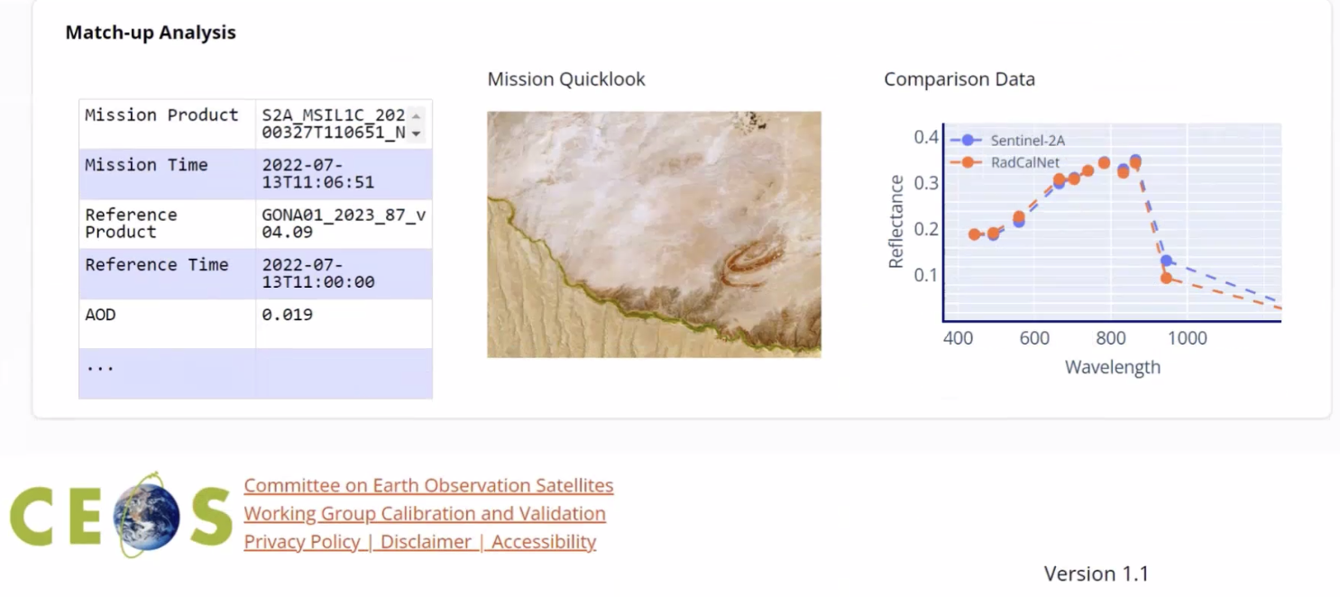
- The software will be open-sourced for transparency and enable community development. Missions can join voluntarily.
- The intention is to provide information on the state of characteristics, but not to force any changes to biases or corrections, etc.
- Conclusion:
  - Applying NPL's cal/val pipeline to answer needs from New Space vendors/users - proposed as a CEOS calibration monitoring system;
  - Seeking volunteer beta testers from New Space to trial integration;
  - Interest from vendors has been noted at VH-RODA;
  - Looking to be in a position to have a live demo site later in 2024, which will be open sourced with beta testers involved.
- Dave Borges, Philippe Goryl and Nigel Fox will consider collaboration opportunities between the SEO’s CEOS Analytics Lab and the UK match-up data cube.
- The key focus is on using common sites, consistently, to provide a baseline. Get all CEOS efforts using the same sites, provide a source of data for New Space comparison. Having a set of common sites resolves issues with agencies asking for conflicting or additional observations.
- Jean-Christopher Lambert (BIRA-IASB) noted that the fitness for purpose should be left to the user themselves to judge. QA4EO stopped at the point of providing metrics and indicators so that the end users can judge this for themselves. The same approach is suggested for this initiative, providing guidelines and tools without engaging in compliance checking. Fitness for purpose assessment is not for WGCV.
- IVOS recommends the sites Cody Anderson previously presented. IVOS Chair will seek formal endorsement during the IVOS agenda item of WGCV-53 along the following lines:
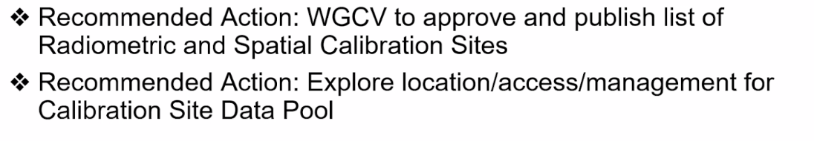
- Medhavy Thankappan (GA) asked about the representativeness of the sites. Nigel noted that at this point, it is a minimum required level of representativeness – other sites can be added in future to increase the diversity of the types of sites.
Day 1 Close
Philippe Goryl (WGCV Chair, ESA) thanked everyone for joining and closed Day 1 of the WGCV-53 meeting.

