Minutes
WGCV-53 Day #2
Wednesday, 6 March 2024

Participants (* Virtual Participants)
AEM Adrian Guzman*
ASI Antonio Montuori*
BIRA-IASB Jean-Christopher Lambert
CONAE Ana Medico, Angel Matias Palomeque, Laura Frulla, Marc Thibeault
CSA Stephane Cote*
CSIRO Cindy Ong*, Ian Lau*, Matt Garthwaite
CSIRO Chile Jonathan Hodge*
Servicio Aerofotogramétrico Andres Jordan*, Carolina Barrientos*
DLR Albrecht von Bargen*
ESA Dirk Geudtner, Fabrizio Niro*, Paolo Castracane, Philippe Goryl
EC-JRC Peter Strobl*
GA Medhavy Thankappan
ISRO Santhisree, Raghavendar?? (Virtual or in person?)
JAXA Akihiko Kuze
MYSA Adhwa Amir Tan*, Wayne Ng*
NASA Xiaoxiong (Jack) Xiong*, Eric Vermote, Kurt Thome*, Dave Borges
(SEO)
NASA-JPL Bruce Chapman*
NCC-CAS Jian Xu
NOAA Taeyoung Jason Choi*, Manik Bali*, Larry Flynn*
NRSCC Xiaolong Dong*
NPL/UKSA Nigel Fox
USDA Michael Cosh*
USGS Cody Anderson, Tom Stone*
WGCV Sec Matt Steventon, Riza Singh*

Welcome and Review of Actions
Presenter: Philippe Goryl (WGCV Chair, ESA)
Main points:
- Philippe Goryl (WGCV Chair, ESA) welcomed everyone to Day 2 of the WGCV-53 meeting.
- Matt Steventon (WGCV Secretariat) reviewed the decisions and actions from Day 1.
Microwave Sensors Subgroup (MSSG) Report [Slides]
Presenter: Xiaolong Dong (Virtual)
Main points:
- MSSG covers sensors operating in the microwave spectrum, except SAR.
- Reported the progress made on the two ongoing deliverables: CV-23-05: Retrieval and validation with high winds with combined active-passive microwave measurements and CV-23-06: Retrieval and validation of sea surface atmospheric pressure with microwave remote sensing. Both the deliverables will be completed in Q2 2025.
CV-23-05
- CV-23-05 is led by Prof. Wenming Lin from Nanjing University of Information Science and Technology (NUIST). The task monitors extreme sea surface winds using satellite-based microwave sensors. The task team includes members from NUIST, NSCC, KNMI, NSOAS, NSMS/CMA and NOAA.
- The expected deliverable is to provide comparisons of respective wind results from both types of sensors (active and passive) and prepare examples of joint application methods for high wind retrievals. The main goal is to re-calibrate microwave radiometer brightness temperature, radar scatterometer and synthetic aperture radar (SAR) normalised radar cross section (NRCS, σ0), and to derive well inter-calibrated high and extreme sea surface wind products.
- In terms of the validation reference aspect, collocations in storm-centric coordinates to improve storm centre location are completed. For spatial representativeness, suitable SFMR upscaling for each SAR, scatterometer and radiometer is also completed.
- The sensitivity of normalised radar cross sections for high and extreme winds was concluded as a 0.1 db sigma-0 change which corresponds to a 3.6 m/s wind speed change.
- Passive microwave radiometer brightness temperature for high and extreme winds had better agreement with SFMR.
- Recalibration of the satellite winds using an empirical adjustment was conducted, resulting in a performance improvement. Ku-band analysis was also conducted.
- Future works include combined active/passive inversion for extreme winds. The wind retrieval process has been developed but validation works are still to be done. A comprehensive validation of different wind products will be conducted. By the end of 2024, a task team meeting will be organised to refine and release a review of deliverables.
CV-23-06
- CV-23-06 is led by Dr. Zijin Zhang from the National Space Science Centre, CAS.
- Covers retrieval and validation of sea surface atmospheric pressure with microwave remote sensing.
- Progress includes the development of retrieval algorithms for sea surface pressure by passive microwave observations, analysis of the relationship between TB warm anomalies and surface pressure fields of tropical cyclones, improvement of the retrieval algorithms under strong wind conditions, analysis of the surface pressure information content obtained by 50-60 GHz and 118 GHz radiometers, to develop joint retrievals.
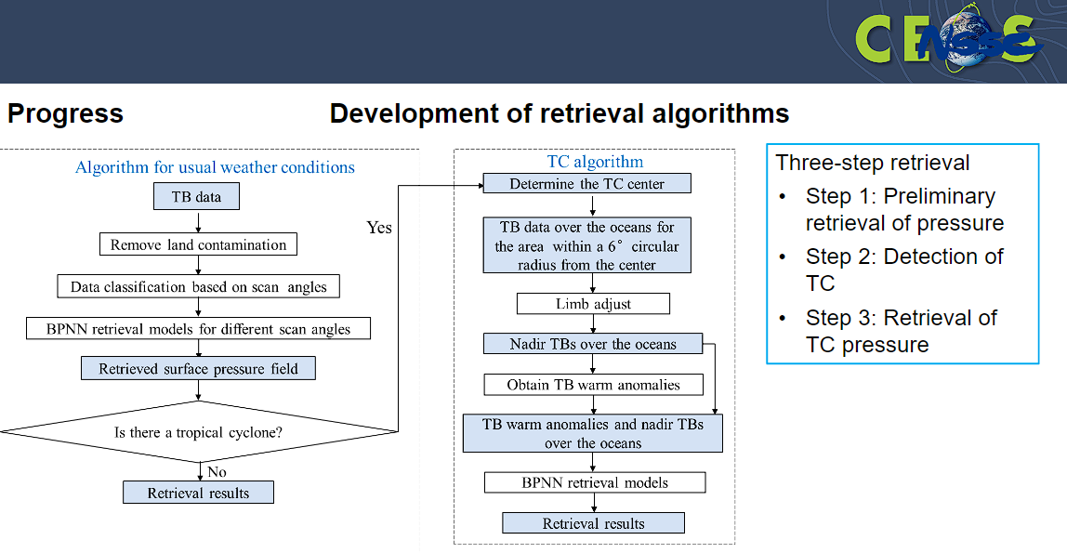
- Channels used for joint retrievals are selected based on the retrieval content. A reanalysis of the data was done. The conclusion is that MWTS-II+MWTHTS achieves better retrieval accuracy.
- Other work in the preparation includes promoting the ISO Technical Specification (TS) on calibration and retrievals of sea surface wind by radar scatterometry and cal/val for sea surface wind and soil moisture data by GNSS-R.
- More details can be viewed from the linked slides.
Discussion
- Dirk Geudtner (ESA) acknowledged that Xiaolong Dong's presentation showed that the MSSG had employed empirical adjustment and recalibration techniques. He noted that empirical adjustment does not sound very systematic and should not be the solution for any kind of reliable and robust algorithm. Dirk advised against recalibrating data to fit geophysical models, citing the potential risks of producing strange trends or measurements. Dirk emphasised the need for a more unified and reliable model, particularly one that works across multiple sensors, especially in the context of combining scatterometer and SAR retrievals.
- Xiaolong Dong (NRSCC) noted that the developed new TMF is adapted to high-wind situations. The challenge is that physical based TMF and models are still not available, and hence the reliance is on the empirical adjustment. He agreed that the approach is not ideal but it has to be done to adjust the data from the sensor and produce a consistent result.
- Xiaolong Dong (NRSCC) noted that SAR offers the highest resolution for analysing the fine resolution structure of tropical cyclones, and scatterometer resolution is comparatively lower. Highlighted the optimisation of wind retrieval using a microwave radiometer as a reference.
- Paolo Castracane (ESA) invited Xiaolong to provide updates or materials for inclusion on the cal/val portal.
- Philippe noted the overlap of MSSG activities with GSICS. Xiaolong noted his colleague will attend the GSICS meeting in March 2024. Xiaolong noted ongoing discussions with Cindy Wu from CMA, who is the co-chair of the Microwave Subgroup of GSICS.
- Philippe mentioned that the ASCAT lead at ESA expressed interest in joining MSSG. Philippe will facilitate connection with Xiaolong.
- Philippe asked about the relevance of the FRM concept in the microwave domain and proposed the definition of a reference site. Philippe suggested that this topic could be explored further within the MSSG subgroup, noting relevance to Copernicus.
- Philippe noted the Preflight calibration workshop and mentioned there was an interest in organising a similar workshop for microwave sensors. He suggested that this could be a longer-term plan.
- Philippe recalled the proposal to share standards related activities in reports to CEOS Plenary, and noted MSSG work on the ISO Technical Specification (TS) on calibration and retrievals of sea surface wind by radar scatterometry. It was suggested to incorporate this information into the WGCV presentation for the 2024 CEOS Plenary.
WGCV-53-ACT-08 | WGCV Chair to inform MSSG Chair of new ESA representatives to the MSSG. | May 2024
WGCV-53-ACT-09 | MSSG Chair and WGCV Chair to coordinate a discussion in MSSG on the relevance of the FRM concept and explore the potential for a contribution to the Assessment Framework activities. | May 2024
Land Product Validation (LPV) Subgroup Report [Slides]
Presenter: Michael Cosh (Virtual)
Main points:
- LPV held a 'town hall’ meeting at AGU in December 2023 to increase awareness of the group’s activities and establish connections within the community.
- A workshop on good practices for LPV was held at IEEE GRSS in January 2024, providing another opportunity for community engagement.
- LPV is working on elevating various validation protocols to higher validation stages. Soil moisture validation is being elevated to stage 4, with the release of FRM4SM, albedo is being elevated to stage 4 and burned area to stage 3.
- LPV is reviewing and updating LPV Essential Climate Variables (ECVs) in response to the latest WMO GCOS requirements.
- Regarding biodiversity, noted the “Priority list of Biodiversity metrics to observe from space” paper which was contributed to by LPV members. This is currently being reviewed to assess the alignment of the Essential Biodiversity Variables (EBVs) with LPV focus areas.
- For new land product focus areas within LPV, LPV is currently considering GPP/NPP and Evapotranspiration. Noted openET connection and review in paper.
- Contributing to GEO TREES, BCI Panama TLS processing as a showcase. TIGs are being established, with the first workshop scheduled for 15-17 May 2024.
- A workshop on Quality Assurance for Soil Moisture (QA4SM) is planned for 4-7 June 2024. LPV is working on a new release with new functionality aiming towards fully automated dataset validation using FRMs and good practice protocols. Noted cost analysis currently ongoing for soil moisture networks, estimating approx 5000 USD per year to run a soil moisture station, so a network of ~100 stations is a significant investment. The sustainability of funding and the value added is under review.
- Noted Vegetation Parameters CCI, which provides LAI and fAPAR – particularly helpful to ‘non-expert’ users.
- Biophysical updates:
  - TIRCalNet preparation study and coordination meeting was held in January 2024;
  - Extension of Copernicus LAW stations is ongoing;
  - ECOSTRESS forward processing and reprocessing for Collection 2 higher level products (ET, ESI, WUE) has begun;
  - SBG-TIR Key Decision Point (KDP)-B is expected in March 2024;
  - The International Science Workshop on High-resolution Thermal Remote Sensing is expected to take place in India.
- LST updates:
  - The paper "Upgrade and extension of LSA-SAF land surface albedo archive from EPS Metop/AVHRR: description and quality assessment," published on 21 Jan 2024, addresses the Surface Albedo Climate Data Record (CDR) based on EPS Metop/AVHRR.
  - The validation process utilises the CEOS LPV protocol but is spatially limited. The evaluation focuses on completeness and stability. Direct validation is constrained, relying solely on data from six stations. Local product intercomparison is conducted with MODIS serving as the reference dataset.
- Snow updates:
  - It is the next big opportunity for satellite Earth observation, recent papers were noted. LPV is looking at the specifics of snow missions and the protocols that would be needed. Noted ‘snow school’ activities where these protocols and approaches are being discussed and investigated.
  - Various validation campaigns are ongoing.
  - Preparing for CIMR (will include snow retrieval), NASA Earth System Explorer 2, and Canadian TSM (pre-phase A).
- LPV is currently reviewing supersites to reflect the latest focus areas and updated needs. Efforts are directed towards reducing the isolation of sites and maximising their potential for overlap and support across focus areas. Coordination and alignment of sites to support multiple products and purposes are being explored. LPV aims to optimise sensor allocation to establish true supersites.
- Various works were carried out under the LPV focus areas including biophysical, Fire/Burn Area, Phenology, Vegetation Index, Land Cover, Snow Cover, Surface Radiation, Soil Moisture, LST and Emissivity and Aboveground Biomass. The details can be viewed in the linked slides.
Discussion
- Addressing the cost of maintaining the soil moisture network is important, considering it involves a significant investment of time and money. The network is a multi-million dollar investment, with an average sensor lifespan of about five years.
- This means the entire network needs replacement every five years, including components like data loggers and solar panels, which can typically be covered by a budget of USD 5000. Within CRM, the budget discussion has been ongoing in NOAA for multiple years. There was a decision to remove the network, which faced opposition and garnered media attention. Politicians intervened to reverse the decision, seeking information on network users and impacts. However, obtaining such information proved challenging for various reasons. Public awareness prompted senators to write to decision makers, leading to a temporary hold on the network's removal. Despite ongoing discussions, funding remains a challenge. Some resources have been secured to maintain parts of the network. More information: https://www.drought.gov/drought-in-action/national-coordinated-soil-moisture-monitoring-network
- Philippe Goryl (WGCV Chair, ESA) noted the need for further coordination between MSSG and LPV on snow, and also other groups. A better mechanism is needed for collaboration.
- Nigel (UKSA) noted that in the context of LST, under the IVOS banner, relevant individuals from LPV subgroups participated in the LST workshop. While formal outreach may be lacking, there is awareness and participation from LPV members in relevant activities.
- LPV is hoping to organise workshops that bring together instrument scientists and end users, facilitating improved communication and understanding between these groups. The goal is to enhance connections between those working at the sensor level and end users, ultimately improving the usability of data.
TIRCalNet [Slides]
Presenter: Philippe Goryl
Main points:
- During the CNES CEOS Chair term, calibration and validation of thermal infrared were highlighted as a priority.
- Several TIR missions are operational such as ECOSTRESS, ASTER, LANDSAT-8&9, MODIS, VIIRS, SLSTR, SEVIRI, etc. TIR future missions with higher resolution include TRISHNA, LSTM, and SBG. There are also various commercial missions coming down the pipeline.
- There are demanding LST accuracy requirements better than 0.1 K for climate studies. It is important to perform vicarious calibration for the validation of on-board calibration systems (black bodies) or direct calibration and L2 products (temperature and emissivity) validation needs.
- TIRCALNET objectives are:
  - To collect surface temperature and emissivity, and atmospheric data necessary for the simulation of observations by TIR optical sensors and thus verify their radiometric calibration;
  - To increase the number of matchups between in-situ measurements and space sensor observations to reduce the overall uncertainties, and reduce the efforts of individual agencies;
  - To ensure traceability of the space sensor radiometry to SI;
  - To support the establishment of the Global Earth Observation System of Systems by providing measurements to verify the radiometric consistency between EO space sensors;
  - To build on success and experience of the RadCalNet network dedicated to VNIR-SWIR optical sensors;
- Current limitations of existing LST sites include spatial representativeness of the in situ reference measurements for higher resolutions, directional effects, lack of emissivity measurements, data access, data harmonisation, not providing TOA radiances, data quality assurance (an error budget traceable to SI), in situ instrument calibration quality and traceability, need for the development of a denser ground-based reference network.
- ESA and CNES defined, after discussions with domain and agency (CNES, ESA and NASA) experts that TIRCALNet should be able to provide TOA brightness temperature signals propagated from BOA measurements of approx. 0.5K uncertainty. A set of necessary tasks were then identified:
  - Identification of uncertainty contributors to TOA-derived BT;
  - Sensitivity analysis of uncertainties on TOA BT estimation;
  - Definition of best site characteristics, optimal instrumentation and forward propagation scheme;
  - Selection of potential candidate sites;
  - Interaction with Working Groups and network roadmap.
- A study was conducted to identify the uncertainty budget at the La Crau, Gobabeb, Lake Tahoe, and Lake Constance sites. The study confirmed that the main impact on TOA Brightness Temperature is the uncertainty of the ground emissivity. Uncertainties on the atmospheric profiles are an issue but of lesser impact. The atmosphere tends to compensate for errors on surface emissivity, noting the lower errors for Lake Constance than Lake Tahoe. The emissivity and atmospheric error hypothesis has to be consolidated.
- The next steps include the transfer of the CNES La Crau uncertainty budget template to other sites (e.g., from ESA LAW project) and performing similar simulations to gain an understanding of how the site environment may influence the uncertainty, developing a full site uncertainty budget template inclusive of atmospheric, forward propagation, instrumentation and site environment uncertainties, development of a site measurement and forward propagation protocol to minimise uncertainties at TOA, analysis of site characteristics (surface, cloud cover, etc.) to find possible candidate sites (e.g. Lake Tahoe, Acqua Alta platform, Russel Ranch), develop a roadmap to equip and operate sites, hold discussions with partnering agencies on how to collaborate and set up and operate networks (funding for instrumentation, site operation, data analysis, supporting studies, etc.).
- Aim to create and provide input to an international working group consisting of NASA-JPL, CNES, ESA, CSIRO, and INGV. The main project output will be a site prototype design and a roadmap towards an operational network that provides essential TIR ToA anchoring points for radiometry cal/val.
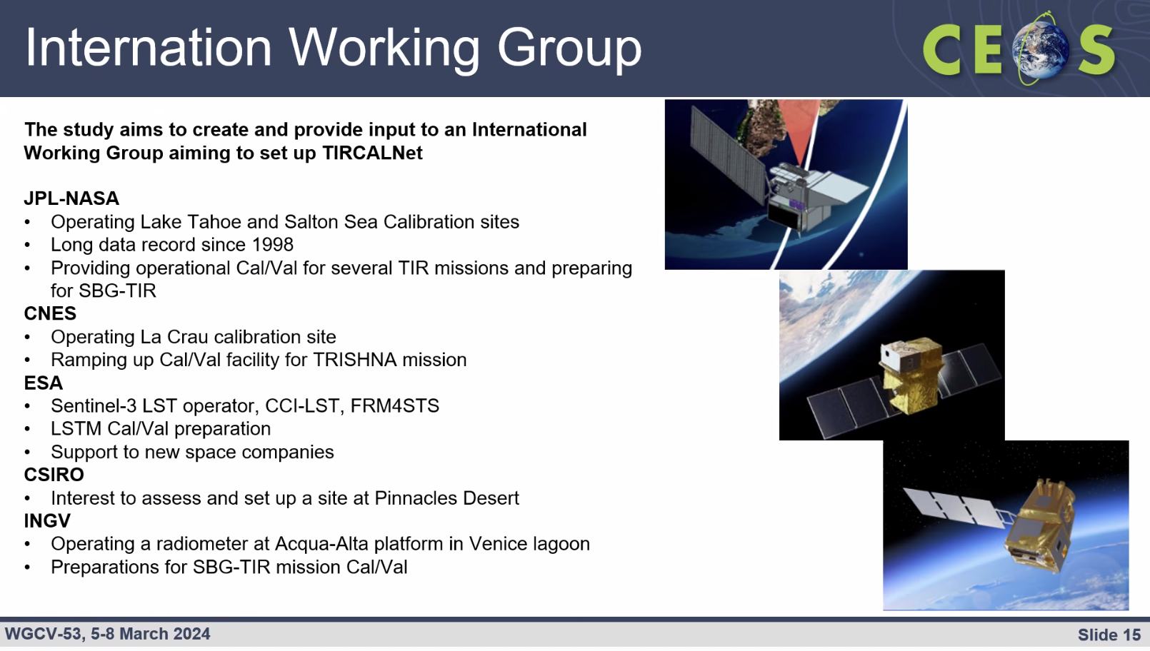
- The working group is not yet formalised and remains open for additional contributors. Interested individuals are encouraged to address their contributions to Steffen Dransfeld (ESA) and Aimé Meygret (CNES).
- Once established, the Working Group will need to develop a framework similar to RadCalNet to equip sites and commence operations.
- While it is premature to provide a timeline, at some point, beta testers from TIR mission operating entities will need to be included in the data uptake and assessment process.
Discussion
- The focus initially is on providing data for specific wavebands of TRISHNA and SBG missions. However, there are plans to offer fully spectrally resolved data in the future. This broader spectrum coverage will require more time to implement comparisons for specific bands, hence the decision to start with specific bands.
- ISRO offered to explore the possibility of a TIRCalNet site in India. Philippe Goryl (WGCV Chair, ESA) will follow up with Steffen Dransfeld and Aimé Meygret.
- Nigel Fox (UKSA) commended the rapid progress of the project and applauded the efforts of the team, noting impressive developments since the last IVOS meeting in 2023.
- Nigel highlighted a challenge regarding data access policies for commercial providers of thermal infrared data. There are concerns about the sustainability of managing these sites and the reluctance of commercial providers to readily share data. It is essential to address these concerns soon to avoid potential issues with data availability and ensure that commercial operators are satisfied. Discussions on data access policies should be initiated early to clarify expectations and ensure access to data.
WGCV-53-ACT-10 | Santhi Sree and WGCV Chair to follow up with Steffen Dransfeld and Aimé Meygret regarding the potential for a TIRCalNet site in India. The first action is to join the Working Group. | May 2024

Infrared and Visible Optical Sensors (IVOS) Subgroup Report [Slides]
Presenter: Nigel Fox (NPL)
Main points:
- Reviewed IVOS mission statement, vision, terms of reference, objectives and work plan.
- Reviewed IVOS 35 meeting held at Oberpfaffenhofen, Germany hosted by DLR in September 2023. The discussion topics included comparison tools, QA initiatives, cal/val methods and services including RadCalNet, Hypernets, RT-Code, STAR, the impact of solar irradiance spectrum change, TIRCalNet, etc.
- Noted DIMITRI tool of ESA, which facilitates radiometric intercomparison of multispectral instruments. Various updates are planned for this tool, including MERIS 4th reprocessing, improvement of PICS and snowy site methods, adaptation to FLEX, and creation of an online tool based on DIMITRI called VICALOPS.
- IVOS requests WGCV endorses identified subset of test-sites as a minimal set to request relevant satellite operators (particularly new space) to make regular acquisitions and provide data (imagery and radiometry to CEOS WGCV as a means of evidencing their capability in a consistent manner:
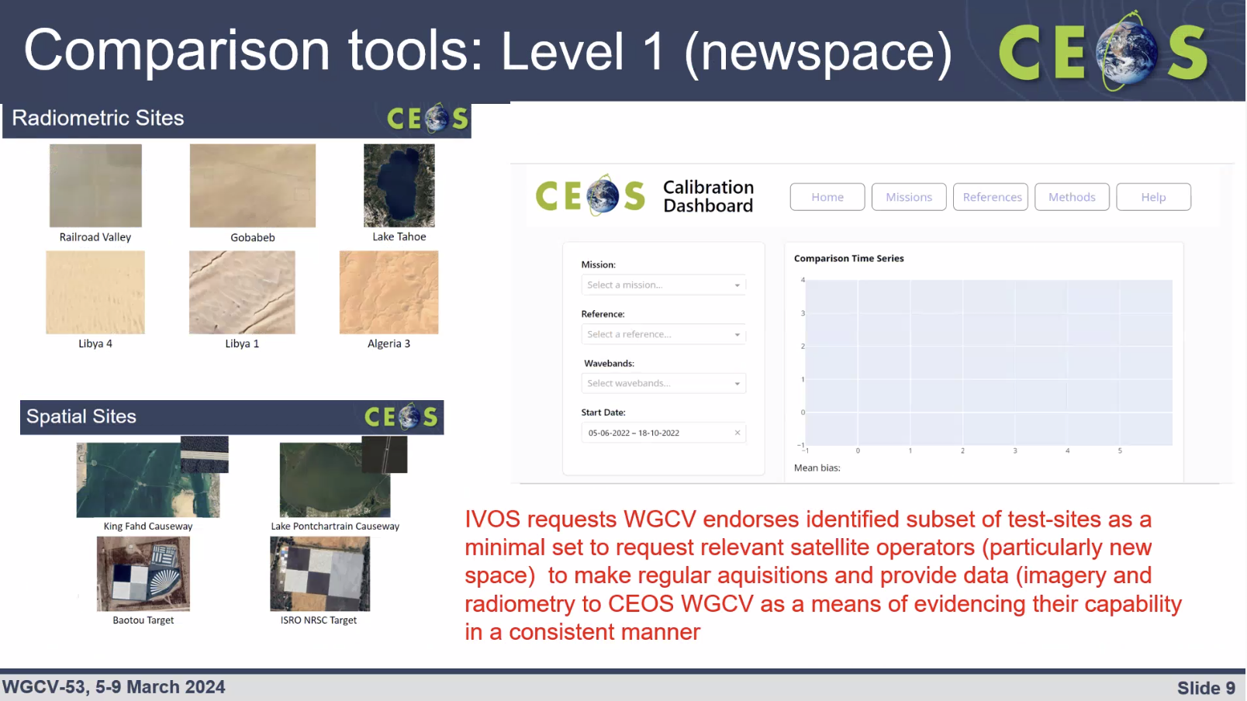
- CEOS reviewed L1 vicarious cal/val infrastructure. There was a request from FLARE/Labsphere for CEOS endorsement of its equipment, which was deemed not appropriate. Consequently, efforts were directed towards establishing a framework to establish means to achieve L1 radiometric interoperability and provide a community reference. This initiative was undertaken under WGCV deliverable CV-17-01.
- A template will be created on the Calibration/Validation (Cal/Val) portal to document achievable uncertainties for different methods. IVOS will populate the template with relevant data. All methods must be thoroughly documented and subjected to peer review by the IVOS team. Evidence of results will ideally include data from specific sensors such as Sentinel-2/3, Landsat 8/9, and VIIRS. All methods, regardless of type, will be eligible for inclusion in the template. The next step will involve determining the most effective way to combine results from various methods. The database will allow users to assess the relative merit of choosing a particular calibration methodology for their application.
- Looked at Eradiate as a new radiative transfer model and validated it using a known target. Confirming for the first time a true physical comparison of a radiative transfer code.
- Looked at RadCalNet, doing regular comparisons. Using Sentinel-2 Level 2A as a transfer standard.
- Updates on various cal/val methods both pre and post-launch were shared.
- At the GSICS workshop on lunar calibration, a comparison was made between OLCI-A and OLCI-B using three different lunar models. The bias observed was very consistent, but there was a notable 10%variation in bias between models.
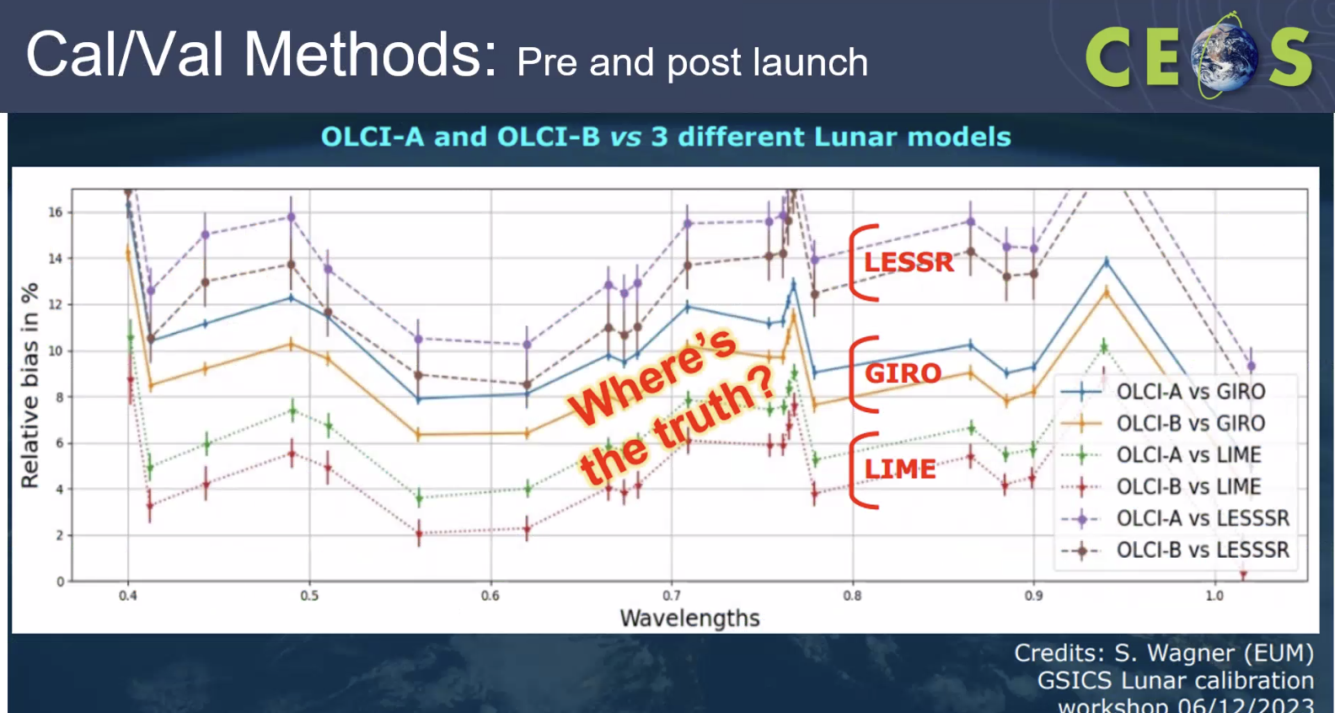
- The TSIS spectrum was endorsed at a previous WGCV meeting. However, there are still issues for some people in understanding how to manage the change when switching from one spectrum to another. Additionally, it was noted that some organisation's communities are experiencing difficulties because TSIS is not included in the database of RT code. ESA is reprocessing S3-OLCI from Thuillier to TSIS to make a switch in spectrums.
- The Solar Irradiance Spectrum page on the cal/val portal requires additional details on the importance of stating a reference. Examples demonstrating this importance should be included on the portal. Efforts will be made to promote this information to the New Space community, including a presentation at VH-RODA.
- Various sensor status and performance analyses were presented at IVOS.
- Noted that Sentinel 2B has been harmonised with Sentinel 2A with a bias correction. It is important to ensure continued transparency and communication of such changes to the community. This is an important adjustment and not as clear as it could be.
- Engagement with Pixxel and Orora (TIR missions) took place at IVOS 35, reflecting an increase in commercial engagement and interest in participation of these companies.
- Referred to the cal/val portal for details on hyperspectral materials from IVOS 35.
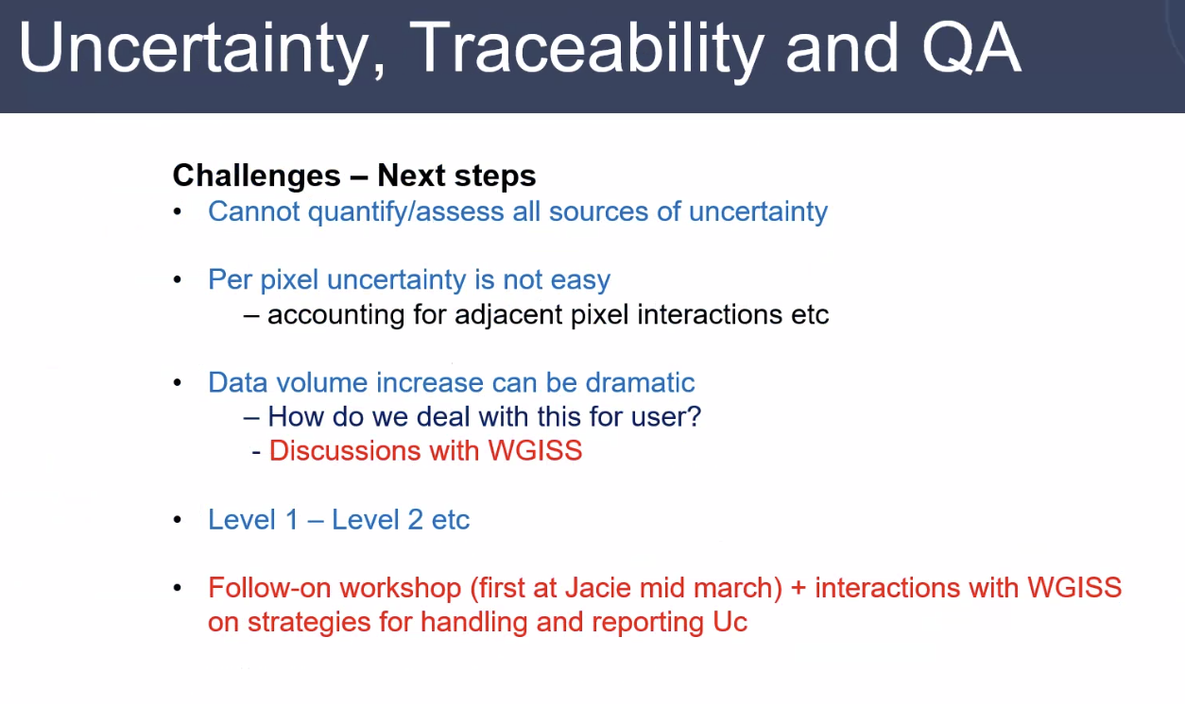
- Two new test sites are being discussed in IVOS, one in northwestern China and the other in Israel. Please refer to the slides for more details.
- New Space is keen to have access to the TIRCalNet data, particularly from the existing sites such as Lake Tahoe, but there is hesitancy regarding sustainability. Comparisons and evaluation processes were demonstrated for the La Crau site which is now rolled out to other sites.
- The Phase 2 results of FRM4SST are set to be published soon and will also be available on the FRM4SST website.
- CEOS communications needs identified by IVOS team:
  - Not getting maximal impact/awareness from WGCV/IVOS activities
  - Request a cal/val portal page on IVOS support to New Space
  - Suggest linking agency pages on cal/val projects from the cal/val portal
  - Additional CEOS News items: e.g., on forthcoming meetings (JACIE, VH-RHODA, cal/val workshops, campaigns, etc.).
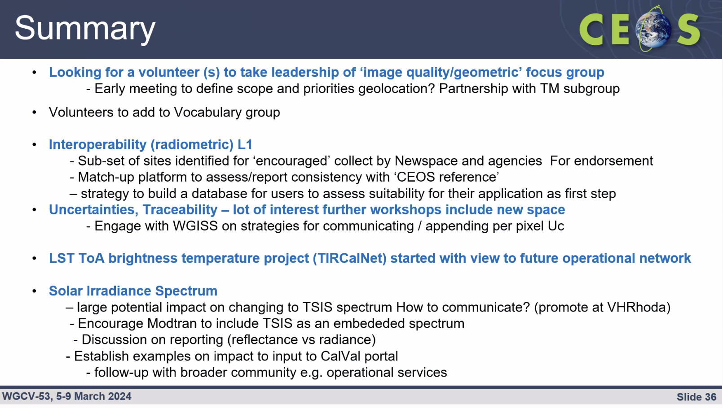
Discussion
- Medhavy Thankappan (GA) highlighted the publication on the choice of solar irradiance models for various missions and proposed adding the reference to the cal/val portal. Publication link: https://www.mdpi.com/2072-4292/15/13/3391
- Dave Borges (SEO, NASA) noted the CEOS communications team is keen to support IVOS in its communications ambitions. There should be someone from the IVOS team to provide initial drafts of news stories and other communication materials.
- There was a suggestion for potential revamping of the cal/val portal to improve communications, including the need for more non-scientific distillations of the very technical activities.
- Regarding the comparison test sites, Peter Strobl (EC-JRC) asked about what ‘regular’ acquisitions mean and what the frequency of acquisitions over test sites will be for radiometric comparisons. Nigel noted that ideally, acquisitions should occur every time the satellite passes over the site. He suggested keeping the term ‘regular’ open-ended to allow for interpretation, which may encourage more participation. If the requirements are too onerous it may discourage participation of New Space companies. It is important however to ensure acquisitions are frequent enough to be consistent with their declared uncertainties.
Decision 02 | WGCV agreed to endorse an identified subset of test-sites as a minimal set to request relevant satellite operators (particularly New Space) to make regular acquisitions and provide data (imagery and radiometry) to CEOS WGCV as a means of evidencing their capability in a consistent manner. The proposal will be summarised in a short (1 page) proposal and circulated for review and endorsement via email.

WGCV-53-ACT-11 | Paolo Castracane to add the MDPI Open Access publication on “Choice of Solar Spectral Irradiance Model for Current and Future Remote Sensing Satellite Missions” to the Cal / Val portal, as an example to support IVOS communications regarding the change to the reference solar spectrum.  Link: https://www.mdpi.com/2072-4292/15/13/3391 | April 2024
WGCV-53-ACT-12 | Dave Borges to connect the CEOS Communications Team with Nigel Fox to investigate opportunities and develop strategies for better promotion and communication of IVOS achievements, recommendations (e.g., solar spectrum), news, events, etc.  The CEOS Communications Team could also discuss support for WGCV more broadly, noting the general need for clearer, non-scientific distillations of WGCV outputs and more effective online promotion. | May 2024
WGCV-53-ACT-21 | Cody Anderson and Nigel Fox to summarise the proposed endorsement (ref: Decision 02) regarding a subset of test-sites as a minimal set to request relevant satellite operators (particularly New Space) to make regular acquisitions and provide data (imagery and radiometry) to CEOS WGCV as a means of evidencing their capability in a consistent manner. That is, the match-up database. The communication will include details of the location where this data should be sent/stored. The proposal will be summarised in a short (1 page) proposal and circulated for review and endorsement via email (e.g., one week turnaround for comments). | June 2024
Fiducial Reference Measurement (FRM) Assessment Framework Pilots Review [Slides]
Presenters: Paolo Castracane (ESA), Nigel Fox (NPL)
Main points:
- The Roadmap towards an Assessment Framework for Fiducial Reference Measurements (FRM) has been finalised and attention has now turned to pilots to trial the framework.
- Completed pilots for CEOS FRM assessment maturity matrix include Pandonia Global Network (PGN) performed by Stefano Casadio, RadCalNet performed by Marc Bouvet, Integrated Carbon Observation System - Ecosystem Component (ICOS) performed by Fabrizio Niro, FRM4DOAS (Ground Based DOAS Air Quality Observations performed by Michel Van Roozendael Jean-Christopher Lambert, BAQUNIN (PREDE-POM LUNAR) tested by Stefano Casadio and CSIRO (DION) from Janet Anstee and Matt Garthwaite.
- The pilots in progress include Brewer Spectrometer Measurements being tested by Henri Diemoz and Hypernets being tested by Nigel Fox.
- The Maturity Matrix Tool can be viewed here: https://mmt.skytek.dev/. Login credentials can be requested from Paolo.
- The details of the pilot assessment results are available in the linked slides.
- General considerations/discussion points:
  - There is a bias in the weighting of the Verification column on the overall assessment result. This affects measurements that are of high maturity for most of the categories except for Verification see e.g.: ICOS, RadCalNet or FRM4DOAS examples.
  - There is room for subjectivity in providing answers which can be mitigated by having independent verification.
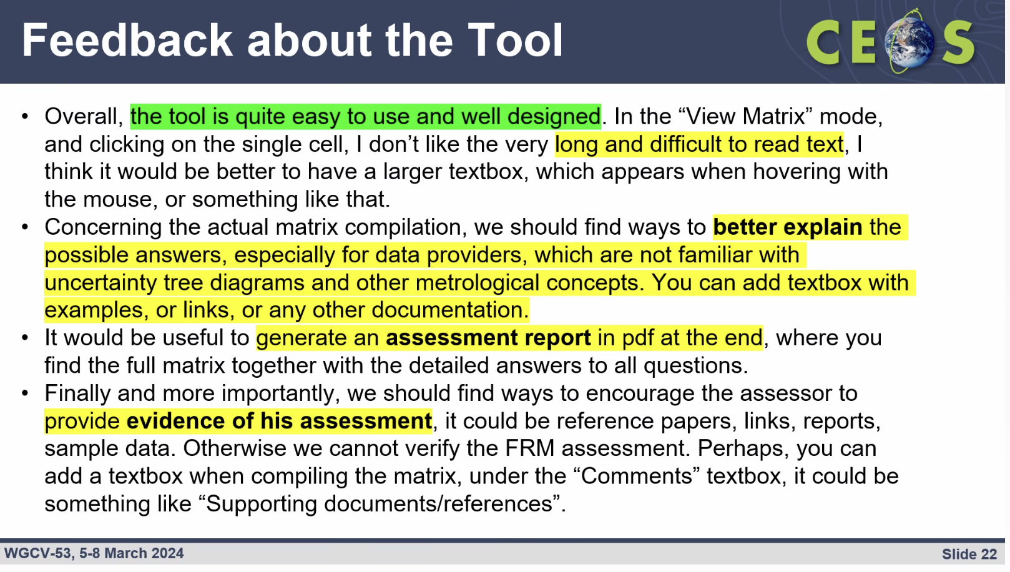
Discussion
- The ICOS team is committed to addressing the current deficiencies in their FRM assessment. There is a proactive and productive relationship between ESA and ICOS on the FRM MM. The collaboration serves as a good example of the FRM Assessment Framework working to encourage changes and improvements to compliance.
- The words of the parameters should be refined to make it clear that the assessment is taking place against the intended purpose of the site, not against unrealistic expectations. For example, RadCalNet has never been intended for sub 3% radiometric gain sensors, and should not be assessed as such.
- One of the initial steps in the assessment process is to specify the purpose for which the FRM is being assessed. This statement serves as a reference point for evaluating adequacy throughout the assessment.
- Verification should be done by independent people from CEOS, not the person filling in the template. Going forward, the initial template will clarify that the first part is for self-assessment, followed by an independent review.
- This process is not suitable for the atmospheric domain due to the complexity and variability of atmospheric measurements. A different approach is necessary, considering factors such as product type, sensor, and viewing geometry.
- Regarding the point “FRM Classification A, B, C, D is by definition related to the Verification category. This may affect measurements that are of high maturity for most of the categories except for Verification see e.g.: ICOS, RadCalNet or FRM4DOAS examples.” – Nigel Fox (UKSA) clarified that this is how it should be. There is no purpose in classifying something as good or fit for purpose if it doesn't have the underlying metrology required to be an FRM.
- Paolo suggests that the subjectivity issue can be handled through a consultation process (iterative assessment) and also with clear documentation and attachments, to demonstrate work has been done.
- Jean-Christopher Lambert suggested the next version of the tool could include some educational materials and references.
WGCV-53-ACT-13 | Paolo and Nigel to make updates to the FRM Assessment Framework documentation to:  - Make clear that the assessment is relative to the intended purpose of the site.  - Remove subjectivity in parameters by incorporating clarifications present in the accompanying documentation, but which have to date been left out of the Matrix description.  - Clarify that verification should be undertaken by independent people from CEOS, not the person filling in the template (i.e., self-assessment followed by independent review).  - Make the Validation column a different colour.  - Consider inclusion of additional links to reference materials, mechanisms to allow assessors to provide feedback, etc.  Aim to have an updated Version 2.0 by the May timeframe. This will align well with the next NDACC Steering Committee meeting. | May 2024
WGCV-53-ACT-14 | Paolo, Nigel and Kuze-san, to work with Jean-Christopher Lambert on the issues with the FRM Assessment Framework specifically for the atmospheric domain.  Notes: May need some clarifications in the accompanying documentation regarding the situation / approach for Level 2 atmospheric data. | End April 2024
Synthetic Aperture Radar (SAR) Subgroup Report [Slides]
Presenter: Dirk Geudtner (ESA)
Main points:
- The 30th CEOS SAR WGCV Workshop took place at the German Aerospace Centre (DLR), Oberpfaffenhofen, Germany on 16-18 October 2023. There were 118 participants with 64 presentations over three days on cal/val activities from various space agencies, industry, research organisations and universities.
- SAR subgroup members presented updates at the workshop:
  - Cal/val methods are evolving in the operational phase to maintain or improve long-term system performance monitoring. The SAR community is expanding with new national missions and New Space missions. Standardised RFI information in product annotations is a focus.
  - NISAR, BIOMASS and ROSE-L missions reported on their on-ground characterisation activities and in-orbit cal/val preparations.
  - Various adaptive approaches were presented, aiming to enhance efficiency and flexibility in response to changing conditions in sensor (ex.: aging) and sensing environments (ex.: atmosphere, ionosphere).
  - Notable insights include Amazon rainforest time-of-day backscatter biases reported for X-band, updates on multi-band (X and L) precision transponders, and the need for better characterisation of natural sites for calibration improvements in L-band.
  - Four SAR-specific CEOS-ARD specifications have been published: Normalized Radar Backscatter, POLarimetric radar, Ocean Radar Backscatter, and Geocoded Single-Look Complex (NRB, POL, ORB, GSLC). The combined SAR CEOS-ARD Specification has been approved. There is a significant uptake and interest from space agencies and other data providers.
- Dirk has been appointed as the new chair of the SAR Subgroup, with Stephane Cote from CSA as the new Co-Chair. Bruce Chapman will continue leading the SARCalNet initiative.
- Some current challenges for SAR calibration and validation include cross-calibration between two SAR spacecraft of same SAR mission (e.g., Sentinel-1A/B/C) and between different SAR missions (e.g., Sentinel-1, RADARSAT-2, RADARSAT Constellation Mission), use of long data time-series with Persistent Scatterers (PS), synergistic combination of L- and C-band SAR imagery for Sea Ice and Iceberg monitoring, calibration of multi-channel SAR systems (e.g., SCORE, MAPS) for next-gen missions. Further challenges are summarised in the slides.
- The next SAR Subgroup meeting is planned to be hosted by the Space Applications Centre (SAC) at ISRO, Ahmedabad, India, in November 2024.
SARCalNet [Slides]
Presenter: Bruce Chapman (NASA/JPL)
- The www.sarcalnet.org website is now live, albeit password-protected, offering access to sample target sites, a document library featuring drafts of the SARCalNet Handbook, requirements documents covering artificial and natural targets, image calibration analysis, submission templates, and links to various resources including software calibration tools and SAR data providers.
- SARCalNet was highlighted at IGARSS 2023 during discussions on "Opportunities for coordination of Cal/Val, data fusion and data assimilation for international spaceborne SAR missions." Additionally, updates and discussion topics regarding SARCalNet were addressed at the CEOS WGCV SAR subgroup meeting in 2023.
- The initiative will be presented at EUSAR 2024 under the theme "The CEOS SAR Calibration Network – SARCalNet."
- The next steps for SARCalNet include refining the website design by June 2024, finalising drafts and reviewing additional documents by September 2024, establishing a committee to review submissions following a process similar to CEOS-ARD (by October 2024), and beginning natural target selection and monitoring in January 2025.
- Future enhancements include expanding the software tools library to provide enhanced capabilities and facilitating access to public repositories of SAR calibration imagery by hosting or linking to them on the platform.
Discussion
- It was noted that people will be asked to register an account for SARCalNet in order to collect a list of users, analytics, etc. but for now, SARCalNet is restricted as it is under development. It is not anticipated to have a presence at IGARSS 2024.
- Philippe Goryl (WGCV Chair, ESA) commended the effort on the development of SARCalNet.
- Philippe noted SWOT and SAR altimetry. There is currently no representation of altimetry in WGCV. Is that something that we need to consider? It might be a good addition to the SAR subgroup.
- Dave Borges (SEO, NASA) noted the potential application of CAL for SARCalNet and for X and L band interoperability studies.
WGCV-53-ACT-15 | WGCV Chair and SAR Subgroup Chair to explore whether altimetry might be a good addition to representation of the SAR subgroup (or WGCV generally). | June 2024
WGCV-53-ACT-16 | Dave Borges (CEOS SEO) to follow up with SAR subgroup lead regarding potential support of the CEOS Analytics Lab to SARCALNET (e.g., for X/L band interoperability studies). | June 2024
WGCV Response to Cal/Val Related GCOS IP 2022 Actions [Slides]
Presenter: Philippe Goryl (WGCV Chair, ESA)
Main points:
- Philippe wants to ensure that WGCV is contributing to the CEOS-CGMS space agency response to the GCOS IP where possible.
- The 2022 GCOS Implementation Plan aims to identify the major practical actions that should be undertaken in the next 5-10 years. It identifies six major themes that should be addressed. Within each theme, several actions are identified.
- The GCOS IP space agency supplement only lists those actions within each theme that are targeted at the space agencies. Within each action, the specific activities for the Space agencies are highlighted in bold.
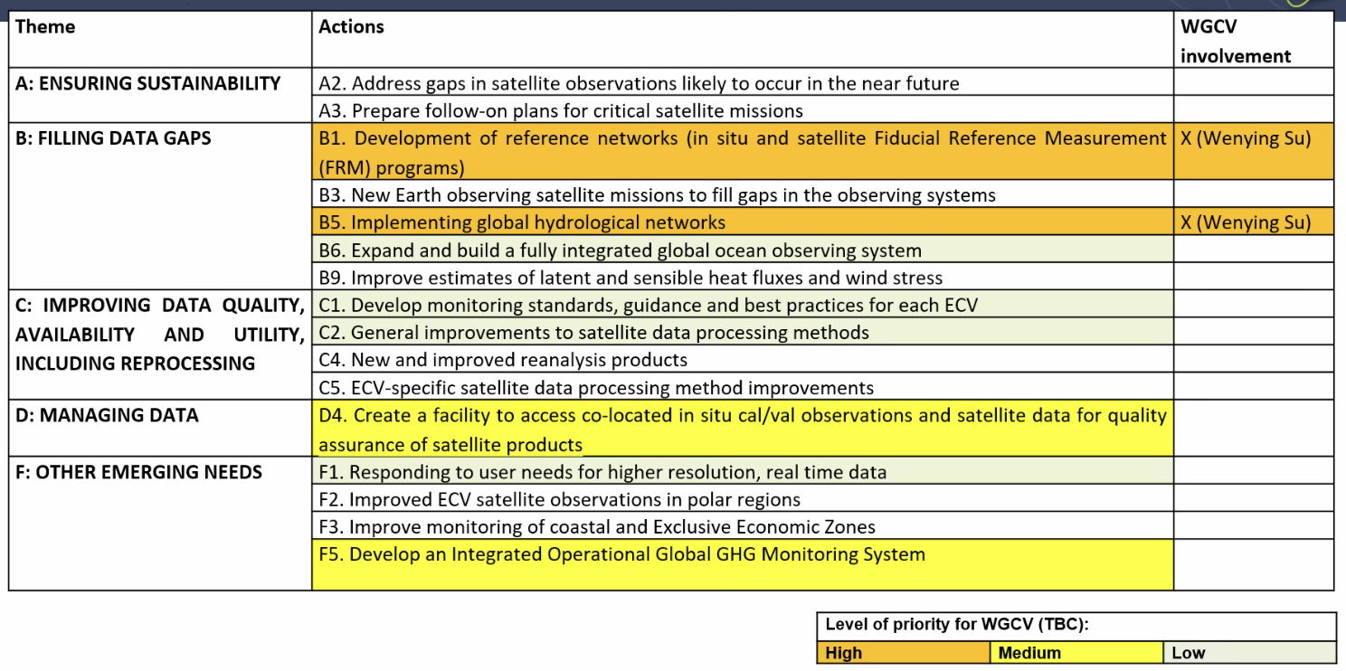
- Proposed WGCV activities for B1 include better alignment of the satellite FRM program.
- Proposed activities for B5 include improving the collection of hydrological observations. ESA St3TART and Australian/CSIRO AquaWatch programs could also be identified as contributions.
Discussion
- Coordination and collation of these resources at the WGCV level is currently lacking.
- Albrecht von Bargen (DLR) suggested focusing on identifying potential contributions and longer-term actions instead of addressing everything immediately.
- Albrecht suggested that the WGCV Chair attend the WGClimate meeting at the end of March 2024 to ensure WGCV activities are integrated into the overall response effectively. Albrecht suggested that GCOS representatives need to be present as well.
- Albrecht will ensure that Philippe is invited to the WGClimate meeting at the end of March 2024.
- Philippe Goryl (WGCV Chair, ESA) noted that many things are already underway but haven’t been communicated properly. Better communication is needed and for this, Philippe proposed to summarise the WGCV related efforts in the cal/val portal. After identifying ongoing efforts, the next step is to identify gaps and put in more effort.
- There are three key aspects: seeing how we can contribute, better communicating efforts, and identifying and filling gaps.
Summary: Responses to GCOS IP Action Items from WGCV-53 Meeting
B1.3 Better align the satellite FRM program to the reference tier of tiered networks and enhance/expand FRM to fill gaps in satellite cal/val
- WGCV recognises the importance of aligning FRM efforts with initiatives such as the Global Space-based Reference Network (GSRN) and will explore opportunities for greater consistency and collaboration.
- WGCV acknowledges the suggestion put forward by Albrecht von Bargen to establish coordination between the WGCV Chair and GSRN Task Team Chair, Tilman Holfelder (DWD), to discuss the alignment of CEOS and GSRN FRM efforts.
- WGCV can clarify the underpinning requirements that WGCV have in the CEOS FRM Assessment Framework and make sure that there are similar requirements in terms of performance and quality for the GSRN in situ network. It's important to note that WGCV has a specific focus on satellite FRM. There is a need to ensure that the underlying metrics of the requirements are common and to explore the possibility of aligning the FRM efforts of CEOS and GSRN for greater consistency.
B1.5 Establish a long-term space-based reference calibration system to enhance the quality and traceability of earth observations.
- This is precisely SITSats. WGCV has established the SITSat Task Team to coordinate matters related to these types of missions.
- As of mid-2023, the Climate Absolute Radiance and Refractivity Observatory (CLARREO) Pathfinder (CPF) mission is in the midst of rigorous instrument integration and test activities to verify its ability to meet the 0.3% (1-sigma) reflectance radiometric uncertainty requirement. It is expected to be launch-ready in mid 2024; however, the launch is delayed to potentially late 2025 due to limited ISS occupancy availability and a limitation of launches to ISS with compatible launch vehicles. Although just one year of operations is included in the scope of the mission, negotiations are ongoing to extend its scheduled occupancy and operations on ISS at least through the end of the current ISS schedule (approximately 2030). Mission extension for any NASA mission is subject to the senior review process, and this would include CPF’s potential extension in mission operations. PREFIRE will measure emissivity from 0 to 54 µm in 64 channels to better understand polar far-IR radiation budget with a planned lifetime of 6 months. ESA is planning to launch FORUM in early 2027 to measure spectral far-IR radiation. The TRUTHS mission is working to refine the design specifications needed to meet its science requirements, including a 0.3% (2-sigma) radiometric uncertainty, and is expected to launch in the early 2030s, with a nominal lifetime expected to be at least seven years. Overlap between the CPF and TRUTHS missions would be ideal to provide a rigorous independent verification of these two visible/near-infrared climate observing spectrometers, each with unprecedented accuracy. The Chinese Space-based Radiometric Benchmark (CSRB) project has been under development since 2014 and plans to launch LIBRA around 2025. LIBRA will offer measurements with SI traceability for the outgoing radiation from the Earth and the incoming radiation from the Sun with high spectral resolution.
B5.1b Increase the number of in situ river level observations that are exchanged internationally and can be used to calibrate satellite observations of water levels
- ESA St3TART and Australian/CSIRO AquaWatch programs could also be identified as good contributions.
- Cody Anderson (WGCV Vice-Chair, USGS) noted USGS has a long history of water gauges. USGS Stream Gauge website: https://waterdata.usgs.gov/nwis/rt
- Matt Garthwaite (CSIRO) noted the AusCalVal GNSS project for inland water that could also be applicable. This is the Googong platform floated in January 2024. First instrument (Kurloo GNSS) installed 1 Feb 2024.
D4. Create a facility to access co-located in situ cal/val observations and satellite data for quality assurance of satellite products
- WGCV are progressing the idea of a ‘match up’ database for commercial / new space
- WGCV have initiated the drafting of a dedicated page for the Cal/Val Portal to consolidate WGCV's contributions to climate/GCOS IP.
F5. Develop an Integrated Operational Global GHG Monitoring SystemD
- It was noted that this is broader than CEOS. The focus is on the WMO G3W.
- CEOS and CGMS have been working towards establishing an integrated operational global GHG monitoring system. The current monitoring system includes OCO-2/3, GOSAT-1/-2, and Sentinel-5 Precursor/TROPOMI already provides good coverage. The near-future system is expected to provide near-real time global coverage by the end of 2026 with the launch of CO2M Mission, Sentinel-5, and GOSAT-GW to provide operational GHG monitoring and services.
WGCV-53-ACT-17 | Albrecht von Bargen to ensure that the WGCV Chair/Vice Chair are invited to the WGClimate meeting at the end of March to discuss WGCV inputs to the Space Agency Response to the GCOS Implementation Plan. | March 2024
WGCV-53-ACT-18 | Paolo Castracane to draft a page for the Cal/Val Portal where WGCV’s contributions to climate / GCOS IP can be collated. | May 2024
WGCV-53-ACT-19 | Albrecht von Bargen to make a connection between the WGCV Chair and GSRN Task Team Chair, Tilman Holfelder (DWD), to discuss coordination of the CEOS and GSRN FRM efforts. | June 2024
WGCV-53-ACT-20 | WGCV Secretariat to set up a teleconference between the WGCV Chair and WGClimate leadership (Jeff Privette, Wenying Su) and Albrecht von Bargen to discuss an initial WGCV response to the GCOS IP. | April 2024

Space Agency Reports
CONAE [Slides]
Presenter: Marc Thibeault (CONAE)
- The CONAE System Engineering Calibration Facility (SECF) monitors and ensures L0, L1, and specific cal/val and SAR health products. It generates weekly and monthly reports.
- Network of corner reflectors across Argentina. Support ASI with calibration of COSMO-SkyMed. These will be contributed to SARCalNet.
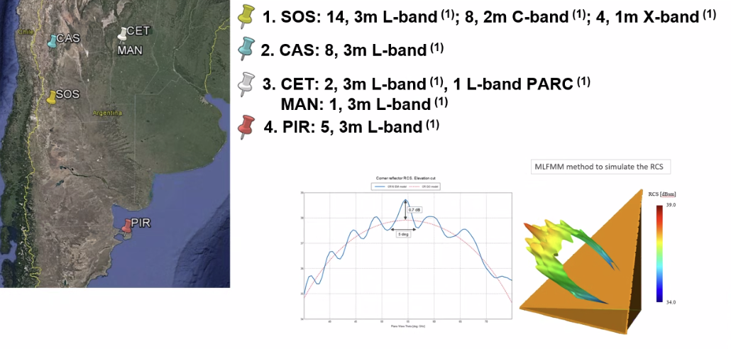
- Using Amazon and Congo rainforests as natural distributed targets.
- CONAE is also conducting higher level product validation. E.g., using SMAP to cross-calibrate SAOCOM soil moisture products. Noted ‘sunflower’ campaigns and also a comparison of ascending and descending passes on the same day to compare soil moisture retrievals and the impact of different characteristics of these passes.
- Pre-launch characterisation and calibration of cameras for the SABIA-Mar mission are ongoing, along with simulations of L2 products. Post-launch campaigns will involve standard procedures such as onboard calibration, geolocation validation (using dams and coastlines), and vicarious calibration.
- Collaboration with CVST and JAXA for cross-calibration efforts is ongoing, including joint acquisitions with SAOCOM and ALOS-2 over the aforementioned rainforest sites. Plans for ALOS-4 are also being developed.
- Measurement protocols for SAOCOM soil moisture derived from SMAP are being developed. CONAE is working with NASA on various campaigns and cross-calibrations with SMAP.
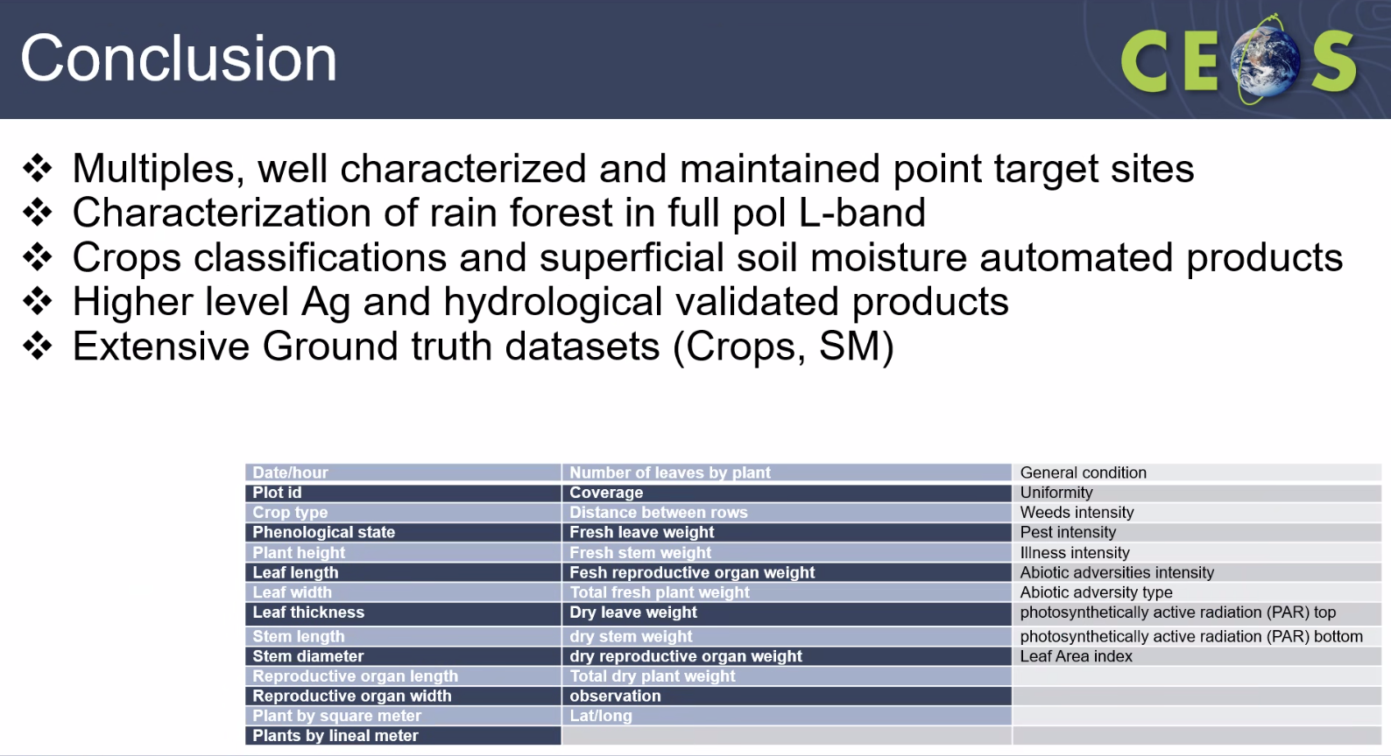
Discussion
- It was noted that CONAE frequently uses the Australian Queensland Corner Reflector Array, and since last year, they have been using these larger reflectors due to biases found in their own sites. The QCRA has been critical, providing an alternative resource for CONAE and supports their operations.
JAXA [Slides]
Presenter: Akihiko Kuze (JAXA)
- JAXA missions overview was presented:
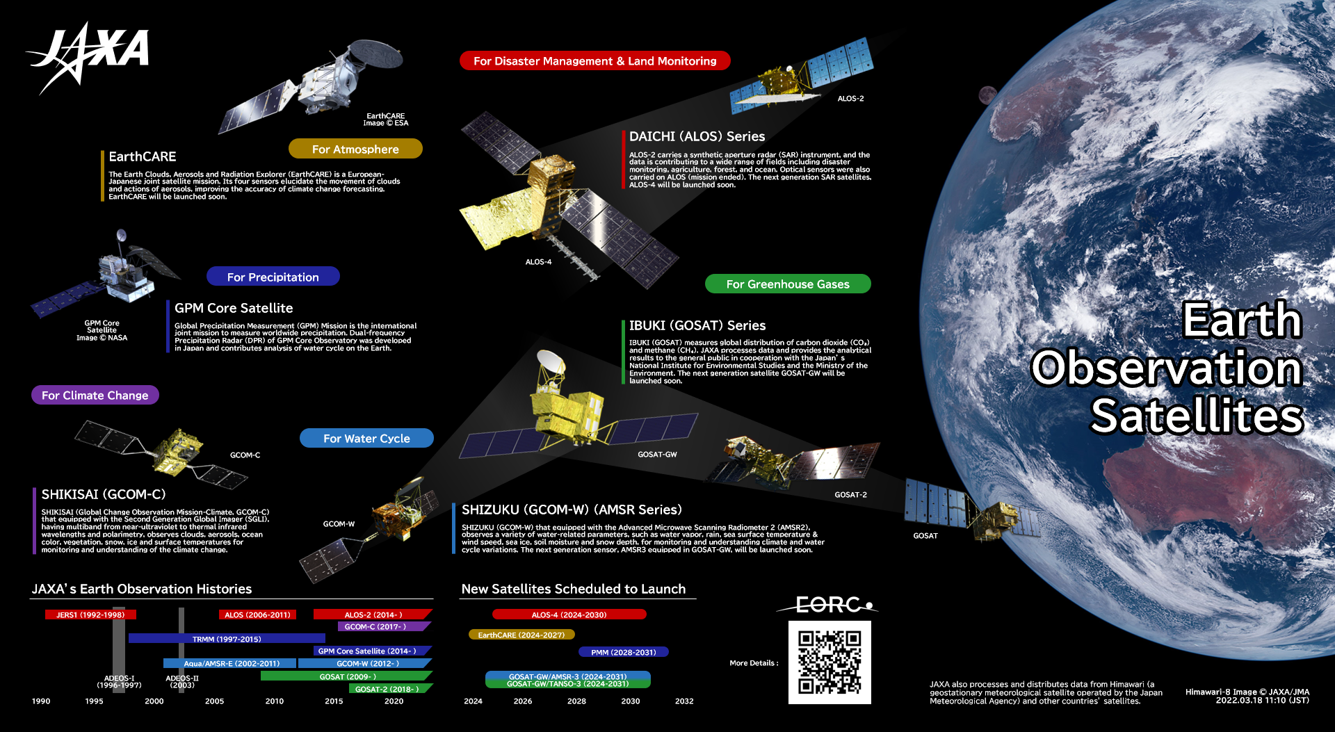
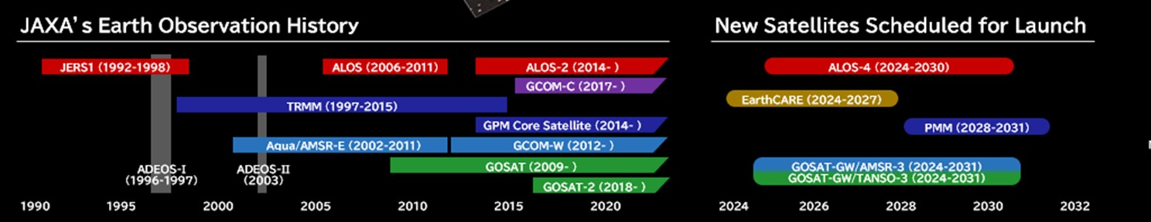
- JAXA launched the second H3 Launch Vehicle (H3TF2) at 9:22:55 (JST) on 17 February 2024 from the Tanegashima Space Centre.
- In March 2023, the ALOS-3 (Optical) satellite was lost due to the failure of the H3 Test Flight #1 (TF1) rocket. On February 17, 2024, the H3 TF2 rocket was successfully launched. In May 2024, the EarthCARE satellite was launched by SpaceX Falcon 9, with JAXA providing the Cloud Profiling Radar (CPR).
- In 2024, the GOSAT-GW satellite equipped with GHG spectrometers and a microwave radiometer will be launched in H-IIA. ALOS-4 (SAR) satellite is also scheduled to be launched in H-3 F3 in 2024.
- ALOS-4 is a successor of the SAR mission of ALOS and ALOS-2. ALOS-4 will be equipped with the phased array type L-band synthetic aperture radar (PALSAR-3). The observation swath of ALOS-4 will be drastically increased from 50 km (ALOS-2) to 200 km while maintaining its high resolution.
- Initial operation plan for ALOS-4: 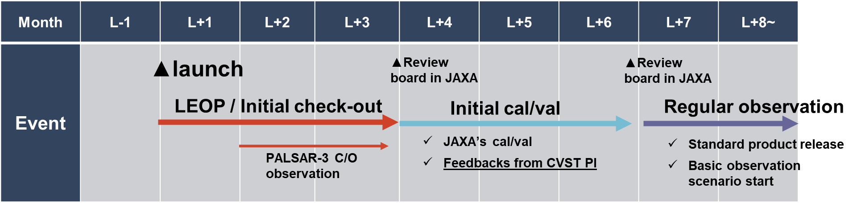
CSIRO [Slides]
Presenter: Matt Garthwaite (CSIRO, AusCalVal Lead)
- The CSIRO AusCalVal program was introduced at WGCV-52. Initially part of the Australian National Space Mission for Earth Observation (NSMEO). Included federal government investment to sustain Australian cal/val infrastructure and establish new cal/val capabilities. Federal government announced NSMEO cancellation on 28 June 2023. CSIRO Space and Astronomy is currently exploring the possibility of continuing with an “AusCalVal facility” and refining the scope of such a facility.
- As part of a search for new calibration sites, CSIRO completed an Australia-wide Landsat-8 analysis. The study leveraged 10 years of USGS Landsat-8 collection 2 level 2 SR products. The results align with previous Landsat 5 analysis. The code and workflow are open and re-usable globally on CSIRO’s EASI hub. There were challenges with the standard cloud layer (from USGS and DEA), validating the need for activities such as CMIX.
- An update on Darkwater Inland Observatory was provided. The Googong platform was floated in January 2024, and the first instrument (Kurloo GNSS) was installed on 1st February 2024. Further instrumentation is scheduled to be installed in March 2024, including TriOS Ramses Ed, Lsky, and Lw on a pan/tilt unit, weather station, horizontal and forward-looking cameras, water temperature sensors at three depths (0/4/8 m) along with a thermistor chain, two heitronics thermal radiometers, autonomous power and communications. A pilot FRM maturity matrix assessment has been conducted for this site.
- Ian Lau and Cindy Ong from CSIRO have joined the TIRCalNet study team. Working with NASA JPL on the deployment of a TIR radiometer at Pinnacles with the current schedule planning deployment in April 2024. Preliminary ground TIR characterisation was conducted and results indicate that the ground spectral characteristics align with ECOSTRESS.
- For the RadCalNet site, CSIRO performed a swap of the CIMEL instrument. The instrument is currently in rest/sleep mode to work on a few glitches related to the cable entanglement and mechanical issues related to the mast. CSIRO is working with CNES on some technical issues with data processing ahead of submission to RadCalNet.
- Other Pinnacles activities include recent campaigns for EnMAP, DESIS and PRISMA inter-comparisons to understand the disparity between the sensors. Similar inter-comparisons may be conducted at Calperum (SRIX4Veg-II location) if time permits.
- CSIRO has been working with the Australian Antarctic Division (AAD) to deploy a temporary corner reflector at Casey station in Antarctica. The immediate goal is to help support NISAR calibration after launch. The future aspiration is to install permanent large targets at all AAD bases including Mawson, Casey, and Davis in continental Antarctica, and Macquarie Island.
- In support of ESA, CSIRO is discussing the addition of a Pandora spectrometer at Darwin with University of Wollongong and Bureau of Meteorology. This would be co-located with the TCCON instrumentation at Darwin. This would be the third Pandora site in Australia after Alice Springs (GA) and Broadmeadows (Melbourne; BoM).
- Officially launched in 2023, AquaWatch's portfolio has grown to include 15 pilot projects in a variety of international locations. In-situ observations at AquaWatch pilot locations typically include both above-water radiometry and in-water optics. Key features of these observations include autonomous sensor measurement at 10-15 minute intervals, real-time data telemetry via the mobile network, a live dashboard for monitoring system status and various water quality parameters, with a remotely programmable system for efficient power management.
- Lucinda was shown, along with Cimel / SeaPRISM radiometer that is integrated into the Aeronet-OC network. Showed results of study into platform shading effects. Conclusion is that any platform perturbations are negligible below 2%, which provides further assurance of the high quality of these radiometric observations at Lucinda.
- Recalled results of IMOS Radiometry Task Team activity comparing laboratory and field inter-comparison for a range of radiometer systems. One key finding was that sensor temperature has an influence on the magnitude of spectral calibration coefficients. To compensate for that, temperature corrections have now been routinely implemented for our ship-borne underway radiometric observations with the DALEC instrument. See slides for details.
- Showed details of Australian instrumentation to support cal/val of ocean surface waves and wind measurements. For waves, large gaps exist in the Southern coast, Northern WA and the top end. Australian offshore wind measurements are scarce, so satellite observations are particularly critical.
- Noted TERN’s work on CMRSET – CSIRO MODIS Reflectance based Scaling EvapoTranspiration, which is an algorithm that blends Landsat, MODIS and VIIRS to achieve monthly, 30 m resolution, continuous (no gaps due to clouds) actual EvapoTranspiration (AET) across continental Australia.
- More details can be viewed from the linked slides.
Discussion
- Matt Garthwaite noted that the process used for the Landsat Continental Analysis could be deployed to the CEOS Analytics Lab if it were helpful for others to use for similar studies.
Day 2 Close
Philippe Goryl (WGCV Chair, ESA) thanked everyone for joining and closed Day 2 of the WGCV-53 meeting.

