Minutes
WGCV-53 Day #3
Thursday, 7 March 2024

Participants (* Virtual Participants)
ASI Antonio Montuori*
BIRA-IASB Jean-Christopher Lambert
CONAE Ana Medico, Angel Matias Palomeque, Laura Frulla, Marc Thibeault
CSA Lucie Viciano*, Yves Crevier*
CSIRO Cindy Ong*, Ian Lau*, Matt Garthwaite
CSIRO Chile Jonathan Hodge*
Servicio Aerofotogramétrico Carolina Barrientos*
DLR Albrecht von Bargen*
ESA Dirk Geudtner, Marc Paganini*, Paolo Castracane, Philippe Goryl,
Valentina Boccia*
EC-JRC Peter Strobl*
GA Medhavy Thankappan
GISTDA Prayot Puangjaktha*
ISRO Santhisree
JAXA Akihiko Kuze
MYSA Adhwa Amir Tan*, Wayne Ng*
NASA Dave Borges (SEO), Eric Vermote, Gary Geller
(EETT), Kurt Thome*, Xiaoxiong (Jack) Xiong*
NASA-JPL Bruce Chapman*, John R. Worden (GHG TT)*
NCC-CAS Jian Xu
NOAA Larry Flynn*, Manik Bali*, Taeyoung Jason Choi*
NPL/UKSA Nigel Fox, Emma Woolliams*
USDA Michael Cosh*
USGS Cody Anderson, Tom Stone*
WGCV Sec Matt Steventon, Riza Singh*

Welcome and Review of Actions
Presenter: Philippe Goryl (WGCV Chair, ESA)
Main points:
- Philippe Goryl (WGCV Chair, ESA) welcomed everyone to Day 3 of the WGCV-53 meeting.
- Matt Steventon (WGCV Secretariat) reviewed the decisions and actions from Day 2.
- For Decision 02, it was suggested to note an action for Cody and Nigel to draft a one-page document to summarise the proposed endorsement (ref: Decision 02) regarding a subset of test sites as a minimal set to request relevant satellite operators (particularly New Space) to make regular acquisitions and provide data (imagery and radiometry) to CEOS WGCV as a means of evidencing their capability consistently.
WGCV-53-ACT-21 | Cody Anderson and Nigel Fox to summarise the proposed endorsement (ref: Decision 02) regarding a subset of test-sites as a minimal set to request relevant satellite operators (particularly New Space) to make regular acquisitions and provide data (imagery and radiometry) to CEOS WGCV as a means of evidencing their capability in a consistent manner. That is, the match-up database. The communication will include details of the location where this data should be sent/stored. The proposal will be summarised in a short (1 page) proposal and circulated for review and endorsement via email (e.g., one week turnaround for comments). | June 2024

SRIX4Veg [Slides]
Presenter: Valentina Boccia (ESA)
SRIX4Veg-I
Main points:
- Speaking on behalf of the entire SRIX4Veg-I team, cooperating agencies and partners.
- The idea for SRIX4Veg-I came after understanding the need to upgrade to a new Surface Reflectance (SR) measurement instrument. UAVs mounted instruments are lighter, cheaper and more effective. There is a growing demand for UAV measurements from different communities.
- SRIX4Veg aimed to assess the variability among different teams conducting the same validation work and establish agreed protocols.
- The team decided to conduct an intercomparison exercise. The first exercise involved SR validation data collected by participants following a pre-defined initial protocol. The second exercise involved SR validation data collected by participants using a protocol but with some predefined information.
- Results and outcomes of SRIX4Veg-I were presented, showing a reduction in the average median difference when all teams used the same protocol.
- A second workshop was held in 2023, following the intercomparison exercise conducted in summer 2022. Participants from various countries, including Australia and Canada, were involved, with many connecting remotely.
- Discussions during the workshop covered results, challenges, retrospective analysis, and the design of a draft protocol for UAVs. The aim was to draft the protocol collectively, with contributions from the international community that participated in the intercomparison exercise.
- It would be beneficial for the WGCV, particularly IVOS and LPV subgroups, to review the draft.
- The final version is scheduled for submission to CEOS in early September 2024.
- The protocol will be a living document. A draft protocol has been shared with Cindy to lay the groundwork for SRIX4Veg-II. A team is set to travel to Australia next week to participate in SRIX4Veg-II. Anticipate updating the protocol based on insights gained from SRIX4Veg-II.
SRIX4Veg-II [Slides]
Presenter: Cindy Ong (CSIRO)
Main points:
- SRIX4Veg-II serves as an extension of SRIX4Veg-I and is scheduled to take place in Calperum Station, Australia from 11-15 March 2024, hosted by TERN and CSIRO.
- Six teams are expected to participate: NPL/ESA, TERN, GA, DES, OSS/DCCEEW and MAITEC.
- Calperum Station also serves as the LPV supersite, characterised by the Mallee woodlands landscape.
- A pre-field work workshop was conducted in February 2024 to discuss site selection, ground measurement instruments, and the SRIX4Veg protocol.
- The target spaceborne sensors for imaging spectroscopy VNIR-SWIR at 30 m resolution include EnMAP, PRISMA, DESIS, CHIME, and SBG.
- Scheduling of the activities for SRIX4Veg-II has been completed, with a focus on targeting a sun elevation angle greater than 30 degrees. It is expected to be extremely hot on 11-15 March 2024, raising concerns about potential instrument performance issues. Contingency plans have been developed to address such challenges.
- A final preparation meeting was held on 7 March 2024 to identify potential challenges such as instrument delays and to make contingency plans for such issues.
- An opportunity has arisen to conduct a workshop at the Advanced EO Forum in September 2024, which is a biannual EO conference in Australia. SRIX4Veg was introduced a couple of years ago, and there is considerable interest among team members in participating in a follow-up post-intercomparison workshop at the EO forum.
Discussion
- Cindy Ong (CSIRO) noted that the Skycam data will be made available along with any corresponding satellite data.
- Nigel Fox (UKSA) encouraged addressing updates in the first version of the SRIX4Veg protocol to avoid publishing two versions in a short timeframe. Cindy Ong agreed, while noting that major differences may necessitate a second version, while minor changes could be included in Version 1.
- Philippe Goryl (WGCV Chair, ESA) noted that the MHR Camera, a new development by CIMEL, is a fish-eye camera with multispectral capabilities, with a prototype expected in 1-1.5 years. Updates on the MHR Camera will be provided at the next WGCV meeting.
Decision 03 | LPV and IVOS Chairs will coordinate a review of the SRIX4Veg Good Practice Protocol with feedback to be returned by June. Feedback will be used to update the document by September, ahead of the next IVOS meeting, where final changes will be reviewed ahead of submission of the document for endorsement at WGCV-54 in October.

WGCV-53-ACT-22 | Valentina Boccia to distribute the draft SRIX4Veg Good Practice Protocol for LPV and IVOS review. | End of April 2024
WGCV-53-ACT-23 | LPV and IVOS Chairs to coordinate a review of the SRIX4Veg Good Practice Protocol with their subgroups and provide feedback to Valentina Boccia so an update can be prepared for the September IVOS meeting and then a subsequent final version for endorsement at WGCV-54 (October). | June 2024
CEOS-ARD [Slides]
Presenter: Medhavy Thankappan
Main points:
CEOS-ARD
- CEOS-ARD aims to ease the use of satellite EO data to reach new non-expert users and increase data uptake and use.
- Reviewed latest updates, including the Combined SAR PFS and the RISAT-1A and NovaSAR assessments.
- Potential new PFS could be Precipitation, Sea Surface Temperature, Ocean Reflectance or Atmospheric Composition. Precipitation actively under investigation by P-VC.
- An ARD self-assessment User Guide was published in 2023 to support data providers with their self-assessments.
- CEOS-ARD Oversight Group (ARD-OG) was established in 2022, primarily to oversee the cross-domain uptake of the CEOS-ARD concept. CEOS-ARD Oversight Group Terms of Reference were endorsed at SIT-37. Ferran Gascon (ESA) is the ARD-OG lead.
- The ARD-OG engages with the OGC ARD Standards Working Group (SWG) to investigated formal standards built on the basis of CEOS-ARD.
- The 2024 CEOS-ARD Strategy document reflects on the progress to date, takes stock of future directions and needs and confirms the strategy for the next few years. The strategy activities are categorised into five broad themes:
  - CEOS-ARD Availability, Product Diversity, and Representation
  - Framework and Specification Advancement
  - Discovery, Access, Utilisation, and Interoperability
  - Community Engagement
  - Research, Test Cases, and Pilot Activities
- WGCV input on the draft CEOS-ARD Strategy is welcome.
Discussion
- It was noted that the upcoming potential specifications for Precipitation might require some new representation in the WGCV peer review team. While it is not an immediate consideration, it is flagged for future attention.
- There was a question about the PFS for Ocean Reflectance. It was noted that there are existing specifications for inland and coastal areas (Aquatic Reflectance PFS) and efforts are underway to expand this specifications to cover oceans – in collaboration with OCR-VC and IOCCG.
- Regarding the PFS update process, it was noted that SAR specifications are managed by Ake Rosenqvist (JAXA). The process relies on feedback from the community and is iterative. An example was provided regarding issues with Sentinel-3 data and the subsequent minor update of the Surface Reflectance specification.
Surface Reflectance Quality, Equivalency and Consistency [Doc]
Presenter: Medhavy Thankappan (GA)
Main points:
- Reference paper here.
- The CEOS-ARD SR-PFS provides a good starting point for interoperability of multi-sensor SR products, but leads to different processing approaches to derive SR products with differences.
- Proposal is to build on CEOS-ARD achievements and take next steps to deliver on CEOS-ARD multi-sensor interoperability objectives.
- Seeks to establish a set of inputs, corrections, associated parameters and tolerances for achieving SR equivalence in support of interoperability between CEOS-ARD SR products.
- There is a need for an agreed and unambiguous definition of SR in the context of CEOS-ARD cross-sensor interoperability, potential for WGCV to provide guidance.
Discussion
- Nigel Fox (UKSA) suggested defining Surface Reflectance and its purpose. He suggested addressing uncertainties associated with SR products for specific application cases.
- Philippe Goryl (WGCV Chair, ESA) suggested clarifying what users can expect from the product. Simply using BRDF and uncertainties will not make it clearer to the user.
- Philippe Goryl (WGCV Chair, ESA) asked whether a high level of interoperability was desired. He noted the need to use the same atmospheric corrected and data processing approaches to achieve harmonised datasets. Philippe suggested starting from L0, L1 data and then processing towards SR would be more suited to harmonisation efforts as opposed to beginning with CEOS-ARD. Eric Vermote (NASA) echoed Philippe’s suggestion.
- Nigel Fox (UKSA) noted the need for sensor interoperability, for example, if want to do something for climate, Fundamental Climate Data Records (FCDR) would not start from ARD, but rather from L0 and L1 data, harmonise those and then define SR, emphasising the importance of understanding the associated uncertainties.
- It was noted that the definition of SR is clear but the reporting of what is in the ARD products needs to be clarified. There is firstly, the need for an unambiguous definition of SR and secondly, the importance of clarifying the reporting criteria for ARD SR products.
- Cody Anderson (WGCV Vice-Chair, USGS) noted there is a mismatch between the intended users of CEOS-ARD and those of climate / other highly specific expert users. CEOS-ARD is targeting new users and expanding the user base. There is a need to delineate between scientific expert users and non-expert users.
- It was noted that WGISS would be the main forum for discussions needed to increase the interoperability of SR datasets. The WGCV and WGISS joint meeting will be a key opportunity.
- Landsat and Sentinel 2 are not providing per-pixel uncertainty at present so we cannot expect others, e.g., New Space, to do so.
- There was a suggestion that reporting what is done in the process for SR is important, rather than an unambiguous definition as currently written. Metadata should include information indicating what is being produced to avoid confusion and ensure consistency.
- It is important to clarify the meaning of the term ‘interoperability’. It was suggested that it means consistency in datasets to enable their use together.
- Philippe Goryl (WGCV Chair, ESA) suggested including the table which highlights the inclusion of BRDF, etc. in the CEOS-ARD table on ceos.org/ard to capture this information clearly. That is, capturing the information shown in the following table:
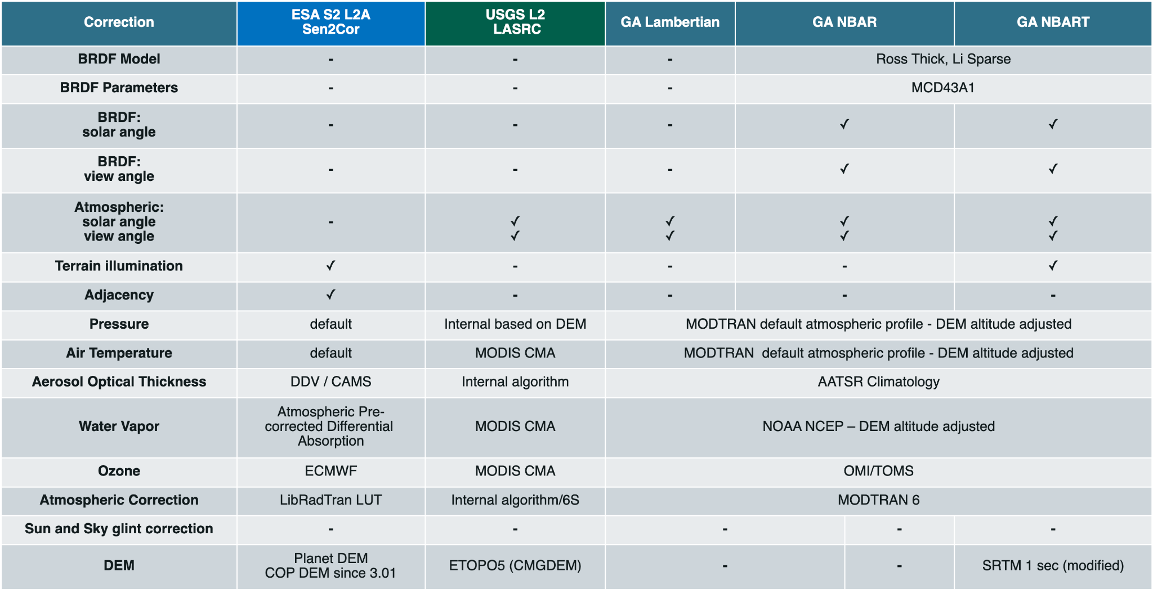
WGCV-53-ACT-24 | Medhavy to share table from SR equivalency paper with Matt Steventon for reflection on the CEOS-ARD table on ceos.org/ard to capture information about datasets (whether they include BRDF, etc.). Better capture what each dataset provides. | COMPLETE  Medhavy has shared the table. It will be implemented on the ceos.org/ard website soon.
CEOS Analytics Lab (CAL) [Slides]
Presenter: Dave Borges (SEO, NASA)
Main points:
- Previously known as the CEOS Earth Analytics Interoperability Lab (EAIL), the CEOS Analytics Lab (CAL) is a multiuser gateway for spatial data science made possible by the CEOS Systems Engineering Office and CSIRO. Every user is provided a customised JupyterLab environment to easily load EO data products and seamlessly scale to additional computational nodes through the Dask Gateway. More information can be found at: ceos.org/cal.
- CAL is driven by the partnership between SEO and CSIRO. CAL is an implementation of CSIRO’s Earth Analytics Science and Innovation (EASI) platform and combines several different open-source projects such as JupyterHub, Open Data Cube (ODC) and Dask (parallel and distributed computing library).
- Current datasets include Landsat (5-9) surface reflectance, Landsat (5-9) surface temperature, DEMs (Cop 30/90; nasadem), Sentinel-1 rtc, Sentinel-2 l2a and ALOS Palsar scansar.
- Dave expressed interest in incorporating other datasets as possible and noted recent offers from CONAE for the inclusion of SAOCOM data and ISRO for the inclusion of RISAT-1A and ResourceSat-2 data.
- CAL is not just a data repository but also provides a significant and powerful analytics layer on top of the data.
- Undertaking a New Space data interoperability project in response to the CEOS New Space Task Team’s recommendations:
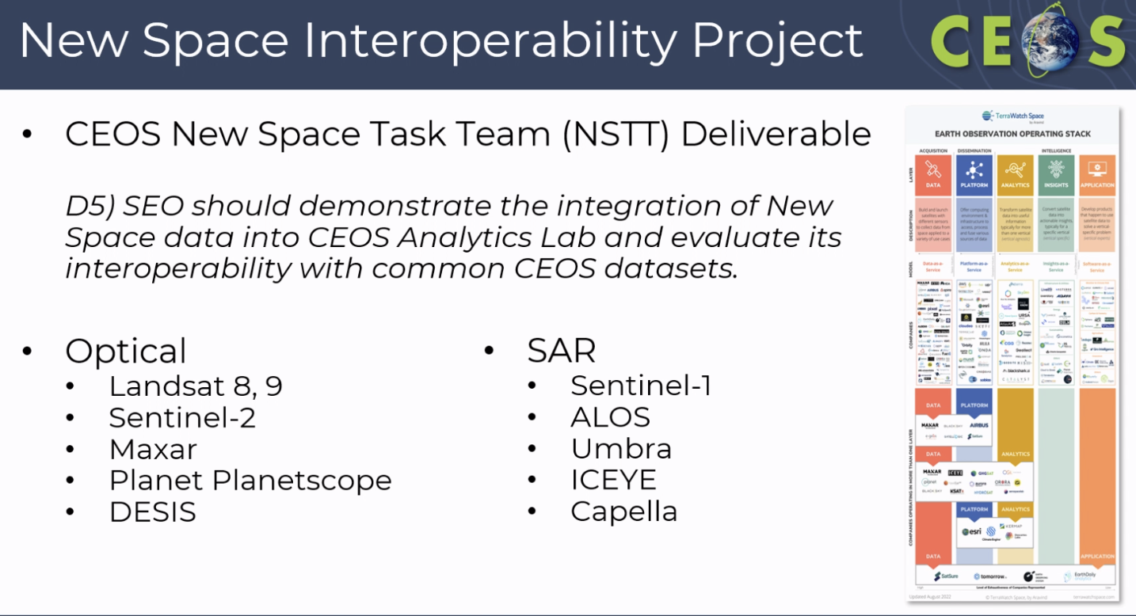
- Noted action from Day 1 of WGCV-53 for SEO to look at using CEOS Visualization Environment (COVE) for the SITSat effort. Welcomed other suggestions for applications of COVE.
- The SEO will represent CEOS at SatSummit 2024 in Washington, D.C., scheduled for 16-17 May 2024. CEOS SEO will also host a booth at IGARSS 2024 in Athens, Greece, taking place from 7 to 12 July 2024.
Discussion
- There was a discussion on the generalisation of the approach for intercomparison exercises as they are being conducted using different platforms. It was suggested that CAL could be promoted for intercomparison exercise activities.
- There was a discussion in WGCV-52 about using the OLIVE tool for LPV. It was a benchmark tool for FaPAR and LAI validation.
- CAL is a resource for the CEOS community. Please reach out to Dave if you need any support.
- There is no cost to CEOS members for using CAL.
- Sentinel-1 RTC data hosted in CAL are generated by ASF. CAL pulls Sentinel-1 data from ASF for specific areas on a per request basis.
- Dirk Geudtner (ESA) suggested adding RADARSAT Constellation Mission (RCM) to the list of datasets for the intercomparison activity. Dave Borges (SEO, NASA) noted SEO is already having discussions about including RADARSAT-2 data and expressed interest in looking into RCM data inclusion also.
- Philippe Goryl (WGCV Chair, ESA) suggested clarifying how data is accessed by CAL without duplicating archives or downloading data. It was suggested that understanding this process from the user’s perspective and linking CAL to existing archives would be beneficial.
- Dirk Geutdner (ESA) asked if the versions of acquisition planning for various missions are updated on the COVE visualisation tool. Dave Borges (SEO, NASA) confirmed the acquisition planner is actively updated from agency acquisition plans via API where available.
WGCV-53-ACT-25 | Marc Thibeault to share SAOCOM data provisioning information with Dave Borges for CEOS Analytics Lab. | May 2024
Pre-flight Calibration Workshop Update [Slides]
Presenter: Nigel Fox (NPL), Xiaoxiong (Jack) Xiong (NASA)
Main points:
- The workshop is scheduled for 19-22 November 2024 at ESTEC, Noordwijk, The Netherlands.
- A dedicated website for the workshop has been developed and shared. Link here: https://atpi.eventsair.com/pre-flight-calibration-workshop/
- The scope of the workshop includes all passive optical sensors, primarily solar reflective domain less than approximately 2500 nm. The final day will be dedicated to TIR.
- The target audiences are engineers, science PI’s, and to some extent managers/funders, across public/commercial and all instruments scales including ‘New Space’.
- The format will be to have topic themes with time for facilitated discussion per theme. There will be a call for poster and oral presentations in Spring 2024.
- The output of the workshop will be to develop a citable guidance document on good practices, within a year.
- The proposed timeline is as follows:
April 2024 | Abstract Submission Deadline
July 2024 | Notifications to Authors
September 2024 | Preliminary Programme
Mid-October 2024 | Registration Deadline
19 - 22 November 2024  December 2025 | Workshop  Publication of proceedings and good practices
- Reviewed the roles of the organising committee and scientific committee.
- Reviewed the workshop strawman. The details can be found in the linked slides.
Discussion
- There was an acknowledged need for transparency to facilitate effective discussions at the workshop, with the hope that funding agencies could support this initiative.
- Nigel asked Cody Anderson (WGCV Vice Chair, USGS) to share details of the Pre-flight calibration workshop with JACIE and GSICS communities.
- Albrecht von Bargen (DLR) suggested changing ‘to some extent manager/funders’ to include ‘space agencies’ to avoid limiting participation.
- Albrecht suggested collaborating with Dirk Geutdner (ESA) to ensure that the outcomes of a similar workshop on the SAR side are captured consistently with the output of this workshop.
- The desired outcome of the workshop includes the publication or creation of a reference book. It was suggested to work with the CEOS Communications team to produce a branded report jointly with GSICS.
- Dirk noted that on the SAR side, calibration is mostly based on internal closed systems, which are considered sensitive information. He expressed uncertainty about whether these details could be shared and of interest to the user community.
- The main objective is not necessarily to provide fine details of results for every activity, but rather to define methodologies and approaches that can be universally adopted to obtain the best information. For example, determining the best methods and minimum requirements for specific types of sensors, such as for stray light. The aim is to share this information within the community to improve value and to guide New Space on what is needed for their data to be usable.
- Transparency is essential because trust in the methodology is crucial to allow trust in the data. In most cases, there is no real commercial sensitivity, and there should be encouragement to share information among the community.
GSICS Collaboration Update [Slides]
Presenter: Paolo Castracane (ESA), Manik Bali (NOAA / GSICS)
Main points:
- Areas of cooperation include WGCV and GSICS sharing methods and protocols on vicarious calibration, SITSat, joint organisation of the Pre-Flight Workshop Calibration/Characterisation, and New Space topics and Maturity Matrix approaches – noting examples of EDAP and CEOS FRM.
- GSICS Newsletter was edited by the GSICS Coordination Center and is shared by CEOS WGCV in the cal/val portal. GSICS Notebooks and Notebooks in the CoMET Toolkit are shared by ESA. Joint articles on Notebooks were published by Manik Bali (Vice Chair GDWG) and Paolo Castracane (ESA) in GSICS Quarterly Newsletter V16 No 4.
- Paolo Castracane (ESA) presented the GSICS Overpass Tool at the GSICS Data Working Group web meeting.
- Larry Flynn and Manik Bali from GSICS are also members of the SITSat Task Team. GSICS initiated a discussion on Data Standardisation of SITSat data at the ITOVS meeting in Tromso, Norway 2023.
- GSICS is seeking guidance from WGCV on the following activities:
  - GSICS has a Lunar Subgroup. How can we leverage this opportunity to open new channels of interaction with CEOS WGCV? (e.g. SITSat)
  - GSICS also has a new Space Weather Subgroup. Can CEOS benefit in any way?
  - Can CEOS help in public access to Commercial and New Space mission data (L1 and beyond)?
- The GSICS 2024 annual meeting will be held 11-15 March 2024 in Darmstadt, Germany. More details are available here.
- Larry Flynn (NOAA) provided an update on the GSICS UV/Vis/NIR Spectrometer Subgroup:
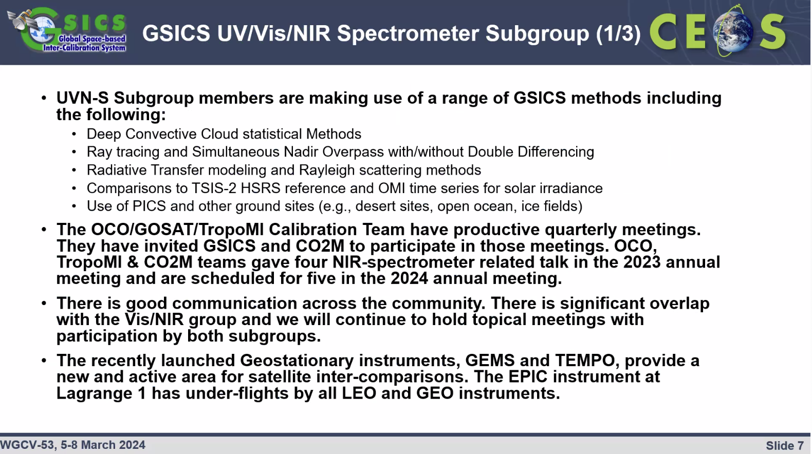
- The OCO/GOSAT/Tropomi Calibration Team has productive quarterly meetings. They have invited GSICS and CO2M to participate in those meetings. OCO, Tropomi and CO2M teams gave four NIR-spectrometer related talks in the 2023 annual meeting.
- There is good communication across the community. There is significant overlap with the Vis/NIR group and we will continue to hold topical meetings with participation by both subgroups.
Discussion
- Philippe Goryl (WGCV Chair, ESA) noted that while CEOS cannot help in public access to commercial and New Space mission data (L1 and beyond), agency programs like CSDA, TPM, etc. can assist in this regard. CEOS can however facilitate sharing of information and connection via workshops like JACIE, ARD2x, VH-RODA, etc.
- There has been a considerable discussion within CEOS regarding New Space. Philippe noted the Spire mission as an example where data is being utilised operationally, suggesting potential collaboration opportunities with GSICS.
- Philippe noted that there is no overlap between CEOS WGCV and the space weather subgroup under GSICS, with GSICS playing a more significant role in space weather than WGCV.
- Nigel Fox (UKSA) noted that GSICS collaboration with IVOS already exists and he hopes to strengthen the collaboration further by engaging directly with the lunar subgroup. The lead of the lunar subgroup is already active in IVOS and efforts are underway to expand this collaboration to cover the SITSat context as well.
- Tom Stone (USGS) noted that the lunar component is not very strong in CEOS IVOS. Tom will reduce his involvement with the subgroup in a couple of years. It would be beneficial to strengthen the ties in this area, particularly by making measurements of the moon part of the FRM.
- Nigel agreed and noted the need to assess how we can get the transparency and visibility of the FRM process for the other models and coordinate those models into a single viewpoint.
- Larry Flynn (NOAA) noted that he will be in discussion with Jean-Christopher Lambert regarding the possibility of implementing similar initiatives for trace gas retrieval algorithms as was done for ozone profile retrievals. He recommended starting with NO₂ and noted he will present the outline at the GSICS meeting and further discuss with the WGCV Atmospheric Composition Subgroup.
- GSICS Overpass Tool link: https://evdc.esa.int/orbit/
Greenhouse Gas Cal/Val and Network Updates
Presenter: Akihiko Kuze (JAXA), Jean-Christopher Lambert (BIRA-IASB), John Worden (NASA/JPL)
GHG Task Team (Joint Campaign and Match-up Datasets) [Slides]
Presenter: Akihiko Kuze (JAXA)
Main points:
- A joint Cal/Val Campaign meeting for OCO-TROPOMI-TEMPO-GOSAT was held on 19 January 2024. The meeting discussed 2023 campaign results, uncertainty in vicarious calibration, and solar and lunar calibration high spectral resolution data sets.
- For solar and lunar calibration products the TSIS team is interested in long-term and high spectral resolution data from solar calibration by GHG spectrometers.
- The 16th joint Vicarious Calibration Campaign is scheduled for 12-17 June 2024. OCO-3 is expected to be operating, after removal from storage and initial checks.
- SNO match-up dataset: Collaborating with SSEC, University of Wisconsin. GOSAT, GOSAT-2 AIRS will be replaced by NOAA-20, NOAA-21 CrIS, IASI. The long-term (5 year) plan includes GOSAT-2 IASI SNO.
- The GHG match-up database (off-nadir), essential for 2-orthogonal simultaneous off-nadir overpass (2O-SONO) needs, illustrates how GOSAT and GOSAT-2's 2-axis pointing capability enhances targeting of greenhouse gas emission points, like megacities, whereas thermal infrared (TIR) requires frequent calibration, though only with 1-axis rotation, demonstrating the contrast between absolute temperature (AT) and cross-track (CT) cross-calibration.
- Multiple sensors observe the RRV calibration site from various geometries, with surface reflectance, bidirectional reflectance distribution function (BRDF), and emissivity data being accessible. Employing a double difference approach will minimise bias resulting from divergent geometries.
- Long-term and high spectral resolution data will be available from the GHG calibration site, and integrated into the match-up database.
Greenhouse Gas Cal/Val Networks, Resources Catalogue and IMEO WG [Slides]
Presenter: Jean-Christopher Lambert (BIRA-IASB)
Main points:
- GHG Constellation Roadmap v2.3 – Annex C: Implementation actions include the Calibration and Validation of GHG networks. This include: CV-2: Identify the current shortcomings/gaps/sustainability in GHG calibration and validation capabilities, and formulate recommendations on the medium- to long-term way forward, that is with a specific focus on GHG Fiducial Reference Measurement (FRM) and CV-5: Identify gaps and suggest improvements in ground-based and airborne validation infrastructure (i.e. geographical / geophysical gaps for FRM) and other long-term validation needs (at horizon 2025-on)
- Reviewed the recommendations for GHG Cal/Val Networks sustainability that were presented at CEOS SIT TW 2023 and which have now been added to Annex C of the CEOS GHG Roadmap.
- A session on GHG Cal/Val was organised at the joint AC-VC-19 and ACSG meeting in Brussels in October 2023. More information can be viewed here.
- At the WGCV-52 meeting, a suggestion was made to consider developing a guidance document on cal/val resources for GHG, similar to the hyperspectral guidance document. Relevant discussions took place at the AC-VC/ACSG joint meeting, highlighting that while existing validation resources are outlined in CEOS white papers on GHG constellation Architecture (2018) and Roadmap (2020), they are not the primary focus. It was acknowledged that there is a need for a new resource. It was emphasised that the scope and objectives of this document need to be clarified. The primary focus of this document would be on global GHG mappers initially, as validation of point-source emissions data is not yet mature, as indicated by needs identified in the IMEO Cal/Val Testing Working Group.
- It was suggested to coordinate the development of the cal/val resources catalogue with the update of the GHG Constellation Roadmap Annex C, which will be further discussed in the next 3.7 report by John Worden. Furthermore, it was proposed to coordinate this effort with the elaboration of the supersites concept outlined in the ACSG report.
- The purpose of the UNEP/IMEO Cal/Val Testing Working Group is to define testing methodologies and metrics for different patterns of emissions and scales with the intent of providing an understanding of data product quality and uncertainties. More details can be viewed in the slides.
Discussion
- Philippe Goryl (WGCV Chair, ESA) asked about the coordination mechanism among the various IMEO working groups. He also asked to clarify the actionees for the cal/val networks recommendation, particularly the action regarding a central processing facility.
- Jean-Christopher noted there is ad hoc participation in the Working Groups and activity has been low since the initial workshop. There is no concrete coordination except via the CEOS GHG Task Team.
- Regarding the central processing facility: ESA has taken some responsibility for the COCCON Network, and EUMETSAT is active for TCCON. There is an FRM processing facility at EUMETSAT dedicated to EUMETSAT sensors but also used for TCCON. ACSG communicates, exchanges information, and attends meetings. ACSG, GHG Task Team and AC-VC are good forums to collect information, discuss together, perform the gap analysis and see what the next steps are.
- John Worden (NASA/JPL) added that the GHG Task Team has to take the recommended issues to validate point source methane emission estimates. The groups who are doing the validation are doing it on an ad hoc basis with no funding from the space agencies. IMEO and the Dept. of Energy in the U.S. are funding some point source validation. On the other hand, many of the missions in the pipeline including EMIT, CarbonMapper, and MethaneSAT, all need to understand how to get access to the point source methane validation measurements. There is a coordination activity that CEOS needs to be involved with but the form of the coordination still needs to be determined because of the various groups involved in this activity.
- Peter Strobl (EC-JRC) asked if there is a definition of a point source and if the definition varies depending on the resolution of the sensors.
- John added that emissions from sources like chimneys, wellheads, or manure collection sites can generate significant emissions. The ability to resolve these emissions depends on the size of the plume. Typically, elevated concentrations of methane are observed over a specific area, and satellite imagery may be used to identify the source of the plume. However, in cases where multiple sources are close together, the plumes may overlap, making it challenging to pinpoint the exact source.
- Jean-Christopher further noted that there is a difference between diffuse emissions and point source emissions. Diffuse emissions typically refer to natural fluxes, such as those from oceans, as opposed to emissions expelled through exhaust, etc.
Update on GHG Roadmap Annex C [Slides]
Presenter: John Worden (NASA/JPL)
Main points:
- The GHG Task Team is responsible for maintaining and implementing the GHG Roadmap and its identified actions. It interfaces with, stimulates and monitors GHG-related activities across various CGMS and CEOS WGs mainly WGClimate, WGCV, AC-VC, WGCapD, etc.
- The task team actively ensures the representation of CEOS and CGMS bodies by identifying POCs for tasks to be executed by these bodies.
- Area leads plus deputies have been appointed using the thematic areas of Annex C (actions) in the GHG Roadmap.

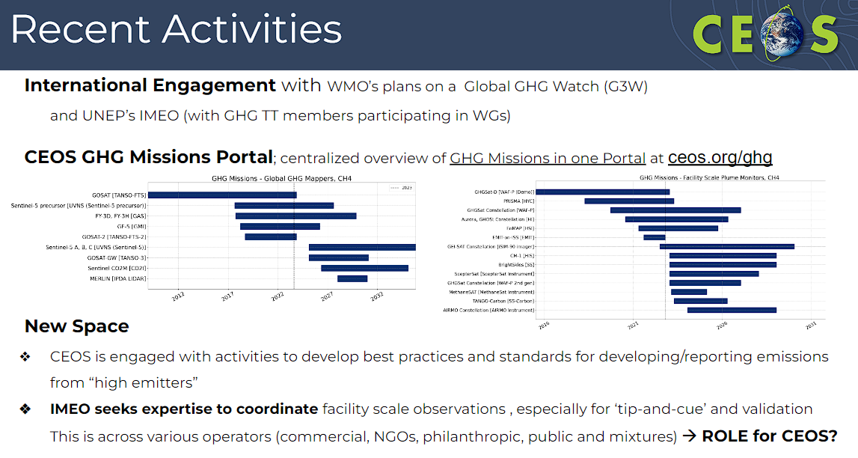
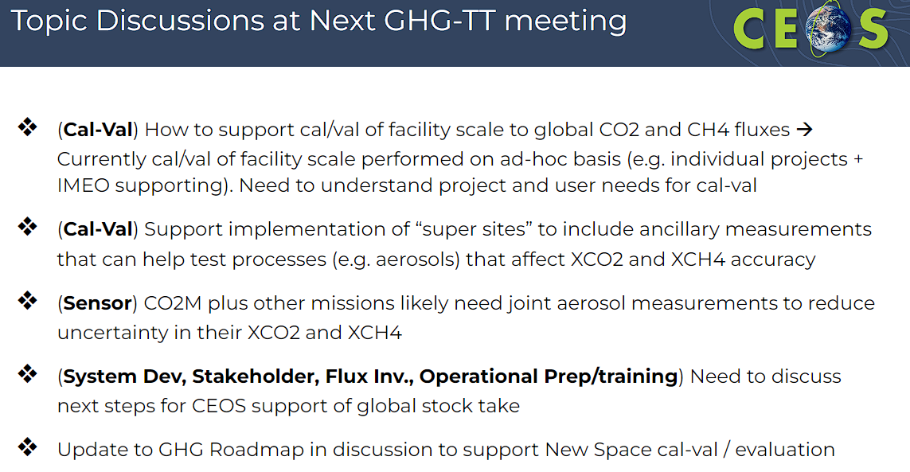
Discussion
- Philippe Goryl (WGCV Chair, ESA) mentioned that ESA and NASA are collaborating to develop a framework for assessing data quality, which is being expanded to include GHGSAT and other atmospheric missions. Philippe suggested either John Worden or someone from the GHG Task Team could be involved in the discussion involving representatives from NASA, ESA, and NPL. John confirmed his existing involvement in this initiative.
WGCV Collaboration with BIPM-WMO [Slides]
Presenter: Emma Woolliams (NPL)
Main points:
- Presented the next steps for BIPM-WMO Workshop recommendations.
- The aim is to explore collaboration opportunities between CEOS and BIPM-WMO.
- In September 2022, WMO and BIPM organised a workshop on metrology for climate action. More information is available at: bipmwmo22.org
- Various recommendations resulted from the workshop.
- BIPM is organising a follow-on stakeholders workshop, 1st CIPM STG-CENV, on 16-18 September 2024, with options for online participation. The call for abstracts has been released. The workshop aims to review progress on recommendations from the last workshop and explore collaboration opportunities:
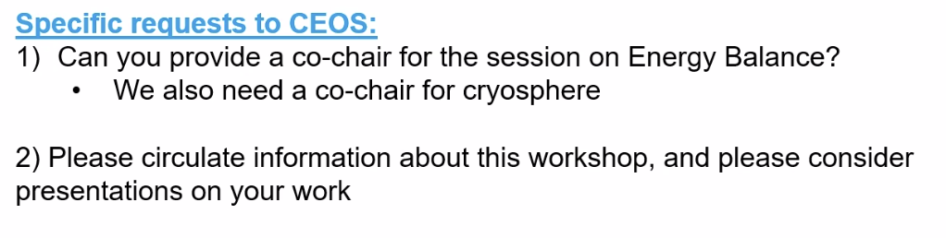
- Interoperability is a headline. Interoperability is a characteristic of a product or system to work with other products or systems. The CEOS Interoperability Framework, FRM Framework, and EDAP, all contribute to these conversations.
- In the context of climate, there's a need for interoperability between satellite and non-satellite systems, as well as integration with the modelling community. The workshop aims to facilitate these connections.
- Noted GCOS IP: Action B1: 3. Better align the satellite FRM program to the reference tier of tiered networks and enhance / expand FRM to fill gaps in satellite cal/val. All of these frameworks are helping. The metrology community could be a bridge between the CEOS and WMO activities and help align these activities
- Reviewed recommendations from the last workshop. Please refer to the attached slides for more details.
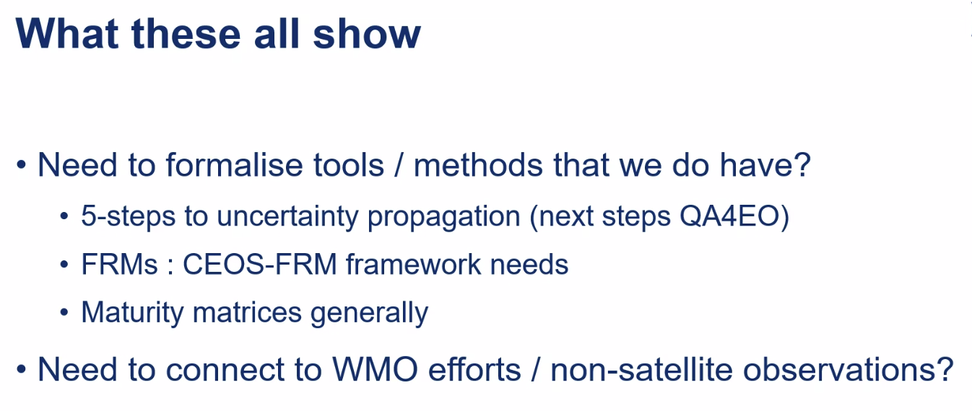
- Need to connect and formalise existing efforts across various initiatives.
- There are two topics on biosphere and cryosphere where CEOS proposed a step-by-step approach towards more rigorous methods.
- The community is keen to have more satellite community participation in the 2024 workshop. Would be good to have a GHG Task Team representation at the CIPM STG-CENV meeting in September 2024.
Discussion
- If willing to support this workshop on energy balance and cryosphere, WGCV members are asked to please let Emma know by 25 March 2024. Workshop details can be found at: https://bipm-cenv2024.org/
- There is a need to reinforce the cooperation with WMO and ensure the participation of CEOS. Philippe Goryl (WGCV Chair, ESA) will be reporting on the CEOS WGCV activities at the 2024 workshop to see how some of the activities respond to or fulfil some of the recommendations. Many recommendations are already ongoing. From this, we can identify some gaps or efforts where we need to put additional effort. The most important thing is to let people know what CEOS WGCV is active on FRM, vocabulary, uncertainty assessment, Interoperability Framework, etc. Having those messages would be good and should also help other communities and the GCOS response.
- Nigel Fox (NPL) will Co-Chair the energy balance session at the workshop representing CEOS unless another suitable candidate is identified.
- Emma Woolliams (NPL) and Philippe will discuss recommendation responses in a dedicated teleconference.
- Need to consider the extent to which Philippe should summarise a slide on each topic or if dedicated sessions on specific issues are preferable. Emma will press for a cross-cutting session if Philippe is available. Additionally, ensure WGCV presentations are included in each technical session. Given that the Theme 2 area will likely be dominated by ground/airborne participants, it's important to have representation from the space sector there. Technical representation in each group and a cross-cutting presentation would be beneficial. Consider dedicating items for ACSG, LPV, etc.
WGCV-53-ACT-26 | WGCV members to consider participation in the WMO 1st CIPM STG-CENV, 16-18 September. Also seeking co-chairs for the cryosphere and energy balance sessions from CEOS. Please send expressions of interest to Philippe and Emma. | 24 March 2024  Closed
WGCV-53-ACT-27 | Emma Woolliams to organise a follow on conversation with Philippe regarding CEOS representation at the 1st CIPM STG-CENV meeting. | July 2024
WGCV Support to 2024 CEOS Chair Priority on Biodiversity
Presenters: Philippe Goryl (WGCV Chair, ESA), Gary Geller (NASA/JPL), Marc Paganini (ESA), Yves Crevier (CSA)
Main points:
- Philippe highlighted that the CEOS Chair 2024, CSA, has prioritised biodiversity initiatives. The idea of this session is to see how WGCV can support this priority. Philippe believes that WGCV can support at three levels:
  - Cal/val is critical to the underlying products;
  - Intercomparison exercises, possibly a revamp of BRIX;
  - Validation for EBVs, application of LPV protocols.
Biodiversity Importance and Role in CEOS [Slides]
Presenter: Gary Geller (NASA/JPL)
- Biodiversity is the variety of life on Earth at the genetic, species and ecosystem level.
- It is important to humans in various ways including provisions such as food, fibre, regulation of water resources, pollination, and recreation.
- There is an interdependent relationship between biodiversity and climate.
- Key organisations involved in biodiversity initiatives are the United Nations Convention on Biological Diversity (UN CBD), the Intergovernmental Science-Policy Platform on Biodiversity and Ecosystem Services (IPBES), and the Group on Earth Observations Biodiversity Observation Network (GEO BON).
- The Ecosystem Extent Task Team (EETT) commenced in 2022 and had the EETT white paper endorsed in 2023. In 2024, Ecosystem Extent Demonstrators activities are ongoing and CSA has this as a priority for their chair year.
- Optical, Radar, and Lidar, provide various information for assessing biodiversity. Integration of data from these sources is the key to biodiversity monitoring.
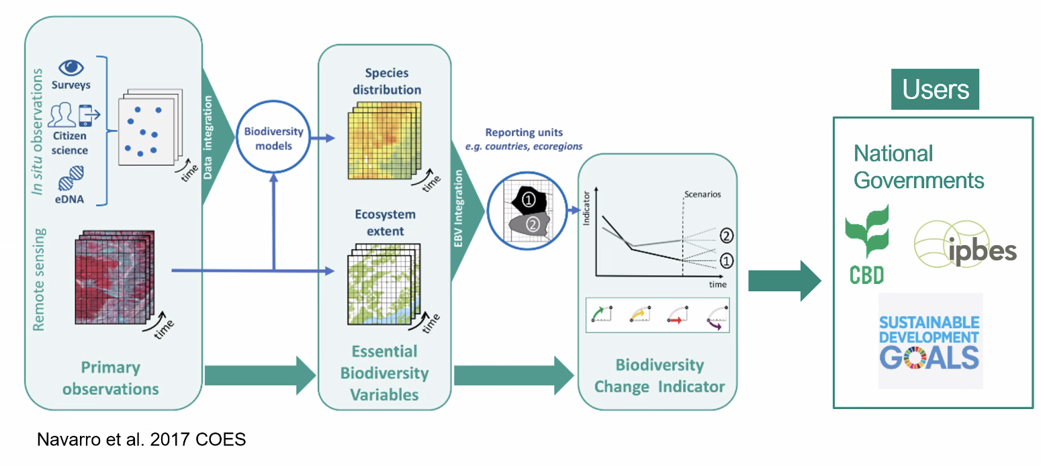
- End-to-end continuity is essential.
- Key opportunities exist around combining different data, hyperspectral data, AI/ML, Data Cubes, and global monitoring. While Data Cubes are not widely used in the biodiversity community, they are particularly important for combining diverse datasets effectively.
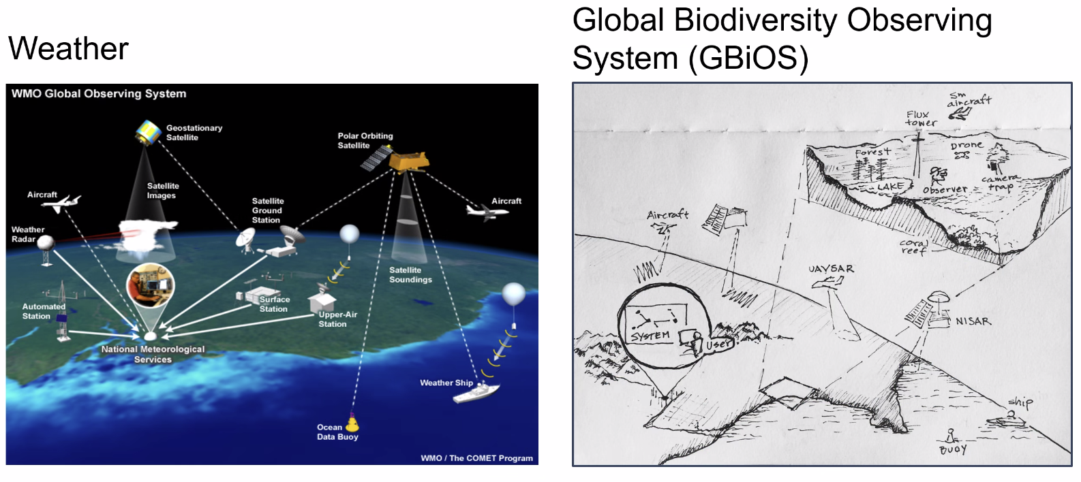
- Combining data poses challenges in terms of operationalising workflows, enhancing the useability of EO, improving the technical capacity of users, ensuring standards, interoperability and comparability, and achieving global monitoring. These are all substantial challenges that need to be addressed.
Essential Biodiversity Variables (EBVs) [Slides]
Presenter: Marc Paganini (ESA)
- Essential Biodiversity Variables (EBVs) are key variables essential to be collected globally and regularly for studying, reporting and managing changes to biodiversity, and monitoring progress towards Biodiversity targets. EBVs were developed by GEO BON in 2013.
- Noted papers on EBVs and measurement from space. Please refer to the linked papers: Agree on biodiversity metrics to track from space and Priority list of biodiversity metrics to observe from space.
- It is not the mandate of space agencies to produce EBVs or EAVs operationally. However, space agencies can contribute by helping to define workflows that could then be adopted by biodiversity practitioners.
- Presented some ideas on potential WGCV support to EBVs:
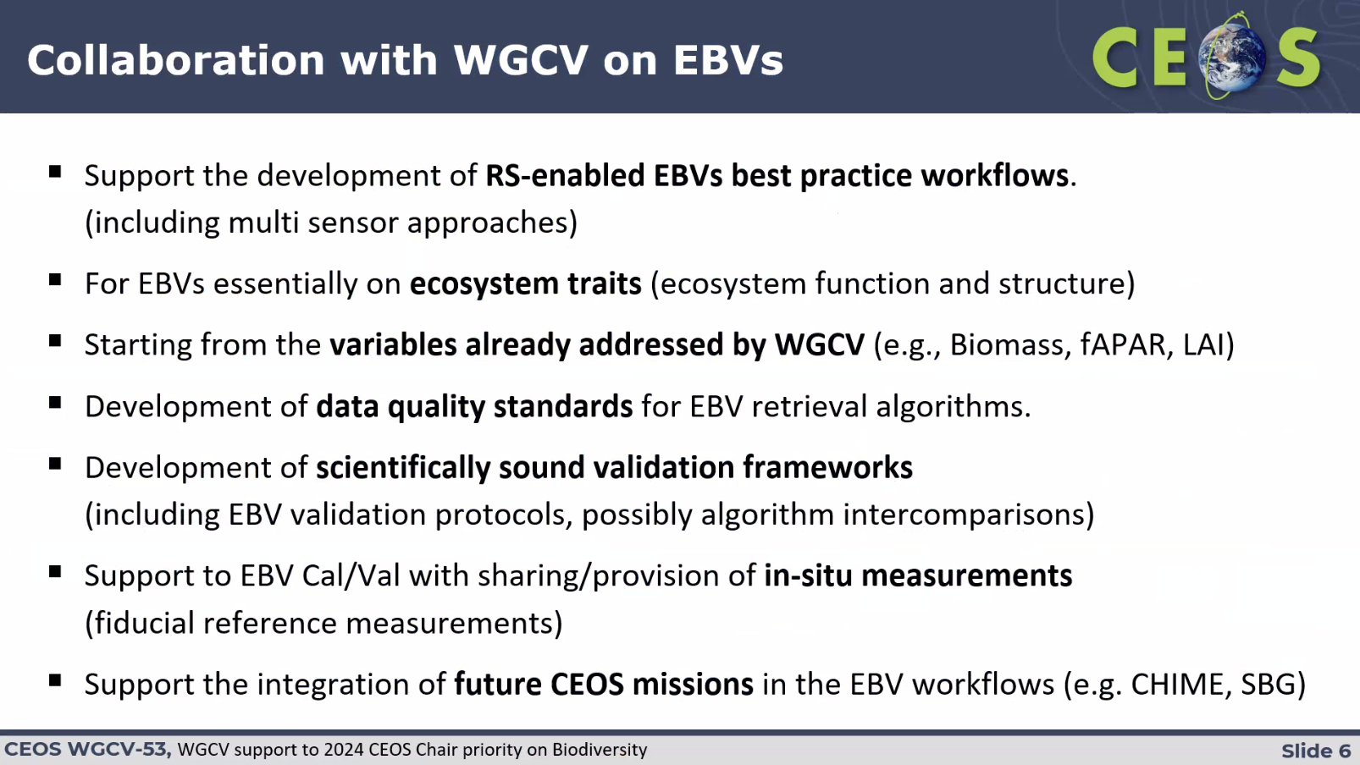
Leveraging the RADARSAT-2 Dataset Archive Over the Circumtropical Forest [Slides]
Presenter: Yves Crevier (CSA)
- With the increasing data volume and emphasis on interoperability/comparability, as well as the growing use of AI/ML and higher-level products, derived data, and the need for Monitoring Reporting Verification, all require high levels of radiometric and geometric consistency, and WGCV is at the heart of ensuring this consistency.
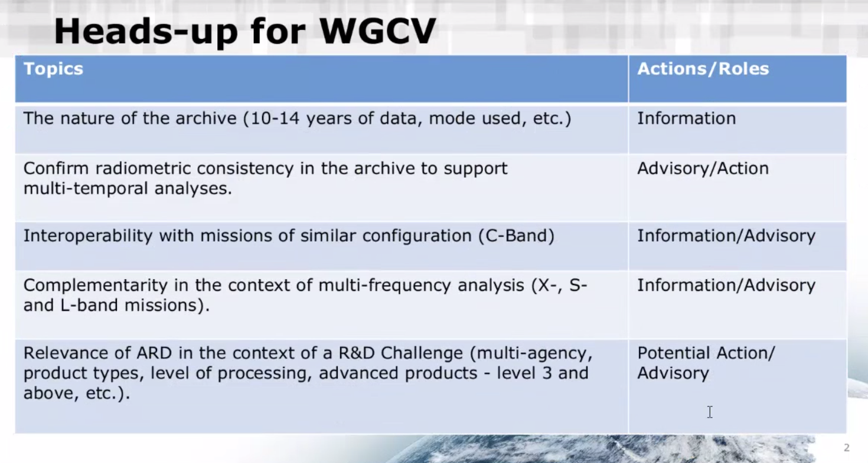
- Since 2012, CSA has been running a background mission with RADARSAT-2 over the circumtropical forests.
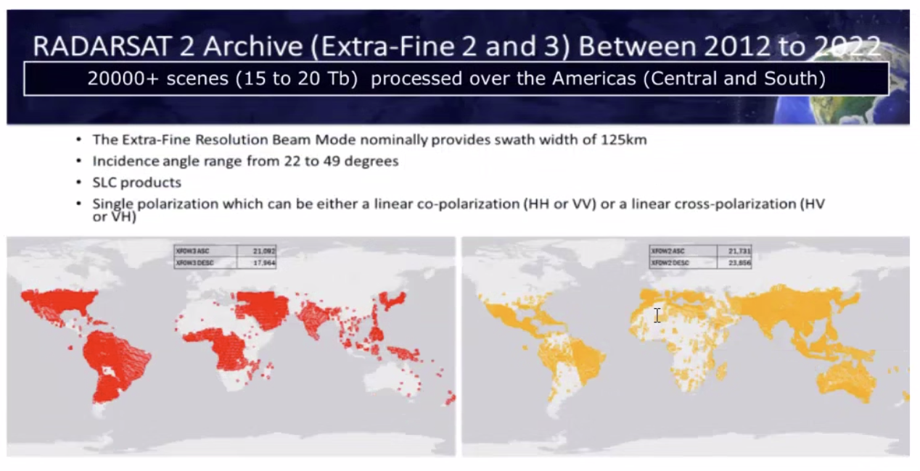
- The aim is to make this dataset available for various applications through the framework of CEOS for forest mapping and monitoring, biodiversity and ecosystem monitoring, carbon accounting, national resource management, and disaster management.
- NISAR will be a great opportunity to explore complementarity with existing missions.
- CSA is planning an R&D / Challenge framework to address various questions. The details will be published in the coming months and the R&D community will be invited to answer the questions and assess how the C-band radar data can contribute to the three elements noted below.
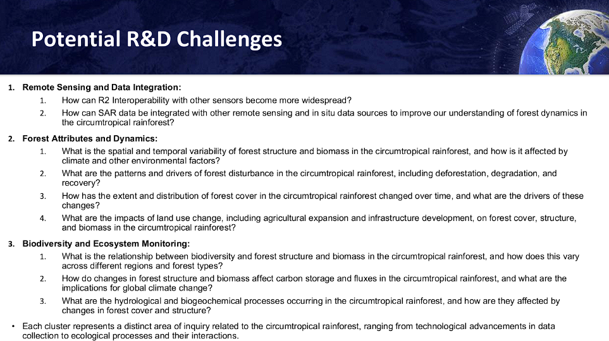
- CSA is working with ESA on an interoperability study involving Sentinel-1. Support from WGCV could be helpful for that.
- Noted AO from CSA and DLR on complementarity of C and X-band data.
Discussion
- Philippe Goryl (WGCV Chair, ESA) noted that WGCV could contribute to some of the collaboration tasks such as developing EBV validation protocols. LPV is making progress in this area. WGCV can focus efforts on algorithm intercomparison, particularly for biomass, which would be beneficial for biodiversity studies. Philippe emphasised the need to have a concrete mechanism for a request and response system between WGCV and Biodiversity.
- Marc Paganini (ESA) noted the need for reorganisation within CEOS on biodiversity. There needs to be a structure under CEOS to make addressing biodiversity easier. There are many EC, NASA and ESA projects trying to develop workflows. A CEOS biodiversity group will first need to see what WGCV has done and how it could be used by the biodiversity community.
- Gary Geller (NASA/JPL) noted we have to see what home biodiversity gets in CEOS. Currently, the focus is on the Ecosystem Extent Task Team (EETT) with a two-year mandate, but there's uncertainty about the future direction of CEOS and biodiversity. This is what the 2024 CEOS Chair is seeking to clarify.
- WGCV should leverage the Demonstrators to develop the necessary biodiversity workflows.
- Philippe suggested having a WGCV-54 session on the WGCV activities that are relevant to biodiversity.
- Dave Borges (SEO, NASA) noted in the context of the CEOS New Space Task Team, SEO took an action to conduct SAR analysis with like bands, also noted one of the EETTs led by ECCC on Hudson Bay lowlands is actively using CAL. Dave will follow up with Yves to get the RADARSAT data into CAL. Dave will provide some background to Yves. Yves is interested in discussing further.
- Dirk Geutdner (ESA) noted that the SAR Subgroup is already performing comparisons between Sentinel-1, RADARSAT-1 and 2 data. The SAR Subgroup is working with Stephane Cote from CSA in the context of in-orbit calibration of Sentinel-1 A/B. The comparison will be continued for Sentinel-1C. He noted the goal is to understand algorithm sensitivity and ensure radiometric consistency.
- Yves Crevier (CSA) noted the need to address concerns regarding radiometric consistency and dataset accuracy, particularly in the context of AI/ML algorithms.
- Santhisree (ISRO) noted that ISRO would like to access the RADARSAT data for various analyses if it is open. Yves Crevier (CSA) noted CSA has to comply with the Remote Sensing Space System Act in Canada. Data will be available free of charge to certified end users. Users who want to access the data will need to be certified to access the data freely. Dirk asked about specific products available to wide user communities and the need for control over data distribution. Yves acknowledged these concerns, stating they are being addressed in the definition of their challenge.
WGCV-53-ACT-28 | Matt Steventon to add RADARSAT-2 ARD pilot / test case paragraph to the CEOS-ARD Strategy 2024. | June 2024
WGCV-53-ACT-29 | WGCV Chair to coordinate a follow up discussion with subgroup chairs regarding biodiversity activities and potential collaborations. Particularly LPV, SAR subgroup, and also the Ecosystem Extent Task Team Demonstrators. | Mid-May 2024
Space Agency Reports
Servicio Aerofotogramétrico (SAF) [Slides]
Presenter: Carolina Barrientos (SAF)
- Chilean space programme consists of five systems:
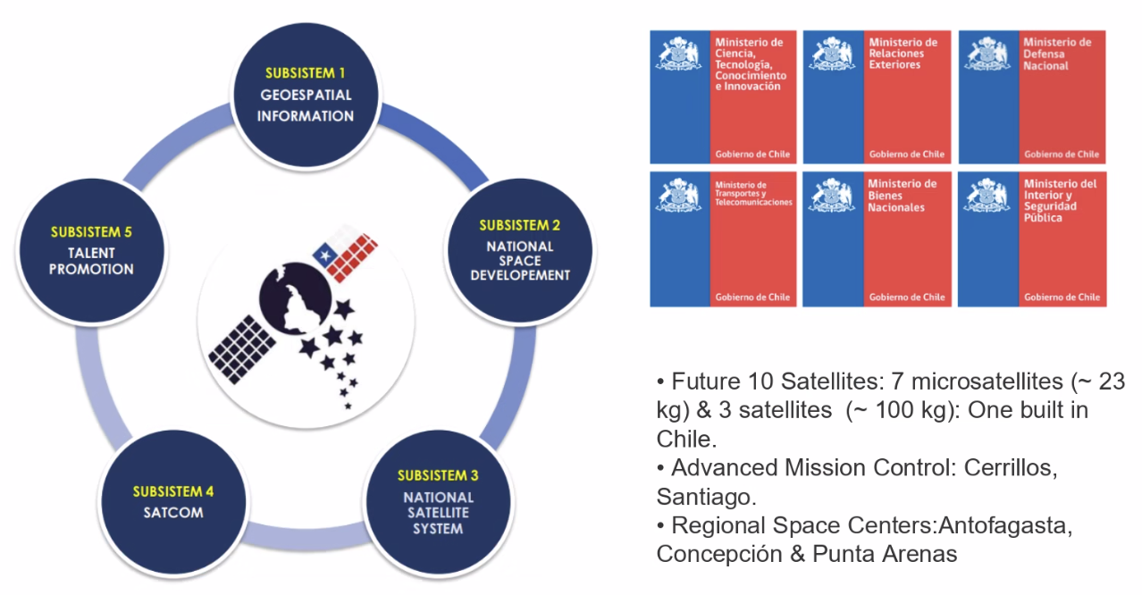
- The Sistema Satelital para la Observación de la Tierra (SSOT) – FASat-Charlie satellite was launched in 2011.
- Since 2014, field campaigns have been conducted in collaboration with the National Institute for Space Research and Laboratory for the Analysis of the Biosphere (LAB) at the University of Chile.
- SAF is using RadCalNet and other WGCV resources. Interested in providing a site for RadCalNet. Some of the results were shared. SAF has been interacting with various CEOS agency cal/val activities such as those taking place in CSIRO, NASA and DLR.
- Details of other campaigns and future activities were shared. Please refer to the linked slides for more information.
Discussion
- Nigel Fox (UKSA) noted that IVOS as an entity is willing to help SAF activities (in particular RadCalNet site establishment) and encouraged Carolina to make a similar presentation to IVOS in September 2024, to foster connection with the rest of the IVOS team.
- Dirk Geudtner (ESA) noted that from the radar perspective, the Atacama site is an ideal test site for radiometric calibration. He mentioned the cross interferometry between Sentinel-1A/B/C - for which the site would be very useful.
Geoscience Australia (GA) [slides]
Presenter: Medhavy Thankappan (GA)
- Showed results of ground-based validation of satellite-derived surface reflectance. Targeted field validation campaign focussed on dual satellite overpasses (L8, L9, S2) in November 2023. There were four dual overpasses. Additionally, DESIS, EMITS, EnMAP, and PRISMA were tasked over the sites for cross-validation opportunities. Due to poor weather, only two sites were visited, and no UAV-based hyperspectral instruments were deployed. The next opportunity is in April 2024.
- GA is contributing to the SRIX4Veg-II campaign.
- GA continues to maintain the Queensland Corner Reflector Array (QCRA) of 40 corner reflectors. ESA leverages the QCRA for ongoing Sentinel-1 data quality assurance.
- AusCalVal (CSIRO) supported the maintenance of the QCRA site in May 2023 and is directly supporting work underway to get QCRA admitted as part of SARCALNET.
- The Pandora instrument has been successfully redeployed at GA’s Satellite Ground Station Facility in Alice Springs after re-calibration. The instrument continues to generate data as part of the global Pandonia network.
Discussion
- Dirk Geudtner (ESA) noted that ESA has their transponder for the BIOMASS mission situated in Australia. Matt Garthwaite (CSIRO) added that CSIRO manages the site under contract from ESA.
USGS [Slides]
Presenter: Cody Anderson (USGS)
- Landsat 9 is performing well and there have been no changes over the past year.
- Landsat 8 celebrated its 10-year anniversary. The following trends in sensor characteristics have been found:
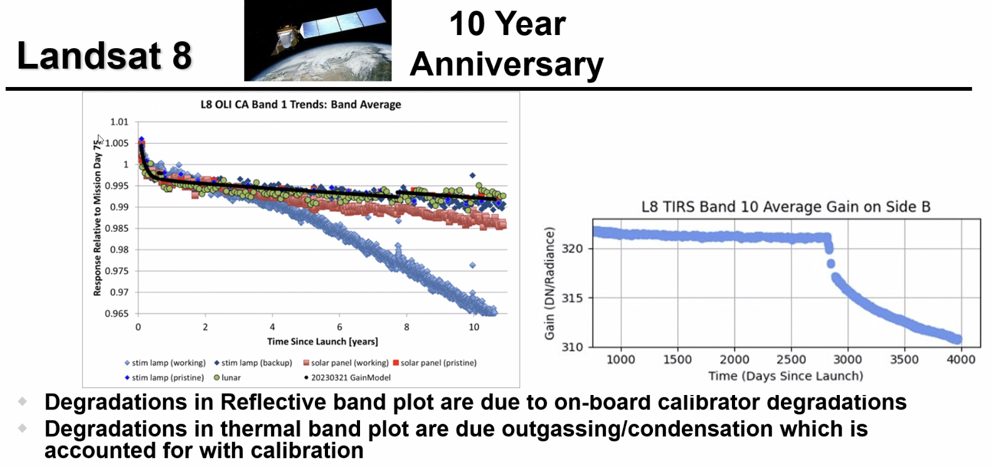
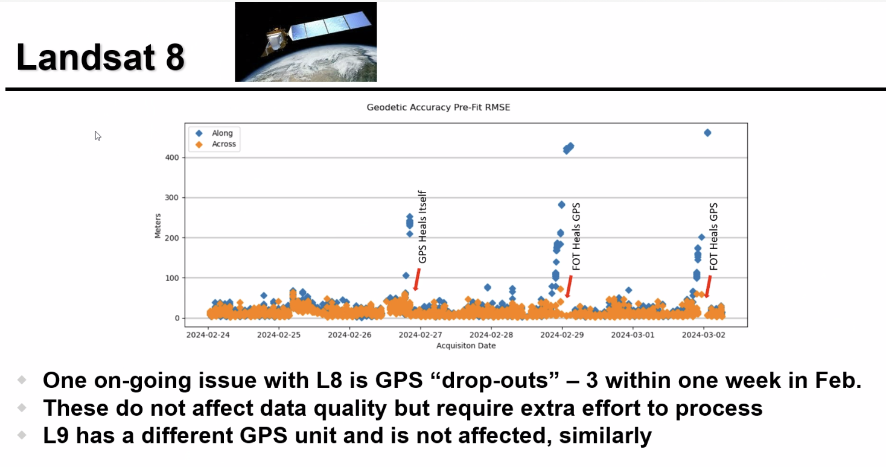
- In Landsat 8, there is currently a GPS issue over specific areas where GPS blocking is occurring. However, Landsat 9 is not experiencing this issue due to its different hardware configuration.
- The Landsat 7 science mission ended on 6 April 2022. An extended science mission went through to 19 January 2024. With the cancellation of OSAM-1, Landsat 7 will cease all operations. There may be an attempt to perform one last acquisition on its 25th anniversary.
- Landsat Next (3 satellites) will feature 26 spectral bands, with 10-20 m resolution in VSWIR bands, and 60 m atmospheric/TIR bands. The mission will use a triplet constellation providing a repeat interval of 6 days. Target launch is around 2030.
- Landsat Collection 3 is expected to be processed around 2028, with the following characteristics:
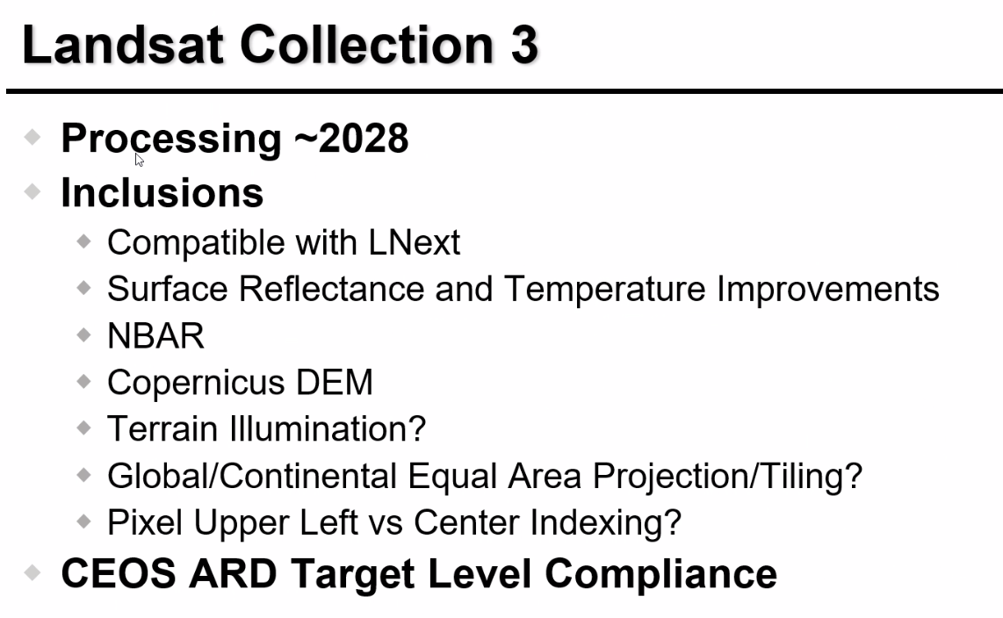
- Link to JACIE Satellite Compendium: https://calval.cr.usgs.gov/apps/compendium#
- Link to Spectral Characteristics Viewer: https://landsat.usgs.gov/spectral-characteristics-viewer
- Link to Land Product Characterization System (LPCS): https://calval.cr.usgs.gov/apps/lpcs
Discussion
- The tools shared above are also linked on the CEOS WGCV cal/val portal.
- Matt Garthwaite (CSIRO) will investigate something similar to the Land Product Characterization System (LPCS) for SAR, potentially through SARCalNet.
ISRO [Slides]
Presenter: Santhisree (ISRO)
- Provided an update on EOS-06 (Oceansat-3) which was launched on 26 November 2022 and has recently been declared operational.
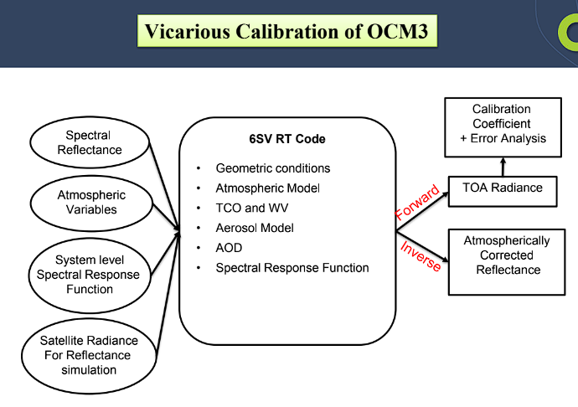
- For observations over water, OCM3’s radiometric response is in close agreement with ground measurements.
- Provided an update on the radiometric calibration status of Resourcesat-2A, INSAT-3D, INSAT-3DR and EOS-4. On-orbit consistency was observed for EOS-4.
- Resourcesat-2A post-launch response is consistent for all three payloads, LISS-4, LISS-3 and AWiFS. INSAT-3D and INSAT-3DR were found to be within 10% Radiometric error.
- Various preparatory activities have been conducted for the NISAR mission. Corner reflectors designed and developed for the NISAR mission have been deployed. More details are available in the slides.
- An ISRO-ASI project for the calibration of optical space-borne sensors over pseudo-invariant calibration sites is in progress.
Discussion
- Medhavy Thankappan (GA) asked whether there was a permanent deployment of cal/val infrastructure for NISAR or if it was just a limited-time campaign. Santhisree (ISRO) noted that currently there is a limited campaign of corner reflector deployment, but ISRO is also planning to establish a permanent network. They are using square corner reflectors. The EOS-04 mission used the Australian Queensland Corner Reflector Array for the commissioning phase. However, since EOS-04 is not a global mission, it does not regularly image over these sites now.
BELSPO [Slides]
Presenter: Jean-Christopher Lambert (BIRA-IASB)
- The Belgian Science Policy Office (BELSPO) oversees 10 federal scientific institutes including BIRA-IASB, RBINS and RMIB. It is responsible for the funding of national research programmes, management of national and international coordination.
- The Belgian Space Strategy involves participation in international organisations dealing with space including ESA where BELSPO is the 5th largest contributor, ECMWF, EUMETSAT, ESO and EU programmes such as Copernicus, Galileo, Research Infrastructures, etc. Bilateral cooperation with France and Argentina is also part of the space strategy.
- On a national level, Belgium has established EO programs like STEREO and TERRASCOPE.
- Atmospheric Limb Tracker for Investigation of the Upcoming Stratosphere (ALTIUS), an ESA Earth Watch mission carries a high-resolution spectral imager and uses a limb-sounding technique to deliver profiles of ozone, other trace gases and aerosols in the middle and upper atmosphere. It is an ESA mission partly financed by BELSPO.
- Belgium is highly active in cal/val activities for atmospheric, land and marine domains. BELSPO supports validation and calibration via the National STEREO Programme and ESA (Future-EO, PRODEX).
- Some of Belgium's EO Cal/Val activities include operational validation of Sentinel-5P and Sentinel-3, and participation in various validation networks such as Hypernets, NDACC, PGN, TCCON, and Harmonisation VGT-1 and VGT-2 PROBA-V.
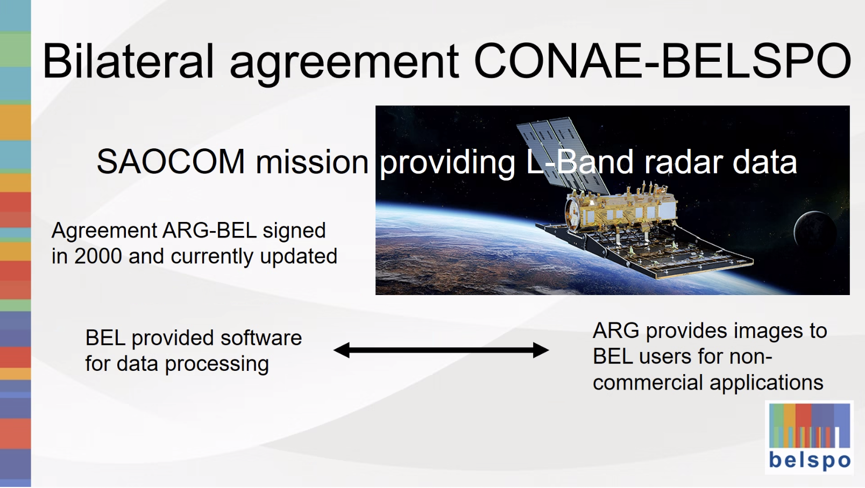
CEOS WGCV Cal/Val Portal Updates [Slides]
Presenter: Paolo Castracane (ESA)
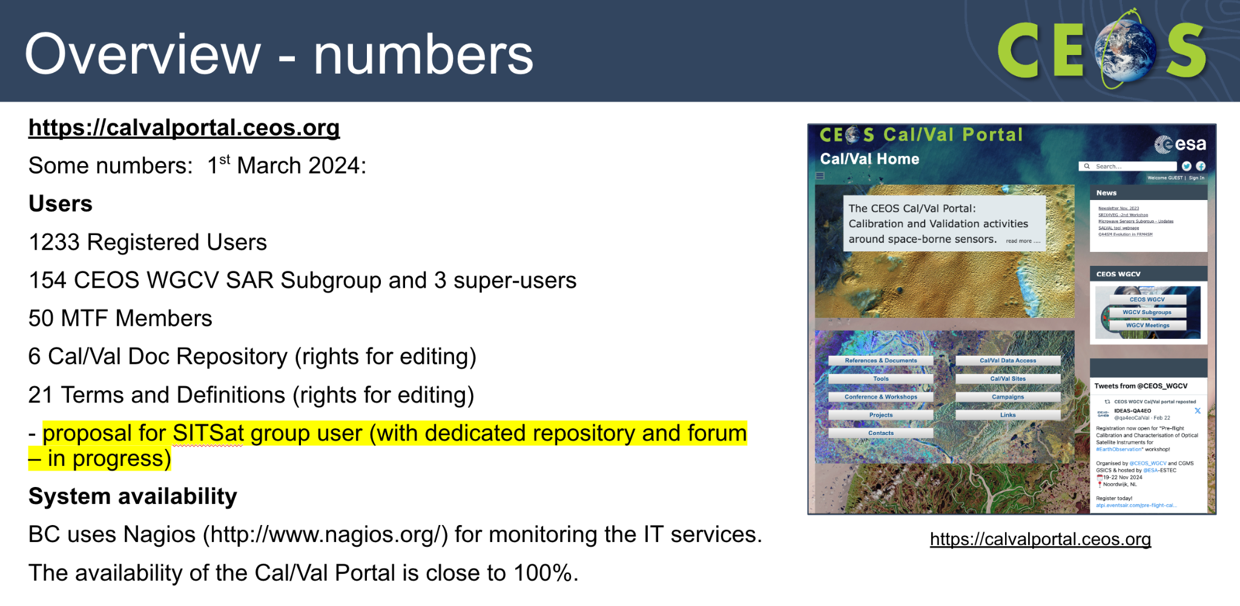
- Reviewed the WGCV cal/val portal action updates from WGCV-52.
- WGCV-51-ACT-10 related to the IVOS Calibration Database is still open. IVOS teams have been requested to fill out a web form or submit a formatted table containing information on a specific calibration method. May plan a refresh of the action to reflect the latest.
- Hyperspectral cal/val resources page has been published here.
- The Roadmap towards an Assessment Framework for Fiducial Reference Measurements (FRM) is available at https://calvalportal.ceos.org/web/guest/frms-assessment-framework. The purpose of the document is to propose a roadmap towards an assessment framework to endorse a specific class of measurements as Fiducial Reference Measurements (FRM). The first version has been published. A counterpart Maturity Matrix web tool has been developed: https://mmt.skytek.dev/
- New CEOS endorsed Solar Irradiance Spectrum (TSIS-1) has been published on the cal/val portal. There is a new action WGCV-53-ACT-11 and WGCV-53-ACT-12 about further communicating this information to CEOS and the broader community.
- New content has been added about the LIME project. This includes deliverable documents from the project, links to the database, LIME toolbox, and installers for Windows, Mac, Linux and Debian (Ubuntu). Final presentations are also available in the cal/val portal.
- A new page dedicated to GCPs for Very High-resolution analysis has been added to the cal/val portal. It includes information about QGIS Cloud, uploading and downloading GCPs, and VH-RODA 2023 questionnaires.
- IVOS 35 meeting materials are now available on the cal/val portal. Information on the last SAR Subgroup meeting is also available.
- Paolo has drafted a proposal for the SITSat Task Team page on the portal.
- The WGCV cal/val portal newsletter was published in November 2023. It includes updates on the content for each subgroup, hyperspectral cal/val resources, the FRM Assessment framework, outreach, and video tutorials.
Discussion
- A general call was issued for any materials for the cal/val portal and promotion via the portal and the CEOS communications team. Philippe Goryl (WGCV Chair, ESA) thanked SEO for offering support on the communications aspect.
- It was suggested that the inclusion of test site information in the cal/val portal would be beneficial.
WGCV-53-ACT-30 | Nigel Fox to provide Paolo Castracane with a list of current SITSat Task Team members in order to set up a group on the cal/val portal. | Complete
Plans for the WGCV-54 Meeting [Slides]
Presenter: Cody Anderson (WGCV Vice Chair, USGS)
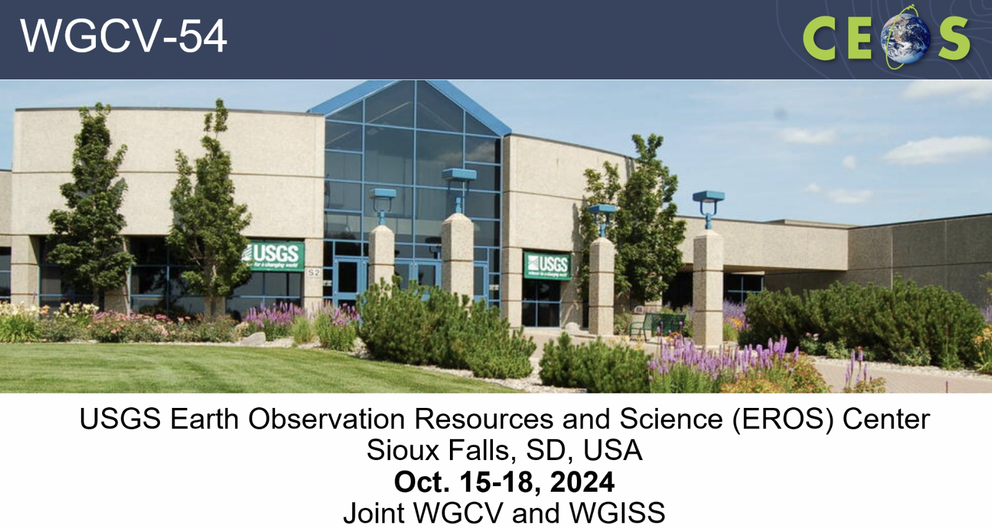
- The WGCV-54 meeting will be held at USGS EROS, in Sioux Falls, South Dakota, USA, from 15-18 October 2024.
- There was a suggestion to organise the joint WGCV-WGISS session for more than half a day. The opportunity of a joint meeting is unique and CEOS does not have many of these cross-cutting opportunities and discussions. It presents an opportunity to craft a unique and impactful agenda.
WGCV-53-ACT-31 | WGCV Secretariat to set up the next WGCV team call after SIT-39, in mid-May 2024.  The WGCV Secretariat will also set up a coordination meeting regarding the plans for the joint WGCV-WGISS session in October 2024 with Tom Sohre, Nitant Dube, Philippe Goryl, and Cody Anderson. | In Progress
Action Review
Matt Steventon (WGCV Secretariat) reviewed the decisions and actions from Day 3.
Day 3 Close
Philippe Goryl (WGCV Chair, ESA) thanked everyone for joining and closed Day 3 of the WGCV-53 meeting. Philippe extended his thanks to CONAE, in particular Laura Frulla, Ana Medico, and Matias Palomeque, for hosting the meeting.

