CEOS-ARD Surface Reflectance Products: Quality, Consistency and Equivalence
(for information / discussion at the ARD Session WGCV-53, Cordoba)
The CEOS-ARD Surface Reflectance (SR) Product Family Specification (SR-PFS) provides a good starting point for interoperability of multi-sensor SR products. However, the SR-PFS is non-prescriptive, and often leads to different approaches being used to derive SR products, thus limiting interoperability of products.
Data providers will have their own constraints, priorities, and approaches when it comes to defining and implementing an SR product processing chain. Comparisons between SR workflows have shown that using equivalent processing steps and model inputs results in SR products that are more consistent and able to be used effectively for multi-sensor analyses. Consistent SR measurements are therefore critical for interoperability and data integration involving multi-sensor analyses.
Inconsistency in SR measurements and their impact on analyses are well documented and have been expressed anecdotally by industry representatives, who have noted the need to rewrite data processing pipelines to address incompatibility between SR products from CEOS agencies. Although SR products are compliant to the CEOS-ARD SR-PFS, CEOS member agencies’ own efforts in producing the NASA Harmonised Landsat Sentinel (HLS) and ESA Sen2Like products demonstrate the need to improve the compatibility of SR products across different providers to enable harmonisation and fusion of datasets. It is appropriate for CEOS agencies to collectively take steps to address the inconsistencies in SR products and build on the substantial gains that have been achieved through the CEOS-ARD initiative and advance further along the data interoperability continuum.
This proposal seeks to establish a set of inputs, corrections, associated parameters and tolerances for achieving SR equivalence in the context of interoperability between CEOS-ARD SR products and facilitate effective multi-sensor analyses. The table below highlights the variability in approaches for deriving SR products and lists corrections that could be the focus for identifying the parameters for achieving SR equivalence.
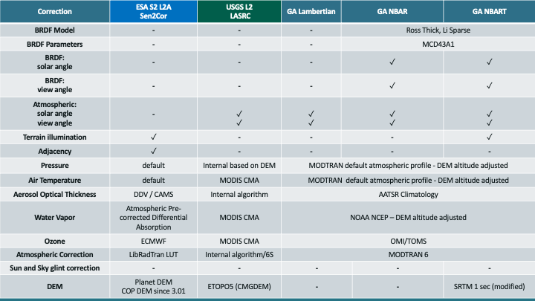
A critical first step for achieving SR equivalence is the recognised need for an agreed definition of SR in the context of cross-sensor interoperability of CEOS-ARD datasets. This proposed activity could be led by LSI-VC as the sponsor of the ARD initiative and guided by the CEOS Interoperability Framework. Any potential work on this could also serve as a use case for broader data interoperability within CEOS. There is potential for WGCV to provide input into the definition of SR and tie this to work on definitions being undertaken within WGCV and other CEOS entities.

