Minutes of the 19th Meeting of the CEOS Land Surface Imaging Virtual Constellation (LSI-VC)

Hosted by USGS EROS, Sioux Falls, South Dakota, United States

Table of Contents
Day 1: Tuesday, April 21, 2026 3
Session L1: Opening Session 3
L1.1: Recap and Reflection on Day 1 3
L1.2: Action Review 3
L1.3: Confirmation of CEOS-ARD PFS Building Blocks Implementation 3
Session L2: Agency / CEOS-ARD Self-Assessment Reports 4
L2.1: GISTDA 4
L2.2: ISRO [slides] 5
Session L3: LSI-VC Thematic Session 6
L3.1: GEO Land Degradation Neutrality [slides] 6
L3.2: LSI-VC Forests and Biomass Subgroup Report [slides] 7
L3.3: Wetlands [slides] 8
L3.5: GEOGLAM (Agriculture) [slides] 8
Session L4: Wildfires 10
L4.1: LSI-VC Wildfire Subgroup [slides] 10
L4.2: USGS Fire Science Activities [slides] 12
L4.3: Endorsement: LSI-VC Terms of Reference Update to Incorporate the Wildfire Subgroup 12
Session L5: CEOS-ARD Product Family Specification Updates 13
L5.1: CEOS-ARD Surface Temperature PFS Version 6.0 [slides] 13
L5.2: Endorse Version 1.0 of the Composite Backscatter SAR PFS [slides] 13
Day 2: Wednesday, April 22, 2026 14
Session L7: 2026 CEOS-ARD Strategy Pillar: Standards and Interoperability 14
L7.1: Introduction [slides] 14
L7.2: Existing ISO standards and the cross walk to CEOS-ARD [slides] 14
L7.3: Candid Core Framework [slides] 15
L7.4: CEOS-ARD UML [slides] 15
L7.5: CEOS-ARD Discoverability and Accessibility [slides] 16
L7.6: Update on OGC/ISO Standards and Engagement [slides] 17
L7.7: CEOS-ARD in the Cloud (VC-23-06) [slides] 18
L7.8: Discussion 19
Session L8: AOB 19
L8.1: PolSAR Project Update and SAR-VC Considerations [slides] 19
L8.2: LSI-VC-20 Meeting Plans 21
Appendix A: List of Participants 21
Appendix B: Decisions 23
Appendix C: Actions 24

Day 1: Tuesday, April 21, 2026

Session L1: Opening Session

L1.1: Recap and Reflection on Day 1
LSI-VC Members discussed the inputs received from WGCV toward the Quality, Integrity, and Provenance and Fitness for Purpose pillars of the CEOS-ARD Strategy. Developing CEOS-ARD as a fitness for purpose baseline was considered, though it would need to account for many user and application requirements. CEOS Agencies could be consulted to share their user groups and application areas, and provide bounds for the product selection framework / fitness for purpose application.
There was a discussion around aligning the categorisation of datasets, product levels, and use cases between platforms such as GEE, CDSE, and Esri.
LSI-VC-19  Action 01 | Peter to engage KCEO colleagues including Mark Dowell in the Product Selection Framework / fitness for purpose application, with a view to reusing their past work on fitness for purpose and application requirements. | June 2026

LSI-VC-19 Decision 01 | Further development of the Product Selection Framework / fitness for purpose application presented by Matt Adams was supported.

L1.2: Action Review
Matt Steventon (LSI-VC Secretariat) shared updates on actions from the LSI-VC-18 Meeting and invited members to add action status updates to the document.

L1.3: Confirmation of CEOS-ARD PFS Building Blocks Implementation
Chris Barnes (KBR/USGS) reported various points from his assessment of the consistency between the old and new GitHub based optical PFS (slides here).
Discussion followed:
- How is the self-evaluation conducted now that the columns have been removed from the PFS?
  - Matthias Mohr (SEO) noted that the Word (DOCX) versions of the PFS will retain space for people to fill out self-assessments. In time this could shift to a more digital self-assessment tool, which should replace the need for manual assessment in Word. With the publication of new patch versions of the PFS, we should direct people specifically to the Word version for self-assessment.
- The Aquatic Reflectance PFS includes references for each parameter. There is a question as to whether we want to enforce this across all the PFS. The AR PFS team went through a more rigorous due diligence process to include references for each parameter. These references will change through time, so is that something that needs to be updated constantly?
  - References should be included in their own field, and should not be mixed with notes within requirements.
Ake Rosenqvist (JAXA) reported outcomes from his consistency checks of the SAR PFS GitHub and legacy versions (slides here):
- The biggest differences between the PFS versions 5.5 and 5.5.1 is the numbering of parameters. The parameter requirements have not changed for existing ones but there are some changes to the threshold requirements for GSLC and InSAR.
- Matthias suggested that new SAR PFS versions be incremented as minor versions (e.g. v5.X.0). The SAR PFS Building Block conversion is planned for May/June, with the conversion of the XML metadata requirements to follow, and STAC development potentially in Q3/Q4 2026. STAC for SAR is probably a ~2027 task.
- Within the semantic versioning convention adopted, the first digit (major) requires a new assessment, the second (minor) carries compliance and does not require reassessment, and third (patch) includes editorial changes with no material change. The convention will be added to the 2026 update of the CEOS-ARD Governance Framework.
LSI-VC-19  Action 02 | LSI-VC team to contribute updates to the 2026 revision of the CEOS-ARD Governance Framework. | July 2026

Session L2: Agency / CEOS-ARD Self-Assessment Reports

L2.1: GISTDA
Pawarin Kuha (remote)reported updates from GISTDA, including the THEOS-1/-2 missions and progress on their self-assessment for CEOS-ARD.
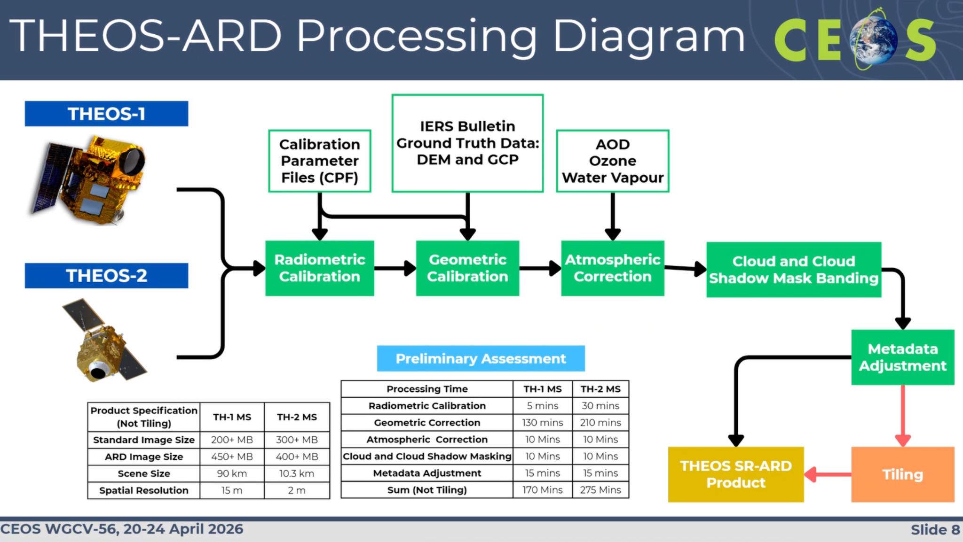
- GISTDA is currently focusing on THEOS-1 ARD processing only, due to the sub-pixel geometric accuracy requirement in the PFS being too difficult to reach for the higher resolution THEOS-2 sensor.
- In the development of THEOS-ARD, selecting a tiling size for both THEOS-1 and -2 is proving difficult as the swath widths differ. GISTDA asked whether the tiling needs to be the same size, and whether small or larger is preferable.
Discussion
- Regarding the VHR issues, CE90 10m was proposed as a limitation, requiring data to roughly fit within the Sentinel-2 geometry irrespective of resolution.
- Co-registration will need to be considered separately as well, as done by the AR PFS, with a conservative threshold to ensure we aren’t being restrictive.
- For THEOS co-griding, it was recommended that both sensors sample to the same grid. The SAR PFS demonstrates an implementation of this. The actual tile size does not matter. Ferran Gascon (ESA) noted the need for a reference grid, but one has not been established for CEOS-ARD.

L2.2: ISRO [slides]
P.V. Jayasri (remote) reported on ISRO ARD development progress. EOS-04 (RISAT-1A) has been approved as CEOS-ARD and is freely available via the Bhoonidhi portal. ISRO’s roadmap for SAR CEOS-ARD products is as follows:
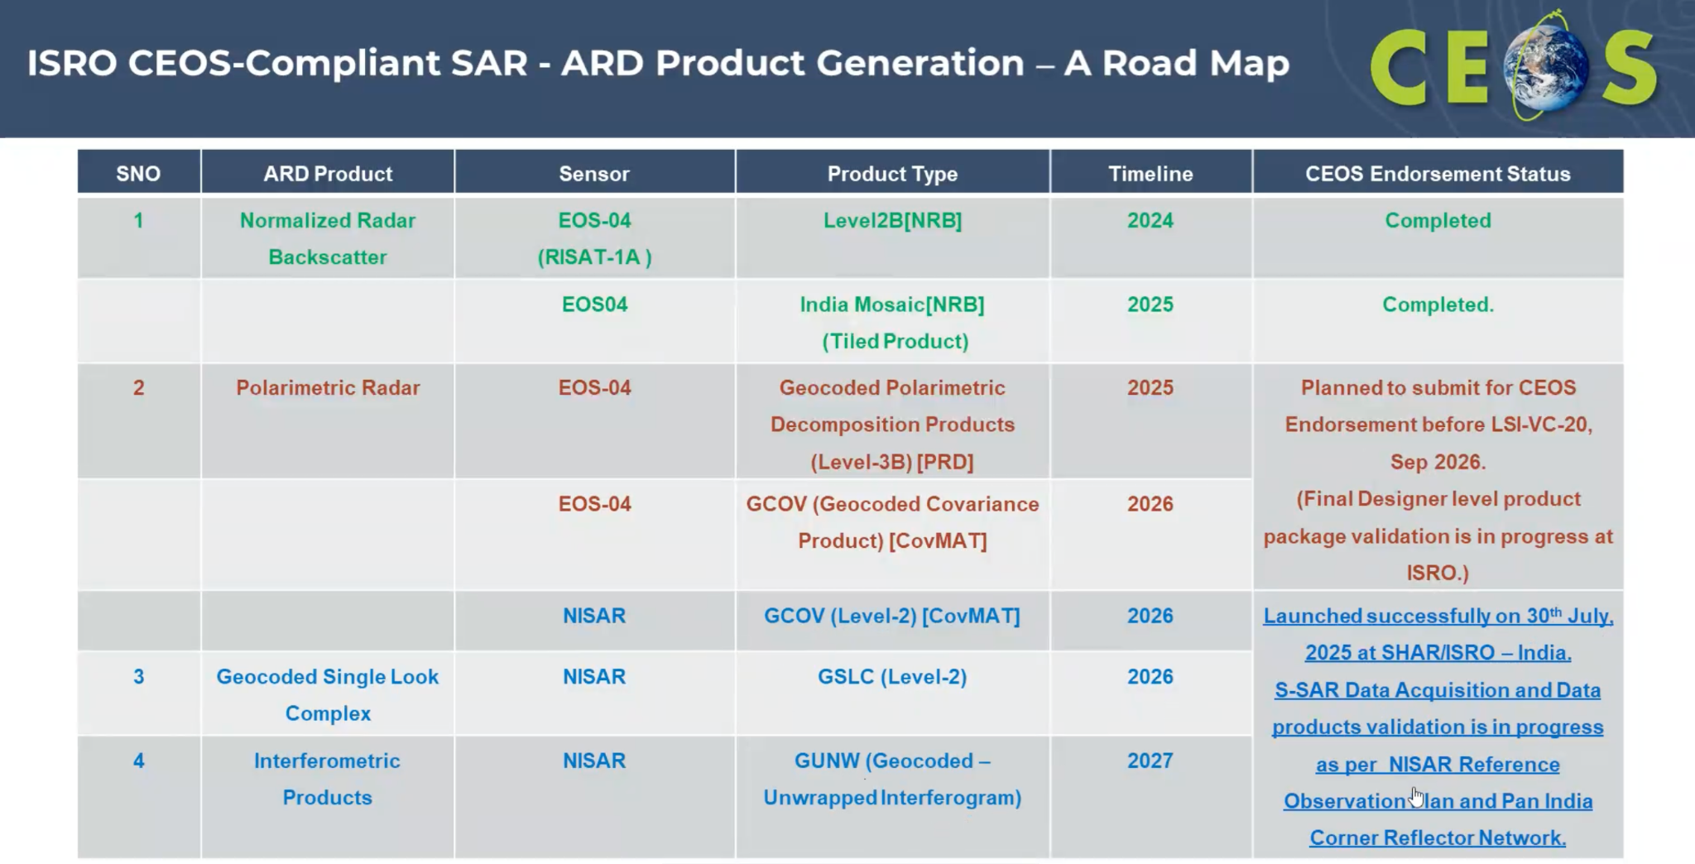
Discussion
- Ake Rosenqvist (JAXA) looked forward to the debut of the NISAR S-band product, representing a new ‘colour’ for SAR. He expressed interest in the specifications for NISAR's Level-4 application data products.
LSI-VC-19  Action 03 | ISRO to share details of their NISAR Level-4 application data products so that the specifications can help inform development of the CEOS-ARD Product Selection Framework application. | June 2026

Session L3: LSI-VC Thematic Session

L3.1: GEO Land Degradation Neutrality [slides]
Neil Sims (NCVC) noted that GEO-LDN is trying to make connections between CEOS agencies and UNCCD, and recalled initiatives like the SDG Support Sheets and the LDN Toolbox. The LDN Toolbox is a great mechanism to connect data to users that CEOS should feature in. GEO-LDN has focused much more on making standards and connections to the LDN Toolbox, rather than direct product development.
Discussion
- There was discussion around using LDN as a test case for the CEOS-ARD fitness for purpose / product selection tool, as well as the flavours of higher level ‘essential land degradation variables.’
- Stability is a big factor for LDN and an ongoing discussion within WGClimate, WGCV and LSI-VC to develop a CEOS-ARD metadata requirement for dataset stability.
- Ecoregions were established to manage diverse vegetation across regions, representing critical spatial information and a priority for UNCCD, despite being difficult to map on a global scale.
- Catching peak growth seasons is difficult using NDVI approaches, especially during outlier years. NDVI approach. Ake noted that SAR data could potentially fill the gaps in NDVI.
LSI-VC-19  Action 04 | Matt Adams to connect with Neil Sims of GEO-LDN regarding development of land degradation profiles for the CEOS-ARD Product Selection Framework (fitness for purpose tool) and potential inclusion of the tool in UNCCD/GEO-LDN reporting guidance and support packages. | July 2026
LSI-VC-19  Action 05 | Ake to follow up with Neil Sims regarding incorporation of SAR into GEO-LDN approaches to fill gaps in optical derived NDVI. | May 2026

L3.2: LSI-VC Forests and Biomass Subgroup Report [slides]
Takeo Tadono (JAXA) reported an update on the CEOS AFOLU Roadmap and its recommendations, a stocktake of CEOS Agency contributions and activities, and future plans. In 2026, the subgroup would like to establish a public-facing means to stocktake and present CEOS Agency contributions to the roadmap.
Discussion
- Peter Strobl (EC-JRC) noted the need to identify POCs to help us understand the gaps, interoperability of datasets, etc. It could lead CEOS-ARD to develop a PFS for land cover as a subsequent activity.
- Some potential contributions to the roadmap activities were presented:
  - ISO 19144 standard on FAO LCCS metadata mapping (Siri Jodha Khalsa)
  - Esri MapBiomas data - the most accurate dataset of South America (Rob Waterman)
  - Google Earth Engine (Simon Ilyushchenko)
LSI-VC-19  Action 06 | Matt to follow up with Simon (Google Earth Engine) regarding potential contributions for the CEOS AFOLU Portal. | June 2026

L3.3: Wetlands [slides]
Ake Rosenqvist (JAXA) reported on the Ramsar convention and strong representation of space-based data in the COP15 resolutions, as a result of JAXA, ESA and other agency engagement. The STRP is tasked with developing a work plan for resolutions that have a technical nature, and was recently met in November 2025, developing Thematic Work Area tasks including tools for wetland assessment, mapping, monitoring and development of inventories.
Identifying Essential Wetland Variables is a key task for the GEO Wetlands group - those that capture the state and spatial/temporal dynamics of wetland ecosystems. It is important to capture the min/max inundation extent over time to map the geographic bounds of the wetland.
The next version of the GMW dataset (v4) will be released in July 2026 on World Mangrove Day. A demonstration of GMW v4.0 was shared with Amazon basin water extent products. The GMW and water extent datasets might be able to find a place on the Esri living atlas.

L3.5: GEOGLAM (Agriculture) [slides]
Alyssa Whitcraft (GEOGLAM; remote) reported on the GEOGLAM activities including the reconstitution of the subgroup, identification of new POCs and phase 1 of the EAV stocktake. There is an opportunity for other agencies to step up as a coordinator for the EAV stocktake phase 2, requiring an estimated 0.5 FTE.
Like the AFOLU Roadmap’s effort to identify AFOLU activities, the EAV stocktake seeks to identify all CEOS agency efforts related to the EAVs. Identifying products, datasets, etc.
GEOGLAM is working with WGCV LPV on a joint evapotranspiration workshop, planned to take place in Oct/Nov 2026 over three days. The workshop will work towards a summary of operational EO-based ET products relevant to agricultural monitoring, derive recommendations on validation approaches and reference datasets; provide guidance on intercomparison practices, including metadata and interoperability considerations; A user-oriented note on interpreting ET products and assessing confidence in operational applications; Identification of priorities for future collaboration between ET product developers, validation experts, and operational users; and generate recommendations that can inform CEOS Land Product Validation (LPV) activities and the broader ET community.
Discussion
- Matt Adams (GA) demonstrated the CEOS-ARD product selection framework as a potential tool for agricultural product fitness for purpose evaluation. Alyssa saw applications for remote sensing experts looking for the most appropriate, high quality datasets, e.g. when turning a surface reflectance product into an agriculture product. The following mapping would be a good starting point:
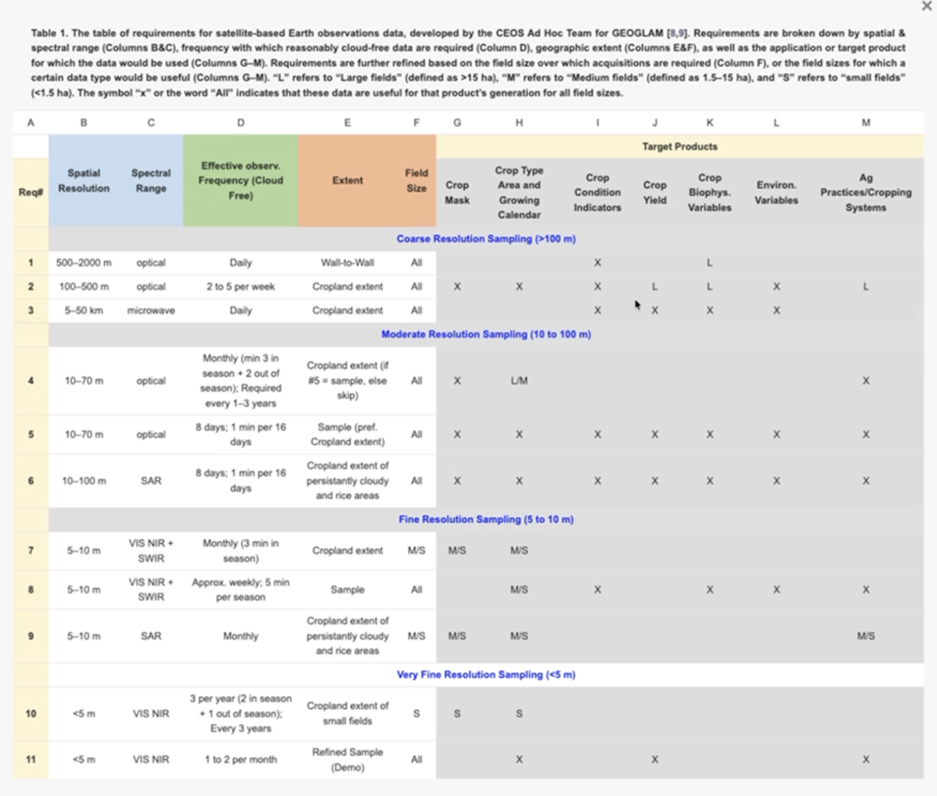
- There was discussion on the need for constellations to be considered, by ensuring the filtering is not based on the temporal resolution of a single dataset. The WGCV Surface Reflectance Consistency Project could support this combined use of datasets and potentially multi-modal applications as well.
- An example of how the product selection framework could feed into a data hierarchy / value chain was shared (below). The selection tool fits into the bottom of the value chain as an incentive for promoting CEOS-ARD datasets. EAVs would be a good input.
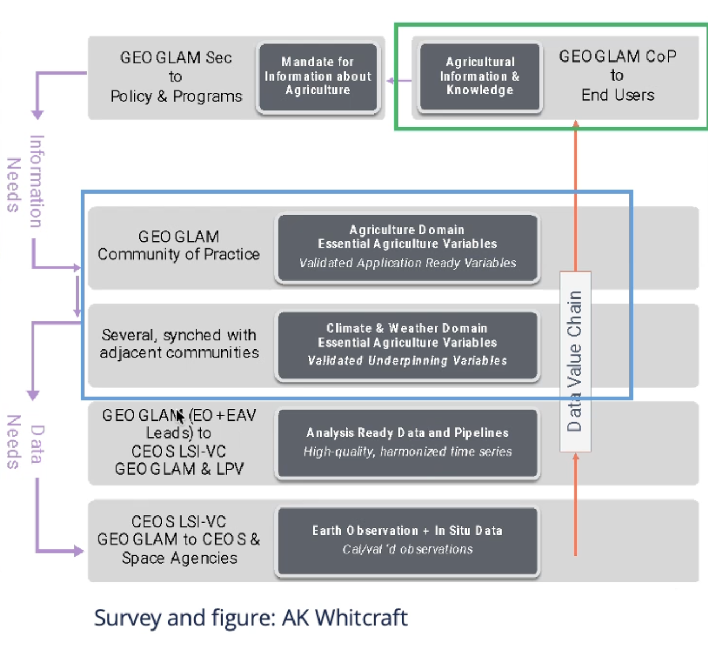
- The mapping table (above) aims to return ARD associated with each requirement across spatial scales and temporal frequency. She noted difficulties answering users' questions, and ideas to construct an EAV database. Many ‘next users’ will know about the relevant satellite data products covered by the ARD suite, so we could work further to construct a narrative around what can be used together, inclusive of uncertainty.
LSI-VC-19  Action 07 | Matt Adams to connect with Alyssa Whitcraft (LSI-VC Agriculture subgroup co-lead) regarding incorporation of the Essential Agriculture Variables work in the CEOS-ARD Product Selection Framework / fitness for purpose tool. | June 2026

Session L4: Wildfires

L4.1: LSI-VC Wildfire Subgroup [slides]
Mark De Jong (NRCan) introduced the LSI-VC Wildfire Subgroup, which aims to support coordination between agencies producing EO data for wildfire monitoring products and the downstream community, to enhance reliability and support wildfire management with current and future satellite missions. The subgroup is currently membered by nine CEOS Agencies.
A key aspect to consider is that most wildfire products used are not designed for operational use, and are often based on opportunistic observations. The community identified the need for an independent fire product endorsement process while increasing the number of systems being used for active fire and burnt area monitoring. The increasing number of ARD products has made development simpler, yet it often results in limited consistency and quality concerns across products.
A CEOS-backed fire product endorsement ‘clearing house’ should be independent of producers, authoritative, and traceable. The endorsement process could include product QA, validation, periodic assessment, and tiered endorsement levels.
Discussion
- Rob Waterman noted that Esri is seeing the same proliferation and of ARD, and emphasised the importance of it to stamp this activity as authoritative. He highlighted the need for land cover and thematic product ARD.
- Simon Ilyushchenko wrote the pipeline for NASA’s Fire Information for Resource Management System (FIRMS), which is based on MODIS pixels, not images. It would be helpful to have guidance on how to rasterize the pixels for GEE.
- Thermal commercial sector missions are being evaluated in the Copernicus MPC framework, perhaps there is an EDAP quality specification that could be leveraged. Further links to incentivising investment in data quality and validation were discussed.
- There was discussion regarding the overlap with the CEOS-ARD Surface Temperature PFS. The Wildfire Subgroup was encouraged to participate in the PFS development to ensure the necessary quality parameters are included. Active wildfire could then be a derivative of this PFS, whereby the common metrics in the ST PFS could facilitate and support data providers. It was noted that burned area would be more a derivative of the Surface Reflectance PFS.
- Linkages with the WGCV’s Land Product Validation (LPV) Subgroup were also discussed, with their Focus Area and protocols on Fire Product Validation.
LSI-VC-19  Action 08 | Harvey to follow up with Leonardo De Laurentiis of ESA regarding procedures for evaluation of thermal data products in Copernicus Mission Performance Cluster (MPC). | June 2026
LSI-VC-19  Action 09 | Harvey to ensure that the LSI-VC Wildfire subgroup and Birgit Peterson of USGS are connected to the group updating the CEOS-ARD Surface Temperature PFS. Furthermore, connect Birgit with the leads of Wildfire Pilot II under WGDisasters. | May 2026

L4.2: USGS Fire Science Activities [slides]
Birgit Peterson reported on the USGS’ fire activities, priorities, and research for pre-fire, active fire, and post-fire monitoring.
Discussion
- Matt Steventon (LSI-VC Secretariat) asked if there is a need for Fire product certification processes, as envisioned by the Wildfire Subgroup. USGS has looked at some commercial products (higher resolution is a big draw) but they need to be assessed for accuracy. A certified product process would be beneficial.
- Peter Strobl (EC-JRC) asked if there is any harmonisation between national activities for fire risk and burn severity, noting initiatives in GFOI and UN FAO.
- There is work being done to integrate between Canada and the USA, but less so beyond the continent. There is, however, a growing realisation of the global issue where sharing resources and common terminology is a bottom-line safety factor. This coordination should be actively pursued by the Wildfire Subgroup.
- If a PFS were to be developed, end users should first communicate their needs for interoperability, which would drive the development of metadata requirements.
LSI-VC-19  Action 09 | Harvey to ensure that the LSI-VC Wildfire subgroup and Birgit Peterson of USGS are connected to the group updating the CEOS-ARD Surface Temperature PFS. Furthermore, connect Birgit with the leads of Wildfire Pilot II under WGDisasters. | May 2026

L4.3: Endorsement: LSI-VC Terms of Reference Update to Incorporate the Wildfire Subgroup
Matt Steventon (LSI-VC Secretariat) shared the updated LSI-VC Terms of Reference to include the LSI-VC Wildfire Subgroup, for endorsement. A couple of editorial changes were requested and subsequently accepted.
LSI-VC-19  Decision 02 | Endorsed the updated LSI-VC Terms of Reference which includes the addition of the Wildfire subgroup and a number of other editorial changes.

Session L5: CEOS-ARD Product Family Specification Updates

L5.1: CEOS-ARD Surface Temperature PFS Version 6.0 [slides]
Harvey Jones (CEOS-ARD Secretariat) reported an update of the Surface Temperature PFS, which has convened a working group membered by the public and private thermal EO agencies following the LSI-VC-18 Meeting (Action LSI-VC-18-12).
Discussion
- Ferran Gascon (ESA) questioned the treatment of ice surface temperature under the proposed multiple measurand approach, as it is one of the focuses for LSTM. There was discussion on whether the ST PFS should be split into separate PFS for water, land, and ice surface temperature, or whether to stick with a single ST for all surface types.
- The coverage of interfaces like inland waters should be decided, as it could fall under an LST or an SST PFS with an inland water mask. The principles used by the Aquatic Reflectance PFS could be used as an example.
LSI-VC-19  Action 11 | Ferran/Harvey to seek guidance from Silvia Scifoni regarding how to treat ice surface temperature in the ST PFS update. | In progress
LSI-VC-19  Action 12 | Harvey to clarify with the ST PFS update team whether inland water is covered under the SST or LST side of the requirements. Need to discuss whether there is an inland water mask and could perhaps look at the logic used in the AR PFS as an example. | May 2026

L5.2: Endorse Version 1.0 of the Composite Backscatter SAR PFS [slides]
Ake Rosenqvist (JAXA) presented the Composite Backscatter PFS for endorsement, as an addition to the Combined SAR PFS forming Version 1.3.0.
New parameters were introduced for Composite Backscatter Processing (General Metadata), Contributing Observations Image and Composite Quality Map Image (Per-pixel Metadata), with no additions to Radiometric and Geometric Corrections Metadata.
Discussion
- The parameters in Section 1.6 highlight all the input data for all products. Peter noted that in the case of a composite product the section will vary for each pixel, blurring the General and Per-pixel metadata sections.
- Composite mosaics apply equally to optical data. We should ensure definitions for ‘Composite’ and ‘Mosaic’ are added to the EO Glossary, with WGCV’s input too. Composites and mosaics should apply, in theory, to any of the products we have in CEOS-ARD.
- Consistency between the Composite Backscatter and optical PFS should be ensured, so the endorsement decision was postponed until the upcoming CEOS-ARD Oversight Group Meeting.

Day 2: Wednesday, April 22, 2026

Session L7: 2026 CEOS-ARD Strategy Pillar: Standards and Interoperability

L7.1: Introduction [slides]
Matt Adams (GA) presented the context of the Standards and Interoperability pillar of the CEOS-ARD Strategy.

L7.2: Existing ISO standards and the cross walk to CEOS-ARD [slides]
Ivana Ivanova (Curtin University) presented an overview of ISO/OGC standards related to CEOS-ARD and the systematic review undertaken by Curtin on ARD standards and reproducible workflows. An example presented the construction of metadata profiles as a combination of existing ISO standards.
Relevant standards in ISO include 19176 (ARD), 19115-1:2014 (Metadata Fundamentals), 19115-2:2019 (Extension of -1 with ISO 19157 as normative reference; contains acquisition and processing related metadata). 19115-2:2019 is very relevant to ARD production. Also ISO 19115-4 on JSON encoding, 19157 (data quality), 19124 series on cal/val specifications; 19130-1/2 (imagery sensors for geopositioning); and 19131 (data product specification). The 19100 series of metadata is being reviewed to evaluate what needs to be extracted in order to enable ARD.
Discussion
- Siri Jodha Khalsa (IEEE) pointed to the heterogeneity of the ARD definition across the various references, and asked if CEOS-ARD had significant weighting among other standards.
- The research uncovered terminological mismatches, with varying definitions. 19176 was expected to bring some consensus on the definition. The main focus is ensuring a comprehensive and consistent metadata profile.
- Peter noted the STAC example, with its adoption raising the need for more agile standards. The closed nature of ISO is not helpful and incompatible with the CEOS-ARD ‘EO for Everyone’ vision. An OGC community standard could be the approach to create an open metadata mapping.
- Matthias Mohr (SEO) added that STAC is getting adopted due to its openness, being easily extensible and simple to read, and having broad software support.

L7.3: Candid Core Framework [slides]
Simon (Vsevolod) Ilyushchenko (Google, Earth Engine) shared a series of case studies and recommendations on data governance journeys, and the impacts of making decisions from uncertain data.
Discussion
- Chris Barnes (KBR/USGS) noted that capturing the value of CEOS-ARD has become a priority for the CEOS-ARD Strategy, under the Adoption, Enablement & Impact pillar. Matt Steventon (LSI-VC Secretariat) noted the relevance of the Candid Core framework to the AI Enablement & Trustworthy Geospatial Foundation Models (GFM) pillar.
- There was discussion on the importance of consistent terminology, with the term “Translation is betrayal”. Value judgements were also discussed, and the difficulty of representing the suitability of a product generically at the data card level.
- The Candid Core framework is user facing, focused on their needs.

L7.4: CEOS-ARD UML [slides]
Sumit Sen and Siri Jodha Khalsa reported on metadata modeling with Universal Modeling Language (UML), and using ISO 19115-2 to model CEOS ARD.
ISO 19115-2 provides a strong foundation for CEOS ARD with core capabilities like lineage, quality, and acquisition metadata are already supported; enabling a large portion of ARD to be modeled without introducing extensions.
However, ARD requirements go beyond ISO's native scope, missing support for pixel-level quality and bitmasks, algorithm parameter provenance, and multi-stage processing chains. UML is essential for formalisation and validation, clear conceptual modelling, standardised interpretation across agencies, and to ensure compatibility with STAC.
Discussion
- The CEOS-ARD SAR XML format covers all the requirements in the metadata file, in a direct mapping. UML can be encoded in XML/JSON, and looks at the entire framework. We would need to ensure the XML metadata spec, UML, and CEOS-ARD building blocks are all aligned. WGISS should also be involved in these discussions, with connection to WGISS Connected Data Assets (CDA).
- Damiano Guerrucci (ESA, WGISS Vice Chair) noted interest to have a UML for CEOS-ARD, which could include all the different characterisations and encoding of ARD.
- A good a priori model will make subsequent steps easier. WGISS is looking more at the discovery of ARD, and any further depth into its characteristics require deeper dives into the model.
- Peter Strobl (EC-JRC) recognised some conceptual and semantic issues, especially when considering higher level products. Analysis ready ‘data’ or ‘products’ is a huge point of confusion requiring clarification at the conceptual level. Simon added that ‘dataset’ is too vague, and referenced this blog post from CNG.
- The CEOS-ARD Strategy should have an initiative to align terminology, using the EO glossary. Matt sketched out a diagram on a whiteboard of the different stakeholders that need to be part of the coordination.
- Increasing consistency through the building blocks and ensuring terminology consistency between them is the single most important thing we can tangibly do to improve interoperability and provide a solid foundation for ARD.
LSI-VC-19  Action 13 | Peter to provide a shortlist of important terms that need to be agreed before the UML diagram can proceed – working to ensure all terms are included in the CEOS EO glossary. | June 2026

L7.5: CEOS-ARD Discoverability and Accessibility [slides]
Yves Coene (ESA/Spacebel) reported on the collaboration between WGISS, WGCV, CEOS-ARD OG, and SEO to develop a ‘Guide to Enable Discoverability of Datasets.’
Brian Terry (SEO) shared the need for established processes for publishing new PFS and the auto-generation of a uniform resource identifier (URI). URIs for the latest PFS versions should not change, but we should retain the ability to have URIs that point to past versions.
The CEOS-ARD Oversight Group should decide on whether the URI process needs to be moderated in the CEOS-ARD Governance Framework. There was discussion about creating a machine readable definition of the PFS, including the URI, acronym, and a two line description of what this product family is.
LSI-VC-19  Action 14 | CEOS-ARD Secretariat to raise for Oversight Group discussion the need for the URI generation process for all PFS versions to be moderated (in the context of the CEOS-ARD discoverability and accessibility work ongoing under WGISS). The agreed process should be reflected in the CEOS-ARD Governance Framework update. | June 2026
LSI-VC-19  Action 15 | Matthias to work with Yves Coene on a mechanism for generating a small description of each PFS so that it can support the work on URIs/discoverability and accessibility. | July 2026
LSI-VC-19  Action 16 | LSI-VC Secretariat to organise a CEOS-ARD Development Sprint alongside LSI-VC-20 as a means to accelerate the CEOS-ARD Building Blocks work, among other topics. | September 2026.

L7.6: Update on OGC/ISO Standards and Engagement [slides]
Dave Borges (SEO) reported on the latest target for the OGC ARD Standards Working Group to Domain Working Group vote and Stage 0 -> Stage 1 ISO TC/211 motion.
At the ISO/TC 211 62nd Plenary, the preliminary work item could either progress to Stage 1 to begin standard development, stay at Stage 0 for another six months, or cancel the project entirely. There was consensus to cancel the ISO 19176-1 Preliminary Work Item.
Discussion
- CEOS and OGC leadership supported the conversion from SWG → DWG. Open questions include whether we target June or October for the conversion, and who will co-chair the group (minimum 2 required).
- Through a DWG, an OGC Community Standard (the same as STAC) can be pursued. Through this, an OCC Community Standard could be leveraged into ISO. An alternative is to create an OGC Best Practice and re-establish a joint OGC/ISO SWG.
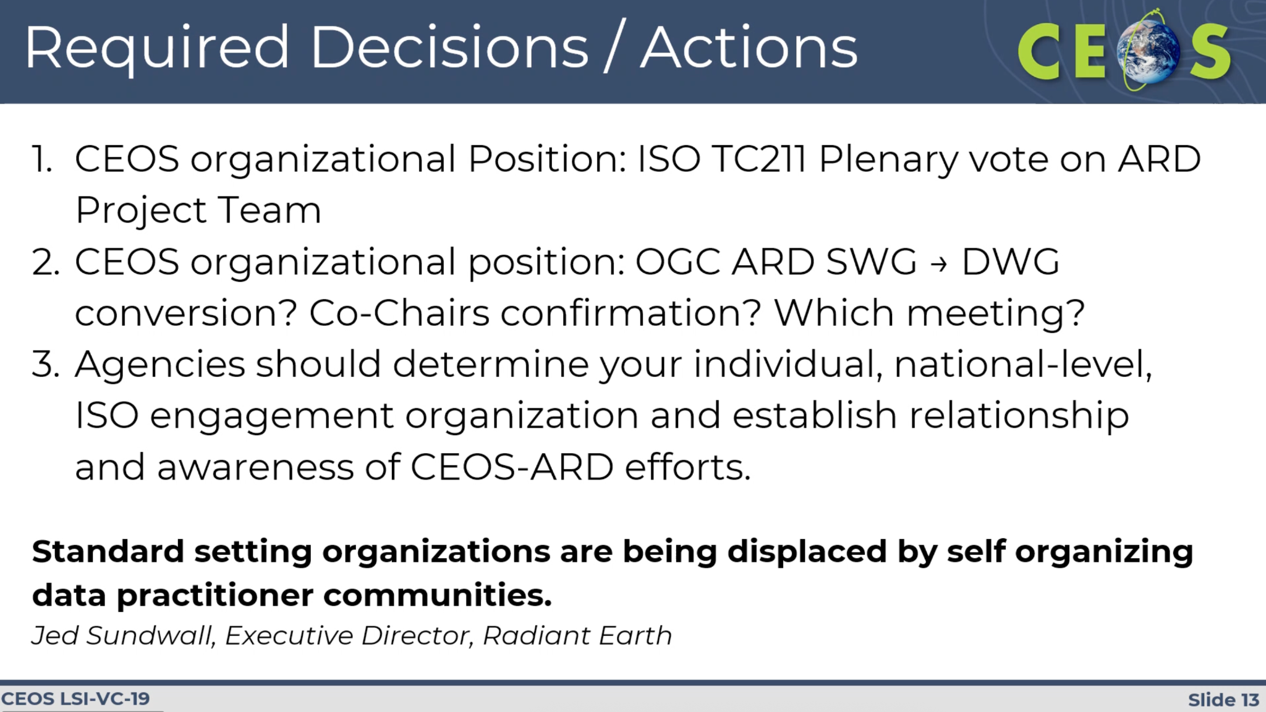
- GA and Siri Jodha Khalsa have been identified as interested in co-chairing the eventual DWG.
- Andreas Brunn (Constellr) offered to make a connection with German NSB, while Matt S follows up Norway through CEOS Chair team and Asmund Tjora, and Sumit offered to connect with the Indian standards body.
​​LSI-VC-19  Decision 03 | LSI-VC agreed with the proposed motion to cancel the ISO 19176-1 Stage 0 Preliminary Work Item.
LSI-VC-19  Decision 04 | Agreed that a final OGC ARD SWG meeting should be convened in Helsinki in the first week of June to propose a motion to dissolve the SWG and convert it to a DWG, which could then proceed to develop an OGC Community Standard for CEOS-ARD.
LSI-VC-19  Action 17 | Dave and Chris to generalise and share existing boilerplate text for engaging national standards bodies on the issue of the ISO 19176-1 discontinuation motion. | April 2026
LSI-VC-19  Action 18 | Dave to follow up with Scott Simmons of OGC to communicate LSI-VC-19 Decision 04 regarding the way forward for a transition of the OGC ARD SWG to a DWG and development of an OGC Community Standard for CEOS-ARD. | April 2026

L7.7: CEOS-ARD in the Cloud (VC-23-06) [slides]
Megan Rush (KBR/USGS) reported on the implementation of the USGS collections in the cloud, including STAC and the work done to define Landsat Collection 3.
Discussion
- Esri and GEE confirmed they do not use checksums when ingesting. Although they are useful for authenticity purposes.
- Simon shared an analysis done with AGU/NASA on determining the provenance of a pixel that is complicated by different access points, etc.
  - https://medium.com/google-earth/ensuring-dataset-replication-integrity-in-earth-engine-a-collaborative-approach-0a330a4044bc
  - https://developers.google.com/earth-engine/datasets/papers/AGU_2023_NASA_GEE_replicas.pdf
- The target timeline for Landsat Collection 3 is 2029, with Critical Design Review in 2028.
- Simon noted that GEE is a heavy user of the USGS/EROS Machine-to-Machine (M2M) Application Programming Interface (API), and commended its utility.

L7.8: Discussion
Moderators: Ferran Gascon (ESA), Matt Adams (GA)
- The PFS should be cross-checked to ensure consistency of terminology and reference the CEOS EO Glossary as a core architecture. The need for higher precision across metadata requirements was discussed, as well as caution when referencing specific standards.
- There was discussion around adding new metadata requirements with the building block structure, and their mapping from YAML to other formats like STAC or ISO references. The UML should be written and then integrated into the building block structure.
- STAC was able to move quickly with a healthy representation of different communities. They had in their early phase practitioners, programmers, etc, highlighting the importance of engaging a broad community to develop an effective standard.
LSI-VC-19  Action 19 | LSI-VC Secretariat to connect with Simon regarding end user studies that have been compiled via the GEE community. | June 2026

Session L8: AOB

L8.1: PolSAR Project Update and SAR-VC Considerations [slides]
Ake reported progress on the PolSAR activity, with connections made to various mission operators.
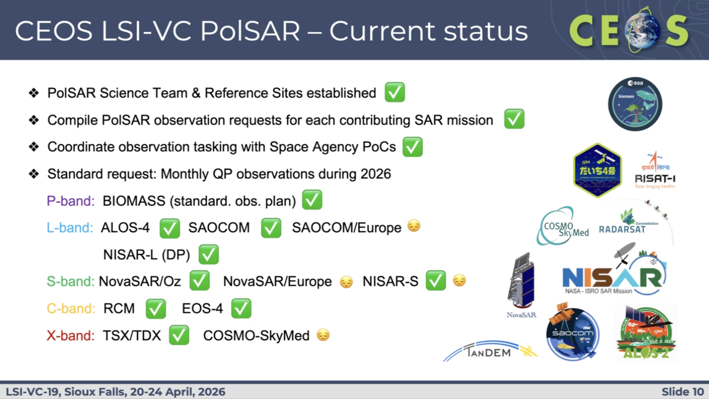
- The team is using the CEOS Analytics Lab in the PolSAR data repository, although there is no capability in CAL for polarimetric analysis yet.
- With a SAR-VC likely to be established, potential implications for LSI-VC were discussed. The VC will be membered by the existing International Coordination Group for Spaceborne Synthetic Aperture Radar (ICGS-SAR).
- The PolSAR activity aligns with ICGS-SAR Thematic Area 1 on Polarimetric and Multi frequency SAR. Transitioning the activity from LSI-VC to SAR-VC would be reasonable.
- Wetlands and Ramsar are a natural part of AFOLU under LSI-VC, while SAR-VC will be focused on technical coordination, not policy. Ake proposed to keep the topic in LSI-VC.
- The CEOS-ARD SAR team coordination would be relevant to both LSI-VC and SAR-VC, requiring the CEOS-ARD Oversight Group to act as a bridging solution. It is important to keep coordination between the SAR and optical PFS.
- SAR-VC is the natural ‘badge’ home for the SAR PFS and the SAR CEOS-ARD team. Ake could serve as the SAR-VC representative to Oversight Group, taking another step towards a more robust representation of VCs in the group.
LSI-VC-19  Decision 05 | Noting that a SAR Virtual Constellation seems likely to eventuate at the 2026 CEOS Plenary, it was agreed that:  - The PolSAR activity currently under LSI-VC should move to the SAR-VC.  - The SAR CEOS-ARD PFS development activity will be branded as a SAR-VC output, but development will continue within the existing group of people engaged by Ake (not necessarily SAR-VC members) and a critical bridge maintained to LSI-VC meetings via Ake and Takeo.  - SAR-VC should be represented in the CEOS-ARD Oversight Group by Ake and Takeo.  - The wetlands and Ramsar work of LSI-VC needs to continue under the LSI-VC Forests and Biomass umbrella, as it is a core CEOS AFOLU Roadmap task.

L8.2: LSI-VC-20 Meeting Plans
The LSI-VC-20 Meeting will be held around the 2026 SIT Technical Workshop (8-10 September 2026 in Washington DC, USA). Options for locations and dates were discussed, as well as the next CEOS-ARD PFS Development Sprint to be held alongside LSI-VC-20.
LSI-VC-19  Decision 06 | LSI-VC-20 will be held on September 14-16, the week after the 2026 SIT Technical Workshop at USGS Headquarters in Reston, Virginia. September 14 will be designated as a CEOS-ARD Development Sprint and Oversight Group meeting day (with participation of all LSI-VC members encouraged).

Appendix A: List of Participants
In person |  | Virtual
Agency | Full Name | Agency | Full Name
Constellr | Andreas Brunn | BIS India | Sumit Sen
EC-JRC | Peter Strobl | CEOS Executive Officer Team | Julia Caufape
ESA | Ferran Gascon | Curtin University | Ivana Ivanova
Esri | Rob Waterman | ESA | Damiano Guerrucci
GA | Matt Adams | ESA / Spacebel | Yves Coene
Google Earth Engine | Simon Ilyushchenko | GEOGLAM | Alyssa Whitcraft
IEEE | Siri Jodha Khalsa | GISTDA | Pawarin Kuha
JAXA | Takeo Tadono | ISRO | P.V. Jayasri
JAXA | Ake Rosenqvist | ISRO | Keerthi
Matt Steventon | LSI-VC Secretariat | MYSA | Wayne Su Wai
NASA | Rodrigo Vieira Leite | NASA | Quiang Zhou
NASA | Margeret Wooten | NCVC | Neil Sims
SEO | Dave Borges | NRCan | Mark De Jong
SEO | Brian Terry | SEO | Matthias Mohr
USGS | Evan Neuwirth | USGS | Chase Mueller
USGS | Birgit Peterson | USGS | Todd Taylor
KBR/ USGS | Megan Rush
KBR/USGS | Chris Barnes

Appendix B: Decisions
LSI-VC-19 Decision 01 | Further development of the Product Selection Framework / fitness for purpose application presented by Matt Adams was supported.
LSI-VC-19  Decision 02 | Endorsed the updated LSI-VC Terms of Reference which includes the addition of the Wildfire subgroup and a number of other editorial changes.
​​LSI-VC-19  Decision 03 | LSI-VC agreed with the proposed motion to cancel the ISO 19176-1 Stage 0 Preliminary Work Item.
LSI-VC-19  Decision 04 | Agreed that a final OGC ARD SWG meeting should be convened in Helsinki in the first week of June to propose a motion to dissolve the SWG and convert it to a DWG, which could then proceed to develop an OGC Community Standard for CEOS-ARD.
LSI-VC-19  Decision 05 | Noting that a SAR Virtual Constellation seems likely to eventuate at the 2026 CEOS Plenary, it was agreed that:  - The PolSAR activity currently under LSI-VC should move to the SAR-VC.  - The SAR CEOS-ARD PFS development activity will be branded as a SAR-VC output, but development will continue within the existing group of people engaged by Ake (not necessarily SAR-VC members) and a critical bridge maintained to LSI-VC meetings via Ake and Takeo.  - SAR-VC should be represented in the CEOS-ARD Oversight Group by Ake and Takeo.  - The wetlands and Ramsar work of LSI-VC needs to continue under the LSI-VC Forests and Biomass umbrella, as it is a core CEOS AFOLU Roadmap task.
LSI-VC-19  Decision 06 | LSI-VC-20 will be held on September 14-16, the week after the 2026 SIT Technical Workshop at USGS Headquarters in Reston, Virginia. September 14 will be designated as a CEOS-ARD Development Sprint and Oversight Group meeting day (with participation of all LSI-VC members encouraged).

Appendix C: Actions
LSI-VC-19  Action 01 | Peter to engage KCEO colleagues including Mark Dowell in the Product Selection Framework / fitness for purpose application, with a view to reusing their past work on fitness for purpose and application requirements. | June 2026
LSI-VC-19  Action 02 | LSI-VC team to contribute updates to the 2026 revision of the CEOS-ARD Governance Framework. | July 2026
LSI-VC-19  Action 03 | ISRO to share details of their NISAR Level-4 application data products so that the specifications can help inform development of the CEOS-ARD Product Selection Framework application. | June 2026
LSI-VC-19  Action 04 | Matt Adams to connect with Neil Sims of GEO-LDN regarding development of land degradation profiles for the CEOS-ARD Product Selection Framework (fitness for purpose tool) and potential inclusion of the tool in UNCCD/GEO-LDN reporting guidance and support packages. | July 2026
LSI-VC-19  Action 05 | Ake to follow up with Neil Sims regarding incorporation of SAR into GEO-LDN approaches to fill gaps in optical derived NDVI. | May 2026
LSI-VC-19  Action 06 | Matt to follow up with Simon (Google Earth Engine) regarding potential contributions for the CEOS AFOLU Portal. | June 2026
LSI-VC-19  Action 07 | Matt Adams to connect with Alyssa Whitcraft (LSI-VC Agriculture subgroup co-lead) regarding incorporation of the Essential Agriculture Variables work in the CEOS-ARD Product Selection Framework / fitness for purpose tool. | June 2026
LSI-VC-19  Action 08 | Harvey to follow up with Leonardo De Laurentiis of ESA regarding procedures for evaluation of thermal data products in Copernicus Mission Performance Cluster (MPC). | June 2026
LSI-VC-19  Action 09 | Harvey to ensure that the LSI-VC Wildfire subgroup and Birgit Peterson of USGS are connected to the group updating the CEOS-ARD Surface Temperature PFS. Furthermore, connect Birgit with the leads of Wildfire Pilot II under WGDisasters. | May 2026
LSI-VC-19  Action 10 | Matt Steventon to publish the new LSI-VC Terms of Reference, which incorporates the Wildfire subgroup, on the CEOS website. | May 2026
LSI-VC-19  Action 11 | Ferran/Harvey to seek guidance from Silvia Scifoni regarding how to treat ice surface temperature in the ST PFS update. | May 2026
LSI-VC-19  Action 12 | Harvey to clarify with the ST PFS update team whether inland water is covered under the SST or LST side of the requirements. Need to discuss whether there is an inland water mask and could perhaps look at the logic used in the AR PFS as an example. | May 2026
LSI-VC-19  Action 13 | Peter to provide a shortlist of important terms that need to be agreed before the UML diagram can proceed – working to ensure all terms are included in the CEOS EO glossary. | June 2026
LSI-VC-19  Action 14 | CEOS-ARD Secretariat to raise for Oversight Group discussion the need for the URI generation process for all PFS versions to be moderated (in the context of the CEOS-ARD discoverability and accessibility work ongoing under WGISS). The agreed process should be reflected in the CEOS-ARD Governance Framework update. | June 2026
LSI-VC-19  Action 15 | Matthias to work with Yves Coene on a mechanism for generating a small description of each PFS so that it can support the work on URIs/discoverability and accessibility. | July 2026
LSI-VC-19  Action 16 | LSI-VC Secretariat to organise a CEOS-ARD Development Sprint alongside LSI-VC-20 as a means to accelerate the CEOS-ARD Building Blocks work, among other topics. | May 2026.
LSI-VC-19  Action 17 | Dave and Chris to generalise and share existing boilerplate text for engaging national standards bodies on the issue of the ISO 19176-1 discontinuation motion. | April 2026
LSI-VC-19  Action 18 | Dave to follow up with Scott Simmons of OGC to communicate LSI-VC-19 Decision 04 regarding the way forward for a transition of the OGC ARD SWG to a DWG and development of an OGC Community Standard for CEOS-ARD. | April 2026
LSI-VC-19  Action 19 | LSI-VC Secretariat to connect with Simon regarding end user studies that have been compiled via the GEE community. | June 2026

