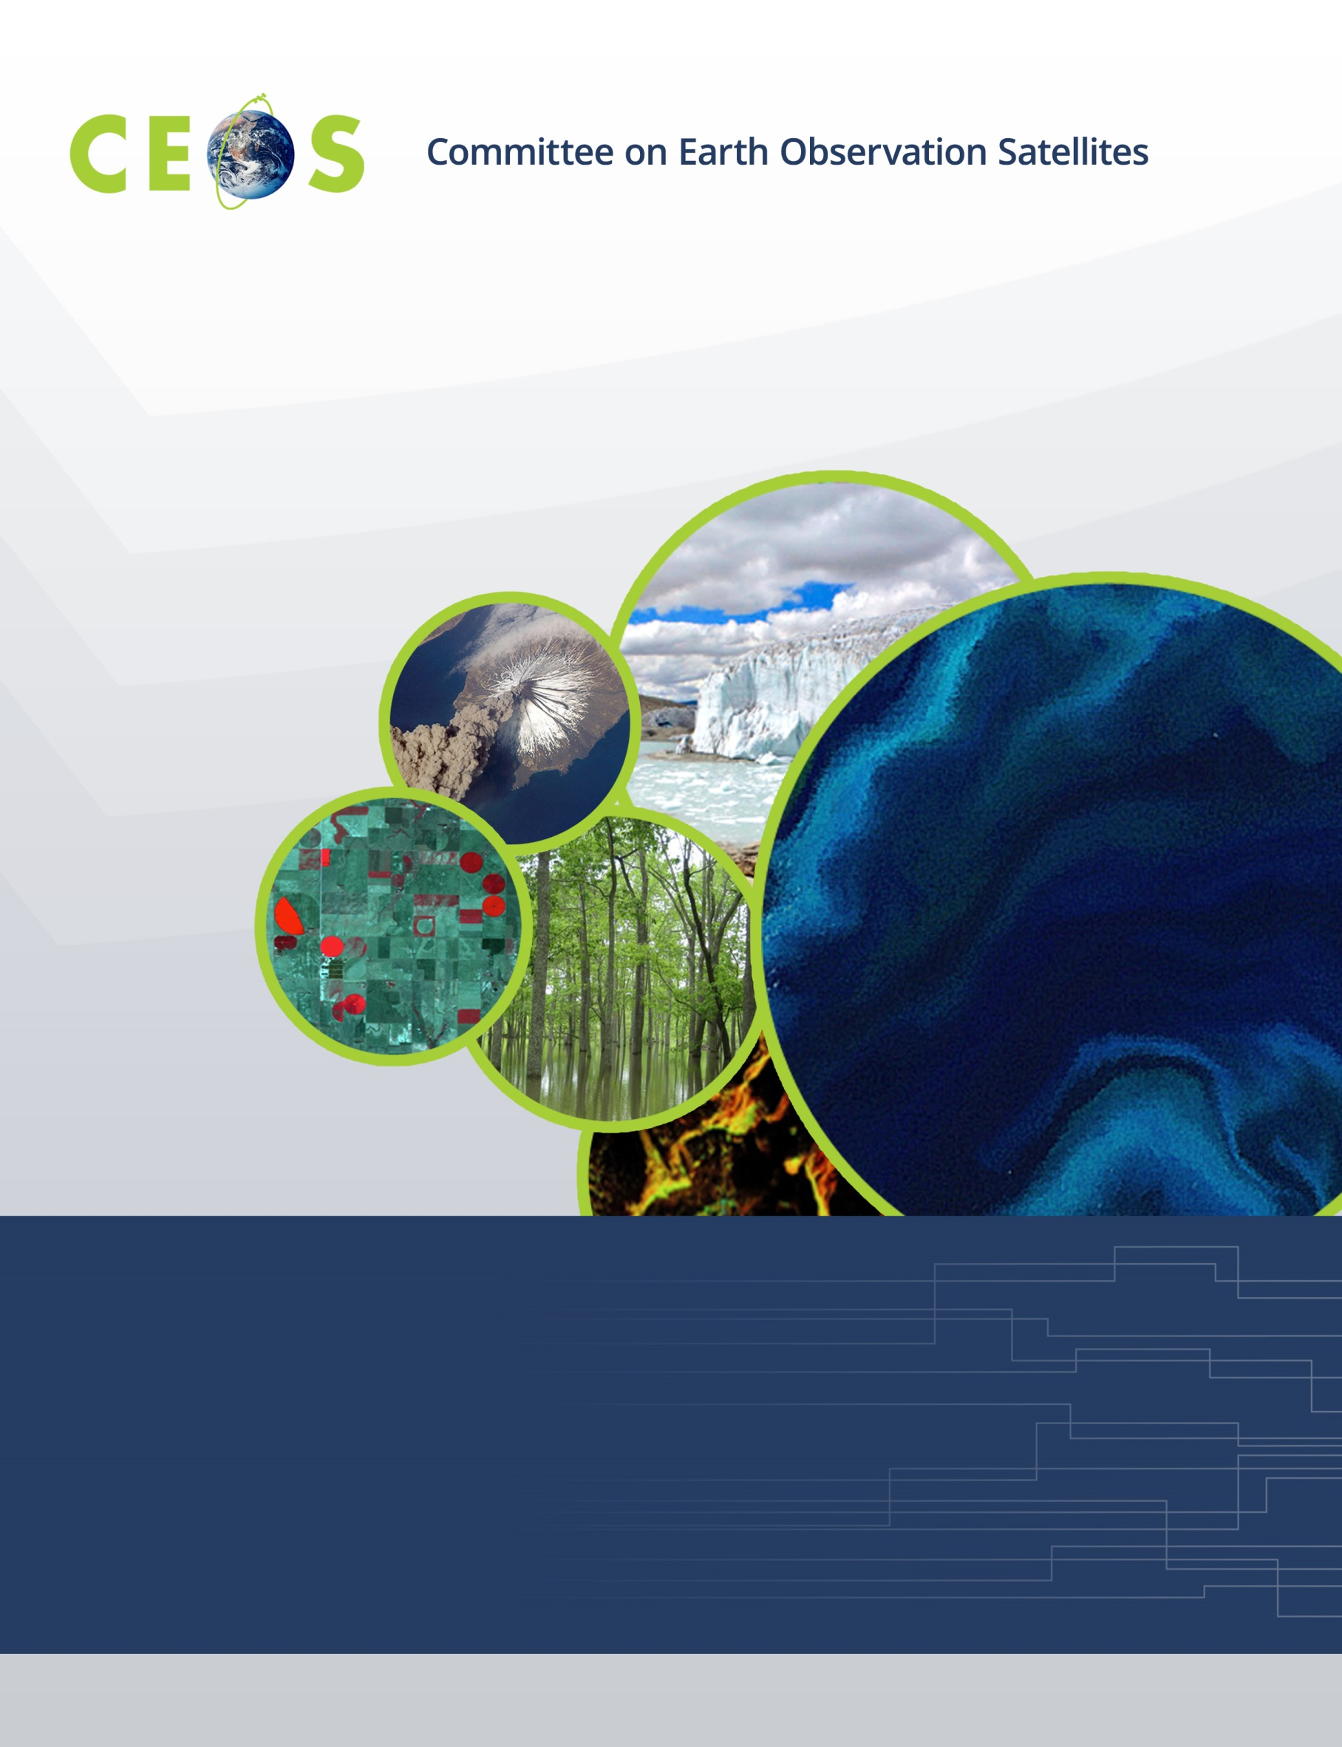

WGCapD Support to AmeriGEOSS Week Disaster Training Report
CEOS WGCapD Support to AmeriGEOSS Week Disaster training
DRAFT REPORT
6-9 June 2016

Hosted by: The government's Institute of Hydrology, Meteorology, and Environmental Studies (IDEAM) hosted the meeting on the campus of the National University of Colombia

Location: National University of Colombia, Bogota, Colombia

Participants in AmeriGEOSS Week 2016, including Americas Caucus members, Coordination Working Group members, and training participants.

The Committee on Earth Observation Satellites’ (CEOS) Working Group on Capacity Building & Data Democracy (WGCapD) supported SAR training for the disasters session. The training included an overview of SAR, an introduction to geohazards applications of InSAR, and the specific application to volcanic deformation and the seismic cycle.

WGCapD member from ESA (Francisco Sarti) provided support for Dr. Jill Pearse from the Universidad de los Andes to provide SAR training. On behalf of WGcapD, instruction was provided on the application of SAR data for two days. Instruction for the remaining two days was provided by NASA. There were 25 participants mainly from Colombia as well as from other AmeriGEOSS countries (Argentina, Bahamas, Belize, Brazil, Canada, Chile, Colombia, Costa Rica, Ecuador, Honduras, Mexico, Panama, Paraguay, Peru, the United States, and Uruguay). Participants were from governments and universities.

Other CEOS WGCapD members contributed significantly to the training, although these contributions were coordinated through their GEO contributions. These contributors include NOAA, USGS, and INPE.

Stu Frye, instructor in disasters session.

The agenda for the meeting is included in Appendix 1.

On the last day of the workshop, the participants were required to complete a survey of the course, with the following results:
• More than 50% highly agreed or agreed objectives were clearly defined.
• Less than 50% thought participation was promoted.
• More than 50% found the topics relevant to their work
• Over 50% thought the content was organized and easy to follow.
• More than 75% found the material and presentations helpful.
• More than 75% acquired knowledge useful to their work.

Lessons learned from the instructors was the importance of teaching in Spanish for better uptake by the participants. Lessons learned by the organizers is the importance to be clear about responsibilities and attribution between the various contributors to the training.

Appendix I
AmeriGEOSS Week: Train the Trainer Workshop on Disasters in the Americas
Utilizing Remote Sensing Models and Monitoring
7 - 10 June, Bogotá Colombia
Universidad Nacional, Edificio Insignia de Ingeniería (Edif 401)
AGENDA
Instructors:
Mr. Stuart Frye, NASA Goddard Space Flight Center - Greenbelt, MD 20771
Dr. Jill Pearse, Universidad de Los Andes (Colombia)

07 June 2016 Tuesday – Overview of Remote Sensing Capabilities for Disasters,
Instructor: Stuart Frye/NASA

08:30 – 09:00 Registration and Arrival
09:00 – 10:00 Welcome, and Introductions – AmeriGEOSS Plenary
10:00 – 10:15 Break
10:15 – 11:00 Review of satellite and other remote sensing platforms…missions,
instruments, and measurements – Mr. Stuart Frye
11:00 – 11:30 Disaster cycle and response timeline
11:30 – 12:00 Regional focus groups and training on informing disaster management
protocols to include satellite and UAS products
12:00 – 13:00 Lunch
13:00 – 16:00 Satellite data processing algorithms, visualization software, tools, and
example products
16:00 – 16:30 Wrap up first day

08 June 2016 Wednesday

08:30 – 9:00 Arrival
09:00 – 10:00 Assimilated “nowcasts” and predictive models from satellite data
10:00 – 10:30 Product formats, distribution techniques, and user feedback mechanisms
10:30 – 11:00 Break
11:00 – 11:30 Data access and coordination with International Disaster Charter
11:30 – 12:00 AmeriGEOSS Disasters Working Group organization and coordination
12:00 – 13:00 Lunch
13:00 – 15:45 How to request NASA and CEOS data and products…Where to find them
15:45 – 16:00 Wrap up second day

09 June 2016 Thursday – Applications of SAR for Volcanology and Seismology,
Instructor: Dr. Jillian Pearse

09:00 Overview and introduction to satellite-based SAR – Dr. Jillian Pearse
09:30-10:30 Synthetic Aperture Radar: Theory
10:30-11:00 Break
11:00-12:00 InSAR: Theory
12:00-13:00 Lunch
13:00-15:45 InSAR theory continued; data acquisition and processing; Introduction to
Sentinel Toolbox, process flow and interferogram formation; image
characteristics
15:45-16:00 Wrap up third day

10 June 2016 Friday

09:00-09:30 Introduction to geohazards applications of InSAR
09:30-10:30 Volcanic deformation: interpretation
10:30-11:00 Break
11:00-12:00 Volcanic deformation: modeling
12:00-13:00 Lunch
13:00-15:45 InSAR and seismic cycle: interpretation and modeling
15:45-16:00 Wrap-up and Adjourn

