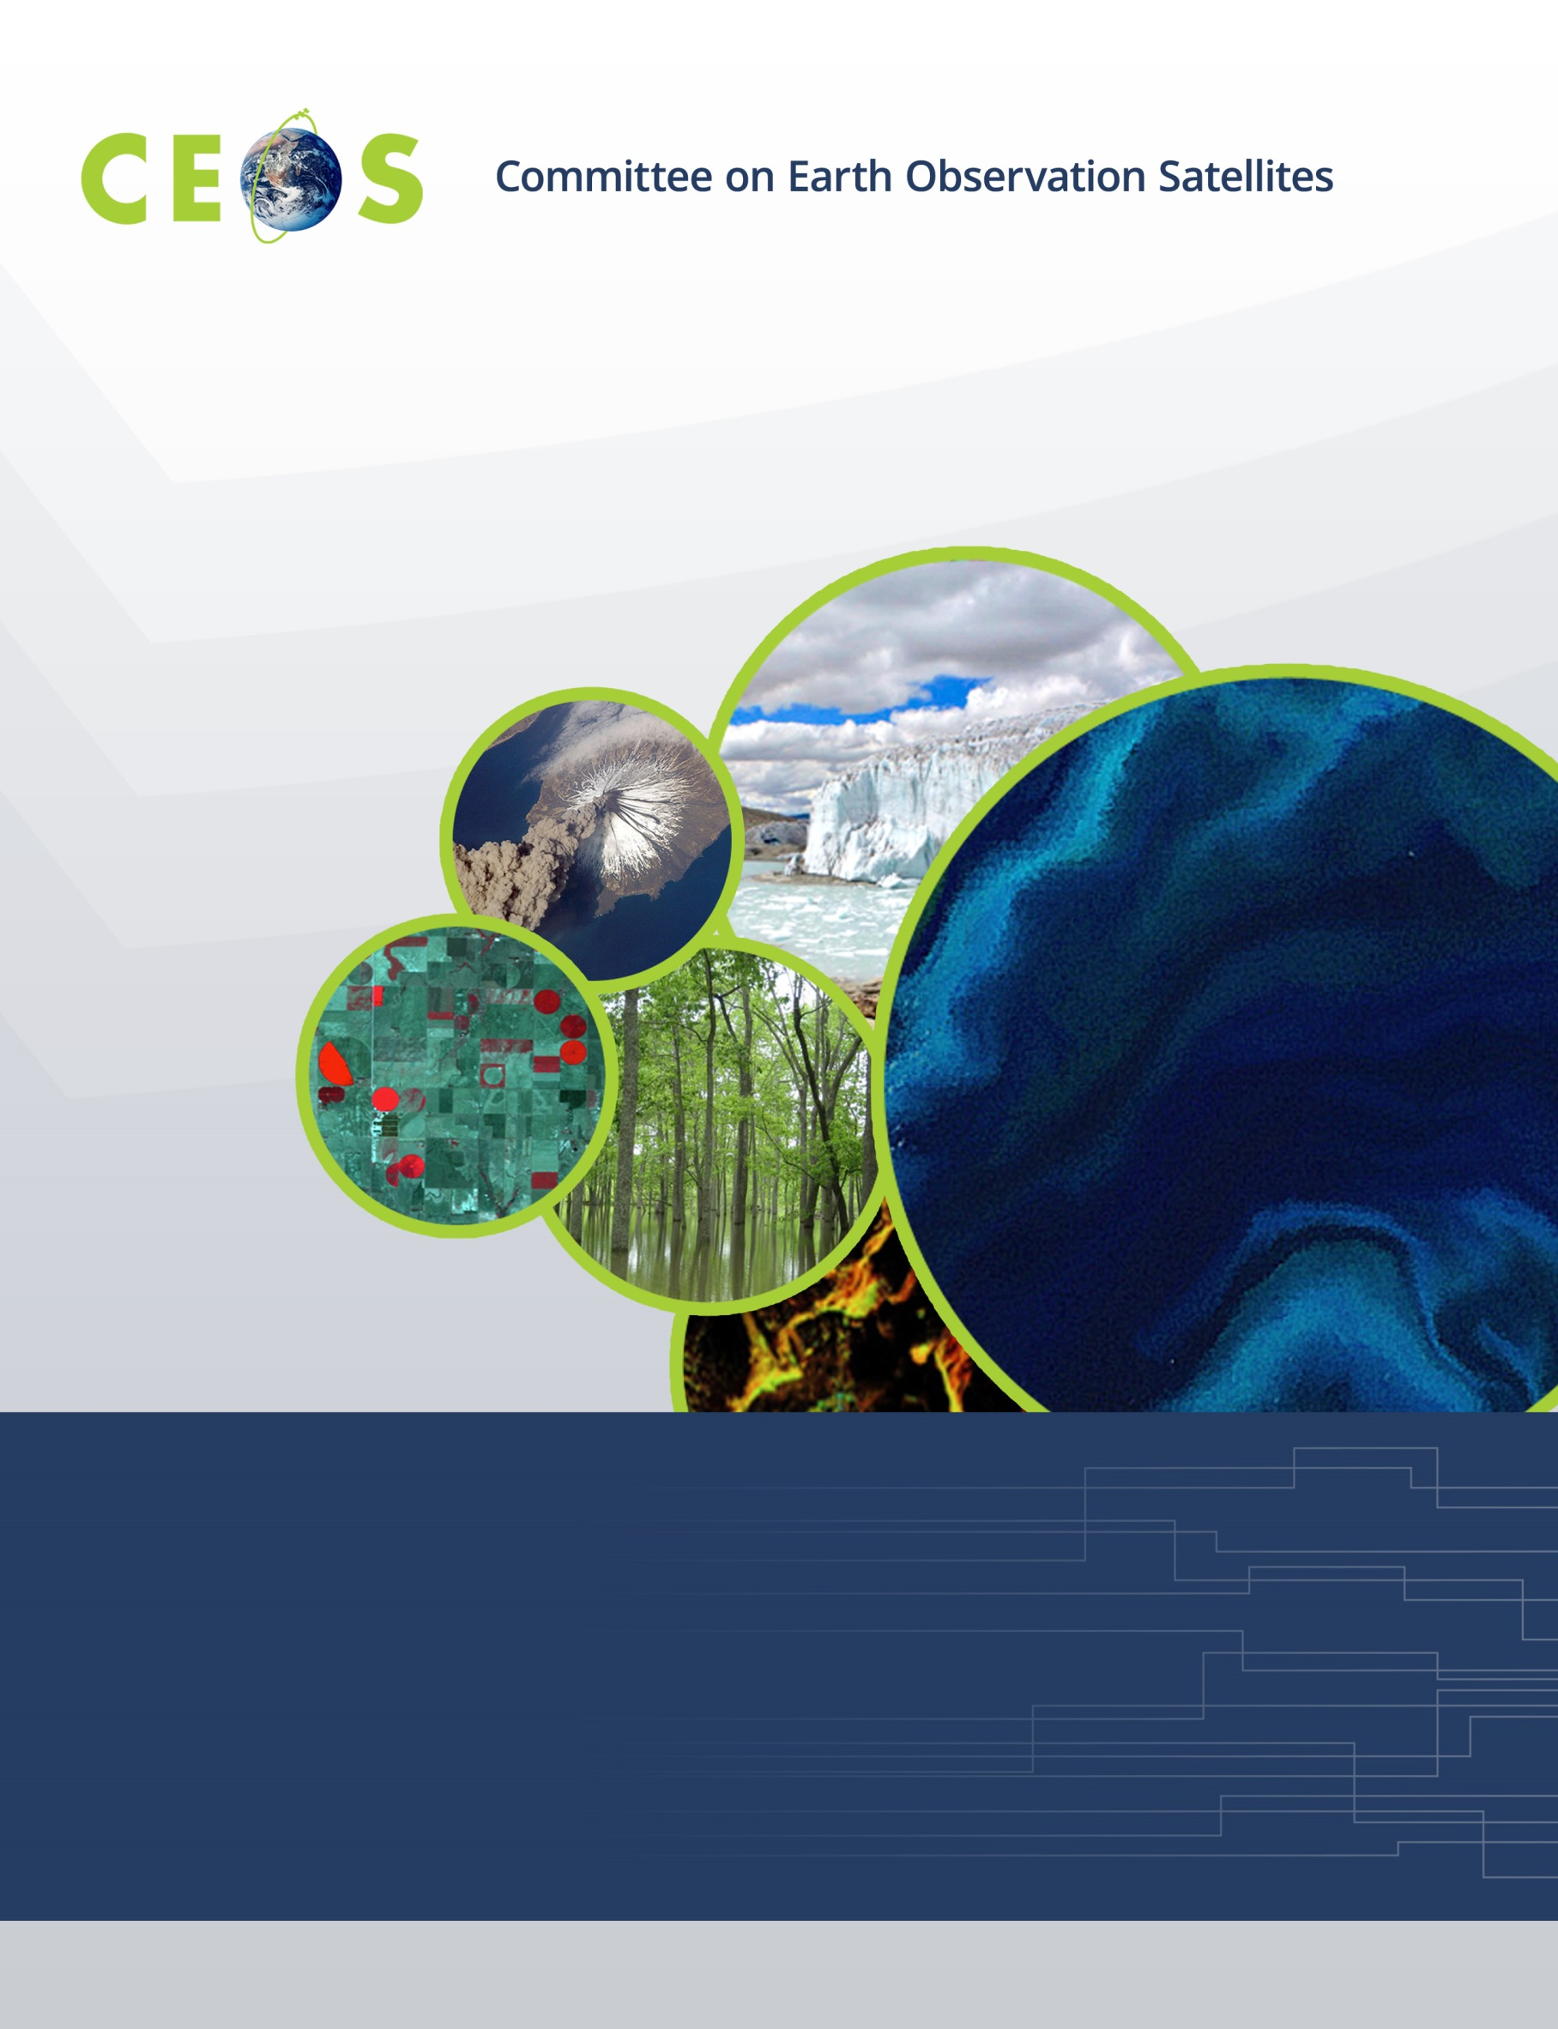
CEOS WGCapD Post-Training Questionnaire
Sample Questions

v.1 (April 2020)
Post-Training Questionnaire

About Trainee: (optional)

Name:
Organization:
Country:
Gender:

How did you hear about this training? Circle one.

CEOS listserv email
Email from a colleague
Online Search
CEOS training calendar
Social media posting
CEOS member agency’s website
Other

Was this the first CEOS training you’ve taken? Circle one. Yes No
Training Feedback:
Please reflect on the following statements and provide your level of agreement by putting a mark in the corresponding box. | Strongly Disagree | Disagree | Neutral | Agree | Strongly Agree
Training objectives were clear.
The content presented aligned with training objectives.
In general, instructors were well prepared and clearly presented their ideas and information.
The amount of time I spent taking this training was appropriate for the amount of information I learned.
The training increased my awareness of Earth observation resources available.
My capacity to use Earth observations has been improved through this training.
The training provided information useful and relevant to my work.
I plan to use information learned in the training in my work.
If you experienced any obstacles to your learning, please describe. (e.g. technical issues, language barriers)
Any comments you'd like to share about the training?
Feedback for Future Trainings:
Do you have any suggestions for how to improve future trainings like this?

What Earth observation-related topics might help you in your decision making processes and would you suggest that future trainings focus on?

