WGCapD-10: Guidance on Meeting Platforms

- Meeting ground rules

- Please mute your microphone when not speaking.
- For Q+A sessions, please use the hand-raising function (see image below) or write your question in the chat.
- Please be brief in your interventions.

- GoToMeeting is the main meeting platform.
https://www.gotomeet.me/WGCapD/ceos-wgcapd-10-annual-meeting
- You may join via the desktop app or the browser, which uses a Chrome extension. The desktop app gives you more functions.
- Recommended use of cameras:
  - Keep camera ON during the opening and introduction sessions and during discussions
  - Turn cameras OFF during the Session 2 and 3 panels. Choose “active camera view” to display the panelists (See Image below). That will give us a true “panel” look.

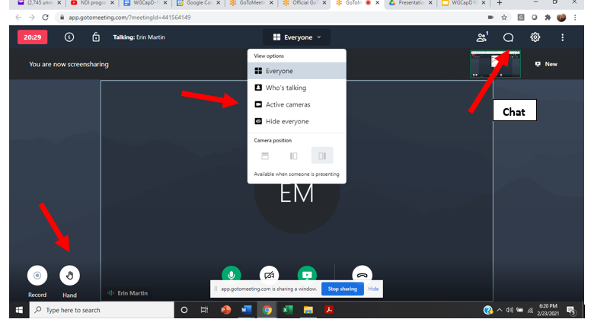

- We are using Wonder.me for socializing during the breaks.
https://www.wonder.me/r?id=a463bc20-edef-4263-9cb5-4ef6ec929410

- When you open the app, Wonder will ask to take your photo. Please say yes. This photo becomes your avatar and a vehicle for moving from room to room.
- Note that Wonder turns your video and sound on automatically. If you leave the GoToMeeting window open, please mute the microphone and cut off the camera so those functions work in Wonder.
- Click on your avatar and drag it to the room you want to visit. As soon as you enter a box, you will be put automatically into a room.
- You can connect with another person outside a room by intersecting with their avatar.
- Wonder has several useful functions:
  - Private and group chat
  - Search for participants
  - Invite participants to a room

- We are using Padlet for collaborating during discussion sessions.

- Links for the padlets are included in the agenda. They will also be sent out via the chat during the meeting.
- If you click on the link, you will open the padlet and be able to contribute.
- You are not required to sign in, but creating an account in advance will mean that your name is associated with your comments. Otherwise, the comments are attributed to “Anonymous”.
- The page is divided into columns. Each column represents a discussion topic.
- To add a comment, click on the arrow at the bottom of the corresponding column.
- You can add a comment to any column at any time – you do not have to wait for the discussion.
- You can add a title and a comment. Click anywhere else on the screen to post the comment.
- If you like someone else’s comment, you can hit the heart button.
- Once the comment is posted, you can click on the dots on the top right corner to edit, delete and change the color of the note.
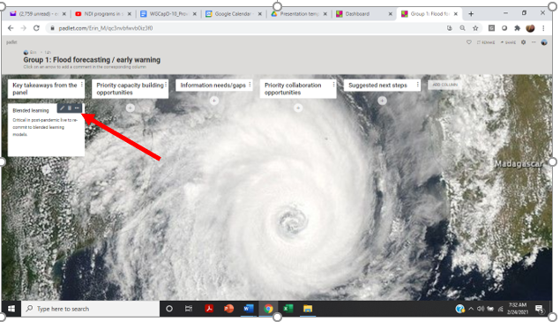
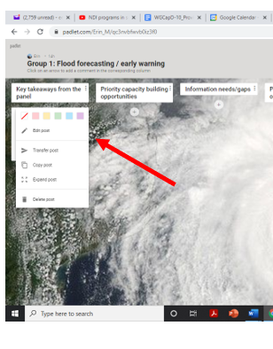
Tech problems during the meeting? Send an email to Yasha at yakov.m.moz@nasa.gov.

