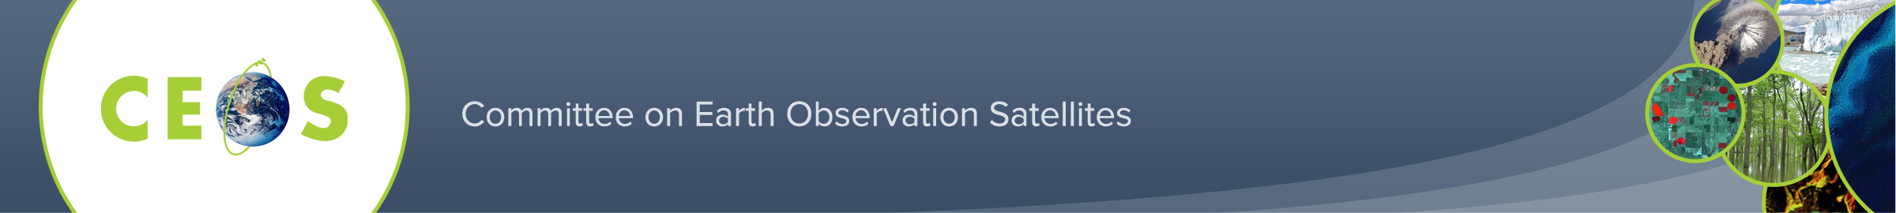

CEOS WGCapD – Distance Education Course - Webinar Series:

Remote Sensing Technology for Disaster Management

The CEOS Working Groups on Capacity Building and Data Democracy (WGCapD) and Disasters (WGDisasters) are pleased to inform you that registration is now open for the WGCapD Distance Education Course - Webinar Series on Remote Sensing Technology for Disaster Management (DM).

This course consists of a comprehensive series of eight introductory webinars that address the use of remote sensing technology for DM. They will be held each Tuesday from April 6 to May 29, 2015 from 13:00-14:00 UTC (Time Zone Converter: http://www.worldtimebuddy.com).

We cordially invite DM practitioners with an interest in geospatial technology to register for this webinar series, which we offer free of charge. Elementary knowledge about Remote Sensing, Geographic Information Systems (GIS) and Digital Image Processing is advised.

Please complete the registration form on our website (http://ceos.org/meetings/wgcapd-distance-education-2015/) and e-mail to Hilcéa Ferreira (ceos.inpe@dpi.inpe.br) by March 30, 2015.

Registration Deadline: March 30, 2015.

Note: We are only able to accommodate 100 participants on a first come, first served basis. Please register at your earliest convenience.

Certificate: Certificates of Participation will be issued for students who participate in all webinars.

Course objectives include to:

- Provide access to expertise from space agencies around the world.
- Link participants to a global network of experts and policymakers.
- Create awareness about international coordination bodies, such as CEOS, Group on Earth Observations (GEO), United Nations Office for Outer Space Affairs (UNOOSA), and the International Charter for Space and Major Disasters.
- Provide access to datasets and useful tools available from CEOS Members.
- Help participants enhance their DRM skills.
During this webinar series, we will cover the following topics:
- Introduction to Disasters
- Space-based Earth Observation Systems and their Applications for Hydro-meteorological Disasters (Floods), Geological Disasters (Earthquakes, Landslides, and Volcanoes) and Environmental Disasters (Forest Fires)
- Real-Time-Monitoring of Global Precipitation from Space: New Technologies Applied to Heavy Rainfall Risk Reduction
- Concepts and Applications of Internet GIS and Sensor Web for Disaster Management and How to Use the TerraMa2 Open Source Computational Platform to Develop Monitoring, Analysis, and Alert Systems
- Rapid Mapping and Emergency Services: Success Stories of the International Charter for Space and Major Disasters
Please visit our website for more information. Once registered, you will receive a confirmation email containing more information about how to participate.

