CEOS-CGMS ECV Inventory Life Cycle – Process, Configuration, and Roles and Responsibilities

Draft V0.1 – John Bates 11/12/2014

This is meant to be a living document that captures the progress on several distinct, but related aspects of the ECV Inventory. The steps involved in the iterative process of collecting, configuration management and control, assessment, gap analysis, and proposed mitigation are shown graphically in figure 1.

Figure 1. Iterative cycle of WGClimate ECV Inventory.

Each of the steps involved contains its own internal processes and these are in turn linked to the others. The rest of this document contains the plans for each step. The Chair of the CEOS-CGMS Working Group on Climate provides oversight of the complete system and there are major contributors to each element. The ECV inventory is considered Version 0.1- 0.4 and not for public release until the first iteration is complete and then will be identified at V1.0. To indicate which of the above steps are complete, I propose the following names and conventions. This first version is ECV Inventory I and when step 1 below is complete (which is actually close or complete) we will label it as V0.1 (it is V0.0 until then). When the reference assessment is complete, it will become V0.2, etc. around the full cycle.

I. CEOS-CGMS ECV Inventory Responsibilities between WGClimate and the NASA SEO - Based on Brian Killough diagram at CEOS Plenary 28; updated with input from R. Husband.

The WGClimate has lead responsibility for formulating the content of the ECV questionnaire, final control of the content and iterating with the SEO and data providers to ensure completeness and accuracy of the content, and release of the ECV database to the public. The SOE provides support to the WGClimate through hosting the questionnaire for input, versioning of the questionnaire, configuration control, providing internal (i.e., working version to WGClimate members) and external (i.e., to the public) search and query capabilities. Other related activities are also supported as detailed in Figure 2.

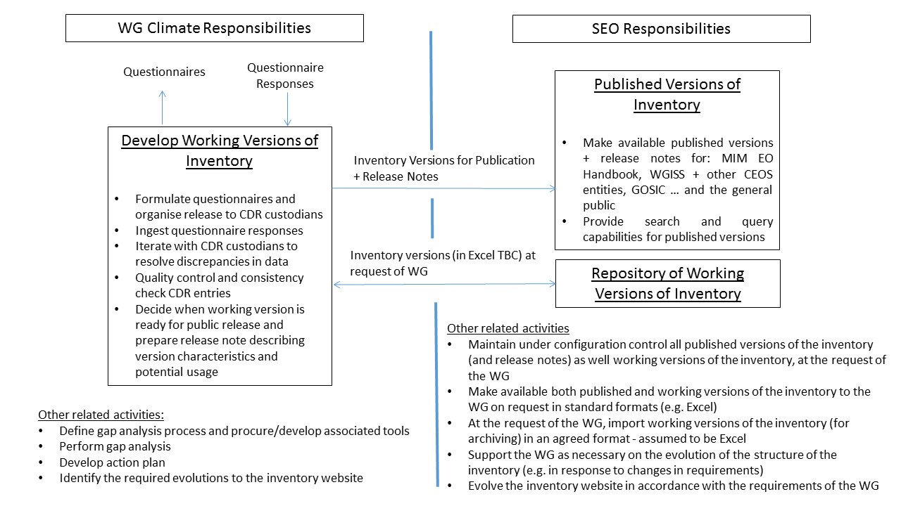

Figure 2. Proposed roles and responsibilities for WGClimate and SEO in support of the ECV inventory..

The current ECV questionnaire and inventory are at http://ecv-inventory.com/ecv2/
II. Reference Assessment – Lead Bates
The WGClimate is responsive to the GCOS WCV requirements provided in the GCOS 2010 implementation plan (GCOS-138; hereafter referred to as GCOS IP10) and the related satellite supplement (GCOS-154). The specific requirements for the ECVs that can be observed from satellites are given in the satellite supplement and were driven be user needs following the UN Framework Convention on Climate Change (UNFCCC). The relationship between these entities is shown schematically in figure 1.
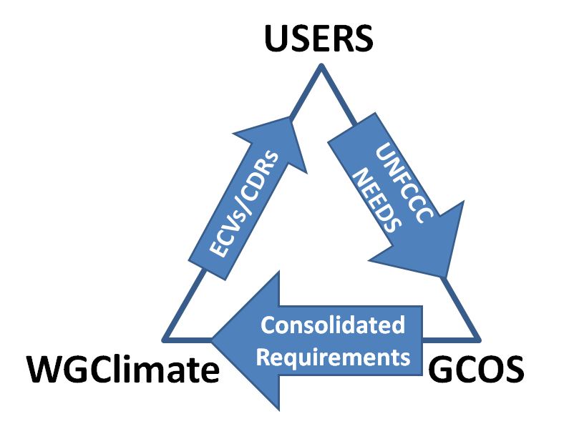
Figure 3. Flow of needs to requirements to the WGClimate.
ECVs can refer to a single geophysical variable, or a group of geophysical variables, and we refer to these as climate data records CDRs. CDRs are further defined as fundamental CDRs (the remote sensing observable) and the derived geophysical variable, also defined as a thematic CDR (TCDR) We limit the entries in the ECV inventory to only those ECV/TCDR pairs identified in GCOS-154 (see tables 2-4, TCDRs are the column labeled ‘global products…’ ).
Recall the 4 pillars of the climate monitoring architecture and related flow of information shown in figure 4.
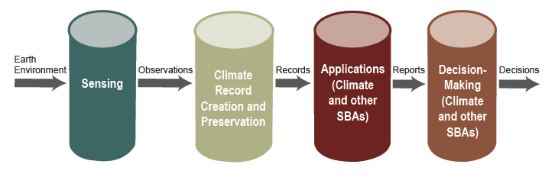
The ultimate goal of an assessment against this architecture requires that we identify a metric, or metrics, to assess the quality of each pillar as well as the entire value chain against the GCOS requirements. The GCOS requirements, since they were motivated by the UNFCCC, are oriented to detection of signals on decadal to centennial times and space scales. This is our focus in this exercise.
One of the earliest attempts to provide guidance on climate monitoring was the identification of climate monitoring principles in the late 1990s (see Annex II in GCOS-143). These were helpful principles, however, they were difficult to quantify as metrics. More helpful recently has been the development of guidelines for the generation of datasets and products meeting GCOS requirements (GCOS-143) and the related data maturity models (Bates and Privette, 2012 and CORE-CLIMAX model of Schulz et al., 2014).
Proposed assessment of existing ECV/CDRs
Each of the pillars of the climate monitoring architecture needs to be assessed. I propose that WGClimate members volunteer to conduct group assessments using the following 3 metrics:
1. Evaluation of compliance with the GCOS-143 ’12 needs’.
2. Evaluation of the system maturity matrix using the CORE-CLIMAX criteria.
3. Evaluation of applications and decision making against GCOS criteria of GCOS-153 identified ‘benefits’ and ‘other applications’ as listed for each ECV should be used only in the evaluation of the ‘Usage’ column of this criteria (Users guide pdf and Excel sheet for evaluation are included).
Proposed assessment of FCDRs and future ECV/CDRs
1. The assessment of existing ECV/CDRs will inform our process for a gap analysis of the expected future climate observing system. I propose that, using the FCDRs identified in the existing ECV/CDR analysis, we use information in the ECV inventory, as well as the CEOS MIM data base, to perform an analysis of the future system.
III. Gap Analysis – Lead Lecomte (from 10/28/2014 email)
Talking with my colleagues we have identified four main types of gap (or shortfall), mappable to components of CEOS logical view.
- Sensing gaps. Gaps between the sensing capabilities of past / current / planned missions, and the GCOS requirements of ECVs which the sensors (Level 0) directly map to. For example, Satellite x instrument y Level 0 is fine for deriving the Sea Level ECV but fails on accuracy for Sea Ice ECV products. Follow-up analysis could comprise macro-scale discussion between agencies for modified planned or new future missions or programmes to collaboratively fill the gap.
- CDR gaps. Gaps between the current / anticipated ECV products per ECV and the associated GCOS requirements (after sensing gaps accounted for). The required input data exists / is planned for the creation of an ECV product satisfying all its ECV requirements, but the (re-) processing hasn’t taken place yet (for instance, limited computing, time, other resources). Follow-up analysis includes agencies further pooling their resources to develop pan-agency ECV products.
- Applications gaps. Complete list of applications (such as agrometeorology) / SBAs (such as urbanisation spread) should each be mappable (1-to-many) to ECVs. Nevertheless, there could be gaps regarding non- GCOS-ECVs which are required for an Application / SBA. A complete systematic analysis would aim to define a complete list of potential applications / SBA, mapping each to its required ECVs and non-ECVs data. A further analysis is then required to ascertain whether the identified non-ECV data records exist at all, and where not to then identify these as perhaps required for collaborative gap-filling by the agencies. Additionally, although a fully compliant ECV may exist for an application, the ECV may have a technical shortfall in context to the application use. Further analysis & opportunity for collaborative agency cooperation for the gap filling.
- Decision-Making gaps. Decision-making includes climate change mitigation & adaptation as well as monitoring (a departure from the previous components). An analysis could be undertaken to assess how the preceding ECVs and applications are used for playing out mitigation and adaptation scenarios, and so identifying shortfalls. Each agency should draw on previous and current projects using earth observation for monitoring & mitigation.
This approach explicitly makes reference to the Climate Architecture figure 6.1, like that, it clearly matches the logic developed so far.
It also give a hook to explain two concepts:
- A gap is not necessarily linked to a lack of level 0 (sensing)
- A gap might be linked to a specific application.
There might be other useful outcomes of that approach.
We could for example identify a complete 'taxonomy' of gaps across the logical architecture, choose which gap-types to tackle for CMRS-2 (rather than the whole lot) and have an analysis strategy for each one (for instance, if it's a lack of level 0 we do x, if it's an application having the ECVs but not at the required accuracy do y, etc, etc, etc).
It might also help defining what a gap actually is.
The weak-point with this approach might be on the Decision-Making part of the logical view, how it would actually fit here, what does a gap mean really, but perhaps not relevant now anyway for CMRS-2 (at least not in the early iterations).
IV. Mitigation Plan and Action Plan. - TBD

