CEOS DRM Thematic Pilots
Semestrial Report for DRM Flood PIlot

PI or PoC: Stu Frye Date: 14 February 2015
Collaborating organisations: CEOS Agencies - NASA, NOAA, USGS, CSA, ESA, JAXA, CNES, ASI, SANSA

Local/National/Regional Agencies - RCMRD, Namibia Department of Water Affairs, CIMH, Mekong River Commission, Kavango/Okavango River Commission

Research Centers/Institutes - CIMA, SERTIT, Deltares, JRC, ACRI, HRC, Luxembourg Institute of Science and Technology, Athena Global

International Organizations – Red Cross/Red Crescent, UNESCO, WFP, World Bank GFDRR

Universities - University of Maryland, University of Colorado, University of Oklahoma, University of West Indies
Achievements:
- Upgraded flood models (CREST and GFMS) to provide 1km resolution results
- Created Flood Dashboard for Southeast Asia regional component
- Improved delivery of flood extent maps by converting from raster to vector formats and by standardizing maps legend content requirements
- Improved validation of flood maps by integrating river gauge information and extending crowd sourcing techniques to enable local practitioners to correct and annotate maps and share them easily on the internet

Activities: one or two paragraphs describing main activities
Primary activities of the team were to explore integration opportunities between the global and regional components. The team worked with national, regional, and international partners to extend modeling and monitoring capabilities during flooding in Malawi to show intercomparison between model outputs, flood extent maps, and ground truth information. Products from the team were used in situation reports distributed by the World Food Program and the World Bank to Malawi and Mozambique authorities. Flood modeling workshops were setup in cooperation with the CEOS WGCapD to explore improvements induced by inclusion of the newly released SRTM-2 30m DEM and to train local and regional practitioners on uptake of these improvements into their processing streams. The schedule for workshops is included below.

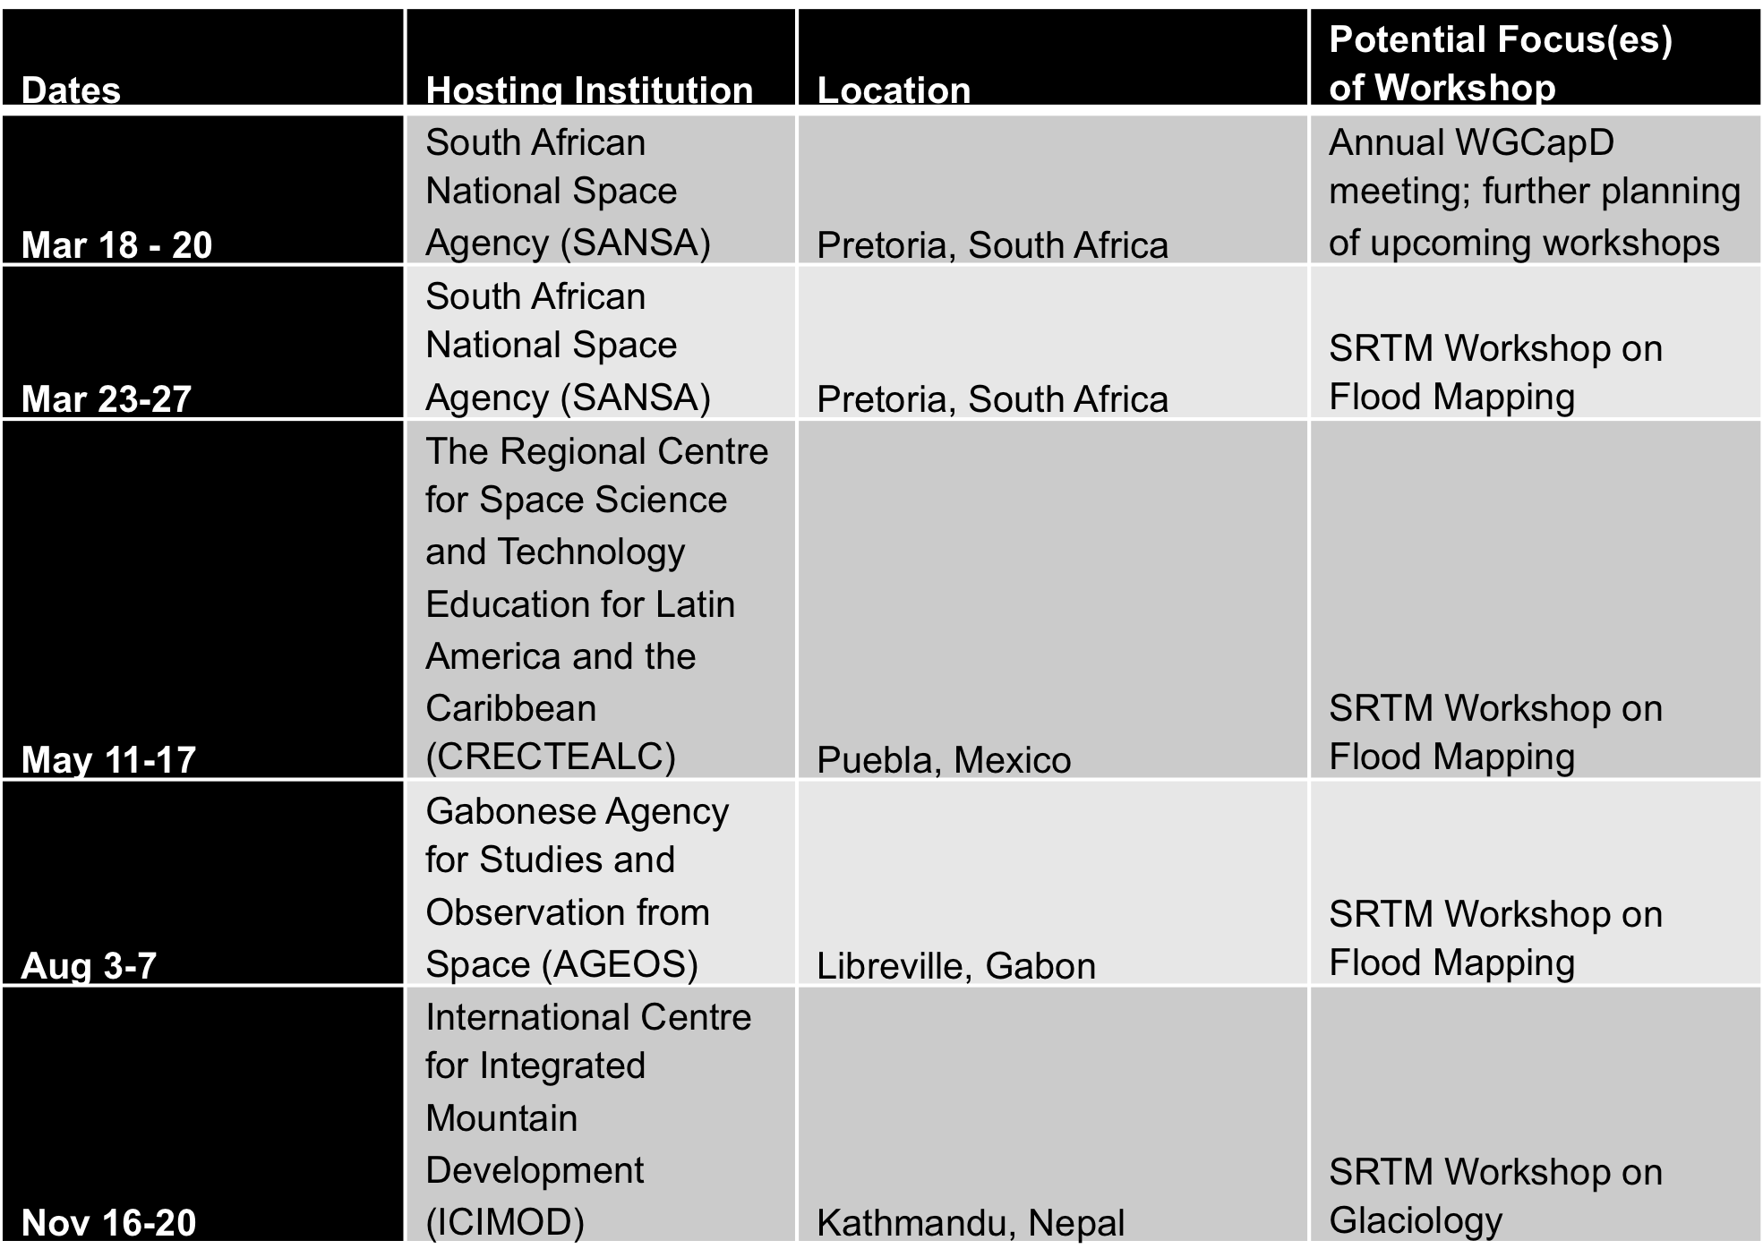

Data accessed this Q (#images /satellite)  - 94 images from Radarsat-2 for Caribbean/Central America and Southern Africa regional components | Total data accessed to date (#images /satellite)  - Requested access to particular SPOT archive data over the Mekong  - Requested access to charter activation data over Malawi and Bangladesh  - Worked with ASI to construct list of COSMO-SkyMed images over Indonesia and Haiti to model impacts of subsidence on flooding
Products: (delivered this quarter)  - CREST Flood Model training materials  - GFMS flood forecasts over Bangladesh, Mozambique, and Malawi  - Flood extent maps for these areas over a 2-3 week period  - Open Source processing software suite posted on GitHub  - Intercomparison results for MODIS, EO-1, Sentinel-1, and Radarsat-2 flood extent maps over Malawi | User (by product)  - WFP  - World Bank  - Malawi civil authorities  - RCMRD | User or practitioner endorsement/opinion/outcomes  - RCMRD said the products were very helpful and the delivery was extremely responsive to their targeted needs  - World Bank and WFP commented that Charter coverage missed some areas of flooding and the visibility into the charter targeting was difficult
List any publications directly stemming from pilot work
- Presentation at the Davos Conference (Andrew – could you supply a call-out for this???)
- Article on CEOS activities relevant to WCDRR submitted to ISRSE
- Article on Southern Africa accomplishments published as part of the EO Handbook Special Edition

List objective milestones and state progress to date (%)
- Global Component 50% - Global Flood Dashboard website with linkages to major global projects and systems…design completed and linkages defined. Looking for hosting location
- Caribbean Regional Component 50% - flood dashboard based on Namibia pilot adapted to Caribbean users; contributions of data to KAL Haiti data base…Dashboard for flash flooding in Central America completed, review with regional partners scheduled for 17 February 2015. COSMO-SkyMed data request for KAL Haiti database formulated and ready to submit to ASI, EO-1/MODIS/Landsat flood maps provided for Panama.
- Southern Africa Component 100% - Namibia/Malawi/Mozambique flood monitoring during early 2015 delivered; training and capacity development planned for 23-28 March 2015 hosted by SANSA; Windhoek workshop scheduled for week after the SANSA workshop; updates to Southern Africa flood dashboard completed for inclusion of Open GeoSocial API processing suite; Training for Open GeoSocial API planned for RCMRD 8-12 March 2015
- 50% - flood dashboard based on Namibia pilot adapted to SEAsia users completed.; user consultations on new pilot products conducted with international stakeholders during series of meetings in Washington DC, New York City, and in Europe; establishment of regional GEO pilot and new SERVIR Hub completed; test TRMM/GPM-based high resolution flood monitoring product over the Lower Mekong Basin (contingent on river gauge data being obtained) not started;

Issues identified and risk management approach
Pilot management support for coordination, documentation, and meetings is minimal and likely to dwindle to unsustainable levels in February 2015. Actively seeking funding for pilot management from ESA, NASA, and NOAA. Gaps may occur that will slow progress on pilot accomplishments starting March 2015.

