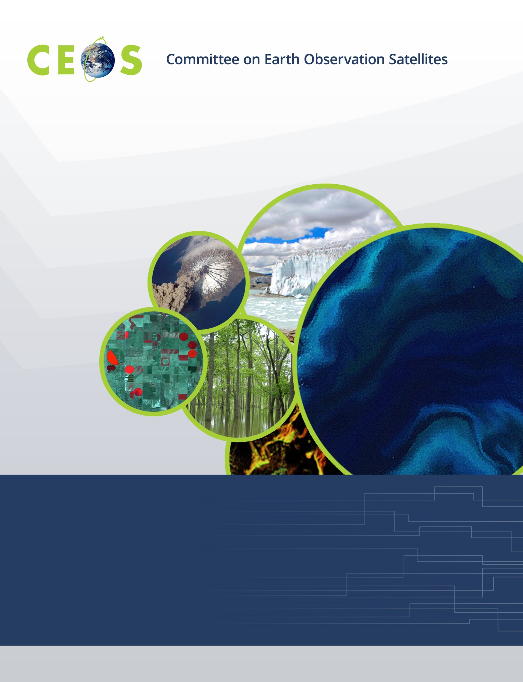
WGCapD - Distance Education Course:
Remote Sensing Technology for Disaster Risk Management
Version 10
March 5, 2015

DRAFT (in yellow everything that has to be decided)

WGCapD - Distance Education Course
Remote Sensing Technology for Disaster Risk Management

- Overview

  - Background

The Committee on Earth Observation Satellites (CEOS) mission is to ensure international coordination of civil space-based Earth observations programs and promote exchange of data to optimize societal benefit and inform decision making for securing a prosperous and sustainable future for humankind. CEOS supports effective societal decision-making in the areas of climate monitoring and research; carbon observations, including observations to support the effective monitoring and management of the world’s forested regions; food security; disaster risk management; biodiversity; capacity building; data availability and access, and more.

Disaster Risk Management (DRM) continues to gain political, economic, and geopolitical importance as disasters cause increasing human and economic losses. These losses are only expected to grow as a result of increasing global urbanization (expected to double by the year 2050) and an increasing number of extreme events (expected to triple by the year 2100). Several major international organizations such as the World Bank, the United Nations International Strategy for Disaster Reduction (UNISDR), and the European Commission are focusing their efforts on responding to crisis events after they’ve occurred (disaster response). Just as it is important to continue improving space agency support to post-crisis response, it is also critical that space agencies invest in disaster preparedness and prevention.

The CEOS Working Group on Capacity Building & Data Democracy (WGCapD) (formed at the 25th CEOS Plenary in 2011) undertakes a variety of activities based on the four pillars of the Data Democracy Initiative, as depicted below:

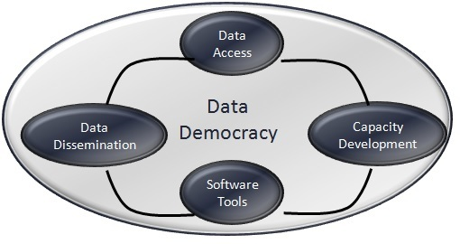

The WGCapD builds upon this Initiative in an effort to increase the capacity of institutions in less developed countries for effective use of Earth Observation data for the benefit of society and to achieve sustainable development.

This way, the WGCapD Distance Education Course is an effort by CEOS Agencies toward:

- Disseminating remote sensing technology among disaster risk management practitioners with an interest in geospatial technology
- Providing wider and easier access to Earth observation data
- Increasing the sharing of software tools such as open source software and open systems interfaces
- Increasing data dissemination capabilities and transferring relevant technologies to disaster risk management practitioners
What makes this course unique? This course is:

  - Offered free of charge
  - Provides access to expertise from space agencies around the world
  - Links participants to a global network of experts and policymakers
  - Creates awareness about international coordination bodies, such as CEOS, Group on Earth Observations (GEO), United Nations Office for Outer Space Affairs (UNOOSA), and the International Charter for Space and Major Disasters
  - Provides access to datasets and useful tools available from CEOS Members
  - Builds skills on DRM.

The Distance Education Course is divided into two Phases:
  - Phase 1 consists of a series of introductory webinars that address the use of remote sensing technology for Disaster Risk Management.
  - Phase 2 gives practitioners a hands-on understanding of one geospatial toolset currently used for Disaster Risk Management.

  - Course Team

NAME | E-MAIL | INSTITUTION | ROLE
Hilcéa Ferreira | hilcea@dpi.inpe.br | INPE | Coordinator/Instructor
S.P.Aggarwal | spa@iirs.gov.in | IIRS/ISRO | Coordinator/Instructor
Marie-Josee Bourassa | marie-josee.bourassa@asc-csa.gc.ca | CEOS CEO | Contributor
Kim Holloway | kim.e.holloway@nasa.gov | CEOS SEO | Contributor
Antonios Mouratidis | antonios.mouratidis.esa.int@gmail.com | ESA | Instructor
Ivan Petiteville | ivan.petiteville@esa.int | ESA - WGDisasters | Contributor
Jesus A. G. Bernal | jagonzalez@ccc.inaoep.mx | INAOE/CRECTEALC | Contributor
Claudia Lucaccioni | claudia.lucaccioni@gmail.com | INPE | Moodle Tutor
Daniel Vila | daniel.vila@cptec.inpe.br | INPE | Instructor
Alberto Setzer | alberto.setzer@cptec.inpe.br | INPE | Instructor
Fabiano Morelli | fabiano.morelli@cptec.inpe.br | INPE | Instructor
Su-Yin Tan | su-yin.tan@uwaterloo.ca | ISU - International Space University | Instructor
Nancy D. Searby | nancy.d.searby@nasa.gov | NASA | Contributor
Phila Sibandze | psibandze@sansa.org.za | SANSA | Contributor
Lorant Czaran | lorant.czaran@unoosa.org | UNOOSA | Contributor
Eric Wood | woodec@usgs.gov | USGS | Contributor

  - Schedule
  - Phase 1: April 6 — May 29, 2015 (1 webinar per week)
  - Phase 2: June 1 — July 3, 2015 (4 weeks and evaluation)

  - Language
  - The entire distance education course is delivered in English.

  - Target Region
  - The course is open to participants from all countries.
  - All course materials will be provided in English.

  - Audience
  - Disaster Risk Management practitioners with an interest in geospatial technology

  - Methodology
  - This course is an online distance education program that allows participants to fully engage with program content, their peers, and their instructors via live lectures, discussion forums, group work, online chat, question/answer sessions, and feedback/assessment mechanisms. It consists of an interactive webinar series (Phase 1) and corresponding hands-on course in DRM (Phase 2), conducted entirely online.
  - The Learning Platform Moodle (acronym for modular object-oriented dynamic learning environment) will be used for the course administration, documentation, tracking, reporting and delivery system. It will be hosted at the National Institute for Space Research - INPE (Moodle Learning Platform)
  - Citrix GoToMeeting (GTM) (hosted by NASA) will be used for synchronous communication among teachers and students and live sessions. In Phase 1, one 1-hour session per week is foreseen. In Phase 2, two 1-hour sessions per week are foreseen: one for presentation & GIS tools demonstration and one for Questions & Answers.

  - System Requirements
  - For Moodle:
    - Recommended Browsers: most browsers will handle the Moodle pages without problem. Some individual modules may require special software or plugins. Minimum recommended browser: Google Chrome 11, Firefox 4, Safari 5, Internet Explorer 8
    - Recommended Settings:
- Make sure that the browser is set to accept cookies.
- Javascript must be enabled.
  - For GTM (please check the following website for GTM System Requirements)

  - Number of Participants:
  - Phase 1: 100-200 participants. Note: Some portions of this course will be delivered using GoToMeeting (GTM). For greater than 76 participants, the CEOS Systems Engineering Office (SEO) will need to increase the allowable number of GTM participants on their GTM account for ~ 2 months. Contact: Kim Holloway.

  - Phase 2: To be determined (e.g. 10-15 for some types of disaster: hydro-meteorological, geological and environmental, upon instructor availability)

  - Partnership with CEOS Working Group on Disasters (WGDisasters)
  - The WGDisasters will help recruit experts as Phase 1 instructors and Phase 2 hands-on contributors.
  - The WGDisasters will help identify the appropriate audience for participation.

  - Instructors
  - CEOS Members: INPE, ISRO, INPE, NASA SEO, ESA, USGS and WGDisasters
  - Collaboration with ISU (International Space University)
  - Possible collaboration with NASA ARSET (Applied Remote Sensing Training): exchange of training material.
  - Possible contributions and collaboration with the Faculty of Geo-Information Science and Earth Observation (ITC) through the Earth Observation for Economic Empowerment (EOPOWER) Project. Contacts:
    - Joan Looijen
    - Raymond Nijmeijer
    - Iris van Duren

  - Commitment by Instructors
  - Phase 1 - approximately 4 hours for:
    - Preparation of a 1-hour presentation using CEOS template
    - Preparation of 5-10 questions for a quiz
    - Preparation of instructional materials or links of interest to be sent to participants
    - Availability to participate live on the correspondent webinar session
    - Answer possible questions and doubts from participants via email
  - Phase 2 - approximately 5 hours per week (total of 20 hours during 1 month: June 1 — July 3) for:
    - Preparation of a 1-hour presentation using CEOS template
    - 2-hours per week to participate in live sessions (lessons, demonstration and Q&A)
    - Preparation of instructional materials or links of interest to be sent to participants
    - Provide guidance and advise students during the whole project development process.

  - Certificate for Instructors
  - Since Instructors are volunteers, they will be rewarded in some way: certificates of participation, proposing to write a joint paper etc.
  - Certificates will be issued by the CEOS SEO

  - Announcement
  - CEOS website
  - Virtual Laboratory for Training and Education in Satellite Meteorology (VLab website and newsletter).
  - Regional Centers for Space Science and Technology Education (affiliated with the United Nations)
    - Latin America and the Caribbean (Mexico and Brazil): CRECTEALC (Regional Centre for Space Science and Technology Education for Latin America and the Caribbean)
    - Asia and the Pacific (India): CSSTEAP (entre for Space Science and Technology Education in Asia and the Pacific)
    - Africa (Morocco): CRASTE-LF (African Regional Centre for Space Science and Technology Education-in French Language)
    - Africa (Nigeria): ARCSSTE-E (African Regional Centre for Space Science and Technology Education in English Language)
    - Western Asia (Jordan): Regional Centre for Space Science and Technology Education for Western Asia
  - Regional centers
    - Regional Centre for Mapping Resource for Development (RCMRD) in Nairobi, Kenya.
    - Regional Centre for Training in Aerospace Surveys (RECTAS) located within the campus of Obafemi Awolowo University, Ile-Ife, Nigeria.
    - More?
  - ISU (International Space University)

  - Registration
  - CEOS & WGCapD websites

  - Selection Process
  - Define rules and priorities for student selection. (WGDisasters)

  - Certificate of Participation
  - Given only to Phase 2 participants
  - Designed and distributed by the CEOS SEO

  - Instructional materials:
  - Presentations given via PowerPoint
  - Recorded online sessions
  - Data source and reading material links
  - Frequently Asked Questions (FAQ)
  - All materials will be made available inside Moodle.

  - Copyrights
- All instructional materials and recorded live sessions will be licensed under a Creative Commons Attribution-Share Alike 4.0 International License

  - Course evaluation
  - Surveys (e.g. SurveyMonkey®) for the students to evaluate Phase 1 and Phase 2

- Phase 1: Webinars Series (8 session scenario)

  - Schedule
  - April 6 — May 29, 2015 (1 webinar per week)

  - Prerequisite
  - Elementary knowledge about Remote Sensing, Geographic Information Systems (GIS) and Digital Image Processing

  - Webinar Objectives
By the end of this webinar series, students should:
  - Understand the use of EO systems in Disaster Risk Management
  - Know about data availability through the International Disaster Charter during a disaster
  - Know how to utilize satellite data from different sources for DRM
  - Be able to determine which specific GIS capabilities and kinds of data are required to support emergency management work before, during and post disaster
  - Be able to support decision makers as advisor for role of space technology in DRM

  - Themes for Webinars

- Introduction to Webinars Series
Week of April 6, 2015
  - Overview of CEOS/WGCapD
  - Where CEOS can help: Datasets and Useful Tools: CEOS Visualization
Environment (COVE), the CEOS Earth Observation Handbook
  - International Collaboration for DRM: International Charter for Space and Major
Disasters
Instructors: Hilcea Ferreira / NASA SEO / WGDisasters

- Introduction to Disasters: Causes, effects, monitoring, mitigation, and management. Methods of hazard, vulnerability, and risk assessment and the role of geospatial data. Week of April 13, 2015
Instructor: Su-Yin Tan

- Space-based Earth observation systems and their applications for hydro-meteorological disasters (floods)
Week of April 20, 2015
Instructor: S.P. Aggarwal

- Space-based Earth observation systems and their applications for geological disasters (earthquakes, landslides, and volcanoes)
Week of April 27, 2015
Instructor: Antonios Mouratidis

- Space-based Earth observation systems for environmental disasters (forest fires)
Week of May 4, 2015
Instructors: Alberto Setzer and Fabiano Morelli (Forest Fires)

- Satellite communication systems for early warning, search and rescue, and emergency response. Applications of mobile geographic information systems (GIS) and crowd-sourcing in real-time data collection with reference to disaster management. (Example with Rainfall and Floods)
Week of May 11, 2015
Instructor
Daniel Vila (Real Time Monitoring of Global Precipitation from Space: New Technologies Applied to Heavy Rainfall Risk Reduction)

- Concepts and applications of internet GIS and Sensor Web (network of sensors) for disaster management. Example of a tool (TerraMa2 - computational platform for developing Monitoring, Analysis and Alert systems)
Week of May 18, 2015
Instructor: Laércio Namikawa

- Rapid mapping and emergency services: Success stories (Example with volcanoes)
Possible examples of Charter
Week of May 25, 2015
Instructor: TBD

  - Student Assessments
  - Online Quizzes (5-10 questions) on the key points of each webinar session
  - Note here that these are for self evaluation. They don’t go towards any certification of pass/fail for Phase 2.

- Phase 2: Interactive Online Hands-on Course

  - Schedule:
  - June 1 — July 3, 2015

  - Prerequisite
  - Elementary knowledge about remote sensing/GIS and digital image processing.
  - Thorough understanding of materials presented in Phase 1. The background material from Phase 1 will not be repeated, thought recordings of the eight webinars will be available on the Moodle platform.

  - Online Course Objectives
By the end of this online course, students should:
  - Be able to engage in and discuss online hands-on activities: useful geospatial toolset and applications for Disaster Risk Management.
  - Be able to engage in active work after they complete the course.
  - Be able to demonstrate geospatial toolset useful for particular types of disasters.

  - Program
  - Develop detailed programs for the 4-week online hands-on courses
  - Students will be divided into groups based upon their areas of interest (e.g. landslides, floods, earthquakes — TBD).

  - Student Assessments
  - Quizzes, assignments, problem-based learning: hands-on actitivities in different types of disaster (hydro-meteorological, geological and environmental) and final report.

