Volcano Pilot results

Text for main page, with links to secondary pages in bulleted list

The Volcano Pilot has focused efforts on three objectives over the 2014-2017 life of the project: 1) a regional study of volcanic unrest and eruption in Latin America using SAR and visible/IR satellite data; 2) support of volcano Supersites, especially in Hawaii, Iceland, and Italy; and 3) comprehensive remote sensing coverage of a significant eruptive event that threatens population, preferably located in Southeast Asia (where Pilot activities are currently limited). Thus far, the third objective has not been started, since a suitable eruption has not occurred within the 2014-present timeframe. A number of results have been achieved in the first two objectives, however, ranging from research into magma plumbing systems to monitoring of sudden hazardous eruptive activity. In all cases, results were achieved either achieved collaboratively with, or communicated to, local scientists and stakeholders. Thus, the Volcano Pilot is well on its way towards its goal of demonstrating that remote sensing data have exceptional value in monitoring, assessing, mitigating, and researching volcanic hazards, during all phases of the eruption cycle—before eruptions occur, during eruptions, and post-eruption recovery.

Noteworthy results from the Volcano Pilot include:

- Eruption of Calbuco, Chile
- Volcanic unrest in South America (Cerro Negro / Chiles, Ecuador-Columbia border)
- Deformation of Fernandina, Galapagos
- May 2015 intrusion at Kilauea Volcano, Hawaii
- Post-eruptive inflation of Cordon Caulle, Chile
- Tracking changes associated with unrest at Cotopaxi, Ecuador

Eruption of Calbuco, Chile
> separate page linked to corresponding main-page bullet

After 43 years of quiescence, Calbuco, Chile, began erupting on 22 April 2015, prompting the evacuation of thousands of residents. SAR data from the pilot project were used to characterize co-eruption surface deformation, which helps to constrain the location of the magma body that fed the eruption. Coeruptive ascending Sentinel-1 interferograms show deflation with a maximum line of sight change of 12 cm located on the west flank of the volcano. Other interferograms constrain the deformation to have started no later than 1.5 days before the eruption, and to have lasted no more than 1 day. A model of the deflation indicates that the source is located about 5 km SW of the volcano’s summit at a depth of 9.3 km beneath the surface, with a volume changes of ~0.045 km³. This source geometry and strength is consistent with recordings from a tiltmeter located 4 km W of the volcano.

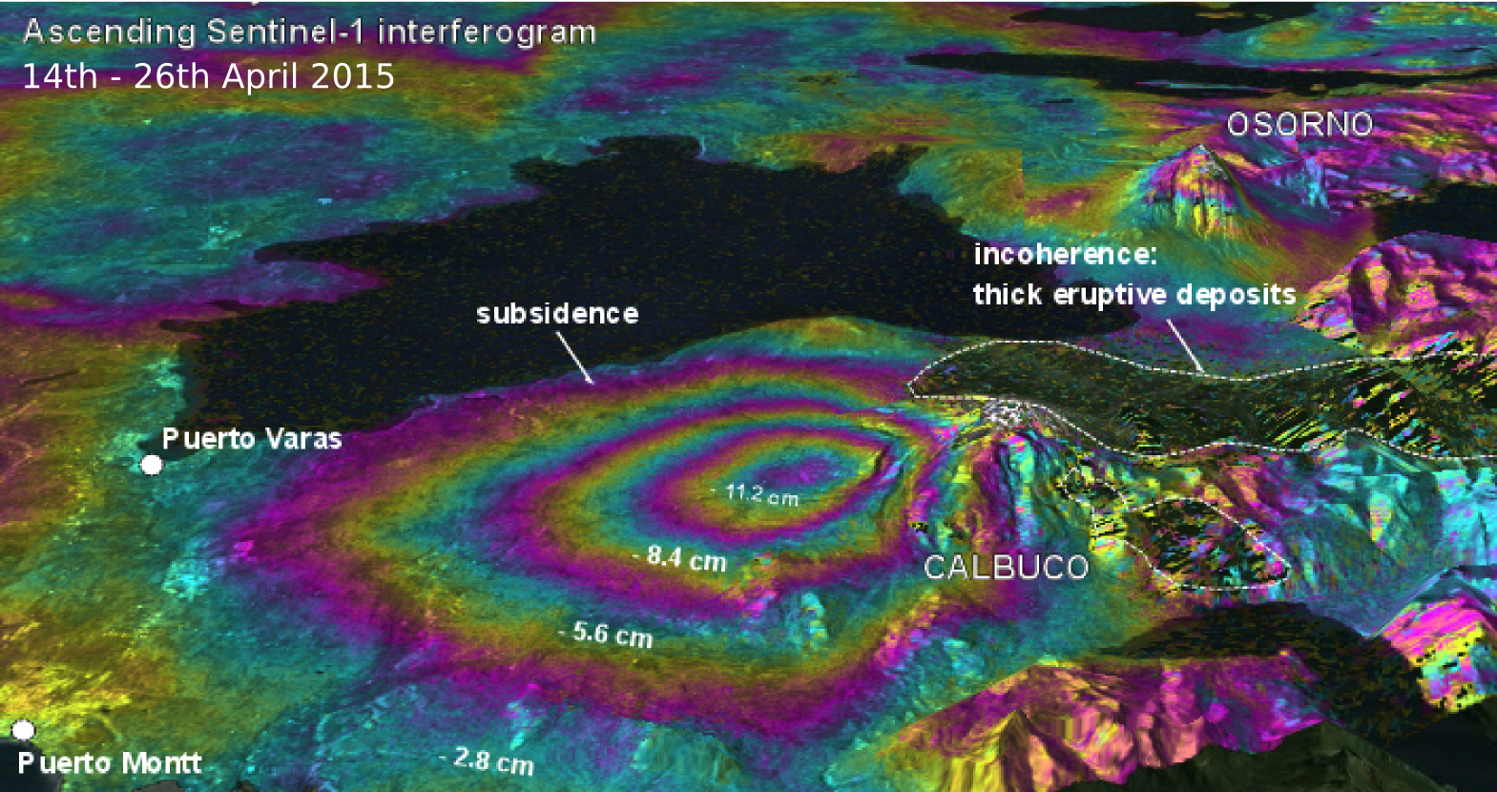
Perspective view of deformation at Calbuco as determined from a Sentinel-1a interferogram

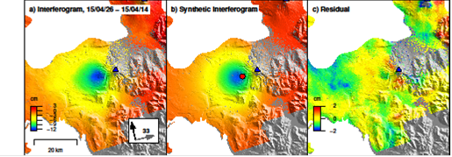
Observed (left), modeled (center), and residual (right) deformation at Calbuco from a Sentinel-1a interferogram spanning April 14–26, 2015. Deformation can be approximated by a source at ~9 km depth beneath the volcano’s west flank.

The large amount of ash released by the eruption (more than 0.1 km³) had a significant impact on air traffic in Chile and Argentina. This ash was tracked using a variety of thermal and visual remote sensing data and was communicated to the Volcano Ash Advisory Center in Buenos Aires.
Partner agencies: SERNAGEOMIN, Chile; Buenos Aires Volcano Ash Advisory Center, Argentina; University of Bristol, UK; Cornell University, USA; National Oceanic and Atmospheric Administration, USA

Volcanic unrest in South America (Cerro Negro / Chiles, Ecuador-Columbia border)
> separate page linked to corresponding main-page bullet

Within Latin American, only about 35% of the potentially active volcanoes have some type of seismic, deformation or gas monitoring according to the United Nations Global Assessment of Risk 2015 report (GAR15). To demonstrate how satellite observations can be used to cost-effectively monitor all 315 volcanoes in the region that erupted in the last 10,000 years, CEOS began a 3-year volcano pilot project to complement the available ground observations.
During the first 18 months of the pilot project, an international group of experts in remote sensing have provided imagery from the partner space agencies to the volcano observatories in the Latin American countries who are governmentally responsible for volcano monitoring, and they have worked together to interpret the data, which have been used to identify unrest at such volcanoes as Chiles-Cerro Negro (Colombia-Ecuador border), (Sabancaya) (Perú), and Guallatiri (Chile). Although no large eruptions have yet occurred at these volcanoes, the satellite data provided unique information on ground deformation and thermal characteristics that would not otherwise be known because of a lack of ground sensors.
The Chiles-Cerro Negro unrest is perhaps the most intense. Chiles and Cerro Negro are stratovolcanoes on the Ecuador-Colombian border that, until recently, had no historical activity. Since 2013 unrest has persisted at the volcanoes, culminating in a swarm of several thousand volcano-tectonic earthquakes per day in October 2014. At the height of this unrest there was a M5.6 earthquake just south of Volcán Chiles. CEOS data, in particular CosmosSkyMed and TerraSAR-X interferograms, showed about 30 cm of ground movement associated with this earthquake, and allowed us to estimate the position and slip on the fault plane that ruptured (Figure). Larger earthquakes that occur during volcanic unrest can tell us about changes to the subsurface stress field and are important to understand for assessing volcanic hazard.
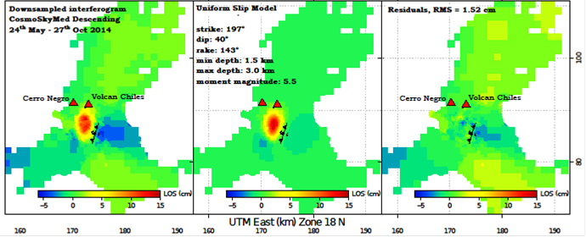
Observed (left), modeled (center), and residual (right) deformation at Chiles-Cerro Negro on the Ecuador-Columbia border based on a COSMO-SkyMed interferogram spanning May 24–October 27, 2014. Deformation in the image is modeled as mostly due to reverse faulting along the M5.6 slip plane.
Partner agencies: SERNAGEOMIN, Chile; Observatorio San Calixto, Bolivia; Instituto Geofísico del Perú, Instituto Geofísico de la Universidad Nacional de San Agustín, Peru; Instituto Geofísico, Escuela Politécnica Nacional, Ecuador; Servicio Geológico Colmbiano; University of Bristol, UK; Cornell University, USA; National Research Council of Italy, Istituto Per Il Rilevamento Elettromagnetico Dell'Ambiente, University of Miami, USA; Pennsylvania State University, USA

