CEOS Thematic Pilots
Q1-Q2 2016 CEOS Seismic Pilot report

Seismic Pilot/ Objective A, B and C
March 2016-August 2016 | PI or PoC: Philippe Bally (ESA) and Stefano Salvi (INGV). |  | Collaborating organisations:  CEOS partner agencies: ESA, NASA, ASI, CNES, DLR, JAXA  Other partners: INGV, NOA, UNAVCO, COMET+, University of Miami, University of Pavia, ISTerre/IPGP, CNR IREA
Achievements:
- Results stemming out from the pilot work have been published on the GEP that represents a tool for the geohazards community for accessing and sharing EO data and products including product generation though Cloud based hosted processing.
- The GEP has engaged 32 organizations as early adopters that are able to exploit on demand EO processing chains. In addition 4 of these organizations are CEOS Seismic Pilot partners and are able to access CEOS data collections through the GEP. INGV, NOA, ISTerre and CNR IREA are extensively working on integrating EO processors in the platform. They also contribute to refine platform requirements and performing user validation of hosted services.
- A new Italian organization with a mandate concerning geo-information services to support DRM has been engaged in the Pilot team: the CNR-IREA is the Center of Competence (CoC) on DInSAR for the Italian Civil Protection Department (DPC). In case of major (Mw >6) and shallow depth earthquakes occurring within the Italian territory, CNR-IREA has the mandate to rapidly provide the DPC with DInSAR Earth surface deformation maps, as soon as the first post-seismic SAR acquisition is available. Today the Pilot has two Italian mandated organisations loking at satellite EO and geohazards: the INGV and CNR IREA.
- Thanks to CNR IREA and INGV, the Seismic pilot established relations to an end-user for the first time: DPC is the end user of INGV and CNR IREA concerning terrain motion maps in Italy. In addition DPC may also ask for displacement measurements related to earthquakes that occur abroad, in the framework of international collaborations with foreign authorities.
- As an illustration of this, DPC collaborated with CNR IREA in the context of the earthquake that stroke Ecuador on 16 April 2016.

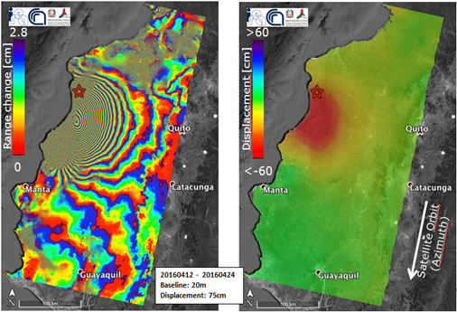
INTERFEROGRAM AND DISPLACEMENT MAP GENERATED BY CNR-IREA, EXPLOITING COPERNICUS SENTINEL-1 AQCUISITIONS OF 12 AND 24 APRIL 2016.
For this event, the generated deformation maps are used by DPC and other DPC CoCs to understand the extension of the area affected by displacement and better focus the activities during the emergency. Moreover, these maps can also be used to model the seismogenic fault in order to increase the knowledge on the earthquake causes. For this event the SBAS-InSAR processor was used by CNR IREA to generate Sentinel-1 interferograms.
- COMET provided preliminary results for the Turkey validation site (Objective A), using 18 months Sentinel-1 data.
- The DIAPASON chain was processed to generate interferogram after the xxx Kumamoto earthquake
- The day of the earthquake, the CEOS Seismic Pilot was activated by the specialists of INGV, the National Institute of Geophysics and Volcanology of Italy to provide access to EO data to pilot contributors, and extract information from them to derive advanced science products in support of the emergency activities. INGV and CNR IREA generated a range of specialised products to support seismological analysis.

Activities over Q1-Q2:
- Revisiting membership: Fabio Dell’Acqua previously affiliated to the EU Centre is now affiliated to the University of Pavia.
- COMET team has worked primarily on the Turkey test site (Objective A validation site) and has a preliminary Sentinel-1 result for the whole of Turkey, along with a result from Envisat that can be used for validation. Comparison (below) between (a) line-of-sight deformation measured by Sentinel-1 over 18 months, and (b) east-west velocities from 7 years of Envisat data. Both data sets show a strong change in colour across the North Anatolian Fault, where tectonic strain is accumulating. Note the different colour scales as one is LOS motion and one is E-W. They are currently preparing a paper for this study.
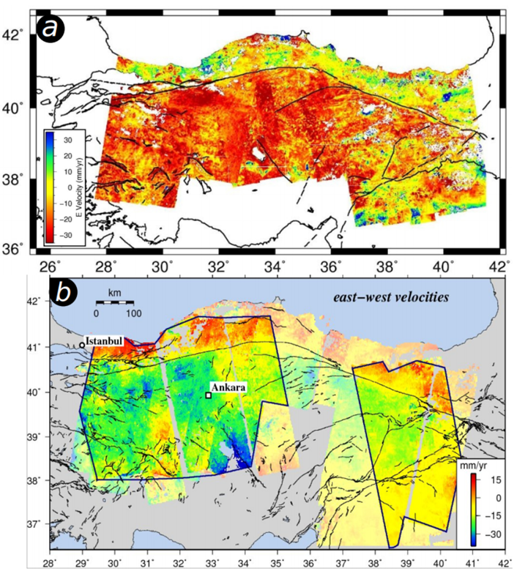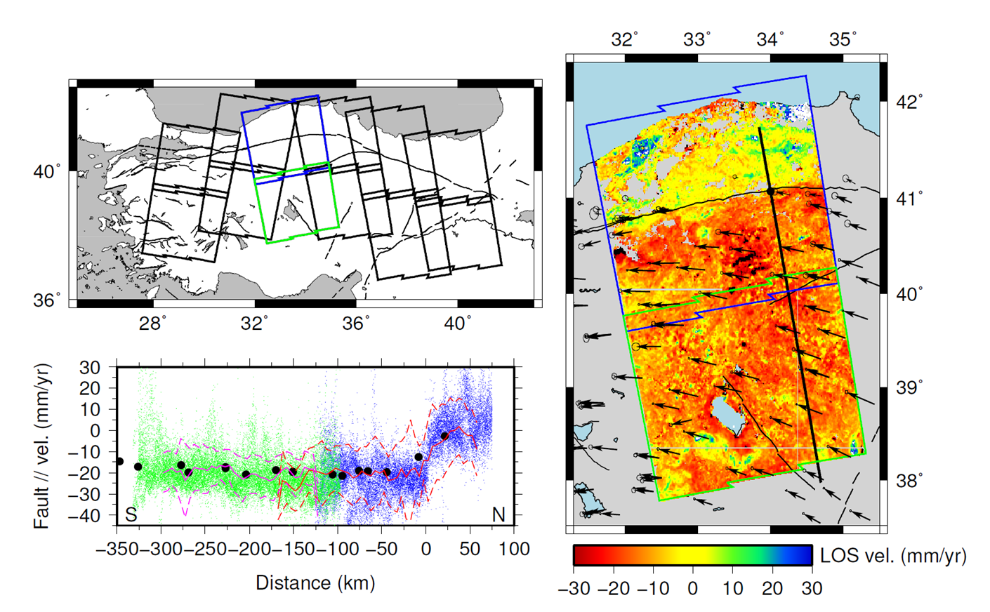

- NOA is exploiting CEOS data in order to study the Ionian Sea tectonics:
- Radarsat-2 data are used to analyse the deformation pattern of the 2015 Lefkada earthquake. This is an on-going work that focuses on the analysis of the deformation pattern of the Island using multiple sensors. Additionally, the study focuses on the slip distribution modeling that uses various inputs (together with Radarsat-2 data from CEOS). These co-seismic results of the Lefkada earthquake are going to be presented in a peer-review journal.
- Regarding the TSX tasking, we are going to use the acquisitions for the study of the post-seismic deformation pattern. When an adequate stack of images will be available, NOA will start the mass processing in order to define the surface velocities. The post-seismic surface velocities are then going to be modelled in terms of an afteslip. The results of this post-seismic study are going to be published in a peer-reviewed scientific paper.
- NASA JPL has been doing extensive analysis of the Gorkha Earthquake in Nepal, both coseismic and postseismic deformation using ALOS-2 and Sentinel-1 data. A paper on the coseismic deformation was just accepted in Tectonophysics last month. They are working on additional analysis of the postseismic deformation, including time-series analysis of the ALOS-2 ScanSAR and Sentinel-1 data with atmospheric corrections with the Caltech GIAnT and PyAPS packages. Results so far indicate that the very large atmospheric effects are still larger than the expected postseismic deformation.
- NASA JPL is also doing coseismic analysis of the Lefkada and Ecuador earthquakes. For the 2015 Lefkada Earthquake, JPL processed the Sentinel-1A 12-day pairs on ascending track 175 (2015/11/05 and 11/17) and descending track 80 (2015/11/11 and 11/23) using prototype processing modules with the JPL InSAR Scientific Computing Environment (ISCE) as part of the Caltech-JPL Advanced Rapid Imaging and Analysis (ARIA) project. They used the SRTM version 3 DEM in the coregistration step. The unwrapped phase was converted to range change and is contoured with 5 cm contours in the maps. The USGS National Earthquake Information Center epicenter for the Lefkada Earthquake and uncertainty is plotted with a red star and error ellipse. The two interferograms have been converted to a prototype interferogram archive product in HDF5 format and uploaded to the UNAVCO SSARA Interferogram archive (https://winsar.unavco.org/portal/insar/) for use by the geophysics community.
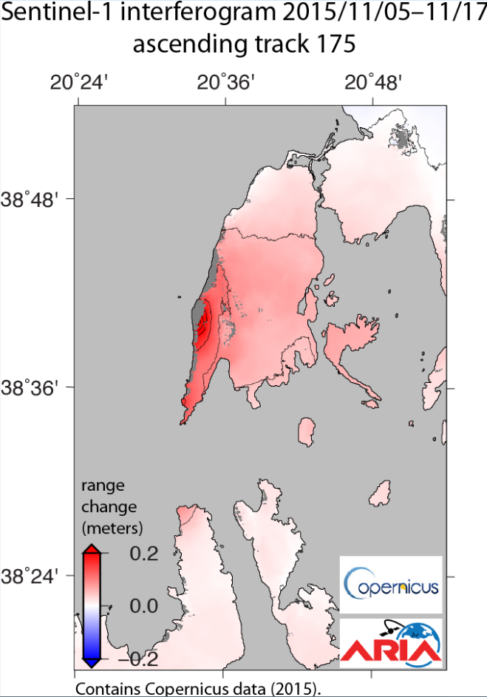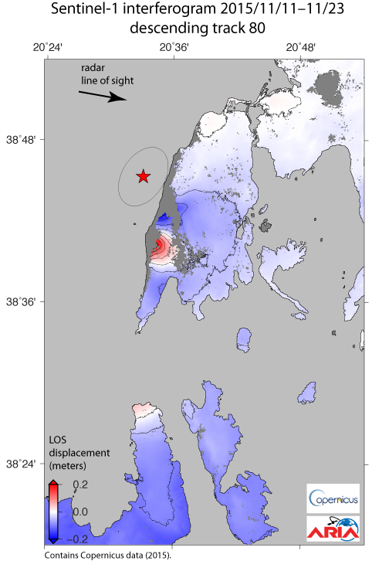

- The Italian earthquake: INGV and CNR-IREA have used Sentinel-1, ALOS-2 and Cosmo-SkyMed data to generate the first products to cover the Accumoli (Italy) earthquake that stroke on August 24 (Obj. C). An order for Pleiades data are on-going.

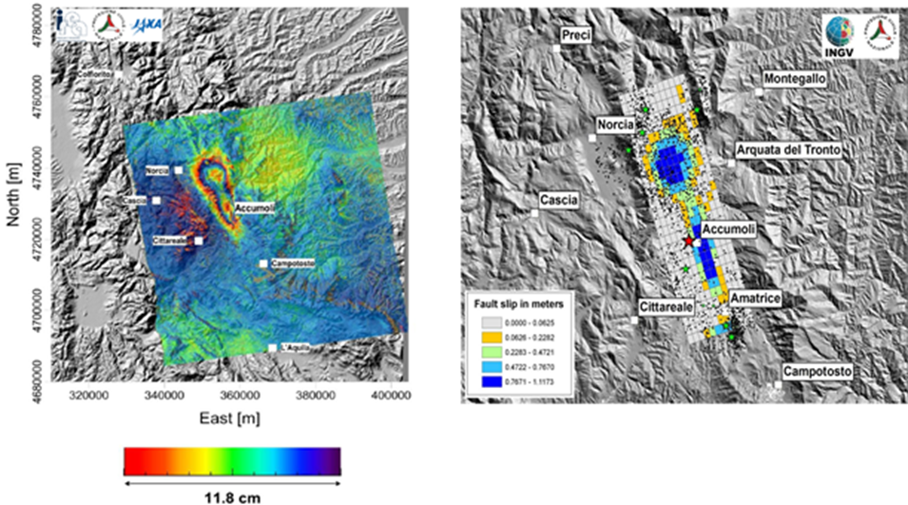
PRELIMINARY EARTHQUAKE SOURCE GENERATED BY INGV EXPLOITING THE TERRAIN MOTION MEASUREMENTS FROM ALOS-2 AND COPERNICUS SENTINEL-1 AQCUISISTIONS FROM BEFORE AND AFTER THE 24TH AUGUST EARTHQUAKE. THESE DATA WERE MODELED TO CALCULATE THE LOCATION, GEOMETRY AND AMOUNT OF SLIP ON THE SOURCE FAULT. THE SLIP IS DISTRIBUTED MAINLY IN TWO PATCHES WITH MAXIMUM VALUES OF ABOUT 1.3M.
INTERFEROGRAM GENERATED BY CNR-IREA, EXPLOITING ALOS-2 ACQUISITIONS OF 27TH JANUARY 2016 AND 24TH AUGUST 2016.

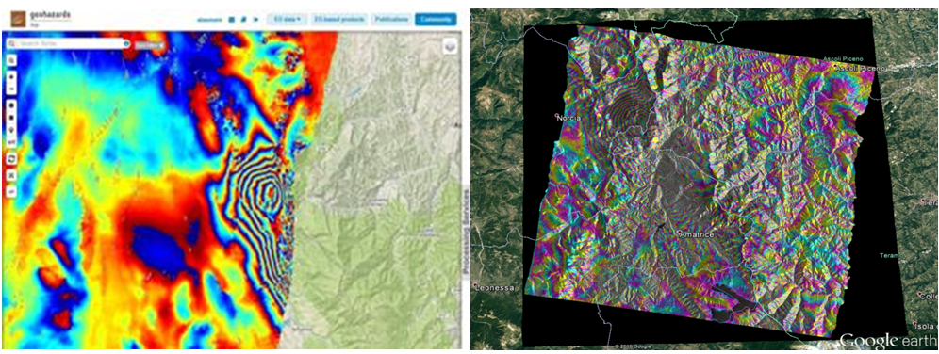
INTERFEROGRAM GENERATED BY INGV, EXPLOITING HIGH RESOLUTION COSMO-SKYMED ACQUISITIONS.
INTERFEROGRAM BASED ON THE GEP-HOSTED PROCESSING CHAIN DIAPASON OF CNES AND PROCESSED BY INGV USING SENTINEL-1 AQCUISITIONS OF 14TH AND 26TH AUGUST 2016 COVERING THE LEFT PART OF THE IMAGE.

- Objective A data request over NAFS: A TerraSAR-X request for the NAFS was approved under Objective A, in order to demonstrate that TerraSAR-X can observe inter-seismic strain accumulation (under evaluation).
- After the agreement between CNES and Airbus to open access to non-French users, four Pleiades requests are being prepared (Nepal, Ecuador, China and Iran) and will be forwarded to CNES in September.
- Data access for the pilot: After ESA’s arrangement with ASI, DLR and JAXA to support data dissemination using the Geohazards Exploitation Platform (GEP), ESA requested CSA to confirm if Radarsat-2 data collection (Lefkada) can be hosted on GEP too, to ease the common access to all interested pilot partners. Following the earthquake in Italy, ESA made also an arrangement with CNES to host the Pleiades metadata (footprints) on the GEP, with access restricted to CEOS Seismic pilot users.
- Data access for the GSNL, other pilots and the community:
- The Volcano pilot is using the platform for data dissemination (11TB for ALOS-2 data).
- COSMO-SkyMed collections for Nepal through the GSNL (Obj. B) are available on the GEP (only for users that have signed the ASI license form).
- Copernicus Sentinel-1 data were made available (in raw as well as SLC format) starting with CEOS Pilot targets and with the goal to gradually provide global coverage.
- Copernicus Sentinel-2 data are available on the platform.
- First Copernicus Sentinel-3 data were made available.
- Data processing (on the platform):
- Seismic pilot users (NOA, INGV, ISTerre, CNR-IREA) access and exploit EO data to generate measurements. Users are able to process using applications on the platform or after integrating (themselves) their own processing.
- Publications on the platform: Sentinel-1 interferograms over Ecuador and Italy (Obj. C) were generated by CNR IREA using SBAS-InSAR. The processings were run on ESA’s Grid Processing On-Demand (G-POD) where the algorithm is currently integrated. The integration of the SBAS-InSAR service on the GEP is still on-going. Sentinel-1 interferograms over Italy (Obj. C) were generated by INGV using DIAPASON.
- Support to GSNL (Obj. B): The pilot continued to support the Gorkha earthquake Event Supersite.
- The new GEO Programme Board has reviewed the GSNL Implementation Plan for 2017-2019, requesting only minor integrations. The plan will be approved in August, and represent a big challenge for GSNL.
- There have been no requests for new Event Supersites.
- For Permanent Supersites, after SAC approved the new Greek Supersite, most space agencies committed resources to support it. Some agencies kindly accepted to start acquisition even before formal approval by the CEOS Plenary, to start building a good archive. The Greek Supersite coordinator is already preparing a dedicated web site.
- The 2014 San Andreas Fault Supersite proposal has eventually been re written according to the new template and re-submitted to the SAC. SAC approval should occur by end of August, then it will be submitted to the CEOS DCT for approval, hopefully to be formalised at the Plenary in November.
- The GSNL Chair has requested the CEOS DCT to verify if it is possible to modify the Supersite acceptance procedure, since now it is necessary to wait for the CEOS plenaries to formally accept the Supersite, and this may delay the Supersite activation by several months.
- A number of publications stemmed out of pilot work (listed in the related section, below).
- Pilot users are promoting their results through: the CEOS website (http://ceos.org/ ), the GSNL portal (http://www.earthobservations.org/gsnl.php ) and the Geohazards Exploitation Platform (https://geohazards-tep.eo.esa.int/ ). The platform hosts results from the broad geohazards community using satellite EO, not only results from CEOS Pilot users and not necessarily processed on the GEP.

Data accessed over this period  - 10 ALOS-2 images (a total of 37 images will be downloaded under Obj. C for year 2015, over Nepal)  - 7 ALOS-2 over the Andes (interseismic)  - 24 ALOS-2 over NAFS (interseismic)  - 2 ALOS-2 images over Italy  - 14 TerraSAR-X images (Greece, Obj. C) currently acquired (some of them already accessed)  - 30 COSMO-SkyMed images over Greece (Obj. C), Iran and China (Obj. A)  - A number of Sentinel-1 images  - A large number of COSMO-SKyMed, as well as S1 and Pleiades data are ordered for the Italian earthquake on August 24. |  | Total data accessed to date (#images /satellite)  - 26 ALOS-2 images (out of a total of images that will be downloaded under Obj. C for year 2015, over Nepal, as JAXA will not provide data through the GSNL)  - 2 ALOS-2 over Italy  - 7 ALOS-2 over the Andes (interseismic)  - 24 ALOS-2 over NAFS (interseismic)  - 14 TerraSAR-X images (Greece, Obj. C) currently acquired (in total 65 will be acquired)  - 4 Radarsat-2 images (Greece, Obj. C)  - 99 COSMO-SkyMed images over Greece, Italy (Obj. C), Iran and China (Obj. A)  - A number of Sentinel-1 images
Products:  - Range change maps over Lefkada/Greece and Ecuador  - LOS displacement maps, Lefkada/Greece and Ecuador  - LOS and E-W velocity maps over Turkey (NAFS)  - Ground displacement maps, Accumoli/Italy  - Deformation maps over Accumoli/Italy  - Fault slip maps over Accumoli/Italy  - Interferograms over Accumoli/Italy |  | User (by product):  - NASA JPL  - CNR IREA  - COMET  - CNR IREA  - CNR IREA  - INGV  - INGV, CNR IREA  Link for the Accumoli earthquake products: https://discuss.terradue.com/t/2016-central-italy-earthquake-esa-announcing-the-first-sentinel-1-based-measurements-after-the-earthquake/70 |  | User or practitioner endorsement/opinion/outcomes  DPC (end-user) used deformation maps (Ecuador: range change and LOS displacement maps) generated by CNR-IREA to understand the extension of the area affected by displacement and better focus the activities during the emergency. DPC asked IREA a detailed report on the surface deformations due to the mainshock, which was also forwarded to the Ecuadorian authorities of civil protection.
List any publications directly stemming from pilot work:
- Yue H. et al. (2016), Depth varying rupture properties during the 2015 Mw 7.8 Gorkha (Nepal) earthquake, Tectonophysics, In Press
- Papadopoulos et al. (2016), The Mw6,5 earthquake of 17 November 2015 in Lefkada Island and the seismotectonics in the Cephalonia Transform Fault (Ionian Sea, Greece), Geophysical Research Abstracts, Vol. 18, EGU2016-9041-1, 2016 (accepted, NOA, Obj. C)
List objective milestones and state progress to date (%):

Objective A:
- Partial results of validation – Turkey, California, Japan, other selected areas

Objective B:
- The GEP has been successfully used to support the Nepal Event site (first COSMO-SkyMed data available).

Objective C:
- Earthquakes identified in 2016: Ecuador, Nepal (on-going), Greece (on-going) and Italy (on-going).
- Comparison of results obtained by different groups/algorithms/approaches (has not started, is a complex activity which requires collaboration and funding)
- Examine the gaps of existing acquisition plans over the major cities of the world in areas of high seismic risk (90% completion). All megacities in areas at high seismic risk are at least partially covered by SAR sensor. The study identified sites with good coverage using nearly global coverage missions as Sentinel-1 and ALOS-2, but for many sites there is not full coverage with ascending and descending acquisitions from Radarsat-2, TerraSAR X, and COSMO-SkyMed.
- Demonstration of the generation of different products for 1-2 earthquakes (90%).
- Product assessment by the final users (50%): DPC is the first end user that uses Seismic pilot data. The products were generated by CNR IREA, who has the mandate to rapidly provide the DPC with DInSAR Earth surface deformation maps, as soon as the first post-seismic SAR acquisition is available. For the Ecuador earthquake, on April 17, 2016, the Ecuador government asked assistance to the Directorate-General Humanitarian Aid and Civil Protection of the European Commission. On this basis, and under the coordination of the United Nations, Italy declared the emergency state for the Ecuador earthquake, which allowed Italian logistic support and technical experts to be provided for the evaluation of strategic buildings on site. Within this frame, DPC asked IREA a detailed report on the surface deformations due to the mainshock, which was also forwarded to the Ecuadorian authorities of civil protection. In this case, as in other cases, the generated deformation maps were used by DPC and other DPC CoCs to understand the extension of the area affected by displacement and better focus the activities during the emergency. Moreover, these maps can also be used to model the seismogenic fault in order to increase the knowledge on the earthquake causes.

Issues identified and risk management approach
- Most pilot users are EO practitioners from the category of science users (rather than end-users). The way to reach an end-user is through a science user.
-In case of earthquake response it is difficult to identify end-users in advance as earthquake location and time are not predictable.
-Accounting of data accessed can be difficult in absence of user feedback.
-It takes time to organize data supply to users. We set up a dedicated group to follow this process.
- It requires changes of behavior and is time consuming to move from standalone processing to an ecosystem of hosted services. However once done many low level tasks (data selection, data fetching, selection of set up of processing chains) aren’t a burden to users any longer.

