Agenda of CEOS Working Group on Disasters Meeting # 9
March 12, 2018 (version 6)
The CEOS Working Group on Disasters (WGDisasters) will hold its ninth meeting from March 13th to March 15th in Brussels, at the invitation of the European Commission’s Copernicus Emergency Management Service.
A telephone conference system will be set up before the meeting. The times indicated in the agenda correspond to the local times in Brussels. Please note different locations for the different days – all in very near distance in EU quarters.

DAY 1 (Tuesday, March 13th)
DEVCO VIDEOCONF L-41 02/A73
LUNCH DEVCO MEET L-41 05/A128 (social)
41 rue de la Loi,
1040 - Bruxelles
12:00 | Welcome sandwiches/coffee - DEVCO MEET L-41 05/A128 (social)
13:00 | 01 - Opening and welcome | Mauro Facchini, EC Copernicus Programme  Simona Zoffoli
13:15 | 02 - Tour de table of participants | All
13:25 | 03 - Logistics | Francoise Villette
13:30 | 04 - Outstanding WG business :  MoM from teleconference #20: Review of open actions | Andrew Eddy, Simona Zoffoli
14:15 | 05 - Meeting objectives  Reporting on activities – GSNL, GEO-DARMA, Haiti RO, Landslide Pilot, Geohazards Lab  Defining new demonstrators: Volcanoes, seismic hazards and floods  Strategy for communicating the success of the pilots and engaging demonstrator communities  Engagement with new partners – IWG-SEM joint session, report on AmeriGEOSS cooperation | Simona Zoffoli, Andrew Eddy
14:30 | Group Photo
14:45 | Coffee Break
15:00 | 06 - European Commission’s Copernicus Emergency Management Service | Francoise Villette, Peter Spruyt
15:30 | 07 – GSNL Session  - Results from supersites  - New supersites  - Vision for future | Stefano Salvi
17:30 | ADJOURN
 | No organized dinner

DAY 2 (Wednesday, March 14th)
TRADE ROOM CHAR 08/209 VIDEOCONF
Charlemagne building
170 rue de la Loi,
1040 - Bruxelles
09:00 | 08 – GEO-DARMA | Ivan Petiteville (remotely), Andrew Eddy
10:30 | Coffee Break
10:45 | 09 – Landslide Pilot | Jean-Philippe Malet, Sigrid Roessner (remotely)
11:45 | 10 – Geohazards Lab | Philippe Bally, Stefano Salvi, Dorella Papadopoulou
12:30 | Lunch Break - Canteen Charlemagne Building
14:00 | 11 – Recovery Observatory | Helene de Boissezon, Boby Piard (remotely)
15:30 | Coffee Break
16:00 | 12 – DRM Demonstrator development  - Flood demonstrator (45 min)  - Seismic hazards demonstrator (45 min)  - Volcano demonstrator (and report on volcano pilot Objective C) (60 min) | Bob Kuligowski (remotely), Stu Frye (remotely)  Philippe Bally, Dorella Papadopoulou  Mike Poland, Simona Zoffoli
18:30 | ADJOURN
 | Joint social dinner in local restaurant details tbc at meeting

DAY 3 (Thursday, March 15th) – note two different - nearby – locations

AM: DEVCO VIDEOCONF L41 02/A73
41 rue de la Loi, 1040 Bruxelles
PM: ECHO J-79
79 rue Joseph II, 1040 Bruxelles
ECHO MEET 0/MED3 AUD

9:00 | 13 – Joint session with International Working Group of the Satellite Emergency Mapping (IWG-SEM)  - Introduction of IWG-SEM membership and activities  - General discussion on possible collaboration | Stephen Clandillon, Chair of IWG-SEM (SERTIT)  (other IWG-SEM members remote connection to be arranged)
10:30 | Coffee Break
11 :00 | 14 – Strategy for communications and engagement  - Target audiences  - Website update  - Pilot user testimonials  - Handbook distribution  - User engagement through demonstrators | Simona Zoffoli, Andrew Eddy
11:45 | 15 - News from agencies:  - Presentation of “Russian Space Systems” Research Center for Earth Operative Monitoring  - Other agencies? | Andrei Kuklin
12:15 | 16 – Conclusion, Summary of follow-up action points and Next WG Disasters meeting
12:30 | Lunch @ DG ECHO, ECHO MEET 0/MED3 AUD, 79 rue Joseph II
Visit of DG ECHO EU Emergency Response Coordination Centre (ERCC), 79 rue Joseph II
14:30 | Arrive at Emergency Response Coordination Centre – DGECHO MEET 0/MED 3 AUD
14:45 | 17 – Site visit of European Commission's ERCC  - Visit  - General discussion on work of ERCC | Francoise Villette  Spyros Afentoulidis
16:30 | END of MEETING

Access map to the buildings
DG DEVCO - L-41 - 41 rue de la Loi, 1040 Bruxelles –
DEVCO MEET L-41 05/A128 (social)
CHAR - Charlemagne building - 170 rue de la Loi, 1040 – Bruxelles
DG ECHO - J-79 - 79 rue Joseph II, 1040 Bruxelles - ECHO MEET 0/MED3 AUD

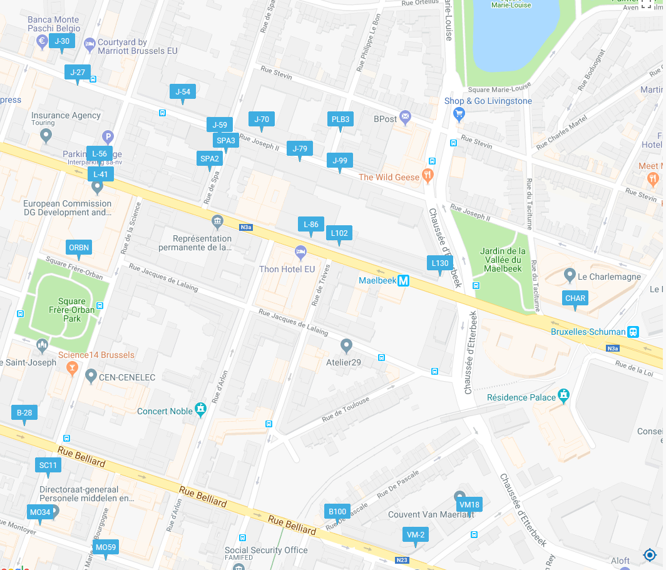

Calling details for ROOM L-41 02/A073

over SIP (max bw 1,5mbps) :

- Using URI : 3224191268@ec.europa.eu

over IP (max bw 1,5mbps) :

- Using a Cisco/Tandberg: 3224191268@ec.europa.eu (or 3224191268@147.67.16.68 or 3224191268@147.67.224.68)

- Using a Polycom or Lifesize: 147.67.16.68##3224191268 (or 147.67.224.68##3224191268)

- Using a Sony/ Other device: 147.67.16.68#3224191268 (or 147.67.224.68#3224191268)

over ISDN (max bw 384kbps):

/!\ As of Feb 1st, 2017, the European Commission Video Conferencing Services will no longer support video connections using ISDN/RNIS (H.320). Please communicate this information to all your partners to make sure they will be able to find a solution to connect using IP (Internet Protocol) (H.323 or SIP).

/!\

Phone inside the room:

58861

Calling details for TRADE ROOM CHAR 08/209

Dial-in information for external participants

EC System Name: CHAR 08/209
EC System alias : 3224191327
Dial from externally to this system : 3224191327@ec.europa.eu
The systems at the European Commission supports H.323 and SIP.
To know how to compose and/or format the dial string on your specific system, please consult your system's user guide or ask the system's administrator.
It might be different depending on your system's brand, type and/or version used.
Systems not able to resolve DNS lookups may replace the domain name (ec.europa.eu) by the IP address 147.67.224.68 or 147.67.16.68

Non-binding, non-exhaustive examples
REMOTE SITE NUMBER TO DIAL
Generic : 3224191327@147.67.224.68
Polycom, lifesize… : 147.67.224.68##3224191327
Sony, Aethra,… : 147.67.224.68#3224191327

Note: Since Feb 1st, 2017 the European Commission no longer supports H.320 (ISDN) for video-connections. Audio-only connections are still supported
+3224191111 [IVR msg] 3224191327#
+352263531111 [IVR msg] 3224191327#
(use DTMF code to enter the alias, note the # sign to terminate the sequence)

