Information for
CEOS WG on Disasters Meeting #10
Napoli, Italy
September 5-7, 2018

Meeting Times

The meeting will start at 9.30 PM on September 5 and end at 5 PM on September 6

On September 7 we will organize an all day field trip to Campi Flegrei, Vesuvius (and if time allows also Pompei), see below.

Meeting Venue

INGV - Osservatorio Vesuviano
Via Diocleziano 328,
Napoli, Italy
INGV-OV switchboard Tel.: +39 081 6108111
Website: http://www.ov.ingv.it/ov/en.html

Registration

Please register by filling and sending the form at the end of this document to stefano.salvi@ingv.it and antonio.montuori@asi.it, by July 20 at the latest.
Contacts for the logistics

Stefano Salvi
Osservatorio Nazionale Terremoti
Istituto Nazionale di Geofisica e Vulcanologia
Via di Vigna Murata, 605 Roma Italy
Tel. +39 06 51860438
Mobile +39 340 5606494
Email: stefano.salvi@ingv.it

Antonio Montuori
Agenzia Spaziale Italiana - ASI
Unità Osservazione della Terra - UOT
Via del Politecnico s.n.c., 00133, Roma Italy
Tel: +39 06 8567 812
Email: antonio.montuori@asi.it

Visa requirements

If you need a latter of invitation in order to secure a VISA to Italy for the meeting, please contact Stefano Salvi to arrange for an official letter to be sent by INGV.

Accommodation

The Osservatorio Vesuviano is located in the Campi Flegrei caldera, in Fuorigrotta, which is off the main Napoli attractions (other than the caldera!).
We thus suggest you select a hotel in a more central location and connect with the Osservatorio Vesuviano by subway (see next section).
For easiness of transport, we propose to stay in one of the following three hotels - or in any other in the same area. They are close to the Mergellina metro station, which is two 2-3 stops away from the Osservatorio Vesuviano.

- Hotel Metro 900
Corso Vittorio Emanuele, 6
https://www.metro900hotel.com/

- H Rooms Boutique Hotel
Via F. Caracciolo, 11
http://www.hroomsnaples.it/

- Hotel Mergellina
Via Giordano Bruno, 115
https://www.hotelmergellina.it/

Directions to INGV - Osservatorio Vesuviano

From the Napoli airport: the fastest way is to take a taxi. The tariffs from the airport to the main city places are available here: http://www.taxinapoli.it/en/tariffs/. Check the URBAN PREDETERMINED RATES and ask the taxi driver to apply this tariff to your ride. They are obliged to accept. The "tariffa predeterminata" for Mergellina is 25 Euro.
You may find it convenient to fly to Roma and then reach Napoli by high velocity train. Depending on the train and time of day the trip can take as little as 2h 10' from the Rome airport to the Napoli train station (Piazza Garibaldi). From there the Osservatorio Vesuviano is 7 stops away on the metro line 2.
The best way to reach the Osservatorio Vesuviano from most locations in the city is to take the metro line 2 and get off at the station Cavalleggeri Aosta.
Here below you will find the Line 2 station list and a city metro map. Much more info is available here: http://www.wikinapoli.com/transport

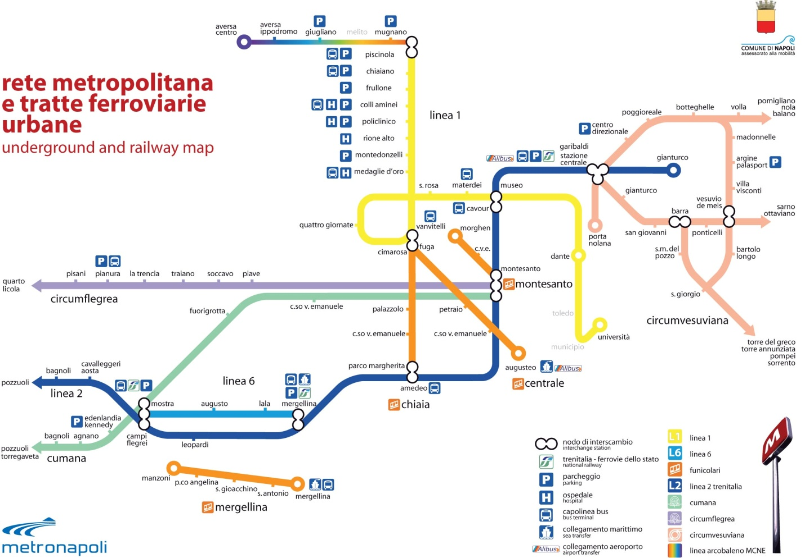

Entering INGV

Please fill the registration form to speed up access. In the lobby you will be given directions to the meeting room.

Meals

Lunch will take place at places nearby INGV. Please be sure to have some cash because most of small eating places do not accept cards.
For dinners, we will advise you locally, but in general the area around Mergellina is full of good restaurants.

Meeting Dinner

We will have a casual, no-host dinner on September 6, likely in downtown Napoli. Price for the dinner could be around 40 €.

Please indicate whether or not you will join the dinner on the registration form.

Field trip

An optional full day field trip will be organized for Friday 7.
At this moment, we do not know if we will have funding for the field trip. If this will not be the case, the participants will be requested a contribution of about 25 € to pay for the bus transportation.
We are planning to visit the Campi Flegrei Caldera and the Vesuvius, and discuss the risk associated to these two main sources. We may have time for a short visit to Pompei or Ercolano, but we will finalize the plan during the meeting.
The Vesuvius walk will be best done using boots than sneakers.

Please indicate on the registration form whether or not you will join the field trip.

REGISTRATION FORM for
CEOS Disasters WG Meeting #10
Napoli, Italy
September 5-7, 2018

To be returned to Stefano Salvi (stefano.salvi@ingv.it and antonio.montuori@asi.it), no later than July 20, 2018.

PARTICIPANT DETAILS
Title | Name | First name
Agency/organization

Address

Email | Tel. | Mobile

Mandatory information required to allow access to INGV - Osservatorio Vesuviano in Napoli

Nationality
Date of Birth
Passport number
Issue date
Issuing authority
Expiry date

I will stay for the three days □ I will stay the following day(s): 5 □ , 6 □ , 7 □
I will participate to the no-host group dinner (location TBD) on September 6: Yes □ No □
I will participate to the field trip on September 7: Yes □ No □
I have the following dietary restrictions:

