Information for
CEOS WG on Disasters Meeting #11
Kallithea, Athens. Greece
March 5-7, 2019

Meeting Times

The meeting will start at (14 PM) on March 5 and end at (5 PM) on March 7.

On March 8 we will organize an all-day field trip. (To be confirmed)

Meeting Venue

Harokopio University
El. Venizelou 70, 17671
Kallithea, Athens, Greece
Tel.: +30 21 0954 9101
Website: https://www.hua.gr/index.php/en/

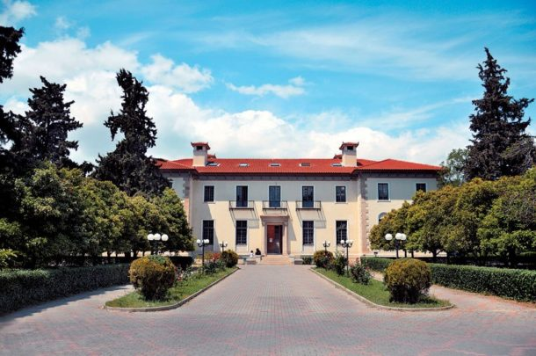

3D CAMPUS MAP of the premises: https://www.hua.gr/media/hua3d/

Registration

Please register by filling this form https://goo.gl/forms/uIAWxUR6HraUaond2 by (January 30) at the latest.

Contacts for the logistics

Parcharidis Issaak
Professor
Department of Geography
Harokopio University
70 El. Venizelou Str., Kallithea
17671, Athens, Greece
Tel.: +30 210 95 49 345
Fax: +30 210 95 14 759
Email: parchar@hua.gr

Mourampetzis Athanasios-Emm.
Department of Geography
Harokopio University
70 El. Venizelou Str., Kallithea
17671, Athens, Greece
Tel: +30 6984355491
Email: gs21548@hua.gr

Visa requirements

If you need a letter of invitation in order to secure a VISA to Greece for the meeting, please contact Parcharidis Issaak to arrange for an official letter.

Accommodation

The Harokopio University is located in Kallithea, Athens. Since it is very near the center, we thus suggest you select a hotel in central location and connect with the Harokopio University by subway (see next section).

For easiness of transport, we propose to stay in one of the following three hotels - or in any other in the same area. They are close to the Monastiraki and Syntagma Metro Station and the Trolley Lines 1 and 5.

- ZILLERS ATHENS BOUTIQUE HOTEL 4 Stars
Address: Mitropoleos 54
website: https://thezillersathenshotel.com/
Monastiraki Square in 400m 5min walk

- EMPORIKON ATHENS HOTEL 4 Stars
Address: Aiolou 27A
website: http://emporikonathenshotel.com/
Monastiraki Square in 270m 3min walk

- NEW HOTEL ATHENS 5 Stars
Address: 16, Filellinon Street, Athens, Greece
website: https://www.oandbhotel.com/
Monastiraki Square in 900m 12min walk

- A FOR ATHENS 4 Stars
Address: Miaouli 2-4, Monastiraki Square
Website: https://aforathens.com/the-hotel/

Directions to Harokopio University

From the El. Venizelos airport:
- By Taxi. The tariffs from the airport to the city of Athens are a fix price of 30 Euro during the day and after 12 the midnight a fix price of 50 Euro.
- By Train. You can take the Metro Line 3 (indicated in blue) which cost a fix price of 10 Euro. Using the Subway, you can reach all the major downtown places and our suggested hotels.
- By Bus. The line Χ95 goes directly from the airport to Syntagma Square, the cost is a fix price of 5 Euro.

You can reach the Harokopio University from your hotel and the most locations in the city using the Metro Line 1 (indicated in green) and get off at the station “Tavros”.

The Metro Lines in the center of Athens cost a fix price of 1,40 Euro for 90 min of travelling with any mean of transportation. You can also board the trolleys 1 and 5 from Syntagma Square and get off at the Bus Stop “Harokopou” 200 meters from Harokopio University.

Moreover, you can take a Taxi from any of the suggested Hotel with a tariff price of approximately 5 Euro.
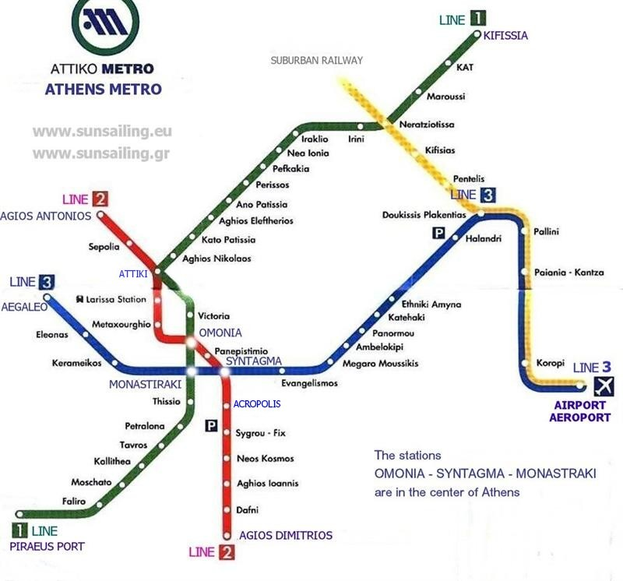
If you wish to arrive with your own car you can do so, since we have a parking area within the University premises.

Entering Harokopio University

During the meet up time we will have someone waiting for you at the entrance of the University.

Meals

Lunch will take place at places nearby Harokopio University. There are a lot of fast food places as well as small restaurants for a quick lunch. Please be sure to have some cash because most of small eating places do not accept cards.

For dinners, we will advise you locally.

Meeting Dinner

We will have a casual, no-host dinner on March 6, likely in downtown Athens near the Parliament. Price for the dinner will be approximately 25 Euro per person.

Please indicate whether or not you will join the dinner on the registration form.

Field trip

On March 8 we will organize an all-day field trip. (To be confirmed)

Please indicate on the registration form whether or not you will join the field trip.

