Information for

**CEOS WG on Disasters Meeting #12**

Reykjavík, Iceland

September 24-26, 2019

**Meeting Time**

The meeting will start at (9 AM) on September 24 and end at (5 PM) on September 26. This time period includes half a day visit to the Icelandic Meteorological Office and Icelandic civil protection.

On September 27 an all-day field trip is organized

**Meeting Venue**

University of Iceland (Nordic Volcanological Center, Institute of Earth Sciences

Askja, Building of Natural Sciences

Sturlugata 7, IS-101 Reykjavík

Websites: <https://english.hi.is>; http://earthice.hi.is

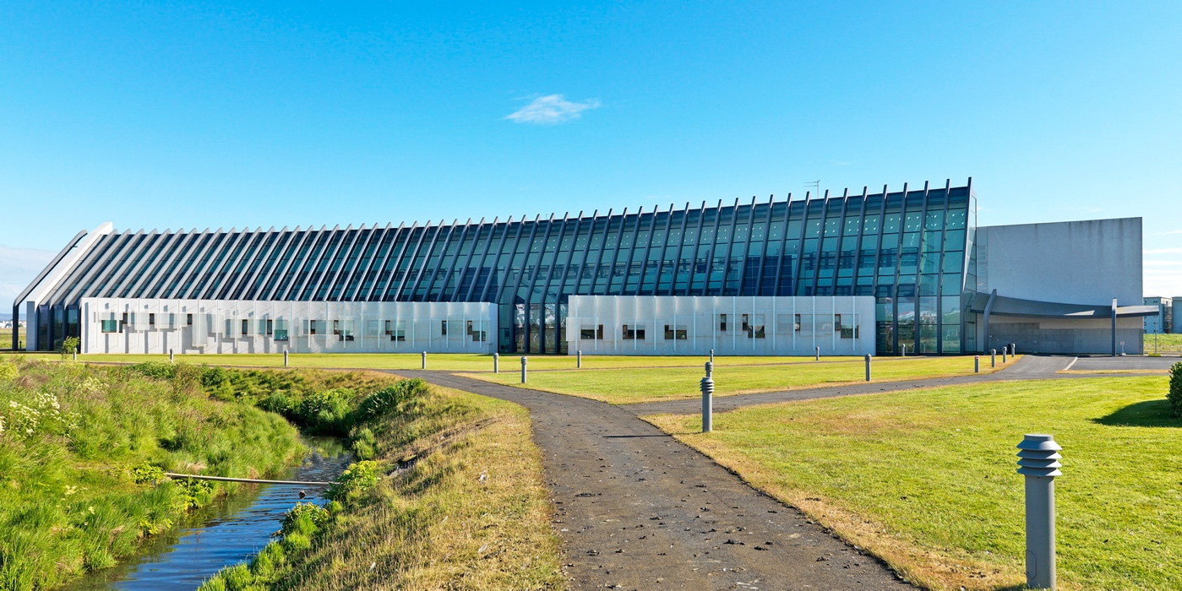

University of Iceland Campus map: <https://english.hi.is/map>

**Registration**

Please register by filling and sending the form at the end of this document to [fs@hi.is](mailto:parchar@hua.gr), [michelle@vedur.is](mailto:michelle@vedur.is) and [antonio.montuori@asi.it](mailto:antonio.montuori@asi.it), **by July 20 at the latest.**

**Contacts for the logistics**

**Freysteinn Sigmundsson**

Research Professor

Nordic Volcanological Center, Institute of Earth Sciences

University of Iceland

Sturlugata 7, IS-101 Reykjavik, Iceland

Tel.: +354 8934607

Email: [fs@hi.is](mailto:parchar@hua.gr)

**Michelle Parks**

Icelandic Meteorological Office

Bústaðavegur 7-9, IS-108 Reykjavík

Tel: +354 8372326

Email: michelle@vedur.is

**Visa requirements**

In case you need a letter of invitation in order to secure a VISA to travel to Iceland for the meeting, please contact Freysteinn or Michelle to arrange for an official letter.

**Accommodation**

University of Iceland is located near the down-town area of Reykjavík, within walking distance for some of the accommodation possibilities. We suggest you select accommodation of your own choice, considering availability in the time period of the meeting and your travel plans (see next section).

See map on the next page.

Costs of accommodation are high, comparable to some the more expensive major cities in the world. Costs of food and taxis are also high compared to European/US standards.



Map of the part of Reykjavík. The Askja Building where the meeting will be held is identified with its name. North of the there is a green area, and a pond (in blue). The old central part of Reykjavik is north of there.

Locations of possible accommodation is shown, according to one search engine on 13 June.

Accommodation books up fast, so best to arrange this as soon as you know your travel plans

**Directions to University of Iceland**

The international airport in Iceland has the code KEF, and goes under either the name “Reykjavík Keflavik International Airport” or “Keflavik airport”. From there it is about a 50 minute drive to downtown Reykjavík. Options to get from the airport to Reykjavík:

1. By “Flybus”, the most common way. See https://www.re.is/tour/flybus/.
2. By Taxi. See e.g. <http://www.hreyfill.is/en/keflavik-airport/>

A good option if 3 or more are travelling together and going to the same location in Reykjavík

1. Renting a car. Expensive. You will not need a car during the time of the meeting unless you are extending your visit

Depending on where your accommodation will be, you can reach the Askja bulding from your hotel/guest house in many cases by walking for 15-25 minutes. Alternatively take a taxi or public transport. Inquire at your hotel/guest house after arrival.

**Meeting Dinner**

We will have a casual, no-host dinner on September 25, likely in downtown Reykjavík near the Parliament. Price for the dinner will be approximately 60 Euro per person.

Please indicate whether or not you will join the dinner on the registration form.

**Field trip**

On September 27 we will organize an all-day field trip on Selected Volcanoes of the Eastern Volcanic Zone of Iceland  
  
Departure:  8 AM from University of Iceland

Arrival: 9PM at University of Iceland

Guides:  Freysteinn Sigmundsson and Michelle Parks  
  
We will explore selected volcanoes of the Eastern Volcanic Zone Iceland. The plan is to visit Hekla and Torfajökull volcanoes (Landmannalaugar area), exploring lava fields, tephra deposits and geothermal activity.  Hekla is a stratovolcano and one of the most active volcanoes in Iceland, with last eruption in 2000. Since then it has been inflating.  It has produced large volumes of lava and tephra - we will visit some of these.  Torfajökull has Iceland largest caldera and the largest silicic volcanic center in Iceland, and we explore how basaltic and silicic volcanism interact. Detailed plans depend on weather

Total costs:  about 150 euros, including bus and driver, food while in field and dinner (without wine) on the way back. There is no accommodation.  People simply stay at their hotels in Reykjavík the night before, and following the trip.

This would mean flight departure from Iceland on Saturday (unless people want to stay longer on their own).

Please indicate on the registration form whether or not you will join the field trip

**Entering the Askja building**

There is free access to this university building (no control). We will put signs with “CEOS meeting” indicating the way the meeting on the third floor (top floor)

**Meals**

For lunch, participants may go to a restaurant at the nearby Nordic House with possibility to have a fixed lunch menu to save time. In detail, one course lunch is about 2600 ISK (about 19 euros per person). Alternatively, you may decide to go and buy sandwiches and drinks (about 10 euros or less per person).

Dinner: Choose from wide selection of restaurants in the central area of Reykjavík.