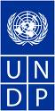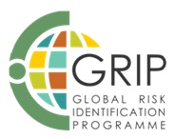

Global Risk Identification Programme

GRIPWeb:
A Community-based Knowledge Management Centre for Risk Assessment and Decision Making

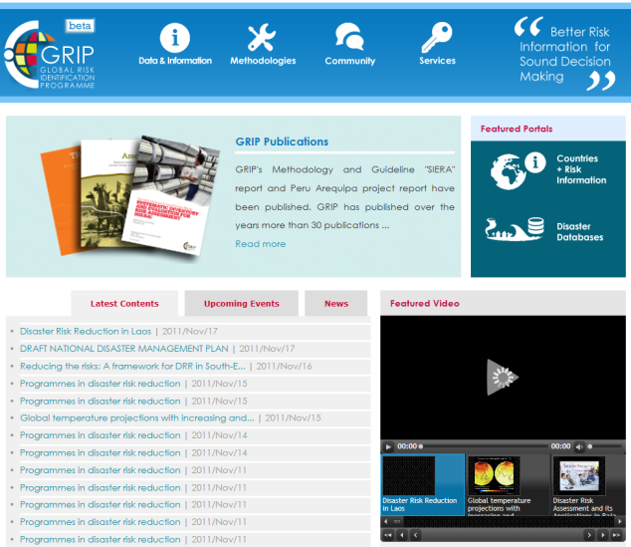
GRIPWeb is GRIP’s online knowledge management centre that serves as an open platform for risk assessment professionals, practitioners, and policy/decision makers to share practices and experience, disseminate and generate risk data, information and knowledge, and develop methodologies, tools, guidelines, and build skills in risk assessment. It is featured with five key functionalities: Online content management, data and file repository, online trainings, community of practice, and online mapping services. GRIPWeb has been designed to become the World’s de-facto risk information source to the international DRR communities. GRIPWeb is accessible at http://www.gripweb.org.

At GRIPWeb, information on disasters and risks is integrated at the Countries + Risk Information portal that is specifically designed to archive country's disaster risk profiles, hazard risk maps and datasets, documents and publications, databases and information systems, projects and programs etc. It serves as a common risk information system for all users to share and access risk-related information from different dimensions – geographic region, country, province/state, city/municipality; organization and programme, themes including risk assessment type, hazard, sector, elements at risk, application areas, and geographical coverage, etc.

GRIPWeb makes it easy the construction of risk information systems at different geographic / administrative levels, by different organizations, by different sector, or by different themes. The following are some examples:

- Risk Information Systems at different geographic / administrative levels

- Regional Risk Information Systems (RRIS): The Regional Risk Information System for the South Eastern Europe covers 8 countries in the Region (the Balkans countries and Turkey). The SEE RRIS page is accessible at <here>.

- National Risk Information Systems (NRIS): Examples include NRISs of Mozambique, Nepal, Armenia, and Lebanon. All the existing risk information for each country are compiled through the Systematic Inventory and Evaluation for Risk Assessment (SIERA) projects that GRIP has assisted these countries to implement. The NRISs are accessible through the Country Pages .

- Sub-national Risk Information Systems: As an example, the Baja California page is accessible at <here>.

- Risk Information Systems by sector or theme

- Sectoral Risk Information Systems: Sectoral risk information is available for several organizations/institutions. Example: WHO; IFRC;

- Programme-related Risk Information Systems: Regional SEE DRM Programme page can be found <here>;

- Disaster Databases Catalogue: Disaster data and information is available from the Global catalogue of disaster databases which currently contains 48 disaster databases (with global, regional, national and sub-national coverage) can be found <here>.

For the countries to build their National Risk Information Systems, GRIP has developed a set of methodology and tools including as follows:

- Systematic Inventory and Evaluation for Risk Assessment (SIERA) for the comprehensive analysis of country situation.
- Online common risk information platform – The Countries + Risk Information Portal at GRIPWeb
- Implemented pilot projects for the Country Situation Analysis (CSA) of Disaster Risk Assessments (DRA)
  - DRA Country Situation Report of Mozambique
  - DRA Country Situation Report of Nepal
  - DRA Country Situation Report of Armenia
  - DRA Country Situation Report of Lebanon
  - DRA State Situation Report of Baja California, Mexico

Contact Information:

Global Risk Identification Programme (GRIP)
Bureau for Crisis Prevention and Recovery (BCPR)
United Nations Development Programme (UNDP)

11-13 chemin des Anemones, CH-1219 Geneva, Switzerland

Tel: +41-22-9178399 Email: info@gripweb.org
Fax: +41-22-9178060 Website: http://www.gripweb.org

