|  |
| --- |
| **­­­­CEOS** |
| **Working Group on Information Systems and Services**  **Data Stewardship Interest Group** |



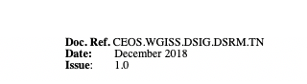

**Background**

One of the CEOS WGISS Preservation and Stewardship Interest Group pillars represents drafting common, cross-agency, best practices and guidelines for data stewardship, for possible adoption by WGISS. The need of a Reference Model for data stewardship planning and implementation first arose in the frame of the CEOS 2017-2019 Work Plan. The requested activity refers to preparing a reference model that provides guidelines and recommendations for the preservation and improvement of data, including a roadmap for scientific data stewardship improvement.

**Scope**

This white paper is intended to assist data owners and data managers in Earth observation (EO) data centres in the task of implementing and improving data stewardship.

The Data Stewardship Reference model describes a series of WGISS assets to be applied and used, before, during, and/or after the end of an Earth observation mission, in order to ensure Earth observation space data sets are preserved and valorised.

**Introduction**

**Data Stewardship or Preservation Workflow**

Before starting presenting the data Stewardship roadmap, it is important to have a clear understanding of the Data Stewardship and Preservation Workflow. In the figure below, the major related activities are reported for each ECSS or mission phase. Regarding all the details in terms of input/output and tasks, please refers to the CEOS Preservation Workflow Best Practices (In the Annex A the list with all assets and the relative web address).

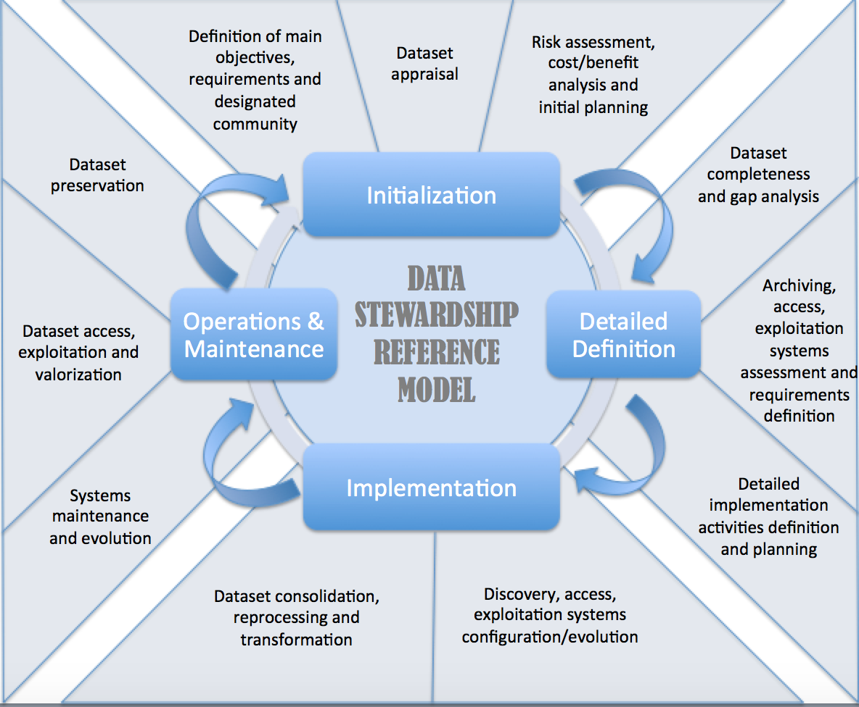

The Stewardship process starts during the initialization phase and continues until the Operations and Maintenance phase. For each new data reprocessing the process needs to be restarted. The main goal of this white paper is to indicate which kind of WGISS assets are needed at each step in the process, and if they are required for application or only for monitoring and review.

**WGISS Assets Supporting Data Stewardship**

The main WGISS assets involved in the data stewardship are presented in the figure below:

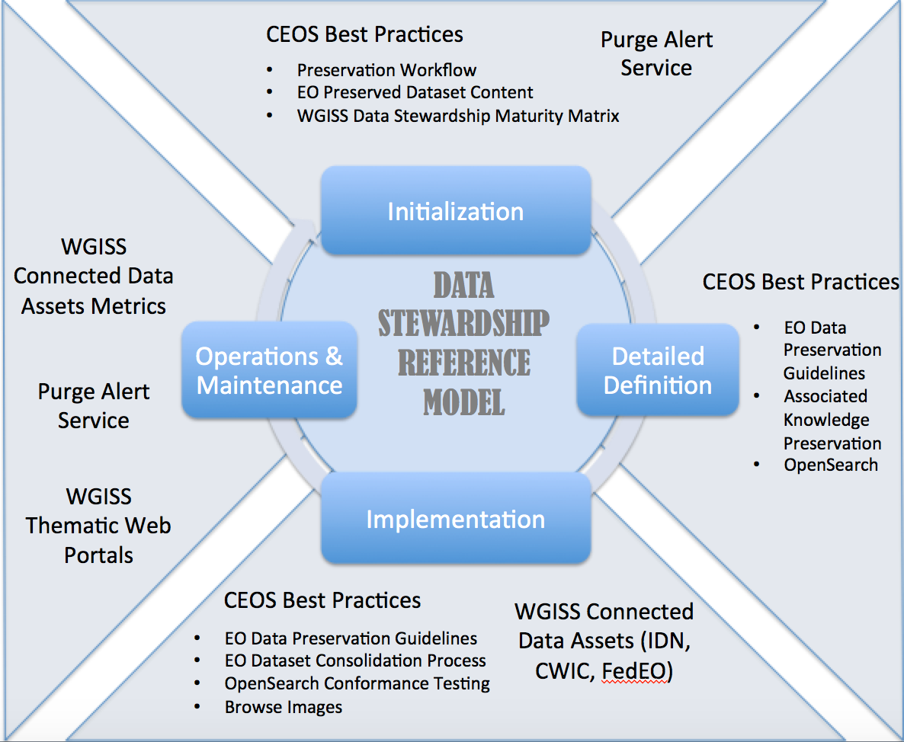

The WGISS Assets can be distinguished in two categories:

* Best Practices and White Papers
* Systems and services

The Best Practices and White Papers produced in the frame of WGISS are the following:

* EO Data Glossary of Acronyms and Terms
* Preservation Workflow
* EO Data Preservation Guidelines
* Preserved Data Set Content
* Generic EO Data Set Consolidation Process
* Persistent Identifiers
* Associated knowledge Preservation
* EO Data Purge Alert Procedure
* WGISS Data Stewardship Maturity Matrix
* Measuring of Earth Observation Data Usage
* Data Stewardship Reference Model
* Browse images
* CEOS OpenSearch Best Practice Documents
* CEOS OpenSearch Conformance Test Plan

The System and Services implemented in the frame of WGISS are the following:

* WGISS Connected Data Assets:
  + IDN
  + FedEO
  + CWIC
  + Open Search
* Purge Alert Service
* WGISS Thematic Web Portals

**Data Stewardship Reference Model**

The following statements facilitate the understanding and utilization of the roadmap presented in the figure below:

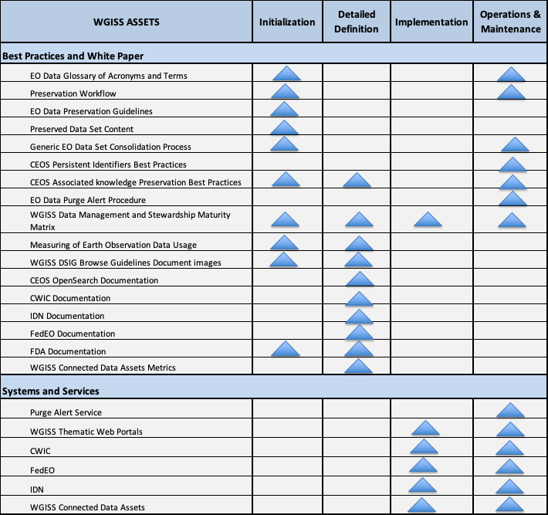

**ANNEX A**

In the following table the WGISS assets and the relevant web address link:

|  |  |
| --- | --- |
| Asset | Link |
| EO Data Glossary of Acronyms and Terms | http://ceos.org/document_management/Working_Groups/WGISS/Interest_Groups/Data_Stewardship/White_Papers/EO-DataStewardshipGlossary_v1.2.pdf |
| Preservation Workflow | http://ceos.org/document_management/Working_Groups/WGISS/Interest_Groups/Data_Stewardship/Best_Practices/Preservation%20Workflow_v1.0.pdf |
| EO Data Preservation Guidelines | http://ceos.org/document_management/Working_Groups/WGISS/Interest_Groups/Data_Stewardship/Recommendations/EO%20Data%20Preservation%20Guidelines_v1.0.pdf |
| Preserved Data Set Content | http://ceos.org/document_management/Working_Groups/WGISS/Interest_Groups/Data_Stewardship/Recommendations/EO%20Preserved%20Data%20Set%20Content_v1.0.pdf |
| Generic EO Data Set Consolidation Process | http://ceos.org/document_management/Working_Groups/WGISS/Interest_Groups/Data_Stewardship/Best_Practices/GenericEarthObservationDataSetConsolidationProcess_v1.0.pdf |
| CEOS Persistent Identifiers | http://ceos.org/document_management/Working_Groups/WGISS/Documents/WGISS%20Best%20Practices/CEOS%20Persistent%20Identifier%20Best%20Practices_v1.2.pdf |
| CEOS Associated knowledge Preservation | http://ceos.org/document_management/Working_Groups/WGISS/Documents/WGISS%20Best%20Practices/CEOS%20Associated%20Knowledge%20Preservation%20Best%20Practices_v1.0.pdf |
| EO Data Purge Alert Procedure | http://ceos.org/document_management/Working_Groups/WGISS/Interest_Groups/Data_Stewardship/Recommendations/WGISS_DSIG_Data%20Purge%20Alert_WP.pdf |
| WGISS Data Management and Stewardship Maturity Matrix | http://ceos.org/document_management/Working_Groups/WGISS/Interest_Groups/Data_Stewardship/White_Papers/WGISS%20Data%20Management%20and%20Stewardship%20Maturity%20Matrix.pdf |
| Measuring of Earth Observation Data Usage | To Be Inserted |
| Data Stewardship Reference Model | To Be Inserted |
| WGISS DSIG Browse Guidelines Document images | http://ceos.org/document_management/Working_Groups/WGISS/Interest_Groups/Data_Stewardship/White_Papers/WGISS_DSIG_Browse-Guidelines-Document-v2_Aug2013.pdf |
| CEOS OpenSearch Documentation | http://ceos.org/ourwork/workinggroups/wgiss/access/opensearch/ |
| CWIC Documentation | http://ceos.org/ourwork/workinggroups/wgiss/access/cwic/ |
| IDN Documentation | http://ceos.org/ourwork/workinggroups/wgiss/access/international-directory-network/ |
| FedEO Documentation | http://ceos.org/ourwork/workinggroups/wgiss/access/fedeo/ |
| FDA Documentation | To Be Created |
| WGISS Connected Data Assets Metrics | http://ceos.org/ourwork/workinggroups/wgiss/connected-data-assets/ |
| WGISS Connected Data Assets | http://ceos.org/ourwork/workinggroups/wgiss/access/ |
| IDN | To Be Inserted |
| FedEO | To Be Inserted |
| CWIC | To Be Inserted |
| Purge Alert Service | http://ceos.org/ourwork/workinggroups/wgiss/preservation/data-purge-alert/ |
| WGISS Thematic Web Portals | To Be Inserted |