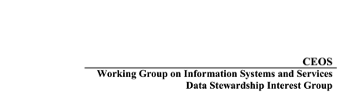

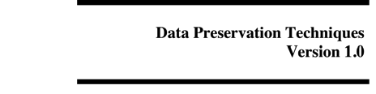
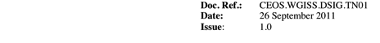

Introduction

This white paper promotes best practices for data preservation of earth observation records. Topics such as media management, environmental control, data migration and storage refresh, multiple copy strategy, physical security, access, and archival facility standards are addressed. It is hoped that by sharing these practices within our community our EO data will be available for the scientist currently relying upon the records as well as future generations of researchers who will require a look back at our planet when we were caretakers of the observational data.

Media Management

The management of media continues to be an important part of preserving Earth observation data. There is no perfect media. Constant vigilance is required to detect problems lurking. A good practice to control manufacturing problems is to track all media used by the manufacturer source, the lot number, and the dates received. While more difficult, also attempt to track media used by date, i.e. when the media was first written to so that an age of the media can be determined. This information can be used to inform projects when media should be migrated or at least to inform them that their risk is increasing because of obsolescence or decay. An example spreadsheet of such a tracking is illustrated below:

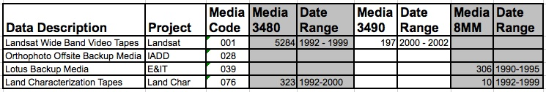

It also is good practice to conduct file checking to validate data integrity. A system of checking a percentage of new data written to disk or tape along with periodic sampling is recommended. In addition, a series of random sampling is a good practice to discover media going bad or data problems undetected previously.

Environmental Control

Many environmental factors can affect the longevity of the media data are stored on. Combined, temperature and relative humidity play critical factors in this area. The Image Permanence Institute has provided extensive guidance on the recommended combinations of temperatures and relative humidity for different media. Some of them are detailed below:

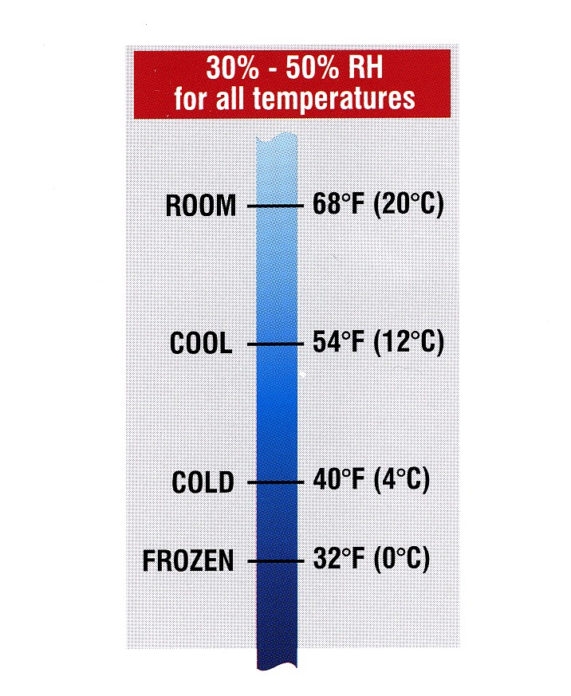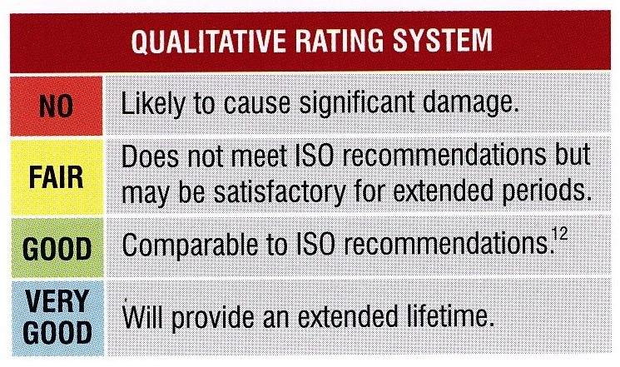

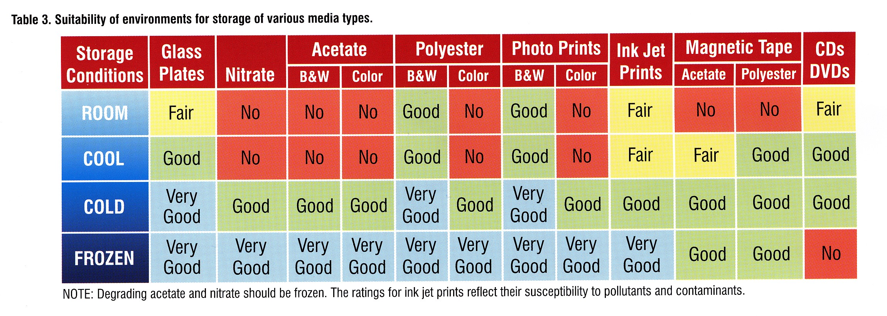

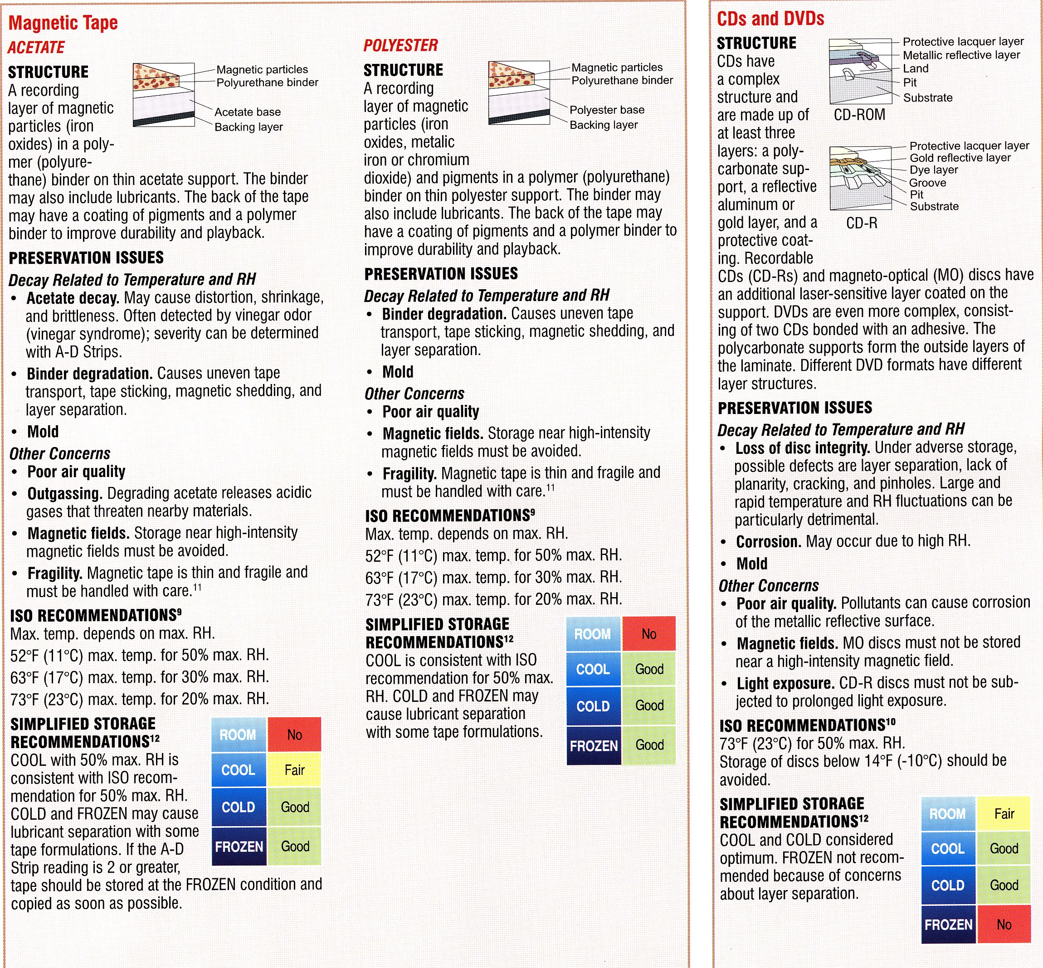

Source: Image Permanence Institute (IPI) Media Storage Quick Reference, 2nd Edition, by Peter Z. Adelstein, 2009.

The U.S. National Archives and Records Administration (NARA) has also provided temperature and relative humidity guidance for different media. The following was taken from NARA’s 1571 Archival Facility Standards:

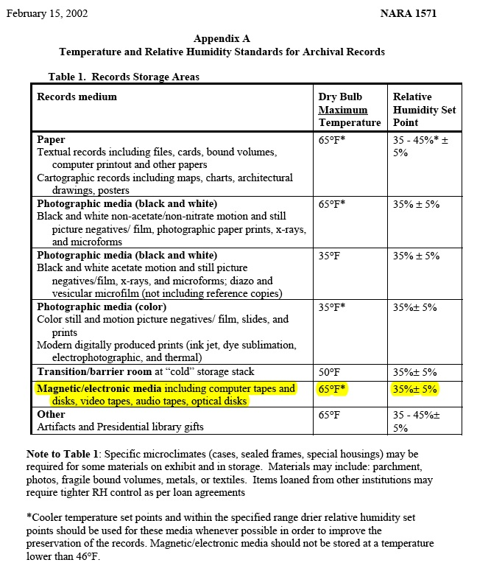

So while there are different ranges of recommended temperatures and relative humidity that can be applied toward magnetic media, a good, minimal target would be 65 degrees Fahrenheit and relative humidity near 35 percent. Maintaining these monthly averages is acceptable along with the goal of minimizing peak occurrences of levels exceeding the thresholds. These levels apply to magnetic disk, magnetic tape, and optical media.

Data Migration / Storage Refresh

All hardware, software, firmware, and media need to be refreshed at some point. Technology changes so fast that it is recommended that all electronic hardware, software, firmware, and media be reviewed for migration or transcription needs within a three- to five-year period. Note the Google study on hard disks failure referenced. While this short period will be challenging to address, it is incumbent upon all who oversee electronic records to ensure that they are preserved and maintained through their useful life.

Multiple-Copy Strategy

As a responsible risk mitigation approach, it is recommended to maintain three complete copies of all long-term Earth observation data. The arrangement of the copies regarding on-line, near-line or off-line is at the discretion of the maintainer. Of the three, however, it is highly recommended to have at least one copy reside physically removed from the main campus where the primary copies reside. Of the remaining two, it is advisable to maintain them in physically separate systems. An example of a three-copy strategy is depicted below:

Physical Security

Good physical security of areas having Earth observation records is a requirement. Whether the records are stored off-site at a commercial facility, in a robotic library in the middle of a computing facility or in an archive, only staff with access needs should have physical contact. Likewise, electronic access must be scrutinized routinely to help ensure that only staff with programmatic need have access to the data files.

Access

One of the main premises behind maintaining Earth observation data is that they become more useful with age allowing greater change analysis opportunities. Those opportunities are enhanced when access means are optimized allowing researchers to discover and utilize Earth observations. Compiling metadata allows catalog systems to present the data to researchers. Using standards like the ISO 19115:2003 or U.S. FGDC Content Standard for Digital Geospatial Metadata allows multiple catalogs to share the information.

Archival Facility Standards

The U.S. National Archives and Records Administration (NARA) has a comprehensive recommendations standard regarding archival facilities entitled, NARA 1571. The standard addresses environmental, fire safety, preservation, and security standards for archival facilities. While the document is targeted at NARA and US federal agencies, it provides useful guidelines for any organization creating new or modifying existing archival facilities. The document is presented on the following pages:

National Archives and Records Administration

TO: Office Heads, Staff Directors, ISOO, NHPRC, OIG
SUBJECT: Archival Storage Standards
NARA 1571
February 15, 2002

Purpose of this transmittal memo. This transmits a new policy directive establishing the internal NARA structural, environmental control, fire safety, preservation, and security standards for appropriate archival storage conditions in NARA archival facilities. Additional facility specifications that are not directly related to appropriate storage conditions for archival records may be included in supplements to this directive.

JOHN W. CARLIN
Archivist of the United States

1571.1 What is the purpose of this directive?
This directive establishes structural, environmental control, fire safety, preservation, and security standards for appropriate archival storage conditions in NARA archival facilities.

1571.2 What is the authority for this directive? The authorities for this directive are

a. 44 U.S.C. 2109, which makes the Archivist of the United States responsible for the preservation of records or other documentary material transferred to the Archivist’s legal custody. Appropriate storage conditions are an essential component of a strategy for preservation of archival records.

b. 44 U.S.C. 2112 and 2903, which make the Archivist responsible for custody, control and operation of certain buildings, land, and space.

c. 44 U.S.C. 2112(a)(2), which requires the Archivist to promulgate architectural and design standards for new and existing Presidential libraries.

1571.3 Definitions
For purposes of this directive, the following definitions apply a. Archival facility means
(1) A NARA-owned or leased facility used to store archival records;

(2) A GSA-owned or leased facility used by NARA to store archival records;
or
(3) A Presidential library acquired by agreement in accordance with 44 U.S.C.
2112(a)(1)(B)(i).

b. Archival records means

(1) Federal records, Presidential historical materials, Presidential records, and donated historical materials transferred to the legal custody of NARA; and

(2) Supreme Court records and the records of Congress that have been deposited in NARA's physical custody.

c. Facility manager means the program official who is responsible for facility management activities within that building.

d. Records area means a records storage area, a designated processing area, an exhibit area, or a preservation (conservation, duplication, microfilm, digital imaging) laboratory. The term covers areas where records may be kept for extended periods.

e. Records storage area means an area containing archival records that is enclosed by four firewalls, the floor, and the ceiling. The term includes general stack areas, vaults, and storage areas for exhibits and museum objects, but does not include reference space, staff offices, public spaces (e.g., restrooms and lobbies) or processing areas.

f. Research room means a room in which researchers may use original records and for which they must be issued a researcher identification card.

1571.4 Responsibilities

a. Space and Security Management Division (NAS)

(1) Conducts periodic building condition surveys as outlined in par. 1571.23 and assists the program offices in establishing and maintaining a system-wide facility improvement and renovation program;

(2) In coordination with other NARA offices, establishes architectural and design standards for all leased and NARA-owned facilities;

(3) Furnishes professional and technical advice on the design and construction of archival storage facilities; and

(4) Acts as project manager for archival facility design and construction
projects.

b. Preservation Programs (NWT) conducts an integrated, scientific preservation program, including

(1) Developing and recommending long-range preservation plans and policy for archival records, coordinating with the Office of Presidential Libraries (NL) and the Office of Regional Records Services (NR), as necessary;

(2) Writing specifications for and providing quality assurance testing of those
materials used to prolong the useful life of records (e.g., folders and boxes) and of materials that will be used in the proximity of records (e.g. paint, adhesives and finishes, carpeting, pesticides, and cleaning supplies);

(3) Monitoring environmental conditions of archival facilities; (4) Administering integrated pest management programs;
(5) Providing technical advice and consultant services on specialized storage requirements to NL, NR, and the Office of Records Services – Washington, DC (NW);

(6) Furnishing professional and technical preservation assistance; and

(7) Reviewing the design and construction of archival storage facilities for records preservation issues.

c. Presidential library directors administer the day-to-day facilities management program of the library in coordination with the NL, and major renovation and restoration projects in coordination with NL and the Office of Administrative Services (NA).

d. Regional administrators and facility directors administer the day-to-day facility management programs of the regions in coordination with NR.

e. Facilities and Materiel Management Services Division (NAF) is responsible for the day-to-day facility management program of the National Archives Building and the National Archives at College Park (Archives II).

1571.5 To what NARA archival facilities does this policy apply?

a. This policy applies to all new NARA archival facilities occupied by NARA on or after October 1, 2001, except new space leased for archival programs on a short-term basis while a permanent archival facility is being built or renovated. Additional facility specifications that are not directly related to appropriate storage conditions for archival records may be included in supplements to this directive.

b. New space leased on a short-term basis must meet the facility standards for storage of permanent Federal records specified in 36 CFR Part 1228, Subpart K.

c. To the extent feasible and financially practicable, existing NARA archival facilities should conform to these standards when the facility is renovated or otherwise significantly modified. If the facility cannot be brought into conformance with every standard, NA and the affected program office determine what mitigating action will be taken to minimize threats to the holdings. For example, if piping within a storage area cannot be removed, a mitigating action, such as frequent inspections, may be identified. Mitigating actions must be coordinated with NWT and approved by the Archivist.

d. All NARA archival facilities must have an Integrated Pest Management program
(see par. 1571.17) and must enforce the facility policies specified in par. 1571.24.

e. All NARA archival facilities must comply with pars. 1571.14 and 1571.15 when selecting and installing new furnishings and materials, including carpet, in the facility and par. 1571.12 when painting records storage areas.

1571.6 What are the general structural standards for NARA archival facilities?

a. The facility must be designed in accordance with regional building codes to provide protection from building collapse or failure of essential equipment from earthquake hazards, tornadoes, hurricanes, and other potential natural disasters.

b. The facility must be constructed with non-combustible materials and building elements, including roofs, walls, columns, and floors.

c. A floor load limit must be established for the records storage area by a licensed structural engineer. The limit must take into consideration the weight of the specific type(s) of archival records to be stored, height and type of the shelving or storage equipment, the width of the aisles, the configuration of the space, etc. The allowable load limit must be posted in a conspicuous place and must not be exceeded.

d. The architectural and engineering design team for the facility must include and work closely with a preservation specialist, who has experience in developing archival storage facilities and has been approved by NARA. The plans for the facility must be reviewed by NWT at each submission stage.

1571.7 What standards must be followed to protect against water damage?

a. Location of facility. The archival facility must be sited a minimum of five feet
above and 100 feet from any 100 year flood plain area, or be protected by an appropriate flood wall that conforms to local or regional building codes.

b. Roof. The facility must ensure that the roof membrane does not permit water to penetrate the roof. Place nothing on the roof that may cause damage to the roof membrane, including equipment. Do not install skylights or sloped glazed windows in areas where records are regularly present. Avoid roof penetrations, including vents, over these areas. However, automatic roof vents, designed solely to vent in the case of a fire, with a temperature rating at least twice that of the sprinkler heads, may be used over records storage areas.

c. Piping.

(1) Do not run piping (except fire protection sprinkler piping and storm water roof drainage piping) through records storage areas.

(2) If drainage piping from roof drains must be run though records storage areas, the piping must be run to the nearest vertical riser and must include a continuous seamless gutter sized and installed beneath the lateral runs to prevent leakage into the storage area.

Vertical pipe risers in records storage areas must be fully enclosed by shaft construction with appropriate maintenance access panels.

d. Location of records within the facility.

(1) Do not store records below grade. Cave/underground facilities may be exempted from the requirement to store records above ground if the facilities

(a) Meet the other standards in this directive;

(b) Demonstrate long-term low risk to records because of water, fire, or structural threats; and

(c) Are granted a waiver from a specific standard by the Archivist. (2) Store records at least 3 inches from the floor surface.
(3) NWT and NAS must review plans to place records shelving equipment along an exterior wall in advance.

(4) No fountains, pools, or standing water are allowed over or adjacent to areas where records are stored, processed, used, or exhibited.

e. Water detection system. If special considerations indicate concerns with
possible water damage in records storage areas, consult with NWT on the advisability of installing a water detection system.

1571.8 What are the general heating, ventilation, and air conditioning (HVAC)
requirements?

a. Archives storage areas, processing areas, and preservation laboratories must be served from separate HVAC systems. All other areas of the building may share the same HVAC system. HVAC equipment must not be mounted on the roof of a new facility.

b. Air handling units serving records storage and processing areas must provide sufficient air exchanges to maintain requirements for temperature, relative humidity, and pollutant control. The number of air exchanges are determined by the planned size of the room, volume of records, volatile organic compounds coming off the records, occupancy, etc.

c. The records storage areas of the facility must be kept under positive air pressure
especially in the areas adjacent to the loading dock. Loading docks must have an air supply and exhaust system that is separate from the remainder of the facility.

d. Areas where records are used, processed, stored, or exhibited must be isolated
from sources of pollutants and particulates, such as the loading dock, machine
rooms, or areas where woodworking or painting take place. Doors to the
record areas must not open directly onto the loading dock, machine rooms,
locations where woodworking or painting takes place, or other similar areas.
The air intakes and returns must be designed such that lower quality air and
environment cannot affect the records areas, and must have direct venting to the
outdoors.

1571.9 What are the temperature and humidity standards?

a. Appendix A specifies the maximum acceptable temperatures in areas where records are stored, and the maximum acceptable temperature set point for areas where records are exhibited, processed, or used. Appendix A also specifies the acceptable range for relative humidity in areas where records are stored, processed, exhibited, or used. Use cooler temperature and drier relative humidity set points whenever possible, as these conditions extend the life and significantly enhance the preservation of the records. Coordinate the selection of temperature
and relative humidity set points with NWT.

b. The standards specified in Appendix A must be maintained 24 hours per day, 365 days per year, unless otherwise stated. Once a set point is programmed, daily fluctuations must not exceed 5° F and/or 5 percent relative humidity. Relative humidity levels represented in a range indicate minimum and maximum set points. Seasonal movement between these set points must not exceed 5% per month while staying within the +/-5% daily band restriction.

c. Seasonal relative humidity drift in actual operation of the system to reconcile energy efficiency and external climate extremes in certain geographical locations and with certain building types may occur. The building should be designed to accommodate the environmental requirements in a highly energy efficient manner.

d. Temperature and relative humidity conditions in records areas must be continuously monitored and must be recorded at intervals that are frequent enough, and in a sufficient number of locations to demonstrate and confirm compliance with the standard. The facility manager must maintain the HVAC systems and integrated monitoring equipment according to manufacturer’s specifications. The facility manager is responsible for monitoring the temperature and relative humidity conditions in the facility following NWT guidance and specifications, and ameliorating problems as they develop. Report ongoing problems to NWT and NAS.

1571.10 What are the limits for air pollutants (particulate and gases)?

Appendix B specifies the maximum allowed levels of particulates and gases in records storage areas, processing areas, exhibit areas, and research rooms. The facility manager is responsible for monitoring for pollutants in the facility at intervals frequent enough to demonstrate and confirm compliance with the standard, following NWT guidance and specifications. The facility manager is responsible for maintaining particulate and gas filtration systems according to manufacturer’s specifications and ameliorating problems as they develop. Report ongoing problems to NWT and NAS.

1571.11 What air handling and filtration systems are required?

The following filtration systems are required in the air handling unit for the records storage and processing areas:

a. Gas-phase filtration system. The gas phase filtration system must control effectively gas phase contaminants including, aromatic, aliphatic, oxygenated hydrocarbons, chlorinated hydrocarbons, and inorganic acid/basic compounds. The operation of the air purification system may be a combination of chemisorption, adsorption, and catalytic processes. The system must be designed to allow periodic monitoring of the filter performance by providing sampling ports or access to the filter ports.

b. Particulate filtration system. The particulate filtration system for archival records storage and processing areas must have a Minimum Efficiency Reporting Rating (MERV) of 14 or greater based on ASHRAE 52.2, “Methods of Testing General Ventilation Air Cleaning Devices for Removal Efficiency by Particle Size.” To extend the service life of the system, it may be desirable to install preliminary filters with lower MERV ratings. A pressure drop measurement system or other equipment must be provided to determine when the filters need to be changed

c. Humidification control system. The air handling units must be designed for both humidification and dehumidification. Humidification must be achieved by a clean steam injection system (such as an electronic steam humidifier), an atomized air system using clean water, or equivalent system located down stream of the gas filtration system. The design of the system must ensure that the system does not generate or harbor microorganisms.

1571.12 What finishes are permitted in records areas?

a. Use a water-based latex paint for painting walls and ceilings. All concrete block walls in the storage area must be primed and painted to prevent dust.

b. Use a low volatile organic compound (VOC) acrylic membrane curing compound for the concrete floors of the records storage areas, after which apply a floor epoxy. Limit the VOC off-gassing of any epoxy and floor coatings in any area where records are processed, used, stored, or exhibited to less than 0.1 part per million by restricting the use of toluene and xylene in the floor coating mix.

c. Use a powder-coating system to paint all painted metal shelving surfaces (including map cases, museum cabinets, etc.) used within all records areas. The powder-coating polymer must be a polyester epoxy hybrid or best equivalent available that passes NWT- conducted or independent lab tests for hardness, coating stability, bending, coating adhesion, and coating durability. The paint must not exceed the off-gassing limits specified in Appendix B. Do not apply powder coating to the metal surfaces onsite in the storage area.

d. If ceiling pipe or exterior stack wall metal panels are to be painted, use an acrylic water reducible primer covered by two latex paint coats.

1571.13 What finishing materials are prohibited in areas where records are used or stored?

The following materials are not permitted in the areas where records are used, processed,
exhibited and stored, including vaults, but may be used in other areas of the facility. For renovated facilities, this paragraph does not apply to previously installed or applied materials.

a. Cellulose nitrate lacquers and adhesives;

b. Polyurethane products, including paints, varnishes, and foams;

c. Acid-curing silicone sealants and adhesives;

d. Sulfur containing materials that could release SO2;

e. Pressure sensitive adhesives that release VOCs;

f. Unstable chlorine polymers (PVCs);

g. Formaldehyde emitting compounds, such as might be found in particle boards;

h. Vinyls; and

i. Oil-based paints and varnishes.

1571.14 What materials may be used in records storage areas and records areas, and how is their suitability determined?

a. Finishing materials, such as paints, finishes, fabrics, carpeting, and floor and wall
coverings, used in areas where records are processed, stored, or exhibited for any purpose, must be approved by NWT. NWT may need to test or direct the testing of materials to determine suitability and render approval. Sufficient time to undertake testing must be incorporated into planning and construction schedules.

b. Cleaning supplies used in areas where records are regularly present should be
selected carefully to minimize potential damage to records. NWT will provide more
specific guidance on how to select appropriate products, and types of products or
specific products whose use is restricted or prohibited.

1571.15 Are carpeting and wall coverings permitted?

Carpeting, vinyl tiles, and wall coverings are not permitted in the records storage areas, but may be used in other parts of the archival facility. Carpeting, vinyl tiles and wall coverings that minimize off gassing of VOCs must be used in areas where records are regularly present.

1571.16 What are the requirements for lighting?

a. Records storage areas.

(1) Normal light levels must not exceed 500 Lux measured 36 inches above the floor level. Ultraviolet (UV) filtration on emergency lighting is required so that UV radiation below 400 nanometers in wavelength does not exceed 75μ W/lumen and 75 μW per square
meter of surface area.

(2) Where records are not protected by an enclosure:
(a) UV filtration as specified in subpar. a(1) is required on all lights. (b) Lights in the storage areas that are not required for safety must be
off when work is not taking place. Systems (e.g. motion
detectors, timers, etc.) should be incorporated to ensure that
light exposure to the holdings is minimized.

b. Processing areas. Lighting levels for normal office space may be used. UV
filtration is required so that UV radiation below 400 nanometers in wavelength does not exceed 75μ W/lumen and 75 μW per square meter of surface area.

c. Exhibit areas. Lighting must have the capability of full control for light levels 0-
200 lux. UV filtration is required so that UV radiation below 400 nanometers in wavelength does not exceed 75μ W/lumen and 75 μW per square meter of surface area.

d. Research rooms. Lighting levels for normal office space may be used. UV
filtration is required so that UV radiation below 400 nanometers in wavelength does not exceed 75μ W/lumen and 75 μW per square meter of surface area.

1571.17 What are the requirements for pest and vermin control?

The archival facility must have an Integrated Pest Management (IPM) program as defined in the Food Protection Act of 1996 (Section 303, Public Law 104-170, 110 Stat. 1512). The facility manager is responsible for monitoring and amelioration of problems as they develop. Report problems to NWT.

1571.18 What are the general fire-safety requirements for archival facilities?

a. NARA archival facilities must comply with requirements and recommended practices specified in NFPA 232-2000, Standard for the Protection of Records unless a requirement in this directive is more stringent.

b. Do not install mechanical equipment containing motors rated in excess of 1 HP
within records storage areas.

c. Do not install high-voltage electrical distribution equipment (i.e., 13.2kv or higher switchgear and transformers) within records storage areas.

d. Penetrations in the walls must not reduce the specified fire resistance ratings.

e. Provide a redundant source of primary electric service, such as a second primary service or an appropriately rated emergency generator to ensure continuous, dependable service to the fire alarm and fire protection systems. Manual switching between sources of service is acceptable.

f. Do not store hazardous materials, including records on cellulose nitrate film, in records storage areas. Records on cellulose nitrate film may include still photographic negatives, still photographic transparencies, x-rays, motion picture film and microfilm. Nitrate motion picture film and nitrate sheet film may be stored in separate areas that meet the requirements of the appropriate NFPA standard, NFPA 40 (1997), Standard for the Storage and Handling of Cellulose Nitrate Motion Picture Film, or NFPA 42 (1997), Code for the Storage of Pyroxylin Plastic.

1571.19 What are the smoke detection system requirements?

a. The archival facility must have an approved, supervised automatic smoke detection system providing full-building coverage. Smoke detection systems must meet the requirements of NFPA 72, National Fire Alarm Code, and must be maintained in accordance with NFPA 72, Part H.

b. Locate smoke detection devices to provide a 99 percent reliability of detecting the origin of the fire in less than 5 minutes. Use photoelectric-type detectors in records storage areas.

1571.20 What are the requirements for automatic sprinklers?

a. All records storage and adjacent areas must be protected by a professionally designed automatic sprinkler system that is designed to limit the maximum anticipated loss from any single fire event to a maximum of 300 cubic feet of records destroyed. Sprinkler systems for records storage areas must be separately zoned from other building areas.

b. A wet sprinkler system, installed in accordance with NFPA 13, Standard for the
Installation of Sprinkler Systems, must be used except as provided in subpar. c.

c. Clean agent systems that comply with NFPA 2001, Standard on Clean Agent Fire Extinguishing Systems, or pre-action sprinkler systems must be used in cold-storage rooms and other areas subject to temperatures below 40°F, and may be used in records storage vaults and museum storage areas. These systems also may be used in computer rooms and electrical and telephone closets.

1571.21 What are the security requirements for archival facilities?

a. The facility must comply, at a minimum, with the security specifications for a Level III facility as defined in the Department of Justice, U. S. Marshals Service report Vulnerability Assessment of Federal Facilities dated June 28, 1995. A copy of the specifications is provided in Appendix A to 36 CFR Part 1228. NAS designates facilities that require higher level security specifications.

b. The facility must have an anti-intrusion alarm system to protect against unauthorized entry.

c. The facility must enforce controls on access to records storage areas.

d. Special security measures may be required for records storage vaults to comply with information security requirements or to protect materials of high intrinsic or monetary value.

1571.22 How should the building condition be monitored and maintained?

The facility manager must ensure that

a. Schedules are developed for maintenance and calibration of control system devices for all major building systems in accordance with manufacturers’ recommendations;

b. Scheduled maintenance is performed promptly; and c. Schedules are reviewed and updated annually.
1571.23 How often should building condition surveys be conducted?

To ensure that archival facilities subject to this directive meet the standards, NAS should conduct (or contract for) building condition surveys according to the following schedule:

a. New facilities. Once before acceptance of a new archival facility, at two years, and
again when 10 years old. After 10 years, follow the schedule for existing facilities. If any “punch-list” items are identified in the inspection before acceptance, NAS must monitor correction/completion of those items.

b. Existing facilities. Every 5 years. When an existing facility is renovated or
significantly modified, the 5-year cycle begins again in the fiscal year following completion of the renovations or modifications. A pre-acceptance inspection is performed for building renovations. If any “punch-list” items are identified in the inspection before acceptance, NAS must monitor correction/completion of those items.

1571.24 What other facility use policies contribute to appropriate archival storage conditions?

a. Prohibit smoking, eating, and drinking in all areas in which records are stored,
exhibited, or used.

b. In facilities that have records processing areas, prohibit processing records and
photocopying in the records storage areas. To ensure that records are subjected to the best environmental conditions available, retain them in processing areas for as short a time as possible.

Appendix A
Temperature and Relative Humidity Standards for Archival Records

Table 1. Records Storage Areas
Records medium | Dry Bulb Maximum Temperature | Relative Humidity Set Point
Paper  Textual records including files, cards, bound volumes, computer printout and other papers  Cartographic records including maps, charts, architectural drawings, posters | 65°F* | 35 - 45%* ±  5%
Photographic media (black and white)  Black and white non-acetate/non-nitrate motion and still picture negatives/ film, photographic paper prints, x-rays, and microforms | 65°F* | 35% ± 5%
Photographic media (black and white)  Black and white acetate motion and still picture negatives/film, x-rays, and microforms; diazo and vesicular microfilm (not including reference copies) | 35°F | 35% ± 5%
Photographic media (color)  Color still and motion picture negatives/ film, slides, and prints  Modern digitally produced prints (ink jet, dye sublimation, electrophotographic, and thermal) | 35°F* | 35%± 5%
Transition/barrier room at “cold” storage stack | 50°F | 35%± 5%
Magnetic/electronic media including computer tapes and disks, video tapes, audio tapes, optical disks | 65°F* | 35%± 5%
Other  Artifacts and Presidential library gifts | 65°F | 35 - 45%±  5%

Note to Table 1: Specific microclimates (cases, sealed frames, special housings) may be required for some materials on exhibit and in storage. Materials may include: parchment, photos, fragile bound volumes, metals, or textiles. Items loaned from other institutions may require tighter RH control as per loan agreements

*Cooler temperature set points and within the specified range drier relative humidity set points should be used for these media whenever possible in order to improve the preservation of the records. Magnetic/electronic media should not be stored at a temperature lower than 46°F.

Table 2. Other Areas/Rooms

Space used for: | Maximum Dry Bulb  Temperature  Set Point* | Relative Humidity  Set Point*
Processing areas/rooms | 70°F ± 5° | 35-45% ± 5%
Exhibit areas/rooms (see Appendix A, Note 1) | 70°F ± 5° | 35-50% ± 5%
Research rooms | 70°F ± 5° | 35-50% ± 5%

*Cooler temperature set points and, within the specified range, drier relative humidity set points should be used for these media whenever possible in order to improve the preservation of the records. Magnetic/electronic media should not be stored at a temperature lower than 46°F.

Appendix B
Air Pollutant Limits

Following are the limits for pollutant gases in records storage, processing, and exhibit areas. The levels of pollutant gases specified in this appendix are based on the lowest concentrations that can readily be measured and achieved with current air filtration technology. There are no known “safe” lower limits below which pollutants will not cause damage.

Type of pollutant | Maximum permitted after air filtration
Sulfur dioxide | 1 ppb (part per billion); 2.7 μg/m3.
Nitrogen dioxide | 2.6 ppb; 5.0 μg/m3
Ozone | 2.0 ppb; 4.0 μg/m3.
Formaldehyde | 4.0 ppb; 5.0 μg/m3.
Acetic acid | 4.0 ppb; 10.0 μg/m3

Note: Research rooms must have at least office quality air filtration.

Data Preservation Techniques References

Failure Trends in a Large Disk Drive Population (Google Hard Disk Study)
http://static.googleusercontent.com/external_content/untrusted_dlcp/labs.google.com/en/us/papers/disk_failures.pdf

International Standards Organization ISO 19115:2003
http://www.iso.org/iso/catalogue_detail.htm?csnumber=26020

Federal Geographic Data Committee Content Standard for Digital Geospatial Metadata
http://www.fgdc.gov/metadata/geospatial-metadata-standards#csdgm

