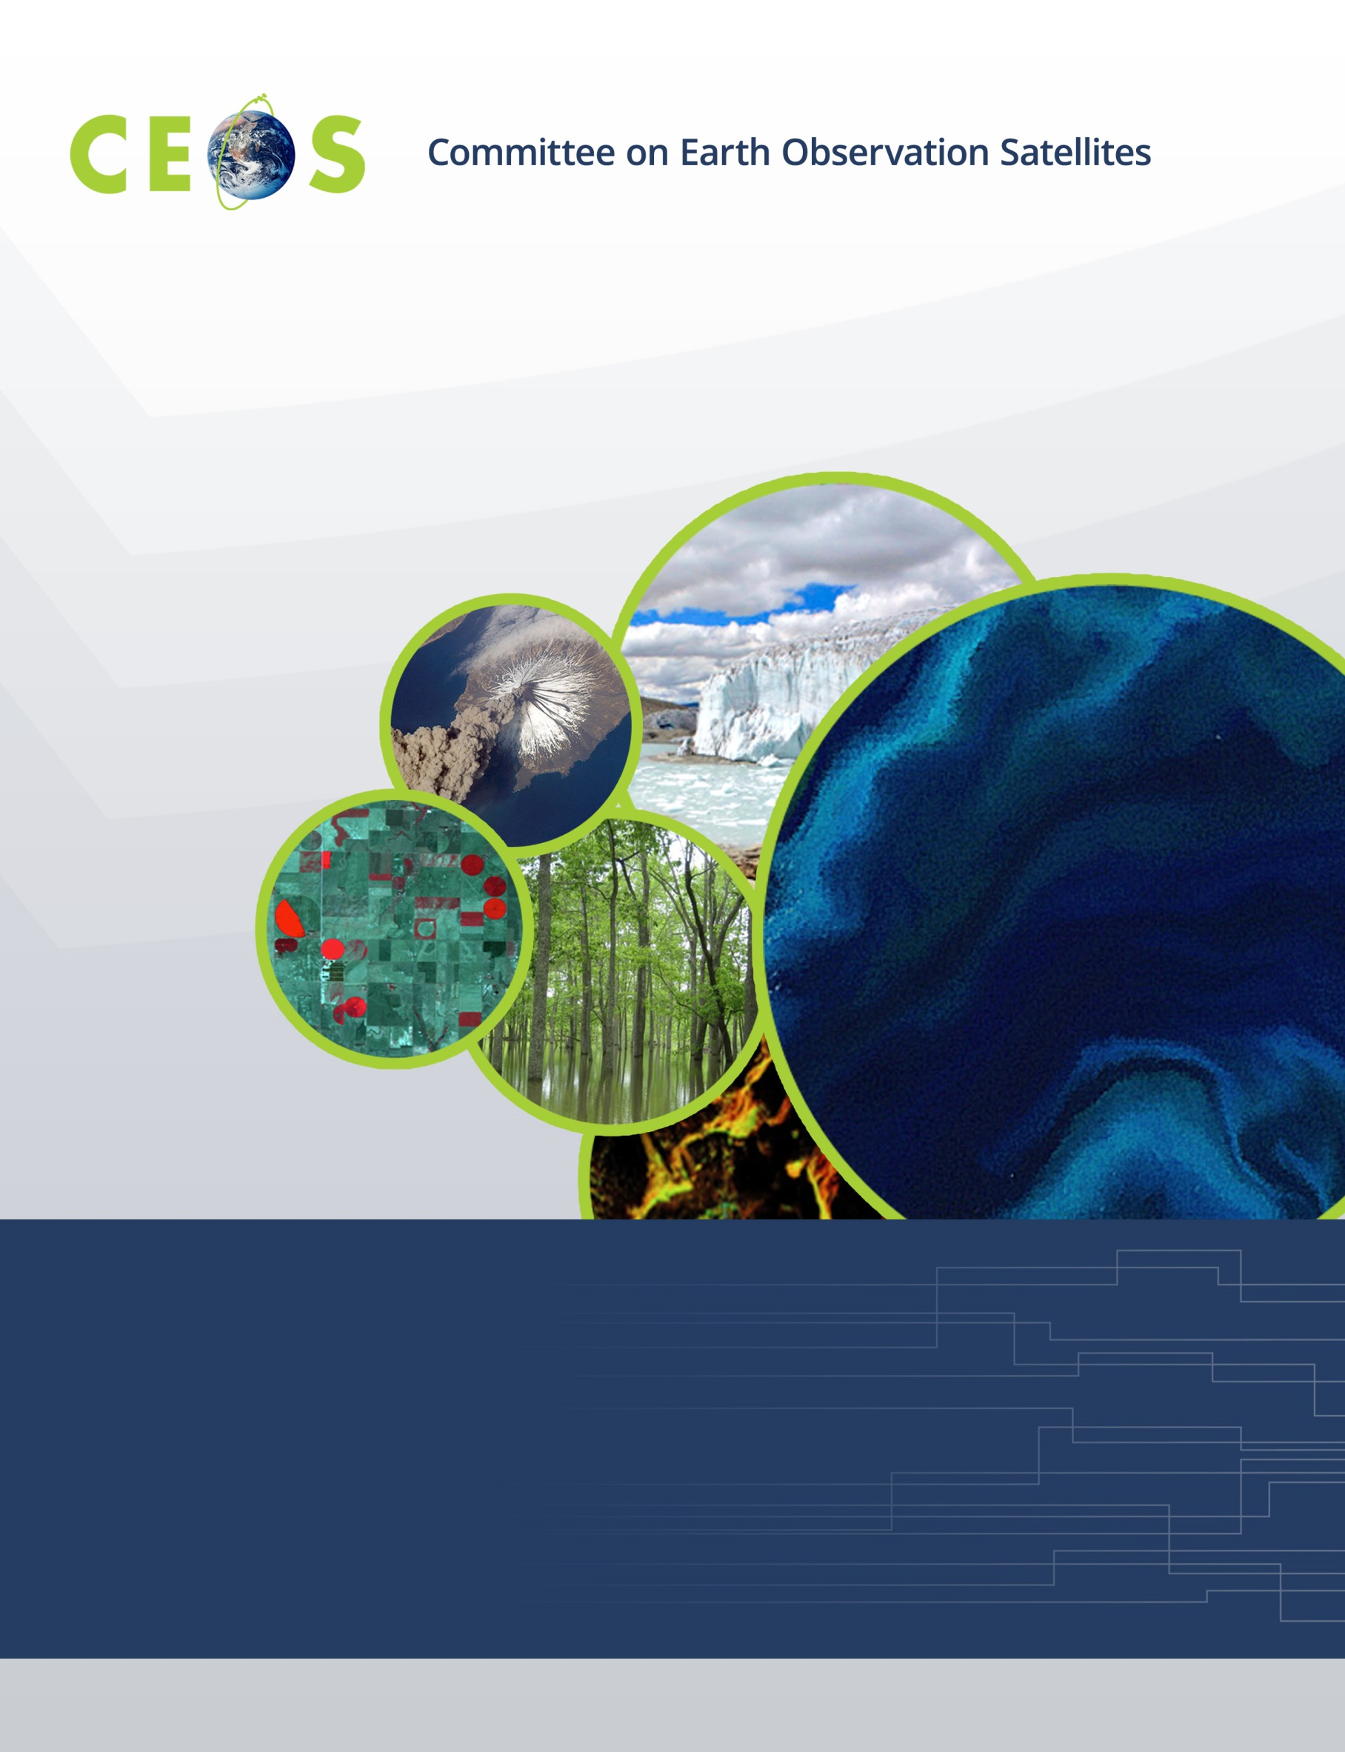

Monday, March 14, 2016
Agenda
CEOS WGISS-41 Plenary Canberra, Australia
Hosted by Geoscience Australia and CSIRO
March 14 – March 18, 2016
Version 1.0 March 14, 2016
*Indicates remote presentation

08:30 Convene

WGISS PLENARY Andrew Mitchell
08:30 Host Welcome Logistics Information GA/CSIRO
09:00 Welcome and Introductions Andrew Mitchell
09:10 GA Welcome Address Dr Stuart Minchin
Chief of Division of the Environmental Geoscience, GA
09:20 Adoption of Agenda Andrew Mitchell
09:30 WISP, Meeting Instructions Martin Yapur
09:40 WGISS Chair Report Andrew Mitchell
10:00 Review of WGISS Actions Andrew Mitchell

11:00 Break
11:15 Discussion on joint activities with WGCV All

12:30 Lunch
PRESERVATION
13:30 Data Stewardship Interest Group Overview and Updates Mirko Albani
14:15 Preservation of Software and Documents Mirko Albani
14:45 Report on Agencies Stewardship Activities
NOAA - Scientific Maturity Model Martin Yapur
ESA - Maturity Matrix/Model for Harmonization Mirko Albani

15:15 Break
15:30 Report on Agencies Stewardship Activities
Landsat Global Archive Consolidation (LGAC) Kristi Kline
ESA-NASA Joint Effort for Historical Data Recovery Andy Mitchell, Mirko Albani
16:15 Preservation Discussion All
Thesaurus Richard Moreno
Persistent Identifiers Andrew Mitchell/Richard Moreno
16:45 Minutes and Action Items review Michelle Piepgrass

18:00- 20:00 Joint Ice Breaker Event at Walt and Burley, sponsored by CSIRO.

Snacks and cash bar will be available.

Please be ready in hotel foyer for transportation to event at 17:40.

Delegates are responsible for dinner and transportation after the event.

Tuesday, March 15, 2016

08:30 Convene

WGISS PLENARY Andrew Mitchell
08:30 Review of Presentation Instructions Michelle Piepgrass
TECHNOLOGY EXPLORATION
08:35 Introduction and Overview Satoko Miura
Semantics
08:45 Natural Language Interface for Exploratory Data Analysis Peter Wang (CSIRO)
09:00 Remote Sensing Data Semantics Lizhe Wang (TBD)

Big Data
09:15 Bridging the gap between the HPD/HPC 'Big Data' Lesley Wyborn (NCI)
09:35 Recent Work on Remote Sensing Cloud Computing and Lizhe Wang
Big Data Processing
09:50 NOSQL influenced solution for EO data exploration Jeremy Hooke (GA)
10:10 Discrete Global Grid Systems - a New way to manage Matthew Purss (GA)
'Big Earth Data’

10:30 Break
10:45 Optimisation of Storage Structure to Enable Efficient File Joshua Sixsmith (GA)
Access and Processing on Massive Time-series of EO Data
11:05 Bringing the Processing Close to the Data Richard Moreno
11:25 Technology Exploration Discussion: Semantics and Big Data All
12:15 Next Steps Satoko Miura

12:30 Lunch
USE
13:30 Future Architecture of Data Kristie Kline, Richard Moreno,
Robert Woodcock
14:30 WGISS Contribution to CEOS Future Data Architectures All
Study Team Report
15:00 CEOS Data Cube prototypes in Kenya and Colombia Brian Killough (SEO)

15:30 Break
15:45 Recovery Observatory Project Richard Moreno
16:15 USE Discussion All
16:45 Minutes and Action Items review Michelle Piepgrass

17:00 Adjourn

Wednesday, March 16, 2016

08:30 Convene

WGISS/WGCV JOINT PLENARY Andrew Mitchell (WGISS Chair),

Albrecht von Bargen (WGCV Chair)
08:30 Welcome and Introductions Andrew Mitchell,
Albrecht von Bargen
08:40 Host Welcome Opening Address Dr. Chris Pigram (CEO of GA)
08:55 Host Welcome Opening Address Alex Held
09:10 Adoption of Agendas Andrew Mitchell,
Albrecht von Bargen
09:20 CEOS Executive Officer Report Jonathon Ross (CEO)
09:50 GEO Secretariat Report Osamu Ochiai* (GEO)

10:20 Group Photo

10:30 Break
11:00 GEO Work Plan IN-02-C1 / GEO Strategic Plan GD 5 All
11:30 Introduction on WGCV/WGISS Joint Efforts Andrew Mitchell, Albrecht von Bargen
Future Data Access
Carbon Action items
Metadata and Metrics
LSI Virtual constellation
NMA initiative (for information)
12:00 Discussion on Joint Interaction All

12:30 Lunch
13:30 Discussion and Summary of Joint Interaction All
14:15 Joint Recommendations to CEOS and GEO All
14:45 Minutes and Action Items review Michelle Piepgrass, Christian Rolf

15:00 Break
15:30 Tour of GA Facility All

17:30 Transportation directly from meeting venue to National Arboretum

18:00 Joint Network Cocktail Event sponsored by GA at National Arboretum

Dinner and beverages provided; neat casual attire please

21:15 Transportation to Garden City Hotel

Thursday, March 17, 2016

08:30 Convene

WGISS PLENARY Andrew Mitchell
08:30 Review of Presentation Instructions Michelle Piepgrass
ACCESS
08:35 Water Portal Project Satoko Miura
Project Summary
Discussion
Project Closing
09:00 IDN Michael Morahan
09:45 OpenSearch II Andrea Della Vecchia*

10:30 Break
10:45 FedEO Andrea Della Vecchia*,
Philippe Mougnaud*
11:30 CWIC Yonsook Enloe,
Ken McDonald*
CWIC Report Yonsook Enloe
ESDC – Future CWIC Client Yonsook Enloe
ISRO Report Nitant Dube*
NOAA Notes Martin Yapur

12:30 Lunch
13:30 WGISS Connected Assets Yonsook Enloe
14:00 Additional Data Sources Yonsook Enloe
14:30 ACCESS Discussion All
14:55 Minutes and Action Items review Michelle Piepgrass

15:00 Transportation from meeting venue to NCI

15:30 Tour of National Computing Infrastructure (NCI)

17:15 Transportation back to Garden City Hotel

Friday, March 18, 2016

08:30 Convene

WGISS PLENARY Andrew Mitchell
08:30 Review of Presentation Instructions Michelle Piepgrass
08:35 Agency/Liaison Reports
CNES Richard Moreno
GA/CSIRO Simon Oliver
GSDI Gabor Remetey
JAXA Satoko Miura
NASA Andy Mitchell
NOAA Martin Yapur
USGS Kristi Kline
ISRO Nitant Dube

10:30 Break
10:45 Discussion on WGCV joint activities
11:15 WGISS-42 Agenda Plan Andrew Mitchell
11:30 Future Meetings Mirko Albani
11:45 WGISS Summary Andrew Mitchell
12:15 Action Items Status Michelle Piepgrass
12:45 Concluding Remarks Andrew Mitchell

13:00 Adjourn

