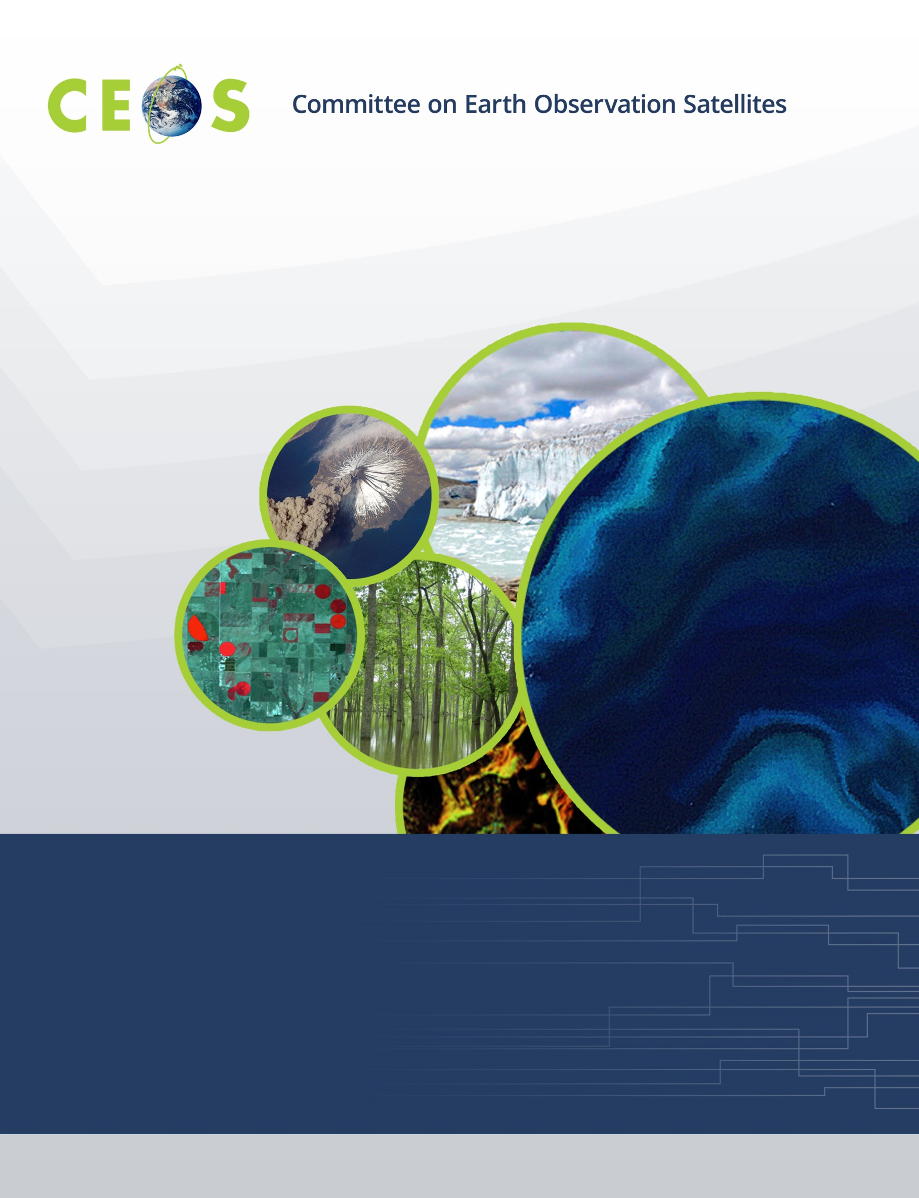

Monday, September 25, 2017
Agenda
CEOS WGISS-44 Beijing, China
Hosted by the Institute of Remote Sensing & Digital Earth (RADI), Chinese Academy of Sciences (CAS)
September 25-28, 2017
Version 1.1 September 24, 2017
*Indicates remote presentation

08:00 Meet in Hotel Lobby for Transportation to Meeting

08:30 Registration

09:00 Convene

WGISS PLENARY Andrew Mitchell
09:00 Host Welcome and Logistics Information Lizhe Wang
09:10 Welcome and Introductions, Adoption of Agenda Andrew Mitchell
09:20 RADI Welcome Address Prof. Guoqing Li, Head of Satellite
Technology Division, RADI
09:40 WISP Report Martin Yapur
09:50 WGISS Chair Report Andrew Mitchell

10:15 Break
10:30 WGISS Chair Report, continued… Andrew Mitchell
11:30 WGISS Response to WGCapD All

12:00 Lunch
CEOS/GEO Activities
13:30 WGISS Brochure Andrew Mitchell
14:00 CEO Report Jonathon Ross*
15:00 NextGEOSS Bente Bye*

15:15 Break
15:30 GEOSS EVOLVE Massimo Craglia*
15:50 Federated User Management
GEOSS Steve Browdy*
NextGEOSS Juan Jose Doval*
ESA Mirko Albani
Discussion All
16:45 Minutes and Action Items review Michelle Piepgrass

17:00 Adjourn

Tuesday, September 26, 2017

08:30 Meet in Hotel Lobby for Transportation to Meeting

09:00 Convene
09:00 Data USE
SEO Report Brian Killough*
09:30 Data ACCESS
WGISS Connected Assets Introduction Yonsook Enloe
IDN Michael Morahan
FedEO Andrea Della Vecchia
CWIC Yonsook Enloe,
Ken McDonald
Data Partners
ISRO Nitant Dube*
NRSCC Yuqi Bai
NOAA Martin Yapur,
Ken McDonald

10:30 Break
10:45 Client Partners
WGISS Client/Carbon Portal Ken McDonald,
Liping Di
Earthdata Search Tool Yonsook Enloe
GEOSS Portal demonstration Andrea Della Vecchia
CEOS OpenSearch Best Practices Andrea Della Vecchia
GeoJSON Andrea Della Vecchia

12:30 Lunch, Tour and No-Host Dinner

Wednesday, September 27, 2017

08:30 Meet in Hotel Lobby for Transportation to Meeting

09:00 Convene
Technology Exploration
Future Data Access and Analysis Architectures Workshop
09:00 Introduction Andrew Mitchell
Robert Woodcock
09:15 Advances and Lessons Learned on Colombia Data Cube Pilar Lozano-Rivera*,
Harold Castro*
09:45 INPE e-Sensing Project Lubia Vinhas*
10:15 Status of Open Data Cube Initiative Brian Killough*

10:45 Break
11:00 Cloud Utilization Kristi Kline*
11:30 CSIRO's developments on the Open Data Cube and Robert Woodcock
Earth Analytics Industry Innovation Hub

12:00 Group Photo

12:15 Lunch
13:30 TERN/AusCover Matt Paget
14:00 Rasdaman Datacube Engine Peter Baumann*
14:30 Swiss Data Cube: EO for Monitoring the Environment of Switzerland Bruno Chatenoux*
In Space and Time

15:00 Break
15:15 Exploitation Platforms Architecture and Technology Antonio Romeo*
15:45 Copernicus Data and Information Access System (DIAS) Martin Ditter*
16:15 OGC Testbed 13 Cristiano Lopes*
16:45 Workshop Summary Andy Mitchell,
Robert Woodcock

17:00 Adjourn

Thursday, September 28, 2017

08:30 Meet in Hotel Lobby for Transportation to Meeting

09:00 Convene
Agency/Liaison Reports
09:00 CNES Richard Moreno
CSIRO/GA Robert Woodcock
NASA Dawn Lowe
NOAA Martin Yapur
NRSCC Chuang Liu
GSDI Liaison Report Gabor Remetey
ISO TC 211 Liping Di

10:45 Break
Data PRESERVATION
11:00 Data Stewardship Interest Group Topic Session Mirko Albani
11:15 Long Term Archive: Infrastructure, Processes, Volume and Trend
NASA Dawn Lowe
NOAA Ge Peng,
Nancy Ritchey*
JAXA Shinichi Sekioka

12:30 Lunch
13:30 ESA Archive Technology and Solution Workshop Mirko Albani
14:00 Data Stewardship Reference Model and
WGISS EO Stewardship Maturity Matrix Iolanda Maggio*

14:30 DSIG Standards Iolanda Maggio*

14:45 Break
15:00 Future Meetings Mirko Albani
15:15 WGISS Summary Andrew Mitchell
16:15 WGISS-43 Action Items Michelle Piepgrass
16:45 Concluding Remarks Andrew Mitchell

17:00 Adjourn

