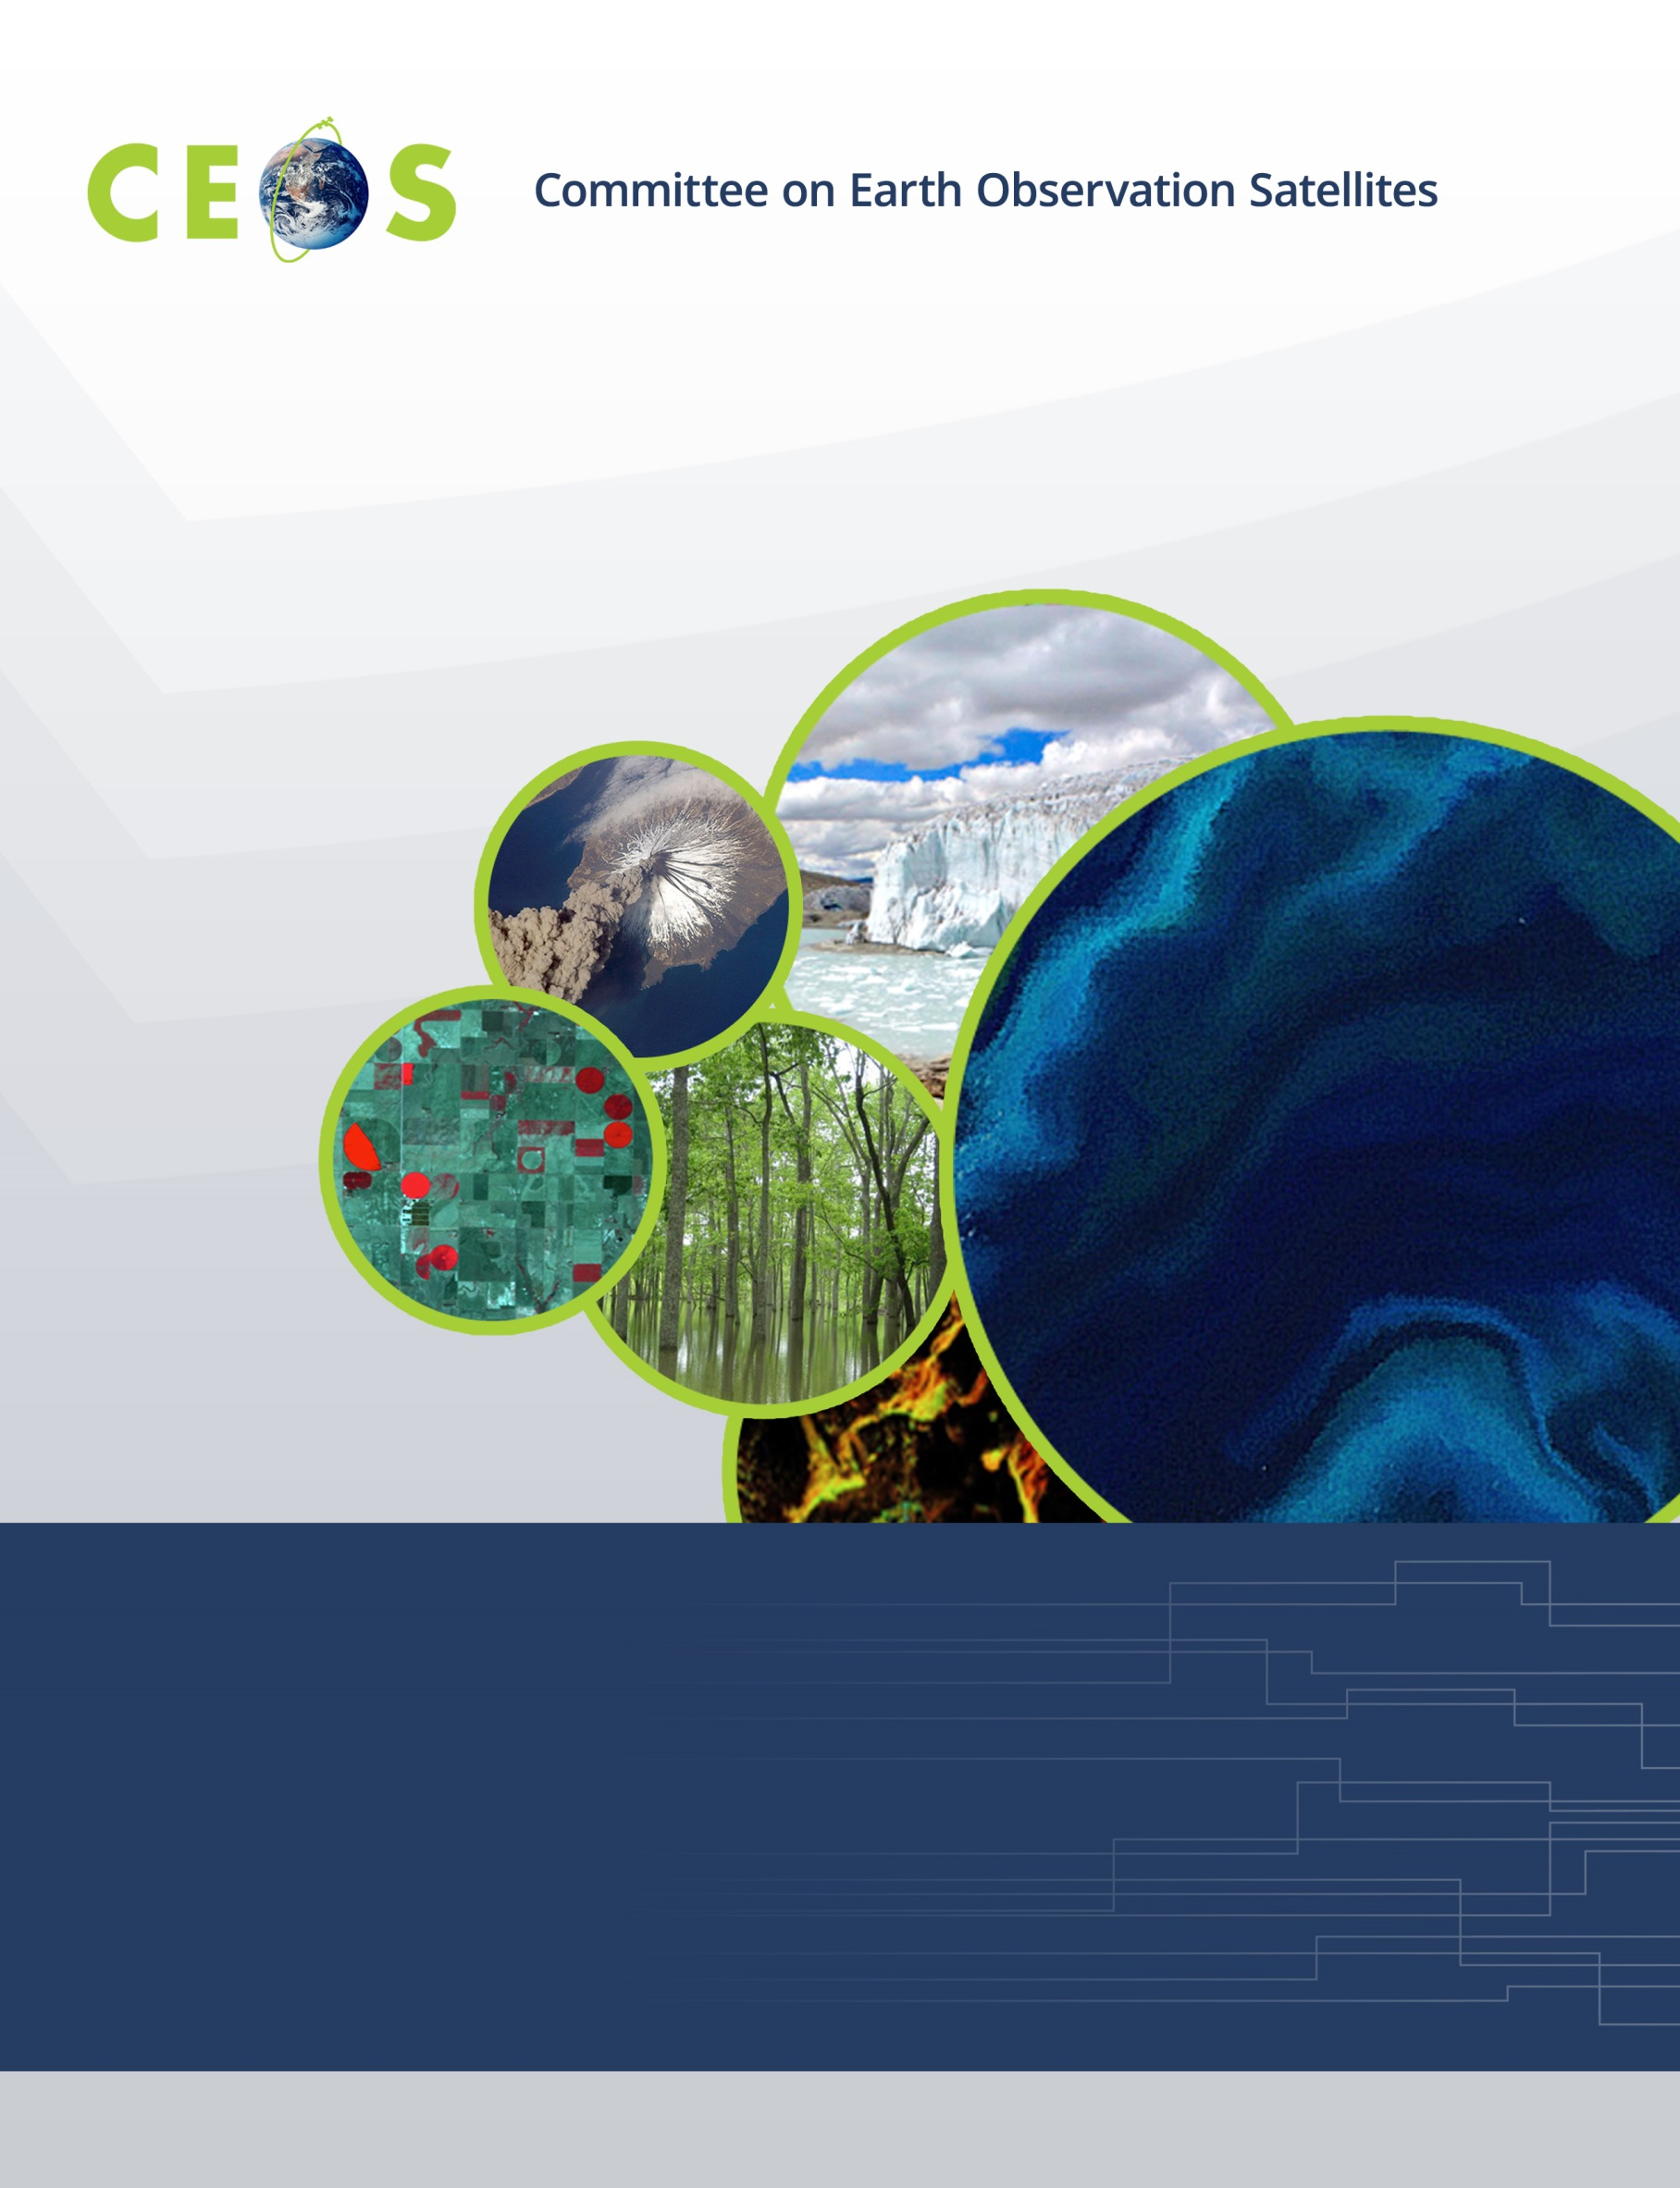

Sunday, October 21, 2018
Agenda
CEOS WGISS-46
October 22-26, 2018
Hosted by the German Aerospace Center (DLR)
Version 1.0 October 21, 2018
*Indicates remote presentation

18:00 WGISS-Exec Meeting Piushof Hotel Lobby

Monday, October 22, 2018

08:15 Meet at corner Mühlfelder Str./Seestr.: https://goo.gl/maps/9aaCK2dLmqM2 for

Transportation to Meeting

08:30 Registration

09:00 Convene

WGISS PLENARY Mirko Albani
09:00 Host Welcome and Logistics Information Stefan Dech
09:10 Welcome and Introductions, Adoption of Agenda Mirko Albani
09:20 WISP Report Michelle Piepgrass
09:30 WGISS Chair Report Mirko Albani
10:00 Review of WGISS 2018-2020 Work Plan Mirko Albani

10:30 Break
Data PRESERVATION and STEWARDSHIP
10:50 Data Stewardship Reference Model Iolanda Maggio
11:10 WMO-wide Stewardship Maturity Matrix for Climate Data Ge Peng
11:40 Data Management and Stewardship Maturity Matrix
Lessons Learned Liu Chuang
12:10 EVER-EST to support the Research Life cycle management Federica Foglini*
Rosemarie Leone*

12:30 Lunch
Data PRESERVATION and STEWARDSHIP, continued
13:30 Knowledge Management System (KMS)
Information Preservation Processes Rosemarie Leone*
14:00 Measuring EO Data Usage – Best Practices Iolanda Maggio
14:30 CERN Archiving Centre Jamie Shiers
15:00 ISO 19165-2 Standard status Hampapuram Ramapriyan*

15:30 Break
15:50 Knowledge Sharing Opportunities: Conferences Esther Conway*,
Iolanda Maggio
16:00 CEOS Executive Officer Report Steven Hosford*
16:20 SEO Report Brian Killough*
16:40 WGCapD Report Dieter Hausamann
16:50 Hungarian Space Office Liaison Report Gabor Remetey*
17:00 WGISS Brochure Iolanda Maggio

17:15 Adjourn

Tuesday, October 23, 2018

08:15 Meet at corner Mühlfelder Str./Seestr.: https://goo.gl/maps/9aaCK2dLmqM2 for

Transportation to Meeting

09:00 Convene
Data DISCOVERY and ACCESS
09:00 Introduction Yonsook Enloe
WGISS Connected Data Assets Report Yonsook Enloe
CWIC Report Yonsook Enloe
IDN Report Michael Morahan
FedEO Update Andrea Della Vecchia
European Partners’ Data Collections Registration into IDN through FedEO
ESA Catalog Evolution

10:30 Break
10:50 ESA TPM Datacube Demonstration Andrea Della Vecchia
Partner Reports
EUMETSAT Report Uwe Voges
JAXA Portal Yousuke Ikehata
CEOS OpenSearch Conformance Test Document Andrea Della Vecchia
WGISS Connected Data Assets Client Guide Document Yonsook Enloe

12:30 Lunch
TECHNOLOGY EXPLORATION
13:30 Interfacing Tools with Data Chris Lynnes
13:45 FOSS Libraries and Tools to Raise EO Data and Applications Homero Lozza*
14:05 Google Dataset Search Tool Evaluation (DLR) André Twele
14:15 Google Dataset Search Tool Evaluation (NASA) Doug Newman*
14:25 DATA-14: White Paper on Single Sign-On (SSO) Authentication Marco Leonardi
14:40 Artificial intelligence for Earth Observation - Towards an R&I Sveinung Loekken
15:10 FDA topics going forward Robert Woodcock

15:30 tour of the German Space Operations Center

17:15 Adjourn

Wednesday, October 24, 2018

08:15 Meet at corner Mühlfelder Str./Seestr.: https://goo.gl/maps/9aaCK2dLmqM2 for

Transportation to Meeting

09:00 Convene
GEOSS-WGISS Interoperability and Future Data Architectures
09:00 Introduction Mirko Albani
09:10 CEOS WGISS Overview and report Mirko Albani
09:30 GEO SEC Overview and report Paola de Salvo*
10:00 WGISS Connected Data Assets State of the Art Yonsook Enloe

10:30 Break
10:50 CEOS Future Data Architectures (FDA) Activities Robert Woodcock
(e.g. Data Cubes, Exploitation Platforms)
11:50 GEOSS Platform and GEO Portal Joost van Bemmelen*,
Guido Colangeli*,
Stefano Nativi*

12:15 Group Photo

12:30 Lunch
13:30 NextGEOSS Bente Lija Bye*
13:50 Regional GEOSS: Architectures/Interoperability/Technology/Cooperation
AmeriGEOSS Eldrich Frazier*
AfriGEOSS Imran Saloojee*
EuroGEOSS Anica Huck
14:50 GEOSS Data Providers Workshop Outcomes Paola De Salvo
15:10 GEOSS EVOLVE and Future Vision Stefano Nativi*

15:30 Break
15:50 WGISS Contribution to DMP Evolution Iolanda Maggio
16:10 Discussion Topics: Rob Woodcock, Yonsook Enloe
Stefano Nativi*,
Joost von Bemmelen*
Current GEOSS Challenges with Respect to Data Discovery and Access Systems
What is working, what can be working better, what is not working
GEOSS/WGISS interoperability issues
GEOSS Future Vision and CEOS Future Data Architectures:
Challenges, synergies, and opportunities

17:15 Adjourn

18:30-22:00 Social Event; no-Host dinner restaurant Klostergasthof at the Andechs Monastery

Thursday, October 25, 2018

08:15 Meet at corner Mühlfelder Str./Seestr.: https://goo.gl/maps/9aaCK2dLmqM2 for

Transportation to Meeting

09:00 Convene
Data INTEROPERABILITY and USE
09:00 FDA-08: FDA Reference architecture Robert Woodcock
09:25 WGCV-3: CEOS Data cubes and test site data access Robert Woodcock
09:50 WGCV-1: Data formats and interoperability Kristi Kline
10:15 FDA-09: Inventory and characterize existing FDAs Mirko Albani

10:40 Break
11:00 FDA-10 Inventory of software and tools (open source) Iolanda Maggio
11:25 CARB-15 Carbon data portal prototype Liping Di*
11:50 GO FAIR, RDA Richard Moreno
Agency/Liaison Reports
12:15 NASA Andrew Mitchell

12:30 Lunch
13:30 ESA Mirko Albani
13:40 CSIRO Robert Woodcock
13:50 CNES Richard Moreno
14:00 NRSCC Chuang Liu
14:10 INPE Lubia Vinhas*
14:20 USGS Kristi Kline
14:30 JAXA Makoto Natsuisaka
14:40 EUMETSAT Uwe Voges
14:50 NOAA Martin Yapur
15:00 UKSA Uzma Ali
15:10 Future Meetings Robert Woodcock

15:20 Break
15:40 WGISS Summary Mirko Albani
16:00 WGISS-46 Action Items Michelle Piepgrass
16:45 Concluding Remarks Mirko Albani

17:15 Adjourn

