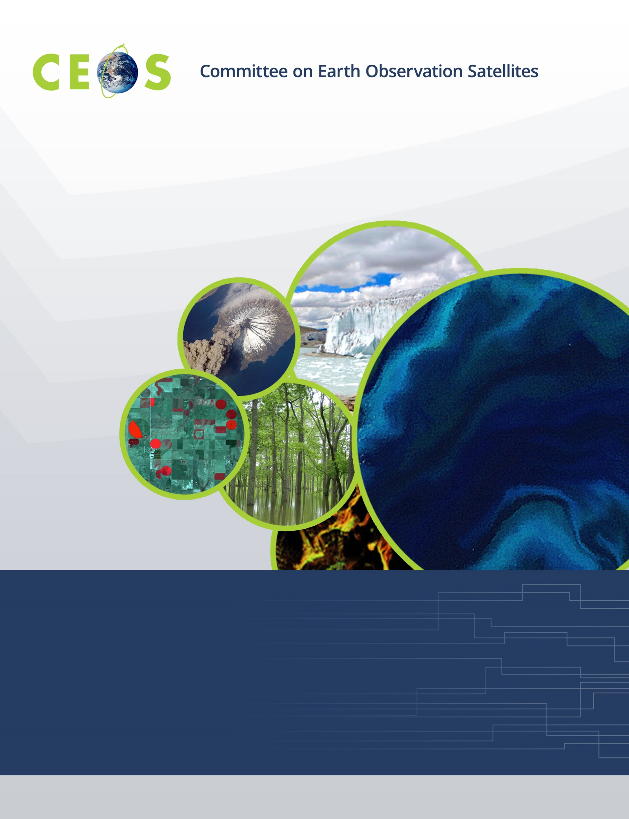

Monday, October 7, 2019
CEOS WGISS-48, Agenda
Hanoi, Vietnam, October 8-11, 2019
Hosted by the VIETNAM NATIONAL SPACE CENTER (VNSC)
Version 1.0 October 1, 2019
*Indicates remote presentation

18:00 WGISS-Exec Meeting

Hanoi Garden Restaurant, 36 Hàng Mành, Hàng Gai, Hoàn Kiếm

Tuesday, October 8, 2019

Meeting room 903, 9th floor, Building A6, VAST campus, 18B Hoang Quoc Viet str., Hanoi

09:00 Registration

09:30 Convene

WGISS PLENARY
09:30 Host Welcome Dr. Vu Anh Tuân,
VNSC Vice Director General
10:00 Welcome and Introductions, Adoption of Agenda Mirko Albani
10:10 Systems Engineering Office (SEO) Report Brian Killough*
Data DISCOVERY and ACCESS
10:30 Connected Data Assets System Level Team
10:30 WGISS Connected Data Assets Status Report Andrew Mitchell
10:50 CWIC Report Archie Warnock*

11:10 Break
11:30 IDN Report Michael Morahan
11:50 FedEO Report Mirko Albani
12:10 NASA Services/Tools Metadata Refactoring Efforts Valerie Dixon

12:30 Lunch VNSC canteen, 10th floor
13:30 NOAA One-Stop and the Cloud Ken Casey
13:50 OGC Happenings Yves Coene*
Testbed15 “Service Discovery”
OGC 17-184 “Collection Description”
14:10 GEOSS Platform – New Version: "Data & Knowledge” Guido Colangeli*
14:30 Data Discover and Access Discussion, Summary of Actions Mirko Albani
WGISS PLENARY, continued
15:00 WISP Report Michelle Piepgrass

15:20 Break
15:40 WGISS Chair Report Mirko Albani
16:10 CEOS Executive Officer (CEO) Report Steven Hosford*
16:30 WGISS Plenary Discussion, Summary of Actions Mirko Albani
17:00

17:30 Adjourn

Wednesday October 9, 2019

Meeting room 903, 9th floor, Building A6, VAST campus, 18B Hoang Quoc Viet str., Hanoi

09:30 Convene
Data INTEROPERABILITY and USE
09:30 Future Data Architectures Robert Woodcock
09:40 ARD/AODS in Apache SDAP Thomas Huang*
10:00 OPeNDAP in the Cloud James Gallagher*
10:20 Forest Monitoring Initiative and Vietnam Data Cube Dr. Vu Anh Tuân

10:50 Break
11:10 Carbon Portal Presentation and Demonstration Liping Di
11:30 UK ARD, Downstream and Calibration Data Esther Conway
11:50 UK Open Data Cube Initiatives Rob Fletcher

12:15 Group Photo

12:30 Lunch VNSC canteen, 10th floor
13:30 Inventory and Characterise Existing FDAs (FDA-09) Iolanda Maggio
13:50 Inventory of Software and Tools (Open Source) (FDA-10) Iolanda Maggio
14:10 Why to Watch WFS 3.0 Valerie Dixon
14:30 ONDA DIAS Franck Ranera*
14:50 CREODIAS Alek Cesarz*

15:10 Break
15:30 Data Cubes Interoperability – Setting the Scene Robert Woodcock
15:40 Progress on the Euro Data Cube Philippe Mougnaud*,
Grega Milcinski*
16:00 Progress on the HMDC Mirko Albani
16:20 Progress on the ODC Data Cube Robert Woodcock
16:40 Roadmap and Short Term Activities on Interoperability between ODC / HMDC / EuroDC Robert Woodcock,
Data Cubes (e.g. Jupyter notebooks with XArray API and WCS / WPS) Brian Killough*
17:10 Data Interoperability and Use Discussion, Summary of Actions Robert Woodcock

17:30 Adjourn

18:30 No-Host Dinner, Hanoi Garden Restaurant, 36 Hàng Mành, Hàng Gai, Hoàn Kiếm

Thursday October 10, 2019

Meeting room 903, 9th floor, Building A6, VAST campus, 18B Hoang Quoc Viet str., Hanoi

09:30 Convene
Agency and Liaison Reports
09:30 ISO 19165-2 Hampapuram Ramapriyan*
09:45 ISO TC 211 Liping Di
10:00 UKSA Esther Conway
10:10 JAXA Makoto Natsuisaka
10:20 CNES Richard Moreno
10:30 NASA Andrew Mitchell
10:40 ESA Mirko Albani

10:50 Break
Data PRESERVATION and STEWARDSHIP
11:10 Persistent Identifiers – Approaches and Processes, Documentation and Software,
Landing Page Approach, Lessons Learned
11:10 ESA Iolanda Maggio
11:30 NOAA Ken Casey
11:50 CNES Richard Moreno
12:10 Preservation Pilot Project Mirko Albani

12:30 Lunch VNSC canteen, 10th floor
13:30 PV2020 Conference Esther Conway
13:50 Use of SKOS Interface and Tools Damiano Guerrucci*
14:10 NOAA Maturity Matrix Self-Assessment Tool Ken Casey
14:30 EDAP: Quality Assessment Matrix Philippe Goryl*
14:50 RDA Fair Maturity Model and Way Forward for Finalization of WGISS Maturity Matrix Iolanda Maggio
15:10 AVHRR European Dataset Preservation and Valorization Project Stefan Wunderle*
15:30 Data Preservation and Stewardship Discussion, Summary of Actions Mirko Albani

15:50 Break
WGISS PLENARY, continued
16:10 GEO Secretariat Report Gilberto Camara*
16:30 GEO Work Programme and WGISS Contributions Mirko Albani
16:40 GEO Discussion, Summary of Actions Mirko Albani
TECHNOLOGY EXPLORATION
17:00 Blockchain and Earth Observation Antonio Romeo*

17:30 Adjourn

Friday October 11, 2019

Meeting room 903, 9th floor, Building A6, VAST campus, 18B Hoang Quoc Viet str., Hanoi

09:30 Convene
TECHNOLOGY EXPLORATION, continued
09:30 Introduction Valerie Dixon
09:40 NASA Knowledge Graph Prototype3 Doug Newman*
10:00 Linked Data at Scale in the Global Change Information Service Reid Sherman*
10:20 SELFIE (Second Environmental Linked Features Interoperability Experiment) D Blodgett*,
Alistair Ritchie*

10:40 Break
11:00 OGC API - Features: a resource oriented alternative to WFS George Percivall*
11:20 STAC – Spatiotemporal Asset Catalog Dan Pilone*
11:40 Technology Exploration Discussion, Summary of Actions Valerie Dixon
WGISS PLENARY, continued
12:20 Future Meetings Robert Woodcock

12:30 Lunch VNSC canteen, 10th floor
13:30 CEOS Working Groups Reports and Progress on Cooperation with WGISS
13:30 WGCV Cindy Ong*
13:50 WGCapD Lauren Childs*
14:10 WGClimate Joerg Schultz*
14:30 SDG AHT Marc Paganini*
14:50 CEOS Working Groups Cooperation Discussion, Summary of Actions Mirko Albani

15:10 Break
15:30 WGISS Summary Mirko Albani
15:50 Review of WGISS-47 Actions Michelle Piepgrass
16:10 WGISS-48 Actions Michelle Piepgrass
16:40 Concluding Remarks Mirko Albani

17:00 Adjourn

