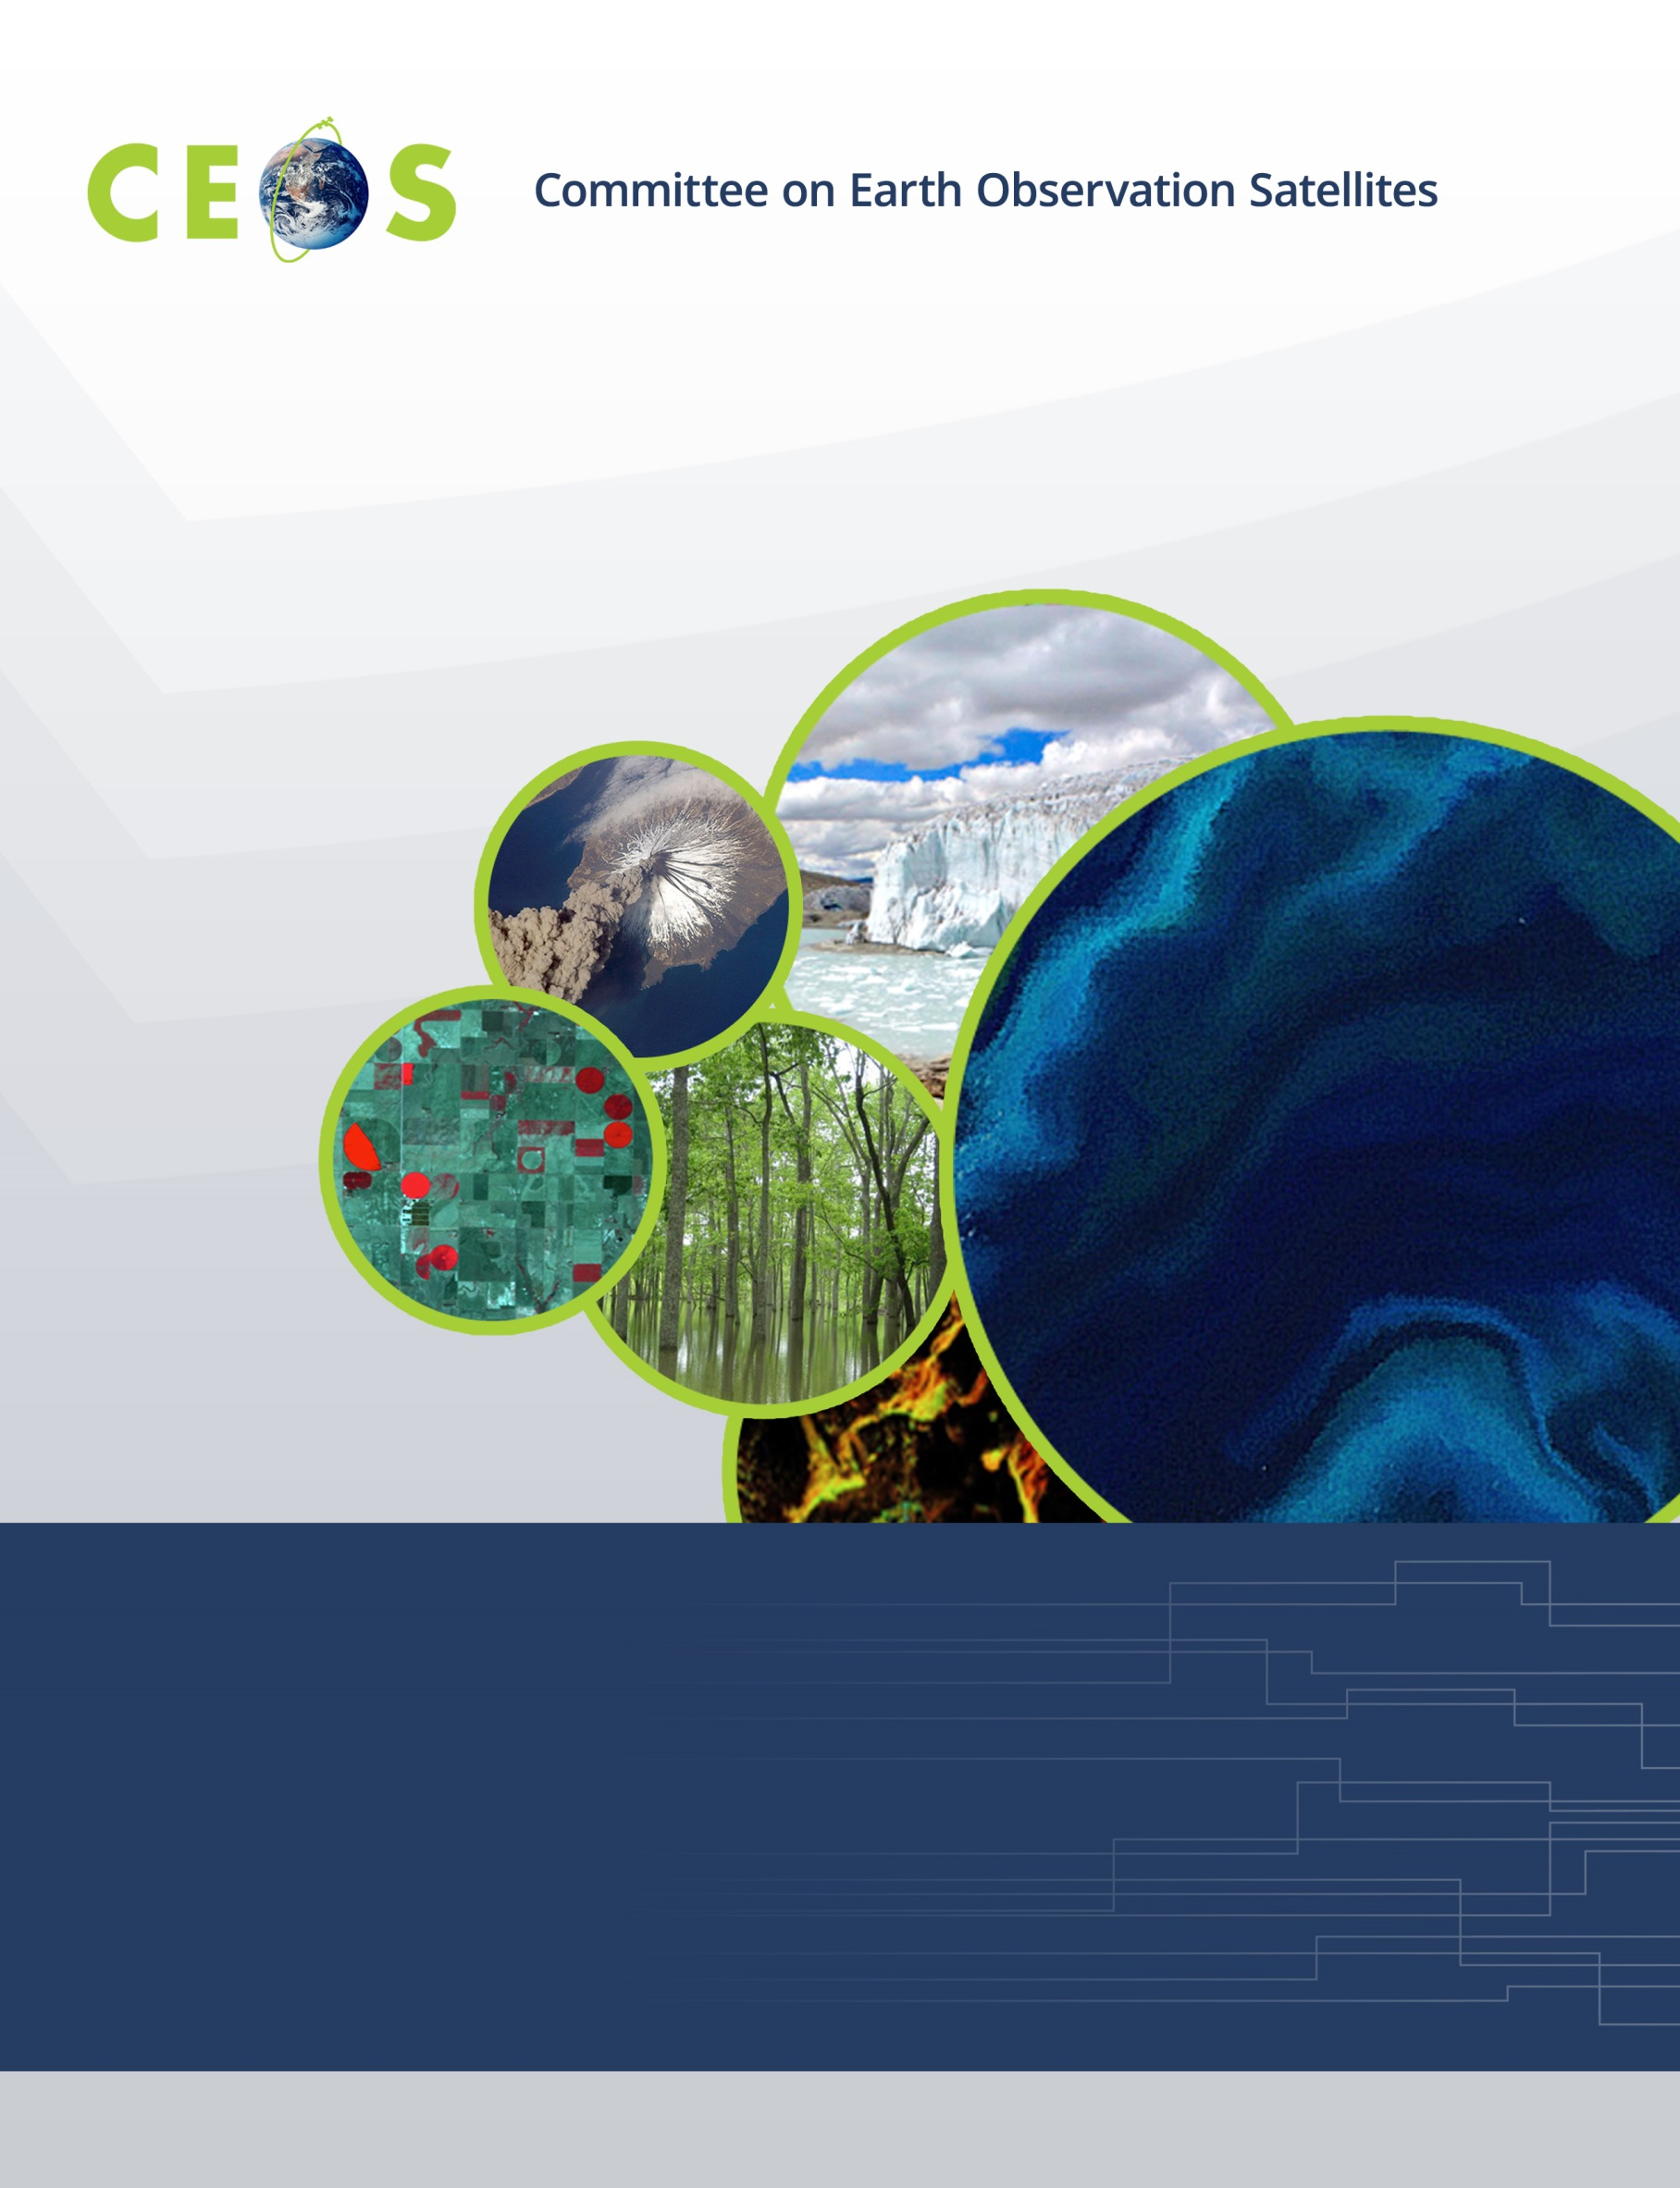

CEOS WGISS-51, Agenda
Virtual Meeting, April 20-22, 2021

All times are Universal Time (UTC), all presentations are remote
Version 1.0 April 19, 2021

Tuesday, April 20, 2021

11:00 Convene

WGISS PLENARY
11:00 Welcome Robert Woodcock (CSIRO)
WGISS Chair Report Robert Woodcock (CSIRO)
CEOS Executive Officer (CEO) Report Marie-Claire Greening
Systems Engineering Office (SEO) Report Brian Killough (NASA)
GEO-SEC Report Gilberto Camara (GEOSEC)
Announcements of New Datasets All
WGISS Plenary Discussion, Summary of Actions, Chair Report Highlights Robert Woodcock (CSIRO)
Data DISCOVERY and ACCESS
12:00 Introduction Damiano Guerrucci (ESA)
General Reports
IDN Michael Morahan (NASA)
CWIC and CWIC Evolution Minnie Wong (NASA)
FedEO Y. Coene (Spacebel, ESA),
A. Della Vecchia (Randstad, ESA)
OpenSearch Best Practices Document (Recent Updates) Minnie Wong (NASA)
QC-MMS – Experience with Quality Metadata, Catalog and Jupyter Notebook Y. Coene (Spacebel, ESA)
NASA EOSDIS STAC
State of STAC Matt Hanson (Element 84/NASA),
STAC and Harmony Amy Steiker (NSIDC/NASA
STAC’s Potential for Federated Search Doug Newman (Raytheon/NASA)
USGS Migration to Cloud Kristi Kline, USGS
NASA Cloud Data Access Chris Lynnes (NASA)
ESA Extended Data Access G. Troina (ESA),
A. Della Vecchia (Randstad, ESA
ESA Earth Observation Identity Access Management V. Amans (ESA),
M. Leonardi (Rhea, ESA)

13:00 Adjourn

Wednesday, April 21, 2021

11:00 Convene
Data INTEROPERABILITY and USE
11:00 Introduction: Cloud Formats Best Practice or White Paper Development Robert Woodcock (CSIRO)
Technical Readiness of ARD P. Goryl (ESA)
Analysis Ready Satellite Data Chris Lynnes (NASA)
SEO Perspective on CEOS Satellite Data in the Cloud Brian Killough (NASA)
ESA Digital Twin Earth Climate Explorer Project on JASMIN Phil Kershaw,
Ag Stephens (NCEO/UKSA)
Cloud-Native Earth Observation Data and Metadata Standards Alex Leith (GA)
at Digital Earth Australia
CEOS EAIL Update Robert Woodcock (CSIRO)
Zarr Cloud Format in Open Data Cube for Hyperspectral Data Peter Wang (CSIRO)
A Parquet Cube Alternative to Store Gridded Data Jean-Michel Zigna (CLS, CNES)
for Data Analytics and Modeling
Data Interoperability and Use Discussion, Summary of Actions Robert Woodcock (CSIRO)

TECHNOLOGY EXPLORATION
12:00 Introduction Yousuke Ikehata (JAXA)
WGCapD Webinar Toolkit Kenton Ross (NASA)
Jupyter Notebook for WGCapD Webinar Esther Conway (UKSA)
CSIRO Jupyter Notebook Experience Matt Paget (CSIRO)
Developing a Jupyter Notebook Best Practice Esther Conway (UKSA)
Discussion and Planning for Jupyter Notebooks Best Practice Yousuke Ikehata (JAXA)
Future Topics for Technology Exploration All

13:00 Adjourn

Thursday, April 22, 2021

11:00 Convene
Data PRESERVATION and STEWARDSHIP
11:00 CAL/VAL Maturity Matrix Paolo Castracane (Rhea, ESA),
P. Goryl (ESA)
NOAA Maturity Matrix Self-Assessment Tool Nancy Ritchey (NOAA)
PID Open Point discussion Mirko Albani (ESA)
NASA PID Dawn Lowe (NASA)
Archive holdings and technology session
ESA Daniele Iozzino (Rhea, ESA)
NOAA Nancy Ritchey (NOAA)
STFC/CEDA Esther Conway (UKSA)
USGS Ryan Longhenry (USGS)
NASA Diane Davies (NASA)
JAXA Makoto Natsuisaka (JAXA)
ISRO Kalpana Tanguturu (ISRO)
International Cooperation on AVHRR Data Mirko Albani (ESA)
WGISS PLENARY
12:10 Agency Reports
NASA Andy Mitchell (NASA)
NOAA Ken Casey (NOAA)
CSA-CCMEO Will Mackinnon (CSA-CCMEO)
USGS Tom Sohre (USGS)
CNES Richard Moreno (CNES)
Future Meetings Makoto Natsuisaka (JAXA)
WGISS Summary and Discussion Robert Woodcock (CSIRO)
Review of WGISS Actions Michelle Piepgrass (CSIRO)
Concluding Discussion and Remarks Robert Woodcock (CSIRO)

13:00 Adjourn

