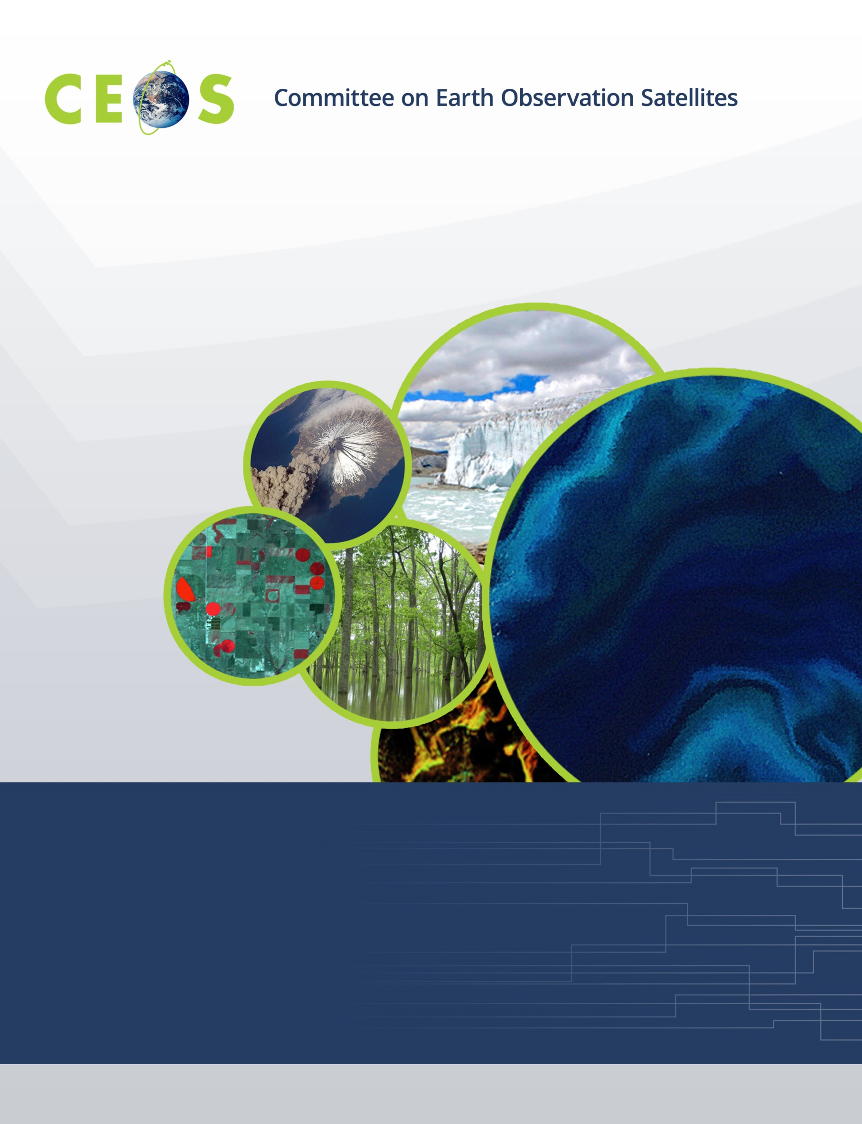

CEOS WGISS-52, Agenda
Virtual Meeting, October 19-21, 2021

All times are Universal Time (UTC), all presentations are remote
Version 0.6 Updated October 12, 2021

Tuesday, October 19, 2021

10:00 Convene

WGISS PLENARY
10:00 Welcome and Chair Report Robert Woodcock (CSIRO)
10:05 CEOS Executive Officer (CEO) Report Marie-Claire Greening (CEO)
10:15 Announcements of New Datasets, Services, and Tools All
Enabling Open Science
10:20 Introduction Andy Mitchell (NASA)
10:30 OpenEO Platform: Current Status and Evolution P. Griffiths (ESA)
10:45 Euro Data Cube - Bring Your Own Algorithm (BYOA) Anja Vrecko (Sinergise),
P. Mougnaud (ESA)
11:00 Open Science by Design K. Baynes (NASA)
11:15 USGS Pete Doucette (USGS)
11:30 Discussion Andy Mitchell (NASA)

11:40 Break
Data DISCOVERY and ACCESS
11:50 Introduction Damiano Guerrucci (ESA)
11:55 Status of GEO DAB Interoperability CEOS Catalogues Roberto Roncella (CNR-IIA/ESA)
General Reports
12:00 IDN Michael Morahan (NASA)
12:10 CWIC and CWIC Evolution Minnie Wong (NASA)
12:20 FedEO Y. Coene (Spacebel/ESA)
12:30 Discovery of Services Y. Coene (Spacebel/ESA)
12:45 Processing-On-the-Fly Macro-Language (POF-ML) S. Riazanoff (VisioTerra)
for Data Access and User Services

13:00 Adjourn

Wednesday, October 20, 2021

10:00 Convene
Data INTEROPERABILITY and USE
10:00 Introduction Robert Woodcock (CSIRO)
10:05 ARD Services for ECV Data in WGISS Carbon Community Portal Liping Di (NASA, NOAA)
10:20 Progress on developing ISO 19124-1 Calibration and Validation Standard Liping Di (NASA, NOAA)
10:35 Data Deployments in the Cloud – Summary Diane Davies (NASA)
10:50 Cloud Computing Technology
10:50 Cloud Migration Archive Pilot Ken Casey (NOAA)
11:05 Earthdata Cloud Dan Pilone (NASA)
11:20 Update on Earth Analytics Interoperability Lab (EAIL) Robert Woodcock (CSIRO)
11:30 FDA and OSS Inventories Iolanda Maggio (Rhea/ESA)

11:40 Break
TECHNOLOGY EXPLORATION
11:50 Introduction Yousuke Ikehata (JAXA)
11:55 Webinar with Jupyter Notebook Report with WGCapD Esther Conway (UKSA)
12:00 Joint Webinar Planning with WGCapD Kenton Ross (NASA)
12:10 Jupyter Notebook Best Practice Esther Conway (UKSA)
12:25 Blockchain KSI Technology Priit Anton (Guardtime/ESA)
12:40 NEODAAS AI Service or PML with AI and Machine Learning Katie Awty-Carroll (PML/UKSA)
12:55 Technology Exploration Action Plan Yousuke Ikehata (JAXA)

13:05 Adjourn

Thursday, October 21, 2021

10:00 Convene
Data PRESERVATION and STEWARDSHIP
10:00 Developing Community Guidelines to Promote Global Access to
and Harmonization of Quality Information of Individual Earth Science Datasets Ge Peng (NASA)
10:15 Term 'Level' Used in Maturity Matrix and Product Level Definition – Discussion Iolanda Maggio (Rhea/ESA)
10:20 Session on Data Quality Self-Assessment and Indicators
10:20 WGISS Data Management and Stewardship Maturity Matrix Iolanda Maggio (Rhea/ESA),
and Quality Indicators P. Castracane (Rhea/ESA)
10:30 Data Quality at ESA Philippe Goryl (ESA)
10:40 Data Quality at NOAA Nancy Ritchey (NOAA)
10:50 Data Quality at JAXA Makoto Natsuisaka (JAXA)
11:00 Data Quality at USGS Cody Anderson (USGS)
11:10 Provenance Using KSI Blockchain Pilot Project Priit Anton (GUARDTIME/ESA)

11:20 Break
11:30 OAIS Interoperability Framework (OAIS-IF) Roberta Svanetti (DEDACLOUD/ESA)
11:45 Data Integrity and Authenticity on Cloud Iolanda Maggio (Rhea/ESA)
12:00 CEOS Common Online Dictionary Katrin Molch (DLR)
12:15 International Cooperation on AVHRR Data Mirko Albani (ESA)
WGISS PLENARY
12:25 Agency Reports
12:25 CONAE Homero Lozza (CONAE)
12:30 NASA Andy Mitchell (NASA)
12:35 USGS Tom Sohre (USGS)
12:40 Future Meetings Makoto Natsuisaka (JAXA)
12:45 WGISS Summary and Discussion, Concluding Remarks Robert Woodcock (CSIRO)

13:00 Adjourn

