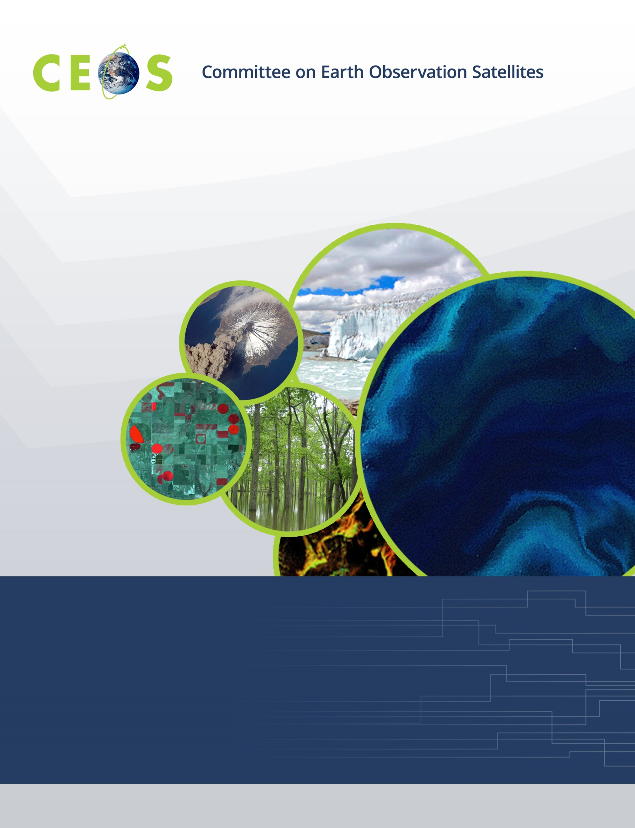

CEOS WGISS-53, Agenda
Virtual Meeting, March 22-24, 2023

All times are Universal Time (UTC), all presentations are remote
Version 1.0 Updated March 21, 2022

Tuesday, March 22, 2022

10:00 Convene

WGISS PLENARY
10:00 Welcome Makoto Natsuisaka (JAXA)
10:05 WGISS Chair Report Makoto Natsuisaka (JAXA)
10:20 CEOS Executive Officer (CEO) Report Marie-Claire Greening (CEOS)
Data DISCOVERY and ACCESS
10:35 Introduction Damiano Guerrucci (ESA)
General Reports
10:40 IDN, CWIC Michael Morahan (NASA)
10:50 FedEO Yves Coene (Spacebel/ESA)
11:00 Data Storage and Format on Cloud C. Noel (Spacebel/ESA)
11:15 STAC for Federated Search Doug Newman (NASA)

11:30 Break
11:45 GEOSS Platform – Data Brokering R. Roncella (CNR/ESA)
12:00 Service Discovery OpenSearch Best Practices Yves Coene (Spacebel/ESA)
TECHNOLOGY EXPLORATION
12:15 CEOS Jupyter Notebooks Best Practice and Exemplars Esther Conway (UKSA)
12:25 Jupyter Notebooks Approach at EUMETSAT Julia Wagemann (EUMETSAT)
12:35 Jupyter Notebooks Day and Survey Esther Conway (UKSA)
12:45 WGCapD and Support for Webinar Plus Kenton Ross, Lauren Childs (NASA)
12:55 Topics/Sessions for Future WGISS Meetings Yousuke Ikehata (JAXA)

13:00 Adjourn

Wednesday, March 23, 2022

10:00 Convene
Data PRESERVATION and STEWARDSHIP
10:00 Object Storage Benchmark Report Daniele Iozzino (Rhea/ESA)
10:15 WGISS Data Management and Stewardship Maturity Matrix: Application Use Case Iolanda Maggio (Rhea/ESA)
10:30 Session on Data Integrity and Authenticity on Cloud
10:40 ESA Approach Mirko Albani (ESA)
10:50 NASA Approach Manil Maskey (NASA)
11:00 JAXA Approach Makoto Natsuisaka (JAXA)
11:05 USGS Approach Tom Sohre (USGS)
11:15 STFC/CEDA Approach Sam Pepler (STFC/CEDA)
11:25 Discussion

11:35 Break
11:50 CEOS Common Online Dictionary Katrin Molch (DLR)
12:05 NRSCC’s Methodology for Data Publishing and Repository Liu Chuang (NRSCC)
12:15 Topics/Sessions for Future WGISS Meetings Iolanda Maggio (Rhea/ESA)
Data INTEROPERABILITY and USE
12:30 Explore ARD with the Data Cube for Atmospheric Composition Federico Fierli,
Julia Wagemann (EUMETSAT)
12.45 Internet of Things: Liu Chuang (NRSCC)
Monitoring High Quality Geographical Products for Environment and Sustainability

13:00 Adjourn

Thursday, March 24, 2022

10:00 Convene

WGISS Cooperation with other Working Groups
10:00 Updates from GEO Paola De Salvo (GEO)
10:15 Progress on ISO 19124-1 Liping Di (ISO/NASA)
and the New Joint ISO-OGC Standard Initiative on Analysis-Ready Data
10:30 WG Disasters Laura Frulla (CONAE)
Agency Reports
10:45 NASA Andy Mitchell (NASA)
10:55 USGS Tom Sohre (USGS)
11:05 JAXA Yousuke Ikehata (JAXA)
11:15 ISRO Nitant Dube (ISRO)
11:25 NOAA Ken Casey (NOAA)

11:45 Break
WGISS PLENARY
12:00 Future Meetings Tom Sohre (USGS)
12:10 WGISS Summary and Discussion Makoto Natsuisaka (JAXA)
12:30 Review of WGISS Actions Michelle Piepgrass (JAXA)
12:50 Concluding Discussion and Remarks Makoto Natsuisaka (JAXA)

13:00 Adjourn

