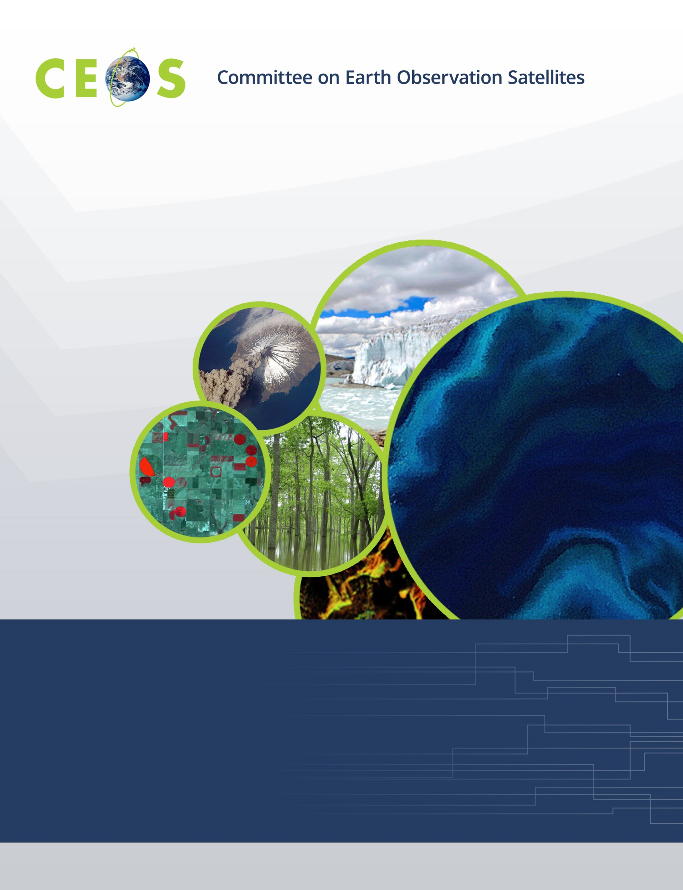

CEOS WGISS-54, Agenda
October 3 to 7, 2022; all times are Japan Standard Time
Hosted by Japan Aerospace Exploration Agency (JAXA)
at The International House of Japan, Tokyo, Japan
Version 1.0 Updated October, 2022
*Indicates remote presentation

Friday, September 30, 2022

10:00 WGISS Chair Team Meeting
@ Meeting Room in The International House of Japan
10:00 Review Facility Setup and Connectivity
10:30 WGISS Chair Strategy Meeting
Discussion Topics:
- Review WGISS Organizational Structure
- Review WGISS ToR
- Rebuild Data Interoperability and Use Interest Group
- WGISS Contributions to the CEOS Interoperability Framework and CEOS Engagement with Standards Organisations initiatives
- WGISS Vice-Chair Solicitation
- Date for WGISS-55
- Location of WGISS-56

17:00 Adjourn

Monday, October 3, 2022
@ Meeting Room in The International House of Japan

16:00 WGISS Exec Pre-meeting

16:00 Final Review for the Agenda
16:30 Logistics

17:00 WGISS Non-hosted Icebreaker

Tuesday, October 4, 2022
@ Meeting Rooms 403 & 404 in The International House of Japan
WebEx: https://ceos.my.webex.com/ceos.my/j.php?MTID=mdcaf70aaa28ea2fce44327774cef511a

09:30 Convene

WGISS PLENARY, Part 1
09:30 Opening Remarks and Logistics Makoto Natsuisaka (JAXA)
09:45 Welcome from the Director of JAXA Earth Observation Research Center Riko Oki (JAXA)
10:00 WGISS Chair Report Makoto Natsuisaka (JAXA)
10:20 CEOS Systems Engineering Office Report Brian Killough (NASA)*
10:40 ISO TC211 Liaison Report Liping Di (GMU for NASA) *

11:00 Break

Data PRESERVATION and STEWARDSHIP
11:20 Session Objectives Mirko Albani (ESA)
11:30 Archive Technology and Future Trends
11:30 NOAA Nancy Ritchey (NOAA)*,
Kenneth Casey (NOAA)*
11:45 WGISS DSIG Best Practices Refreshment Iolanda Maggio (RHEA for ESA)
12:00 AVHRR Recovery Activity Mirko Albani (ESA)
12:15 FAIR Dataset Quality Information Guidelines Ivana Ivanova (Curtin University for NOAA)*

12:30 Lunch

WGISS PLENARY, Part 1, continued
13:30 CEOS Executive Officer Report Marie-Claire Greening (CEO)*

Data PRESERVATION and STEWARDSHIP, continued
13:50 Cooperation with CGMS Mirko Albani (ESA)
14:10 Archive Technology and Future Trends Mirko Albani (ESA)
14:15 USGS Tom Sohre (USGS)
14:30 NASA Valerie Dixon (NASA)
14:45 CNES Richard Moreno (CNES)
15:00 DLR Katrin Molch (DLR)*
15:15 ESA Daniele Iozzino (RHEA for ESA)*

15:30 Break

Data DISCOVERY and ACCESS
15:50 Session Objectives Damiano Guerrucci (ESA)*
16:00 IDN Update and CWIC Update Michael Morahan (NASA)
16:15 FedEO update Yves Coene (Spacebel for ESA)*
16:30 OGC testbed-18: Secure, Asynchronous Catalogs Yves Coene (Spacebel for ESA)*,
Liping Di (GMU for NASA) *
16:55 Service Discovery Best Practices Yves Coene (Spacebel for ESA)*

WGISS PLENARY, Part 1, continued
17:15 GEO Secretariat Report Paola de Salvo (GEOSEC)*,
Laurent Durieux (GEOSEC)*

17:30 Adjourn

Wednesday, October 5, 2022
@ Meeting Rooms 403 & 404 in The International House of Japan
WebEx: https://ceos.my.webex.com/ceos.my/j.php?MTID=mdcaf70aaa28ea2fce44327774cef511a

09:30 Convene

Technology Exploration
09:30 Jupyter Notebooks: Session Objectives Yousuke Ikehata (JAXA)
09:40 Update on Jupyter Notebook Day Esther Conway (UKSA)
10:00 Best Practice Document Esther Conway (UKSA)
10:20 Current Status WGCapD Kenton Ross (NASA)*

10:40 Break
Agency Reports
11:00 ISRO Nitant Dube (ISRO)*
11:10 JAXA Yousuke Ikehata (JAXA)
11:20 USGS Tom Sohre (USGS)

11:30 Lunch
WGISS-WGCV Joint Symposium
@ Lecture Hall in The International House of Japan

13:00 Group Photo at the garden in the International House of Japan
13:20 Opening Remarks Akihiko Kuze (JAXA)
13:30 WGCV Overview Akihiko Kuze (JAXA)
13:40 WGISS Overview Makoto Natsuisaka (JAXA)
13:50 ESA EO Portal, CEOS CAL/VAL Portal, CEOS MIM Database: Paolo Castracane (ESA),
Status, Synergies and Improvements Matthew Steventon (Symbios for ESA)*,
George Dyke (Symbios for ESA)*
14:20 Status of ARD Activities Matthew Steventon (Symbios for ESA)*,
Ferran Gascon (ESA for the ARD
Oversight Group)

14:50 Break
15:10 Data Quality Assessment and Indicators, and DMSMM Maturity Matrix
Data Quality Indicators Philippe Goryl (ESA)
Data Management and Stewardship Maturity Matrix: Iolanda Maggio (RHEA for ESA)
Introduction, Background and Definitions
AVHRR DMSMM Use Cases and Discussion Paolo Castracane (RHEA for ESA)
15:50 CEOS Interoperability Framework Initiative Peter Strobl (JRC),
Matthew Steventon (Symbios for ESA)*
16:20 CEOS Common Online Dictionary: Progress with Joint Activity Peter Strobl (JRC), Katrin Molch (DLR)*
between WGISS and WGCV
17:00 Summary on Joint Interaction; Additional Opportunities; Akihiko Kuze (JAXA),
Joint Recommendations to CEOS and GEO; Action items Makoto Natsuisaka (JAXA)
17:20 Greetings from the Senior Chief Officer of Earth Observation Missions Takeshi Hirabayashi (JAXA)

17:30 Group Photo with remote participants

17:35 Adjourn

18:15 Ice-breaker at Juban Stand

Thursday, October 6, 2022
@ Meeting Rooms 403 & 404 in The International House of Japan
WebEx: https://ceos.my.webex.com/ceos.my/j.php?MTID=mdcaf70aaa28ea2fce44327774cef511a

09:30 Convene
Data INTEROPERABILITY and USE
09:30 EO Interoperability for Services Andrew Mitchell (NASA)
09:40 Session on EAIL: Use-cases and Vision
09:40 COAST Paul DiGiacomo (NOAA)*,
Merrie Beth Neely (NOAA)*
10:00 CSIRO Jonathan Hodge (CSIRO)*

Technology Exploration, Continued
10:20 Machine Learning, Data Learning, Artificial Intelligence: Session Objectives Yousuke Ikehata (JAXA)
10:30 NOAA Center for Artificial Intelligence Robert Redmon (NOAA)*
10:50 Enhancing Earth Observation Applications Using AI/ML Techniques Nitant Dube (ISRO)*

11:10 Break
11:30 Machine Learning and Graph Doug Newman (NASA)
12:00 USGS AI/ML Use Cases Tom Sohre (USGS)
12:15 New AI/ML Keywords Introduced to GCMD Valerie Dixon (NASA)

12:30 Lunch
13:30 Introducing White Paper for AI/ML Outline. Yousuke Ikehata (JAXA)
13:50 Discussion, Conclusions Yousuke Ikehata (JAXA)
Agency Reports
14:10 DLR Katrin Molch (DLR)*
14:20 NASA Andrew Mitchell (NASA)

Technology Exploration, Continued
14:30 Federation Karim Ramage (CNRS)*,
Richard Moreno (CNES)

15:00 Break
Data INTEROPERABILITY and USE, continued
15:20 Federated Discovery using STAC Doug Newman (NASA),
Yves Coene (ESA, Spacebel)*
15:40 Access Patterns and STAC Implementation at Bhoonidhi T. Sai Kalpana (ISRO)*,
K. Radha Krishna (ISRO)*
16:00 STAC Best Practice Doug Newman (NASA)
16:20 Discussion Makoto Natsuisaka (JAXA),
Tom Sohre (USGS)
WGISS PLENARY, Part 2
16:30 Future Meetings Tom Sohre (USGS)
16:40 WGISS Vice Chair Solicitation Makoto Natsuisaka (JAXA)
16:50 WGISS Summary and Discussion Makoto Natsuisaka (JAXA)
17:10 Review of WGISS Actions Michelle Piepgrass (JAXA)
17:20 Concluding Discussion and Remarks Makoto Natsuisaka (JAXA)

17:30 Adjourn

Friday, October 7, 2022

11:00 Facility Tour - Tsukuba Space Center
11:00 Introduction of Tsukuba Space Center

12:00 Lunch
13:00 Site Tour

16:00 Adjourn

