WGISS-54 Logistics

Venue
The meeting venue will be the International House of Japan, Roppongi, Minato-ku, Tokyo:
Access: https://www.i-house.or.jp/eng/access.html
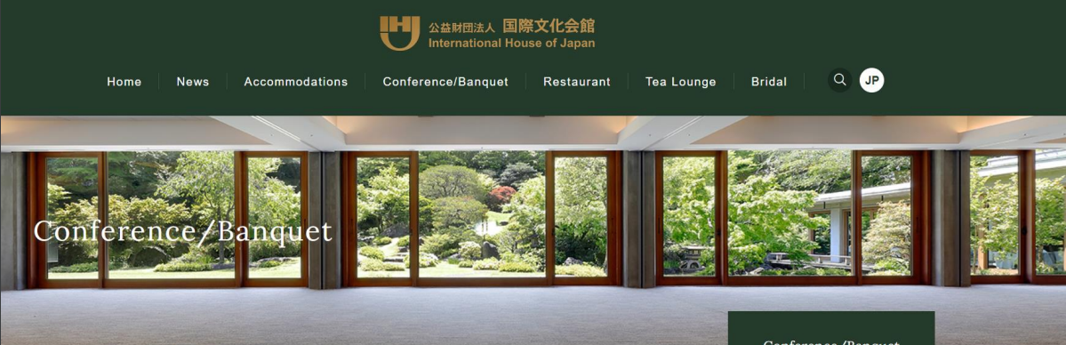

Accommodation
The area where the meeting is located, “Roppongi”, “Azabu”, or “Akasaka”, is in the middle of downtown of Tokyo. There are a lot of hotels in the area, and you can find an excellent hotel which will match your preferences via the travel portals below.

https://www.agoda.com/
https://www.booking.com/
https://www.expedia.co.jp/

We kindly ask you to book your room yourself. It is strongly suggested that you choose a refundable booking.

The following are our suggestions:
- Mitsui Garden Hotel – Roppongi-premier
https://www.gardenhotels.co.jp/roppongi-premier/
=> Recommended, 7-minute walk to the venue, large hotel, new, excellent location
② The Lively – Tokyo Azabujuban
https://www.livelyhotels.com/ja/thelivelyazabu/rooms/
- REMM Roppongi
https://www.hankyu-hotel.com/hotel/remm/roppongi
- APA Hotel Roppongi-six
https://www.apahotel.com/hotel/syutoken/tokyo/roppongi-six/
- APA Hotel Roppongi-ekimae
https://www.apahotel.com/hotel/syutoken/tokyo/roppongi-ekimae/

Travel Guide
There are two international airports in Tokyo: Haneda and Narita. It takes about 30min from Haneda to Roppongi and about 90min to 120 min from Narita to Roppongi by using public transportation. Haneda international airport is more convenient if it’s available since it’s closer to the downtown of Tokyo.

- Haneda International Airport
https://tokyo-haneda.com/en/access/index.html
- Narita International Airport
https://www.narita-airport.jp/en/access

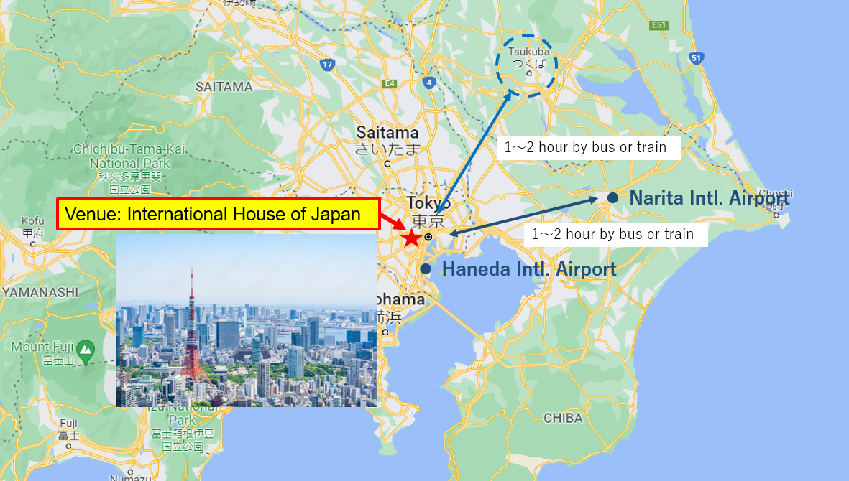

From the airports to Roppongi, there are several options. Please choose what is most convenient for you.
https://world.jorudan.co.jp/mln/en/?sub_lang=nosub

You could find tips on travel in Japan at these sites:
https://matcha-jp.com/en/
https://matcha-jp.com/en/4409
https://boutiquejapan.com/japan-travel-tips/
https://youtu.be/oVFjA7Qy1as
https://youtu.be/IsngamFa1ps

Preparation for Travel

Entry to Japan
Foreign nationals newly entering Japan are limited to a short stay for business purpose and tourism. They are allowed for new entry into Japan in principle, if the receiving organizations located in Japan complete prescribed applications in the Entrants, Returnees Follow-up System (ERFS) (see 4.3.).

Border Measures
In addition, EVERYONE must submit COVID-19 negative pre-test result and Questionnaire. Your quarantine depends on the classification of the country or region of your stay before arriving in Japan, and your vaccination status. All entrants must presentation a certificate of inspection within 72 hours before leaving the country. If you are unable to presentation a valid certificate of inspection, you will not be allowed to enter in Japan based on the Quarantine Law. Vaccination certificate can be approved only valid vaccines by the Japanese government. Those who are required isolation need to submit written pledge for health follow-up
Country or region of your stay before arrival | Valid vaccination certificate | Quarantine
 |  | Pre-departure test  FOR ALL | On-arrival test | Isolation
BLUE | No need to submit | ○ | × | ×
YELLOW | with | ○ | × | ×
 | without | ○ | ○ | 3days at home *1
RED | with | ○ | ○ | 3days at home *1
 | without | ○ | ○ | 3days at facility *2

Information to be described in the certification is listed below.
https://www.mhlw.go.jp/stf/covid-19/border_test.html
They strongly encourage to use the "Fast-Track " method of pre-screening.

The details are explained below.
https://www.mhlw.go.jp/stf/covid-19/bordercontrol.html

ERFS and VISA
All visitors need a VISA. Prior for you to request for VISA to a Japanese Diplomatic Establishment in your country, please input your travel information to JAXA via the below form.

https://forms.office.com/Pages/ResponsePage.aspx?id=Zmk96zt7UU-8KeWxlOc8Hla08PxXoIFGlNigbDtHsOVUNVZYWEExMTlSV0IzVTM3WkFVTFg5VUMzRi4u

JAXA will input your information to “Entrants, Returnees Follow-up System (ERFS)” developed by Japanese Ministry of Health, Labour and Welfare. JAXA will send you the “Certificate for Complete of Registration to ERFS” after receiving it from ERFS. Please request VISA to a Japanese Diplomatic Establishment with the ERFS Certificate.

https://www.mofa.go.jp/ca/fna/page4e_001053.html
https://www.mhlw.go.jp/stf/covid-19/bordercontrol.html

Please check the details in the above process by reading “New Entry Application Procedure_Japan.pptx”.

MySOS
Japanese government requires you to install “MySOS” application to your smart phone. (Fast Track or Visit Japan Web Service is also available.) Please install MySOS following the instructions described in “New Entry Application Procedure_Japan.pptx” before you leave your country to avoid wasting time at the Japanese airport.

Invitation Letter
If you need an invitation letter, please let us know.

5.0 Health and safety
Please take the following countermeasures to prevent the spread of the infection.
- Wear a face mask and take caution to protect others from getting infected.
- Sanitize your hands thoroughly and wash your hands frequently.
- Avoid the three Cs (closed spaces, crowded places, close-contact settings).
If you develop any symptoms, please make a phone call to the Consultation Center for Returnees and Those in Close Contact with the Virus immediately. Inform them the region(s) you had stayed in and visit the specified medical institution.
If you are tested positive after arriving in Japan, please cooperate with the active epidemiological investigations according to the Article 15 of the Infectious Diseases Control Law conducted by public health centers and other facilities.
COVID-19 Mask Use in Community Settings
- It is important to wear a mask as a basic prevention measure against COVID-19. Your action will protect everyone’s health.
- You do not need to wear a mask outdoors when you are approximately 2 meters apart from others, or when you are not talking at a distance of less than 2 meters.
- You do not need to wear a mask indoors when you are approximately 2 meters apart from others and when you are not talking.
- Questions
If you have any question, please feel free to ask us.

WGISS Chair: Makoto Natsuisaka
Natsuisaka.makoto@jaxa.jp
WGISS Secretary: Michelle Piepgrass
mvpiepgrass@gmail.com

