Information for participants
CO-LOCATED MEETING OF WGDISASTERS-19 AND WGISS-55
CONAE-CETT Falda del Carmen, Province of Córdoba, Argentina

VENUE
The meeting will be held at the Teófilo Tabanera Space Center (CETT)
CETT
Ruta C45, km 8
Falda del Cañete – Province of Córdoba

TRANSPORTATION
Transportation will be provided between Cordoba City to the Space Center.
Bus will depart from Hotel NH Panorama Av. Marcelo T. de Alvear 251 – Córdoba Centro Teléfono: 0351 410-3900
Bus will leave Hotel NH Panorama at 8 am on the days of the meeting and will depart the Space Center at 5 pm, except on Tuesday, that will return at 7 pm, after the ice breaker.
For the visits on Friday see schedule apart.
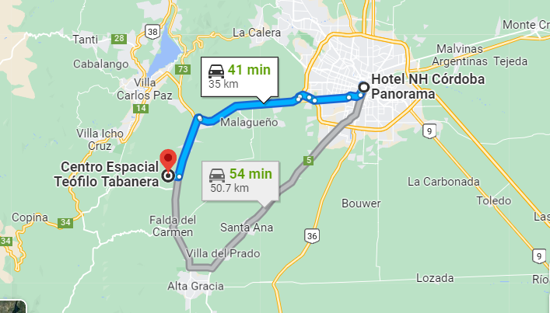

REGISTRATION AND BADGES
All participants must be registered beforehand to enter the Space Center.
Participants will receive a magnetic badge (Tarjeta de Identificación Personal-TIP) that must be worn at all times during the stay at the center. They will be distributed on Tuesday morning, at the time of boarding the bus at Hotel NH Panorama.
Please send your information in advance.
For any questions on logistics, you can send an e-mail to eventos@conae.gov.ar

LUNCH AND COFFEE BREAKS
Joint coffee breaks will be held outside the meeting rooms. Coffee and water will be available at all times.
Lunch will be at the Cafeteria, next to the meeting rooms. Magnetic badges (TIP) can be pre-charged for payment. Receipts will be provided by the cafeteria.
The following are the menus for the week:

TUESDAY
Menu 1: Pork with Criolla sauce and grilled vegetables
Menu 2: Chard pie
Menu 3: Steak and smashed squash
Green menu: Vegetables/Salad

WEDNESDAY
Menu1: Ravioli with chicken sauce
Menu 2: Cheese omelette. Mixed salad
Menu 3: Steak. Stewed vegetables
Green menu: Vegetables/Salad

THURSDAY
Menu 1: Fatay (empanadas arabes)
Menu 2: Zucchini stuffed with chicken
Menu 3: Chicken and potatoes
Green menu: Vegetables/Salad

Menus include beverage (water) and dessert.

Icebreaker: on Tuesday, a reception will be offered at the space center after the end of the session, at the same building.
Dinner: On Wednesday, CONAE will offer a dinner at Alcorta restaurant (Figueroa Alcorta 330 - Córdoba city). The restaurant is located at 800 meters from the Hotel NH Panorama.

TOUR OF FACILITIES
A tour of facilities of the Space Center will be offered for each group separately:
WG Disasters will have the visit on Thursday after the end of the session; the visit is scheduled to finish at 5 pm so both groups will return to the hotel together on the bus.
WGISS will have the visit on Friday morning, starting at 9:30. After the visit ends, a picnic with empanadas will be offered to participants. The bus will return to the hotel after lunch. We will appreciate to receive your confirmation at eventos@conae.gov.ar.

WG Disasters Field trip
On Friday, the visit to the Hydro Meteorological Observatory (OHMC) will be from 9 to 12. We will appreciate to receive your confirmation at eventos@conae.gov.ar.
A bus will depart from the hotel NH Panorama at 8:30.
At the end of the visit, participants can either go back to the hotel or they can join WGISS at the Space Center for a picnic with empanadas. Transportation will be provided.
Address: Ituzaingó al 1300- Parque de la Tejas -Córdoba
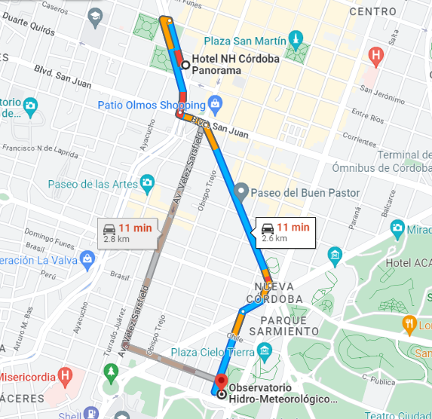

WEEK AT A GLANCE

MO  17/04/2023 | TUE  18/04/2023 |  | WED  19/04/2023 |  | THU  20/04/2023 |  | FRI  21/04/2023
Day 1 | Day 2 |  | Day 3 |  | Day 4 |  | Day 5
Arrival, preparations side meetings | 8:00 am  Bus leaves Hotel |  | 8:00 am  Bus leaves Hotel |  | 8:00 am  Bus leaves Hotel
 | WGISS | WGD | WGISS -WGD Joint Session |  | WGISS | WGD | 9 am-1pm  WGISS Space Center Tour | 9 am-12pm  WGD  Field visit OHMC  Cordoba City
 |  |  | Photo w/remote participants
 | 12:00-12:40  Lunch break |  | 12:00-12:40  Lunch break |  | 12:00-12:40  Lunch break
 | WGISS | WGD | 12:40-01:00  Joint Groups photo |  | WGISS | WGD Space Center Tour
 |  |  | WGISS | WGD
 | 5-7 pm  Icebreaker At Space Center |  | 5pm  Bus Return to hotel |  | 5 pm  Bus Return to hotel
8-10 pm
CONAE hosted dinner

