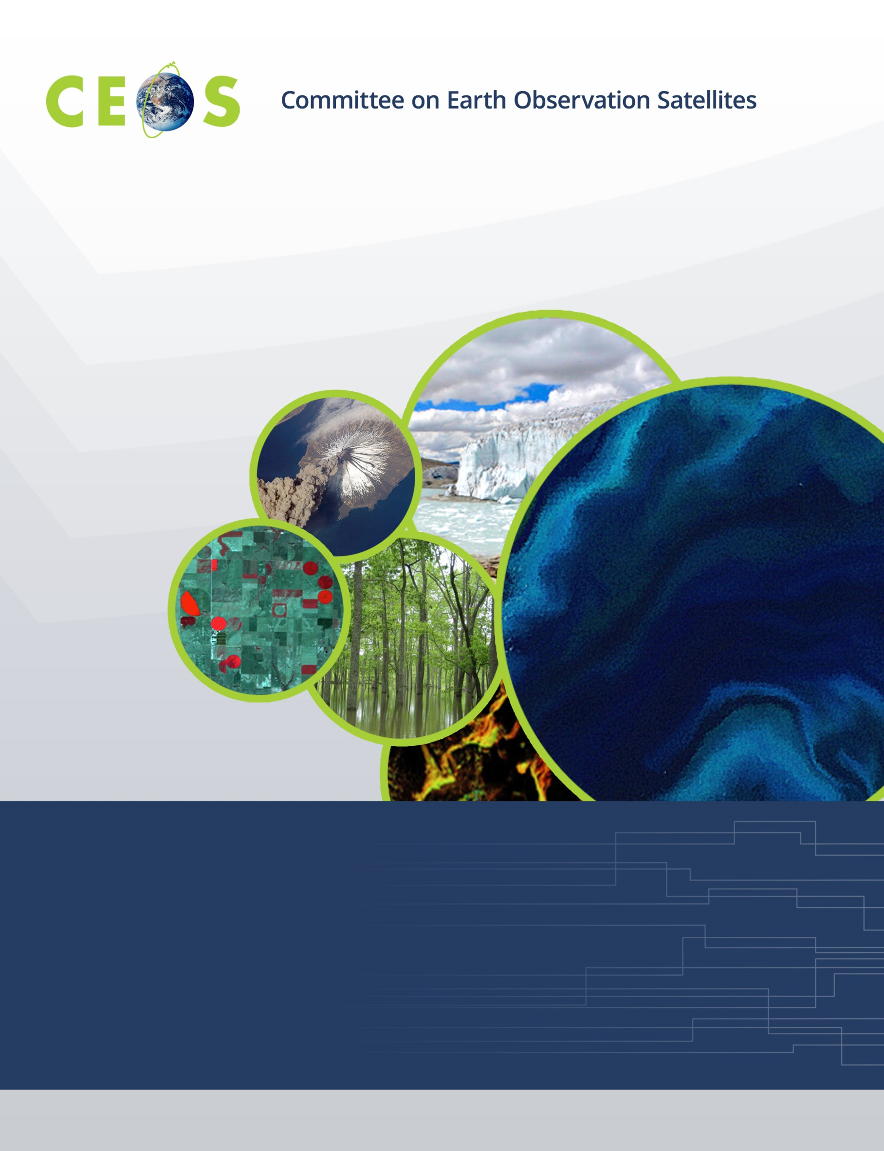

CEOS WGISS-55 Agenda
April 18-20 2023; all times are Argentina Standard Time
Hosted by Comisión Nacional de Actividades Espaciales (CONAE)
In Córdoba, Argentina
Version 1.0 Updated April 17, 2023
*Indicates remote presentation

Monday, April 17, 2023

17:00 WGISS Chair Team Meeting at NH Hotel Panorama
17:00 Meeting Goals Discussion Chair, Vice-chair

17:40 Adjourn

18:00 WGISS Exec Pre-meeting at NH Hotel Panorama
18:00 Final Review of the Agenda WGISS Exec Team
18:30 Meeting Logistics WGISS Exec Team

19:00 WGISS Non-hosted Dinner TBD; All WGISS-55 participants and guests

Tuesday, April 18, 2023

08:00 Shuttle to CONAE, gather at NH Panorama Hotel
WebEx: https://ceos.my.webex.com/ceos.my/j.php?MTID=me51888acb11efd74d5124c8a22d0a271 password will be sent to registered participants.

09:00 Convene at CONAE Room TBD

WGISS PLENARY, Part 1
09:00 Welcome from CONAE Raúl Kulichevsky (CONAE)
09:15 Logistics Homero Lozza (CONAE)
09:20 Opening Remarks Makoto Natsuisaka (JAXA)
Introductions, including remote participants
09:30 WGISS Chair Report Makoto Natsuisaka (JAXA)
09:45 CEOS Executive Officer Report Marie-Claire Greening (CEO)
10:00 Discussion of CEOS Work Plan Deliverables for WGISS All

10:15 Break

CEOS Interoperability Framework
10:30 Session Objectives Makoto Natsuisaka (JAXA)
10:40 Introduction to the CEOS Interoperability Framework Tom Sohre (USGS)
11:00 Professional Open-Source Framework for Earth System Thomas Huang (JPL for NASA)
Digital Twins and Applications
11:40 CEOS Systems Engineering Office Cloud Use Strategy David Borges (NASA)

12:00 Lunch
13:00 Discussion on the Vision, Outcomes, Actions, Next Steps

Technology Exploration
14:00 Session Objectives Yosuke Ikehata (JAXA)
Jupyter Notebooks
14:10 Status of Jupyter Notebooks Best Practice Esther Conway(UKRI/STFC)
14:20 Discussion All
AI/ML
14:25 Proposal for AI/ML Survey in WGISS Yosuke Ikehata (JAXA)

14:50 Break
15:10 NOAA Steps Toward the Geoverse Ryan Berkheimer (NOAA)*
15:35 PML Work David Moffat(PML)*
16:00 MLHub and AI/ML in CMR Valerie Dixon (NASA),
Michael Morahan (NASA)
Federation
16:25 STAC Activity Yves Coene (Spacebel for ESA)
16:40 Discussion All
16:50 Outcomes, Actions, Next Steps Yosuke Ikehata(JAXA)

17:00 Adjourn

17:30 Ice-breaker Reception

18:45 Shuttle arrival at NH Panorama Hotel

Wednesday, April 19, 2023

08:00 Shuttle to CONAE, gather at NH Panorama Hotel
WebEx: https://ceos.my.webex.com/ceos.my/j.php?MTID=me51888acb11efd74d5124c8a22d0a271 password will be sent to registered participants.

09:00 Convene at CONAE Room TBD
WGISS-WGDisasters Joint Symposium
09:00 Introduction of joint session and round table introductions (including remote) Hélène de Boissezon (CNES)
09:10 Introduction to CONAE Laura Frulla (CONAE)
09:25 Overview of WGISS Activities Makoto Natsuisaka (JAXA)
09:40 Overview of WGDisasters Activities Hélène de Boissezon (CNES)
09:55 Presentation of WGISS AI/ML White Paper Yosuke Ikehata (JAXA)
10:10 Presentation of WG Disasters Planned Use Case on ML and the Wildfire Sector Alan Cantin (NRCan),
David Borges (NASA)

10:20 Group Photo of remote participants

10:20 Break
10:35 General Discussion Around Use of ML for EO Analysis and Suggestions All
for Possible Joint Activity
11:00 Service Discovery Best Practice Activity Yves Coene (Spacebel for ESA)
11:15 Use of EAIL in Flood Pilot and Other Possible Synergies Marcelo Uriburu (CONAE)
11:25 General Discussion and Joint Session Wrap-up All
11:35 Agency Presentations (3 to 5 minutes each) Interested agencies
USGS Emergency Operations Activities Tom Sohre (USGS)
ROSCOSMOS Andrey Kuklin (ROSCOSMOS)

12:00 Lunch

12:40 Group Photo @TBD (both Working Groups)

Data DISCOVERY and ACCESS
13:10 Session Objectives Damiano Guerrucci (ESA)*
13:20 Data Access Authorisation - Toward Federated Access
EGI (OpenEO) – Federated Authorisation Valeria Ardizzone (EGI for ESA)*
NASA - Multifactor Authorisation Valerie Dixon (NASA)*
14:00 GEO-ZARR WG led by NASA Christophe Noel (Spacebel for ESA)*
14:20 ISO TC211 Liping Di (NASA)*
14:35 IDN and CWIC Update Michael Morahan (NASA)
14:50 FedEO Update Yves Coene (Spacebel for ESA)

15:00 Break
15:20 Metrics Best Practice on Cloud (NASA Implementation) Doug Newman (NASA), Min Wong (NASA)
15:40 Service Discovery:
OSS Tools Metadata Ingestion Use Cases – FedEO/ IDN Yves Coene (Spacebel for ESA),
Michael Morahan (NASA)
16:00 Outcomes, Actions, Next Steps Damiano Guerrucci (ESA)*
Agency and Liaison Reports
16:30 ESA Mirko Albani (ESA)
16:40 NOAA Ken Casey (NOAA)
16:50 UKSA Esther Conway (UKSA)

17:00 Adjourn

17:00 Shuttle to NH Panorama Hotel

20:00 Hosted Dinner

Thursday, April 20, 2023

08:00 Shuttle to CONAE, gather at Panorama Hotel
WebEx: https://ceos.my.webex.com/ceos.my/j.php?MTID=me51888acb11efd74d5124c8a22d0a271 password will be sent to registered participants.

09:00 Convene at CONAE Room TBD
Agency and Liaison Reports, continued
09:00 ISRO Sai Kalpana Tanguturu (ISRO)*

Data PRESERVATION and STEWARDSHIP
09:10 Session Objectives Mirko Albani (ESA)
09:20 Archive Technologies Evolution White Paper Daniele Iozzino (RHEA for ESA)*
09:40 DSIG Best Practices Refreshment Iolanda Maggio (RHEA for ESA)
10:10 Data Publication, Preservation and Knowledge Hub Liu Chuang (NRSCC)*

10:25 Break
10:40 Copernicus Sentinels Ground Segment Architecture Razvan Cosac (ESA)*
11:05 Session on AVHRR Data Archives
AVHRR Data: European Coverage Mirko Albani (ESA),
S. Wunderle (UniBern)*
AVHRR Data: North American Coverage Ken Casey (NOAA)
AVHRR Data Recovery Project Mirko Albani (ESA)

12:00 Lunch

Data PRESERVATION and STEWARDSHIP, continued
13:00 Introduction of DOIs to the JAXA G-Portal Products Yosuke Ikehata (JAXA)
13:10 Data Replicas (Authenticity and Integrity) in the Cloud Use Case Mirko Albani (ESA)
13:30 Authenticating Data Replicas Doug Newman (NASA),
Michael Morahan (NASA)
13:45 Outcomes, Actions, Next Steps Mirko Albani (ESA)
WGISS PLENARY, Part 2
14:00 WGISS Strategic and Interoperability Framework Discussion Makoto Natsuisaka (JAXA)

15:00 Break
15:20 Future Meetings Tom Sohre (USGS)
15:30 WGISS Vice Chair Solicitation, and Organizational Matters Makoto Natsuisaka (JAXA)
15:45 Summary of Meeting Outcomes, Next Steps Tom Sohre (USGS)
16:30 Review of WGISS Actions Michelle Piepgrass (JAXA)
16:45 Concluding Discussion and Remarks Makoto Natsuisaka (JAXA)

17:00 Adjourn

17:00 Shuttle to Panorama Hotel

Friday, April 21, 2023

09:00 Shuttle to CONAE, gather at NH Panorama Hotel

10:00 Facility Tour at CONAE

12:00 Lunch

15:00 Adjourn

16:00 Arrive at NH Panorama Hotel

