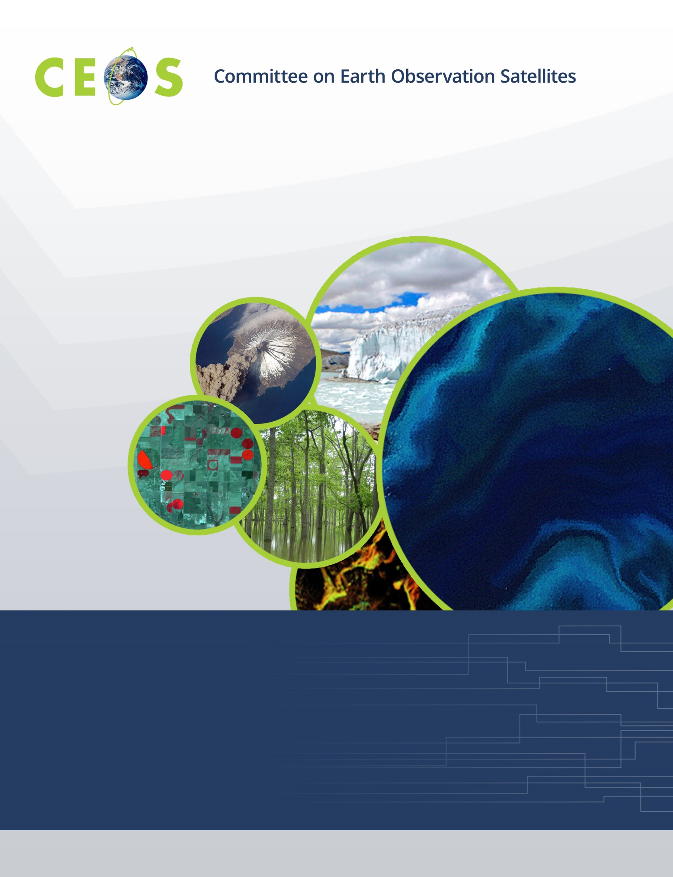

CEOS WGISS-56, Agenda
October 24 to 26, 2023, Paris, France
All times are Central European Time
Hosted by Centre national d'études spatiales (CNES)
Version 1.0 Updated October 23, 2023

Monday, October 23, 2023

18:00 WGISS Exec Pre-meeting, CNES Headquarters, room 5
18:00 Meeting Logistics Update Richard Moreno (CNES)
18:15 Finalization of Agenda All

19:00 Dinner (WGISS Exec and Guests)

Tuesday, October 24, 2023
For internet connectivity, please use Eduroam; if not possible, please obtain a code at registration

09:00 Convene, CNES Headquarters, Salle Espace

WGISS PLENARY, Part 1
09:00 CNES Welcome Véronique Mariette,
CNES Copernicus Program Manager
09:30 Meting Logistics Richard Moreno (CNES)
09:40 Agenda Review and Introduction of Participants Makoto Natsuisaka (JAXA)*
09:50 WGISS Chair Report Makoto Natsuisaka (JAXA)*
10:10 CEO Report Marie-Claire Greening (ESA)

10:30 Break
Agency Reports
10:50 ISRO Agency Report Nitant Dube (ISRO)
11:05 CSIRO Agency Report Matt Paget (CSIRO)
11:20

Technology Exploration
11:30 Session Purpose Yousuke Ikehata (JAXA)
11:40 AI/ML White Paper Status Report Yousuke Ikehata (JAXA)
12:00 Discussion

12:30 Lunch
Data INTEROPERABILITY and USE
13:30 CEOS Interoperability Framework and Roadmap Tom Sohre (USGS)
13:50 Digital Earth Africa Overview and Interoperability Lisa Rebelo (GA/SANSA)*
14:10 SEO Report David Borges (NASA)*

14:30 Break
14:50 Digital Earth Analysis System (IDEAS) Framework Thomas Huang (JPL/NASA)*
15:20 DLR Terrabyte Overview Jonas Eberle (DLR)
15:40 DLR/USGS Interoperability Pilot Jonas Eberle (DLR),
Ryan Longhenry (USGS)*
16:00 Interoperability Framework Next Steps Tom Sohre (USGS)

17:00 Adjourn

Wednesday, October 25, 2023

09:00 Convene, CNES Headquarters, Salle Espace

Data PRESERVATION and STEWARDSHIP
09:00 DSIG Session Introduction Mirko Albani (ESA)
09:10 WGISS Website Refreshment Iolanda Maggio (RHEA for ESA),
Michelle Piepgrass (JAXA)
09:30 AVHRR Data Recovery Project Updates Mirko Albani (ESA)
09:50 AVHRR Datasets Available at CEDA Ed Williamson (STFC/UKSA)
10:00 AVHRR Datasets Available at CSIRO Edward King (CSIRO)*
10:20 AVHRR European Dataset Curation Project Updates Stefan Wunderle (UNIBERN)*
10:40 AVHRR Data Holdings Peter Cornillon (U. Rhode Island)

11:00 Break
11:20 Archive Technologies White Paper Overview Daniele Iozzino (RHEA for ESA)*
11:40 ISO16363 and CoreTrustSeal Standards: Self-assessment at ESA Iolanda Maggio (RHEA for ESA)
11:50 WMO Information System 2.0 Enrico Fucile (WMO)*
12:10 CGMS Cloud Best Practices and Approach to International Collaboration Kathryn Shontz (NOAA)*,
Daniel Lee (EUMETSAT)*

12:30 Lunch

13:30 Group Photo

Data DISCOVERY and ACCESS
13:45 Session Objective Damiano Guerrucci (ESA)
14:00 FedEO Report Yves Coene (Spacebel for ESA)
14:15 IDN Report Michael Morahan (NASA)
14:30 IDN Search Portal Demonstration Michael Morahan (NASA)
14:45 FedEO Connections Result Yousuke Ikehata (JAXA)

15:00 Break
15:15 Discover and Explore Heritage Data Gregory Mazabraud (VisioTerra)*
15:35 Data Access Evolution towards Collaborative Environments Roberto Alacevich (ESA)*
15:55 AI/ML in CMR Jed Sundwell (Radiant/NASA)*
16:15 STAC Browser, Demonstrator Matthias Mohr (for ESA)*
16:30 STAC Best Practices Progress Report Yves Coene (Spacebel for ESA),
Doug Newman (NASA)
16:50 Round Table on STAC-related Activities Damiano Guerrucci (ESA)
17:20 Outcomes, Discussion, Next Steps

17:30 Adjourn

Thursday, October 26, 2023

09:00 Convene, CNES Headquarters, Salle Espace
WGISS PLENARY, Part 2
09:00 CEOS Workplan and WGISS Strategy, WGISS Outreach, Tom Sohre (USGS)
CEOS Engagement with Standards Organizations
09:40 Future Meetings Tom Sohre (USGS)
09:50 WGISS Summary and Discussion Makoto Natsuisaka (JAXA)*
10:10 Review of WGISS Actions Michelle Piepgrass (JAXA)

10:40 Break
11:00 WGISS Chair Team Transition Makoto Natsuisaka (JAXA)*,
Tom Sohre (USGS)

WGISS Cooperation with other Working Groups
11:15 Working Group Disasters (WGDisasters) Helene De Boissezon (CNES),
Aurélien Sacotte (CNES)
Jupyter Notebooks Workshop
11:30 Working Group on Capacity Building and Data Democracy (WGCapD) Jorge del Rio Rivera (UN)*
12:00 GEO Report Paola de Salvo (GEO-SEC)*

12:30 Lunch

13:30 Convene, CNES Headquarters, Salle Espace
13:30 Best Practice Jupyter Notebooks Status Esther Conway (UKSA/NCEO)
13:45 Vision for FEDEO and ESA Registry Tools Yves Coene (Spacebel for ESA),
Damiano Guerrucci (ESA)
14:05 Discussion, Best Practice Documents All
14:15 Jupyter Hub, Binder and Collaboration Examples Esther Conway (UKSA/CEDA)
14:30 CEOS SEO Google Earth Engine Sandpit David Borges (NASA)*
14:45 MAGEO and AI Training Notebooks Dan Clewley (PML/NEODAAS)*

15:00 Break
15:15 EUMETSAT Training Needs Ben Loveday (EUMETSAT)*
15:30 NASA Development: Current Situation and Training Needs Lauren Childs-Gleason NASA)*,
Kent Ross (NASA)*
15:45 AEM: Current Situation and Training Needs Julio Castillo (AEM)*
16:00 NCEO: Current Situation and Training Needs Uzma Saaed, (NCEO)*
16:15 Open Discussion, Future Plans All

17:00 Adjourn

